Willing to Work: National Inquiry into Employment Discrimination against Older Australians and Australians with Disability

Submission No 250
Name Sophie Cotsis MLC
Submission made by
☒ Other
Please describe:
NSW Shadow Minister for Ageing, Disability Services and Multiculturalism

Organisation or Government Agency Submission

About you
What is your role within your organisation?
☐ Owner
☐ Manager
☐ Human Resources Manager
☒ Other
If other, please tell us your role within your organisation
I am the NSW Shadow Minister for Ageing, Disability Services and Multiculturalism.
What is your experience of providing work/services/advocacy for older Australians/Australians with disability?
As the NSW Shadow Minister for Ageing, Disability Services and Multiculturalism, I
am responsible for:
• Scrutinising actions of the NSW Government which affect older people and people with disability in NSW;
• Developing policies to advance the interests of older people and people with disability in NSW;
• Making representations on behalf of individuals to the NSW Government;
• Referring constituents to non-government organisations which provide support and advocacy for older people and people with disability; and
• Liaising with peak bodies and community organisations on matters of public policy, such as the scrutiny of legislation and NSW Government programs which affect older people and people with disability in NSW
What are the impacts of employment discrimination on older Australians/Australians with disability working or looking for work?
Economic impacts
Older Australians
There are significant economic impacts arising from employment discrimination against older Australians.
For people who experience employment discrimination, the economic impacts include lost income, reduced superannuation savings and an inability to prepare for a secure retirement. These impacts can be particularly severe for older people who do not own their own home, and who may have to rely on social housing or the private rental market to provide accommodation in retirement.
The economic impacts that are experienced by individuals aggregate into impacts on the entire community. This can be seen in increased pressure on public finances that arises when governments are deprived of potential revenue and face increased demand for social services.
More than one million people in NSW are aged 65 and over. This number will more than double by 2050. In 2011, the NSW Government released a Long Term Fiscal Pressures Report. This report found that factors such as population ageing and declining labour force participation would lead to a ‘fiscal gap’ worth around $11.5 billion or around 20 percent of total NSW Government budget expenses by 2050.
Overcoming employment discrimination and unleashing the potential of older Australians represents a significant opportunity to grow Australia’s economy. Modelling by Deloitte Access Economics has found that:
• Increasing labour force participation by Australians aged 55 and over by three percent would result in a $33 billion boost to Australia’s economy; and
• Increasing labour force participation by Australians aged 55 and over by five percent would result in a $48 billion boost to Australia’s economy.

Australians with disability
Employment discrimination has a significant impact on people with disability. Forty- five percent of people with disability in Australia live in or near poverty.
The effects of employment discrimination against people with disability include:
• The denial of a source of income that would otherwise enable them to make choices about how they live;
• Increased pressure on families and carers; and
• Increased pressure on public finances as a result of forgone revenue and higher demand for services.
Increasing employment participation by people with disability represents a significant opportunity to increase Australia’s prosperity. PricewaterhouseCoopers has reported that:
• People with a disability in Australia are only half as likely to be employed compared with people without a disability; and
• If Australia were to increase employment participation by people with disability in line with the average for the top eight OECD countries this would:
o Bring 370,000 people into the workforce; and
o Add almost $50 billion to Australia’s economy by 2050.

Social impacts
While the social impacts of employment discrimination may be more difficult to quantity than economic impacts, they are no less serious.
The social impacts for people who are subject to employment discrimination include:
• Social exclusion, including the loss of social connections;
• The loss of feelings of purpose and self-worth;
• Pressure on family relationships; and
• Increased stress and mental health risks.
Ending employment discrimination is essential to building a truly inclusive society in which all Australians can pursue their full potential.

Barriers
Do you think older Australians/Australians with disability face barriers when they work or are in a job?
☒Yes
☐No
☐Not sure
Please tell us more
Australians with disability
One barrier that people with disability face when seeking work in NSW is the NSW Government’s own performance as an employer.
The NSW Government is the largest employer in Australia, with 326,765 full-time employees.
While the NSW Government should be a model employer, its own employment data shows that the proportion of public sector employees with disability has been steadily decreasing over recent years.
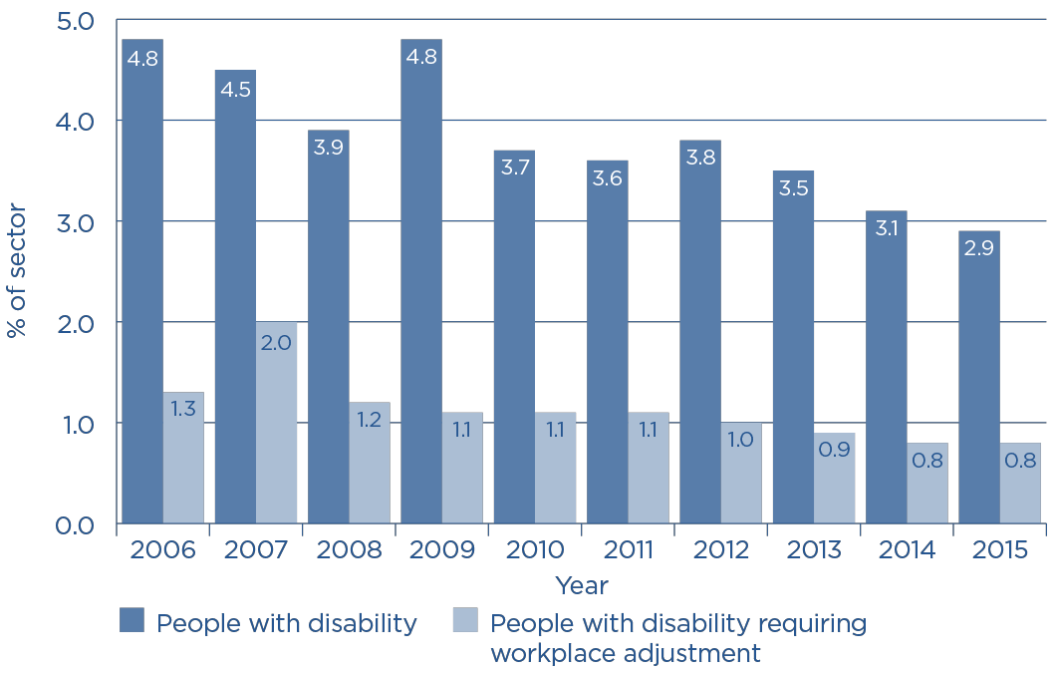

Source: NSW Public Service Commission, State of the Sector (2015) p 24
A key factor contributing to this decline – as identified by the NSW Public Service Commission – is that many NSW Government agencies have failed to develop adequate strategies to recruit and retain people with disability.
The NSW Public Service Commission reports that only half of public sector agencies have developed specific attraction and retention strategies for people with disability, and only nine percent of agencies have done so at a ‘developed’ level.
Older Australians
As identified in previous research by the Australian Human Rights Commission, the policies of state governments can act as a significant barrier to employment for older workers. Policies that may act as barriers include:
• Age limits in relation to workers compensation which may discourage older people from working;
• Licencing requirements, such age-related vehicle licencing requirements; and
• Access to training services such as TAFE which play a vital role in helping older workers to maintain existing skills or re-skill in order to seek new employment.
As the Australian Human Rights Commission has written previously:
TAFEs can and should play a key role in providing this support to older workers by offering training which allows them to re-join or further contribute to the workforce
Unfortunately, recent policy decisions by the NSW Government affecting TAFE NSW are having a significant negative effect on employment prospects for older people in NSW. These decisions include increases to course fees, reductions to the number of courses available, significant cuts to teaching and support staff and plans to close 27 campuses across NSW.
The effect of the present NSW Government’s policies for TAFE on older people is concerning, with the latest data from TAFE NSW shows that enrolments by mature aged students (aged 45 years and over) have fallen by 10.4 percent over the last four years.
By making it harder for older Australians to access training through TAFE, the NSW Government is contributing to the barriers that older people face when seeking employment.

Solutions
What action should be taken to address employment discrimination against older Australians/Australians with disability?
NSW Labor believes that addressing employment discrimination requires a comprehensive approach that encompasses cultural change, improvements in workplace policies and government initiatives.

Cultural change
The starting point for addressing employment discrimination against older Australians and Australians with disability must be a focus on cultural change. As a recent Senate Inquiry into violence, abuse and neglect against people with disability found, the ‘root cause’ of these problems ‘begins with the de-valuing of people with disability’. The de-valuing of people with disability and older people can also be understood to be the root cause of employment discrimination they often experience.
Changing cultural attitudes which de-value the contributions people with disability and older people can make to individual workplaces and the wider economy is fundamental to overcoming employment discrimination. Any proposed solutions to employment discrimination which do not seek to address the underlying cultural attitudes which lead to employment discrimination against people with disability and older people will not be effective.
All levels of government – as well as employers and community organisations – share responsibility for undertaking education programs in workplaces and the wider community in order to change preconceptions and misconceptions about older Australians and Australians with disability in order to recognise and celebrate the valuable contribution they can make.
Workplace policies
In addition to changing attitudes throughout society, attention must be given to policies within workplaces that may impede participation by older Australians and Australians with disability. Overcoming employment discrimination and unleashing the potential of older workers and workers with disability is a responsibility shared by all employers.
Fulfilling this responsibility requires all employers to continually examine policies and practices within their workplaces, including policies for recruitment, career advancement and workplace flexibility.
As noted above, the NSW Government bears special responsibility as Australia’s largest employer to ensure that its workplace policies set the standard for facilitating greater participation by people with disability and older people in the workforce. The fact that only half of public sector agencies have developed specific attraction and retention strategies for people with disability shows that the NSW Government has significant work to undertake if it is to make a meaningful contribution toward meeting its responsibilities as an employer.
Government initiatives
NSW Labor supports all levels of government working to undertake a range of initiatives to overcome employment discrimination against older Australians and Australians with disability. These include:
• Delivering the National Disability Insurance Scheme on-time and in-full to empower people with disability with more choice and certainty over the supports they receive;
• Investing in TAFE to ensure that older Australians and Australians with disability can easily access training programs to develop their skills and gain employment;
• Improving access to transport services, with easily accessible public transport services having a significant effect on the ability of people with disability to travel to work;
• Continuing programs that provide older Australians and Australians with disability opportunities to develop their skills using new technology, such as the successful Broadband for Seniors program;
• Ensuring that there are clearly identified leaders responsible for addressing problems of discrimination by:
o Appointing a specifically designated Federal Disabilities Minister;
o Maintaining State Ministers for Disability Inclusion after the roll-out of the NDIS; and
o Restoring the position of a designated Disability Discrimination Commissioner at the Australian Human Rights Commission;
• Establishing local, regional and national forums to facilitate networking and promote collaboration between private sector employers, older people, people with disability, governments and community groups;
• Setting clear goals for increases in public sector employment of people with disability and older people, with these goals to be accompanied by:
o Well-resourced plans developed in consultation with people with disability and older people; and
o Regular reporting by the Commonwealth Age Discrimination Commissioner and a restored Disability Discrimination Commissioner to hold decision-makers responsible for meeting these goals;
• Reviewing taxation policies – such as payroll tax incentives to encourage the hiring of older workers and workers with disability – to ensure these are meeting their objectives; and
• Reviewing public sector procurement policies to ensure they align with the goal of increasing employment opportunities for older Australians and Australians with disability.

NSW Government, Positive Ageing (2014) <http://www.ageing.nsw.gov.au/ages_65>
NSW Government, Positive Ageing (2014) <http://www.ageing.nsw.gov.au/ages_65>
NSW Treasury, NSW Budget 2011-12 - Budget Paper No. 6: Long-Term Fiscal Pressures Report, (2011) p i <http://www.treasury.nsw.gov.au/ data/assets/pdf_file/0013/22018/bp6_ltfp.pdf>
Deloitte Access Economics, Increasing participation among older workers: The grey army advances (2012) p ii <http://www2.deloitte.com/content/dam/Deloitte/au/Documents/Economics/deloitte-au- economics-increasing-participation-among-older-workers-050515.pdf>
PricewaterhouseCoopers, Disability expectations: Investing in a better life, a stronger Australia (2011) p 26 <http://www.pwc.com.au/industry/government/assets/disability-in-australia.pdf>
PricewaterhouseCoopers, Disability expectations: Investing in a better life, a stronger Australia (2011) p 26 <http://www.pwc.com.au/industry/government/assets/disability-in-australia.pdf>
NSW Public Service Commission, State of the Sector (2015) p 11 <http://www.psc.nsw.gov.au/reports---data/state-of-the-sector/state-of-the-sector-2015>
NSW Public Service Commission, State of the Sector (2015) p 25
NSW Public Service Commission, State of the Sector (2015) p 25 <http://www.psc.nsw.gov.au/reports---data/state-of-the-sector/state-of-the-sector-2015>
Australian Human Rights Commission, Working past our 60s: Reforming laws and policies (2012) <https://www.humanrights.gov.au/publications/working-past-our-60s-reforming-laws-and-policies-2012>
Australian Human Rights Commission, Inquiry into Technical and Further Education in Australia (2014) <https://www.humanrights.gov.au/sites/default/files/AHRC-TAFE-Training-for-Older- Workers.pdf >
TAFE NSW, Annual Report 2014-15 (2015) p 106, <https://www.tafensw.edu.au/data/assets/pdf_file/0005/11696/TAFENSW-Annual-Report-2014-2015.pdf>
Senate Community Affairs References Committee, Violence, abuse and neglect against people with disability in institutional and residential settings, including the gender and age related dimensions, and the particular situation of Aboriginal and Torres Strait Islander people with disability, and culturally and linguistically diverse people with disability (2015) p xxvi <http://www.aph.gov.au/Parliamentary_Business/Committees/Senate/Community_Affairs/Violence_abuse_neglect/Report>
NSW Public Service Commission, State of the Sector (2015) p 25 <http://www.psc.nsw.gov.au/reports---data/state-of-the-sector/state-of-the-sector-2015>

