Willing to Work:
National Inquiry into
Employment Discrimination Against Older Australians and Australians
with Disability

8 January 2016
AIST Submission

AIST
The Australian Institute of Superannuation Trustees is a national not-for-profit organisation whose membership consists of the trustee directors and staff of industry, corporate and public-sector funds.
As the principal advocate and peak representative body for the $600 billion not-for-profit superannuation sector, AIST plays a key role in policy development and is a leading provider of research.
AIST provides professional training, consulting services and support for trustees and fund staff to help them meet the challenges of managing superannuation funds and advancing the interests of their fund members. Each year, AIST hosts the Conference of Major Superannuation Funds (CMSF), in addition to numerous other industry conferences and events.

Contact
Karen Volpato, Senior Policy Advisor 0419 127 496

Tom Garcia, Chief Executive Officer 03 8677 3800

Table of contents

AIST 2
Contact 2
Table of contents 3

1. Executive summary 4

2. Introduction 5

3. AIST Mercer Super Tracker 10 Key Performance Indicators 6
3.1 AIST Mercer Super Tracker 6
3.2 AIST Mercer Super Tracker methodology similar to EU methodology 8

4. Key statistics 10
4.1 Effective retirement age compared with official retirement age 10
4.2 When Australians retire 12

5. Research commissioned by AIST 13
5.1 The Age of Retirement, ACFS 2013 13
5.2 Involuntary Retirement, ACFS 2014 13

6. Superannuation policy affecting older workers workforce participation rates 14

Annexure A AIST-Mercer Super Tracker: The Tracker scores and results of modelling 15
21 policies

Annexure B AIST-ACFS research The Age of Retirement 2013 17
(Enclosed as an attachment to this submission)

Annexure C AIST-ACFS research Involuntary Retirement 2014 18
(Enclosed as an attachment to this submission)

Executive summary
In brief:
AIST’s vision is for a better retirement future for all Australians. A key component of a better retirement future for all Australians is to better enable older Australians to continue working if they are able to do so, and to contribute to their superannuation benefit. Superannuation policy is one driver of workforce participation. Superannuation policies should only be examined within the context of a framework that sets system objectives, Key Performance Indicators, and a governance mechanism to assess progress. The AIST-Mercer Super Tracker is a robust methodology for tracking the objectives of the Australian superannuation system.

AIST notes the existence of a number of outstanding reviews and inquiries, and the need for a robust framework being in place before any changes to superannuation policy are made. We also note our long-standing advocacy of the following policies, which would assist both the ability of members to save an adequate retirement as well as assisting Australia’s productivity:
- Any changes to rules implemented as part of the taxation system, such as the preservation of superannuation, affect decisions of Australians to remain in the workforce. The tax system also needs to recognise and treat fairly those individuals who are unable to work to ‘retirement age’.
- The choice of taxation benchmarks may also impact the decision whether to remain in the workforce. The choice of benchmarks should be linked to objectives that the government is seeking. AIST believes that any review of the taxation of superannuation should examine the impacts of using various tax benchmarks.
- Remove the restrictions on voluntary contributions for members aged 75 years and over, and to extend the work test to these members.
- Retain the work test, but review to ensure it is relevant to modern work practices.
- Enable members to claim deductions for concessional contributions made at age 75 years and over.
- Review the unavailability of the bring-forward rule when making concessional superannuation contributions by those aged over 65.
- Enable a member of a superannuation fund to make contributions for a spouse aged 70 years or over when the spouse meets the work test (subject to reviewing the work test definition).
- Remove the age restriction from age 65 years when the spouse meets the work test, that is, being gainfully employed on at least a part-time basis during the financial year.
- Repeal the restriction on providing government co-contributions for persons aged over 71 years.
- Remove the $450 monthly minimum earnings threshold for Superannuation Guarantee contributions.

Introduction
AIST welcomes the opportunity to respond to Australian Human Rights Commission’s National Inquiry into Employment Discrimination against Older Australians and Australians with Disability.

AIST’s vision is for a better retirement future for all Australians. A key component of a better retirement future for all Australians is to better enable older Australians to continue working if they are able to do so. Superannuation policy is one driver of workforce participation. Since AIST is the principal national peak body representing the not-for-profit superannuation sector, our submission will concentrate on superannuation policy issues associated with older Australians workforce participation rates.

There are also a number of other reviews and inquiries in train, the outcomes of which may also affect superannuation policy. These include the Treasury review of retirement incomes, the Senate Economics review of economic security in retirement for women, and the Re:Think Tax Discussion Paper. Also, the Government has announced as part of its response to the Financial Services Inquiry that it will develop and introduce legislation to enshrine the objectives of the superannuation system by the end of 2016.

AIST has strongly and consistently advocated in our response to all reviews and inquiries that any changes to superannuation policy must be examined only once:
- Objectives for the superannuation system are in place.
- Agreed Key Performance Indicators (KPIs) underpinning the objectives are set.
- A governance methodology for reviewing progress is established.

These cornerstones are needed in order to provide a sound and robust framework within which to see how our superannuation system is going as well as to road-test policies.

The AIST Mercer Super Tracker provides ten robust suggested KPIs for the Australian superannuation system, including one which provides a score for older workforce participation rates. As each KPI is a score, it enables each KPI to be compared with the other KPIs. This highlights which areas in the superannuation system may require more attention and potential policy development.

The AIST Mercer Super Tracker can also be used to road-test policies to see how the scores might vary if the policy was implemented. AIST has used the Tracker to road-test over 20 policies. We include more information about the Tracker in this submission. We would be pleased to arrange a presentation of the AIST Mercer Super Tracker.

This submission outlines:
- How the AIST Mercer Super Tracker scores Australia’s older workforce participation rates.
- Key statistics.
- Research commissioned by AIST into the age of retirement and involuntary retirement.
- Superannuation policy affecting older workforce participation rates.

AIST Mercer Super Tracker
10 KPIs including older age workforce participation

AIST Mercer Super Tracker
In 2015, AIST and Mercer developed a methodology for tracking the costs and benefits of the Australian superannuation system. The result – AIST-Mercer Super Tracker – was launched at the 2015 Conference of Major Superannuation Funds (CMSF).

Our aim with developing the AIST-Mercer Super Tracker was to:
- Develop a robust tool to provide a consistent way to examine Australian superannuation at system level.
- Track adequacy and sustainability of the superannuation system.
- Identify which areas of the superannuation system may need attention.
- Road test the impact of policy changes on a series of metrics. AIST believes that proposed superannuation policies should be road-tested on the grounds of key drivers such as adequacy, fairness, gender impacts on retirement savings, and sustainability.

AIST believes that such a tool is one methodology for measuring the costs and benefits of the superannuation system. Such a tool- or indeed any form of metrics – can work best only where the key objectives of the system, which the tool is examining are known, accepted, and applied.

The Super Tracker was developed as a model that could be used dynamically to model the progress of Australia’s retirement system based upon the available evidence and to determine the impact of potential policy changes that may affect the ongoing development of the system. The Super Tracker does not examine how the Australian superannuation system compares with the systems of other countries – but examines how each of the ten KPIs compare with each other within the Australian system.

The Super Tracker examines a number of areas that affect the sustainability and adequacy of Australia’s superannuation system. Currently, the Super Tracker rates the Australian superannuation system as having a rating of 67.5 out of a possible 100. This recognises that Australia’s retirement income system has many attractive features. However, the Super Tracker identifies a number of areas where we believe improvements could be made.

The metrics used within the Super Tracker and their impact on Australia’s rating are provided in the following table.

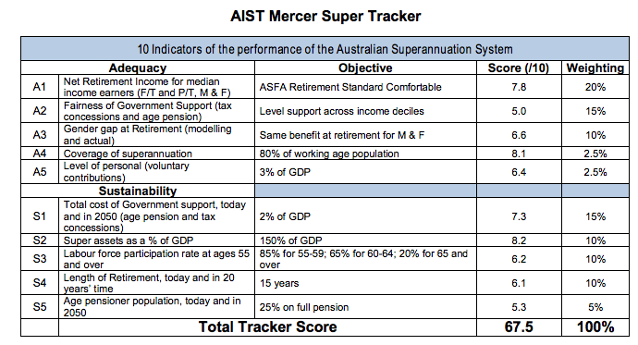
It may be seen from this table that of the ten KPIs, labour force participation rates at older ages has the fourth lowest score. At the time the Tracker was developed in March 2015, the labour force participation score was 5.53 (the third lowest score). Since that time, the score has slightly increased, based on the following older workforce participation rate data:

Age group | Nov 2014 (previous Tracker) | Oct 2015 (new results)
55-59 | 73.0% | 74.0%
60-64 | 53.7% | 56.8%
65+ | 12.4% | 12.5%
We note that the big jump is in the 60-64 age group, but that this number moves around a fair bit. For example, it jumped from 55.5% to 56.8% from September 2015 to October 2015.
In other submissions, AIST has also highlighted issues associated with the relatively low scores for the fairness of the system (the worst score) and the gender gap score. As regards the sustainability of the superannuation system, it may be seen that the Super Tracker rates the total cost of government support KPI well.

AIST notes that the projected figure of the average public pension expenditure across OECD countries is expected to rise from 9.5 per cent of GDP in 2015 to 11.7 per cent of GDP in 2050. The projected Australian figure of 4.9 per cent in 2050 is the second lowest of the 28 countries.

The Tracker could be used, for example, to assess possibilities such as projected increases in older age workforce participation rates upon the Net Retirement Income (A1 in the above table). Annexure A contains outcomes of road-testing 21 possible policies.

The methodology used in the Super Tracker is similar to that adopted by the EU, but has been adapted to Australia.

AIST Mercer Super Tracker methodology similar to EU
In 2012, the EU issued a White Paper examining an agenda for adequate, safe and sustainable pensions. This paper examines a number of initiatives, including examining the sustainability of public pensions, supporting longer working life, and measuring the gender gap in savings.

The White Paper forms part of a series examined by the EU, with three further reports being of particular interest:
- The Pension Adequacy Report sets out the commonly agreed objectives for pensions, which are:
  - ‘Adequate retirement income for all and access to pensions which allow people to maintain, to a reasonable degree their living standard after retirement, in the spirit of solidarity and fairness between and within generations;
  - The financial sustainability of private and public pension schemes, bearing in mind pressures on public finances and the ageing of the populations, and in the context of the three-pronged strategy for tackling the budgetary implications of ageing, notably by:
    - supporting longer working lives and active ageing;
    - by balancing contributions and benefits in an appropriate and socially fair manner; and
    - by promoting the affordability and the security of funded and private schemes;
  - That pension systems are transparent, well adapted to the needs and aspirations of women and men and the requirements of modern societies, demographic ageing (emphasis added) and structural change; that people receive the information they need to plan their retirement and that reforms are conducted on the basis of the broadest possible consensus.’

- Adequacy and Sustainability of Pensions Report, which gives a concise overview of the KPIs of pension adequacy and sustainability in the EU. These indicators relate to adequacy of retirement benefits, the employment rate of older workers, and the sustainability challenge (the long term growth in pension expenditure as a per-cent of GDP).
- Implementation of the Pensions White Paper report, a process for reviewing the outcomes of progress, including the KPIs.

In our submission to the Financial System Inquiry, AIST recommended:
- The primary objective of Australian superannuation is the provision of retirement income.
- This retirement income should be seen in the context of substituting or supplementing the Age Pension, both at an individual and a system level.
- Suggested other objectives, including the achievement of fairer outcomes (e.g. address the gender gap).
AIST strongly believes that such an approach – transparent objectives for the superannuation system, coupled with agreed KPIs and a governance methodology for reviewing the outcomes – would provide a sound platform for reviewing any proposed taxation changes to the Australian superannuation system.

Recommendations
Superannuation policies should be examined within the context of a framework which sets system objectives, KPIs, and a governance mechanism to assess progress.
Superannuation system objectives should include taking into account the demographic ageing of the population.

Key statistics

Effective retirement age compared with official retirement age
As the 2015 OCED Pensions at a Glance mentions, any statutory retirement age sends a signal as to how individuals are expected to modify behaviours when planning for retirement.

The OECD goes on to note that most legislated increases phase in gradually to enable adaptions to retirement planning, and further that many OECD countries have reformed pension rules to extend working lives in the broader context of increasing longer life expectancy.

In Australia, while there is a ‘preservation age’ at which time people who meet certain conditions can access their superannuation and an age pension age, there is in effect no official retirement age. There is a gap between the preservation age and the age pension age.

The following charts who the average effective age of retirement versus the official age across various countries, including Australia. The lower the country’s performance, the bigger the gap between the effective and the official age of retirement is.

It may be seen that for men, Australia ‘performs’:
- 12 out of 34 countries for men’s effective age of retirement versus the official age, and
- For women, 16 out of 34 countries.

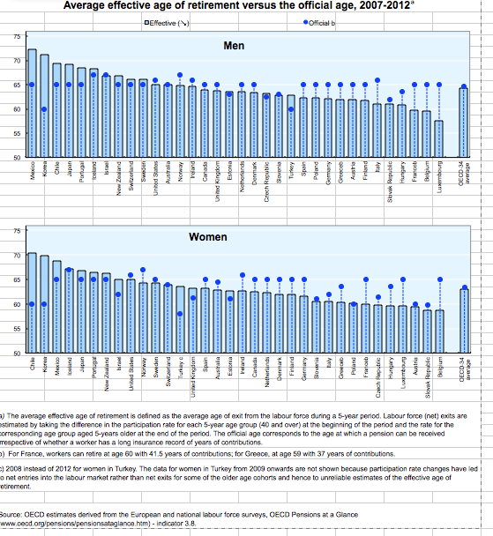

When Australians retire

According to the 2010-2011 Australian Bureau of Statistics survey, the average age at retirement for people aged 45 years and over in 2010-2011 was 53.3 years (57.9 years for men and 49.6 years for women). The ABS notes that due to survivorship bias and because older Australians still in the work force are not surveyed, the actual proportion of all Australians that retire before these ages would be lower.

Recommendations
Any changes to rules implemented as part of the taxation system, such as the preservation of superannuation, affect decisions of Australians to remain in the workforce.

The tax system also needs to recognise and treat fairly those individuals who are unable to work to ‘retirement age’.

Superannuation including taxation of superannuation policies should be examined within the context of a framework which sets system objectives, KPIs, and a governance mechanism to assess progress.

Research commissioned by AIST into the age of retirement and involuntary retirement
As part of its ongoing research program, AIST had commissioned two specific pieces of research into the age of retirement and causes of retirement.

The Age of Retirement – Australian Centre for Financial Studies 2013
This research examines what is meant by the ‘age of retirement’ and includes:
- An examination as to whether Australians believe they will have sufficient retirement moneys.
- A review of the gap between preservation age and age pension age.
- How many people – both in Australia and overseas – go back to work after they have ‘retired’.
- International trends on determinants of actual retirement decisions.
- Identifying issues within the Australian system.
- Which types of members retire involuntarily, as such cohorts would be adversely affected by any changes to preservation age and age pension age and would need policy recognition. These cohorts have their retirement plans abruptly interrupted, and don’t gain the benefits from compound interest further improving their savings over longer periods.
A copy of the research is annexed - see Annexure B.

Involuntary Retirement, Characteristics and Implications – Australian Centre for Financial Studies 2014
This research examines different approaches to retirement, and which cohorts retire involuntarily and the causes, and includes:
- How many retire involuntarily.
- Who is at risk of involuntary retirement.
- The causes of involuntary retirement.
- The impact of involuntary retirement on financial wellbeing.
- Examining the impact that any increase to the official retirement age would have upon Australians.

A copy of the research is annexed - see Annexure C.

Superannuation policy affecting older workers workforce participation rates

Superannuation policy is one driver of workforce participation.

AIST has noted the existence of a number of outstanding reviews and inquiries, and the need for a robust framework being in place before any changes to superannuation policy are made. We also note our long-standing advocacy of the following policies, which would assist both the ability of members to save an adequate retirement as well as assisting Australia’s productivity:
- Any changes to rules implemented as part of the taxation system, such as the preservation of superannuation, affect decisions of Australians to remain in the workforce. The tax system also needs to recognise and treat fairly those individuals who are unable to work to ‘retirement age’.
- The choice of taxation benchmarks may also impact the decision whether to remain in the workforce. The choice of benchmarks should be linked to objectives that the government is seeking. AIST believes that any review of the taxation of superannuation should examine the impacts of using various tax benchmarks.
- Remove the restrictions on voluntary contributions for members aged 75 years and over, and to extend the work test to these members.
- Retain the work test, but review to ensure it is relevant to modern work practices.
- Enable members to claim deductions for concessional contributions made at age 75 years and over.
- Review the unavailability of the bring-forward rule when making concessional superannuation contributions by those aged over 65.
- Enable a member of a superannuation fund to make contributions for a spouse aged 70 years or over when the spouse meets the work test (subject to reviewing the work test definition).
- Remove the age restriction from age 65 years when the spouse meets the work test, that is, being gainfully employed on at least a part-time basis during the financial year.
- Repeal the restriction on providing government co-contributions for persons aged over 71 years.
- Remove the $450 monthly minimum earnings threshold for Superannuation Guarantee contributions.

Annexure A: AIST-Mercer Super Tracker: The Tracker scores and results of modelling 21 policies

In the following tables, we have selected 3 (retirement income, fairness, and gender gap) of the 10 KPIs to road test possible policies. The outcomes are not in any priority order. Possible policies could also be road-tested against other KPIs.
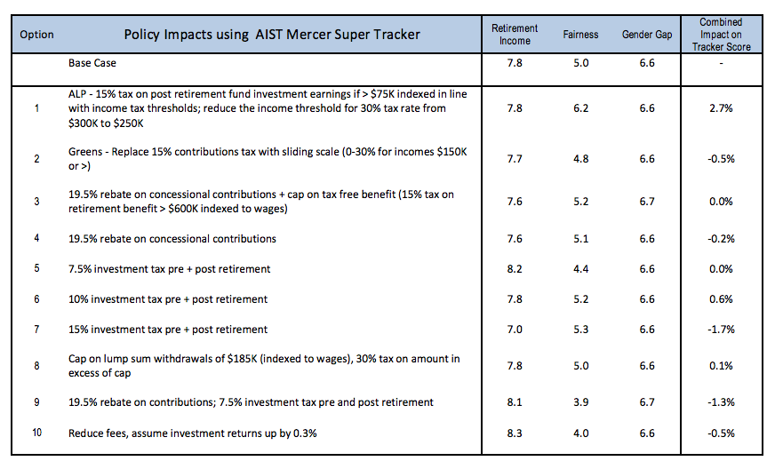

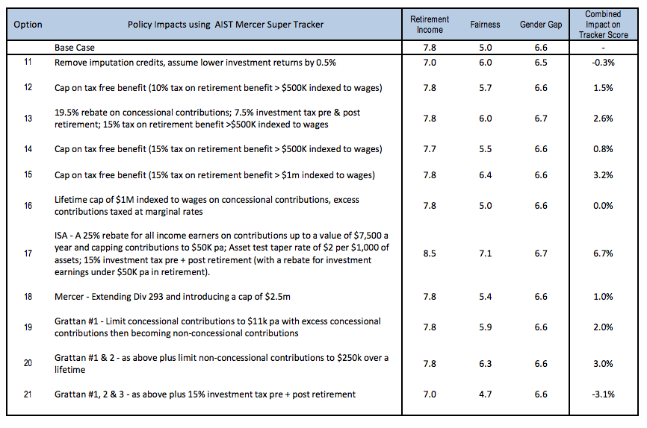

Annexure B: AIST-ACFS research The Age of Retirement 2013

A copy of this research report is enclosed.

Annexure C: AIST – ACFS research Involuntary Retirement Characteristics and Implications 2014

A copy of this research report is enclosed.

* * *

AIST, (2015), Response to Tax Discussion Paper Re:think 1 June 2015 [online]. Australian Institute of Superannuation Trustees. Available at http://tinyurl.com/nbyovqd Accessed 7.1.2016
AIST, (2015), Senate Economics Reference Committee Economic security for women in retirement 30 October 2015 [online]. Australian Institute of Superannuation Trustees. Available at http://tinyurl.com/zl7aowl [Accessed 7.1.2016]
OECD, (2014). OECD Pensions Outlook 2014. [online] OECD. Available at: http://tinyurl.com/ntrluq2 [Accessed 27 May 2015].
European Commission, (2012). White Paper: An Agenda for Adequate, Safe and Sustainable Pensions. Brussels: European Commission. Available at: http://tinyurl.com/mmvnk26 [Accessed 25 May 2015]
European Commission, (2012). Pension Adequacy in the European Union 2010-2050. European Commission.
European Commission, (2013). Adequacy and Sustainability of Pensions. [online] European Commission. Available at: http://tinyurl.com/o9efgrl [Accessed 26 May 2015].
European Commission, (2014). Implementation of the EU White Paper on Pensions. [online] European Commission Available at: http://tinyurl.com/mmvnk26 [Accessed 26 May 2015].
AIST, (2014). Response to the Financial System Inquiry Final Report 31 March 2015. [online] Australian Institute of Superannuation Trustees. Available at: http://tinyurl.com/n4ozc4l [Accessed 25 May 2015].
OECD, (2015) OECD Pensions at a Glance. OECD. Available at http://tinyurl.com/jc8pftp [Accessed 8 January 2015]
Australian Bureau of Statistics, (2010-2011), 2010-2011 Multipurpose Household Survey: ABS. Available at: http://tinyurl.com/zv3ebss [Accessed 8.1.2016]
Assuming a life expectancy of 75, an individual that retires at 55 would be expected to participate in the survey for another 20 years, whereas one that retires at 65 would have an expected survey participation duration of 10 years.

