Factsheet Series: Positive Duty under the Sex Discrimination Act 1984 (Cth)

Steps to meet the Positive Duty
September 2023

The positive duty is a legal obligation introduced into the Sex Discrimination Act 1984 (Cth) in December 2022. It applies to ‘persons conducting a business or undertaking’ and ‘employers’ (as defined in the Sex Discrimination Act). We refer to these duty holders as ‘organisations and businesses’ in this factsheet.
The positive duty requires organisations and businesses to take ‘reasonable and proportionate measures’ to eliminate the following behaviour as far as possible:
- discrimination on the ground of sex in a work context
- sexual harassment in connection with work
- sex-based harassment in connection with work
- conduct creating a workplace environment that is hostile on the ground of sex
- related acts of victimisation.
We refer to these behaviours as ‘relevant unlawful conduct’ or ‘unlawful behaviours’ in our publications about the positive duty.

The term ‘Reasonable and proportionate measures’ means that while all organisations and businesses that have obligations under the Sex Discrimination Act must act, the steps expected of each organisation/business will depend on:
- the size and nature of the organisation/business
- the resources available.
The Australian Human Rights Commission has published a range of resources, including Guidelines for Complying with the Positive Duty, to assist organisations and businesses to understand their obligations and what steps they need to take to satisfy the positive duty.
The Guidelines set out four Guiding Principles and seven Standards that the Commission expects all relevant organisations and businesses to meet to satisfy the positive duty. They are based on research about what works. They provide an end-to-end framework for prevention and response, which businesses can then tailor to their workforce. The Guidelines also provide examples of practical actions that organisations and businesses can take. Organisations and businesses should consider the Guiding Principles and take action against each of the Standards when implementing the positive duty.

Guiding Principles
What works to eliminate relevant unlawful conduct in one organisation or business will be different from what works in another – there is no ‘one-size-fits-all’ approach. The Guiding Principles help to inform the decisions an organisation or business makes about what it needs to do in its own circumstances.
The Guiding Principles are:
- Be consultative – talk to your workers about what they need for a safe and respectful workplace.
- Aim to achieve gender equality – where people have equal rights, rewards, opportunities and resources regardless of gender.
- Think about your people and acknowledge intersectionality. Do your workers have different intersecting identities that may compound or affect their experience of discrimination and harassment? For example, is a particular individual a woman and/or gender diverse, young, from a racial minority, or do they have a disability?
- Be person-centred and trauma informed – support individual choice, safety, dignity and avoid causing harm.

Standards for complying with the positive duty
The seven Standards are a framework to help organisations and businesses determine the practical actions to take to eliminate relevant unlawful conduct and to satisfy the positive duty.
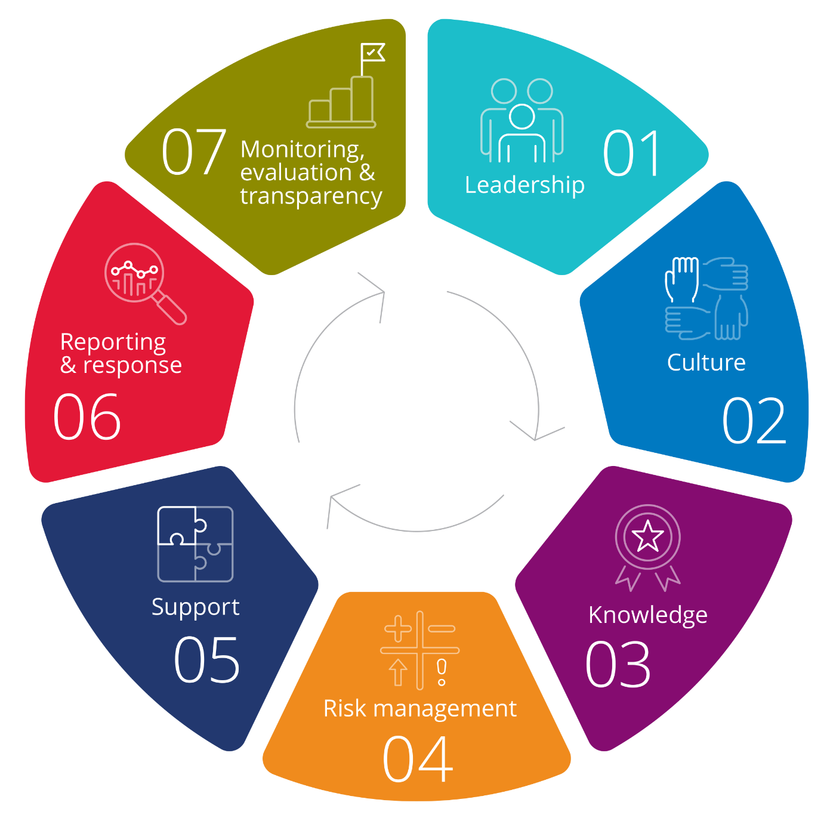

Standard 1: Leadership
Senior leaders understand their obligations under the Sex Discrimination Act and have up-to-date knowledge about relevant unlawful conduct.
Senior leaders are responsible for ensuring that appropriate measures for preventing and responding to relevant unlawful conduct are developed, recorded in writing, communicated to workers and implemented. Senior leaders regularly review the effectiveness of these measures and update workers.
Senior leaders are visible in their commitment to safe, respectful and inclusive workplaces that value diversity and gender equality. They set clear expectations and role model respectful behaviour.
Questions to help consider how to apply Standard 1:
- Do senior leaders understand their obligations under the Sex Discrimination Act?
- Do senior leaders have up-to-date knowledge about workplace sexual harassment, sex discrimination, and other relevant unlawful conduct?
- Do senior leaders know about the causes and impacts of relevant unlawful conduct, how to identify and respond to it, and where to go for advice, information, and support?
- Have senior leaders put in place measures to prevent and respond to relevant unlawful conduct?
- Are these measures documented in a prevention and response plan?
- Do senior leaders check whether these measures are working and update them?
- Do senior leaders role model respectful behaviour in the organisation or business?
- Have senior leaders made it clear that they are committed to creating a safe, respectful, diverse and inclusive workplace?
- Have senior leaders set clear expectations about what behaviour is acceptable in the organisation or business?

Standard 2: Culture
Organisations and businesses foster a culture that is safe, respectful and inclusive and values diversity and gender equality. This culture empowers workers (including leaders and managers) to report relevant unlawful conduct, minimises harm and holds people accountable for their actions.

Questions to help consider how to apply Standard 2:
- Is the organisation or business culture safe and respectful?
- Is the workforce diverse and inclusive?
- Is there attention paid to gender balance when recruiting or promoting people?
- Are all workers supported to report relevant unlawful conduct when it occurs?
- Are reports of relevant unlawful conduct handled in a way that minimises harm?
- Are all people who engage in relevant unlawful conduct held accountable for their actions?

Standard 3: Knowledge
Organisations and businesses develop, communicate and implement a policy regarding respectful behaviour and unlawful conduct.
Organisations and businesses support workers (including leaders and managers) to engage in safe, respectful and inclusive behaviour through education on:
- expected standards of behaviour, including actions and attitudes that foster equality and respect
- identifying behaviours that constitute relevant unlawful conduct and the consequences for engaging in such conduct
- their rights and responsibilities in relation to safe, respectful and inclusive workplaces and working relationships. This includes their role in preventing and responding to relevant unlawful conduct.

Questions to help consider how to apply Standard 3:
- What do staff know about relevant unlawful conduct?
- Do they know about their rights and responsibilities in relation to creating a safe, respectful and inclusive workplace and working relationships?
- Is this information included in staff inductions and training?
- Does education and training include focus on the safe and respectful workplace that you wish to create?
- Does the organisation or business have a policy about respectful behaviour and relevant unlawful conduct and is it consistently enforced?

Standard 4: Risk management
Organisations and businesses recognise that relevant unlawful conduct is an equality risk and a health and safety risk. They take a risk-based approach to prevention and response.

A risk-based approach involves regularly identifying and assessing the risk of relevant unlawful conduct occurring, as well as the impact that it might have on the health and safety of those affected. It also involves implementing effective control measures to address the identified risks and regularly reviewing the control measures to determine whether they remain effective or require adjustment.
Questions to help consider how to apply Standard 4:
- Does the organisation or business understand that relevant unlawful conduct can violate a person’s right to equality, non-discrimination and human dignity and is also a health and safety risk?
- Is the organisation or business taking a risk-based approach to preventing relevant unlawful conduct?
- Has the organisation or business identified the risks present, and taken steps to manage these risks?
- Is the organisation or business checking to see if the approach is effective?

Standard 5: Support
Organisations and businesses ensure that appropriate support is available to workers (including leaders and managers) who experience or witness relevant unlawful conduct.
Workers are informed about the available support, and can access the support, regardless of whether they report the conduct.

Questions to help consider how to apply Standard 5:
- What supports has the organisation or business made available for workers who have experienced or witnessed relevant unlawful conduct?
- Who can your workers speak to about these experiences inside the organisation or business?
- What support services outside the organisation or business can workers access?
- Do managers and workers know about these supports?
- Can workers access support without talking to leadership or management?

Standard 6: Reporting and response
Organisations and businesses ensure that appropriate options for reporting and responding to relevant unlawful conduct are provided and regularly communicated to workers and other impacted people.
Responses to reports of relevant unlawful conduct are consistent and timely. They minimise harm to, and victimisation of, people involved.
Consequences are consistent and proportionate.

Questions to help consider how to apply Standard 6:
- If workers experience or witness relevant unlawful conduct, how can they report it? Are there both formal and informal options for reporting?
- Has the organisation or business advised workers how they can report relevant unlawful conduct?
- How will the organisation or business respond to a report from its workers?
- Will the response by the organisation or business be consistent, timely and prioritise workers’ safety and wellbeing?
- Will the consequences for people who engage in relevant unlawful conduct be consistent and appropriate in the circumstances, regardless of the seniority or importance of the person engaging in the conduct?

Standard 7: Monitoring, evaluation and transparency
Organisations and businesses collect appropriate data to understand the nature and extent of relevant unlawful conduct concerning their workforce.
Organisations and businesses use the data they collect to regularly assess and improve the work culture, as well as to develop measures for preventing and responding to relevant unlawful conduct.
Organisations and businesses are transparent about the nature and extent of reported behaviours that could constitute relevant unlawful conduct concerning their workers and actions taken to address it.

Questions to help consider how to apply Standard 7:
- Does the organisation or business know what relevant unlawful conduct its workers experience or are at risk of experiencing?
- Is it collecting relevant data?
- Is the organisation or business using this data to prevent and respond to risks and incidents of relevant unlawful conduct if/when they occur?
- Is the organisation or business upfront with its workers about the presence or risk of relevant unlawful conduct?
- Has the organisation or business communicated to its workers about what steps it has taken to address incidents and risks of relevant unlawful conduct?
- Is the organisation or business checking to see if what it is doing is working and updating if necessary?

You can find more information about the positive duty under the Sex Discrimination Act on the Commission’s website. Resources include Guidelines for Complying with the Positive Duty, an Information Guide: Relevant Unlawful Conduct, Drivers, Risk Factors and Impacts, a Quick Guide, Small Business Resource, and other factsheets.

