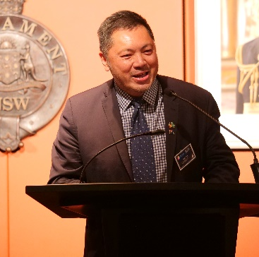 | Chin Tan  Race Discrimination Commissioner  SECOND YEAR OF TERM | ‘Celebrating harmony and eliminating racial discrimination are two sides of the same coin. We cannot eradicate racism without fostering multiculturalism and social cohesion, and vice versa.’

TERM GOALS
Improved protections against racial discrimination | Reduced institutional racism and systemic inequities | Increased capacity for multicultural and racial minority communities to advocate for their rights | Increased awareness of racism and racial discrimination

STRATEGIES  - Focusing on education and capacity building around racism and racial discrimination and to support strategies to address them and build social cohesion and inclusion.  - Empowering communities through participation and strengths-based engagement—consulting and amplifying community voices on key issues.  - Engaging, collaborating and partnering with key stakeholders to increase the reach and scope of work addressing racism and racial discrimination and promoting social cohesion, inclusion and diversity.  - Using an evidence-based approach to shape Australia’s conversation on racism, racial discrimination, social cohesion, inclusion and diversity. | 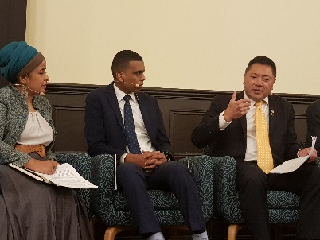  Commissioner Tan with Tasneem Chopra and Ahmed Hassan at the Multicultural Matters Forum, hosted by Victoria University and Melbourne City Council, May 2019.

2019–20 PROGRAMS/PROJECTS
Building community capacity | - Building community capacity through a range of strategies working directly with community members and side by side with community partners. In the coming year we will develop last year's Youth Leadership initiative into an ongoing program.
Driving institutional and organisational change | - Driving change with a program of work to identify and address institutional racism including initiating an Institutional Racism Series focussed on the employment life cycle. Collaborations with key public institutions will seek to affect organisational change around racism and racial discrimination.
Delivering education and raising community awareness | - Raising community awareness about racism and racial discrimination by designing and delivering anti-racism training, tools and resources to the community. The Racism. It Stops With Me campaign will carry core anti-racism messages into the community and contribute to a national discussion about racism.
Building robust evidence for change | - Giving voice to the experiences of racism and racial discrimination in Australia and gathering evidence and intelligence to support Commission initiatives through a national conversation project with Australian Muslims on race, racism, social cohesion, diversity and inclusion and a National Forum on Racial Tolerance. This program of work will also build the Commission’s capacity to counter racist extremism.
Progressing structural change | - Working with experts and government and community partners to identify structural levers to affect change in racial discrimination laws and investigate opportunities for the development of a national reporting system for racism and equality measures.

