 | Kate Jenkins  Sex Discrimination Commissioner  FOURTH YEAR OF TERM | ‘I look forward to a day when men and women are accepted into all walks of life and work—from parenting to rocket science—on the basis of who they are and what they do, and not their gender.’

TERM GOALS
Reduced violence against women | Improved women’s economic security and empowerment | Increased diversity in leadership

STRATEGIES  - Challenging everyday sexism and sexual harassment where we live, work, learn and play.  - Promoting broader social equality and addressing structural discrimination and intersectional disadvantage.  - Challenging the structural and attitudinal barriers affecting working parents, including parental leave, superannuation, flexible work, childcare, and sharing of unpaid work.  - Promoting the benefits of reducing gender-segregated workforces.  - Advocating for improved representation of women and girls in political, corporate, sporting and organisational leadership roles and promoting and facilitating opportunities for women and girls to have their voices heard at a local, national and international level.  - Taking a settings-based approach, focusing on the workplace, education and sport. | 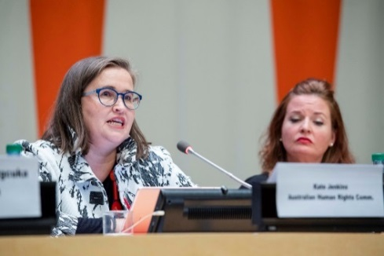  Commissioner Jenkins participating in the 63rd session of the United Nations Commission on the Status of Women, New York, March 2019.

2019–20 PROGRAMS/PROJECTS
Violence against women projects | - This work includes Australia’s first National Inquiry into sexual harassment in Australian workplaces. The Inquiry builds on data from the fourth national sexual harassment in the workplace survey.  - Other projects include continued monitoring of the implementation of the Change the course report recommendations by Australian universities and undertaking sector-specific workplace sexual harassment surveys.
Inclusion and sport | - Projects in this setting include supporting the work of Play by the Rules, a national collaboration to promote child safety, and promoting equal opportunity, anti-discrimination and inclusion in sport, especially in regard to women and girls.
Women’s economic security projects | - Projects include implementing guidelines for the application of special measures under the Sex Discrimination Act 1984 to advance substantial equality between men and women.
Defence Cultural Reform Collaboration 2018–2020 | - This program engages all three Services and the Department of Defence to support and improve Defence cultural reform priorities.
International engagement | - Independently report on the status of Australian women and girls through follow-up reporting to the UN Committee on the Elimination of Discrimination against Women’s priority issues (where appropriate); by attending the Commission on the Status of Women, Session 63; as well as undertaking projects and advocacy associated with Australia’s implementation of the Beijing Declaration and Platform for Action.

