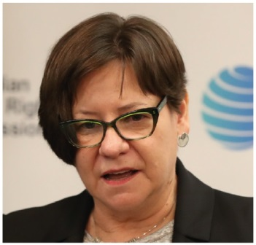 | Megan Mitchell  National Children’s Commissioner  SEVENTH YEAR OF TERM | ‘We need to be promoting and strengthening the rights of children as a fundamental preventive measure. Every child deserves the opportunity to thrive in this country, regardless of the circumstances they were born into.’

TERM GOALS
Safer environments and greater respect for the dignity of the child | Increased safeguards to health and wellbeing of all children in Australia, particularly those who are most vulnerable | Increased children’s civic engagement and active citizenship through education and awareness-raising | Increased Australian commitment to protect the wellbeing and rights of children | Elevated children’s voices and participation

STRATEGIES  - Promoting discussion and awareness of matters relating to the human rights of children in Australia.  - Undertaking research, or educational or other programs, for the purpose of promoting respect for children’s rights in Australia and promoting the enjoyment and exercise of human rights by children in Australia.  - Examining existing and proposed Commonwealth enactments to assess whether they recognise and protect the human rights of children in Australia, and to report to the Minister the results of any such examination.  - Giving particular attention to children who are at risk or vulnerable, and consult with children where appropriate. | 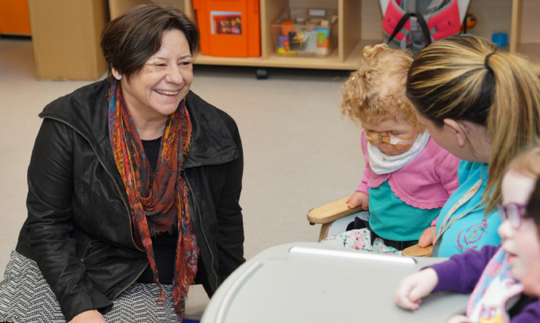  Commissioner Mitchell talking with children, while attending  the British and Irish Network of Ombudsman and Children’s Commissioners meeting in Belfast, February 2019.

2019–20 PROGRAMS/PROJECTS
Monitoring children’s rights program: Children’s Rights Report 2019 | - This year’s statutory report will focus on Australia’s progress in meeting its child rights obligations as described in the United Nations Convention on the Rights of the Child. The Committee on the Rights of the Child should provide its Concluding Observations on Australia’s performance in September 2019 and these will be included in the statutory report with recommendations for possible ways to move forward.  - The report will provide a baseline from which to measure progress when Australia reports to the Committee on the Rights of the Child in 2024.  - The Commissioner will also prepare a report for Australia’s appearance before the Committee on the Rights of the Child in September 2019. This will be based on the many voices of children that the Commissioner has heard over her seven year term.
My Health Record system Project | - The My Health Record system offers an unprecedented opportunity to engage Australian children in an important conversation about their health rights.  - Commissioned by the Australian Digital Health Agency, this project will develop a set of resources to guide and support children using the My Health Record system. These resources will primarily be targeted at 14–17 year olds given children in this age range have control of their own health records. Some of the resources will also aim to educate younger children about their health rights and what to expect when they turn 14.
Child Safe Organisations Project | - This project developed the National Principles for Child Safe Organisations which were endorsed by the Council of Australian Governments in February 2019. The project was carried out in close consultation with stakeholders.  - Practical tools and resources to support the implementation of the principles by organisations across Australia are being developed. This year will see the completion of the implementation resources including the release 11 e-learning modules. These are available free of charge on our website.

