 | Chin Tan  Race Discrimination Commissioner  THIRD YEAR OF TERM | ‘Celebrating harmony and eliminating racial discrimination are two sides of the same coin. We cannot eradicate racism without fostering multiculturalism and social cohesion, and vice versa.’

TERM GOALS
Improved protections against racial discrimination | Reduced institutional racism and systemic inequities | Increased capacity for multicultural and racial minority communities to advocate for their rights | Increased awareness of racism and racial discrimination

STRATEGIES  - Focusing on education and capacity building around racism and racial discrimination and to support strategies to address them and build social cohesion and inclusion.  - Empowering communities through participation and strengths-based engagement—consulting and amplifying community voices on key issues.  - Engaging, collaborating, and partnering with key stakeholders to increase the reach and scope of work addressing racism and racial discrimination and promoting social cohesion, inclusion and diversity.  - Supporting equal participation including by promoting the benefits of culturally diverse workplaces and leaders.  - Using an evidence-based approach to shape Australia’s conversation on racism, racial discrimination, social cohesion, inclusion, and diversity. | 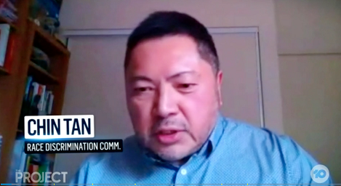 Commissioner Tan, interviewed on The Project on increases in racism amid Covid-19, April 2020.

KEY ACTVITITES/ 2020–21 WORKPLAN
Building community capacity | - Building community capacity through a range of strategies working directly with community members and side by side with community, civil society, and government partners.
Driving institutional and organisational change | - Driving change with a program of work to identify and address institutional racism including initiatives promoting equal participation and culturally competent workplaces. Collaborations with key stakeholders will seek to affect organisational change around racism and racial discrimination.
Delivering education and raising community awareness | - Raising community awareness about racism and racial discrimination by designing and delivering anti-racism training, tools, and resources to the community including resources about bystander action and allyship. The Racism. It Stops With Me campaign will carry core anti-racism and social cohesion messages into the community and contribute to a national discussion about racism.
Building robust evidence for change | - Giving voice to the experiences of racism and racial discrimination in Australia and gathering evidence and intelligence to support Commission initiatives including through advocacy around the seminal national findings of the Sharing the Stories of Australian Muslims Project and advocacy for national data collection. This program of work will also contribute to the Commission’s understanding of racist extremism.
Progressing structural change | - Working with experts and government and community partners to consider the operation of racial discrimination and related laws and taking appropriate advocacy action.

