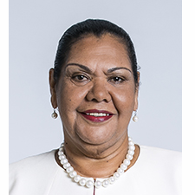 | June Oscar AO  Aboriginal and Torres Strait Islander Social Justice Commissioner  FOURTH YEAR OF TERM | ‘We have a right to our voice, and I am committed to making what you say count. To achieve equality and be free from discrimination we need to be making the decisions that determine our futures.

TERM GOALS
Elevated the voices of Aboriginal and Torres Strait Islander women and girls | Reduced Aboriginal and Torres Strait Islander health inequality | Reduced numbers and rates of Aboriginal and Torres Strait Islander incarceration and children in the out of home care system | Progressed constitutional reform | Progressed the UN Declaration on the Rights of Indigenous Peoples to full effect through a national level coordinated action plan | Progressed native title reform

STRATEGIES  - Applying a human rights-based approach to working with Aboriginal and Torres Strait Islander communities that respects self-determination; participation in decision-making and free, prior and informed consent; non-discrimination and equality; and respect for and protection of culture.  - Empowering communities through participation and strengths-based engagement—gathering, and communicating community voice, content and discussion on key issues.  - Engaging with key organisations and campaigns supporting and advocating for families and enabling children to stay safe and connected to kin and culture and promoting justice sector reform including justice reinvestment initiatives.  - Engaging internationally to highlight Aboriginal and Torres Strait Islander issues, forge links with other Indigenous representatives, and hold our government to account on Indigenous rights.  - Promoting human rights-based, strengths-based and trauma-informed approaches to supporting Aboriginal and Torres Strait Islander people to lead change for their communities.  - Co-ordination, leadership and liaison with key bodies to drive constitutional and native title reform. | 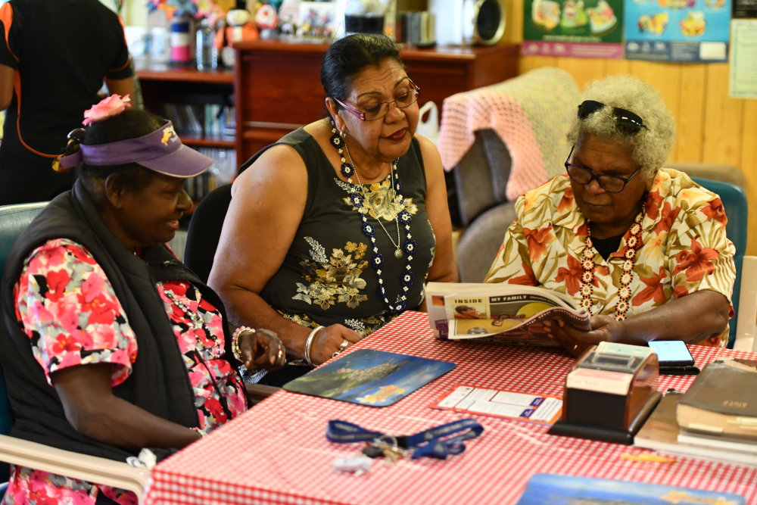  Commissioner Oscar, at Thursday Island’s Home and Community Care Centre, October 2018 (Photograph by Wayne Quilliam).

KEY ACTIVITIES/ 2020–21 WORKPLAN
Wiyi Yani U Thangani (Women’s Voices) Project | This year’s work builds on the Commissioner’s 2018 national conversation with Aboriginal and Torres Strait Islander women and girls. This process engaged 2,294 women and girls in 50 locations across Australia and informed the production of the Wiyi Yani U Thangani (Women’s Voices) Report (2020).  Stage 2 of the Wiyi Yani U Thangani Project is focused on enhancing access to the Wiyi Yani U Thangani Report and its findings, carrying out additional consultations with senior Elders, and the production of knowledge-sharing resources aimed at building capacity for governments, service providers and community to partner on genuinely co-designed initiatives.
Native Title Project | As Australia enters the post-determination era, many Aboriginal and Torres Strait Islander people are deeply disappointed about what Native Title has failed to deliver. There is a need to assess the challenges and opportunities that lie ahead from a human rights-based perspective.  Building on the work of the Wiyi Yani U Thangani (Women’s Voices) Project, the Native Title Project will provide a stories-based picture of the current state of Native Title across Australia, specifically from the perspective of Aboriginal and Torres Strait Islander women involved in Native Title.  The Project will identify and explore the challenges experienced by women in the Native Title system and their perspectives about what reforms are required to ensure Aboriginal and Torres Strait Islander peoples’ full enjoyment of human rights in relation to their traditional lands and waters.
The Close the Gap Campaign | This multi-year collaboration is working with Australia’s peak Indigenous and non-Indigenous health bodies, NGOs and human rights organisations to achieve health and life expectation equality for Australia’s Aboriginal and Torres Strait Islander peoples.

