 | Emeritus Professor  Rosalind Croucher AM  President  FOURTH YEAR OF TERM | ‘Good relationships and open doors are absolutely crucial for us to be able to play the role of trusted adviser to its fullest–to be the devil’s advocate and at times to be the “devil’s blowtorch”, you need to have a respected seat at the table.’

TERM GOALS
Progressed the role and leadership of the Commission as an independent statutory agency and as Australia’s National Human Rights Institution | Advanced the Commission’s relationship with key stakeholders including Commonwealth Government and Parliament | Enhanced community understanding of human rights and an Australian culture of rights-mindedness | Led and managed the internal and external governance of the Commission effectively | Fostered and led a positive and collegiate Commission and organisational culture

STRATEGIES  - Working inclusively to lift the consideration of human rights across law, policy and practice above and ahead of politics.  - Opening the conversation and generating forward momentum in discussing human rights challenges and solutions.  - Leading the united development of a national reform agenda for human rights.  - Ensuring and promoting the Commission’s reputation for human rights expertise, evidence and independence.  - Building understanding through thematically linked speeches and articles.  - Celebrating human rights achievements across the community. | 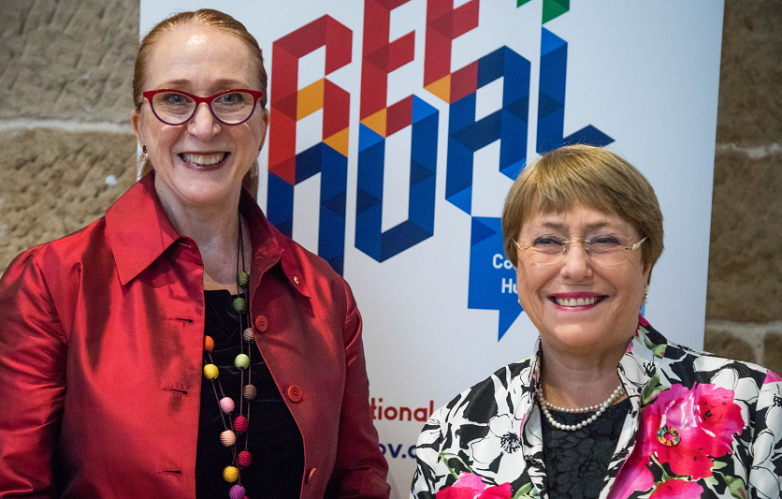  President Croucher with HE Dr Michelle Bachelet, United Nations High Commissioner for Human Rights, at the Free and Equal Conference, Sydney, October 2019.

KEY ACTVITITES / 2020–21 WORKPLAN
In addition to the governance, statutory and leadership functions of the Commission, President Croucher leads these programs.
Free and equal in dignity and rights: An Australian conversation on human rights | - This strategic multiyear initiative aims to lead discussion about how to build a system of human rights protection for 21st century Australia where the promotion of human rights is a shared endeavour—by government, business, the NGO sector, educators, service providers and the community at large. The initiative draws on the expertise and unites the work of all the Commission.  - After the success of last year’s program which included a visit from the UN High Commissioner for Human Rights, a national conference, the release of multiple discussion papers and a consultation process, this year's project will culminate in the release of the project’s final report. There will also be a draft reform agenda, a final consultation process and a series of thematic symposia on a range of technical and more general issues, some with a public-facing element.
Investigation and Conciliation and National Information Services | - These services ensure all Australians can access free and accessible information, and investigation and conciliation services. They provide best practice alternative dispute resolution for complainants and respondents and focus on systemic outcomes that have far-reaching positive benefits for the Australian Community.
Human rights education and training | - This program supports the Commission’s statutory function to ‘promote understanding and acceptance and the public discussion of human rights in Australia’. The program strategically targets audiences and sectors in its aim to ‘build a universal culture of human rights’.  - This year’s program will see the continued development of online human rights learning resources, the re-establishment of an Australian Public Service human rights network, teaching resources mapped to The Early Years Learning Framework and the Australian Curriculum; adult training programs for public servants and private sector employers and the continued development of guidelines and policies to support organisations to comply with their legal anti-discrimination obligations and to promote a best practice human rights-based approach.
Human rights technical co‑operation | - Through funding from Australia’s Aid Program, this year’s programs with other countries include: advancing human rights education throughout schools and universities in Vietnam; strengthening the capacity of the Government of Lao People's Democratic Republic to engage with UN treaty bodies and the Universal Periodic Review process; and supporting the Association of Southeast Asian Nations Intergovernmental Commission on Human Rights.
International engagement | - As an ‘A status’ National Human Rights Institution we have a formal role in the United Nations system. This year involves preparation for Australia’s third United Nations Universal Periodic Review appearance and participating in scheduled Human Rights Treaty body reporting.  - In partnership with other NHRIs we work to advance human rights in our region and globally. This year the President has a pivotal role as a bureau (board) member of the Global Alliance for National Human Rights Institutions and as Chairperson of the Asia Pacific Forum of National Human Rights Institutions, one of the four regional networks in the Global Alliance of NHRIs.
Business and human rights strategy | - This program builds upon the momentum created by recent legislative action in Australia and internationally to begin operationalising the United Nations Guiding Principles on Business and Human Rights and other frameworks.  - A strategic focus is to work with government, business and civil society in the implementation of the Australia Modern Slavery Act 2018 (Cth) and Modern Slavery Act 2018 (NSW).
Human rights scrutiny | - This program aims to improve human rights protections in current and proposed legislation and includes an ongoing relationship with the Parliamentary Joint Committee on Human Rights. The work involves the monitoring of federal legislative and inquiry processes, identifying strategic opportunities for engagement by the Commission, including evidence-based submissions to inquiries.

