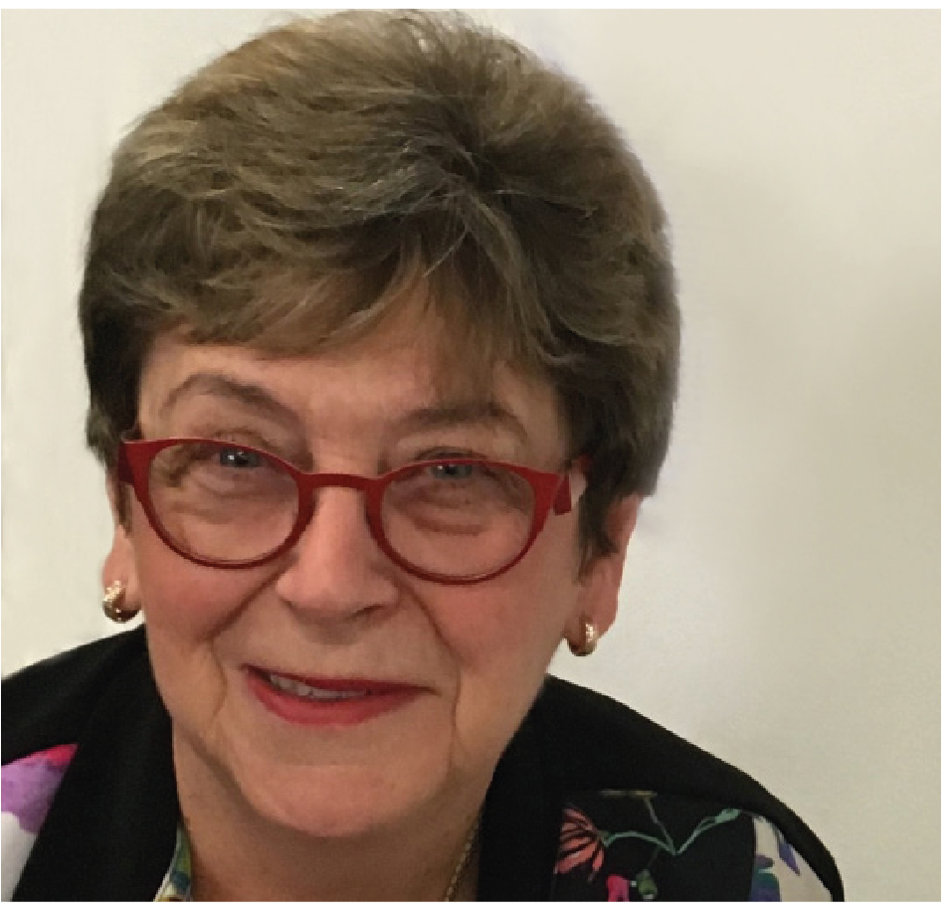 | The Hon  Dr Kay Patterson AO  Age Discrimination Commissioner  THIRD YEAR OF TERM | ‘I have an absolute aversion to good solid reports ending up in the graveyard of good intentions. Therefore I have made it my goal to advance, as far as possible, the implementation of sensible recommendations and practical solutions in relation to three main issues.’

TERM GOALS
Increase employment opportunities for older workers | Improve recognition and responses to elder abuse | Increase housing security for older women at risk of homelessness | Promote positive ageing

STRATEGIES
- Creating relationships and establishing allies, partners and collaborations to uncover common interests and goals.
- Encouraging resource sharing and collaboration to develop new initiatives.
- Promoting and strategically advocating with stakeholders and decision makers to understand, engage with and implement key policy, process and legislative recommendations.
- Developing specific initiatives to reach regional, rural and remote stakeholders.

2018 –19 FEATURE PROGRAMS/PROJECTS
Older Australians and employment program | - Fostering implementation of key recommendations from the 2016 Willing to Work report.  - Human Resources Professionals and Older Workers – this project is a collaboration with the Australian Human Resources Institute to support their 2018 member attitudinal survey and capture an evidenced understanding of current attitudes among human resources professionals about older age employment. The findings will be used to collaboratively explore sector initiatives to address the employment barriers facing older Australians.
Elder abuse awareness program | - Fostering implementation of selected recommendations from the 2017 Australian Law Reform Commission’s Elder Abuse report.  - Elder abuse awareness project partnering with peak professional bodies – this initiative will develop educational materials on elder abuse for members who are in position to identify older people at risk of elder abuse in the community.  - Community elder abuse awareness project – this work has an outreach focus on regional, rural and remote stakeholders and will undertake local educational events as well as harnessing radio to reach people, raise awareness of elder abuse and promote tools and resources for local communities.
Older women at risk of homelessness program | - Encouraging initiatives that increase housing security for older women.  - This program emphasises advocacy with community groups and the private sector to encourage innovative housing solutions for older women at risk of homelessness. It will be informed by an examination of the state of research in this area and a review of the current initiatives and programs being undertaken in Australia.
Supporting and promoting positive ageing | - To raise awareness among older people of their rights in a number of life arenas the first stage of this project will be an update the Your Rights at Retirement resource in the context of the 100-year life, followed by development of a new series of resources.  - Participating annually in the 100: The Centenarian Portrait Project by Teenagers to help this campaign build cross generational awareness of positive ageing.

