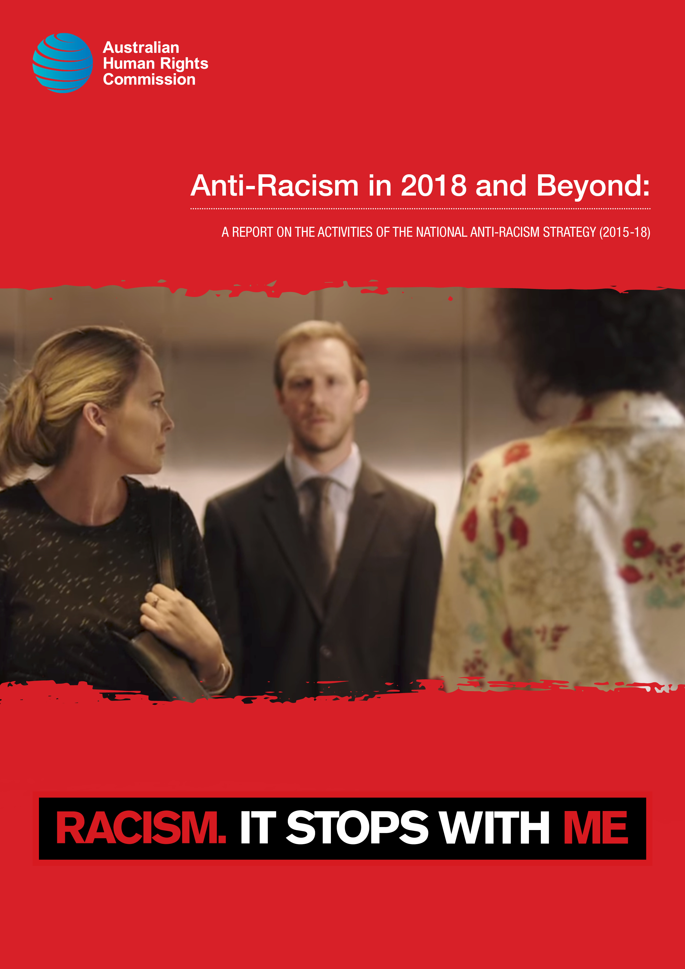

The Australian Human Rights Commission encourages the dissemination and exchange of information provided in this publication.

All material presented in this publication is provided under a **Creative Commons Attribution 3.0 Australia**, with the exception of:

* the Australian Human Rights Commission logo,
* photographs and images, and
* any content or material provided by third parties.

The details of the relevant licence conditions are available on the **Creative Commons** website, as is the full legal code for the **CC BY 3.0 AU licence**.

**Attribution**

Material obtained from this publication is to be attributed to the Australian Human Rights Commission with the following copyright notice:



**Anti-Racism in 2018 and Beyond:** A report on the activities of the national anti-racism strategy (2015-18)

**ISBN 978-1-921449-92-5**

**Third party copyright**

Wherever a third party holds copyright in material presented in this publication, the copyright remains with that party. Their permission may be required to use the material.

The Commission has made all reasonable efforts to:

clearly label material where the copyright is owned by a third party. Please note this does not include photos, images and video which are all regarded as third party material, and ensure that the copyright owner has consented to this material being presented on this website.

**Graphic design** Dancingirl Designs

**Printer** Bright Print Group

**Cover photo** Still from Racism. It Stops with Me campaign community service announcement produced with Banjo advertising agency

**Anti-Racism in 2018 and Beyond:**   
A report on the activities of the national   
anti-racism strategy (2015-18)

**Contents**

1. Introduction 6

2. The State of Play 8

Cultural diversity and racism 8

Racism and tolerance in perspective 8

Population, immigration and multiculturalism 9

Citizenship laws 10

National security, terrorism and crime 11

Foreign influence debates 11

3. Anti-racism interventions and the National Anti-Racism Strategy 13

Background and context 14

The ‘Second Phase’ of the Strategy: 2015-18 15

What was delivered in 2015-18 15

National Anti-Racism Strategy projects: summary 15

*Racism. It Stops with Me* campaign: summary 16

Resourcing and Partnership 17

Diversity and inclusion 17

Building belonging: resources on cultural diversity and prejudice for early childhood 19

Building Inclusive Communities: Community conversations in Hervey Bay, the Sunshine Coast, and Townsville, QLD (2017) 20

National Anti-Racism Youth Leadership Initiative 21

Institutional Racism Forum and Workshop 28

*Racism. It Stops with Me* – Videos, including Community Service Announcements 33

*Racism. It Stops with Me* supporter activities 36

Advocates in Profile 39

4. Framing Future Work in Anti-Racism 41

Public consultation on racism 43

Anti-racism coordination 43

National anti-racism awareness campaign 43

A national day for anti-racism 44

Bystander anti-racism 45

Intergroup contact 45

Institutional racism, including a standing forum for government officials 46

Training for anti-racism advocates 46

# 1. Introduction

The National Anti-Racism Strategy was launched in August 2012 for an initial period of three years. Its objectives were to raise awareness of racism and its effects, promote initiatives that prevent and reduce racism, and empower communities to take action to prevent and reduce racism. In 2015, it was extended for a further three years.

The Strategy is a partnership-based strategy, involving government departments and a number of non-government organisations. I thank all of our partners for their work over the last three years: the Attorney-General's Department, Department of Home Affairs, Department of Social Services, Department of the Prime Minister and Cabinet, National Congress of Australia's First Peoples, Federation of Ethnic Communities’ Councils of Australia, Australian Multicultural Council, Migration Council Australia, Department of Human Services, Reconciliation Australia, and the Australian Sports Commission.

I would also like to thank the campaign supporters of *Racism. It Stops with Me*. As of August 2018, there are more than 370 organisations that are supporters of the campaign. Some of them were interviewed in the preparation of this report.

Since 2015, race has dominated headlines and driven public debates in a way that many would not have anticipated when the National Anti-Racism Strategy was last evaluated. Globally, the rise of anti-immigrant populism has fuelled racism. Australia has not been immune from this. While our multicultural consensus remains strong, it has been challenged by some.

The project and campaign work of the Strategy has only grown in importance and urgency. Our recent community service announcements were the most successful videos of the Strategy so far, receiving 1.6 million views on social media (and were also shown on ABC, SBS and Ten). Project work on early childhood resources, inclusion in sport, community inclusion, youth anti-racism advocacy and institutional racism has started new conversations and empowered more people than ever to take action to prevent or reduce racism in our community.

This report reviews and evaluates the Strategy, including the *Racism. It Stops with Me* campaign. It provides an overview of the state of play on race in Australia, and documents our work since June 2015.

There have been many proud achievements from the past six years of the Strategy. The Strategy has been a success. But there is clearly much more that remains to be done, and an opportunity to renew anti-racism interventions. I hope that this report provides some guidance to future efforts, and wish the next Race Discrimination Commissioner every success in their work on anti-racism.

**Dr Tim Soutphommasane  
Race Discrimination Commissioner**

13 August 2018

# 2. The State of Play

## Cultural diversity and racism

Australia is a highly diverse, multicultural society. According to the 2016 Census, 49 per cent of the population were born overseas or have a parent born overseas.[1]

New analysis published in the Australian Human Rights Commission’s *Leading for Change* report (2018) provides additional nuance to this picture. We estimate that 24 per cent of the population has either a non-European or an Indigenous background.[2] Cultural diversity in Australia has increased over time.

This multicultural reality enjoys widespread public acceptance. According to the Scanlon Foundation’s *Mapping Social Cohesion* study, the overwhelming majority of Australians (83 per cent) say that multiculturalism has been good for Australia.[3]

Nonetheless, racism and racial discrimination continue to exist in Australia. In 2017, 20 per cent of Australians said they experienced discrimination in the past twelve months.[4] Those from non-English speaking backgrounds continue to experience higher levels of discrimination (34.2 per cent in 2017).[5] Moreover, particular migrant communities often encounter particularly intense forms of discrimination.

Aboriginal and Torres Strait Islander people experience racism in systemic and institutional ways. In 2016, 46 per cent of Indigenous respondents reported experiencing prejudice in the previous six months, compared to 39 per cent for the same period two years before. Thirty-seven per cent reported experiencing racial prejudice in the form of verbal abuse, and 17 per cent reported physical violence.[6]

## Racism and tolerance in perspective

Over the past three years, liberal democracy has been under challenge across continents. Far‑right populist movements have grown in support, seizing upon disillusionment with established politics. They have fuelled xenophobia and racism.

The election of Donald Trump to the presidency of the United States, the Brexit vote in the United Kingdom, and the electoral success of numerous far-right political parties across Europe have all been associated with increasingly hostile views towards immigrants and multiculturalism.[7]

Australia is not immune from the global surge of the far right. Extremist and anti-immigrant groups, once considered to be in the political fringe, have enjoyed national attention, including through sympathetic treatment on mainstream commercial television.[8] Groups with professed neo-Nazi and racial supremacist views have become more organised, as demonstrated by their activities, online spaces and distribution of racist and anti-Semitic material in multiple Australian states.[9] The Executive Council of Australian Jewry’s annual *Report on Antisemitism in Australia 2017* noted a substantial increase (9.5 per cent) in the number of anti-Semitic incidents compared to the 2015-16 period, which it attributes to the rise of far-right activity.[10]

Public incidents involving racism continue to attract significant media attention. Widely reported incidents have included verbal attacks,[11] physical violence,[12] racist commentary on social media websites,[13] and the display of racist clothing, graffiti, posters and other material in public places.[14] Moreover, there have been frequent public controversies involving racial offence and casual racism, including notable episodes of ‘blackface’ and racist jokes by public or prominent figures.[15] [16]

There have also been public debates about numerous issues, which have contributed to experiences of racism and the atmospherics of race relations and community harmony.

### Population, immigration and multiculturalism

Australia’s population and, specifically, the level of overseas immigration, have continued to gain prominence as a matter of public debate. Reforms to the visa system,[17] and perceived increased pressure on services in cities, have fuelled a debate on population policy.

Amid more heated public debate, the Scanlon Foundation has found that the amount of people choosing immigration and population growth as the ‘most important problem facing Australia today’ increased from 3.6 per cent to 6.3 per cent over 2012-17 to become the equal third most popular choice in 2017.[18] The Scanlon Foundation did find, however, that a clear majority in 2017 (56 per cent) say that the level of immigration was ‘about right’ or in fact ‘too low’.[19]

However, polling in 2018 has told a different story. A 2018 Guardian-Essential poll found 54 per cent of respondents believe Australia’s rate of population growth is too fast – up from 45 per cent in 2013.[20] Moreover, in 2018 the Lowy Institute Poll found, for the first time, a majority of Australians oppose the current immigration rate. A majority (54 per cent) believed that the total intake of migrants was ‘too high’.[21]

While debates sometimes draw upon race as a subtext, they can also feature more explicit references to race. Commentary can refer to the cultural compatibility of certain migrant groups, or to phenomena such as ‘white flight’ and the consequences of immigration for ‘Anglo families’.[22] Reporting and commentary about housing affordability frequently refers to ‘Chinese foreign buyers’ outbidding Australian buyers.

There have also been recent interventions by prominent politicians raising questions about a non-discriminatory immigration program, a direct challenge to a policy that has been in place since the dismantling of the White Australia policy.[23] In addition, there have been suggestions that Australia is ‘veering towards a European separatist multicultural model’,[24] and that there is increasing ethnic ‘ghettoisation’ of Australian suburbs driven by immigration.

### Citizenship laws

Proposed changes to Australian citizenship laws have been the subject of intense debate since 2017. In April 2017, the Government proposed a number of measures to ‘strengthen the requirements for Australian citizenship’. These included measures with respect to the general residence requirement, English language capability, amendments to the citizenship test, and demonstrated integration into the community.[25] A government bill to give effect to these changes has not yet received the required support to pass in parliament.

In its submission regarding the bill, the Federation of Ethnic Communities’ Councils of Australia warned that the proposed amendments ‘threaten to undermine the decades of successful migration, community harmony and cultural diversity that Australia has worked so hard to build.’[26] The Victorian Multicultural Commission issued concerns that the amendments ‘send a strong message to the Australian community about the [government’s] view of what it is to be “Australian”’, and warned the amendments ‘do not support a multicultural Australia or indeed promote social cohesion as the Bill contends’.[27]

Of particular concern has been the proposal that those wishing to naturalise as Australian citizens be required to demonstrate a level of English competence equivalent to Level 6 of the International English Language Testing System (IELTS). Critics of this proposal have noted this amounts to ‘university-level’ English, given undergraduate academic admission of international (non-English-speaking-background) students to many Australian universities requires an IELTS score of 6. There has been widespread concern that such a standard would demand of non-English-speaking-background immigrants a level of English that not all – or even a majority – of Australian-born citizens would command.[28] In June 2018, the Citizenship Minister suggested that the government is considering requiring prospective permanent residents – not just prospective citizens – to have ‘basic conversational English capability’.[29]

### National security, terrorism and crime

Ongoing concerns about national security and terrorism continue to have an effect on the experience of Arab and Muslim Australians. As the Commission has noted regularly, anti-Arab and anti-Muslim bigotry can surface in the aftermath of terrorist attacks and national security threats.[30]

A study commissioned by the Challenging Racism Project of Western Sydney University and the Islamic Sciences and Research Academy found ‘high experiences’ of racism by members of the Muslim community. A majority (57 per cent) of respondents had experienced racism at least sometimes in at least one of the situations noted in the study (for example, in the workplace, at school, etc).[31]

Since the start of 2018, African-Australian communities – particularly Sudanese-Australian communities in Melbourne – have experienced heightened public attention in response to concerns about youth gang crime. Political and media debates about crime have contributed to racial fear and anxiety towards African-Australians.[32] Some African-Australian leaders have spoken about how the members of their communities are feeling a sense of shame and rejection, and are now retreating from society. The deterioration of public discourse has exacerbated the particularly high levels of discrimination and racial profiling experienced by people from African backgrounds.[33]

### Foreign influence debates

There has been significant discussion about foreign interference with public institutions, in particular, involving the Chinese Communist Party. The Government has introduced legislation aimed at preventing and curbing improper foreign influence, though it maintains this is not aimed at any one particular group or country. The media has investigated the relationship between some elected representatives and their donors, and the apparent sway such relationships have had on their politics.

In 2018, the temperature of public commentary on this issue has risen dramatically. For example, some commentators have referred to the Chinese party-state conducting a ‘silent invasion’ of Australia, which is designed to erode Australian sovereignty. This is a campaign ‘being perpetrated and shaped by a complex system of influence and control overseen by agencies serving the Chinese Communist Party’.

Numerous figures, including many university scholars of China and the Chinese diaspora, have warned about ‘the creation of a racialised narrative of a vast official Chinese conspiracy’, which would ‘encourage suspicion and stigmatisation of Chinese Australians in general.’[34] There is a danger that any concerns about the Chinese Communist Party may spill over into a generalised hostility against people of Chinese background. Language about a ‘silent invasion’ or ‘fifth column’ can flirt with exciting an anti-Chinese or Sinophobic racial sentiment – especially given the historical allusions to the ‘Yellow Peril’.

There has been concern expressed from Chinese-Australians that some of the debate is contributing to a sense that Australian citizens with Chinese heritage are second-guessed about their loyalty and allegiance.

# 3. Anti-racism interventions and the National Anti-Racism Strategy

There is no one way to fight racism. Anti-racism requires actions at a number of levels. This is because the dimensions of racism are multiple, as are its sources.[35]

As noted in section 2, the nature of public discourse shapes experiences of racism. The tone of public debate matters. Where public debates excite racial fear and anxiety, it heightens the exposure of particular groups to prejudice and discrimination. Political leaders and public figures have an important role to play in ensuring debates about immigration, population, diversity, citizenship, national security, crime and the economy do not undermine racial harmony. Anti-racism can begin at the top with public leadership.

In addition to public discourse, there are three other respects at which the work of anti-racism can be understood. These three are not mutually exclusive. Often, they will intersect and reinforce one another:

* Legislative – laws help to set a standard on matters of race and provide people with a means of holding racial discrimination and hatred to account;
* Educative – non-legislative programs can promote better understanding of racism and promote responses to prejudice and discrimination; and
* Socio-cultural – activities within everyday interactions in civil society shape people’s attitudes and behaviour.

The anti-racism work of the Australian Human Rights Commission cuts across each of these areas. The Race Discrimination Commissioner conducts public advocacy and participates in debates about human rights and race. The Commission handles anti-discrimination complaints, including complaints made under the *Racial Discrimination Act 1975* (Cth).

The Commission’s efforts through the National Anti-Racism Strategy can be understood as primarily educative and socio-cultural in nature.

## Background and context

The National Anti-Racism Strategy was launched in August 2012, following the Australian Government’s commitment to its *The People of Australia – Australia's Multicultural Policy 2011*. The Australian Human Rights Commission has led the development and implementation of the Strategy, which has been supported by the National Anti-Racism Partnership, a group consisting of government departments and civil society organisations.

In 2011, the Commission was provided with a budget of $1.7 million over four years to deliver the Strategy. In 2015, the Commission embarked on a ‘second phase’ of the Strategy through to 2018, funded out of the Commission’s ongoing budget (there was no additional, dedicated funding of the Strategy).

The objectives of the Strategy have been to:

* Create awareness and understanding of racism and its effects;
* Identity and promote initiatives to prevent and reduce racism; and
* Empower communities and individuals to take action against racism.

The Strategy has involved two streams of activity: the National Anti-Racism Strategy projects, and the *Racism. It Stops with Me* campaign. The Strategy projects have involved project work in identified priority areas, defined by sector or by theme. The campaign has sought to bring together supporters of anti-racism, and encourages them to speak out against racism and to promote campaign information and materials.

|  |
| --- |
| **National Anti-Racism Partnership members**  Australian Human Rights Commission  Attorney-General’s Department  Department of Home Affairs  Department of the Prime Minister and Cabinet  National Congress of Australia’s First Peoples  Federation of Ethnic Communities’ Councils of Australia  Australian Multicultural Council  Migration Council Australia  Department of Human Services  Reconciliation Australia  Australian Sports Commission |

## The ‘Second Phase’ of the Strategy: 2015-18

In June 2015, the Commission evaluated the first three years of the Strategy, and outlined its second phase to carry through to 2018. We identified that the Strategy had a strong impact in four ways:

* It started conversations about racism;
* It sent a clear message that racism is not acceptable;
* It helped organisations to demonstrate leadership on racism; and
* It empowered individuals and communities to take action against racism.

The Commission identified key areas of focus to include employment, education, media, government service provision, sport and the online environment. We also prioritised the following activities:

* Developing and promoting education, training and resources addressing systemic issues of racism, discrimination, diversity and inclusion;
* Supporting research and good practice in racism prevention and reduction;
* Building and strengthening partnerships with those committed to combatting racism and discrimination, and supporting diversity and inclusion; and
* Promoting community awareness of racism and how to prevent and respond to it.

The Commission also identified expanding the Partnership to broaden the reach of the Strategy. Thematically, the Commission indicated that the work of the Strategy would fall under two complementary themes:

* Combatting racism and discrimination; and
* Supporting diversity and inclusion.

## What was delivered in 2015-18

### National Anti-Racism Strategy projects: summary

We have developed and delivered five projects in the period, with another project ongoing. In line with the priority activities identified in 2015, there has been a mix of developing resources, promoting education and training, and promoting community awareness. There has also been an emphasis on carrying out projects through strategic partnerships.

The five completed projects have been:

* *Building Belonging* (2016), a comprehensive toolkit of early education resources designed for early childhood educators and parents;
* *Building Inclusive Communities* (2017), a series ofcommunity conversations in Hervey Bay, the Sunshine Coast and Townsville conducted in partnership with the Anti-Discrimination Commission Queensland, which were aimed at supporting regional community efforts to strengthen inclusion and social cohesion;
* *Inclusion, Racism and Discrimination in Rugby League* (2018), a partnership with the National Rugby League (NRL) to develop social inclusion and anti-vilification frameworks for the sport;
* *National Youth Anti-Racism Leadership Initiative* (2018), a partnership with the Multicultural Youth Advocacy Network, providing leadership development to youth anti-racism advocates; and
* *Seeing the Unseen* (2018), a forum and workshop on institutional racism aimed at government officials and professional bodies in law and justice, health, education and human services.

Project work has commenced on a collaboration with the Australia New Zealand Policing Advisory Agency relating to anti-racism and diversity training for police.

### *Racism. It Stops with Me* campaign: summary

*Racism. It Stops with Me* has continued to enjoy strong support, though the campaign has also required some rebuilding.

In June 2015, the campaign had more than 360 organisational supporters. However, the term of agreement for organisations that joined as supporters between 2012-15 extended only until June 2015. While most organisational supporters chose to continue their involvement in the campaign beyond June 2015, a proportion of supporters opted to complete their participation at the end of that initial term.

Since July 2015, the numbers of supporters have been rebuilt from 238 to more than 370 in August 2018. We have also continued to support campaign supporters – for example, through the involvement of the Race Discrimination Commissioner in more than 130 events or meetings held by campaign supporters during that time.

A series of four campaign videos were released in October-December 2017. Two videos were concerned with highlighting casual and everyday racism, and were run as community service announcements on a number of free-to-air television networks. The other two videos featured AFL and rugby union themed conversations about racism. These videos have received more than 1.6 million views on social media, and reached more than 3.5 million users on social media (in addition to exposure and reach on television).

In July 2018, we launched an ‘Advocates in Profile’ series on the campaign website. The series provides a resource for the community, which shares inspiring and thought-provoking stories about racism and diversity from a range of anti-racism leaders and advocates.

### Resourcing and Partnership

Efforts on both the Strategy projects and *Racism. It Stops with Me* have been affected by resourcing – namely, a lower level of staff resourcing within the Commission dedicated to the Strategy, compared to 2012-15. This reflects the dedicated funding support from the Australian Government provided for the Strategy during 2012-15.

The Commission has enjoyed support from within the National Anti-Racism Partnership members: in particular, a secondment of staff from the Department of Human Services to work on the Strategy in 2017, and grants by the Department of Social Services in 2016-17. We have also benefited from pro-bono support generously provided by the Banjo advertising agency.

Over 2015-16, the Partnership also expanded its membership to include Reconciliation Australia, the Australian Sports Commission and the Department of Human Services.[36]

### Diversity and inclusion

As noted above, the evaluation of the Strategy in 2015 identified ‘supporting diversity and inclusion’ as a theme for work during 2015-18. This reflected feedback from campaign supporters, in particular, that anti-racism efforts would benefit from a complementary emphasis on diversity and inclusion, which was framed in more positive terms.

Our work since then has taken on a more explicit anti-racism focus. This has reflected how the Commission’s diversity and inclusion efforts on race have taken on a life of their own. There has been a separate program of work on cultural diversity and inclusion, reflected in the Commission’s *Leading for Change* reports (2016 and 2018), the Race Discrimination Commissioner’s establishment of a Leadership Council on Cultural Diversity (2016), and the delivery of a cultural diversity and leadership fellowship pilot program (2017).

We have admittedly also found it challenging to ensure that diversity and inclusion initiatives within organisations address racism and discrimination in a sufficiently direct way. This underlines the importance of having dedicated anti-racism efforts, which are not diluted by a focus on diversity and inclusion (the obvious connections between them and anti-racism notwithstanding).

##### What has been delivered in 2015-18: Overview

| **Priority activity** | **Strategy work** | **Contribution and/or impact** |
| --- | --- | --- |
| **Education, training and resources** | Building Belonging | A comprehensive early childhood education resource on diversity and race – downloaded 50,000+ times |
| National Anti-Racism Youth Leadership Initiative | Training and development for 20 youth anti-racism advocates from across Australia |
| Seeing the Unseen Institutional Racism Forum and Workshop | Professional development and education for senior leaders and executives from more than 68 organisations in law and justice, health, education and human services |
| **Supporting research and good practice** | NRL | A review of the NRL’s policies and programs, leading to a new social inclusion and anti-vilification framework for the sport |
| National Anti-Racism Youth Leadership Initiative | As a pilot, tested new ground in leadership training and development for anti-racism youth advocacy |
| Seeing the Unseen Institutional Racism Forum and Workshop | Showcased leading university research on unconscious bias and discrimination to government officials |
| **Promoting community awareness** | *Racism. It Stops with Me* videos and community service announcements | Videos raising awareness of everyday racism were viewed a cumulative 1.6 million times on social media and reached more than 3.5 million users |
| Ongoing engagement with supporter activities and meetings | Direct Commissioner involvement in over 130 supporter events or meetings |
| Advocates in Profile | Profiled more than 30 anti-racism advocates on the *Racism. It Stops with Me* website |
| Building Inclusive Communities | Met and had discussions with over 140 community members in three locations across regional Queensland |
| **Building and strengthening partnerships** | Building belonging | Expanded on the Commission’s work with Early Childhood Australia and an advisory group of early childhood specialists |
| National Anti-Racism Youth Leadership Initiative | A partnership with the Multicultural Youth Advocacy Network, also supported by EY, SBS and an advisory group of Indigenous and multicultural specialists |
| Seeing the Unseen Institutional Racism Forum and Workshop | A partnership with the National Centre for Cultural Competence, The University of Sydney and supported by PwC |
| NRL | A partnership with the NRL |
| Building Inclusive Communities | A partnership with the Anti-Discrimination Commission Queensland and community organisations in Hervey Bay, the Sunshine Coast and Townsville |
| *Racism. It Stops with Me* videos and community service announcements | Videos produced with the pro bono support of Banjo advertising agency and grant support from Department of Social Services, and with the assistance of ABC and University of Technology Sydney |
| *Racism. It Stops with Me* campaign supporter activities | Collaborated with supporter organisations on events, resources and awareness raising |

### Building belonging: resources on cultural diversity and prejudice for early childhood

The Building Belonging toolkit was a comprehensive suite of resources for early childhood educators and parents. It was launched on 7 October 2016 in Darwin, and was developed following extensive consultation with early childhood educators across Australia.

In a survey of early childhood educators conducted by the Commission in 2015, the majority of respondents (72 per cent) said they faced challenges in educating about cultural diversity. The survey also found that:

* 77 per cent indicated that a child had asked a question about their own or another person’s racial, cultural or ethnic background; and
* 43 per cent of respondents indicated that a child had said something negative about another person’s racial, cultural or ethnic background.

The key challenges identified by educators included:

* lack of knowledge about different cultures;
* lack of confidence in teaching about cultural diversity (particularly in settings where fewer cultures were represented); and
* ability to incorporate teaching about cultures without being inauthentic or tokenistic.

Early childhood is a crucial time to equip children with pride in their own racial and cultural identity and an appreciation of other people’s racial and cultural identities. By teaching children about the importance of treating others equally and celebrating different cultures, educators can make a significant impact on how children’s attitudes mature and develop.

The resources developed for Building Belonging were designed to assist early childhood educators to overcome these challenges, and also to support families and communities in educating young children about cultural diversity. They include an eBook, a song, an educator guide, posters, lesson plans and fact sheets.

It has been downloaded over 50,000 times since its launch and continues to be one of the most popular education resources developed by the Commission.

### Building Inclusive Communities: Community conversations in Hervey Bay, the Sunshine Coast, and Townsville, QLD (2017)

In June and October 2017, the Commission and the Anti-Discrimination Commission Queensland (ADCQ) held community conversations in Hervey Bay, the Sunshine Coast and Townsville. These conversations were forums, which sought to support regional communities in strengthening inclusion and community cohesion.

The exercise was based on a recognition that levels of racial and cultural intolerance vary across regional and metropolitan areas in Australia. It is important that regional Australia is part of conversations about racial tolerance and social cohesion.

The community conversations were co-hosted by Australia’s Race Discrimination Commissioner, Dr Tim Soutphommasane, and Queensland Anti-Discrimination Commissioner, Kevin Cocks. They focused on cultural acceptance, community harmony, and rejecting racism. In total, an estimated 145 people took part in the process.

The conversations were an exercise in deliberative democracy. In a deliberative democracy, members of a community debate issues based on mutual respect and reason, seeking consensus where possible.

Consistent with this approach, the facilitators used the ‘World Café’ method to guide the discussion. This method involved structured conversations in small groups that encourage contributions from everyone, and connect people with diverse perspectives. It also encouraged communities to devise their own solutions to the challenges they are dealing with. Conversation centred around two questions:

* What does it mean to belong in your community?
* How can we share the risk and responsibility to build a safe and inclusive community?

The conversations highlighted the unique qualities and challenges of each community. In each location, specific actions were identified for the community to continue driving social cohesion. In general, however, the strategies focused around four key themes:

* building networks and alliances;
* the role of local government;
* contact and social trust; and
* safe spaces and online resilience.

The ADCQ has embarked upon three projects arising from the community conversations, which are supported by the Commission.

* **Hervey Bay:** working with the Hervey Bay Neighbourhood Centre to deliver education and community awareness raising activities around the *Anti-Discimination Act 1991* (Qld) and *Racial Discrimination Act 1975* (Cth).
* **Sunshine Coast:** facilitating a three-day participatory leadership workshop in partnership with University of the Sunshine Coast and Sunshine Coast Council. The purpose of the workshop is to bring together people from community, private sector and government to learn and practice participatory processes that can be applied to collaborative and creative problem solving of community issues.
* **Townsville:** in partnership with the local community, running a further conversation with young people and relevant youth stakeholders about belonging with a view to empowering young people to participate and contribute to the social and economic life of the community.

### National Anti-Racism Youth Leadership Initiative

Young people experience racism. Those from Aboriginal and Torres Strait Islander and from refugee and migrant backgrounds experience it at significant levels compared to the general population. Bringing these young people together to share experiences, build knowledge, skills and networks represents an important initiative in anti-racism efforts in Australia, as little such work has occurred to date.

The Commission partnered with Multicultural Youth Advocacy Network (MYAN Australia) to support the development of young people’s leadership and advocacy skills. The initiative focused on youth empowerment by building necessary advocacy and leadership skills among emerging youth leaders and role models from Aboriginal and Torres Strait Islander, refugee and migrant communities.

The initiative comprised of a two-day workshop in Melbourne in June 2018, which included seminars about racism and advocacy, visits to the AFL and the Victorian Parliament, training on media, and a pitch exercise. It was attended by 20 young people from New South Wales, Victoria, Queensland, Western Australia, Tasmania, Australian Capital Territory and the Northern Territory. Participants were selected through a nomination process using the advisory group network. The nominees were required to have experience in community or advocacy work, demonstrated leadership or advocacy skills, and the ability to implement skills and knowledge gained at the workshop in their own community.

The initiative aimed to promote the following:

* dialogue between Aboriginal and Torres Strait Islander young people and multicultural youth;
* skills development in leadership and anti-racism advocacy, with a focus on practical strategies;
* networks between Aboriginal and Torres Strait Islander young people and multicultural youth; and
* an ‘infrastructure’ for supporting and coordinating leadership and advocacy among Aboriginal and Torres Strait Islander young people and multicultural youth.

#### Evaluation

Participants were requested to complete a post workshop online survey. A total of 16 (out of 20) participants completed the survey, representing 80 per cent of participants who attended the workshop. The survey results represent the self-assessment views of respondents at a point in time after their workshop experience. As part of the self-assessment, participants were asked to rate their knowledge across various subject areas before and after the workshop. Short qualitative feedback sessions were also sought with five participants during the second day of the workshop. These were undertaken face-to-face with responders immediately after the workshop.

Of the survey respondents, 44 per cent were students and 38 per cent worked full time. 25 per cent of the respondents identified as Indigenous, and 75 per cent identified as culturally and linguistically diverse.

There was overwhelming positive feedback regarding the group of workshop respondents with many describing the group as inspirational, open and encouraging. Respondents learnt and gained confidence from hearing about other participants, their background and experiences. Many cited that the best aspect of the workshop was interacting with diverse participants.

|  |
| --- |
| ‘It was incredible to see multiculturalism in action in how all the participants interacted and encouraged one another. There was a great group culture that was established.’ |

|  |
| --- |
| ‘I learnt a lot about racism and the definition of it [and about] public speaking skills and how to take the best out of each opportunity.’ |

**Infographic 1. Was the workshop well implemented?**

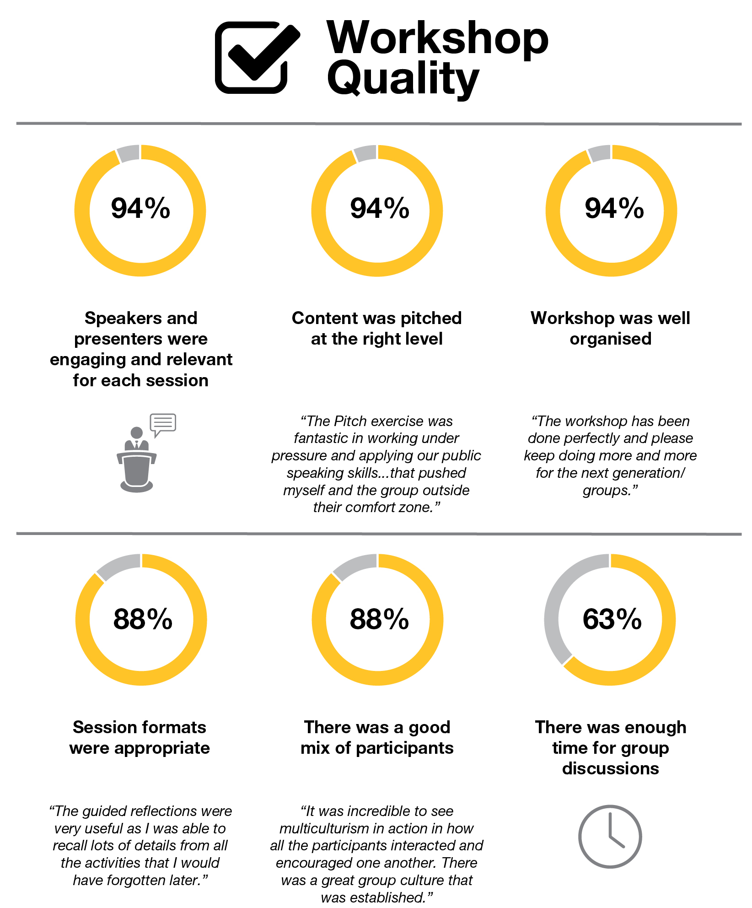

|  |
| --- |
| ‘Connecting with like-minded and enthusiastic individuals from all around Australia was one of the greatest benefits. Everyone involved in the program will definitely lead Australia into a prosperous future and be leaders in their own respect. I think programs and initiatives such as these that connect youth leaders along with the guidance of an older more experienced facilitator are important.’ |

**Infographic 2. Did the workshop make a difference?**

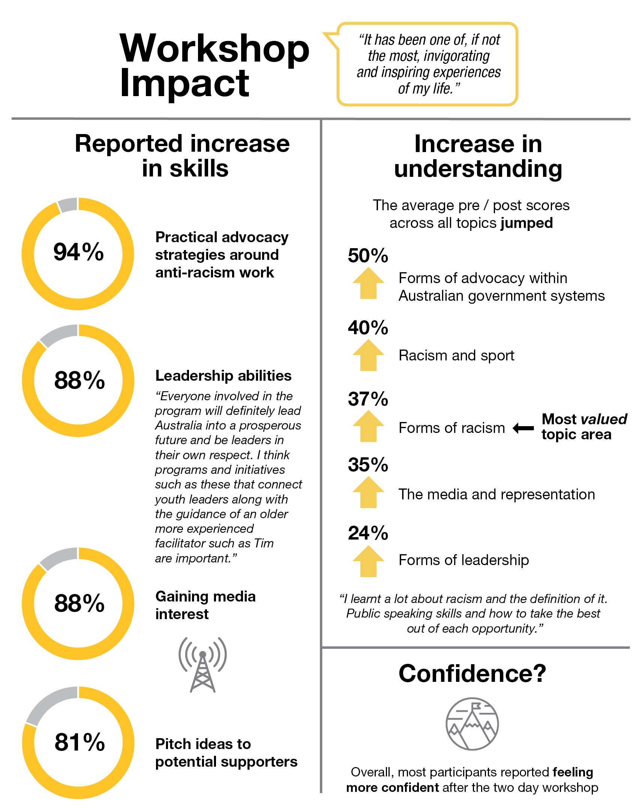

|  |
| --- |
| ‘I loved this workshop more than anything I had before because I had chance to be around indigenous young people and youngsters from different backgrounds not just refugee background like myself. It made feel a bit less than them in the beginning but then it was great chance for me to be around those young leaders who have such a great skills and experiences to learn and share experiences at young age.’ |

|  |  |
| --- | --- |
| **Goal** | **Result** |
| Dialogue between Aboriginal and Torres Strait Islander young people and multicultural youth – sharing experiences and exchanging ideas about anti-racism advocacy. | This was achieved to a large extent, and was reported as the biggest reward amongst respondents. Feedback suggests the workshop could have included more sessions for this type of open dialogue, learning and engagement. |
| Networks developed between Aboriginal and Torres Strait Islander young people and multicultural youth. | Networking among like-minded individuals was highly prized among the group. Where practicable the Commission and MYAN should develop follow-up sessions and workshops to ensure continuity and to foster these networks. |
| Skills development in leadership and anti-racism advocacy, with a focus on practical strategies. | These topic areas were very well received and regarded, and most respondents reported an increase in their understanding and knowledge resulting from the workshop. However more emphasis and time spent on developing practical skills and strategies for participants to apply in their communities and workplaces would have been welcome. |
| ‘Infrastructure’ established for supporting and coordinating leadership and advocacy among Aboriginal and Torres Strait Islander young people and multicultural youth. | The workshop proved to be an excellent start in establishing this type of infrastructure. Many respondents commented that their participation and inclusion in the workshop made it one of the best events they have attended. To ensure further development in this area, the AHRC and MYAN should establish follow-up initiatives and opportunities that are timely and accessible for this group and other young leaders. |

|  |
| --- |
| ‘Lunch at Parliament was a great experience, and great for the speakers to pitch as well. There was a sense of achievement amongst the group throughout the presentations.’ |

|  |
| --- |
| ‘The Pitch exercise was fantastic in working under pressure and applying our public speaking skills. I would have enjoyed more exercises like this that pushed myself and the group outside their comfort zone. It was a great and challenging experience to have to work in teams afterwards, as it demonstrated different leadership and negotiating styles.’ |

### Institutional Racism Forum and Workshop

The Australian Human Rights Commission partnered with the National Centre for Cultural Competence at the University of Sydney to deliver a forum and workshop for Australian public servants that addressed the issue of institutional racism. The Forum and Workshop explored how institutional racism relates to the public sector as well as the professions – in particular, in the areas of law and justice, health, human services and education.

The Forum and Workshop involved a one-day program, and was held in Canberra on 14 June 2018. It brought together a cohort of more than 90 senior leaders from targeted federal and state government departments and agencies, as well as relevant professional bodies.

The program, which focused on anti-racism, included themes such as unconscious bias and ‘colour-blindness’. It sought to equip leaders with a nuanced understanding and perspective of institutional racism, and to provide space for critical reflection, discussion and sharing of experiences.

Immediate intended outcomes of the Forum and Workshop included:

* increased understanding of institutional racism, barriers and solutions;
* increased knowledge of racial literacy on institutional racism; and
* increased confidence in addressing issues.

Intended medium to long term outcomes of the Strategy included:

* enhancing diversity and inclusion strategies for leadership recruitment and retention;
* strengthening leadership, policy development and future decision making; and
* improving government service provision.

#### Evaluation

In total 92 people attended the Forum and Workshop. Attendees were requested to complete an online survey after the event. A total of 40 participants completed the survey, representing just over 43 per cent of total participants. The survey results represent the self-assessment views of respondents at a point in time after their Forum and Workshop experience.

The majority of respondents (86 per cent) worked in the government sector, and 14 per cent worked in the non-government sector. Of the respondents, 35 per cent worked in law/legal organisations, 33 per cent in health, 16 per cent in education and 14 per cent in human services. More than two-fifths of respondents (42.5 per cent) defined their role/position as executive level, 35 per cent as senior executive level, and the remaining 22.5 per cent as senior management or management level.

The findings suggest that the workshop was of high quality, well delivered and was a worthwhile activity for the respondents.

Infographic 3 is a snapshot of the high levels of satisfaction with the delivery, content and overall value assigned to the event.

**Infographic 3. Was the Forum and Workshop event well organised and delivered?**

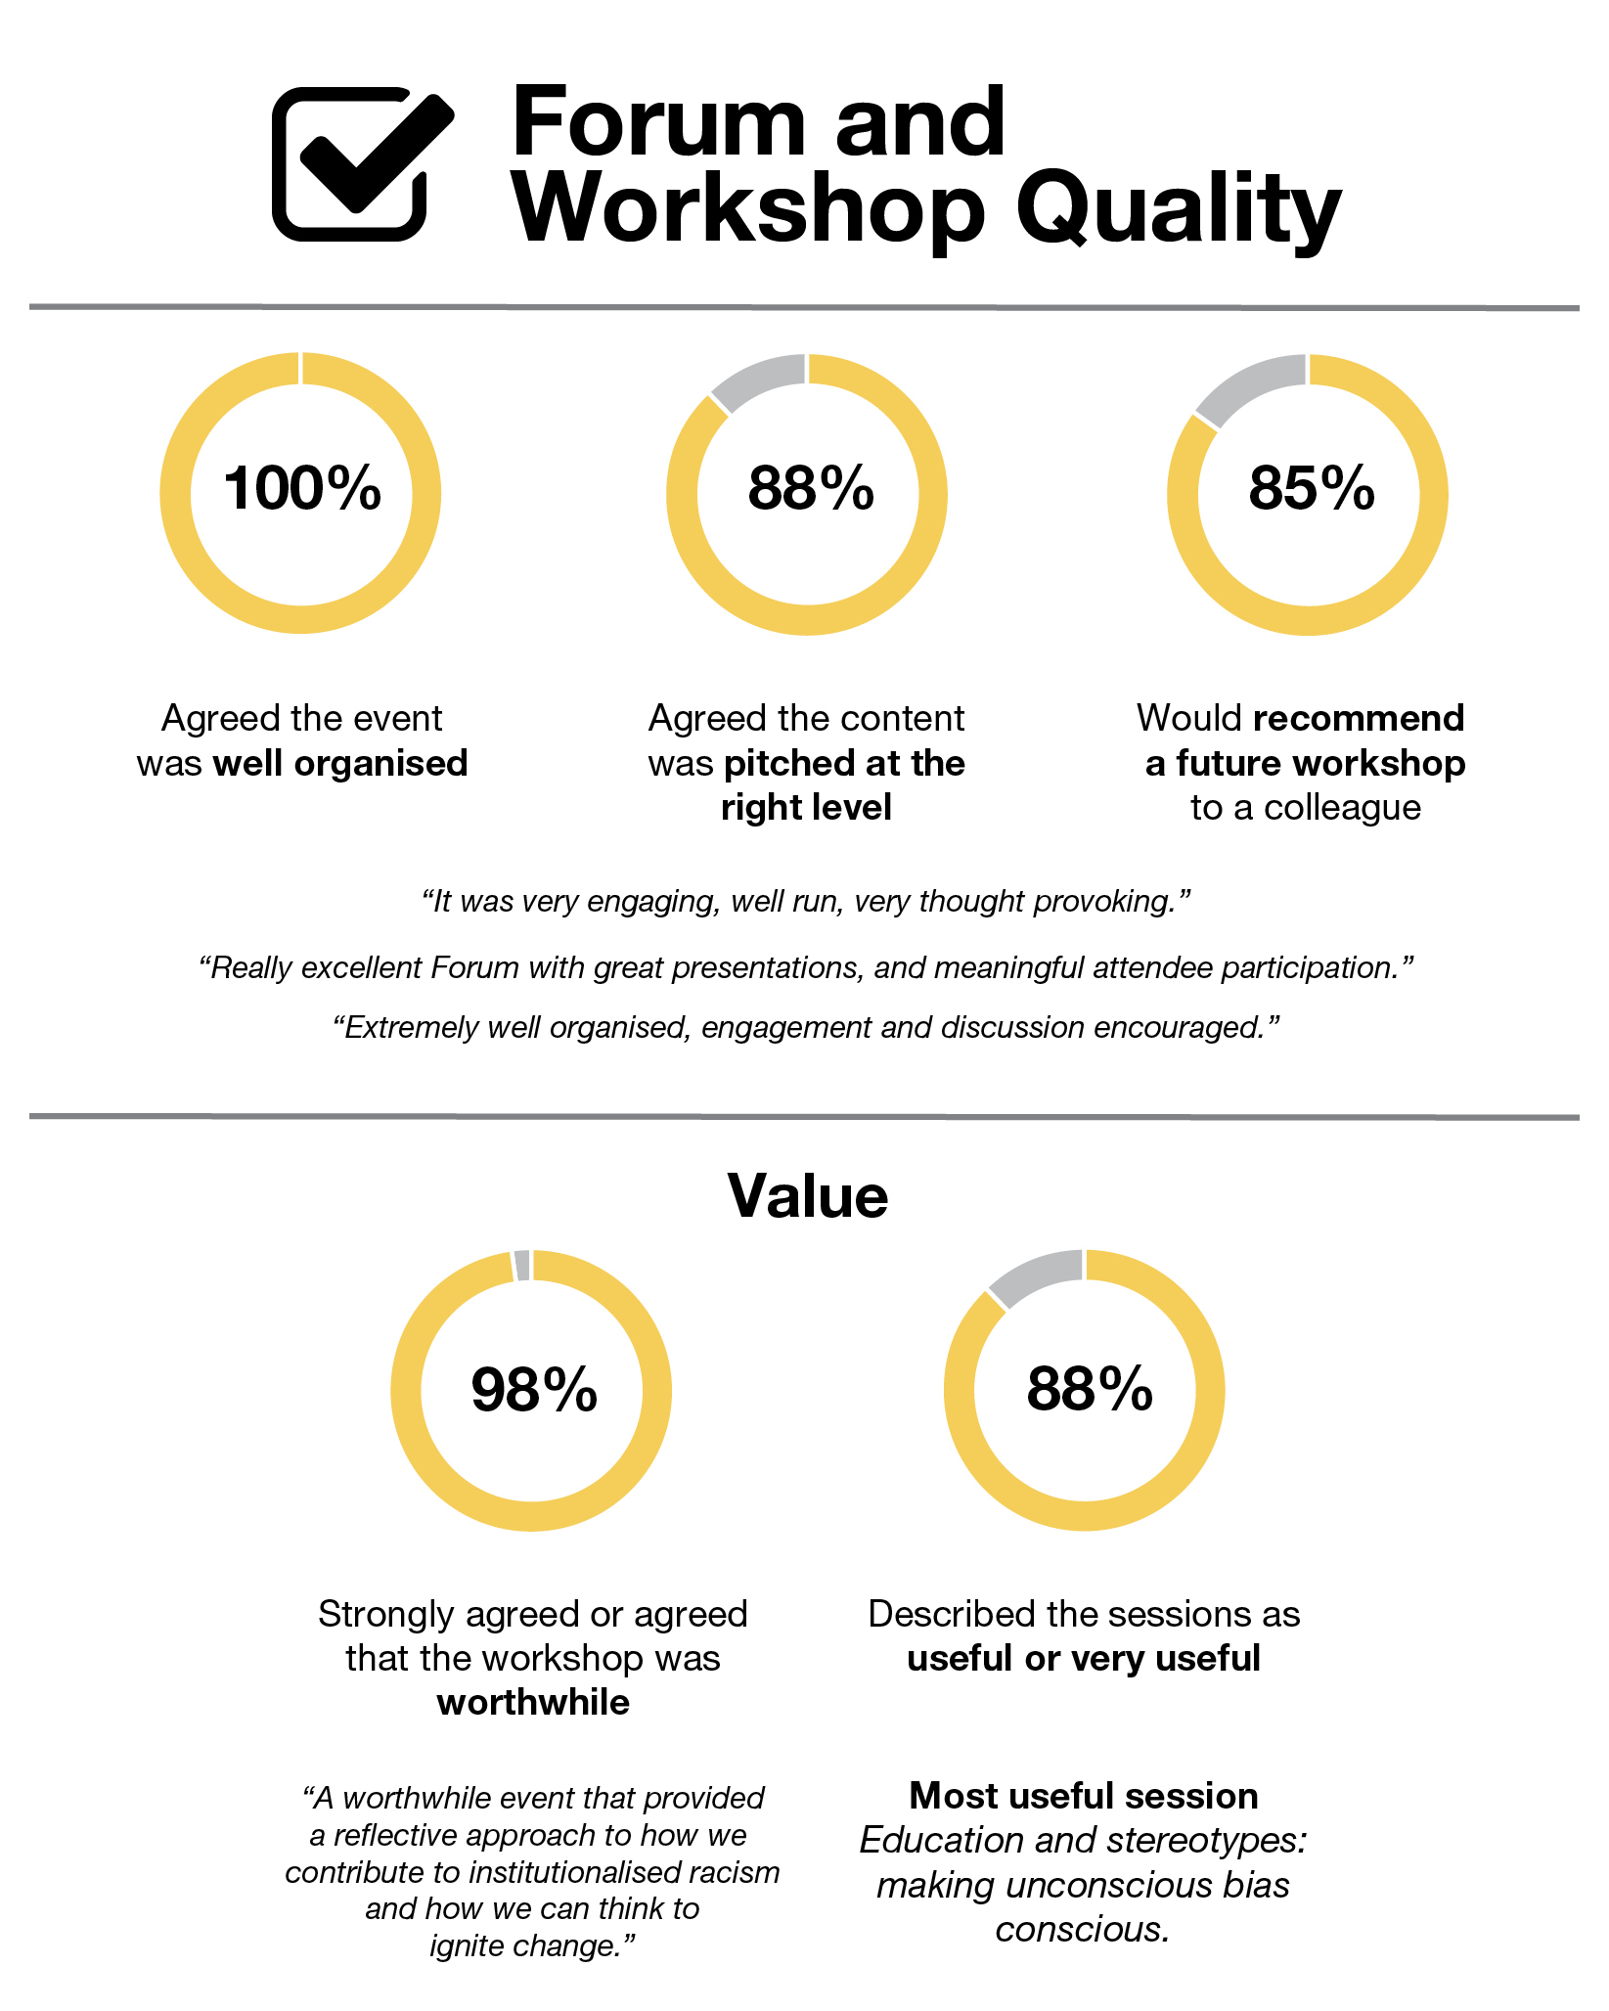

**Infographic 4. To what extent did participants benefit from taking part in the Forum and Workshop?**

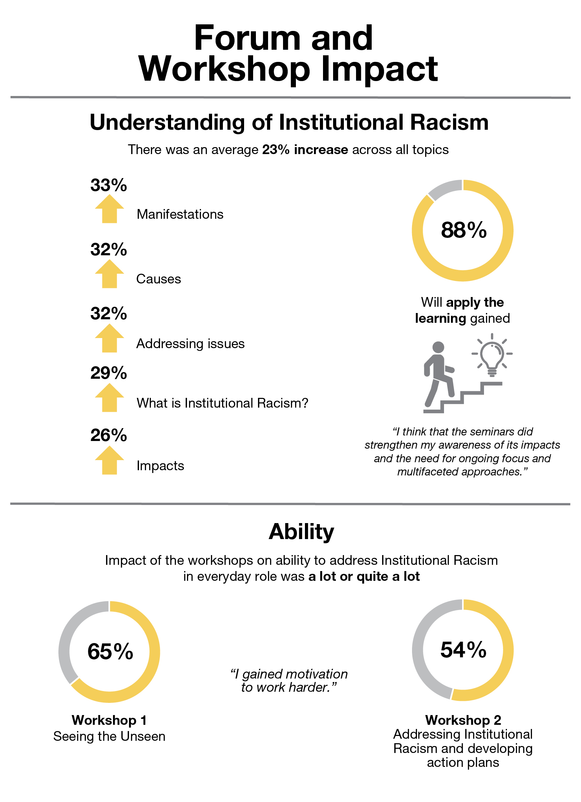

|  |
| --- |
| *I appreciated hearing about examples of what I can do to educate others about racism, with my colleagues*  *I think that the seminars didn’t really change my understanding of institutional racism but they did strengthen my awareness of its impacts and the need for ongoing focus and multifaceted approaches*  *… we need to include people who do not yet appreciate the impact of institutional racism. The invitations to Departmental Secretaries also needs to specify attendees must be at a level to implement the learning at the higher systemic/institutional level*  *Really excellent Forum with great presentations, and meaningful attendee participation*  *Great initiative. Was very glad I attended. Thank you for organising*  *… I think it was a really worthwhile event. I would definitely be interested in attending a future event. Thanks for hosting, appreciate everyone’s efforts*  *… it was very engaging, well run, very thought provoking*  *Extremely well organised, engagement and discussion encouraged* |

|  |  |
| --- | --- |
| **Goal** | **Result** |
| Increased understanding of institutional racism, barriers and solutions. | Overall there was a reported 30 per cent increase in understanding of institutional racism, the causes, manifestations and impact. |
| Increased knowledge of racial literacy on institutional racism. | Overall there was a reported 30 per cent increase in knowledge of racial literacy on institutional racism. |
| Increased confidence in addressing issues. | 88 per cent of respondents stated that they would apply learnings from the forum and workshop, indicating the content was practical and applicable.  Some respondents suggested they would have appreciated more time being devoted to developing strategies to combat institutional racism. |

### *Racism. It Stops with Me* – Videos, including Community Service Announcements

In October 2017, the Commission launched two Community Service Announcement videos (CSAs) and a social media campaign to raise awareness of everyday racism and bystander action.

The campaign ran from 5 October to 5 December on free to air TV channels (ABC, SBS and Ten networks) and on social media (primarily on Facebook). They were produced with the support of funding from the Department of Social Services, and with the support of Banjo advertising agency and Academy Award winning director David Denneen. The Commission held a launch event on 5 October 2017, featuring a panel discussion with ABC presenter Jeremy Fernandez, Verity Firth, Director of Social Justice and Equity at the University of Technology Sydney and Tracey Howe, CEO of New South Wales Council of Social Service.

The two commercials highlighted scenarios of everyday, casual racism and some of the steps that bystanders can take against them. The people who experience racism in the CSAs were an Aboriginal man waiting for a taxi and a woman with an African background in the elevator lobby of an office building.

Independent research has found that Aboriginal and Torres Strait Islander people and people with an African background frequently experience racism at work or while using public services and transportation. For example, the Scanlon Foundation’s *Australians Today* survey recorded 59 per cent of Indigenous respondents had experienced racial discrimination in the previous 12 months. It also found that 54 per cent of respondents with an African background had experienced discrimination in the past year, rising to 77 per cent for South Sudanese respondents.

The Commission’s own data supports those findings. In 2015-16, Aboriginal and Torres Strait Islander people accounted for 54 per cent of complaints received by the Commission under the *Racial Discrimination Act*. According to the Australian Bureau of Statistics, Indigenous Australians account for approximately 3 per cent of the Australian population. According to the Commission’s complaint statistics for 2015-16, 21 per cent of complaints received under the *Racial Discrimination Act* were in relation to employment, with 18 per cent of complaints in relation to the provision of good and services (see *Fact Sheet: Racism. It Stops with Me Community Service Announcements 2017* at: https://www.humanrights.gov.au/our-work/race-discrimination/publications/fact-sheet-racism-it-stops-me-community-service).

Following the launch of the CSAs, the Department of Social Services provided support for the production of two further videos for social media. These two additional videos carried a lighter tone, and focused on the topic of racism and sport, featuring edited versions of unscripted but guided conversations between opposing fans who find common ground in standing up to racism. The opposing fans are separated by a makeshift wall and cannot see each other as they discuss their teams and where to draw the line around sledging, racism and sport. The videos were first broadcast around the time of the domestic football season and several rugby internationals in order to capitalise on interest in sport.

The combined four videos have been supported by a redesigned sub-site, at https://itstopswithme.humanrights.gov.au, which was re-launched to coincide with the release of the Community Service Announcements. They have also been promoted on social media (primarily Facebook).

More than 3.5 million users were reached by the social media campaign, and more than 1.6 million watched the four videos on social media (in addition to views of the CSAs on free-to-air television). The videos also attracted substantial media attention, including on the ABC, and youth-targeted news sites such as Junkee and BuzzFeed.

The aim of this campaign was to start conversations about racism in Australia. This aim was achieved with significant reach for a modest budget.

|  |
| --- |
| By the numbers More than 3.5 million users were reached by the social media campaign, and more than 1.6 million watched the videos on social media.  The campaign attracted more than 4,500 shares and 2,200 comments on Facebook, indicating a high level of engagement. |

**Media coverage of the Community Service Announcements**

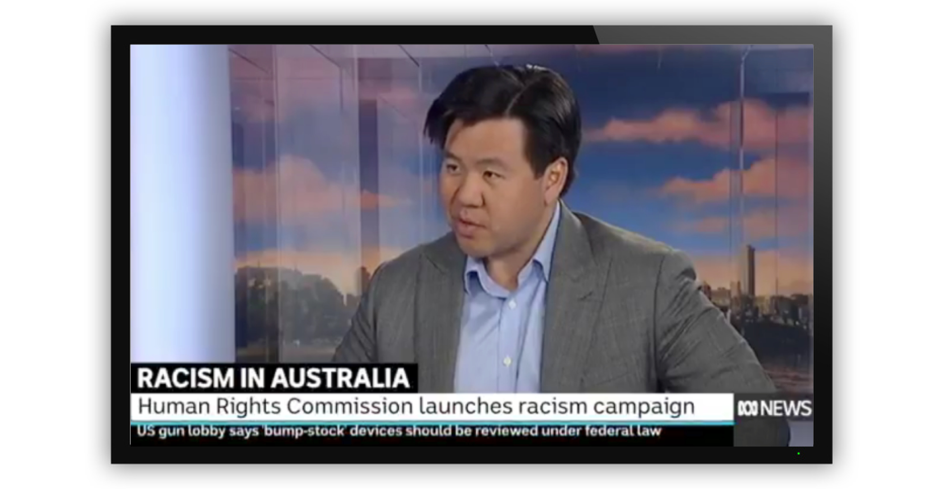

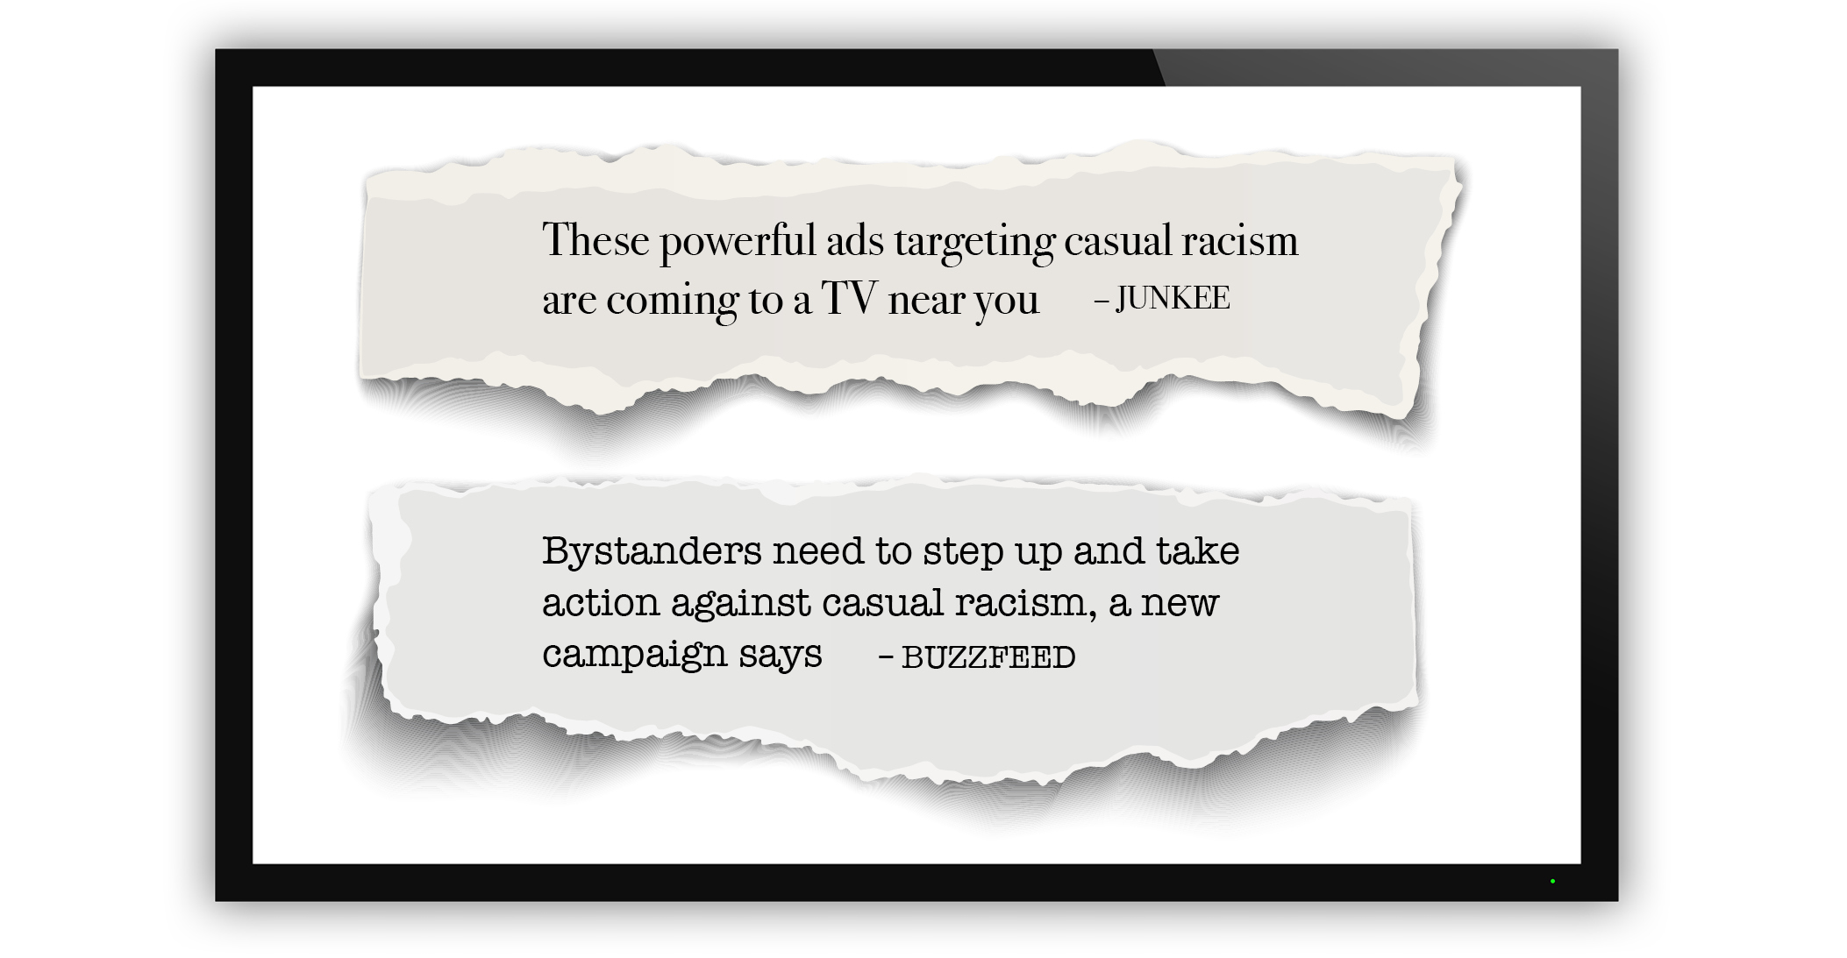

### *Racism. It Stops with Me* supporter activities

*Racism. It Stops with Me* has continued to enjoy strong support, with more than 370 organisational signatories at the time of writing. We have continued to support campaign supporters – for example, through the involvement of the Race Discrimination Commissioner in more than 130 events or meetings held by campaign supporters during that time.

Informal interviews with supporters indicate the campaign can play a powerful function in legitimating or validating anti-racism commitments within their organisation, providing guidance on how to respond to prejudice and discrimination, and provoking or starting discussions about racism. This confirms many of the themes that emerged from consultations in 2015 with supporters. It remains the Commission’s assessment that the *Racism. It Stops with Me* has a significant impact within supporter organisations in starting conversations, sending a message, encouraging leadership, and empowering people to take action.

Many supporters also point to the limitations of the campaign. In particular, its ability to reach those with intolerant or noxious views about race. This highlights an important qualification to the activities of the campaign and its supporters. It would be unrealistic to expect the campaign, with its modest resourcing and current configuration, to reach those with hostility towards racial equality or multiculturalism. The campaign has not been aimed at ‘preaching to the unconverted’, but rather at galvanising those who are already sympathetic to anti-racism – and possibly to prevent those indifferent about racism from drifting towards prejudice.

|  |
| --- |
| I think the fact that there is a campaign linked to the Human Rights Commission out there sends a strong message. – NRL staffer  There’s a fear of preaching to the converted, but we have hope from going into schools and speaking to the young people. We take the campaign resources into schools. – Hervey Bay Neighbourhood Centre  Being a small jurisdiction, we don’t have money to prepare our own collateral, our own videos. It’s really useful to use the campaigns resources …Tasmania doesn’t have the same big profile organisations working on racism, so we’ve seen the need to take the lead – the campaign helps with this. – Equal Opportunity Tasmania  We were trying to push for anti-racism work before the campaign came along, so it helped get everyone on board. – Flinders University  Being a supporter is an invitation for people to actually start talking about [racism]. – Uniting |

We highlight a number of case studies of supporter activities on anti-racism to illustrate the scope and breadth of work currently being undertaken.

#### Case Study: National Rugby League

The NRL has been a supporter of *Racism. It Stops with Me* since 2012.

Building on its support for the campaign, it signed a memorandum of understanding with the Commission in 2015. In 2015, it commissioned a review by the Commission, resulting in a report titled *From Good to Best Practice: Inclusion, racism and discrimination in rugby league*. The report examined Rugby League’s promotion of a safe and inclusive sporting environment through education programs, events, policies, codes of conduct, complaint procedures and sanctions. The report identified an opportunity for the NRL to move from good practice to best practice, cementing the NRL’s reputation as an accessible sport that provides opportunities for everyone to participate.

Recognising the Commission’s expertise, the NRL engaged the Commission to build on this work by developing a Social Inclusion Framework and Anti-Discrimination/Vilification Framework. A strong and productive relationship developed between the two organisations over the course of this project.

To develop the draft frameworks, the Commission conducted briefings and consultations with NRL staff and stakeholders and reviewed the NRL’s policies and programs. The Social Inclusion Framework provides the NRL with a guide to promote participation and engagement across a diverse range of people within the rugby league community. The Anti-Discrimination and Vilification Framework brings together and standardises the NRL’s policies and codes of conduct to ensure that everyone involved in the sport is aware of their rights and responsibilities. Looking ahead, the Commission will develop and deliver a workshop to demonstrate the practical relevance of these Frameworks to the everyday work and activities of the NRL community.

The NRL also conducts the In League In Harmony program, which aims to promote social cohesion by addressing issues including racism and bullying among youth. Youth participants are empowered to acknowledge, appreciate and celebrate the diversity amongst their peers and the wider community. The program, which involved over 1600 students last year and over 3000 students since it commenced in 2015, is delivered over a period of six school based sessions which then culminates in a celebratory Harmony Festival Gala Day.

#### Case Study: Equal Opportunity Tasmania

Equal Opportunity Tasmania has developed a racism training course to assist people in identifying racism and providing practical options to address racism. The course has been delivered to all LINC Tasmania sites, at a University of Tasmania staff session, and a group of hospitality venues in Hobart.

The course begins with a questionnaire that attendees privately answer, which aims to make people reflect on their interaction with racism, or lack thereof. It includes questions such as ‘Have you ever considered changing your name on a job application?’ and ‘When was the last time you were refused service?’. The training touches on:

* Who experiences racism in Australia and at what level;
* What the Tasmanian experience is;
* What racism and casual racism include;
* Self-awareness, self-reflection and recognising personal bias;
* The effects of racism;
* Options to take action against racism and bystander approaches to intervening; and
* Individual rights.

The training also provides a reference list of additional resources and tips for attendees.

#### Case Study: The University of Sydney

The University of Sydney originally became a supporter of the *Racism. It Stops With Me* campaign in 2013, and has reaffirmed its commitment in 2018 with a university wide campaign. The University of Sydney’s plan for 2018 focuses on supporting staff and students to effectively stand up against racism.

The 2018 program of work commenced in May with an event open to students and staff. The Race Discrimination Commissioner gave an opening address which was followed by a conversation with Co-President of the Sydney University Postgraduate Representative Association, Mariam Mohammed.

A strong commitment at the institutional level will support all members of the University community to feel empowered and safe to stand up against racism. The University will be making a visible statement that racism has no place at the University of Sydney and will display *Racism. It Stops With Me* imagery and messages.

A series of training sessions for staff and students designed to equip them with skills and knowledge to engage in anti-racism conversations and to be active bystanders has been planned for the second half of the year. The first session was *Courageous Conversations about* *Race* that provided an opportunity for participants to learn more about what racism is, how it affects people and to learn race terminology. *Courageous Conversations about* *Race* are facilitated sessions designed to address racial disparities through safe, authentic and effective cross-racial dialogue.

Another key training component is anti-racism bystander training which provides participants with the skills and awareness to take safe and constructive action when witnessing racism. The training is specifically designed to enable bystanders to become active advocates for a racism-free workplace, university and community.

To engage student groups, funding will be made available via an application process to assist them implement their own ideas for addressing racism.

### Advocates in Profile

In July 2018, the Commission launched a new sub-site on the *Racism. It Stops with Me* site called Advocates in Profile.

The page recognises the work of anti-racism being done across the country. It features profiles of leaders and advocates in the fields of anti-racism, multiculturalism and Aboriginal and Torres Strait Islander social justice.

The profiles reflect the importance of narrative in building support for anti-racism, and in building confidence among advocates. Through them, we have been able to share some inspiring stories of courage and conviction, and illuminating experiences of learning from different cultures. The profiles have proven to be a valuable resource for Australia’s anti-racism community.

|  |
| --- |
| The most effective way to fight racism is to target the ignorance that fuels it – Violet Roumeliotis  Australia could do better by having more conversations about race … racism is much more complex than just bigoted, overt racist behaviour – Santilla Chingaipe  Our leaders should be making a concerted effort to counter negative stereotypes … They should be openly and proudly rejecting racist ideas and discourses – Mary Patetsos  There are many levels of racism from personal to systemic and organisational that target Indigenous Australians and other minority peoples which impact on their opportunities – Juanita Sherwood  Most racism and hate is caused by lack of understanding and fear of the unknown – Ali Kadri  Standing up to racism is a part of responsible citizenship – Gulnara Abbasova |

# 4. Framing Future Work in Anti-Racism

There is an urgent need to continue and extend efforts in anti-racism, in light of current public debates and the global rise of far-right nationalist populism. But what should be the specific focus of future work in anti-racism? What is the best way for the work to proceed?

The answers depend on a number of factors. It makes a difference, for example, if there is concerted agreement within government at the most senior levels about taking action against racism. In Canada, Prime Minister Justin Trudeau recently announced a $23 million commitment over two years for multicultural programs and consultations on racism – including a national anti-racism plan. An equivalent investment dedicated to anti-racism would dwarf any funding of anti-racism work to date in Australia.

In addition to strong political leadership on anti-racism, there are some general principles that can reliably guide programs and initiatives on anti-racism.

**1. Give voice to individuals and communities**

Anti-racism efforts must bear witness to the experience of racism, and give voice to individuals and communities who experience it. Racial prejudice and discrimination have profound silencing effects on those who are their targets. Racism harms the freedom of its targets, including their freedom of speech. Any anti-racism effort must therefore seek to reclaim the freedom lost by giving voice to people.

Listening to people’s experiences also ensures that programs and initiatives are properly responsive to the realities of racism experienced by the Australian community. Since 2012, the Strategy has been guided by the extensive consultation conducted by the Commission in 2011. It has also been guided by the role of the National Anti-Racism Partnership group, which has included the National Congress of Australia’s First Peoples and the Federation of Ethnic Communities’ Councils of Australia (the two peak representative bodies for Aboriginal and Torres Strait Islander peoples and ethnic communities, respectively). In addition, the Commission has consulted regularly with different communities.

**2. Deal with causes, not just symptoms**

For anti-racism work to have an impact, it must do more than just deal with the symptoms of racism – it must do something about its causes. As noted in section 3, the causes of racism are multiple. It can be caused not just by ignorance but also by arrogance; it can be caused by malice as well as by lazy assumptions. While in some cases, the causes lay in attitudes and behaviour, in others, they lay within systems and institutions.

Any comprehensive approach to anti-racism must respond accordingly. Anti-racism must tackle the causes of racism, which exist in the various realms of:

* attitudes;
* behaviour; and
* structures.

Such an approach recognises the multidimensional nature of racism: it is something that is not only about belief or attitudes, but is also interpersonal and institutional. None of this should suggest that the work of anti-racism can be compartmentalised. Any work in changing attitudes should ideally translate into changed behaviours; and vice versa. Changes to structures should likewise not only lead to different institutional policies or systemic processes, but also lead to attitudinal and behavioural change.

**3. Name racism – explicitly and directly**

There has long been reluctance in dealing with racism in a forthright manner. Some fear that being too direct on matters of racism may have a counter-productive effect, by alienating people or by creating unnecessary division.

While such a narrative often comes from good intentions, it is also misguided. It can be used to stymie or divert anti-racism. There have been many examples within organisations where conversations begin as being concerned with responding to racism, only to be redefined as conversations about celebrating diversity – often with the effect of deflating people who wanted to do something about racism.

If there are divisions around the issue of racism, they are not fundamentally caused by the response to racism. The real division is generated by racism itself. There is no equivalence between racism and anti-racism. Within society – or within communities or organisations – if people are committed to treating people fairly and with equal dignity, they should be prepared to reject racism.

**Guided by these three principles, we highlight the potential for future anti-racism work in the following areas.**

## Public consultation on racism

The original development of the National Anti-Racism Strategy involved a major community consultation undertaken by the Commission over six months in 2012, which generated insights into the lived experience of racism in Australia. Since then, the Commission – through the Race Discrimination Commissioner – has conducted an additional national consultation process on racism during February-April 2015, as part of activities to mark the 40th anniversary of the Racial Discrimination Act.

It would be timely to conduct another public consultation on racism. The social and political climate in Australia has changed in material ways since 2015, as noted in section 2. It is crucial that any future anti-racism work responds to these social and political changes.

## Anti-racism coordination

The Commission is in the process of creating an online platform to connect *Racism. It Stops With Me* supporters. The platform will allow supporters to directly collaborate and share information, events and recommendations with each other and the Commission. It will also help to increase supporter engagement with the campaign and campaign activities.

The National Anti-Racism Strategy has benefited from the contributions of the Partnership group since 2012. Over that time, the composition of the Partnership has expanded, reflecting an acknowledgement that civil society and government departments and agencies can lend expertise in particular areas.

The Commission’s future anti-racism project and campaign work would benefit from the contributions of external organisations. The Commission has experience in working on campaigns such as Close the Gap, which comprise peak organisations from civil society. Consideration should be given to building on the Strategy’s success and incorporate into future anti-racism efforts a steering committee of individuals and representatives with anti-racism and advocacy expertise.

## National anti-racism awareness campaign

*Racism. It Stops with Me* has been a successful campaign during the past six years. Even so, there is clear scope for a renewed public awareness campaign to refresh, broaden and deepen the messaging about racism.

Awareness-raising campaigns are widely recognised as an effective tool for changing public behaviour.[37] They are most effective, though, when they expose high proportions of populations to messages through mass media. Successful campaigns on issues increase people’s ‘mental availability’ on a particular issue.[38]

The history of mass media public awareness campaigns in Australia has featured numerous successes, including in public health and road safety. However, they have all been characterised by significant scale and level of financial commitment.

|  |
| --- |
| Examples of recent awareness campaigns in Australia National Tobacco Campaign on reducing the prevalence of smoking (Commonwealth Government) – $6.6 million in the 2016-17 period  NSW Government/Transport for NSW campaigns on road safety – approximately $5 million in the 2017 period  NSW Government/NSW Environment Protection Authority Hey Tosser littering campaign – $2.94 million in 2017  Victorian Government Family Violence Behaviour Change campaign – $3.96 million in 2016  Australian Government Respect Domestic Violence campaign – $13.4 million in 2016 |

## A national day for anti-racism

March 21 is the United Nations (UN) International Day for the Elimination of Racial Discrimination. Since the 1990s, however, Australia has marked March 21 primarily as ‘Harmony Day’.

There is an undoubted place for the celebration of cultural diversity and racial harmony in a multicultural Australia. But that should complement anti-racism, rather than subsume it – particularly on March 21. There is the risk that emphasising *only* positive messages about cultural diversity and multiculturalism can make it harder to start conversations about racism, a topic that many may deem to be too fraught or difficult to raise. It speaks volumes that many people in Australia, while aware of Harmony Day, are oblivious to how the day falls on the international day dedicated to the elimination of racial discrimination.

Future work on anti-racism must consider how to reconcile the tensions between the current celebratory aspects of March 21 and its more sobering significance in international anti-racism. Given the international standing of March 21, established as it was in 1966 by the UN General Assembly, an alternative date should be explored for the marking of an Australian Harmony Day.

## Bystander anti-racism

Since 2012, the Strategy has emphasised the importance of bystander intervention in acts of racism. As illustrated by the name of the *Racism. It Stops with me* campaign, we have sought to promote people considering their responsibility and ability to respond directly to racism.

Bystander anti-racism is crucial in shifting attitudes and behaviours. It shifts the burden of dealing with racism away from targets of racism to the broader society. It makes the problem of racism one for all of us, rather than just for those who experience it. More specifically, it helps contribute to social norms which make racist behaviour unacceptable in society, and gives licence to people to take a stand against it.

Recent years have demonstrated a willingness by many Australians to intervene in acts of racial discrimination or hatred. Any future work should seek to maintain positive shifts in attitudes, behaviours and norms.

## Intergroup contact

Evidence suggests a correlation between familiarity with cultural diversity and acceptance of it. Some of the areas that display relatively low levels of acceptance of cultural diversity are those with low levels of diversity in its population. Meanwhile acceptance of diversity appears to be higher in areas with relatively diverse populations.[39]

Social psychologists have studied the effects of social contact with groups from different cultural and racial backgrounds. There is a significant body of research that suggests ‘intergroup contact’ can reduce prejudice and stereotyping. Namely, greater familiarity with different groups reduces fears and anxieties, while increasing empathy and trust.[40]

Any future work, particularly with communities, should consider the promotion of positive intergroup contact as a means of reducing racial prejudice.

## Institutional racism, including a standing forum for government officials

Institutional or structural racism can operate with a high level of subtlety. It is frequently reproduced through assumptions, processes and systems within institutions. Decision making within institutions can be shaped by biases and prejudices, of which people may not necessarily be conscious.

Anti-racism work must be prepared to challenge or shift power structures within institutions. It is not sufficient to confine anti-racism efforts to attempts to shift individual attitudes and behaviour.

The success of the Strategy’s Forum and Workshop on institutional racism for government officials provides one possible platform for future work. It is open to explore the establishment of a standing forum for government officials on institutional racism, which aims to share knowledge about institutional racism in areas including (but not limited to) law and justice, health, education and human services. A standing forum or other mechanism could also incorporate elements of training on racial literacy and unconscious bias.

## Training for anti-racism advocates

There remains scope for further initiatives to support anti-racism advocates, in particular youth and those from Indigenous and multicultural communities. This could include providing seminars or workshops about anti-racism, or more dedicated schemes to develop leadership and cooperation between communities and organisations.

The Strategy’s National Anti-Racism Youth Leadership Initiative has served as a useful pilot for a dedicated anti-leadership scheme. While concerned with youth advocates, the experience of the Initiative also holds some possible lessons for schemes aimed at established advocates.

**Endnotes**

1. Australian Bureau of Statistics, ‘Census reveals a fast changing, culturally diverse nation’ (Media Release, 073/2017, 27 June 2017). At http://www.abs.gov.au/ausstats/abs@.nsf/lookup/Media%20Release3 (viewed 30 July 2018).
2. Australian Human Rights Commission, Leading for Change: A blueprint for cultural diversity and inclusive leadership revisited (2018) 7. At https://www.humanrights.gov.au/our-work/race-discrimination/publications/leading-change-blueprint-cultural-diversity-and-inclusiv-0 (viewed 30 July 2018).
3. Andrew Markus, Mapping Social Cohesion: The Scanlon Foundation surveys 2017 (Monash University, 2017). At http://scanlonfoundation.org.au/socialcohesion2017/ (viewed 30 July 2018).
4. Andrew Markus, Mapping Social Cohesion: The Scanlon Foundation surveys 2017 (Monash University, 2017) 31. At http://scanlonfoundation.org.au/socialcohesion2017/ (viewed 30 July 2018).
5. Andrew Markus, Mapping Social Cohesion: The Scanlon Foundation surveys 2017 (Monash University, 2017) 60. At http://scanlonfoundation.org.au/socialcohesion2017/ (viewed 30 July 2018).
6. Reconciliation Australia, 2016 Australian Reconciliation Barometer (2016) 60. At https://www.reconciliation.org.au/wp-content/uploads/2017/11/RA_ARB-2016_-Full-report_FINAL-1.pdf.
7. European Social Survey, ‘Attitudes towards immigration in Europe: myths and realities’ (19 June 2017). At https://www.europeansocialsurvey.org/docs/findings/IE_Handout_FINAL.pdf (viewed 30 July 2018).
8. Melissa Davey, ‘Channel Seven under fire over interview with far-right activist’, Guardian (online) 15 January 2018. At https://www.theguardian.com/australia-news/2018/jan/15/channel-seven-under-fire-interview-far-right-activist-blair-cottrell (viewed 30 July 2018; A Current Affair, ‘Apex members reveal the allure of Melbourne’s notorious teen gang’, 9 News (online) 1 May 2017. At https://www.9news.com.au/national/2017/05/01/18/42/apex-members-reveal-the-allure-of-melbournes-notorious-teen-gang (viewed 30 July 2018).
9. Julie Nathan, ‘Antipodean Resistance: The Rise and Goals of Australia’s New Nazis’, ABC Religion and Ethics (online) 20 April 2018. At http://www.abc.net.au/religion/articles/2018/04/20/4833287.htm (viewed 30 July 2018); Alex Ryvchin, ‘The rise of antisemitism in Australia has a distinctly American tone’, Guardian (online) 10 October 2017. At https://www.theguardian.com/commentisfree/2017/oct/10/the-rise-of-antisemitism-in-australia-has-a-distinctly-american-tone (viewed 30 July 2018); Nick Clark, ‘Nazi attack on University of Tasmania campus condemned’ The Mercury (online) 25 September 2017. At: http://www.themercury.com.au/news/scales-of-justice/nazi-attack-on-university-of-tasmania-campus-condemned/news-story/e2809f0ce6c48b595ac8e200244cd6a6 (viewed 30 July 2018); Finbar O’Mallon, ‘‘All this hatred’: White supremacist material found in Canberra letterboxes’, Canberra Times (online) 17 December 2017. At: http://www.canberratimes.com.au/act-news/all-this-hatred-white-supremacist-material-found-in-canberra-letterboxes-20171214-h04jxq.html (viewed 30 July 2018).
10. Executive Council of Australian Jewry, The ECAJ 2017 Antisemitism Report (2017). At http://www.ecaj.org.au/2017/antisemitism-report-2017/ (viewed 30 July 2018).
11. See, e.g., Brianna Travers, ‘Woman abuses Coles supermarket staff in Melton’, News.com.au (online) 5 January 2017. At http://www.news.com.au/national/victoria/woman-abuses-coles-supermarket-staff-in-melton/news-story/9fd4b4699ae28ec6b932b0071e464f20 (viewed 30 July 2018); Melanie Kembrey, ‘‘You should take that off’: Woman charged after alleged attack at Sydney Shopping Centre’, Sydney Morning Herald (online) 2 April 2017. At: http://www.smh.com.au/nsw/you-should-take-that-off-woman-charged-after-alleged-racist-attack-at-sydney-shopping-centre-20170401-gvbgw8.html (viewed 30 July 2018); Carly Dolan, ‘Professional dancer racially abused in Launceston after DanceSport Championship’, Tasmanian Examiner (online) 19 August 2017. At: http://www.examiner.com.au/story/4866030/dancer-racially-abused-in-launceston/?cs=95 (viewed 30 July 2018).
12. See, e.g., Aneeka Simonis, ‘Shop owner punched in racial attack in Vic’, Herald Sun (online) 21 February 2017. At: http://www.heraldsun.com.au/news/breaking-news/shop-owner-punched-in-racial-attack-in-vic/news-story/941f651b26376de14075e77181e33cac (viewed 30 July 2018); News.com.au, ‘Chinese woman subjected to ‘severe racial attack’ in Burwood, Sydney’, News.com.au (online) 3 March 2017. At: http://www.news.com.au/national/nsw-act/crime/chinese-woman-subjected-to-severe-racial-attack-in-burwood-sydney/news-story/9f7cbf64cbaf38c028e6bc3584096b33 (viewed 30 July 2018); Mark Morri, ‘Four Sydney Muslim women attacked in Broadway’, Daily Telegraph (online) 11 May 2017. At http://www.dailytelegraph.com.au/news/nsw/four-sydney-muslim-women-attacked-in-broadway/news-story/200de25552eec624b488e9a3bb3c9f43 (viewed 30 July 2018).
13. See, e.g., The Australian, ‘Anti-Semitic rants, rape threats ‘not against Facebook community standards’’, Australian (online) 2 May 2017. At: http://www.theaustralian.com.au/business/technology/antisemitic-rants-rape-threats-not-against-facebook-community-standards/news-story/9521d3d05e1e44e0c3487b507718dffc (viewed 30 July 2018); Josephine Lim, ‘Footy fan condemned for ‘Holocaust’ comment on Facebook’, Adelaide Now (online) 8 August 2017. At: http://www.adelaidenow.com.au/news/south-australia/footy-fan-condemned-for-holocaust-comment-on-facebook-after-adelaide-crows-defeat-the-power-in-showdown/news-story/642cc497ca9439417a6eda5d37e30566 (viewed 30 July 2018); Erin Parke, ‘Nurse stood down for racist social media rant, employment lawyer says breaches are common’, ABC News (online) 13 December 2017. At: http://www.abc.net.au/news/2017-12-13/broome-hospital-nurse-stood-down-for-online-racist-rant/9251874.
14. Adelaide Advertiser, ‘Photos emerge on social media of Port Adelaide fan wearing Nazi swastika’ Adelaide Advertiser (online) 19 April 2017. At: http://www.news.com.au/sport/afl/photos-emerge-on-social-media-of-port-adelaide-fan-wearing-nazi-swastika/news-story/1c924bf56fc2d67e40656bd16deaacf2 (viewed 30 July 2018); Rebecca Di Nuzzo, ‘Abusive graffiti daubed on foreign students’ homes in Malvern East’, Herald Sun (online) 15 June 2017. At: http://www.heraldsun.com.au/leader/inner-east/abusive-graffiti-daubed-on-foreign-students-homes-in-malvern-east/news-story/01dc03f4d90dbc4e2ce93d686e62832d (viewed 30 July 2018); Pallavi Singhal, ‘Police investigating racist posters plastered across Sydney’s inner west’, Sydney Morning Herald (online) 11 July 2017. At: http://www.smh.com.au/nsw/police-investigating-racist-posters-plastered-across-sydneys-inner-west-20170710-gx8mcy.html (viewed 30 July 2018).
15. News.com.au, ‘Andrew Fifita hits out at racist attack’ News.com.au (online) 29 June 2017. At: http://www.news.com.au/sport/nrl/andrew-fifita-hits-out-at-racist-attack/news-story/f8d594a51e01c6eab6e2682358c2cc13 (viewed 30 July 2018); Natalie Wolfe, ‘Chris Lilley criticised for racist music video’, The Queensland Times (online) 29 July 2017. At: https://www.qt.com.au/news/chris-lilley-criticised-racist-music-video/3206497/ (viewed 30 July 2018); News.com.au, ‘LNP member Kerri-Anne Dooley photographed with someone wearing blackface’, News.com.au (online) 10 October 2017. At: http://www.news.com.au/lifestyle/real-life/news-life/lnp-member-kerrianne-dooley-photographed-with-someone-wearing-blackface/news-story/c5b300bb641cc84d376cbe57492cb044 (viewed 30 July 2018).
16. Trenton Akers, ‘One Nation Senator Malcolm Roberts’ 7-Eleven jibe’, Courier Mail (online) 19 July 2017. At: http://www.couriermail.com.au/news/queensland/one-nation-senator-malcolm-roberts-7eleven-jibe/news-story/12f18a4fa2bedb4efe034660ce25bf9c (viewed 30 July 2018); Joseph Pearson and Clay Wilson, ‘Nigel Vagana says ignorance is no excuse after Matty Johns Show is accused of casual racism’, Stuff.co.nz (online) 26 August 2017. At: https://www.stuff.co.nz/sport/league/96183528/Nigel-Vagana-says-ignorance-is-no-excuse-after-Matty-Johns-Show-is-accused-of-casual-racism (viewed 30 July 2018).
17. See Department of Home Affairs, ‘Reforms to modernise Australia’s visa system’ (2017) https://www.homeaffairs.gov.au/trav/visa-reform (viewed 10 May 2018).
18. Andrew Markus, Mapping Social Cohesion: The Scanlon Foundation surveys 2017 (Monash University, 2017) 35. At http://scanlonfoundation.org.au/socialcohesion2017/ (viewed 30 July 2018).
19. Andrew Markus, Mapping Social Cohesion: The Scanlon Foundation surveys 2017 (Monash University, 2017) 2. At http://scanlonfoundation.org.au/socialcohesion2017/ (viewed 30 July 2018).
20. Katharine Murphy, ‘Australians growing more concerned over immigration – Guardian Essential poll’, Guardian (online) 24 April 2018. At https://www.theguardian.com/australia-news/2018/apr/24/australians-growing-more-concerned-over-immigration-guardian-essential-poll (viewed 30 July 2018).
21. Alex Oliver, 2018 Lowy Institute Poll (20 June 2018) Lowy Institute. At https://www.lowyinstitute.org/publications/2018-lowy-institute-poll (viewed 30 July 2018).
22. Senator Jim Molan, in his February 2018 maiden speech, articulated concerns about the admission of immigrants “in excess of the capacity of our cities to absorb, both culturally and in terms of infrastructure.” More explicitly, in May 2018, NSW Opposition Leader Luke Foley referred specifically to the phenomenon of ‘white flight’ and the consequences for ‘Anglo families’ of the growing multicultural population of western Sydney. Foley was roundly condemned, including by the NSW Premier, for using “deeply divisive, dangerous and nasty” language.
23. Michael Koziol and Melissa Cunningham, ‘There is a problem’: Tony Abbott questions all African immigration amid gang violence debate, Sydney Morning Herald (online) 25 July 2018. At: https://www.smh.com.au/politics/federal/there-is-a-problem-tony-abbott-questions-all-african-immigration-amid-gang-violence-debate-20180725-p4ztmh.html (viewed 30 July 2018).
24. Alan Tudge, ‘Maintaining social cohesion in a time of large, diverse immigration’ (Speech delivered at the Australia-UK Leadership Forum, London, 19 July 2018) At: http://minister.homeaffairs.gov.au/alantudge/Pages/maintaining-social-cohesion-in-a-time-of-large-diverse-immigration.aspx (viewed 30 July 2018).
25. Australian Government, ‘Strengthening the integrity of Australian citizenship’ (Media Release, 20 April 2017). At https://www.pm.gov.au/media/strengthening-integrity-australian-citizenship (viewed 30 July 2018).
26. Federation of Ethnic Communities’ Councils of Australia, Submission No 410 to Senate Legal and Constitutional Affairs Committee, Parliament of Australia, Inquiry into Australian Citizenship Legislation Amendment (Strengthening the Requirements for Australian Citizenship and Other Measures) Bill 2017, 21 July 2017.
27. Victorian Multicultural Commission, Submission No 482 to Senate Legal and Constitutional Affairs Committee, Parliament of Australia, Inquiry into Australian Citizenship Legislation Amendment (Strengthening the Requirements for Australian Citizenship and Other Measures) Bill 2017, 21 July 2017.
28. Australian Human Rights Commission, Submission No 447 to Senate Legal and Constitutional Affairs Committee, Parliament of Australia, Inquiry into Australian Citizenship Legislation Amendment (Strengthening the Requirements for Australian Citizenship and Other Measures) Bill 2017, 21 July 2017. See also Tim Soutphommasane, ‘Inclusion, citizenship and race’ (Speech delivered at Australian Education Union Victoria Principals Conference, Melbourne, 28 April 2017). At https://www.humanrights.gov.au/news/speeches/inclusion-citizenship-and-race (viewed 30 July 2018).
29. Alan Tudge, ‘The case for English: Why a shared language is key to social cohesion and economic success’ (Speech delivered at The Sydney Institute, Sydney, 14 June 2018) At: http://minister.homeaffairs.gov.au/alantudge/Pages/the-case-for-english.aspx (viewed 30 July 2018).
30. See, for instance, Australian Human Rights Commission, Freedom from Discrimination: Report on the 40th anniversary of the Racial Discrimination Act (2015) 37. At: https://www.humanrights.gov.au/our-work/race-discrimination/publications/freedom-discrimination-report-40th-anniversary-racial (viewed 30 July 2018); Human Rights and Equal Opportunity Commission, Isma – Listen (2003). At https://www.humanrights.gov.au/publications/isma-listen-report (viewed 30 July 2018).
31. Kevin Dunn et al, ‘The resilience and ordinariness of Australian Muslims: Attitudes and experiences of Muslims Report’ (Western Sydney University, Islamic Sciences and Research Academy, Charles Sturt University, Sydney) 27-28. At: https://www.westernsydney.edu.au/__data/assets/pdf_file/0008/988793/12441_text_challenging_racism_WEB.pdf (viewed 8 February 2017).
32. Caroline Zielinski and Chloe Booker, ‘Moomba riots: Police rule out race as a motive’, Age (online) 11 April 2016. At https://www.theage.com.au/national/victoria/police-charge-24-over-moomba-riots-20160411-go34vr.html (viewed 30 July 2018); Luke Henriques-Gomes, ‘It’s not safe for us’: South Sudanese-Australians weather ‘African gangs’ storm’, Guardian (online) 25 July 2018. At https://www.theguardian.com/australia-news/2018/jul/25/its-not-safe-for-us-south-sudanese-australians-weather-african-gangs-storm (viewed 30 July 2018).
33. Andrew Markus, Australians Today: The Australia@2015 Scanlon Foundation Survey (2016) Scanlon Foundation, Australian Multicultural Foundation and Monash University, 62. At http://scanlonfoundation.org.au/wp-content/uploads/2016/08/Australians-Today.pdf (viewed 14 December 2016).
34. Concerned Scholars of China (group), ‘An open letter from concerned scholars of China and the Chinese diaspora’ (26 March 2018) Asia and the Pacific Policy Society Policy Forum. At https://www.policyforum.net/an-open-letter-from-concerned-scholars-of-china-and-the-chinese-diaspora/ (viewed 30 July 2018).
35. Tim Soutphommasane, ‘The many faces of racism’ (Speech delivered at UNESCO Chair Annual Oration, Alfred Deakin Institute for Citizenship and Globalisation, Deakin University, Melbourne, 11 October 2017). At: https://www.humanrights.gov.au/news/speeches/many-faces-racism (viewed 30 July 2018).
36. The Department of Home Affairs also joined the partnership in 2018, following its creation and the transferral of the Multicultural Affairs function from the Department of Social Services to the Department of Home Affairs.
37. See for example: Dorie Apollonio and R. E. Malone, ‘Turning negative into positive: public health mass media campaigns and negative advertising’ Health education research (2008) 24(3) 483; Myde Boles et al, ‘Ability of a mass media campaign to influence knowledge, attitudes, and behaviors about sugary drinks and obesity’ (2014) 67 Preventive medicine S40; Whitney Randolph and Kasisomayajula Viswanath, ‘Lessons learned from public health mass media campaigns: marketing health in a crowded media world, (2004) 25 Annual Review of Public Health 419.
38. Amy Wilson and Nick Danenberg Why Public Health Campaigns Often Neglect The Simple Rules Of Advertising (26 February 2018) Ehrenberg-Bass Institute for Marketing Science. At https://www.marketingscience.info/public-health-campaigns-often-neglect-simple-rules-advertising/, (viewed 25 June 2018).
39. Andrew Markus, Mapping Social Cohesion: The Scanlon Foundation surveys 2017 (Monash University, 2017). At http://scanlonfoundation.org.au/socialcohesion2017/ (viewed 30 July 2018).
40. Frances E Aboud et al, ‘Interventions to reduce prejudice and enhance inclusion and respect for ethnic differences in early childhood: A systematic review’ (2012) 32(4) Developmental review 307, 308.