Our Agenda

A guide to the Commission and its activities for 2013-2014

**Australian Human Rights Commission 2013**



Contents

What are human rights? 4

Who we are 5

Our Agenda 6

Our work plan for 2013-14 7

Freedom from violence, harassment and bullying 7

Building understanding and respect for rights in our community 8

Setting and advancing national agendas 10

Building human rights into Australian laws and practices 12

Resolving discrimination and human rights complaints 14

Monitoring and reporting 15

Engaging regionally and internationally 16

Organisational excellence 18

Our leadership team 19

Organisational structure 20

The Australian Human Rights Commission encourages the dissemination and exchange of information provided in this publication.

All material presented in this publication is provided under a **Creative Commons Attribution 3.0 Australia**, with the exception of:

• The Australian Human Rights Commission Logo

• Photographs and images

• Any content or material provided by third parties

The details of the relevant licence conditions are available on the **Creative Commons** website, as is the full legal code for the **CC BY 3.0 AU licence**.



**Attribution**

Material obtained from this publication is to be attributed to the Commission with the following copyright notice:

© Australian Human Rights Commission 2013.

**Third party copyright**

Wherever a third party holds copyright in material presented in this publication, the copyright remains with that party. Their permission may be required to use the material.

The Commission has made all reasonable efforts to:

• clearly label material where the copyright is owned by a third party. Please note this does not include photos, images and video which are all regarded as third party material.

• ensure that the copyright owner has consented to this material being presented on this website.

**Contact Us**

Communications

Australian Human Rights Commission

GPO Box 5218

SYDNEY NSW 2001

**Telephone:** (02) 9284 9600

**Email:** communications@humanrights.gov.au

**ISSN 1839-728X**

This publication can be found in electronic format on the Australian Human Rights Commission’s website at: **www.humanrights.gov.au/publications-home/all**

**Design and layout** Dancingirl Designs

**Printing** Paragon Australasia Group

# What are human rights?

Human rights are about valuing the inherent worth and dignity of every person. They are an expression of how people should, and should not, be treated – by individuals, by government, and by the community at large. We all have these rights and we all want them acknowledged by our friends, families and employers. Just as importantly, we all have responsibilities to recognise them in others.

Human rights and freedoms are set out in international treaties; to a limited extent in the nation’s Constitution; and, where successive governments have agreed to be bound by these treaties, have been given national effect in many domestic laws. These laws provide legal protection to people who have been treated unfairly and set practical standards for all the community to follow.

# Who we are

The role of the Australian Human Rights Commission is to see that human rights and fundamental freedoms are understood and respected in law, policy and practice. The Commission is independent from government, with a legislative mandate, and recognised internationally as an ‘A Status’ National Human Rights Institution. We strive to resolve complaints, encourage positive law reform and build a shared awareness and recognition of freedoms and rights throughout Australia.

We operate under the *Australian Human Rights Commission Act 1986* (Cth) as well as federal laws that seek to ensure freedom from discrimination on the basis of attributes such as age, disability, race, sex, sexuality and gender identity. The Commission also has specific responsibilities under the *Native Title Act 1993* (Cth) and the *Fair Work Act 2009* (Cth). Our job is to work towards an Australia in which human rights are respected, protected and promoted – finding practical solutions to issues of concern; advocating for systemic change; and raising awareness across the community.

Much of this work is at the policy level – engaging with the public and the media; and encouraging government, industry and community groups alike to see fundamental rights and freedoms realised. It involves building the case for change on issues ranging from paid parental leave to age discrimination in employment. It involves providing a human rights analysis to the courts and to parliamentary inquiries, conducting research and contributing to partnerships. Our work also involves exchanging ideas with equivalent bodies around the world; while, closer to home, we monitor and report on the experiences of those particularly vulnerable to disadvantage.

From addressing individual complaints of discrimination, to engaging with government on policy issues, the Commission’s task is both to apply those rights that are currently recognised in our laws; and to aspire for greater recognition and protection of those that are not.

Our vision is for an Australia where human rights are enjoyed by **everyone, everywhere, everyday**.

# Our Agenda

There is no simple way to solve complex human rights issues. From the challenges that face a person with a disability seeking independent living, through immigration detention policy, the promotion of human rights must address issues for individuals as well as the need for broader, systemic change. That is why the Commission uses a range of integrated approaches, while also focussing on particular areas of discrimination through our specialised commissioners.

This document provides an overview of the Commission’s major activities and programs for 2013-14 which are organised according to the following themes and priorities.

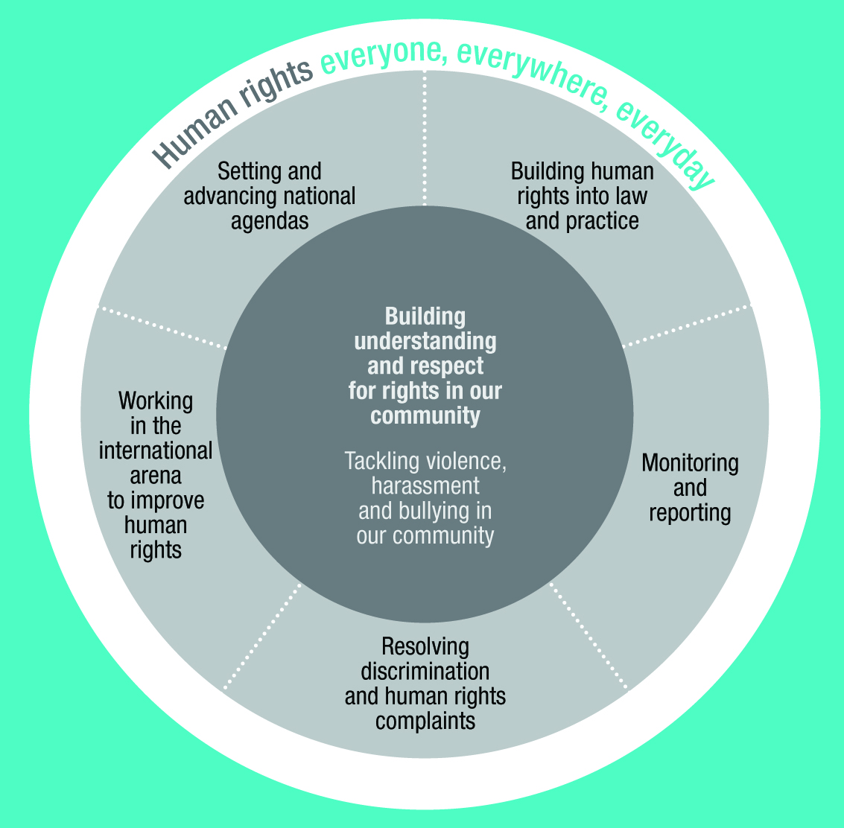

# Our work plan for 2013-14

## Freedom from violence, harassment and bullying

Violence, harassment and bullying profoundly affect the lives of thousands of people living in Australia. Discrimination and breaches of human rights can often be both a contributing factor and a consequence of such acts. The Commission has prioritised work on violence, harassment and bullying since 2010 and will continue to do so for the coming year.

|  |
| --- |
| What we’re doing This year, we will:   * Lead the National Anti-Racism Partnership and Strategy * Support prominent Australian leaders and organisations in taking a public stand through the Racism. It Stops with Me! campaign * Conduct the second round of our BackMeUp competition to engage 13-17 years olds on the issues of standing up to and preventing cyberbullying * Audit the implementation of the Commission’s reports into the treatment of women in the Australian Defence Force and the Australian Defence Force Academy * Identify best practice responses to homophobic bullying at the school level * Provide information and referral assistance about harassment and bullying through our national information hotline * Investigate and conciliate individual complaints of bullying and harassment under federal human rights and anti-discrimination laws. |

|  |
| --- |
| Back Me Up! **“BackMeUp has really helped me understand what I can do if I see cyber bullying happening before me. It provided information that I didn’t get from anywhere else, even school.”**  **Source:** Survey of young people participating in the 2012 BackMeUp cyberbulling campaign.  The Commission’s Back Me Up! Competition encourages young people (aged 13-17 years) to make short videos identifying what practical actions they could take to support a friend who is being cyber-bullied. It uses social media and user-generated content to provide peer to peer education about taking safe and effective action when someone witnesses cyber-bullying  The 2013 edition of the campaign was launched in August 2013 and will run through to November. |

## Building understanding and respect for rights in our community

We all have obligations to respect the rights of others, but for this to take practical effect we need to build wider understanding of human rights and their importance in daily life.

Community education, training and community engagement projects translate human rights values into practical reality. The Commission uses social media and other tools to reach a wide range of members of the Australian population.

|  |
| --- |
| Human rights education and advocacy course **“This course has empowered us to be agents of change… and to mobilise our communities through education about rights and responsibilities so that they can make changes in their own lives.”**  **Source:** Human Rights Education and Community empowerment paper, written and delivered by Certificate IV in Human Rights Education and Advocacy course participants.  The Commission has worked with Granville TAFE to develop training on human rights advocacy for community workers who work with Muslim communities. The next stage of the project is to develop tools which can be built into certificate level courses in the Vocational Education & Training sector. |

**Your rights at retirement**

Launched in July 2013, *Your Rights at Retirement* is a ‘one stop shop’ reference manual that helps older people navigate the complex decisions, services and supports that are part of planning and managing retirement. Initial distribution of the booklet has occurred in collaboration with NSW Department of Ageing.

|  |
| --- |
| What we’re doing Under our *Human Rights Education Program* we will:   * Release a resource for teachers and syllabus writers linking human rights across all areas of the national curriculum * Develop new teaching resources, linked to the national curriculum, exploring issues of disability, racism and cultural diversity * Update our *Rights:Ed* suite of educational resources online * Pilot education and training to enable Australian Public Service (APS) staff to discharge their obligations under the APS Code of Conduct.   In the coming year we will also:   * Continue our *RightsTalk* events which enable members of the public to debate, discuss, argue and learn about human rights issues * Provide education sessions about the law and the complaint process for potential complainant groups, business and government * Celebrate International Human Rights Day with our annual Human Rights Awards event. |

## Setting and advancing national agendas

One of the Commission’s tasks is to draw national attention to areas in which human rights and fundamental freedoms are not being properly recognised or respected.

As a result, we undertake research, provide advice, review laws, engage in public inquiry processes and work with groups from across the community to pursue reform. We develop partnerships and take a constructive approach to help contribute to practical change.

|  |
| --- |
| National Children’s Commissioner – Big Banter **“I have a little sister who is 9 years old. We both know that kids and young people should be safe and be able to go to school and have food, but we’d never heard of the UN convention that puts all of this in writing. In fact, I don’t think many young people know about the convention…it was comforting to see that I – and other young people – are recognized this way…before I become an adult, I’m going to enjoy school and my friends and take comfort in knowing that there’s a special list of rights for people just like me.”**  **Source:** Views from a Big Banter child reporter (Year 10)  The incoming Children’s Commissioner has focused the initial months of her term engaging with children and young people about their rights. This will inform her inaugural report to the federal Parliament in late 2013. |

|  |
| --- |
| What we’re doing In the coming year, we will:   * Assess Australia’s implementation of its commitments made through the United Nations Universal Periodic Review process * Focus on human rights in cyber space by examining freedom of expression online, access to information, and by combating hate on the internet * Research and report on the prevalence, nature and consequences of discrimination in the workplace related to pregnancy, parental leave and return to work and then identify best practice * Work with media, advertisers and corporate Australia to develop responses to our national research about the portrayal of older Australians in the media. |

## Building human rights into Australian laws and practices

The Commission has developed an effective working relationship with the Joint Committee on Human Rights in the Australian Parliament. We consider whether any new legislative proposals raise concerns about human rights and discuss these concerns with the committee to ensure adequate parliamentary scrutiny. In the first year of operation, the Commission has observed and been concerned about a trend in new legislation of limiting civil rights such as the reviewability of decision making and procedural fairness guarantees.

|  |
| --- |
| What we’re doing This year, we will:   * Examine Statements of Compatibility accompanying all new legislation to ensure that human rights and fundamental freedoms are respected * Provide assistance to the courts in discrimination and human rights cases through our intervention and *amicus curiae*, or ‘friend of the court’, roles * Report on access to justice for people with a disability to promote reform in the criminal justice system * Help implement the *UN Declaration on the Rights of Indigenous Peoples* by working in partnership with the National Congress of Australia’s First peoples to increase awareness of, and encourage dialogue about the Declaration. |

|  |
| --- |
| Under our crucial *Business Engagement Program* we will collaborate with the business sector and:   * Work with the Diversity Council of Australia to release a *Work Place Cultural Diversity Health Check* tool which helps employers identify potential barriers to diversity within their organisations * Work with the business sector to promote understanding of new legislative protections against discrimination on the basis of sexual orientation, gender identity and intersex status * Develop a Business Portal on the Commission’s website * Undertake a workplace education campaign on sexual harassment and revise our employer’s resource: *Effectively Preventing and Responding to Sexual Harassment: A Code of Practice for Employers* * Implement the recommendations of the Australian Law Reform Commission’s Age Barriers inquiry, including partnering with the insurance and superannuation industries to develop guidelines to prevent age discrimination and promote redress. |

|  |
| --- |
| Intervention function Our intervention work enables us to be involved in and influence the development of jurisprudence. Last year the Commission intervened in two matters.  The first was a challenge to the validity of mandatory minimum sentences for certain people smuggling offences.  The second was a challenge to the validity of a law restricting possession of alcohol on Palm Island. The High Court considered whether the law was invalid by reason of inconsistency with s 10 of the Racial Discrimination Act 1975. |

## Resolving discrimination and human rights complaints

Through its complaint services, the Commission plays an important role in providing access to justice for people from across Australia.

Our national Information Service receives over 17,000 enquiries each year and provides information about rights and responsibilities under the law and the associated complaint process. In doing so it assists with problem solving and referrals to other services.

Our national Investigation and Conciliation Service receives over 2,100 complaints each year. It resolves disputes about discrimination and breaches of human rights informally, efficiently and in a manner that aims to address the needs of all involved.

|  |
| --- |
| What we’re doing In the coming year, we will continue to provide:   * An efficient and accessible Information Service to respond to enquiries from individuals, business and government alike * An efficient and accessible Investigation and Conciliation Service to help resolve disputes affecting a range of people right across Australia * Information about rights and responsibilities under federal law to various audiences around Australia including potential complainant groups, business and government. |

|  |
| --- |
| Complaint resolution In 2012-13, we conducted approximately 1650 conciliations, 65% of which saw the relevant complaints successfully resolved. This represents successful informal dispute resolution for more than 2150 people and organisations.  In 2012-13, 93% of those who participated in our Service Satisfaction Survey reported that they were satisfied with the service they received and 64% rated the service as ‘very good’ or ‘excellent.’  Some feedback from users of the service include:  **“The service in itself is a fantastic way to reach resolution between parties willing to talk without the length and expense of a court case”**  – A complainant  **“Very impressed with the expertise, skill, professionalism and approach of the Commission. Well done!”** – A respondent  **“The conciliator was excellent. She explained the process very clearly, was very professional ..., sympathetic without taking sides and very efficient in getting back to me when I had questions.”** – A complainant  **“This was my first experience dealing with the Commission… I felt supported and respected throughout the process – Thank you”**  – A respondent |

## Monitoring and reporting

Some people in Australia are especially vulnerable to discrimination, exclusion and unfair treatment. The Commission has a particular responsibility to monitor their experiences, identify issues of concern and propose solutions that will lead to improvement.

Sometimes we do this by holding national inquiries that examine these concerns in detail. We also undertake regular monitoring and reporting work, such as the Social Justice Commissioner’s annual Social Justice Report and Native Title Report on issues affecting Aboriginal and Torres Strait Islander communities, and the annual National Children’s Commissioner report to Parliament.

We also have the long-standing role of monitoring Australia’s immigration detention system and treatment of asylum seekers. We do this through visits to detention facilities, raising public awareness and engaging with the government, NGOs and community groups. We advocate for reforms to the system of mandatory and indefinite detention, and for greater use of community-based alternatives to holding people in closed detention facilities for prolonged periods.

|  |
| --- |
| What we’re doing In the coming year, we will:   * Release a report on the fundamental human rights concerns under Australia’s immigration detention and asylum policy * Advocate for immigration policy and detention conditions that are compliant with Australia’s human rights obligations * Deliver ‘state of the nation’ reports on indigenous issues (the annual Social Justice Report and Native Title Report) and children (the inaugural National Children’s Commissioner report to Parliament). |

## Engaging regionally and internationally

We are often invited to share our knowledge and technical skills with other countries in the Asia Pacific region. As a member of the International Coordinating Committee of National Human Rights Institutions, the Asia Pacific Forum of National Human Rights Institutions and the Commonwealth Forum of National Human Rights Institutions, we share best practice approaches and respond to pressing human rights issues facing Australia and our region. This helps to build our own expertise and informs how we work domestically.

We also have an important role to play in the United Nations system, regularly providing independent reports which describe how Australia is progressing in relation to meeting its human rights obligations.

Taking stock in this way helps to highlight any gap between our international commitments and the domestic reality, contributing to wider awareness of the challenges that remain.

|  |
| --- |
| What we’re doing In the coming year, we will:   * Continue to work in partnership with AusAid to deliver technical programs in the Asia Pacific region, such as in China and Vietnam * Submit information, in our capacity as an A status national human rights institution, to the United Nations on Australia’s performance under international human rights treaties relating to civil and political rights, women, people with disabilities, racial discrimination and torture. |

## Organisational excellence

Our Strategic Plan commits us to working collaboratively, innovatively, and to the highest standard of excellence. This Plan provides a framework to enable us to take stock of progress in our mandate, to measure our impact over time, and to assess whether we are achieving our goals.

We also strive to lead by example – by being transparent and accountable, and by operating in accordance with the human rights standards that we expect of others. We seek to minimise our environmental footprint and to practise and inspire sound corporate social responsibility.

|  |
| --- |
| What we’re doing In the coming year, we will:   * Monitor and evaluate our impact to ensure that our work makes a positive and tangible difference * Finalise our next Strategic Plan for the period from 2014-17, identifying our key strategic focus * Facilitate the transition from our current accountability framework under the Financial Management and Accountability Act 1997 to being a Commonwealth Corporate entity under the Public Governance, Performance and Accountability Act 2013 * Refine the Commission’s document management systems to respond to incoming e-records requirements * Work in a collaborative way that recognises the universal and indivisible nature of human rights * Offer a broad range of flexible working options to our staff and develop staff skills for professional growth within the Commission and beyond. |

# Our leadership team

The work of the Commission is led by a President and Commissioners:

**Emeritus Professor Gillian Triggs**

President

**Mick Gooda**

Aboriginal and Torres Strait Islander Social Justice Commissioner

**Megan Mitchell**

Children’s Commissioner

**The Hon Susan Ryan AO**

Age Discrimination Commissioner

**Graeme Innes AM**

Disability Discrimination Commissioner

**Elizabeth Broderick**

Sex Discrimination Commissioner

**Dr Tim Soutphommasane**

Race Discrimination Commissioner

**Padma Raman**

Executive Director

# Organisational structure

