Free and equal: An Australian conversation on human rights

Issues Paper, April 2019

All human beings are born free and equal in dignity and rights.
Article 1, Universal Declaration of Human Rights

Introduction
On 14 December 2018, I announced that the Australian Human Rights Commission would conduct a national conversation on human rights in 2019. The national conversation asks: What makes an effective system of human rights protection for 21st century Australia?
We all want to live in a society that is fair and where everyone has the opportunity to thrive.
Human rights have a role to play in achieving this.
Human rights can assist us to define what government and the community should be doing to ensure that everyone has equal chances in life.
A range of factors have an impact on the opportunities that people will have throughout their lifetime— for example, due to a lack of services outside major urban and regional centres, systemic or institutional barriers, or the impact of inter-generational poverty.
The purpose of a national conversation on human rights is to develop a roadmap that will guide government action and community partnerships to fully realise human rights and advance equality.
This requires a mixture of actions being taken by government and the community to respect, protect and fulfil human rights.
We should be ambitious in setting targets to address inequality where it exists. We need to reimagine our system of protections of human rights so that we can provide everyone with the opportunity to be the best that they can be.
Everyone has a role to play in this process. Human rights are best protected and promoted by all—they are not just the responsibility of government.
I want to see conversation about how the promotion of human rights is a shared endeavour—by government, business, the NGO sector, educators, service providers and the community at large.
This also necessitates focusing on building ‘rights-mindedness’ and a rights culture in the community.
Eleanor Roosevelt once famously commented on the Universal Declaration of Human Rights that such documents ‘carry no weight unless the people know them, unless the people understand them, unless the people demand that they be lived’. Education and awareness raising about human rights is therefore critical.
By mid-2020 the Commission intends to:
- recommend an agenda for federal law reform to protect human rights and freedoms fully
- recommend priorities for reforming federal discrimination law to make it more effective, comprehensive and fairer in its protection, and simpler to understand
- articulate key actions that all governments must take to adequately protect the human rights and freedoms of all Australians
- identify how we can build community understanding and partnerships to realise human rights and freedoms
- identify options to invest in and build community capacity to realise human rights and freedoms.
We face many challenges as a community. The public’s faith in our democratic processes have been challenged in recent years. Royal commissions into the institutional abuse of children and our banking system, for example, have uncovered concerning practices of some of the key institutions across our society.
A commitment to human rights for everyone—to advance Australia fair—enables us to confirm the common values and bonds we possess across our society, and to contribute to a brighter future for our children’s children.
That is a conversation worth having!

Emeritus Professor Rosalind Croucher AM
President

Section 1: The National Conversation on Human Rights

What is the National Conversation?
Through 2019 and early 2020, the Commission will promote conversation nationally to identify what makes an effective system of human rights protection for 21st century Australia?
The purpose of the national conversation is to:
- Promote awareness of the importance of human rights to 21st century Australia
- Identify current limitations and barriers in the promotion and protection of human rights at the national level
- Identify the key principles and elements of a human rights reform agenda to modernise our human rights protections
- Build partnerships and consensus on the future actions required to better protect and promote human rights across the Parliament, government and the community.

What activities will the Commission be undertaking?
The Commission will run a public submission process through our website. Input will be sought on the questions set out in this Issues Paper. Anyone can lodge a submission through our website and can raise any issues of concern or ideas for reform. The closing date for submissions is Friday 30 August 2019.
This will be supplemented by consultations nationally. The details of these will be published on our website.
The Commission will also convene technical workshops on issues such as:

- discrimination law reform
- direct incorporation of human rights and freedoms into Australian law
- approaches to implementing and monitoring human rights nationally.
This will lead up to a national conference on human rights in October 2019.
Based on the submissions, consultations and workshops, the Commission will prepare a draft reform agenda for human rights in Australia for public consideration at this time. In 2020 the Commission will convene a national NGO Summit to consider the draft roadmap. A final report setting out the national human rights reform agenda will be released in mid-2020.

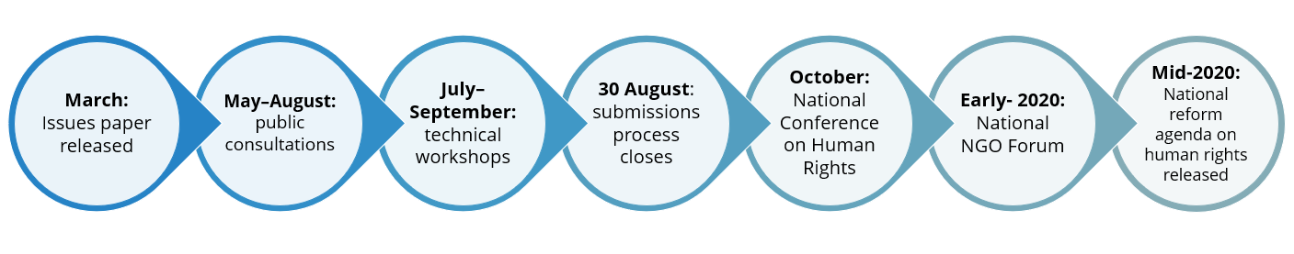

How can you be involved?
We want to hear your vision for the future. We want to hear the views of people from all walks of life so that our human rights protections can genuinely promote equality for everyone.
We want to hear about what human rights matter to you and how respect for human rights can make our lives better and our communities stronger.
We want to hear your ideas for the actions that should be taken by government, business and across the community to achieve this.
Any issue can be raised during the process.
A major focus of our consideration will be the legal and policy framework for respecting, protecting and fulfilling human rights. In other words, we want your views on who has a responsibility to respect human rights and what should happen if someone’s human rights are not respected.

Section 2: Understanding human rights in Australia

What are human rights?
Human rights reflect basic values such as dignity, freedom and equality.
We are all born with human rights, regardless of where we are born, our gender, race, socio-economic background or other characteristic.
Human rights have been recognised through law and practice over many centuries. In modern times, the governments of the world have agreed to a set of common standards for human rights through the ‘international Bill of Rights’, which comprises three documents:
- The Universal Declaration of Human Rights: finalised in 1948, it remains the most important international statement of the fundamental values of equality, dignity and freedom. Australia was one of 8 countries that led the drafting of the Universal Declaration.
- The International Covenant on Economic, Social and Cultural Rights (ICESCR) which Australia agreed to in 1975
- The International Covenant on Civil and Political Rights (ICCPR) which Australia agreed to in 1980.
These documents were developed as a response to the horrors of the two world wars, in order ‘to reaffirm faith in fundamental human rights, in the dignity and worth of the human person, in the equal rights of men and women and of nations large and small’.
The below graphic provides an overview of the human rights identified in the International Bill of Rights.
Figure 1: Key human rights
Guiding Principles
Equality before the law |  |  | Right to self determination
Right not to be discriminated against |  |  | Protection of the family as the fundamental unit of society
Equal treatment of men and women |  |  | Rights of children to special protection

Civil and political rights
Right to life |  |  | Freedom of movement and liberty
Abolition of the death penalty | 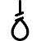 |  | Right to asylum
Right not to be held in slavery or servitude |  |  | Right to a nationality
Right to be free from torture and other cruel or degrading treatment |  |  | Right to marriage
Freedom from arbitrary arrest and detention |  |  | Right to property
Right to a fair trial |  |  | Freedom of thought, conscience and religion and to express them peacefully
Right to be treated with humanity and dignity when imprisoned |  |  | Freedom of opinion and expression
Innocent until proven guilty |  |  | Right to freedom of peaceful assembly, and to association with others (eg unions)
Right to legal assistance and an interpreter in court |  |  | Right to take part in public affairs, and to vote
Right to privacy |  |  | Right of minorities to enjoy their own culture, religion and languages
Criminal laws not to be applied retrospectively
Economic, social and cultural rights
Right to social security |  |  | Right to education
Right to work and to good working conditions |  |  | Right to participate in your community’s cultural life
Equal pay for equal work |  |  | Right to maternity leave
Right to form and join unions |  |  | Right to physical and mental health
Right to rest and leisure |  |  | Moral and intellectual property rights
Right to adequate standard of living including food, clothing, housing, medical care and social services
Some human rights are absolute. For example, the right to life and freedom from torture cannot be breached in any circumstances.
However, the reality is that sometimes human rights will be in conflict. Human rights law includes guidance on how different rights are to be balanced against each other when they conflict—for example, one person’s right to free speech might need to be balanced against another person’s right to be free from discrimination or violence.

Who is responsible for advancing human rights in Australia?
As the Australian Government signs human rights treaties on behalf of Australia, it is the Australian Government that has responsibility for protecting and promoting human rights in Australia.
This includes an obligation to ensure that all governments in Australia (federal, state and territory) respect human rights.
However, governments are not solely responsible for advancing human rights—it is a responsibility across society.

The Universal Declaration of Human Rights states that:
- everyone has duties to the community, and
- every individual and every organ of society… shall strive by teaching and education to promote respect for… rights and freedoms.
This means that not only the government, but also businesses, community organisations, providers of education, health, employment and other social services, police and law enforcement agencies, civil society, and individuals share the responsibility of promoting and respecting human rights.

When exercising our own rights, we have a responsibility to respect the rights of others. Human rights are about creating and maintaining an environment of mutual respect and understanding, so that everyone can participate. This is what true equality means.

What obligations do governments in Australia have to protect human rights?
For the Australian Government, agreeing that all people in Australia will be provided with the protections of human rights treaties creates legal commitments. Governments are obliged to respect, protect and fulfil human rights.
The obligation to respect human rights requires that governments, through their own actions, do not breach human rights.
The obligation to protect human rights requires governments to take actions to prevent others from breaching human rights. Where a person's rights have been breached, the obligation to protect also requires governments to ensure accessible and effective remedies are available to that person.
The obligation to fulfil human rights requires governments to take positive actions to fully realise the equal enjoyment of human rights.
In relation to economic, social and cultural rights, it is also acknowledged that full protection of human rights takes time:

- The progressive realisation principle requires that governments take all necessary steps, to the maximum of available resources, to address human rights concerns.
- This requires governments to justify that they are prioritising key human rights issues and are positively improving outcomes over time, at the greatest rate of progress that is achievable.
- Under this principle, a government can breach human rights by inaction, or failing to take action.

Figure 2: Government obligations to advance human rights
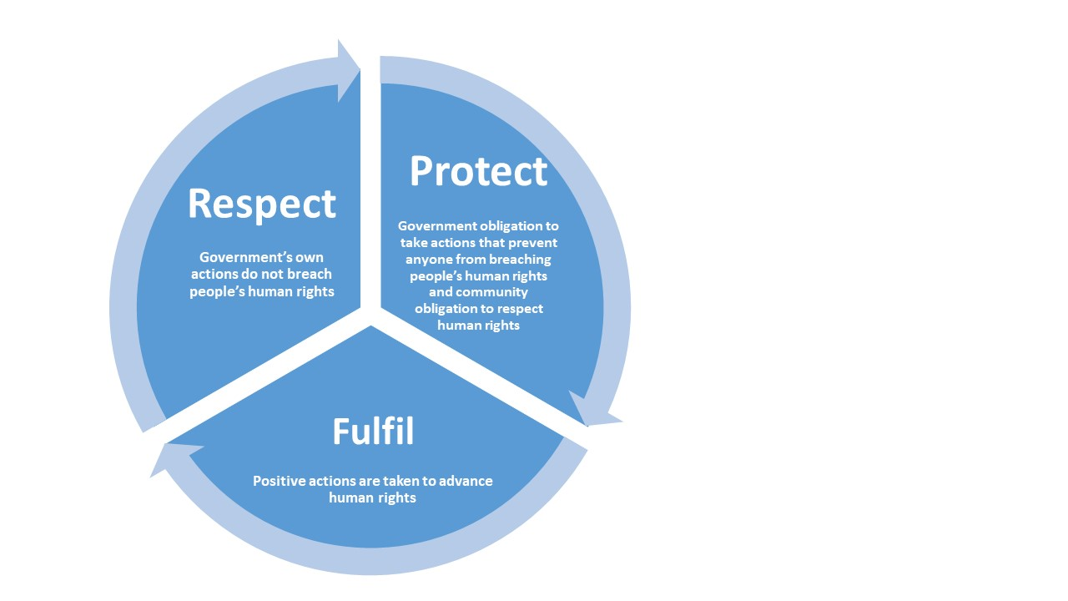
These different obligations reflect that there is no one single action that can fully protect human rights or remedy a breach of human rights. It requires a mixture of actions ranging from legal protections, complaint and compensatory processes, educative measures, community based programs and social services, for example.
Because human rights aim to protect people’s essential dignity and ensure fairness of treatment, it is especially important to ensure that there is a strong focus on prevention of breaches of human rights from occurring in the first place. Where a human rights breach has occurred, the law is limited in what it can do to remedy that breach, as it is very difficult to repair injury to a person’s dignity once it has been damaged.
The table below provides examples of the types of measures that can be taken by governments to respect, protect and fulfil human rights.
Figure 3: Government measures to respect, protect and fulfil human rights
Obligation of government | Actions to meet obligations
Respect: Own actions do not breach human rights | - Human rights are protected in Australian law and remedies are provided for breaches when they occur  - Consideration is given to the human rights impact of laws, policy and practice  - Mechanisms exist to enable the participation of affected groups in law and policy making  - The gender and child’s rights impact of laws and policy is understood
Protect: Action taken by government to prevent others from breaching human rights and obligations on people and institutions across the community to respect human rights | - Laws prevent discrimination and provide remedies for breaches  - Business obligations to respect and protect human rights (eg human rights due diligence to identify, prevent and account for human rights risks and impacts,)  - Human rights education initiatives build awareness of rights and responsibilities in the community  - Partnerships between government, business and community sectors to protect human rights
Fulfil: Positive actions taken to advance human rights | - Programs exist that provide access to basic social services (eg health care; free education for children, and income support)  - Targeted programs exist to address known inequalities (eg Close the Gap; National frameworks on family violence, child protection National Disability Insurance Scheme etc)  - Proactive planning and measurement frameworks address priority human rights issues (eg national action plan on human rights; national implementation mechanism for Sustainable Development Goals)  - Access to justice measures support people to know and protect their rights (legal assistance; advisory services)

What is a human rights based approach?
As the respect — protect — fulfil model illustrates, human rights have an important contribution to make across all areas of law, policy and practice.
Building human rights into all aspects of policy and decision making is often referred to as adopting a human rights based approach. This is forward looking and assists in envisioning what a positive future for all Australians looks like.
Some key features of a human rights based approach include that it:
- Ensures transparency in government decision making: with government considering the impact of their decisions on people’s human rights, and where this involves breaching those rights, in explaining why this is necessary and what remedies will be made available.
- Ensures accountability of government: by putting into place measurements to track progress in achieving human rights.
- Requires participatory approaches: so that the voices of people affected by government actions are heard and contribute to identifying solutions.
- Ensures that all approaches to public policy and law are non-discriminatory: so that all government actions treat people equally, while also taking into account the specific needs of people who are disadvantaged.
- Promotes a forward looking approach: by aspiring to achieve human rights to their maximum, governments are required to think about the future that they are looking to foster for the community
- Builds the capacity across the community to deliver human rights: and supports community driven action.
The challenge we currently face is to ensure a human rights based approach is adopted by government to provide vision and leadership on the type of Australia that we want to be in the 21st century, and for our children’s children.
The United Nations High Commissioner for Human Rights, Dr Michelle Bachelet, recently described this challenge in addressing the global challenge of inequality as follows:
Inequalities threaten our opportunity to achieve sustainable, inclusive development. Inequalities stir grievances and unrest; fuel hatred, violence, and threats to peace; and force people to leave their homes and countries. Inequalities undermine social progress, and economic and political stability.
But human rights build hope. They bind humanity together with shared principles and a better future, in sharp contrast to the divisive, destructive forces of repression, exploitation, scapegoating, discrimination – and inequalities.
By taking steps to advance civil, cultural, economic, political and social rights as mutually reinforcing, (we) can count on building a strong basis for sustainable development and social harmony.
Example: A human rights based approach to health equality

For many years, successive Australian governments have committed to overcoming Aboriginal and Torres Strait Islander disadvantage. In 2005, the then Social Justice Commissioner developed a human rights based approach to achieving this, highlighting a major flaw in the way health services were designed for Aboriginal and Torres Strait Islander peoples: they were reactive, with services designed to address ill health rather than being proactive and designed to promote good health.

The Commissioner noted that 20+ years of commitments to overcoming disadvantage had achieved limited gains as there was an absence of specific targets and goals to be achieved over a short, medium and long term period. Funding and policies were also not designed to achieve progress by reducing the existing inequalities experienced by Aboriginal and Torres Strait Islander peoples.

The ‘Close the Gap’ process that resulted from this has achieved some significant improvements in health outcomes for Aboriginal and Torres Strait Islander peoples, although many challenges remain and critical targets are still unmet. The simple message, however, is that it is difficult to reach a desired end goal (in this case health inequality) if there are not planned steps for how to achieve it.

The voice of children in Australia: what do they see as key human rights issues for their future?
As we consider what makes an effective human rights system for 21st century Australia, it is important for us to consider the views of those who will be most affected by this: our children.
In 2018, the National Children’s Commissioner conducted a national poll of children about their rights. This was to inform her views about Australia’s progress under the Convention on the Rights of the Child. 22,700 children participated in the national poll, with 500 children participating in workshops nationally. Children identified the following human rights issues and concerns.

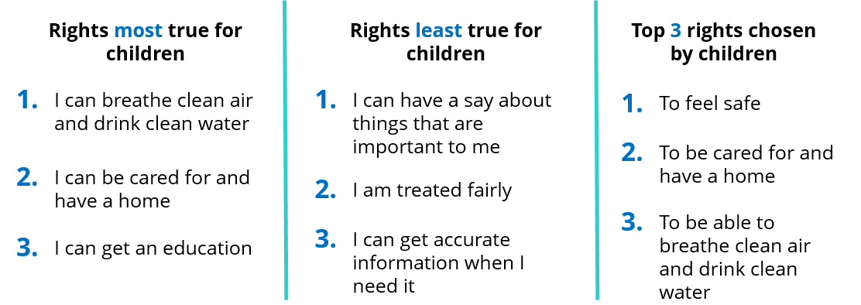

Survey results indicated that Aboriginal and Torres Strait Islander children as well as children from culturally and linguistically diverse communities were over-represented in response rates to the question about the rights that were ‘least true’ for them.

Do you think all children have these rights?

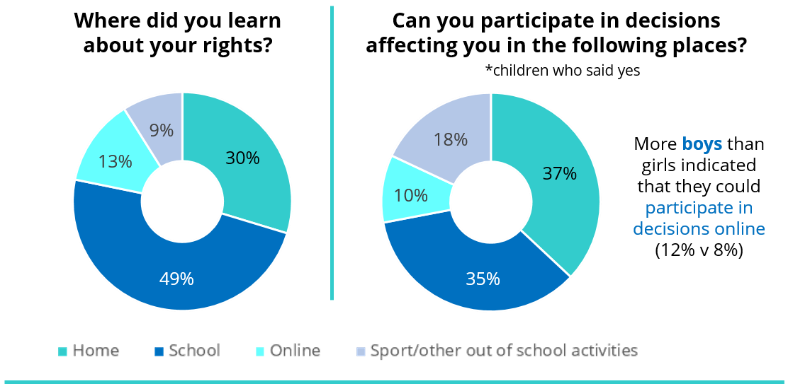

Do you think Australia does enough to help children?

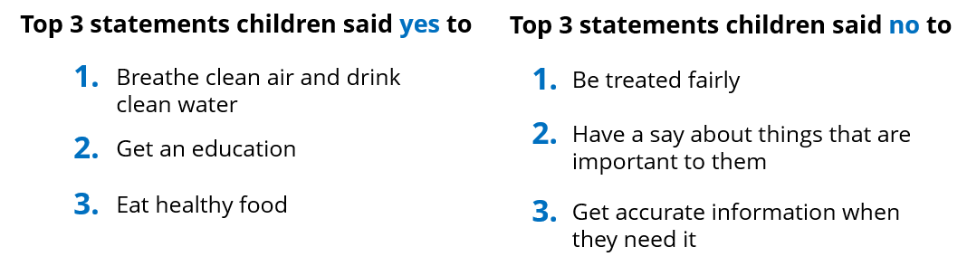

Australia will appear before the UN Committee on the Rights of the Child in September 2019, which will provide further views on the priorities for progressing the rights of children over the coming years.

Section 3: What makes an effective system of human rights protection for 21st century Australia?

How well do we protect and fulfil human rights in Australia?
Our starting point is to acknowledge that Australia is a peaceful, stable democratic country with a relatively high standard of living. We do not face many of the severe human rights challenges that exist in other parts of the world.
We are also a culturally diverse nation, with a rich history of multiculturalism and an enduring commitment to this. We do, however, continue to have unfinished business with our First Nations peoples—Aboriginal and Torres Strait Islanders—who have not equally enjoyed the social and economic benefits of the country.
In terms of economic, social and cultural rights, the OECD’s Better Life Index ranks Australia high on many well-being measures relative to other countries.
While the country as a whole ranks highly, there are significant inequalities in the enjoyment of economic benefits. It is reported, for example, that there is a considerable gap between the richest and poorest – the top 20% of the population earn more than five times as much as the bottom 20%.
While Australia ranks 6th out of the 38 members of the OECD for household income, we also rank 21st for social inequality, indicating that there is a wide gap in social conditions experienced based on economic or social status.
There are pronounced disparities in access to services between urban, regional and remote areas, and there are certain groups in our community (such as Aboriginal and Torres Strait Islander peoples) who experience worse outcomes across many socio-economic indicators.
Economic, social and cultural rights (such as housing, education and health) are most usually implemented through policy or services. Legislation that underpins these, such as for Medicare, includes a guarantee of equal access for all Australians.
In terms of civil and political rights, most Australians would be surprised to learn that there are very few legal protections in Australia. The Australian Constitution protects:
  - the right to vote
  - the right to trial by jury for some offences
  - a limited protection of freedom of religion; and
  - an implied right of political communication.
Victoria, Queensland and the Australian Capital Territory have Human Rights Acts that require the governments in those places to act consistently with human rights and to fully consider human rights in law, policy and practice. No such law exists at the federal level. Reports of the Joint Parliamentary Committee on Human Rights in the federal Parliament indicate that, since 2011, human rights are routinely impinged upon through legislation with little reflection and discussion about the ramifications of this, or the necessity of it.
Federal and state laws make discrimination on certain grounds unlawful. Due to the absence of broader human rights protections federally, there is an over-reliance on discrimination laws to protect human rights.
These laws require an individual who has been discriminated against to bring an action. While systemic outcomes such as changes to policy and practice are often achieved through complaints being made, it is a dispute-focused model that is remedial rather than proactive. Our discrimination laws are also complex, do not protect everyone in our community. They also provide overly broad exemptions for some forms of discrimination.
A range of other laws offer some protection of specific rights, for example laws about evidence and procedure in court cases, or laws about child protection. Some protections have been developed in cases decided by the courts, such as the right to a fair trial. There are also laws that provide limited protection of information privacy at the federal, state and territory levels.
Compared to the human rights standards that Australia has agreed to internationally, there are gaps in protection under Australian laws. For example:
- The federal Parliament can make laws that breach human rights—there is a process to ensure that the human rights impact of laws is fully considered, although there are limitations in the current approach.
- Apart from matters brought under the discrimination laws, our courts are limited in their ability to consider human rights—for example, if parliament has clearly expressed its intention to breach human rights through legislation then the courts have very limited ability to interpret the law in a manner that protects human rights.
- For some human rights not covered by the discrimination laws, people can complain to the Australian Human Rights Commission that their rights have been breached—but if the government does not agree to negotiate an outcome for the person, there is no right to go to court or to get a remedy for having your human rights breached.
- There is an absence of dedicated training and education for public servants about human rights, to assist in understanding the human rights impact of their decisions.
In short, we have an implementation gap between the human rights standards that Australian governments have committed to uphold over many years, and the actual protections in our laws, policies and processes of government.
Without comprehensive legal protection, educational and other measures to promote understanding of human rights and processes for monitoring compliance with human rights, our government is not fully meeting its obligations to make sure that the human rights of all Australians are respected, protected and fulfilled.

Consultation questions
The Commission wants to hear from you about how we can better respect, protect and fulfil human rights in Australia.
The questions set out below are our starting point for the national conversation—we invite your views on how to better protect human rights in Australia by addressing these questions through the public submissions process and face to face consultations.
We will supplement the views received through these processes with technical workshops to obtain greater detail about some more specific aspects of creating a national human rights framework.
We invite your views in response to any or all of the following questions.
- What human rights matter to you?

- How should human rights be protected in Australia?

- What are the barriers to the protection of human rights in Australia?

- How should the Government address the situation where there is a conflict between different people’s rights?

- What should happen if someone’s human rights are not respected?

- What can the community do to protect human rights? How should the government support this?

- How should individuals, businesses, community organisations and others be encouraged and supported to meet their responsibility to respect human rights?

- What should the Australian Human Rights Commission and the government do to educate people about human rights?

- What actions are needed to ensure that the government meets its obligation to fulfil human rights – for example, in addressing longstanding inequalities in the community?

- How should we measure progress in respecting, protecting and fulfilling human rights?

- How should we hold government to account for its actions in protecting human rights?

- Are there other issues on which you wish to comment?
The Commission intends to identify a reform agenda for the protection of human rights in Australia. This will be informed by what we hear during this national conversation.
Some of the outcomes that we think this reform agenda should contribute to are that:
- the community understands human rights and is able to protect them (for themselves and others)
- communities are resilient and a protective factor against human rights violations
- law and policy makers explicitly consider the impact on human rights of their decisions and are accountable for this impact
- robust institutions exist to promote and protect human rights
- government and the community work together to fully realise human rights—understanding the respective role of each other
- public servants, and contracted service providers, see the protection of human rights as core business in exercising their functions
- the key priorities for human rights protection among the Australian community are understood and acted upon.

How can I contribute my views?
To lodge a submission, please visit the Commission’s ‘Join the Conversation’ webpage.
From the Commission’s website, you can also get information about consultations that we are holding nationally.
You can subscribe to our news service to get information about the progress of the national conversation as we go, or contact us through the details provided on our website.
You can also contribute to the Commission’s work on other projects. As part of the national conversation, the Commission will also be fully considering and integrating the outcomes of the project and advocacy work led by our commissioners. For example:
- The Aboriginal and Torres Strait Islander Social Justice Commissioner’s Wiyi Yani U Thangani (Women's Voices) project is documenting the experiences of Aboriginal and Torres Strait Islander women and girls.

- The Sex Discrimination Commissioner’s National Inquiry into Sexual harassment in the Workplace is considering options for addressing sexual harassment, including law reform.

- The National Children’s Commissioner is participating in the UN Committee on the Rights of the Child’s review of Australia’s performance in implementing the Convention on the Rights of the Child, which will identify options for reform to law, policy and practice to promote the rights of children

- The Disability Discrimination Commissioner is similarly participating in the review of Australia’s performance in implementing the Convention on the Rights of Persons with Disabilities by the UN Committee on the Rights of Persons with Disabilities.’

- The Human Rights Commissioner is conducting a major project considering the human rights implication of new technologies, such as artificial intelligence. This project is considering the necessary legal and other safeguards to protect people’s human rights in a changing world.

- The Race Discrimination Commissioner is engaging with culturally and linguistically diverse communities and the wider community about their experiences of multiculturalism, social inclusion and racism, which will identify options for building community awareness of human rights and supporting communities to protect human rights.

- The Age Discrimination Commissioner is identifying options to address elder abuse and to improve employment of older Australians.

Please join us in this conversation about the Australia you want to live in, for yourself, for your children, and your children’s children.

Rosalind Croucher

Endnotes

The project has formal terms of reference that are available online at: https://www.humanrights.gov.au/our-work/rights-and-freedoms/projects/free-and-equal-dignity-and-rights-national-conversation-human.
The outcomes of this reform agenda will also inform the Australian Human Rights Commission’s engagement in the United Nations Universal Periodic Review process in 2020. Australia will appear before the UN Human Rights Council for its review under this process in October or November 2020.
Human rights are written down in international agreements called ‘conventions’, ‘covenants’ and ‘treaties’. They reflect international agreement among the governments of the world about what human rights are, and how they should be protected and promoted. In addition to the ICCPR and ICESCR, Australia has signed up to other international human rights agreements that specify how human rights apply to certain groups of people or in particular situations. These include: - Convention on the Rights of the Child, agreed to by Australia in 1990 - Convention on the Elimination of All Forms of Discrimination against Women, agreed to by Australia in 1983 - International Convention on the Elimination of All Forms of Racial Discrimination, agreed to by Australia in 1975 - Convention on the Rights of Persons with Disabilities, agreed to by Australia in 2008 - Convention against Torture and Other Cruel, Inhuman or Degrading Treatment or Punishment, agreed to by Australia in 1989 - International Labour Organisation Discrimination (Employment and Occupation) Convention ILO 111 (which prohibits discrimination in employment), agreed to by Australia in 1973.
Preamble, Charter of the United Nations, 1945.
This list is a summary of the text of the ICCPR and ICESCR treaties. For the full coverage of these rights, please see the text of the treaties.
It is clearly understood that the internal governance arrangements within countries (such as states and territories) are not an excuse for failing to protect human rights. See for example Article 27 of the Vienna Convention on the Law of Treaties.
Most commonly a human rights based approach is described using the PANEL principles: Participation, Accountability, Non-Discrimination, Empowerment and Legality. See further: https://www.humanrights.gov.au/human-rights-based-approaches.
UN High Commissioner for Human Rights (Bachelet, M), Address – 40th session Human Rights Council, 6 March 2019, Online at: https://www.ohchr.org/EN/NewsEvents/Pages/DisplayNews.aspx?NewsID=24265&LangID=E
The survey ran in July 2018, and was conducted by the National Children’s Commissioner in partnership with the University of Melbourne. The survey was conducted through ABC TV’s Behind the News program.
The Commission has made extensive submissions to the Committee setting out the priority areas for action from the perspective of the National Children’s Commissioner. See further: https://www.humanrights.gov.au/our-work/childrens-rights/projects/reporting-united-nations-childrens-rights.
OECD Better Life Index, Available online at: http://www.oecdbetterlifeindex.org/countries/australia/.
OECD Better Life Index, Available online at: http://www.oecdbetterlifeindex.org/countries/australia/.
See for example the Annual Reports of the Committee, which reflect on this issue. Available online at: https://www.aph.gov.au/Parliamentary_Business/Committees/Joint/Human_Rights/Scrutiny_reports/Annual_Reports/Annual_Report_2018.

