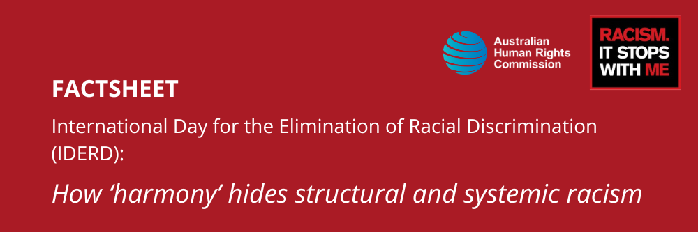

Key details
21 March marks the International Day for the Elimination of Racial Discrimination (IDERD), sometimes known as ‘Harmony Day’ in Australia. However, hiding the true meaning of this day under a mask of ‘harmony’ actively harms our collective anti-racism journey by obscuring structural and systemic racism. This fact sheet explains why.

International history of IDERD
On 21 March 1960, police in Sharpeville, South Africa opened fire on peaceful anti-apartheid demonstrators protesting in response to the Pass Laws Act of 1952. The laws required Black South Africans over the age of 16 to carry a ‘passbook’ – a kind of internal passport known as ‘dompas’ designed to enforce segregation and restrict movement – at all times. A Black South African who forgot to carry the dompas could face arrest and imprisonment. The Pass Law worked in conjunction with other apartheid legislation, working to enforce systemic race-based oppression in South Africa.
On this day, huge numbers of protestors in Sharpeville turned up to the police station without their dompas, exercising their human rights such as the right to non-discrimination based on race and freedom of movement. The planned peaceful protest turned to tragedy when police opened fire on the 7000-person strong crowd, killing 69 people and wounding 180 others.
19 years later, the United Nations (UN) General Assembly resolved that a week of solidarity with peoples struggling against racism and racial discrimination, beginning on 21 March and coined IDERD, would be held annually.
Since then, the international community has built a framework for fighting racism, guided by the International Convention on the Elimination of Racial Discrimination, which Australia ratified in 1975. This led to Australia’s first law actively addressing racial discrimination, the Racial Discrimination Act 1975 (Cth).
Yet still, around the globe – Australia included – too many individuals, communities and societies suffer from the injustice and stigma of both structural and systemic racism.
IDERD remains a powerful vehicle to encourage people everywhere to strengthen and consolidate their voices against racism, to mobilise against all forms and manifestations of racial discrimination and injustice, and to strategise for change.

Creation of ‘Harmony Day’ in Australia
In 1998, the Department of Immigration and Citizenship commissioned Eureka Strategic Research to conduct the first national survey on Australian attitudes about race.
This led to a report which recommended that the Government build the belief that Australian society was fundamentally harmonious and that this harmony should be a cause for celebration.
From 1999 Australia rebranded IDERD from a day of solidarity with people struggling with racial discrimination, to a day for celebration and the focal point of ‘Harmony Week.’
With this framing, the systemic racial discrimination experienced by so many, for so long in Australia was effectively swept under the rug. This move has contributed significantly to the denial of racism that continues to characterise Australia today.

The problem with Harmony Day
The promotion of harmony has characterised policy and politics in Australia over recent decades. While the idea of ‘harmony’ can be a positive message, one of the problems with this approach overtaking IDERD is that it may discourage people from speaking up about racism because it can be seen as opposing a harmonious Australian society.
Calling this commemoration ‘Harmony Day/Week’ causes harm to our collective anti-racism journey, by undermining efforts to identify and address the harm experienced by communities because of racism.
IDERD is an opportunity to meaningfully acknowledge Australia’s deep-seated issues with race and racism, question the various ways racism shapes our society, and redouble our commitment to anti-racism. Only then can we start to build a society that is truly fair and equal, and that recognises the fundamental rights and freedoms of all.

Suggestions for engaging in meaningful anti-racism around IDERD
‘Harmony Week’ is an example of the way language can be used to reframe anti-racism. The language of harmony can operate to reinforce inequality and maintain the status quo.
We all have a responsibility to call racism out, and to interrogate the various ways it operates.
No matter where you are in your individual anti-racism journey, the Racism. It Stops With Me website is a place to learn more about racism and take action to create change.
We’ve also put together this list of suggested readings about the history of Harmony Day and the original intention of IDERD – acknowledging the reality and harms of racism and strategising for change.
- Harmony Day should not be used to sweep racism under the rug by Queensland Human Rights Commissioner, Scott McDougall in the Sydney Morning Herald
- The Strange History of Harmony Day and Australia’s Racism Discussion by Yan Zhuang in the New York Times
- It’s Harmony Week, but let’s discuss what it is really about: racism by Erwin Renaldi in the ABC
- Racism at work: a call to anti-racist action for Australian organisations by Peter Anderson in The Conversation

