All my friends and me
Lesson Plan 3

Stage: Preschool
Year Group: 3-6 years old
Reader notes: Words in bold italics are vocabulary focus areas.
Further resources to support this lesson are available at the Australian Human Rights Commission’s ‘Building Belonging’ website

Intentional Teaching:
This activity gives children the chance to explore their differences and similarities in a small group environment. They will explore how being different to other people does not mean that you cannot be friends, instead it gives you the chance to learn new things.

Aims and Objectives:
- Openly express feelings and ideas
- Feel recognised and respected for who they are
- Display awareness of and respect for others’ perspectives
- Become aware of connections, similarities and differences between people
- Listen to others’ ideas and respect different ways of being and doing
- Notice and react in positive ways to similarities and differences amongst people
- Begin to think critically about fair and unfair behaviour
- Demonstrate trust and confidence
- Show curiosity and be enthusiastic participants in their learning
- Contribute ideas and experiences in small group discussions
- View and listen to printed, visual and multimedia texts and respond with relevant gestures, actions, comments and questions
EYLF Learning Outcomes:
Outcome 1: Children have a strong sense of identity  1.1. Children feel safe, secure and supported  1.3. Children develop knowledgeable and confident self identities  1.4. Children learn to interact in relation to others with care, empathy and respect  Outcome 2: Children are connected with and contribute to their world  2.2. Children respond to diversity with respect  2.3. Children become aware of fairness | Outcome 4: Children are confident and involved learners  4.1. Children develop dispositions for learning such as curiosity, cooperation, confidence, creativity, commitment, enthusiasm, persistence, imagination and reflexivity  Outcome 5: Children are effective communicators  5.1. Children interact verbally and non-verbally with others for a range of purposes  5.2. Children engage with a range of texts and gain meaning from these texts

Australian Curriculum Learning Outcomes:
English: Language
ACELA1426 Understand that English is one of many languages spoken in Australia and that different languages may be spoken by family, classmates and community

English: Literature
ACELT1783 Share feelings and thoughts about the events and characters in texts

English: Literature
ACELT1579 Replicate the rhythms and sound patterns in stories, rhymes, songs and poems from a range of cultures

Humanities and Social Sciences: History
ACHASSK011 Who the people in their family are, where they were born and how they are related to each other

Health and Physical Activity: Personal, Social and Community Health
ACPPS001 Identify personal strengths

Key vocabulary:
Different, same, similar, common, fair, unfair, likes, dislikes, special, discover, friends.

Resources:
‘All My Friends and Me’ e-book (displayed on a computer or smart device, or printed onto paper)
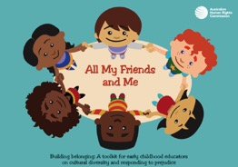
Click here to read the e-book.

Accompanying resource
‘Tell Me About You’ die (provided at the end of this lesson plan)

‘Colours of Australia’ song, poster and song action sheet
Click on this link for the song, poster and action sheet.

Accompanying resource
Story stone characters (provided at the end of this lesson plan)

Introductory Phase:
- Explain to the children that you are going to share a special story with them and ask them some questions about it afterwards, so they should listen carefully.
- Read the e-book ‘All My Friends and Me’ to the children, then discuss what happened in the story.
- From the options listed below, read out some of the questions and ask children to raise their hands or organise themselves into groups based on their answers:
- Who thinks they are tall; who thinks they are small?
- Who has straight hair; who has curly hair; who has another type of hair?
- Who has brown/blue/grey/green eyes?
- Ask children if they think that looking different or not having the same coloured hair, skin or eyes means they can’t be friends with someone?

Main Activity:
- Ask children to sit in a circle. Produce the ‘Tell Me About You’ die (provided at the end of this lesson plan). Explain that this activity will give the children a chance to get to know their friends better and to discover new things about each other.
- Explain how each child will roll the die in turn, and answer the question that the die lands on. Demonstrate how to roll the die within the circle and how you will ask a question that matches the picture. The questions connected to each picture on the die are provided in the key below.
- Play the game, ensuring each child has at least one roll of the die each. Ask additional questions as they arise and give all children a chance to respond.
- Are they surprised by anything they learnt about their friends during the activity? Do they think that liking different things means you can’t be friends with someone? How can liking different things actually make your friendship more interesting and special?

Educator Note
If children answer ‘yes’ to these questions, reiterate that everyone is special and unique. Our friends don’t need to like exactly the same things as us or look the same as us, we still have things in common (like Pax and her friends in the story).
See other suggested responses to children’s comments and questions about diversity in the ‘Responding to comments and questions about Cultural Diversity and Racial Identity’ information sheet.

Key for the die:

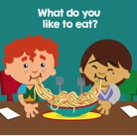 What do you like to eat?

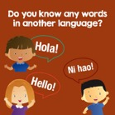 Do you know any words in another language?

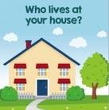 Who lives at your house?

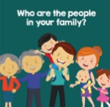 Who are the people in your family?

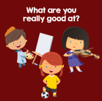 What are you really good at?

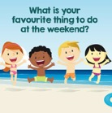 What is your favourite thing to do at the weekend?

Closing Phase:
- Ask children to think of one new thing they have discovered about one of their friends today and why that makes their friend special. Hear a few examples and discuss.
- Reiterate the key messages from the story: we all have things about us that make us similar to other people and things that make us different. These things make us who we are, we are all different and special, but have many things in common.
- Tell children that you have a song to teach them that is all about people being different but having things in common, and you’d like them to sing along and join in with the actions. The actions to go with the song are shown on the ‘Colours of Australia’ song action sheet and the ‘Colours of Australia’ poster.
- Go through the ‘Colours of Australia’ song, verse by verse, and ask children to repeat the lyrics and actions to you. Sing the song together.

Questions for Sustained Shared Thinking:
Prompts for shared conversations, which can be extended and developed:
- I wonder what would happen if you didn’t like tomatoes today, but next week you ate a tomato and really liked it? Do you sometimes change your mind about things?
- How do you think people feel when their friends don’t let them play? Has this ever happened to you? How did you feel?
- Why do some people not like the same things and why is this okay?
- How do you know if you like something or not?
- Do you think it is important to have friends who like different things to you? Why, why not?
- Do you think it is important to be friends only with people who look like you? Why, why not?

Opportunities for further enhancements in the learning environment:

Sensory Play | Offer a variety of objects from a range of cultures to stimulate children’s senses. For example; a bowl of noodles, a small jar of ground coffee, a decorative paper fan, a pashmina, a book with photographs of children from different backgrounds etc.  Children can explore items together and discuss aspects they like and dislike with their peers. This is an opportunity for educators to reiterate that we do not always have to like the same things as our friends, and to foster cultural awareness in children.  Educator Note  Ask families to provide items from their own houses so children can experience peer learning
Creative Play | Accompanying resource  Take photographs of each child in the setting (head and shoulders) and print in black and white. Add these images to the creative area and provide a variety of tools for children to decorate their own images.  For example; children may colour their lips brown and change their eye colour from green to blue. This allows children to see themselves in a different way - with different coloured hair, skin, eyes, lips, clothes, etc. The colours do not have to represent realistic shades; this activity is aimed at allowing children complete control over how they want to change their appearance and provides an opportunity for them to see themselves in many different hues.
Dramatic Play | Using the accompanying story stone cut-outs (found at the end of this lesson plan), stick the characters onto stones and display alongside books about families and friendship.  Children can create their own narratives using the characters from a variety of cultural backgrounds. Extend this activity by printing photographs of the children in your setting and adding them as characters on story stones.
Explanatory Play | Provide small ink pads/finger paints, small cards and magnifying glasses. Children can print their fingerprint onto the card and use magnifying glasses to explore the similarities and differences between their own fingerprints and those of their friends.  This can be extended into a creative activity by providing a large piece of paper with the outline of a tree. Children add their fingerprints as leaves on the tree. The tree could be visible in the setting as part of a display. Write each child’s name next to their fingerprint and create a visual reminder of the beauty that the different fingerprint leaves bring to the tree. All of the leaves are different, but they are each very important in making the tree strong and full.

Accompanying resource

Die Net
How to use: Print, preferably onto A3 card, and cut out. Fold along the creases and secure together using glue or sticky tape.
Roll the die and use the key in the lesson plan (page 4) to ask the children questions.

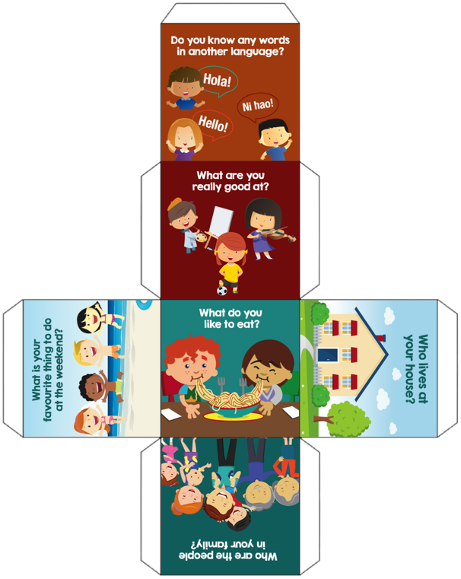
Accompanying resource

Story stone characters
How to use: Print and cut out. Stick them to stones so that children can use them to make up their own stories using the characters.
The characters could also be printed, laminated and stuck to paddle pop sticks.

