
Reliquaire
14 Hamilton St
Latrobe TAS
Australia 7307

Ph. +61 3 6426 2599
Email: shop@reliquaire.com
Web: www.reliquaire.com
ABN: 35714366155
Australian Human Rights Commission
GPO Box 5218
Sydney
NSW 2001

By email to disability@humanrights.gov.au

2 May 2016

Dear Madam/Sir

I am writing to submit a Building Upgrade Plan (Action Plan) under section 64 of the Disability Discrimination Act 1992 in relation to retail premises operating as Reliquaire, Latrobe, Tasmania.

Background
Reliquaire is renowned for its eclectic collection of dolls, teddies, jewelry, soaps & candles, handbags & clothing, Venetian masks, cookbooks, puppets, games, science & education, Tasmanian produce, homemade fudge, leadlight lamps, bronze statues, restoration supplies and antique furniture.

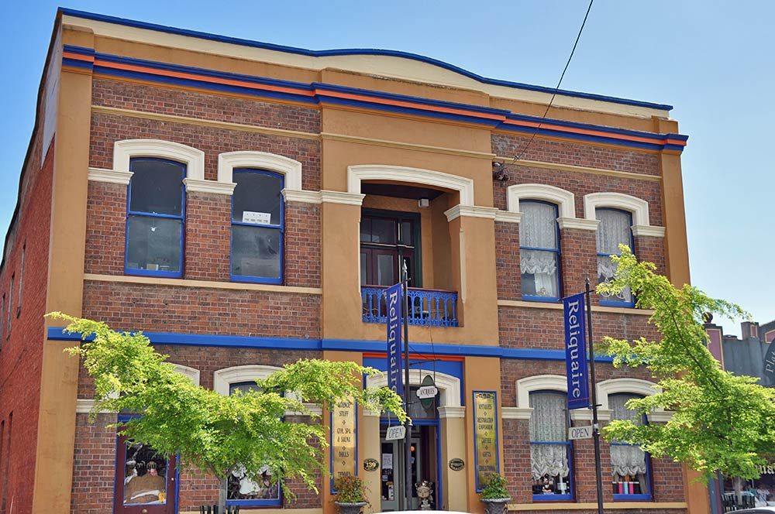
Photo 1 shows the original Reliquaire

Sadly on Christmas Eve 2015 a fire destroyed the entire building and everything inside.

We intend to build a new Reliquaire and in the meantime have been operating a pop-up shop and online ordering service.

In order to ensure the visibility of the business while awaiting the finalization of an insurance claim we have sought a temporary occupation permit to operate a scaled down outlet at 14 Hamilton Street, Latrobe. It is important that the business continues with a physical presence for its long-term viability.

The building at 14 Hamilton Street is on the Heritage Register and currently operates as a family home. Its use as a retail business will require approval for a temporary change of use and occupation permit for a limited period of time while work progresses on a new access compliant building.

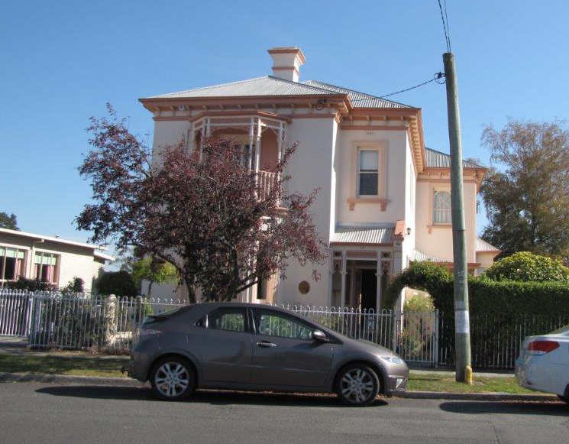
Photo 2 shows the proposed temporary outlet

We note that the Premises Standards at paragraph 4.1(3)(n) envisages that on occasion developing a ‘Building upgrade plan’ would be an appropriate strategy to achieve access compliance over time where arguably immediate compliance was not possible or reasonable.

The Guideline on the application of the Premises Standards at page 43 provides more information on the use of ‘Building upgrade plans’:
Paragraph 4.1(3)(n) of the Premises Standards ensures that action plans will also be relevant to assessing unjustifiable hardship for the purposes of the Premises Standards.
An action plan may take the form of a ‘Building upgrade plan’ that puts forward a plan of action for addressing access issues over a period of time where immediate compliance might affect broader upgrade plans or cause unjustifiable hardship.
For example, a developer might be undertaking some minor upgrade work on a building such as replacing a single loadbearing wall which would require building approval. Such an application would trigger the application of the Premises Standards to the ‘affected part’ of the building. The developer might consider putting forward a ‘Building upgrade plan’ (action plan) proposing a phased implementation of access requirements or a delayed implementation until a major upgrade due to take place in the near future.
A court, if dealing with a complaint in relation to the Premises Standards would consider such a plan in looking at the question of unjustifiable hardship.
A building certifier might also consider such a written plan when assessing an application for building approval or occupancy where specific circumstances might mean that immediate compliance was not possible or reasonable.
Given the temporary use of the building, its heritage status and the technical and cost issues associated with providing access fully compliant with the Premises Standards immediately this Building Upgrade Plan proposes:

- Access arrangements for immediate implementation
- A timeframe for the construction of a new building that complies with the Premises Standards.
This Building Access Upgrade Plan has been established to clearly outline the stages for progressively improved access with the aim of achieving full compliance with the access requirements of the Premises Standard on completion of the new building redevelopment.

Proposed access approach
The following access arrangements will be implemented immediately in relation to the temporary outlet at 14 Hamilton Street, Latrobe.

- An accessible path of travel will be provided from the public footpath across a courtyard and up onto a verandah as agreed with the certifying authority. This entrance will be identified as the principal pedestrian entrance and signage will direct all visitors to the entrance, which, weather permitting, will be open at all times.

- People with mobility disability will be able to circulate around the ground floor level to display rooms off a wide central corridor. Where visitors using mobility aids have difficulty moving into any of the display rooms staff will provide information on items in those rooms and bring any items of interest to the customer.

- There will also be a management approach in place that will give visitors who do not want to, or who cannot, use the stairs access to a portfolio of examples of items on the upper level and staff will bring downstairs any items of interest.

Appendix 1 Building Upgrade Plan (Action Plan) sets out the timeframe for achieving compliant access.

I would be grateful if you could inform me when the Action Plan has been registered.

Yours sincerely,

Sylvia & Kim Christie

Reliquaire
14 Hamilton St
Latrobe TAS 7307

Ph. 03 6426 2599
Mobile. 0419 358 406
Email: shop@reliquaire.com

Appendix 1

Building Upgrade Plan (Action Plan)

Goal: To ensure equitable access to each of the services and facilities provided by the business.

Action | Timeframe | Responsibility
1. Obtain approval for a Temporary Occupation Permit for a period of 2 years subject to meeting the actions set out in this plan. | Within 1 month of the registration of this Action Plan | Owner
2. Implement access arrangements 1, 2 and 3 identified in Proposed access approach | Prior to opening. | Owner
3. Complete construction of compliant new building. | Within 24 months of the registration of this Action Plan. | Owner

Reporting

A report on progress will be provided to the Australian Human Rights Commission 12 months after the registration of this Building Upgrade Plan

https://www.humanrights.gov.au/guidelines-application-premises-standards

