

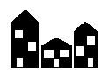
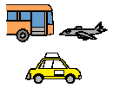

Community Access and
Inclusion Plan 2014-2018

3 Themes
3 Themes

No Steps

Make building easy to get into

Make transport easier to use


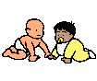


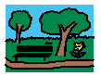

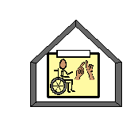
Services

Easier to find
Better to use

Library

Respite care

Children’s Services

Community Halls

Parks


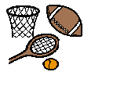
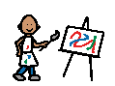

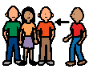
Activities

Be a part of

Sport

Festivals and Events

Art


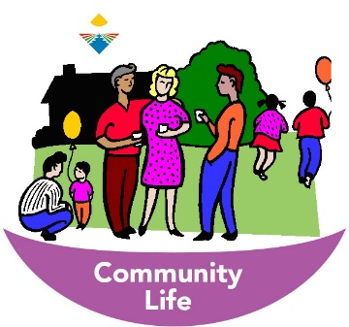
Awareness

Make life better

To be included in community

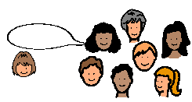
Join Us
The community will want you to join in

Tell the community about people with a disability

