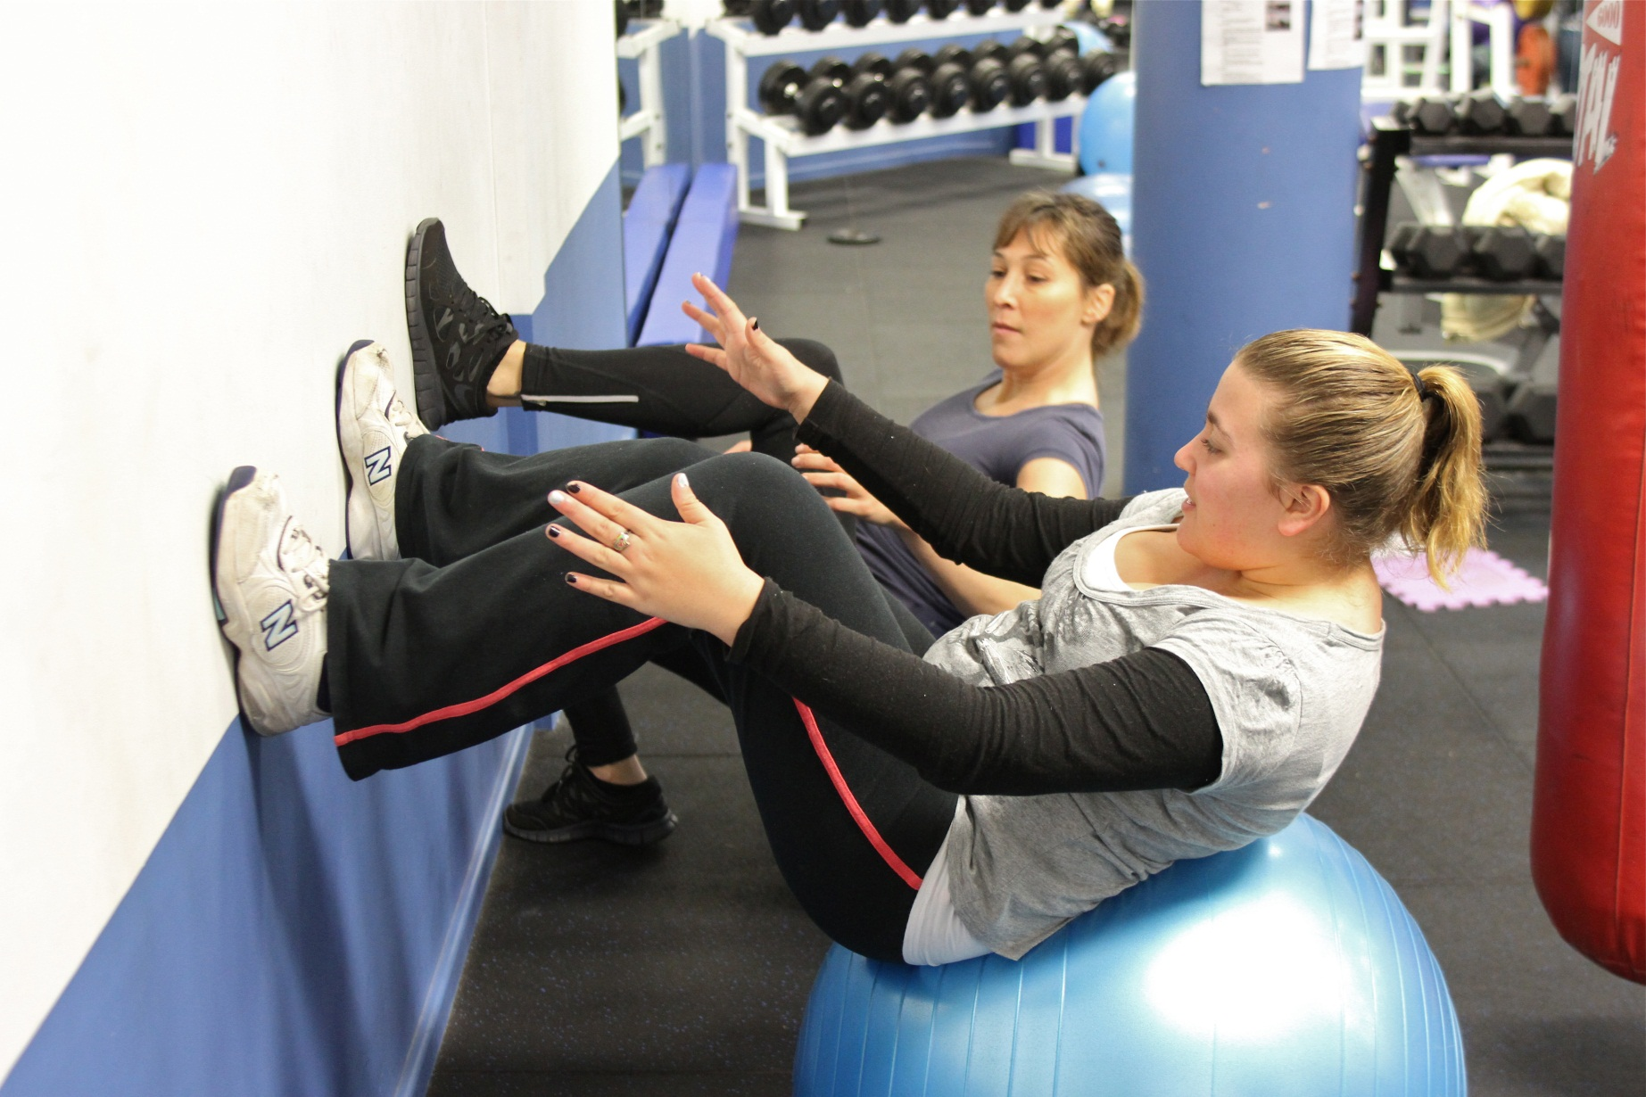
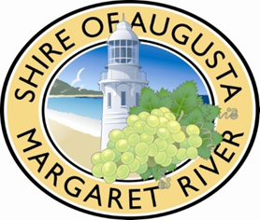
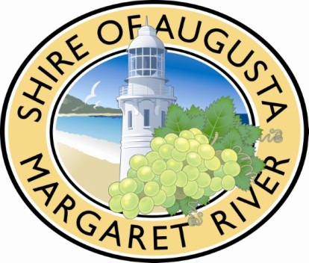
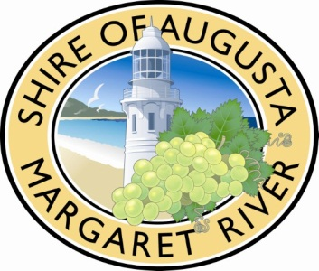

Disability Access and Inclusion Plan
2014-2016
V2 2014

Disability Access and Inclusion Plan
2014-2016
V3 2014

Natural Connected Prosperous

Contents
Chief Executive Officer Message 3
Overview 4
Background 5
The Shire of Augusta Margaret River 5
Role of local government in access and inclusion 7
Community 7
Services 8
Assets 9
People with disability in the Shire of Augusta Margaret River 10
Planning for better access 11
Improvements in the Shire of Augusta Margaret River 12
Development of the DAIP 19
Planning process 19
Engagement process 19
Consultation findings 21
Implementating the DAIP 24
Communication strategy for the DAIP 24
Evaluation and review of the DAIP 24
Review and monitoring 25
Reporting on the DAIP 25
Strategies to improve access and inclusion 2014 -2016 26
Implementation plan 27
Acronyms 37
Related documents 38

Chief Executive Officer Message



When the Shire of Augusta Margaret River produced the Community
Strategic Plan 2013-2033 it recognised the following goals for our future:

 Goal 1: Valuing the natural environment
 Goal 2: Welcoming and inclusive communities
 Goal 3: Managing growth sustainably
Gary Evershed
Chief Executive Officer
 Goal 4: Vibrant and diverse economy
 Goal 5: Effective leadership and governance

An accessible and inclusive community is integral in achieving all of these goals.
Disability Access and Inclusion Plans (DAIPs) are not just about ensuring buildings have wheelchair access, they are also about incorporating inclusion at a participatory and service level. The access and inclusion plan will guide the council in determining strategies and projects that support the achievement of the goals of our community.

Quality services and infrastructure have the capacity to enhance or inhibit the lives of all people, especially those community members and visitors that have disability and diverse needs. They are vital to the social and economic well-being of communities.
It should be noted that access and inclusion issues could be experienced by any member of the community at any time, not just those may not normally identify themselves as having a 'disability'. Pregnant women, mothers with prams, small children, people with a temporary illness or injury, those experiencing various mental health issues, people with low literacy or English language skills, and aged and frail members of the community all experience, from time to time, issues with access and inclusion. An accessible and inclusive community is beneficial to all its members. It is with the view that access and inclusion benefit all community members that the implementation plan and new DAIP has been developed.

Overview

Since 1995, public authorities in Western Australia have been required by the Western Australia Disability Services Act (1993) to have a Disability Services Plan. An amendment to the Act in 2004 brought about a number of changes to this requirement, including a change to the name now titled Disability Access and Inclusion Plan (DAIP).
The Shire of Augusta Margaret River (the Shire) adopted its first Plan in 2001 to address the barriers within the community for people with disability and to meet its statutory requirements. Since that time, the Shire has made significant improvements in access to Shire services, infrastructure, consultation approaches and information provision.
With legislated changes in 2012, the outcomes which dictate the structure of the DAIP include reporting on the following:
- People with disability have the same opportunities as other people to access the services of, and any events organised by the Shire.
- People with disability have the same opportunities as other people to access Shire buildings and other facilities.
- People with disability receive information in a format that will enable them to access the information as readily as other people are able to access it.
- People with disability receive the same level and quality of service from staff.
- People with disability receive the same opportunities as other people to make complaints.
- People with disability have the same opportunities as other people to participate in any public consultation.
- People with disability have the same opportunities as other people regarding employment practices (recruitment and retention).

The Shire has included an eighth outcome relating to review and monitoring:
- The Shire strategically manages the monitoring and review of the access and inclusion plan.

The Disability Access and Inclusion Plan 2014-2016 seeks not only to meet legislative requirements but to strategically address access and inclusion issues to the benefit of all community members making the Shire a people friendly place to live, work and visit.

Background

The Shire of Augusta Margaret River

The Shire of Augusta Margaret River is a rural municipality situated 250 kms from Perth. The Shire has an area of 2,240 square kilometres and an extensive coastline with 120 kilometres of beaches, bays and rocky points.

The Shire’s population of 12,219 (ABS Census ERP data 2011) is dispersed across a network of distinct townships. Margaret River, Augusta and Cowaramup are the major centres in the Shire with other townships consisting of Karridale, Witchcliffe, Kudardup, Rosa Brook, Prevelly/Gnarabup and Gracetown. The population has been increasing at an average annual rate of 1.9% during 2006 to 2011.

Changes in the population, age structure and cultural diversity over time creates challenges in maintaining quality lifestyles for residents and ensuring that adequate infrastructure, facilities and services are available over strategic timeframes.

Margaret River is one of nine regional townships in the southern half of Western Australia to be designated for growth under the Regional Centres Development Plan (SuperTowns) initiative of the Western Australian State Government. The SuperTowns vision is to have balanced communities with lifestyle options, access to adequate infrastructure and services, quality housing and a diverse range of job opportunities.

The provision of social services and facilities is at the cornerstone of satisfied and healthy communities. Investigations through the SuperTowns consultations have found that the Shire is well placed to continue to provide for its communities and promote public participation through a wide range of sporting, social and cultural facilities.

However, the Shire has its challenges in meeting the needs of an ageing demographic while also maintaining and upgrading current assets and services to meet the high level of service expected by residents.

Key projects requiring access and inclusion consideration that have been identified as part of the Southwest Regional and Subregional Infrastructure priorities include:
- Margaret River Town Centre upgrade
- Surfers Point improvements
- Margaret River Cultural and Events Centre redevelopment
- Rails to Trails extension
- Cowaramup Streetscapes upgrade
- Busselton Airport improvements
- Margaret River Industrial area new establishment
- Megafauna Centre at Mammoth Cave
- Augusta Visitor and Whale Interpretive Centre
- Augusta Boat Harbour facilities
- Capes Region Waste Management

Employment of shire residents is dominated by the construction, manufacturing, retail, accommodation and food industries. Education, training, health care, agriculture and administration also employ significant numbers of residents.

Role of local government in access and inclusion

Local governments, because of their broad mandate, play a vital role in the lives of people with disability. Local governments are multi-functional, with extensive responsibilities and activities across asset management, human services and community development. In addition, local governments have the capacity to make policy choices at the local level.

Community
The Shire provides a range of community development activities including the facilitation of the Youth Advisory Council at the Zone Room in Margaret River, a Community CONNECT program for community services, seniors activities, accessible activities and collaborations with community groups such as Artzability.
The Shire also supports community development through annual grants for not for profit groups to run activities or events as well as the leadership and facilitiation of several community interest groups such as the Community Access and Inclusion Reference Group, Community Networking Group, the Liquor Forum, Local Emergency Management Committee and the Local Drug Action Group.
Community resources include our libraries, sport and recreation clubs, recreation centres, and child care centre.
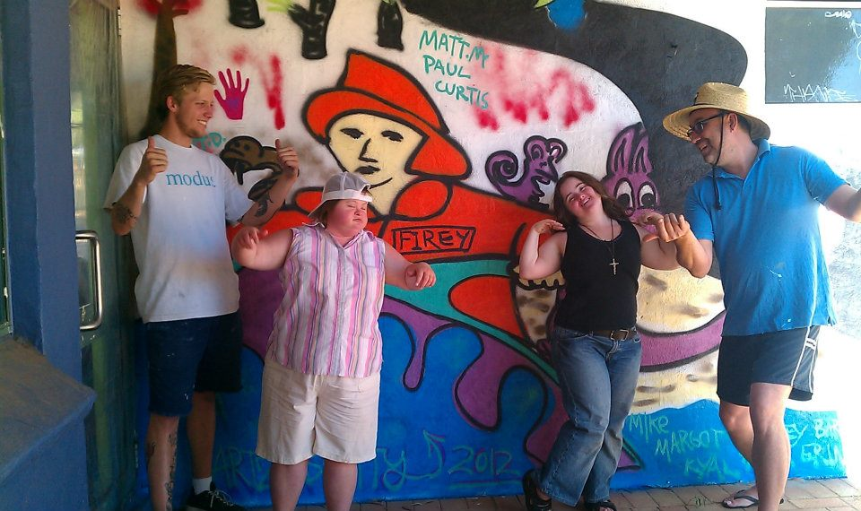

Services
The Shire provides a range of services to the community including:
- Environmental Health and Waste Services: the Shire operates one landfill site in Witchcliffe with a number of transfer stations at various locations. People requiring special assistance with their curb side collection can make arrangements with the Environmental Health unit.
- Recreation services: The Shire operates two recreation centres, one in Margaret River, one in Augusta. The services provided at both facilities cater for a range in ages and abilities.
- Library services: The Shire operates two library branches, one in Margaret River, one in Augusta. Services provided include public access to internet, work processing, sernios PC, one to one tutoring as well as a range of reources in languages other than English.
- Child care services: The Shire operates a creche facility that is open to the public. There is a morning drop in facility, an after school program and school holiday programs that are open to children of all abilities.
- Ranger services: include animal control, parking, emergency services, camping and control of vehicles in off road areas.
- Customer Services: include licencing, registration, payments and all Shire enquiries in both Augusta and Margaret River.
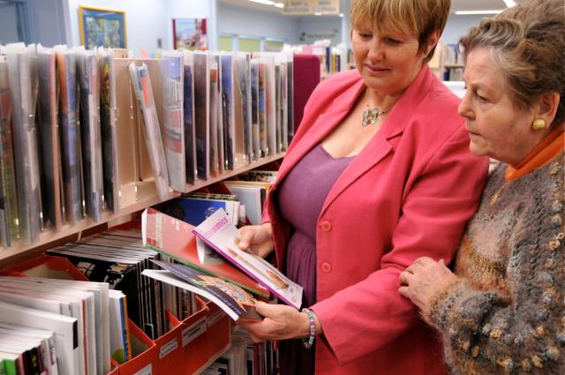

Assets
The Shire manages and maintains public infrastructure facilities within the towns and settlements in its district such as roads, paths, drains, community buildings and recreation spaces. The following is a summary of Shire assets:
- Buildings: The Shire manages 156 buildings including halls, community facilities, sporting facilities, municipal buildings and amenities blocks.
- Footpaths: The Shire’s path network covers 80 km of sealed paths and 30 km of unsealed tracks.
- Car parks: The Shire provides 43 sealed car parks and 11 unsealed car parks.
- Bridges: The Shire manages 18 road bridges and 8 heritage timber pedestrian bridges.
- Foreshore facilities: the Shire mantains 9 boat ramps, 11 jetties and 38 structures including viewing platforms and staircases to assist with beach access.
- Open space: The Shire currently maintains 125 developed parks with an area of 194 ha, landscaped main road verges and traffic islands, rural open space and bush reserves and playgrounds.

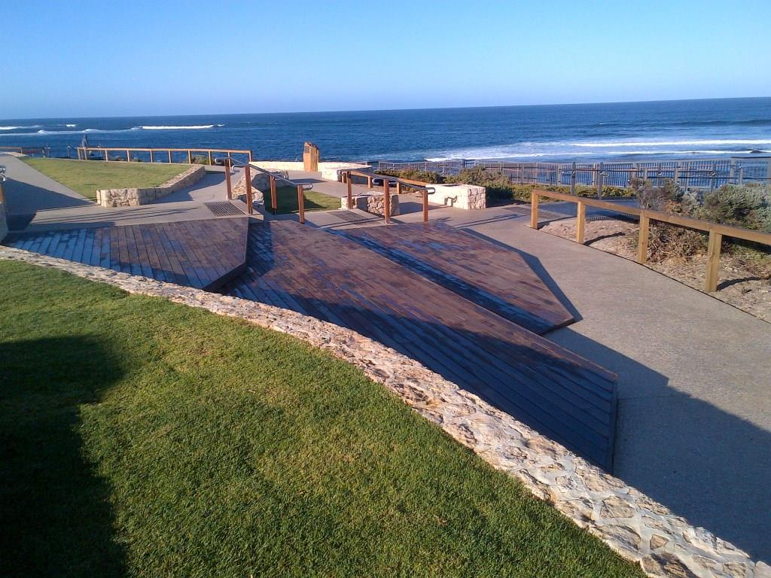

People with disability in the Shire of Augusta Margaret River

According to the Australian Bureau of Statistics (ABS) Survey of Disability, Ageing and Carers 2012, 18.5% of Australians reported to have a disability. A further 21% had a long-term health condition that did not restrict their everyday activities. For those people with disability, 88% had a specific limitation or restriction that meant they were limited in the core activities of self-care, mobility, communication, or restricted in schooling or employment.
The resident population of the Shire of Augusta Margaret River is around 12,219 according to the ABS Census ERP data 2011. Based on these findings, it is estimated that there are around 2,260 people in the Shire with disability and a further 2,565 with a long term health condition. Of those with disability, 1,989 would have a specific limitation or restriction.

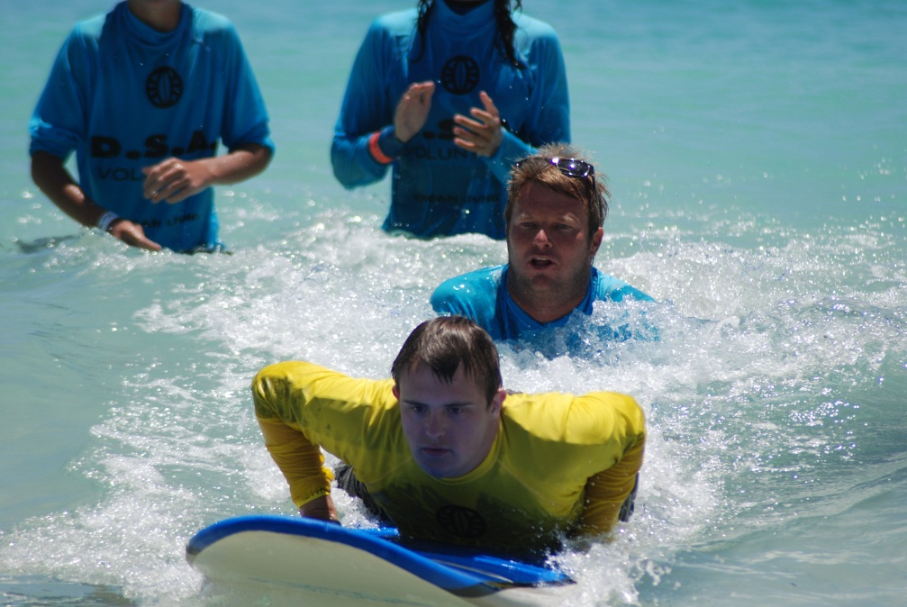

Planning for better access

Australia has experienced a number of changes in disability policy and legislation in the preceding years, these changes have informed the development of the Shire’s Disability Access and Inclusion Plan (DAIP) (2014-2017). Legislation underpinning access and inclusion includes the Disability Services Act (DSA) (1993), the Equal Opportunity Act (EOA) (1984), the Commonwealth Disability Discrimination Act (DDA) (1992).

It is a requirement of the DSA (1993) that all local government authorities develop and implement a DAIP that outlines the ways in which the authority will ensure that people with disability have equal access to its facilities and services.

The Disability (Access to Premises – Buildings Standards 2010) came into force in 2011. It aims to improve access to buildings for people with disability, to ensure the greatest possible participation in the social, economic, cultural and political life of the community. The purpose of the Standard, which is now integrated into the Building Code of Australia, is to provide the building and design industry with detailed information about how they can design and construct their buildings in a way that meets their responsibilities under the DDA.

In Western Australia, alignment with the Disability Service Commission’s state-wide blueprint Count Me In – Disability Future Directions Strategy (2013) provides further opportunities for forward thinking access and inclusion initiatives at the Shire, including a recent recreation program initiative.

Furthermore, the 2012 Federal budget saw a commitment of funding to the National Disability Insurance Scheme (NDIS) which aims to fundamentally improve the system of care and support for Australians with disability and their carers. It is therefore important for the Shire to engage with the NDIS process in order to plan for future demand and provision of services for people with disability.

Improvements in the Shire of Augusta Margaret River

The Shire has been committed to facilitating the inclusion of people with disability through the improvement of access to its facilities and services for many years.

The Shire adopted its first Disabiltity Services Plan (the Plan) in 2001 to address the barriers within the community for people with disability and to address its statutory requirements under the DSA (1993). The Plan was then reviewed and updated on an annual basis.

The DAIP 2010-2013 was designed to meet legislative requirements as well as a response to the needs of the local and extended community.

The following is a sample of the Shire’s progress and achievements in improving access for people with disability that occurred during the last DAIP 2010-2013.

Outcome 1. Improved access to services
- Shire events are increasingly physically accessible through the use of the ‘Accessible Events Checklist’ and good planning using inclusion principles and advertising
- Development of the Delivering excellence in customer service guidelines meet the accessible information standards
- The Shire uses and advertises the use of the National Relay Service
- Improved social and physical access to recreation services through the Count Me In - Access program
- Alternative arrangements for removal of rubbish through Environmental Health Services
- Footpath upgrades included in new development plans
- Universal key system has been implemented for Shire public toilets
- Access membership at the Recreation Centres
- Living Longer Living Stronger program

- Expanded library services:
  - Developed collection in terms of Languages Other than English (LOTE), English as a second language (ESL) users.
‘yourtutor’ online tutoring system for years three and upwards
- ‘Lifelong Learning’ online tutoring system, including resume and letter writing skills assistance
- Extra Public internet PC’s
- A free word processing PC for public use
- Dedicated Senior’s PC’s with one-on-one tutoring available

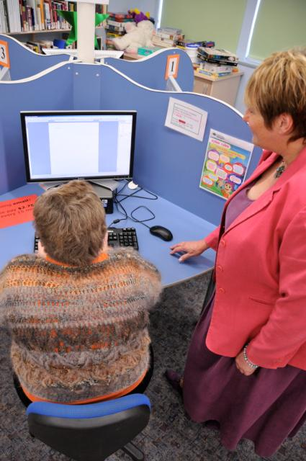

Outcome 2. Improved access to buildings and facilities
- New Civic Administration Centre (CAC)
- New library in Margaret River is accessible
- New accessible doors at the Margaret River Recreation Centre
- Installation of wheel chair accessible picnic tables in Shire parks and open spaces
- Toilet upgrades or new toilets at:
  - Ellis Street, Memorial Park, Rifflebutts, Gnarabup, Rivermouth, Surfers Point, Swimmers Beach Gracetown, Old Settlement
  - Ramp installations and pathway access at:
- Duggan Pavilion, Cowaramup Public Hall, Cowaramup Tennis Club, Gracetown Community Hall, South Point Gracetown, Lesser Hall Augusta, Memorial Park, Augusta Home and Community Care access upgrade.
- Pathway upgrades or new accessible paths:
- Willmott Street, Flinders Bay Caravan Park, Allnut Terrace, Ellis Street, Town View Terrace, Wallcliffe Road, Forrest Road, Hillview Road, Darch Trail, Old Settlement
- Surfers Point, Rifflebutts and Rivermouth were constructed considering the principles of universal access.
- Community Access and Inclusion Reference Group (CAIRG) provided feedback on major and minor assets:
- Gas Bay lookout, Cricket Club upgrades, accessible playground, planned picnic areas, Surfers Point, Mainstreet upgrade, Rifflebutts, Rivermouth, Ellis Street Jetty and the youth precinct.

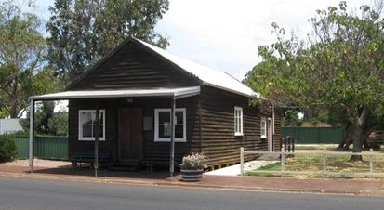

Outcome 3. Improved access to information
- The Shire’s style guide incorporates the state government’s guidelines for accessible information
- The Shire’s Disability Access and Inclusion Plan 2010-2013 is available in a range of formats
- The Shire’s website includes an accessibility function
- The provision of accessible information in Shire buildings and on the website
- The library has continued to grow it’s collection of alternative format resources with new large print, cassettes, cd’s, playaways and alternative language resources.
- A computer is publicly available in the CAC
- Online resources such as yoututor, Lifelong Learning and public internet PCs are available from the Shire’s libraries
- Community disability awareness training opportunities including a sports club sundowner, training at the Sport and Recreation Committee meetings and free workshops on Autism Spectrum Disorder

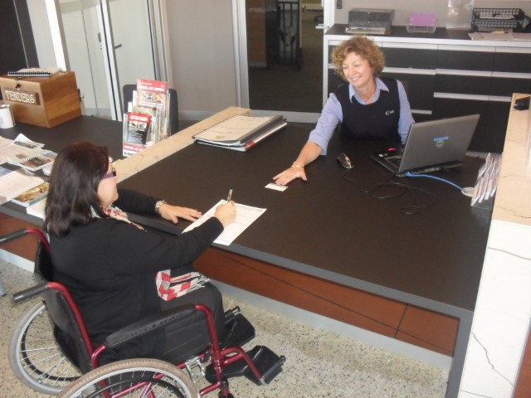

Outcome 4. Improved staff awareness and skills in assisting people with disability
- Customer Service staff received training which included information about the National Relay Service.
- Recreation Centre staff have undergone significant access training as part of the Count Me In program
- Staff awareness of disability has been raised through regular internal promotion and discussion of inclusion as focus for all customer contact
- Approximately half of all Shire staff have completed disability awareness training.
- A strategic plan to induct all staff is currently being implemented
- The ACROD project continues to generate awareness and discussion around the correct use of accessible parking bays
- Assistance animal community awareness raising activities

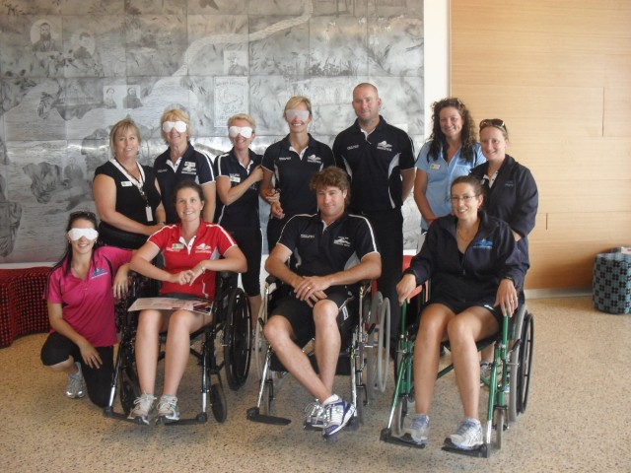

Outcome 5. Improved access for people with disability to complaints mechanisms
- The Shire promotes a number of ways for people to make complaints and compliments including by phone and online through the website.
- Customer services staff are aware of the complaints process and all complaints are recorded in our system and passed on to the area responsible for resolution or response.
- The Shire has a Community Access and Inclusion Reference Group that meets quarterly and is open to any member of the public.

Outcome 6. Improved access to consultation processes
- The Shire has established an internal Access and Inclusion Reference Group made up of strategic positions that are responsible for implementing all DAIP actions.
- The Shire has a Community Access and Inclusion Reference Group (CAIRG) that meets quarterly and is open to any member of the public.
- CAIRG meetings are advertised.
- CAIRG meetings include a range of Shire projects for consultation.
- Venues for stakeholder engagement are selected considering the accessible event guidelines. 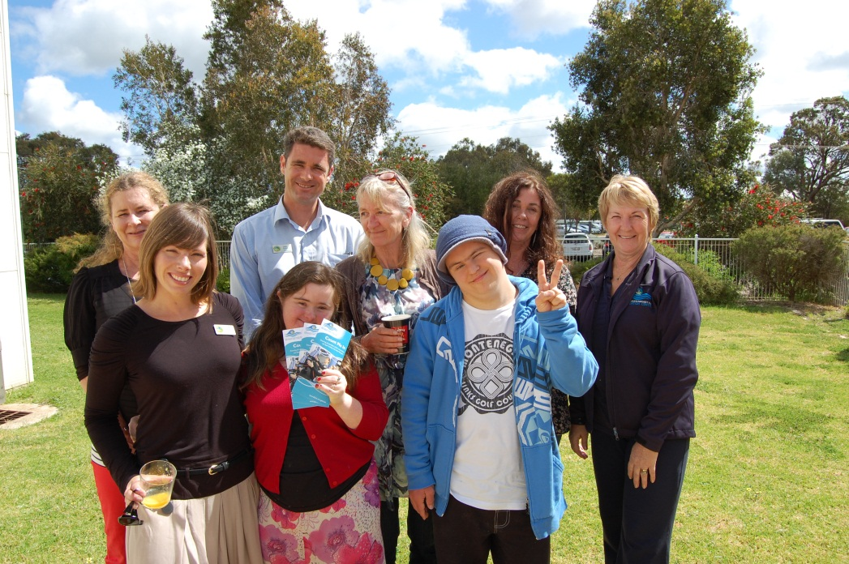

Outcome 7. Access to employment opportunities (new outcome as of July 2013)
- Recruitment practices reflect Equal Employment Opportunity and legislation.
- The Shire is a long term employer of people with disability.

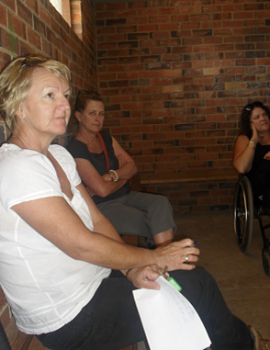

Development of the DAIP

Planning process

Responsibility for developing, monitoring, implementing, reviewing and amending the DAIP is a whole of organisation responsibility that is led by the Community Development Officer. This includes the responsibility of ensuring the plan is rolled out throughout the organisation. The Implementation Plan is integrated within the Shire’s reporting processes with the relevant officers and business units responsible for ensuring each action is completed. The relevant business unit managers meet biannually to review the implementation plan. This group is known as the Access and Inclusion Reference Group (AIRG).

Engagement process

A wide engagement process was carried out to identify potential strategies to be incorporated into the new Plan, with over 50 community members including people with disability, their families and carers, and service providers contributing feedback as well as Shire staff and elected members.

The Disability Services Regulations (2004) set out the minimum consultation requirements for public authorities in relation to DAIPs. Local government authorities must call for submissions (either general or specific) by notice in a newspaper circulating in the local district of the local government under the Local Government Act 1995 or on any website maintained by or on behalf of the local government authority. Other mechanisms may also be used.
The draft DAIP was discussed internally with input from the responsible business units in the formation of the Implementation Plan. The draft Plan was also available on the Shire website for feedback from interested parties including council officers, people with disability, their families, carers, disability organisations and relevant community groups.

The engagement opportunity was advertised or promoted:
- Through the local newspaper in the Public Notices section
- Through the Shire’s Community Update section in the local news paper
- On the Shire’s website
- To individuals and groups through e-mail and phone conversations
- Promoted at Council facilities and events
- Through the Community Access and Inclusion Reference Group (CAIRG)

The various engagement methods used included:
- Discussion with Disability Services Commission My Way Coordinator
- Telephone interviews with community members
- Consultation with the Senior Leadership Team at the Shire
- Consultation with the Community Access and Inclusion Reference Group
- Communication via a 28 day public advertising period
- Through feedback from the Strategic Community Planning process
- Through support services such as Life Without Barriers, Bess and Enable.

Consultation findings

“An inclusive, diverse and vibrant community that celebrates its rich, natural, cultural and indigenous history with a strong and vibrant economic base. A wonderful place to ‘be’”.

The engagement process has shown that the Shire has been working in many positive ways across the organisation to improve access for people with disability to the Shire’s buildings, facilities and services; however the engagement also identified a variety of remaining access issues to be addressed in the Implementation Plan. The most significant issues for community members and staff align with the Shire’s five strategic goals:

 Valuing the natural environment
Welcoming and inclusive communities
 Managing growth sustainably
 Vibrant and diverse economy
 Effective leadership and governance

Particilar suggestions under each goal are summarised as follows:

Environment
- More shade shelters and seating around beaches and parks to enhance the outdoors/natural amenity experience valued by the community
- Wheelchair beach access in Gracetown and Augusta
- More foreshore facilities (seating, shelter, viewing platforms) that are accessible for all (Gracetown, Gnarabup, Rivermouth, Augusta)
- More community consultation when instaling playgrounds in the Shire
- Ensure that public open spaces cater for a range or users paying particular attention to access to trails, walks and parks from car parks to start of trails
  - Carters Road to Bridges Walk

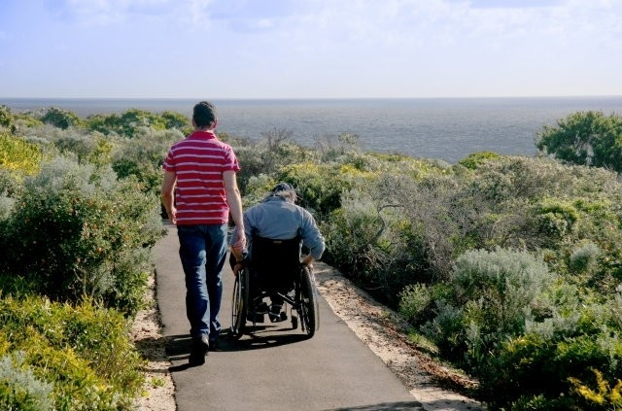

Communities
- Continue to provide recreational opportunities to people of all ages and abilities
- Ensure all services are accessible and inclusive
- Improved access (physical and social) to sporting clubs and facilities
- More opportunties for young adults with disability to participate in social opportunties and events

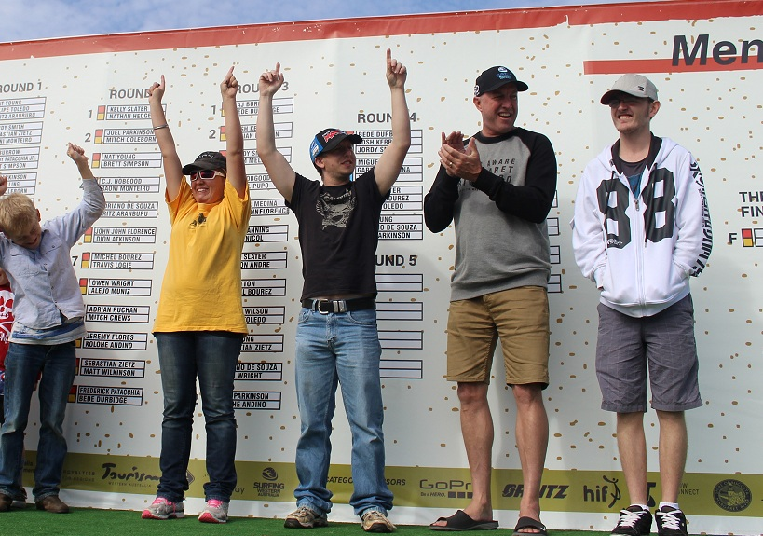

Sustainble growth
- Adequate and ongoing upgrades to existing facilities
  - Full access to the hydrotherapy pool in Augusta (via hoist)
  - Automatic doors at the Augusta Shire office
  - More footpaths linking up town centres
  - Safe main road crossings in Margaret River, Cowaramup and Augusta
  - Safe crossing from the north end of the footbridge in Margaret River to Rotary Park
  - Safe crossing Fearn Avenue between the Library and Coles and then across to the bus stop on Charles West Avenue.

- Safe and connected pathways
  - sealing the pathway on the west side of Bussell Highway between Tunbridge and Higgins (Margaret River)
  - finishing the pathway on Hillview between AllnuttTce and Hart Road (Augusta)
  - continuation of pathway in front of the Bakery on Blackwood Parade (Augusta)
  - continuation of pathway in front of the Augusta Museum on Blackwood Parade (Augusta)
  - improvement of the pathway in front of the petrol station on the Bussell Highway in Cowaramup
  - Improved pathway on Donovan Street connecting the Hospital to Blackwood Avenue (Augusta)
  - improving the ramps, Caltex corner of Ellis Avenue and Blackwood Parade (Augusta)
  - improving the ramps, BP corner of Bussell Highway and Fearn Avenue (Margaret River)
Better parking
  - ACROD parking bays that face the ocean at Gnarabup, Rivermouth and Surfers Point enabling people to enjoy the view
  - ACROD parking with upright signs, re-spraying all those that have faded
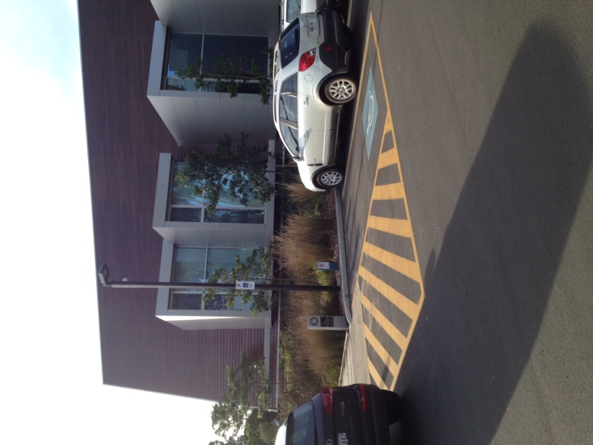

- Increase in the number of public toilets and improved facilites
  - Reuthers Park or Town Square
  - Skate Park Margaret River
  - Margaret River Cultural Centre
  - Margaret River Cemetery
- Toilet upgrades meet standards (placement of toilet roll, door latches, heavy duty toilet seats ) and are maintained to a high standard

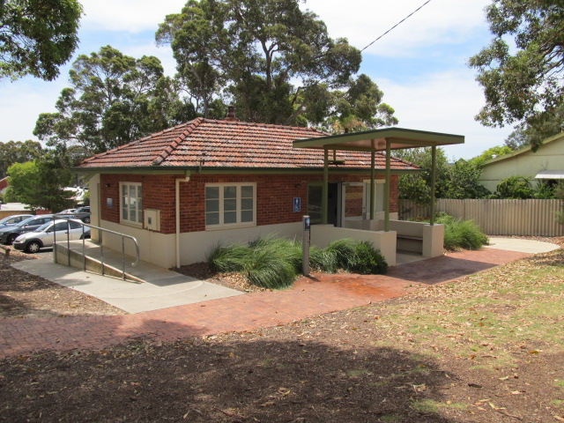

Economy
- Ensuring new commercial developments meet access standards
- Ensuring access to key tourist locations within the Shire (Surfers Point, Rivermouth, Gnarabup, Icon Events, Mainstreets)
- Raising awareness amongst businesses about the value of improving access to shops, restaurants, accommodation
- Working with AMRTA and the Chambers of Commerce to raise awareness of access issues for residents and tourists
- Promoting opportunities for employment of people with disability or people experiencing barriers to employment

Leadership
- Access standards being met in all new builds or significant refurbishments
- Provide a high level of customer service
- Accountability in meeting regulated requirements, transparency in how this is done
- Develop effective partnerships with strategic alliances to maximise community benefit
- Align the DAIP with the Community Strategic Plan to set long term goals
- Communicate effectively with the community and promote the Shire’s positive image in a variety of formats and through a variety of networks
- Develop indicators and measures to ensure that the DAIP is meeting its goals

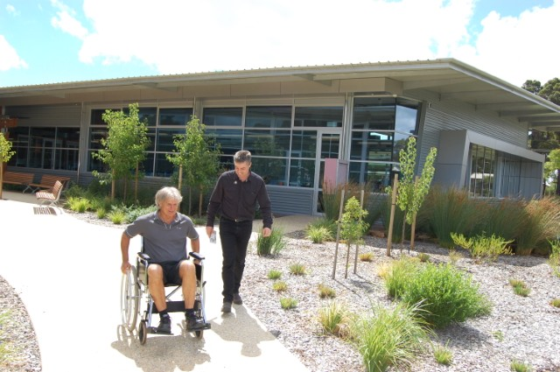

The identification of these barriers helped inform the development of strategies in the DAIP Implementation Plan.

Implementing the DAIP

It is a requirement of the Disability Services Act (1993) that public authorities must take all practical measures to ensure that the DAIP is implemented by its officers, employees, agents and contractors.

Implementation of the DAIP is the responsibility of all areas of local government. Some actions in the Implementation Plan will apply to all areas of the organisation while others will apply to a specific area. The Implementation Plan sets out who is responsible for each action.

Communication strategy for the DAIP

The Shire’s new Disability Access and Inclusion Plan (2014-2016), once endorsed by Council will be lodged with the Disability Services Commission in 2014.

The Shire will advise, through the local media, newspaper and on its website that copies of the DAIP are available to the community upon request and in alternative formats if required, including hard copy in standard and large print, electronic format, audio format on cassette or CD, by email and on the Shire website. As the Plan is updated both staff and the community will be advised of the changes using similar communication strategies.

Evaluation and review of the DAIP

The Disability Services Act (1993) sets out the minimum review requirements for public authorities in relation to DAIPs. The Shire’s DAIP will be reviewed prior to the review of the Community Strategic Plan in 2017, in accordance with the Act. The DAIP Implementation Plan may be amended on a more regular basis to reflect progress and any access and inclusion issues which may arise. Whenever the DAIP is amended, a copy of the amended plan will be lodged with the Disability Services Commission.

Review and monitoring

- The Access and Inclusion Reference Group, will meet every six months from 2014, to review progress on the implementation of the strategies identified in the DAIP.
- A report will be prepared each year on the implementation of the DAIP.
- Once a year prior to 31 July, the Shire will provide advice to the community regarding the implementation of the DAIP.
- The Shire will offer a range of ways for people to provide feedback such as telephone, face to face meetings, email and written feedback.
- Elected members of council and staff will also be requested to provide feedback on how well they believe the strategies are working and to make suggestions for improvement.
- The DAIP will be reviewed in late 2016 in order to inform the Shire’s next four year Corporate Plan.

Reporting on the DAIP

The Disability Services Act (1993) sets out the minimum reporting requirements for public authorities in relation to DAIP’s.

The Shire will report on the implementation of its DAIP through its annual report and on the prescribed proforma to the Disability Services Commission by 31 July each year, outlining:

- its progress towards the desired outcomes of its DAIP;
- the progress of its agents and contractors towards meeting the eight desired outcomes; and
- the strategies it used to inform its agents and contractors of its DAIP.

As part of the Annual Report, the Shire includes all progress made on the DAIP Implementation Plan.
An annual report to Council will be made each year to report on the progress of the Implementation Plan.

Strategies to improve access and inclusion 2014 -2016

The Shire has developed a detailed Implementation Plan that will be used to track the date of implementation and responsible officer against the following strategies and actions.

Implementation plan

Outcome 1
People with disability have the same opportunities as other people to access the services of, and any events organised by the Shire
Strategy |  | Key Performance Indicator |  | Responsibility |  | Timeframes | Linking our goals
1.1 | Shire policies and framework support the DAIP | DAIP listed as key document in Shire policies and frameworks. |  | Corporate planner |  | Ongoing | 
1.2 | Effective internal planning to incorporate access and inclusion | DAIP included as agenda item at the ELT. |  | ELT |  | Ongoing
1.3 | Shire public events including icon events, festivals, meetings and consultation are accessible where possible | Accessible Events Checklist |  | All staff |  | Ongoing | 
1.4 | All contracted services, consultations and events are accessible where possible | Contractors are provided with a link to our DAIP and the Accessible Events Checklist |  | Manager of Environmental Health and Waste Services, all staff that contract out services |  | Ongoing | 
1.5 | Continue to enforce local laws regarding ACROD parking bays | Infringements are issued to people that misuse ACROD bays |  | Coordinator Ranger Services |  | Ongoing
1.6 | Implementation of the ACROD Project – community notification and audit of bays | ACROD project is completed |  | Community Development Officer with Asset Services Officer and/or CD Trainee |  | Annually

Outcome 1
People with disability have the same opportunities as other people to access the services of, and any events organised by the Shire
 | Strategy |  | Key Performance Indicator |  | Responsibility |  | Timeframes | Linking our goals
1.7 | Continue to develop activities and programs at recreation centres to be as accessible and inclusive as possible |  | Number of people with Access memberships |  | Recreation Operations Manager |  | Ongoing
1.8 | Continue to develop school holiday activities and crèche facilities at the Recreation Centre to be as accessible and inclusive as possible |  | Number of children with disability accessing the crèche facilities |  | Recreation Operations Manager |  | Ongoing
1.9 | Provide accessible and inclusive Youth events and activities |  | Number of accessible youth activities |  | Senior Community Development Officer |  | Ongoing
1.10 | Investigate and identify funding sources to support accessible and inclusive services |  | Number of grant applications submitted relating to access and inclusion |  | All areas |  | Ongoing
1.11 | Promote community awareness of the range of services available and of their accessibility to encourage individuals and groups to access them |  | Number of community awareness raising activities, media releases, website updates, information distributed, radio interviews |  | All staff |  | Ongoing

Outcome 2
People with disability have the same opportunities as other people to access the buildings and facilities of the Shire
Strategy |  |  | Key Performance Indicator |  |  | Responsibility | Timeframes | Linking our goals
2.1 | Internal design review team formed to ensure access standards are met at the design stage |  | Design review committee is formed |  |  | Director of Infrastructure Services | 2014 | 
2.2 | All new or major Shire redevelopment work over the value of $200,000 will involve an access consultant or access audit |  | Number of major projects that involved access consultants or specialists |  |  | Director of Infrastructure Services  Director of Sustainable Development | Ongoing as needed
2.3 | Ensure all building applications meet the BCA requirements |  | All applications meet the BCA which includes the Access to Premises Standard 2011 |  |  | Manager of Planning & Development | Ongoing
2.4 | All briefs, tenders and contracts to include a copy of the DAIP responsibilities as part of the contract |  | Number of completed contractors check list |  |  | Coordinator of Building Assets & Maintenance, Administrative & Building Assets Officer | Ongoing
2.5 | Up to date information is made available on accessibility of infrastructure and services |  | Audit of current access of buildings and services |  |  | Coordinator of Building Assets & Maintenance, Administrative & Building Assets Officer | 2015

Outcome 2
People with disability have the same opportunities as other people to access the buildings and facilities of the Shire

2.6 | Create and implement a prioritised list of buildings and facilities that require access upgrades | Creation of a priority list | Coordinator of Building Assets & Maintenance with input from the CAIRG | Annually based on the 2015 audit
2.7 | Create a list of the top 10 access upgrades that would improve the quality of life of visitors and residents and incorporate as many as possible into future or planned projects. | Create a priority list through the CAIRG and through public feedback and requests | Community Development Officer | Ongoing | 
2.8 | Ensure that the Community Access and Inclusion Reference Group (CAIRG) is consulted in regards to new and redevelopment building and asset work | Attendance of project managers at CAIRG meetings | Director of Infrastructure Services, | As required
2.8 |  | Attendance of project managers at CAIRG meetings | Director of Sustainable Development | As required
2.9 | Liaise with the CAIRG on disability access and inclusion requirements for playgrounds or upgrades | Attendance of project managers at CAIRG meetings | Manager Works | Ongoing

Outcome 3
People with disability receive information from the Shire of Augusta-Margaret River in a format that will enable them to access the information as readily as other people are able to access it.
Strategy |  | Key Performance Indicator |  | Responsibility |  | Timeframes |  | Linking our goals
3.1 | All Shire information is available in alternative formats upon request | Number of requests for information in alternative format per year |  | Community Development Officer |  | Annually
3.2 | Continuous improvement to accessibility of website and Shire documents | Website and documents meet access standards |  | Manager Customer & Information Services |  | Reviewed annually
3.3 | Investigate technology and tools available for use by front counter staff to assist people with disability | Number of upgrades or improvements |  | Manager Library Services, Manager Customer & Information Services, Recreation Operations Manager |  | Annually
3.4 | Marketing is consistent with accessibility standard for information | Replace and update the Accessible Information Policy and include a check list for marketing communication manual/policies/procedures. |  | Marketing and Events Officer |  | 2014
3.5 | Library services to continue to identify ways to grow its alternative format resources | Number of new alternative format resources |  | Manager of Library Services |  | Ongoing

Outcome 4
People with disability receive the same level and quality of service from staff at the Shire.
Strategy |  | Key Performance Indicator |  | Responsibility |  | Timeframes | Linking our goals
4.1 | New staff induction and orientation includes access and inclusion component. | Number of staff inducted for A&I |  | Community Development Officer with HR |  | Ongoing as needed
4.2 | All existing staff to undergo access and inclusion inductions if they have not yet completed this training | Audit of staff members who have completed training, schedule of training for those outstanding staff members |  | Community Development Officer |  | 2015
4.3 | All volunteers assisting the Shire delivering service to customers are supported in providing a quality service to people with disability through appropriate training and orientation | Access awareness training sheet developed and provided to all volunteers dealing with the public |  | Community Development Officer |  | 2015
4.4 | Disability awareness training is continuously improved and reviewed | Review is completed |  | Community Development Officer |  | Annual review of best practice and materials
4.5 | Information and resources are readily available to staff on access and inclusion | Number of requests for information |  | Community Development Officer |  | Ongoing
4.6 | Promote the Shire’s achievements regarding disability and access to staff and the community | Number of media releases, web updates and promotional material distributed |  | Community Development Officer |  | Ongoing
4.7 | Investigate and promote accessible accommodation and tourist facilities through the “You’re Welcome Initiative” | Add link to our website http://www.accesswa.com.au/ |  | Manager Customer & Information Services |  | Ongoing

Outcome 5
People with disability have the same opportunities as other people to make complaints to the Shire
Strategy |  | Key Performance Indicator |  | Responsibility |  | Timeframes | Linking our goals
5.1 | Grievance mechanisms are accessible for people with disability and in an appropriate format | Ensure that there are multiple ways and formats for people to make a complaint |  | Manager of Customer & Information Services |  | 2014
5.2 | Improve staff knowledge so they can facilitate and support the receipt of complaints from people with disability | Grievance accessibility information provided to all staff in inductions. All staff to be notified of changes or updates to complaints procedures |  | Manager of Customer & Information Services |  | 2015
5.3 | Feedback received through complaints and compliments forms continuous improvement | Number of complaints/compliments recorded in our records systems |  | Manager of Customer & Information Services |  | Annually

Outcome 6
People with disability have the same opportunities as other people to participate in any public consultation within the Shire
Strategy |  | Key Performance Indicator |  | Responsibility |  | Timeframes |  | Linking our goals
6.1 | Shire staff to advise and/or consult directly with the Community Access and Inclusion Reference Group (CAIRG) on any matters that are put out for public consultation | Number of consultations between Shire staff and CAIRG |  | All shire staff |  | Ongoing
6.2 | Promote the existence and the role of the Community Access and Inclusion Reference Group to the community | Public advertising, website, promotional material, media releases |  | Community Development Officer |  | Ongoing
6.3 | Consult with individuals, disability organisations and networks as required | Number of CAIRG meetings. |  | Community Development Officer |  | Ongoing
6.4 | Aim for ongoing representation of youth with disability on the Margaret River Youth Advisory Council (YAC) | Number of youth with disability engaging in YAC programs |  | Senior Community Development Officer |  | Ongoing
6.5 | Review the Council's policy on consultation and ensure it is aligned with the DAIP | Council Policy is reviewed and updated |  | Community Development Officer |  | 2014

Outcome 7
People with disability have the same opportunities as other people to obtain and maintain employment with the Shire.
Strategy |  | Key Performance Indicator |  | Responsibility |  | Timeframes |  | Linking our goals
7.1 | The Shire’s recruitment strategies ensure equal employment opportunity | EEO listed in all recruitment, Managers are aware of EEO requirements |  | Manager of Human Resources |  | 2014
7.2 | Review/audit physical access to work sites for existing/potential employees. Identify employment barriers and remove where possible | Audit of current access of buildings and services, see Strategy 2.5 |  | Coordinator of Building Assets & Maintenance, Administrative & Building Assets Officer, Community Development Officer |  | 2014 then review annually as needed |  | 
7.3 | Promote the benefits to the Shire of flexible employment and employment of people with disability in all HR and access induction information | Review current induction material and incorporated benefits into inductions for all staff. Distribute any relevant materials developed to all staff involved in recruitment, volunteers or student placements |  | Manager of Human Resources, Community Development Officer |  | 2015
7.4 | Explore work experience opportunities, in particular with people that experience access barriers | Relationship built with stakeholder agencies to build on employment opportunities, including student placements and volunteers that experience barriers to employment |  | Manager of Human Resources with Community Development Officer |  | 2015

Outcome 8
The Shire strategically manages the monitoring and review of the access and inclusion plan
Strategy |  | Key Performance Indicator |  | Responsibility |  | Timeframes | Linking our goals
8.1 | The Access and Inclusion Reference Group meets biannually to monitor and review the Plan’s implementation | Biannual meetings are held |  | Community Development Officer |  | Biannual
8.2 | Report progress towards implementation of the Plan | Statutory report to the Disability Services Commission, Shire's Annual Report and annual report to Council |  | Community Development Officer |  | By June 30 each year
8.3 | Review the Disability Access and Inclusion Plan prior to the review of the Corporate Plan | DAIP is reviewed in late 2016 early 2017 |  | Community Development Officer |  | 2017
8.4 | Review the Council’s Access and Inclusion Policy prior to the Corporate Plan | Review of the Shire's access policy and equity statements |  | Community Development Officer |  | 2014

Acronyms
AIRG | Access and Inclusion Reference Group
CAIRG | Community Access and Inclusion Reference Group
CAC | Civic Administration Centre
DDA | Disability Discrimination Act (1992) Commonwealth
DSR | Disability Services Regulation (2004) Western Australia
DAIP | Disability Access and Inclusion Plan
EOA | Equal Opportunities Act (1984) Western Australia
DSA | Disability Services Act (1993) Western Australia

Related documents

Australian Bureau of Statistics - Disability, Ageing and Carers, Australia: Summary of Findings (2012)
Commonwealth Disability Discrimination Act (1992)
Commonwealth Disability Discrimination Act (1992) Disability (Access to Premises – Buildings Standards 2010
Disability Services Commission (2013) Count Me In – Disability Future Directions Strategy
Government of Western Australia (1993) Disability Services Act (DSA)
Government of Western Australia (2004) Disability Services Regulations
Government of Western Australia (1984) Equal Opportunity Act (EOA)
Shire of Augusta Margaret River (2009) Age Friendly Community Study – Final Report
Shire of Augusta Margaret River (2013) Asset Management Plan 2013-2023
Shire of Augusta Margaret River (2013) Community Strategic Plan 2033
Shire of Augusta Margaret River (2013) Corporate Plan 2013-2017
Shire of Augusta Margaret River (2013) Delivering excellent customer service
Shire of Augusta Margaret River (2010) Disability Access and Inclusion Plan 2010-2013
Shire of Augusta Margaret River (2012) Local Profile
Shire of Augusta Margaret River (2013) Long Term Financial Plan 2013-2023
Shire of Augusta Margaret River (2013) Workforce Plan 2013-2017

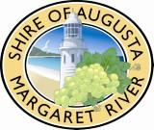
Shire of Augusta-Margaret River
Main Administration Office
41 Wallcliffe Road (PO Box 61)
Margaret River 6285
P: 08 9780 5255, F: 08 9757 2512
Office Hours: Mon to Fri, 9am – 4pm
Phone enquiries: 8am – 4.30pm

Augusta Administration Office
66 Allnutt Terrace
Augusta 6290
P: 08 9780 5660, F: 08 9758 0033
Office Hours: Mon to Fri, 9am – 4pm
(closes for lunch 12pm — 1pm)
Phone enquiries 8am – 4.30pm

www.amrshire.wa.gov.au
amrshire@amrshire.wa.gov.au
If you are deaf, or have a hearing impairment or speech impairment, contact us through the National Relay Service:

- TTY users phone 133 677 then ask for
08 9780 5255
- Speak and Listen users phone
1300 555 727
then ask for 08 9780 5255
- Internet relay users connect to the NRS
(www.relayservice.com.au) and then ask for
08 9780 5255

