REQUEST TO JOIN EXEMPTION APPLICATION LODGED BY THE DEPARTMENT OF
FAMILIES, HOUSING, COMMUNITY SERVICES AND INDIGENOUS AFFAIRS (FaHCSIA)
UNDER S56 OF THE DISABILITY DISCRIMINATION ACT (1992) (CTH)
I/We seek to join/support the exemption application submitted by FaHCS1A as follows:
- 1/We seek an exemption for all existing ADEs from sections 15 and 24 of the DDA, and the Commonwealth (and officers of the Commonwealth) from section 29 for a period of three years.
- This exemption would apply to use of the BSWAT to:
- assess wages for employees; and
- pay wages to ADE employees based on assessments conducted under the BSWAT.
- The proposed exemption would apply while alternative wage setting arrangements are being considered, devised and/or established and implemented by FaHCSIA.
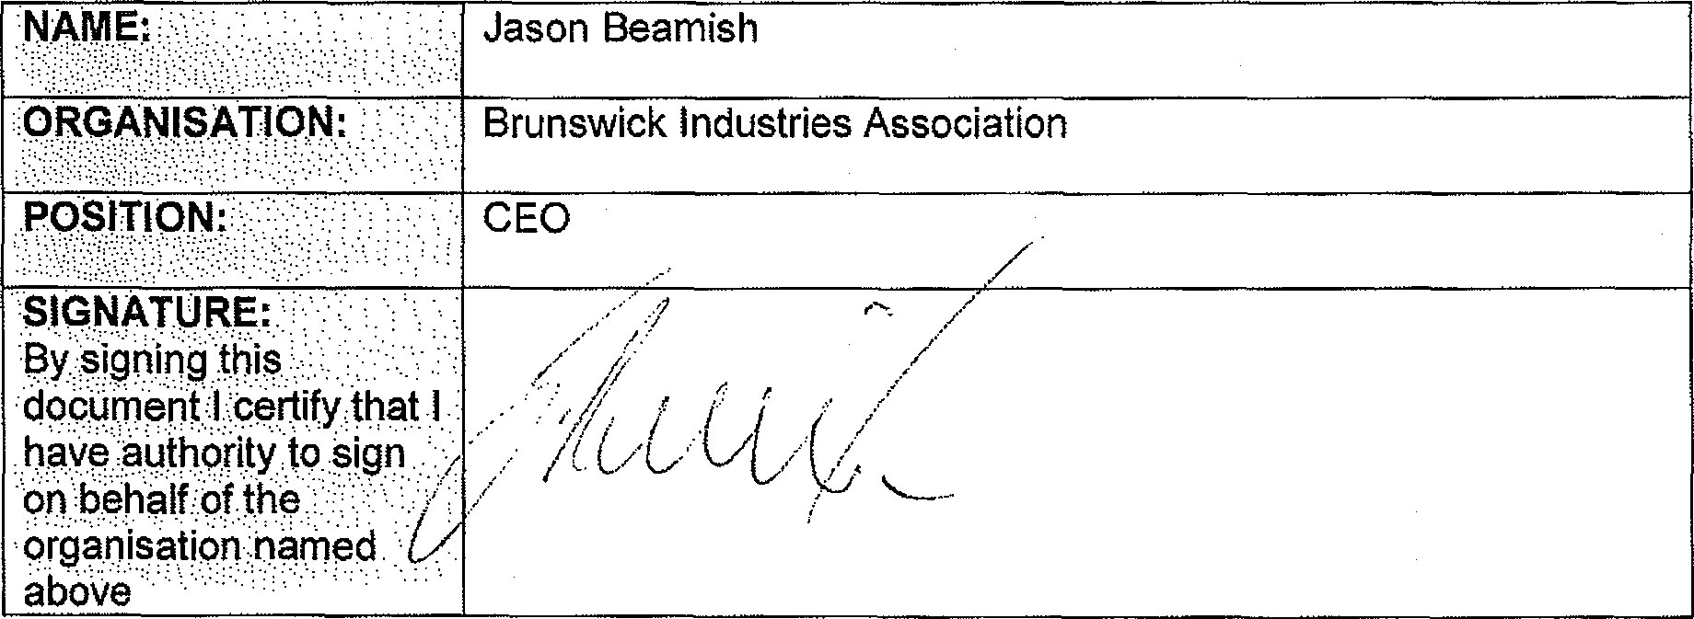
Jason Beamish
.ORGANISATION:
Brunswick Industries Association
CEO
SIGNATURE: By signing this
.clocOment,:l..;Certify.thot 1
have authority to 0199
Or.) behalf of the
organisation name
above
- ( I I^{f} I I
/ C/ L,
COMMENTS
We fully support the application for exemption to continue to use BSWAT whilst a new assessment tool is developed

