REQUEST TO JOIN EXEMPTION APPLICATION LODGED BY THE DEPARTMENT OF
FAMILIES, HOUSING, COMMUNITY SERVICES AND INDIGENOUS AFFAIRS (FaHCSIA)
UNDER S55 OF THE DISABILITY DISCRIMINATION ACT (1992) (CTH)
We seek to join the exemption application submitted by FaHCSIA as follows:
- We seek an exemption for all existing ADEs from sections 15 and 24 of the DDA, and the Commonwealth (and officers of the Commonwealth) from section 29 for a period of three years.
- This exemption would apply to use of the BSWAT to:
- assess wages for employees; and
- pay wages to ADE employees based on assessments conducted under the
- BSWAT.
- The proposed exemption would apply while alternative wage setting arrangements are being considered, devised and/or established and implemented by FaHCSIA.
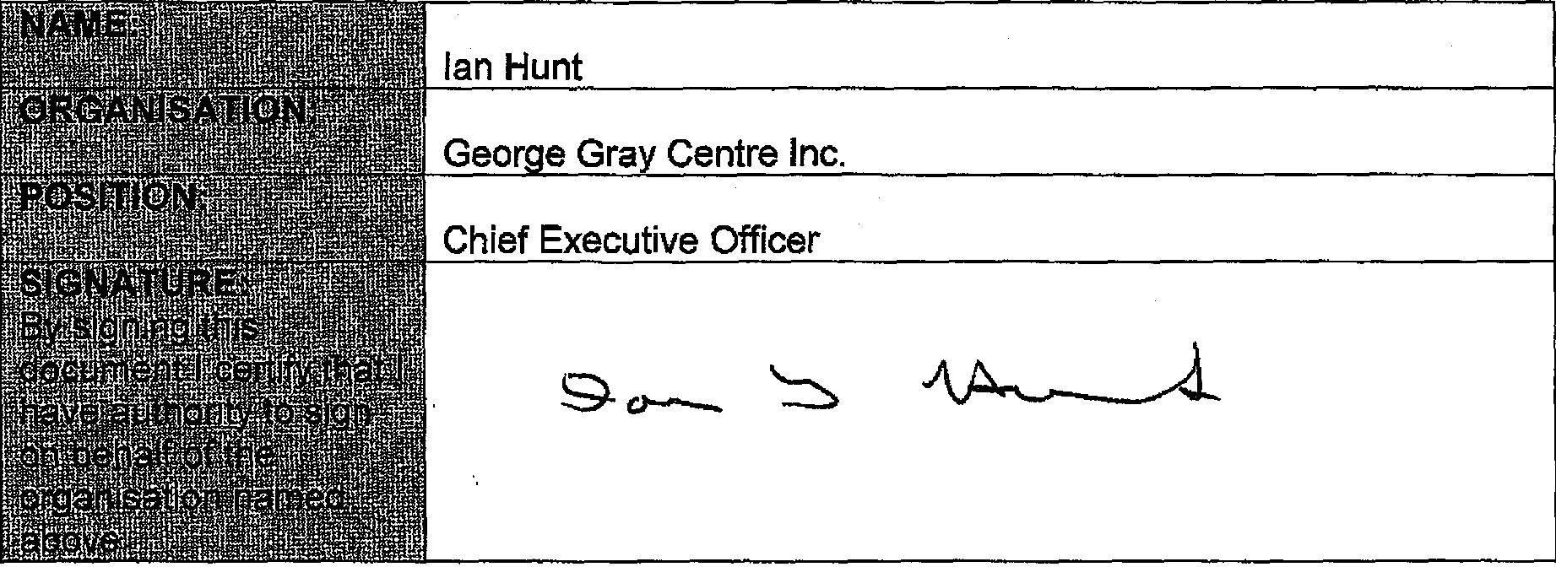
COMMENTS
We are strongly behind this application to ensure continuity of employment for persons with a disability is maintained and to allow our organisation time to plan for the introduction of an alternative wage assessment.

