REQUEST TO JOIN EXEMPTION APPLICATION LODGED BY THE DEPARTMENT OF
FAMILIES, HOUSING, COMMUNITY SERVICES AND INDIGENOUS AFFAIRS (FaHCSIA)
UNDER S55 OF THE DISABILITY DISCRIMINATION ACT (1992) (CTH)
INVe seek to join/support the exemption application submitted by FaHCSIA as follows:
- 1/We seek an exemption for all existing ADEs from sections 15 and 24 of the DDA, and the Commonwealth (and officers of the Commonwealth) from section 29 for a period of three years.
- This exemption would apply to use of the BSWAT to:
- assess wages for employees; and
- pay wages to ADE employees based on assessments conducted under the BSWAT.
- The proposed exemption would apply while alternative wage setting arrangements are being considered, devised and/or established and implemented by FaHCSIA.
Marita Brady
SkillsConnection ADE trading name Jiffy Services CEO
:SIONATY₁
By %
ni6 t
8ig9199t :
have authority to n
namedon behalf of the organisation
above
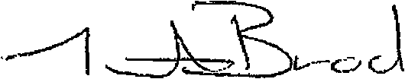
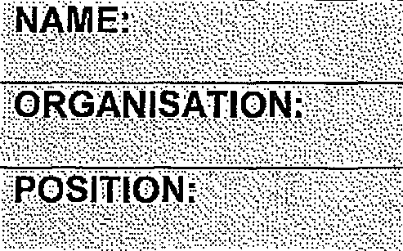
'ORGANISATION
COMMENTS
The current issues facing ADE'S in relation to BSWAT has an immediate impact on our ADE Jiffy Services as 90 % of our employees are due for a wage assessment in the first quarter 2014 If the Australian Human Rights Commission grants the exemption, for BSWAT assessments to re-commence this would provide us the time required to investigate other options.

