Statement of Support for an Australian Modern Slavery Act

Preamble
Slavery is more prevalent today than at any time in human history. As leaders representing civil society, business, investors, academia and faith-based organisations, we support a unified approach in addressing modern slavery.

We support the introduction of a Modern Slavery Act in Australia. This statement sets out some key principles to guide this reform process. Addressing modern slavery requires a collaborative effort between government, business, civil society and people affected by slavery.

Support for Modern Slavery Act
We support the development of a Modern Slavery Act in Australia. We welcome the Interim Report of the Australian Parliament’s Joint Standing Committee on Foreign Affairs, Defence and Trade on modern slavery.

Modern slavery reporting
We welcome the Attorney-General’s Department consultation paper on the reporting of modern slavery in supply chains. We support a requirement that organisations that meet a significant threshold (e.g. large businesses, government agencies and others) report on modern slavery in their operations and supply chains.

Leadership, co-ordination and support on modern slavery
Responsibility should be given to an independent organisation or individual to lead and coordinate efforts in tackling modern slavery, raising awareness and supporting organisations in effectively addressing modern slavery in their operations and supply chains. This could be achieved by the establishment of an Australian Independent Anti-Slavery Commissioner.

Effective compliance
Organisations with reporting obligations should be supported to comply with their obligations including provision of guidelines and education. There should be transparency regarding which organisations do and do not comply, and there should be drivers towards compliance (e.g. penalties and compliance incentives).

Transparency on modern slavery statements
We support the establishment of a government-funded and publicly-accessible repository of all modern slavery statements.

Access to remedy and victim support
Clear guidance and support should be provided for organisations that find modern slavery in their operations or supply chains so that they know how to respond safely and effectively. There should be access to appropriate information, remedies and support for victims.

Government procurement
Public procurement is a major component of the overall economy with consequences for the enjoyment of human rights. The Australian Government should be required to comply with the proposed reporting requirement. The Australian Government should work with State and Territory Governments and lead by example in reporting on actions taken in public procurement to address modern slavery.

Alignment with the UN Guiding Principles
A Modern Slavery Act and guidance should be aligned with and reinforce the United Nations Guiding Principles on Business and Human Rights.

Continual improvement
A Modern Slavery Act should incorporate a requirement for periodic and recurring review (e.g. every 3 years) to seek continual improvement and learn from the operation of the legislation in practice.

Signatories as at 21 November 2017
Edward Santow  Human Rights Commissioner  Australian Human Rights Commission | Reverend Sharon Hollis  Moderator, Synod of Victoria and Tasmania  Uniting Church in Australia
 | 
Justine Nolan, Associate Professor,  UNSW Law & Australian Human Rights Institute, UNSW | Christine Carolan, Executive Officer  ACRATH - Australian Catholic Religious Against Trafficking in Humans
 | 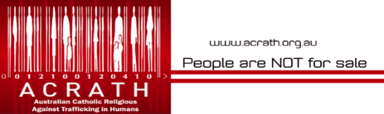
Phil Bloomer, Executive Director  Business and Human Rights Resource Centre | Jennifer Burn, Director  Anti-Slavery Australia, University of Technology Sydney
 | 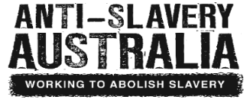
David Baggs, CEO  Global Green Tag | Måns Carlsson-Sweeny, Head of ESG Research ausbil
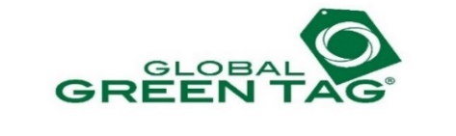 | 
Jenny Stanger, National Manager  The Freedom Partnership | Jonathan Cartledge, Head of Public Affairs  Green Building Council of Australia
 | 
Robin Mellon, CEO  Supply Chain Sustainability School | Tarni Petkal, Employment Project Senior Solicitor  WEstjustice
 | 
Dulux Group | Castan Centre for Human Rights Law
 | 

Signatories as at 21 November 2017 (continued)
Property Council of Australia | Law Council of Australia
 | 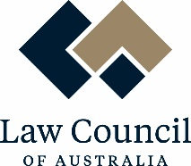
Infrastructure Sustainability Council of Australia | PwC
 | 

