20 January 2026
Committee Secretariat
Senate Economics Legislation Committee
Department of the Senate
Parliament House
Canberra ACT 2600
Australia
By email: economics.sen@aph.gov.au.
Dear Secretary,
Submission to the Senate Economics Legislation Committee
The Australian Human Rights Commission (Commission) welcomes the opportunity to submit to the Senate Economics Legislation Committee (Committee) on the Treasury Laws Amendment (Genetic Testing Protections in Life Insurance and Other Measures) Bill 2025 (the Bill). The Bill amends the Insurance Contracts Act 1984 (Cth) and the Disability Discrimination Act 1992 (Cth) to ban life insurers from using protected genetic information.
We attach the Commission’s October 2025 submission on the Exposure Draft for the Treasury Laws Amendment Bill 2025: Limiting the use of genetic information by life insurers (Exposure Draft). As the Bill is substantively unchanged from the Exposure Draft (as it relates to genetic testing protections), this submission serves as the Commission’s response to the Committee’s inquiry into the Bill as the Commission’s position on matters of substance are unchanged.
The Commission supports the ban on the use of genetic information in life insurance and acknowledges Treasury’s consultation which incorporated some of the Commission’s previous recommendations. However, the Commission continues to have concerns about the Bill in its current form given the recommendations from the October 2025 submission were not accepted or taken on board, including:
- The meaning of protected genetic information does not include inferred genetic information.
- Consent is not a defined term and can be provided by an agent, such as an insurance broker.
- The ban does not apply to life insurance policies that were created before the new law begins.
- The power to make regulations could change the meaning of important terms, which may affect how the ban works.
- There is no requirement for reviews of the ban to assess its effectiveness in reducing discrimination.
Addressing these concerns will ensure stronger protections against genetic discrimination and better protect the human rights of people accessing life insurance policies.
The Commission welcomes further engagement with the Committee on the issues raised in this submission.
Kind regards
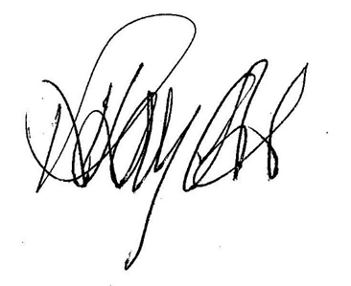
Rosemary Kayess
Disability Discrimination Commissioner
Phone: +61 2 9284 9722
Email: disability@humanrights.gov.au

Lorraine Finlay
Human Rights Commissioner
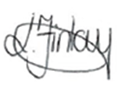
Phone: 02 9284 9814
Email: lorraine.finlay@humanrights.gov.au

The Commission notes that the October 2025 Submission refers to the Exposure Draft and the Explanatory Materials for the Exposure Draft, which can be taken to be references to the Bill and the Bill’s Explanatory Memorandum.
For an overview of the Commission’s previous submissions see: Australian Human Rights Commission, Genetic discrimination in life insurance underwriting’ (Web Page, 12 November 2025) <https://humanrights.gov.au/our-work/submissions/disability-rights/genetic-discrimination-in-life-insurance-underwriting>.

