Supporting participation program
Common questions
Part 2
Funding
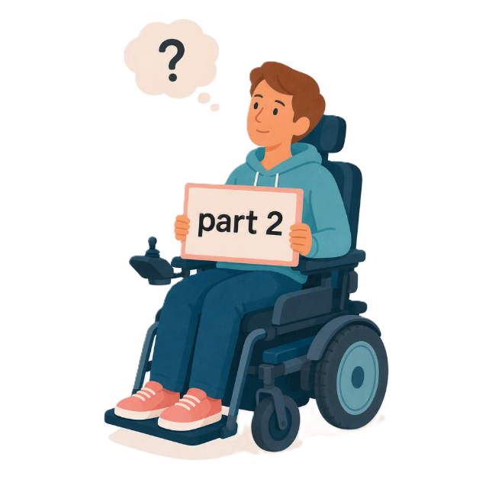
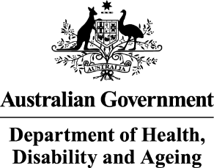 | - The Australian Government Department of Health Disability and Ageing  We say DHDA for short.
 | - The Australian Human Rights Commission  We say AHRC for short.  Wrote this together.  When you see the word we it means  DHDA and AHRC.
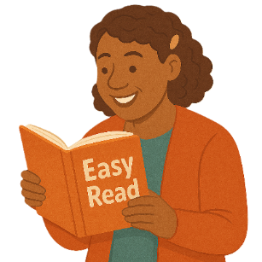 | We wrote this in an easy to read way.  We use pictures to explain some ideas.
 | We have some words in bold.  This means the letters are thicker and darker.  These are important words.
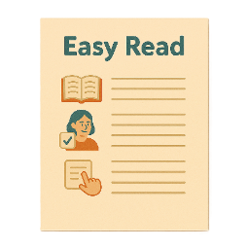 | This is an Easy Read summary of another document.  This means it has the most important ideas.
 | We can answer any questions by email.  Email us disability@humanrights.gov.au
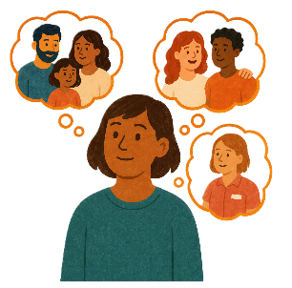 | You can ask for help to read this document.  You can ask  - A friend  - Family members  - A support person.
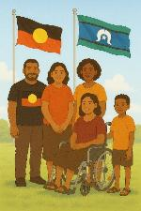 | We recognise Aboriginal and Torres Strait Islander people as the Traditional Owners of the land we live on.
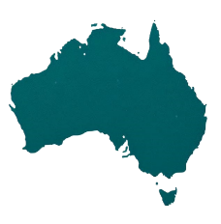 | They were the first people to live on and use the  - Land  - Waters.

Contents

About the Supporting Participation Program | 5
About this document | 9
How much funding can I get | 12
Funding for the different forums | 13
What can the funding be used for | 14
What you can not spend the funding on | 17
What if I do not spend all the funding | 18
When will you get the funding | 19
Tax questions | 21

About the Supporting Participation Program

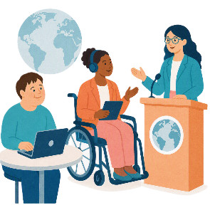 |  | This talks about the  Supporting Participation Program.  We call it SPP for short.
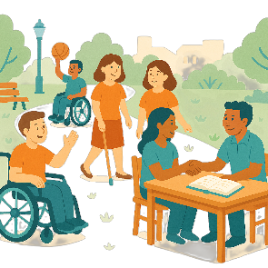 |  | Participation means taking part in something.
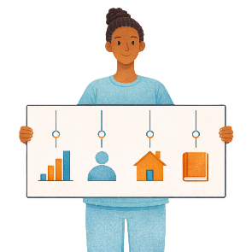 |  | Programs are done to support people in the community.
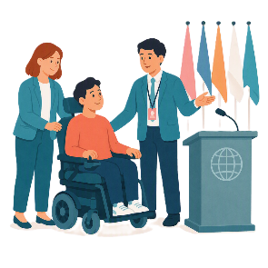 |  | SPP supports people with disability to go to international forums on human rights.  Like the United Nations Conference of States Parties.
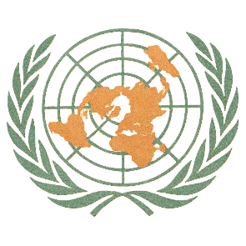 |  | The United Nations is an organisation where countries come together to  - Talk about world issues  - Fix world issues.  We call it the UN for short.
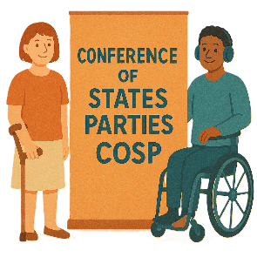 |  | The Conference of States Parties is a meeting for all countries that agreed to support the rights of people with disability.  We call it COSP for short.
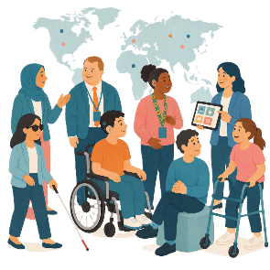 |  | International forums are meetings where people from different countries talk about important issues.
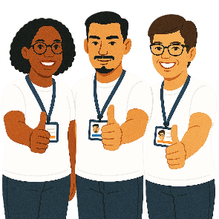 |  | Human rights are rights that everyone has.  Rights are rules about treating everyone  - Fair  - Equal.
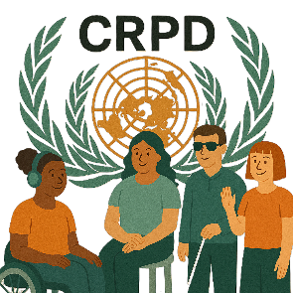 |  | SPP helps Australia to follow the  - UN Convention on the Rights of Persons with Disabilities.  We say CRPD for short.
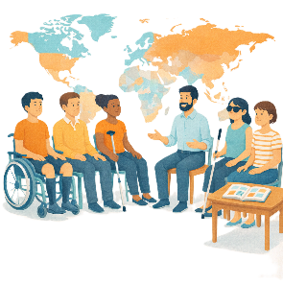 |  | CRPD is an agreement between different countries.  CRPD says how people with disability must have their rights respected.
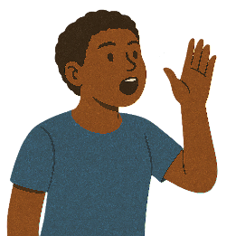 |  | SPP also supports people with disability to  - Speak up about their rights
 |  | - Represent their organisation.

About this document

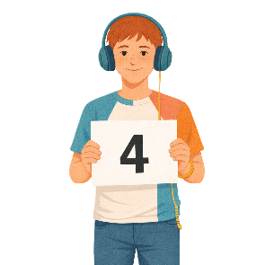 |  | This document has 4 parts.
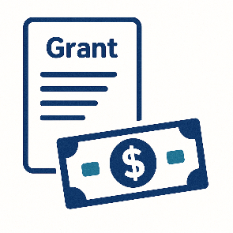 |  | Part 1 is about  - The grant  A grant is when the government gives you money to do something.
 |  | - Where to find information about the grant
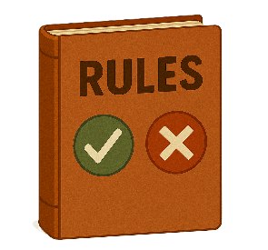 |  | - Rules for the grant.
 |  | Part 2 is about  - Funding.  Funding is money from the government to take part.
 |  | Part 3 is about  - What information is needed
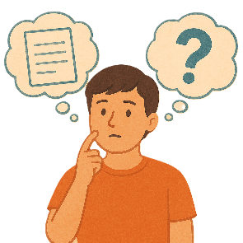 |  | - Can I get help
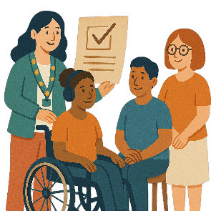 |  | - How organisations will know if they got a grant.
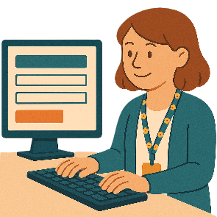 |  | Part 4 is about  - Your application  Applications are forms you fill out to say you want funding to go to a forum.
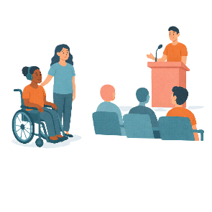 |  | - Going to the forum.  A forum is a meeting to talk about a problem.
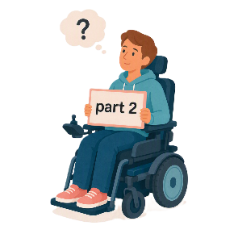 |  | This is part 2.

How much funding can I get

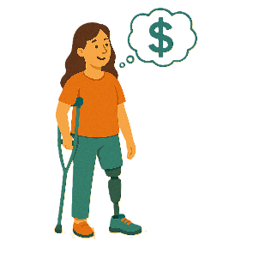 |  | The amount of funding for each person will be different.
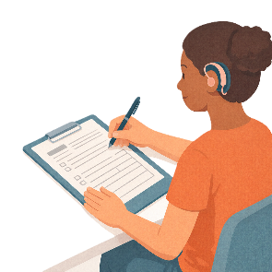 |  | It will depend on what you write in your application.
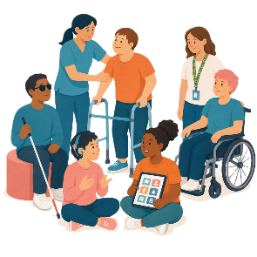 |  | Organisations could get funding for more than 1 person.
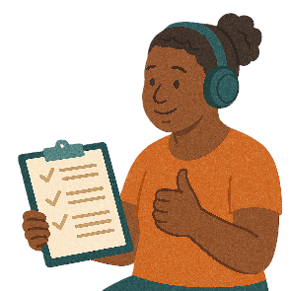 |  | Organisations must make sure you can use all your funding.

Funding for the different forums

 |  | DHDA will decide who get funding.
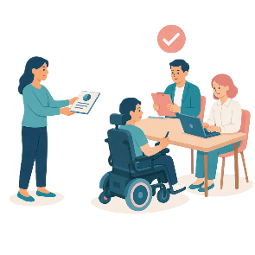 |  | DHDA will look at the report AHRC writes.  This will help them decide.
 |  | Most of the funding will go towards COSP20.

What can the funding be used for

 |  | You can use the funding for  - Travelling to the forum
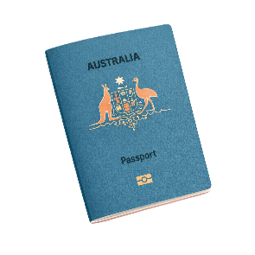 |  | - Passport  A passport is a document from the government.  It says  - Who you are  - What country you are from.  It helps you travel to different countries.
 |  | - Visa  A visa is a document that says you can go to another country for a certain amount of time.
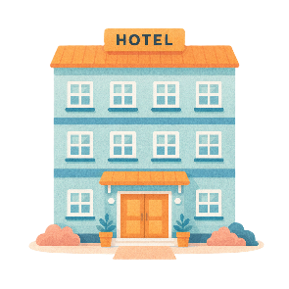 |  | - Accommodation  This is where you stay when you are away from home.
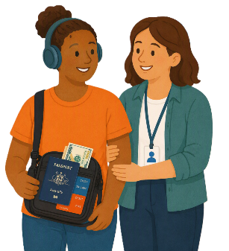 |  | - Support person
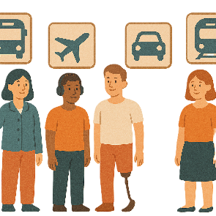 |  | - Transport  Transport is how people move from one place to another.  You can use  - Cars  - Buses  - Planes.
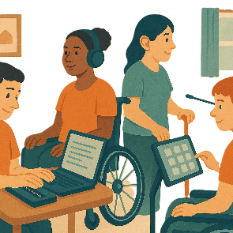 |  | - Assistive technology.  Assistive technology can be things to help you  - Speak  - Move  - See  - Hear.

What you can not spend the funding on

 |  | You can not use the funding for  - Anything not needed to go to the forum like
 |  | - Buying souvenirs  Souvenirs are things you buy to remember a trip or event.  They are not things you need.
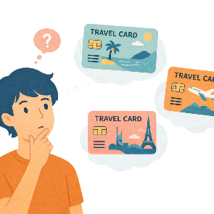 |  | - Extra travel that is not needed to go to the forum
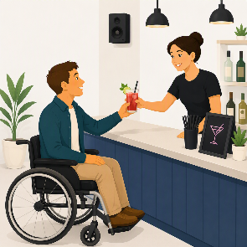 |  | - Alcoholic drinks.

What if I do not spend all the funding

 |  | We will look at why the money was not spent.
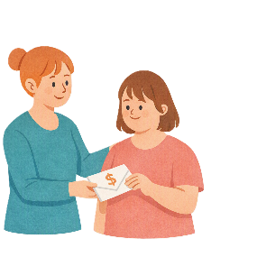 |  | You might need to pay the money back.

When will you get the funding

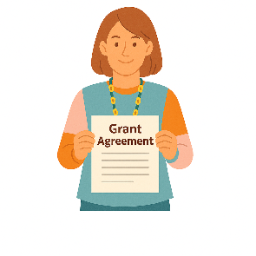 |  | If you get funding your organisation will need to sign a grant agreement.  This says  - How the money can be used  - What rules must be followed.
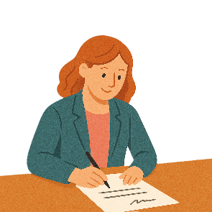 |  | The agreement needs to be signed by  - Your organisation  - DHDA.  This needs to be done before we make payment.
 |  | We think payments will be made in  - February 2027.
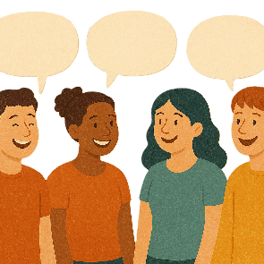 |  | You should check with your organisation before you apply.
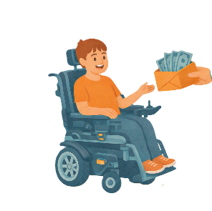 |  | This will tell you  - How they will give you your funding
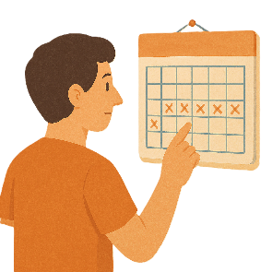 |  | - When they will give you your funding.

Tax questions

 |  | The grant does not include  - Goods and Services Tax  We call it GST for short.  This is tax that is added to things we buy.
 |  | We can not give you any advice about  - Tax.  Tax is money that workers pay to the government.  It helps the government have money to spend on things that everyone uses like roads.

Some images in this Easy Read were made using AI.
You must not share or copy any of the images without permission.
August 2026.

