Supporting participation program

Application guide
Part 1
About SPP
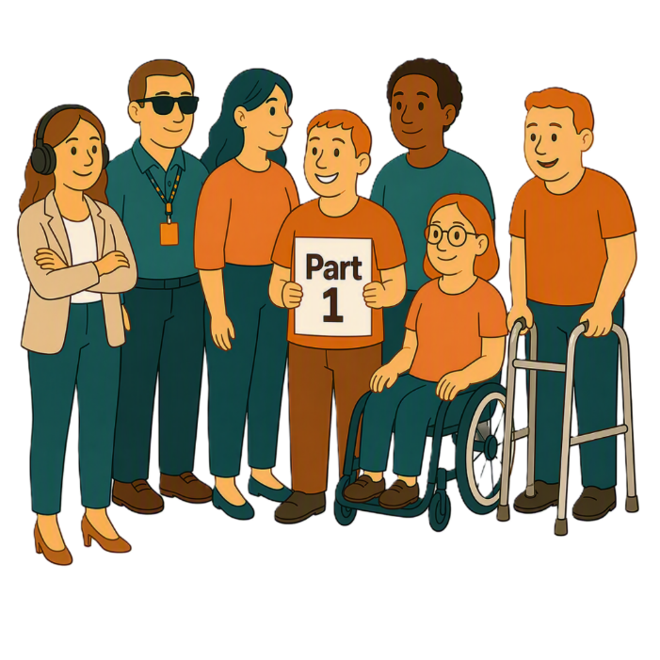
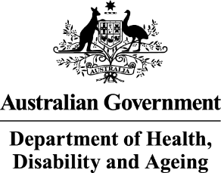 | - The Australian Government Department of Health Disability and Ageing  We say DHDA for short.
 | - The Australian Human Rights Commission  We say AHRC for short.  Wrote this together.  When you see the word we it means  DHDA and AHRC.
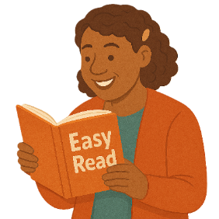 | We wrote this in an easy to read way.  We use pictures to explain some ideas.
 | We have some words in bold.  This means the letters are thicker and darker.  These are important words.
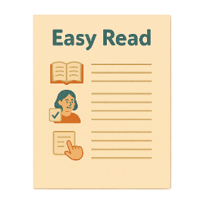 | This is an Easy Read summary of another document.  This means it has the most important ideas.
 | We can answer any questions by email.  Email us disability@humanrights.gov.au
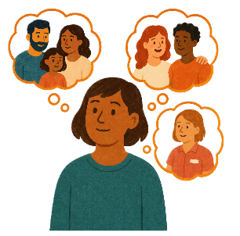 | You can ask for help to read this document.  You can ask  - A friend  - Family members  - A support person.
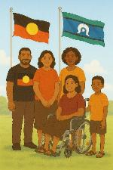 | We recognise Aboriginal and Torres Strait Islander people as the Traditional Owners of the land we live on.
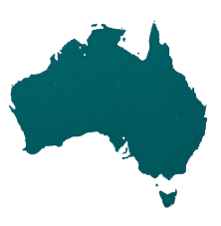 | They were the first people to live on and use the  - Land  - Waters.

Contents

About this document | 5
Supporting Participation Program | 7
Main activities | 10
Goals of the grant | 13
International forums in 2027 | 15
Civil society delegates | 18
Types of delegates | 21
What all delegates must do | 25

About this document

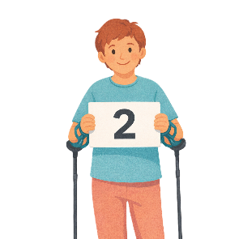 |  | This document has 2 parts.
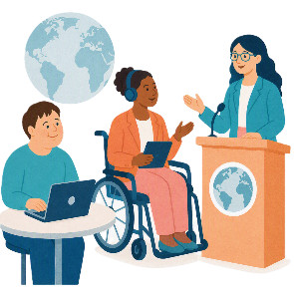 |  | Part 1 is about the  - Supporting Participation Program.  We call it SPP for short.
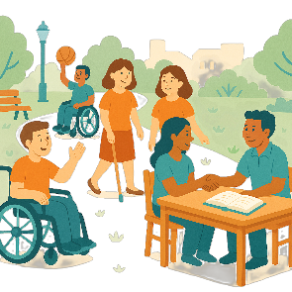 |  | Participation means taking part in something.
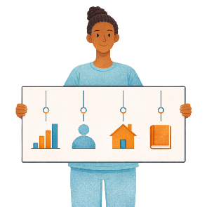 |  | Programs are done to support people in the community.
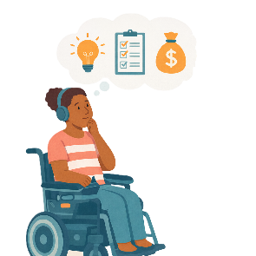 |  | Part 2 is about  - How to apply for the SPP grant.  A grant is when the government gives you money to do something.
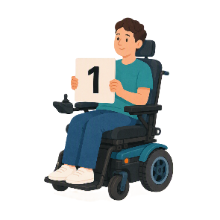 |  | This is part 1.

Supporting Participation Program

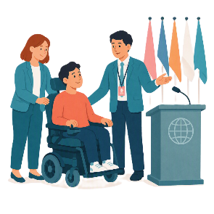 |  | SPP supports people with disability to go to international forums on human rights.  Like the United Nations Conference of States Parties.
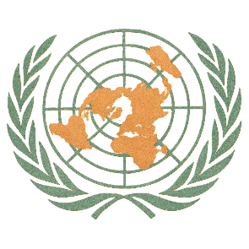 |  | The United Nations is an organisation where countries come together to  - Talk about world issues  - Fix world issues.  We call it the UN for short.
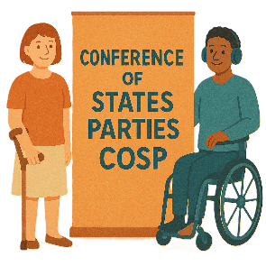 |  | The Conference of States Parties is a meeting for all countries that agreed to support the rights of people with disability.  We call it COSP for short.
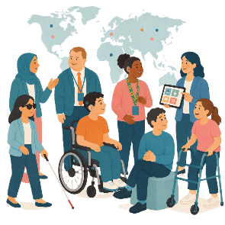 |  | International forums are meetings where people from different countries talk about important issues.
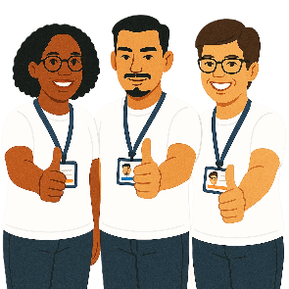 |  | Human rights are rights that everyone has.  Rights are rules about treating everyone  - Fair  - Equal.
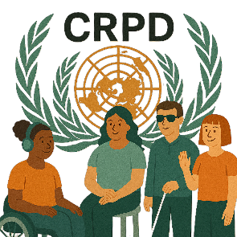 |  | SPP helps Australia to follow the  - UN Convention on the Rights of Persons with Disabilities.  We say CRPD for short.
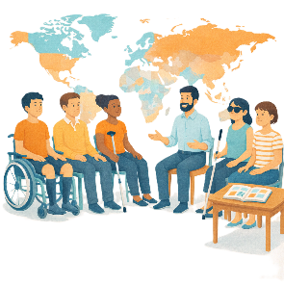 |  | CRPD is an agreement between different countries.  CRPD says how people with disability must have their rights respected.
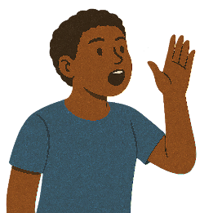 |  | SPP also supports people with disability to  - Speak up about their rights
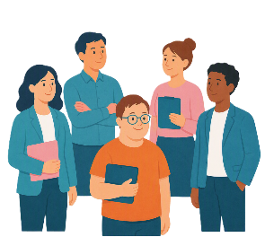 |  | - Represent their organisation.

Main activities

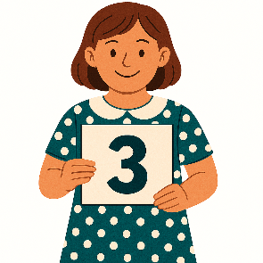 |  | The SPP has 3 main activities.
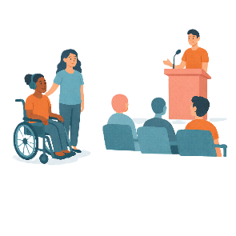 |  | - Civil society taking part in COSP.
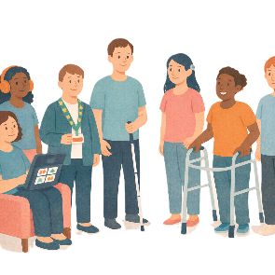 |  | Civil society is groups of people working together to support something.  It is not  - The government  - Business.
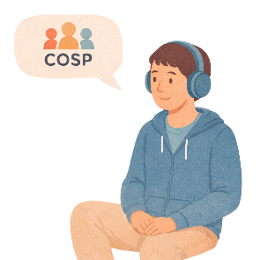 |  | This supports people with disability to go to COSP by giving them a grant.  A grant is when the government gives you money to do something.
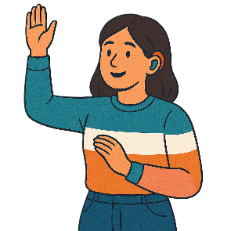 |  | - Application process  An application is when someone says they want to take part in something.  This helps us choose who will get the grant.
AHRC will

- Manage the applications
- Write a report for DHDA about the applications.
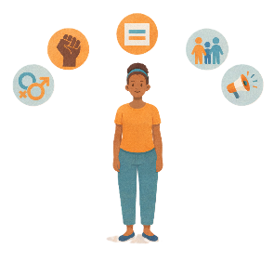 |  | AHRC helps people and communities to  - Understand their rights.  - Speak up about their rights.
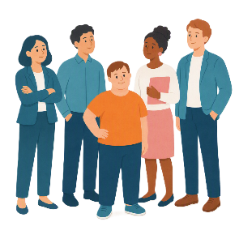 |  | The AHRC also helps to support people who go to a forum.
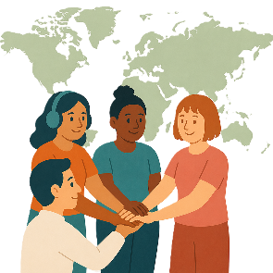 |  | - Support for people to take part in other international forums.
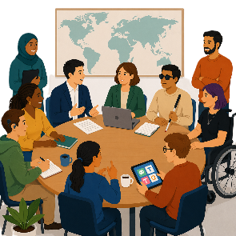 |  | This helps people take part in  - Other important international meetings.

Goals of the grant

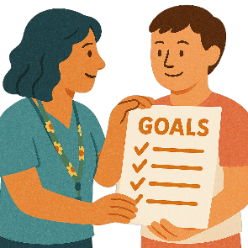 |  | The grant has 4 goals.  Goals are things you want to do.
The goals are to support

- People with disability take part in international meetings about human rights
 |  | - Australia to follow the CRPD
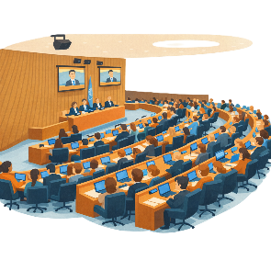 |  | - Disability and community organisations to learn what issues are talked about at COSP
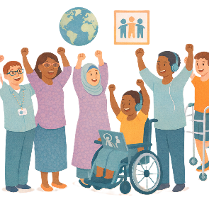 |  | - People to learn more about disability issues at other international meetings on human rights.

International forums in 2027

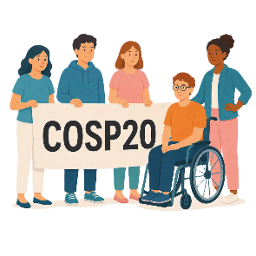 |  | There are 3 international forums in 2027.  They are  - 20th session of COSP  We call it COSP20 for short.
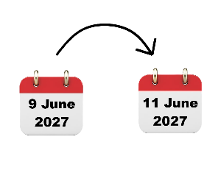 |  | COSP20 will be in New York in the United States of America on  - 9 June to 11 June 2027.  We call it the USA for short.
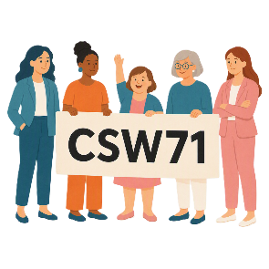 |  | - 71st Session of the Commission on the Status of Women  We say CSW71 for short.
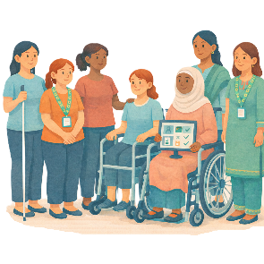 |  | CSW is about  - The rights of women  - Gender equality  Gender equality means that everyone is treated equal no matter your gender.
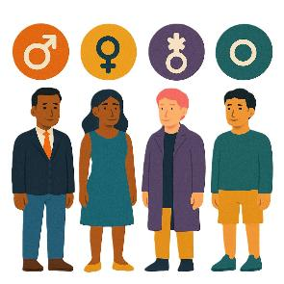 |  | People say what gender they are.  They might be  - A man  - A woman  - A different gender  - No gender.
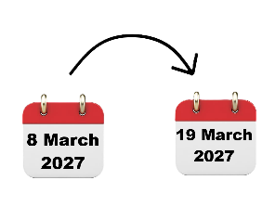 |  | CSW71 will be in New York the USA on  - 8 March to 19 March 2027.
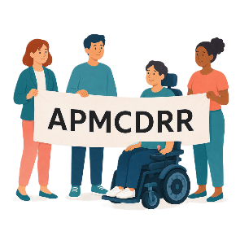 |  | - Asia Pacific Ministerial Conference on Disaster Risk Reduction.  We say APMCDRR for short.
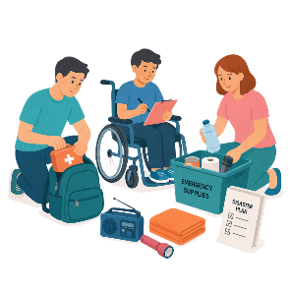 |  | APMCDRR is about  - Preparing for disasters  - Keeping people safe during disasters.
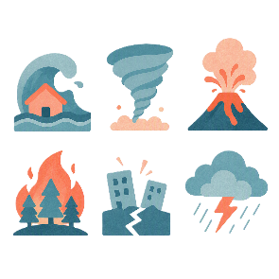 |  | Natural disasters are things like  - Cyclones  - Earthquakes  - Floods  - Volcanoes.
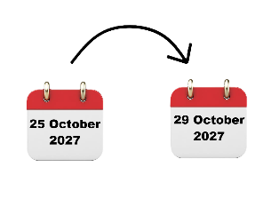 |  | APMCDRR will be in Japan on  - 25 October to 29 October 2027.

Civil society delegates

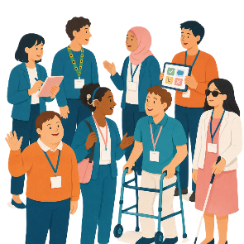 |  | Civil society delegates have things they need to do.  A delegate is a person who  - Is part of an organisation  - Speaks for their organisation  - Speaks up about their experiences.
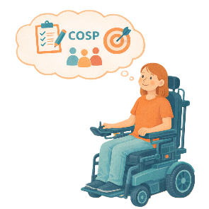 |  | Delegates have to  - Take part in forums
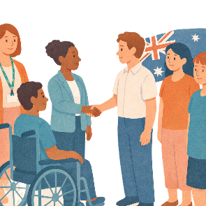 |  | - Be a part of the group of Australian delegates
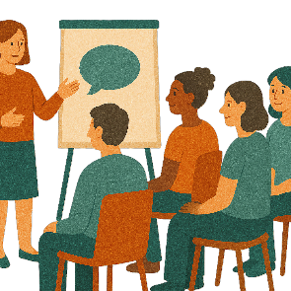 |  | - Go to workshops  Workshops are for delegates to  - Meet each other  - Agree on goals and messages.
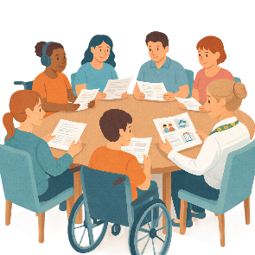 |  | - Go to meetings before and after a forum  The meetings are for delegates to  - Get ready for a forum  - Talk about what happened at the forum.
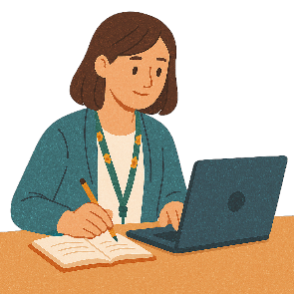 |  | - Learn more about  - Human rights  - Advocacy  - Representing Australia on disability issues
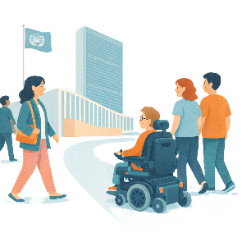 |  | - Visit the UN and other international organisations.

Types of delegates

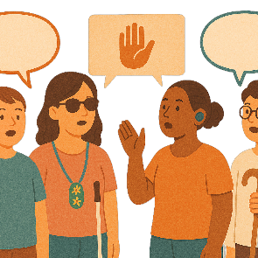 |  | All delegates must be part of a  - Disability organisation  - Advocacy organisation.  Advocacy is when someone supports you to speak up for your rights.
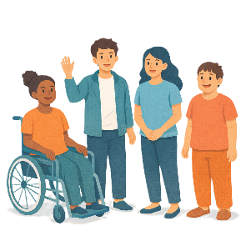 |  | There are 2 types of delegates.  - Emerging Young Leader Delegates  This is for people aged 18 to 35 years old.
 |  | This supports young people with disability build their skills and confidence to be leaders.
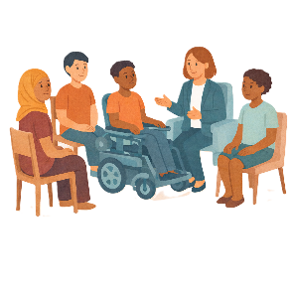 |  | They will have a mentor from the general delegate.  A mentor is someone you can  - Ask for advice  - Get support from.
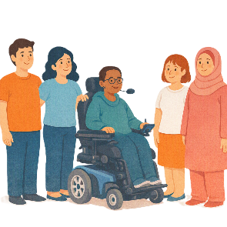 |  | - General Delegates  This is for people 18 years or older.
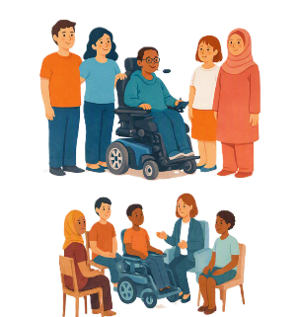 |  | People aged 18 to 35 years old can choose to be  - A General Delegate  or  - An Emerging Young Leader Delegate.
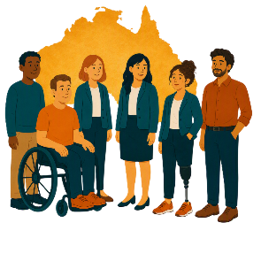 |  | General Delegates support all the Australian delegates.
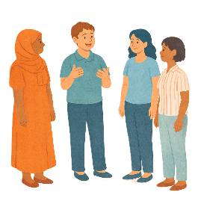 |  | They  - Lead talks about issues for all delegates to think about
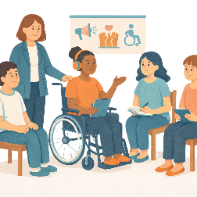 |  | - Share what they have learned in their advocacy work
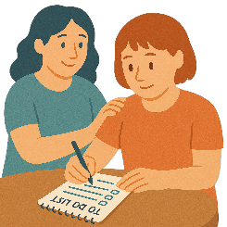 |  | - Help with group tasks
 |  | - Help organise meetings
 |  | - Mentor at least 1 person from the Emerging Young Leader Delegates.

What all delegates must do

All delegates must

- Take part in most forum events
 |  | - Follow the event rules
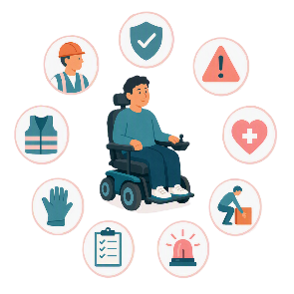 |  | - Follow Work Health and Safety rules  We call it WHS for short.
 |  | - Support the civil society goals
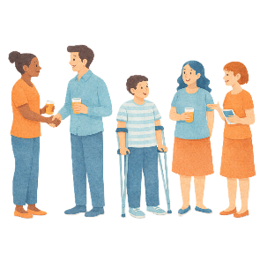 |  | - Network with other people at forums  Network is when people meet and talk to each other.
 |  | - Support the work of the Australian delegates.
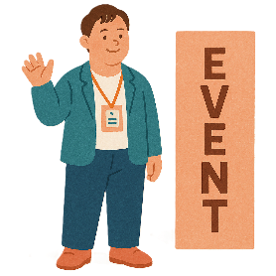 |  | All delegates must also  - Go to most of the event in person
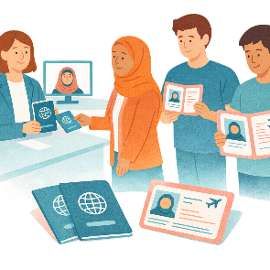 |  | - Make sure they have all the documents needed like  - Passport  - Visa  - Travel Insurance.
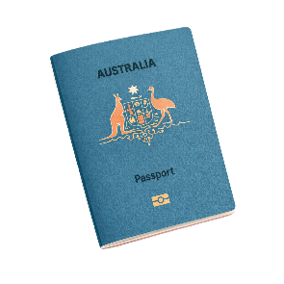 |  | A passport is a document from the government.  It says  - Who you are  - What country you are from.  It helps you travel to different countries.
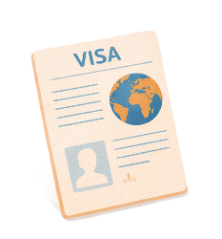 |  | A visa is a document that says you can go to another country for a certain amount of time.
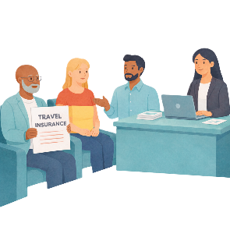 |  | Travel insurance covers lots of different things while you are travelling.  It can cover things like if you  - Miss your flight  - There are changes to your flight  - Get sick or hurt while travelling  - Lose your luggage  Luggage are the bags and things you bring with you when you travel.
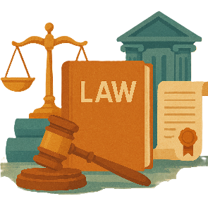 |  | Delegates must follow the laws of  - The country they go to  - Other countries they visit on the trip.  Laws are rules for how we live.

Some images in this Easy Read were made using AI.
You must not share or copy any of the images without permission.
August 2026.

