Supporting participation program
Common questions
Part 1
The grant
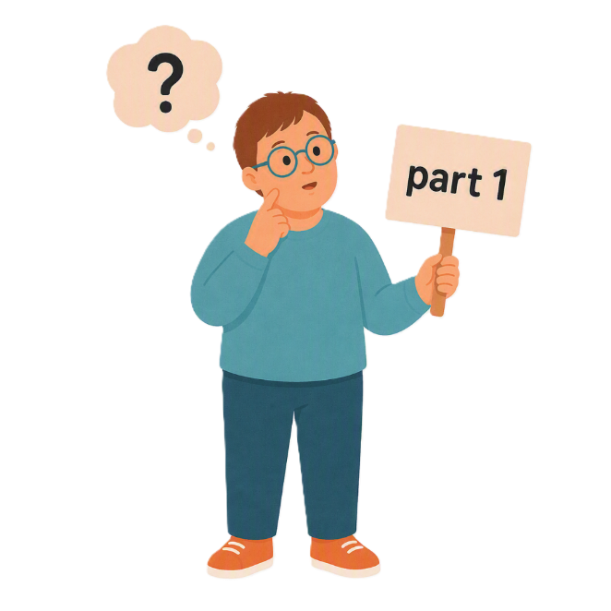
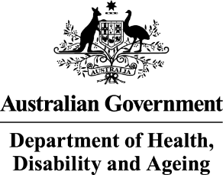 | - The Australian Government Department of Health Disability and Ageing  We say DHDA for short.
 | - The Australian Human Rights Commission  We say AHRC for short.  Wrote this together.  When you see the word we it means  DHDA and AHRC.
 | We wrote this in an easy to read way.  We use pictures to explain some ideas.
 | We have some words in bold.  This means the letters are thicker and darker.  These are important words.
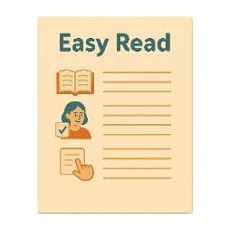 | This is an Easy Read summary of another document.  This means it has the most important ideas.
 | We can answer any questions by email.  Email us disability@humanrights.gov.au
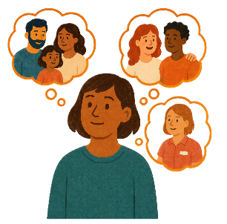 | You can ask for help to read this document.  You can ask  - A friend  - Family members  - A support person.
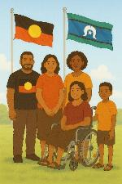 | We recognise Aboriginal and Torres Strait Islander people as the Traditional Owners of the land we live on.
 | They were the first people to live on and use the  - Land  - Waters.

Contents

About the Supporting Participation Program | 5
About this document | 9
Where are the grant documents | 12
What type of grant is this | 14
How can I put in an application | 17
How many applications can I put in | 19
Can I put in a late application | 20
Can I change my mind | 23

About the Supporting Participation Program

 |  | This talks about the  Supporting Participation Program.  We call it SPP for short.
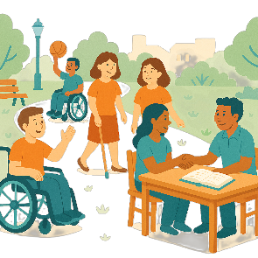 |  | Participation means taking part in something.
 |  | Programs are done to support people in the community.
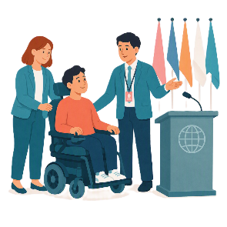 |  | SPP supports people with disability to go to international forums on human rights.  Like the United Nations Conference of States Parties.
 |  | The United Nations is an organisation where countries come together to  - Talk about world issues  - Fix world issues.  We call it the UN for short.
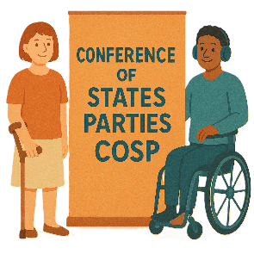 |  | The Conference of States Parties is a meeting for all countries that agreed to support the rights of people with disability.  We call it COSP for short.
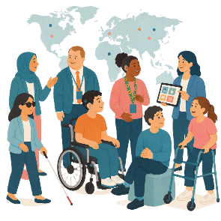 |  | International forums are meetings where people from different countries talk about important issues.
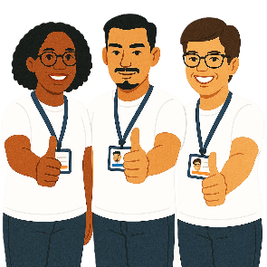 |  | Human rights are rights that everyone has.  Rights are rules about treating everyone  - Fair  - Equal.
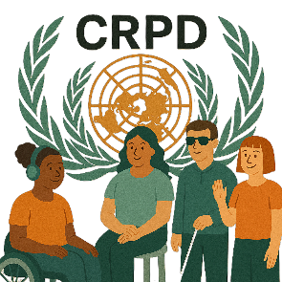 |  | SPP helps Australia to follow the  - UN Convention on the Rights of Persons with Disabilities.  We say CRPD for short.
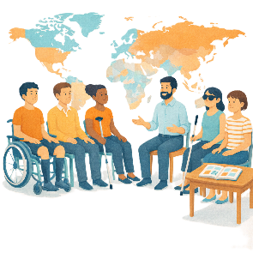 |  | CRPD is an agreement between different countries.  CRPD says how people with disability must have their rights respected.
 |  | SPP also supports people with disability to  - Speak up about their rights
 |  | - Represent their organisation.

About this document

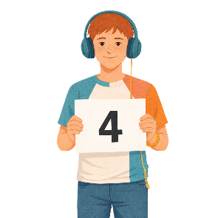 |  | This document has 4 parts.
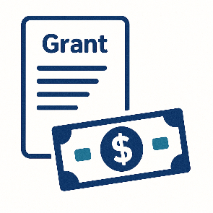 |  | Part 1 is about  - The grant  A grant is when the government gives you money to do something.
 |  | - Where to find information about the grant
 |  | - Rules for the grant.
 |  | Part 2 is about  - Funding.  Funding is money from the government to take part.
 |  | Part 3 is about  - What information is needed
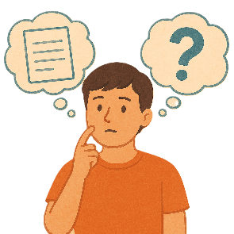 |  | - Can I get help
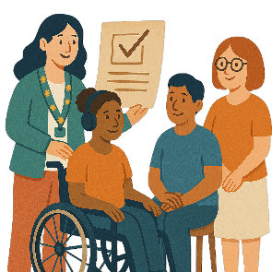 |  | - How organisations will know if they got a grant.
 |  | Part 4 is about  - Your application  Applications are forms you fill out to say you want funding to go to a forum.
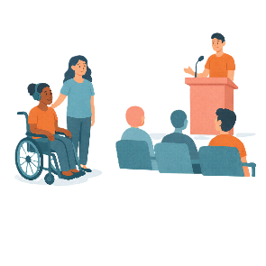 |  | - Going to the forum.  A forum is a meeting to talk about a problem.
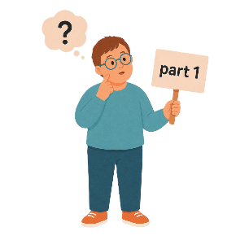 |  | This is part 1.

Where are the grant documents

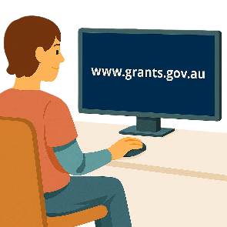 |  | The grant documents are on 2 websites.
 |  | You can go to the AHRC website.  humanrights.gov.au/our-work/topics/disability-rights-what-were-doing/supporting-participation-program  It is not in Easy Read.
You can go to GrantConnect.

www.grants.gov.au/

It is not in Easy Read.
 |  | You need to register to look at the documents on GrantConnect.  Register means put you sign up for something.
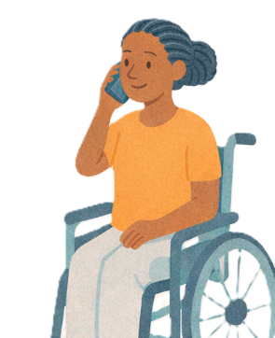 |  | If you have problems going on GrantConnect you can  - Call them on  1300 484 145
 |  | - Send them an email to  GrantConnect@finance.gov.au

What type of grant is this

 |  | There are rules for who can apply for the grant.
 |  | Apply means that you send information about  - Who you are  - What you want to go to.  This will help them know if you can be part of SPP.
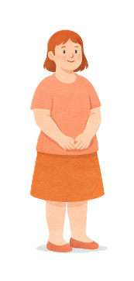 |  | You must be  - 18 years or older
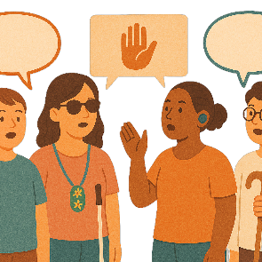 |  | You must be part of a  - Disability Organisation  - Advocacy organisation.  Advocacy is when someone supports you to speak up for your rights.
 |  | Your organisation must have  - Approval from the forums you would like to attend
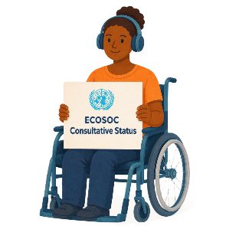 |  | Or  - UN Economic and Social Council Consultative Status.  We say ECOSOC for short.
 |  | ECOSOC status means  - Your organisation has been approved to take part in these meetings.  ECOSOC invites people from other countries to talk about ways to make the world a better place.
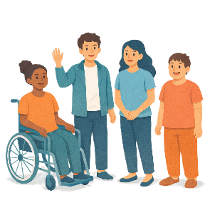 |  | If you want to apply to be an Emerging Young Leader you need to be between  - 18 years old  - 35 years old.
 |  | We will follow the rules to decide who will get a grant.

How can I put in an application

 |  | You can email your application to AHRC  disability@humanrights.gov.au
You need to read all the documents about the grant.

The documents will say what you need to put in your application.
 |  | You need to put in your application before  Sunday 1 November 2026  11pm AEDT.
 |  | AEDT is the time in  - Canberra  - New South Wales  - Tasmania  - Victoria  If you live somewhere else you will need to check the time to send it in by.
If you need help with putting your application in you can email

disability@humanrights.gov.au

How many applications can I put in

 |  | Organisations can only put in 1 application.
 |  | There are 2 parts.  Part 2 is about the person wanting to apply.
 |  | Organisations need to have a part 2 for every person applying.  They could have lots of part 2 applications.  This is so there is a part 2 for each person from the same organisation.
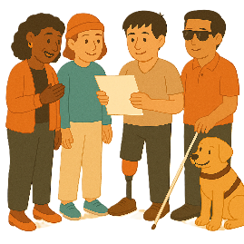 |  | We will only look at the last application if organisations put in more than 1 application.

Can I put in a late application

 |  | We do not normally let people put in late applications.
 |  | There are some reasons that we might.  This is called exceptional circumstances.
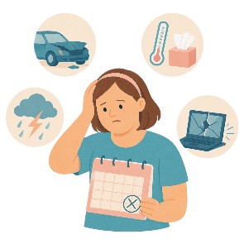 |  | Exceptional circumstances are things  - You do not know will happen  - Can not help  - Can not fix before applications close.
You need to ask if you can put in a late application.

You need to send an email to

disability@humanrights.gov.au
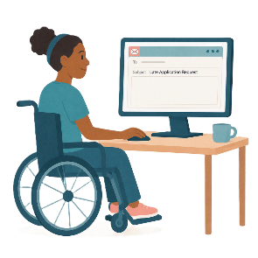 |  | In the email subject line you will need to put  - Late Application Request.  This tells people what the email is about before they open it.
 |  | You need to send the email before  Wednesday 4 November 2026  5pm AEDT.
 |  | In your email you need to say  - Why you could not put your application in on time.
 |  | The person making the decision will look at your reasons.  AHRC will tell you what the decision is.

Can I change my mind

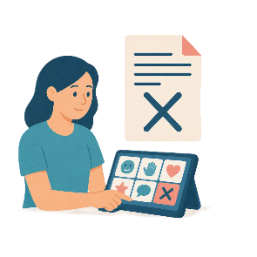 |  | Yes.  You can change your mind about putting in your application.  This is called withdraw an application.
You need to send an email to

disability@humanrights.gov.au
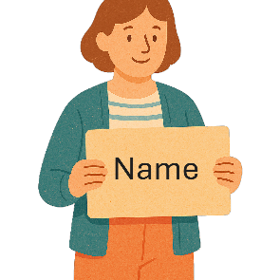 |  | Your email needs to say  - The name of your organisation
 |  | - What grant you applied for
 |  | - Why you changed your mind.
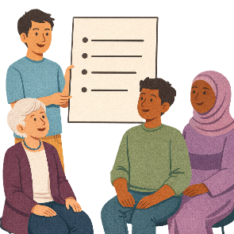 |  | The email needs to come from someone who is in the application.

Some images in this Easy Read were made using AI.
You must not share or copy any of the images without permission.
August 2026.

