Supporting participation program
Part 3
Disability organisations
Roles and responsibilities
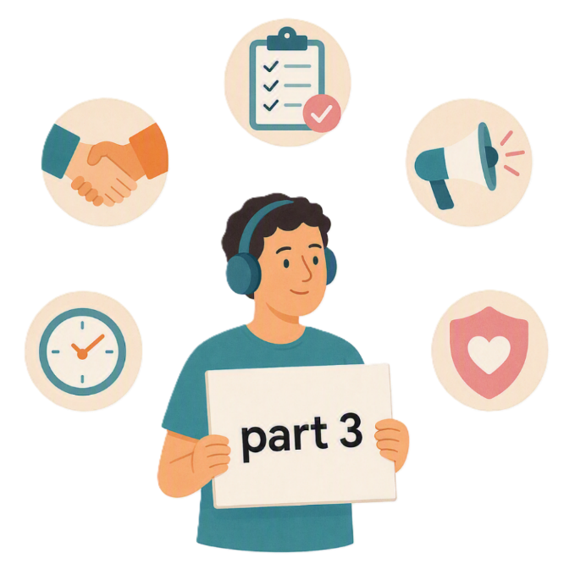
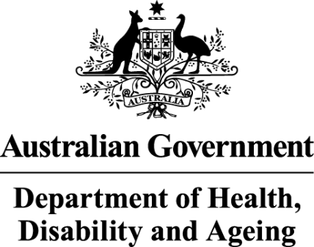 | - The Australian Government Department of Health Disability and Ageing  We say DHDA for short.
 | - The Australian Human Rights Commission  We say AHRC for short.  Wrote this together.  When you see the word we it means  DHDA and AHRC.
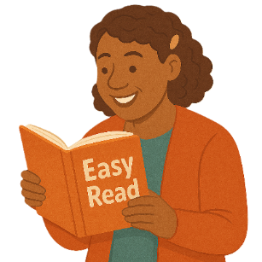 | We wrote this in an easy to read way.  We use pictures to explain some ideas.
 | We have some words in bold.  This means the letters are thicker and darker.  These are important words.
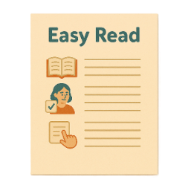 | This is an Easy Read summary of another document.  This means it has the most important ideas.
 | We can answer any questions by email.  Email us disability@humanrights.gov.au
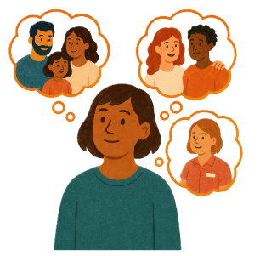 | You can ask for help to read this document.  You can ask  - A friend  - Family members  - A support person.
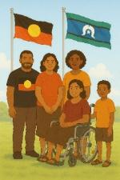 | We recognise Aboriginal and Torres Strait Islander people as the Traditional Owners of the land we live on.
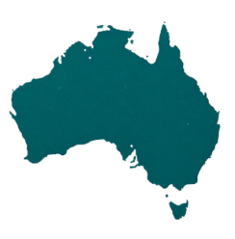 | They were the first people to live on and use the  - Land  - Waters.

Contents

Supporting Participation Program | 5
International forums in 2027 | 9
About this document | 12
Organisations roles and responsibilities | 15
What you will do for SPP | 21
What you must do for SPP | 23

Supporting Participation Program

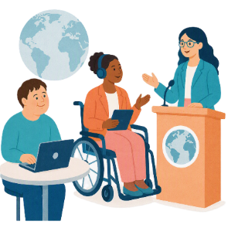 |  | This talks about the  Supporting Participation Program.  We call it SPP for short.
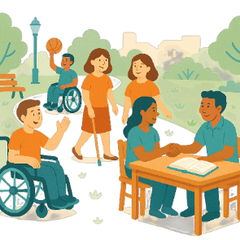 |  | Participation means taking part in something.
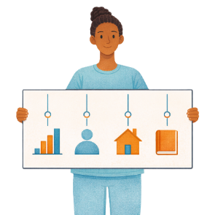 |  | Programs are done to support people in the community.
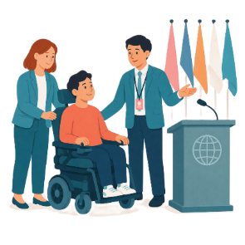 |  | SPP supports people with disability to go to international forums on human rights.  Like the United Nations Conference of States Parties.
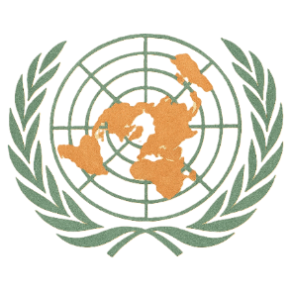 |  | The United Nations is an organisation where countries come together to  - Talk about world issues  - Fix world issues.  We call it the UN for short.
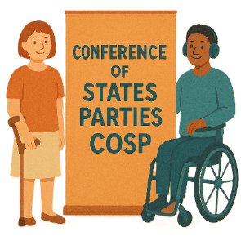 |  | The Conference of States Parties is a meeting for all countries that agreed to support the rights of people with disability.  We call it COSP for short.
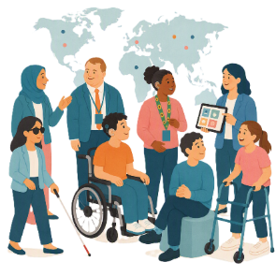 |  | International forums are meetings where people from different countries talk about important issues.
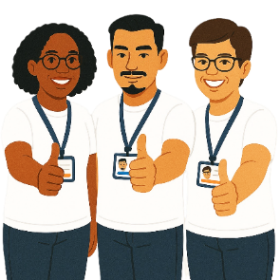 |  | Human rights are rights that everyone has.  Rights are rules about treating everyone  - Fair  - Equal.
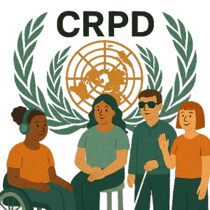 |  | SPP helps Australia to follow the  - UN Convention on the Rights of Persons with Disabilities.  We say CRPD for short.
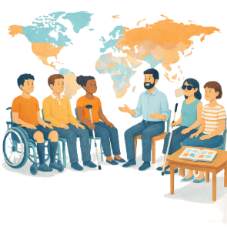 |  | CRPD is an agreement between different countries.  CRPD says how people with disability must have their rights respected.
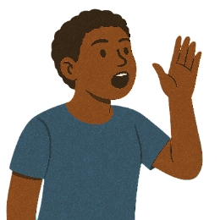 |  | SPP also supports people with disability to  - Speak up about their rights
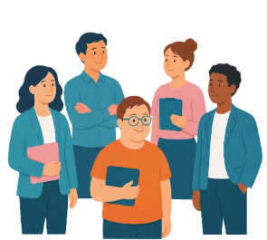 |  | - Represent their organisation.

International forums in 2027

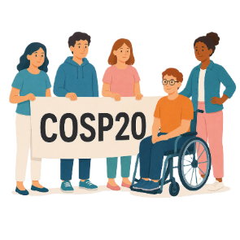 |  | There are 3 international forums in 2027.  They are  - 20th session of COSP  We call it COSP20 for short.
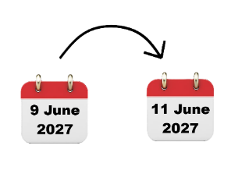 |  | COSP20 will be in the United States of America on  - 9 June to 11 June 2027.  We call it the USA for short.
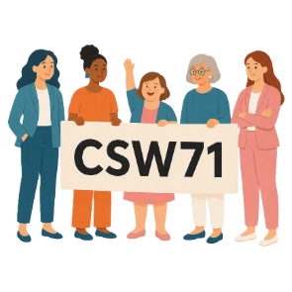 |  | - 71st Session of the Commission on the Status of Women  We say CSW71 for short.
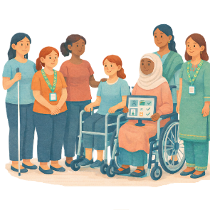 |  | CSW is about  - The rights of women  - Gender equality  Gender equality means that everyone is treated equal no matter your gender.
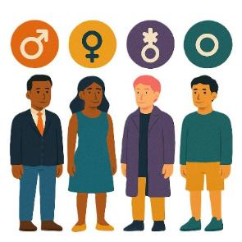 |  | People say what gender they are.  They might be  - A man  - A woman  - A different gender  - No gender.
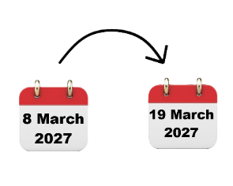 |  | CSW71 will be in the USA on  - 8 March to 19 March 2027.
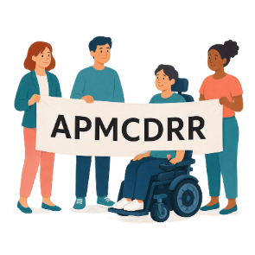 |  | - Asia Pacific Ministerial Conference on Disaster Risk Reduction.  We say APMCDRR for short.
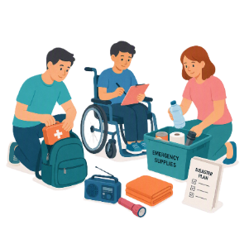 |  | APMCDRR is about  - Preparing for disasters  - Keeping people safe during disasters.
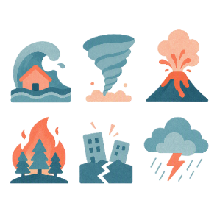 |  | Natural disasters are things like  - Cyclones  - Earthquakes  - Floods  - Volcanoes.
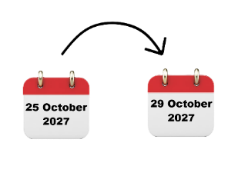 |  | APMCDRR will be in Japan on  - 25 October to 29 October 2027.

About this document

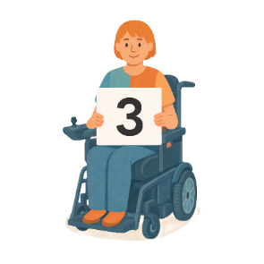 |  | This document is in 3 parts.
Part 1 is about the AHRC

- Objectives

 |  | Objectives are things that we want to do.
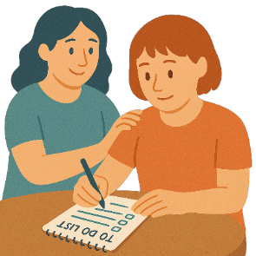 |  | - Roles and responsibilities.  Roles and responsibilities are the things you need to do for SPP.  This makes sure everyone knows what they need to do.
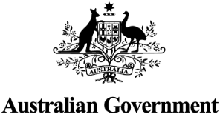 |  | Part 2 is about the Australian Government  - Objectives
 |  | - Roles and responsibilities.
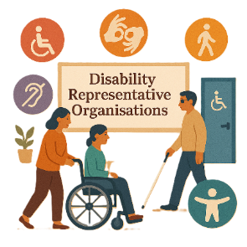 |  | Part 3 is about  - Disability Representative Organisations  We call them DROs for short.
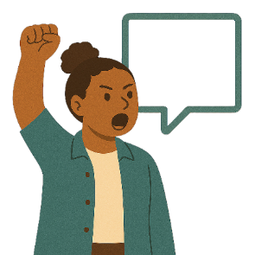 |  | - Advocacy organisations  Advocacy is when someone supports you to speak up for your rights.
 |  | - Their roles and responsibilities.
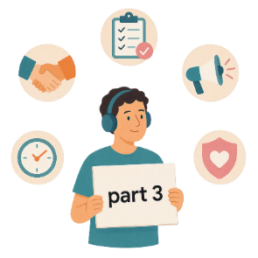 |  | This is part 3.

Organisations roles and responsibilities

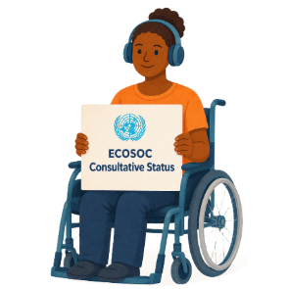 |  | Organisations need to have approval to go to some of the forums.  They must have  - UN Economic and Social Council Consultative Status  We say ECOSOC for short.
 |  | ECOSOC status means  - Your organisation has been approved to take part in these meetings.  ECOSOC invites people from other countries to talk about ways to make the world a better place.
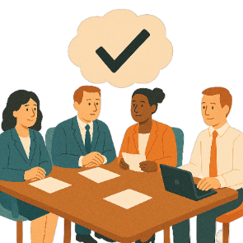 |  | - Approval to go to the forums.  This means you can go to the forum.
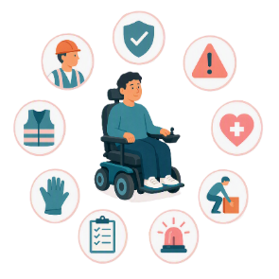 |  | Organisations will  - Make sure everyone follows Work Health and Safety rules  We call it WHS for short.
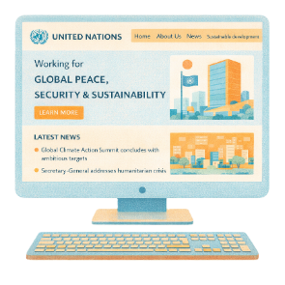 |  | - Check the UN websites  - Share information with everyone going to the forum.
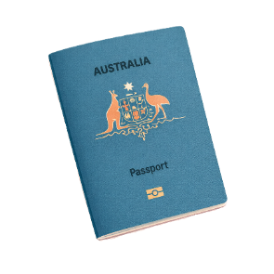 |  | Organisations will support people with things like  - Passport  A passport is a document from the government.  It says  - Who you are  - What country you are from.  It helps you travel to different countries.
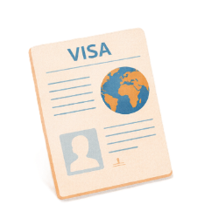 |  | - Visa  A visa is a document that says you can go to another country for a certain amount of time.
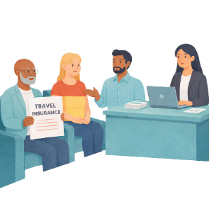 |  | - Travel insurance.  This covers lots of different things while you are travelling.  It can cover things like if you  - Miss your flight  - There are changes to your flight  - Get sick or hurt while travelling  - Lose your luggage.  Luggage are the bags and things you bring with you when you travel.
 |  | Organisations will support people to follow the laws in countries  - The forums are in
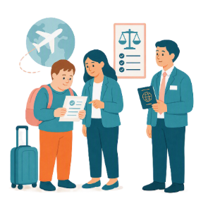 |  | - They travel through to get to the forum.
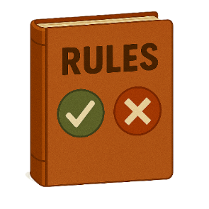 |  | Organisations will support people to  - Follow the rules of the UN
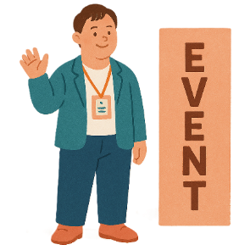 |  | - Look for events to go to
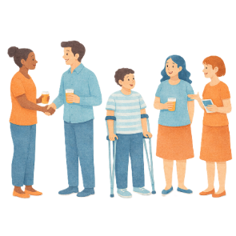 |  | - Look for chances to network.  Networking is when people meet and talk to each other.
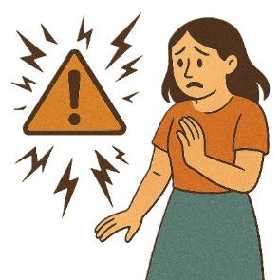 |  | Organisations will  - Manage risks when travelling  Risks are the chance that something bad might happen to you.
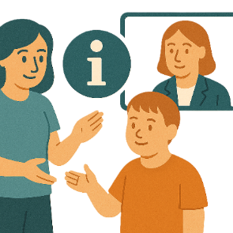 |  | - Share information after the forum.
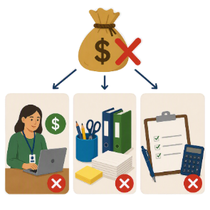 |  | Organisations must give all the funding to the person who is going to the forum.  They can not keep any funding for  - Paying staff  - Office supplies  - Costs of applying for the grant.

What you will do for SPP

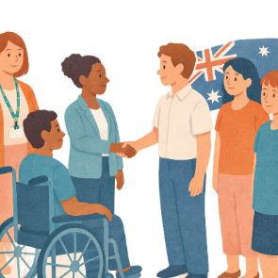 |  | To take part in SPP you will work with other  - People going to the forum  This is called the Australian Delegation.
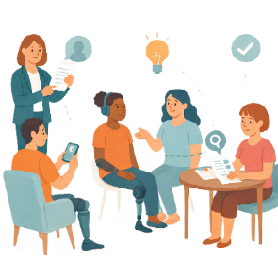 |  | - Organisations about ideas to talk about at the forum.  This includes what to put in interventions.
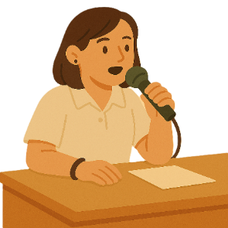 |  | Interventions are talking about an issue from the floor at a forum.  You can only talk for a short time.
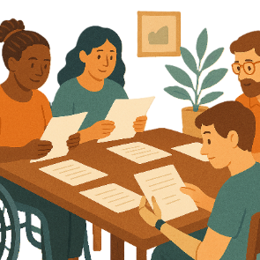 |  | To take part in SPP you will  - Be part of activities for the forum
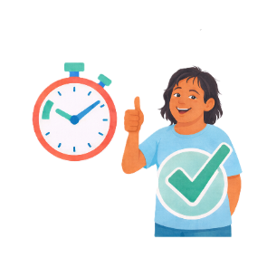 |  | - Give information quickly when it is asked for  This includes  - Contact information  - Forms.

What you must do for SPP

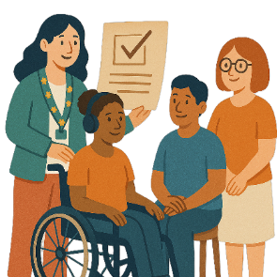 |  | To take part in SPP you must  - Do all the things for the grant in the time given
 |  | - Go in person to more than half of the forum.
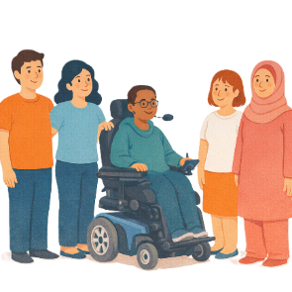 |  | Some people will go as a  - General Delegate  General Delegates are given funding to support everyone going to an international forum.
General Delegates must

- Support the Australian Delegation
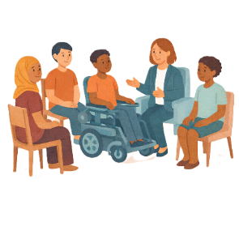 |  | - Mentor at least 1 person from the Emerging Young Leaders Delegation.
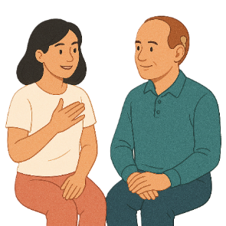 |  | A mentor is someone you can  - Ask for advice  - Get support from.

Some images in this Easy Read were made using AI.
You must not share or copy any of the images without permission.
August 2026.

