Supporting participation program
Part 2

Australian Government

Roles and responsibilities
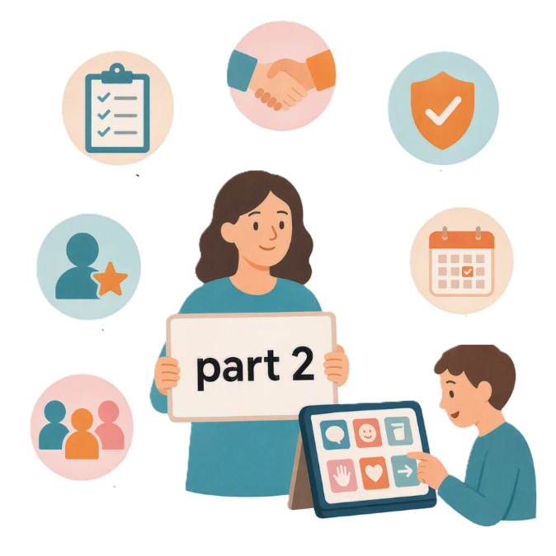
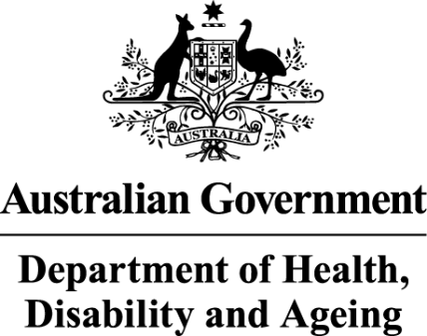 | - The Australian Government Department of Health Disability and Ageing  We say DHDA for short.
 | - The Australian Human Rights Commission  We say AHRC for short.  Wrote this together.  When you see the word we it means  DHDA and AHRC.
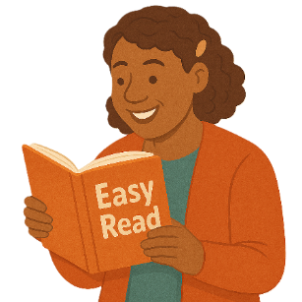 | We wrote this in an easy to read way.  We use pictures to explain some ideas.
 | We have some words in bold.  This means the letters are thicker and darker.  These are important words.
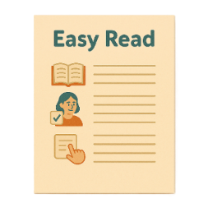 | This is an Easy Read summary of another document.  This means it has the most important ideas.
 | We can answer any questions by email.  Email us disability@humanrights.gov.au
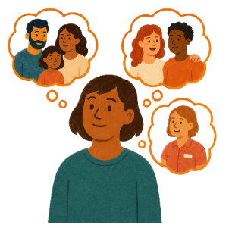 | You can ask for help to read this document.  You can ask  - A friend  - Family members  - A support person.
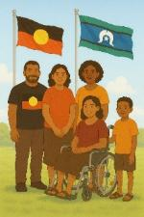 | We recognise Aboriginal and Torres Strait Islander people as the Traditional Owners of the land we live on.
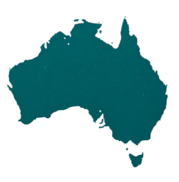 | They were the first people to live on and use the  - Land  - Waters.

Contents

Supporting Participation Program | 5
International forums in 2027 | 9
About this document | 12
Australian Government objectives | 15
Australian Government support | 20
Australian Government contact information | 22

Supporting Participation Program

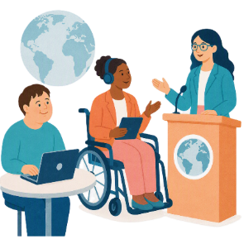 |  | This talks about the  Supporting Participation Program.  We call it SPP for short.
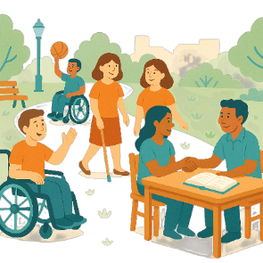 |  | Participation means taking part in something.
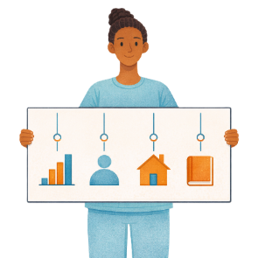 |  | Programs are done to support people in the community.
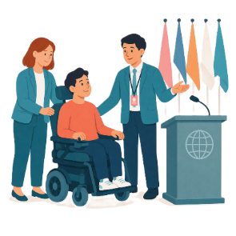 |  | SPP supports people with disability to go to international forums on human rights.  Like the United Nations Conference of States Parties.
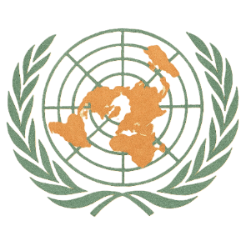 |  | The United Nations is an organisation where countries come together to  - Talk about world issues  - Fix world issues.  We call it the UN for short.
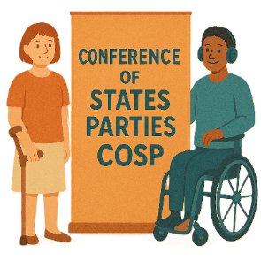 |  | The Conference of States Parties is a meeting for all countries that agreed to support the rights of people with disability.  We call it COSP for short.
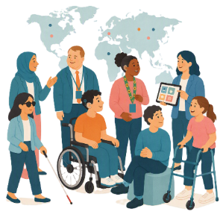 |  | International forums are meetings where people from different countries talk about important issues.
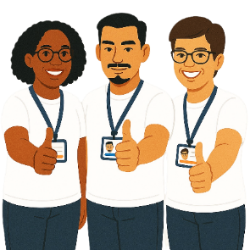 |  | Human rights are rights that everyone has.  Rights are rules about treating everyone  - Fair  - Equal.
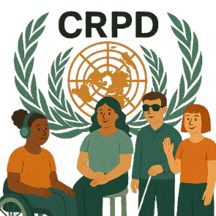 |  | SPP helps Australia to follow the  - UN Convention on the Rights of Persons with Disabilities.  We say CRPD for short.
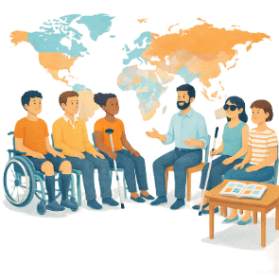 |  | CRPD is an agreement between different countries.  CRPD says how people with disability must have their rights respected.
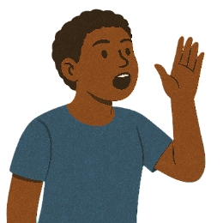 |  | SPP also supports people with disability to  - Speak up about their rights
 |  | - Represent their organisation.

International forums in 2027

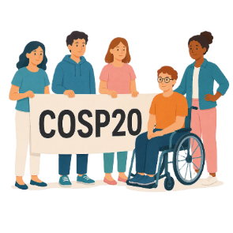 |  | There are 3 international forums in 2027.  They are  - 20th session of COSP  We call it COSP20 for short.
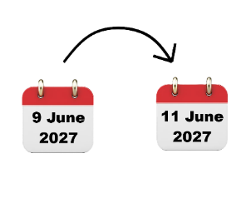 |  | COSP20 will be in the United States of America on  - 9 June to 11 June 2027.  We call it the USA for short.
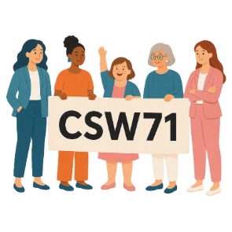 |  | - 71st Session of the Commission on the Status of Women  We say CSW71 for short.
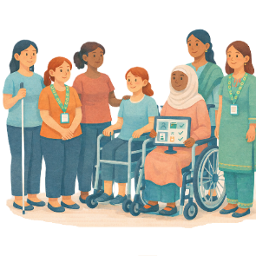 |  | CSW is about  - The rights of women  - Gender equality  Gender equality means that everyone is treated equal no matter your gender.
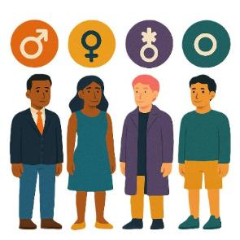 |  | People say what gender they are.  They might be  - A man  - A woman  - A different gender  - No gender.
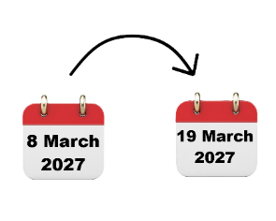 |  | CSW71 will be in the USA on  - 8 March to 19 March 2027.
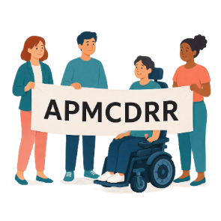 |  | - Asia Pacific Ministerial Conference on Disaster Risk Reduction.  We say APMCDRR for short.
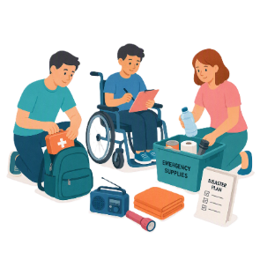 |  | APMCDRR is about  - Preparing for disasters  - Keeping people safe during disasters.
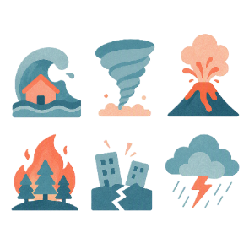 |  | Natural disasters are things like  - Cyclones  - Earthquakes  - Floods  - Volcanoes.
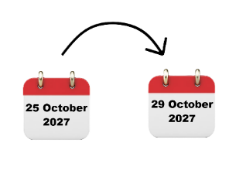 |  | APMCDRR will be in Japan on  - 25 October to 29 October 2027.

About this document

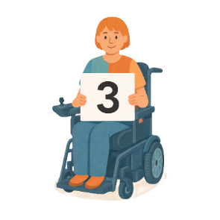 |  | This document is in 3 parts.
Part 1 is about the AHRC

- Objectives

 |  | Objectives are things that we want to do.
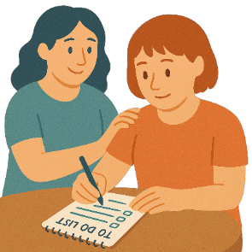 |  | - Roles and responsibilities.  Roles and responsibilities are the things you need to do for SPP.  This makes sure everyone knows what they need to do.
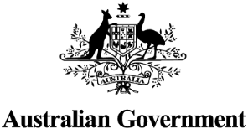 |  | Part 2 is about the Australian Government  - Objectives
 |  | - Roles and responsibilities.
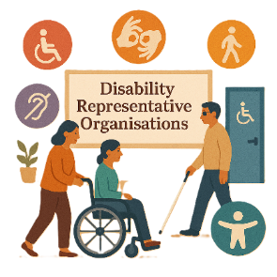 |  | Part 3 is about  - Disability Representative Organisations  We call them DROs for short.
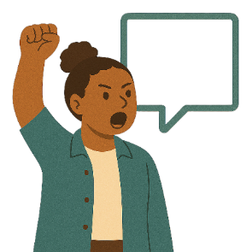 |  | - Advocacy organisations  Advocacy is when someone supports you to speak up for your rights.
 |  | - Their roles and responsibilities.
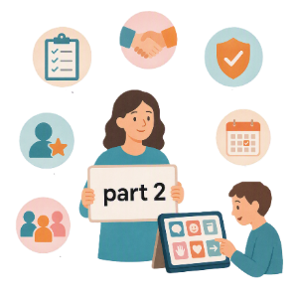 |  | This is part 2.

Australian Government objectives

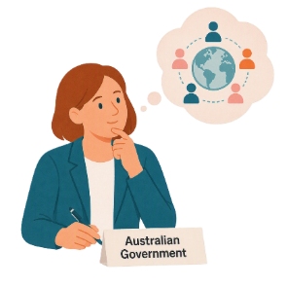 |  | The Australian Government has things they want to do at all international forums.
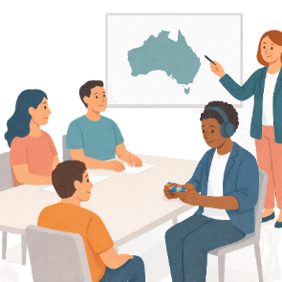 |  | The Australian Government wants to  - Represent Australia at international meetings
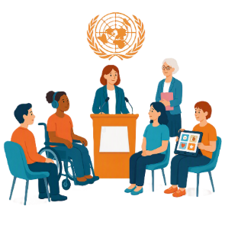 |  | - Say the National Statement.  This is the message from the Australian Government.  It says all the good things they are doing about disability issues.
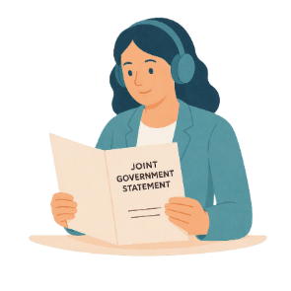 |  | The Australian Government wants to  - Support joint government statements  This is the message from 2 or more different governments.  They all agree  - On the same message  - About the issues together.  1 person will say the statement.
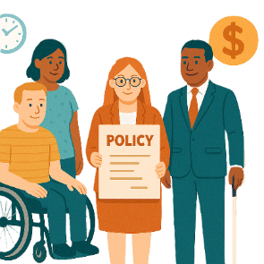 |  | - Share the work Australia is doing on disability issues like  - Policies  Policies are plans for how to do things.
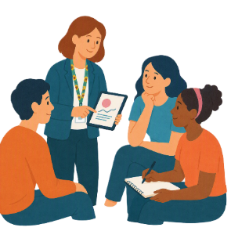 |  | - Best practice  Best practice is the way of doing things.  They are ways that give good results.
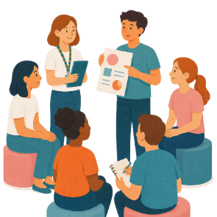 |  | - Things we have learned.
The Australian Government wants to

- Have meetings with other countries
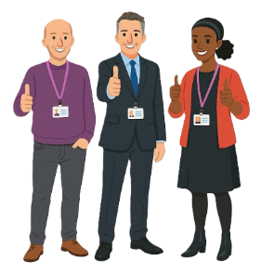 |  | - Support Ministers to take part in international forums  Ministers are leaders in an area of the government.
 |  | - Help Australia be a leader to support the rights of people with disability.
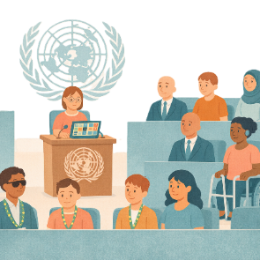 |  | The Australian Government wants to  - Show that Australia thinks it is important to take part at the UN for  - Civil society  - People with disability  - DROs  - Advocacy organisations
 |  | - Support civil society to take part in work for the CRPD
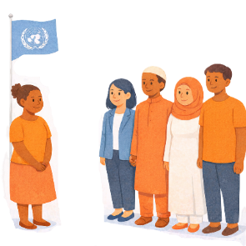 |  | - Have good relationships with people in different countries to talk about disability policy work
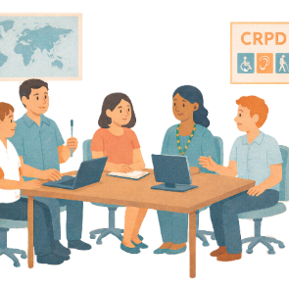 |  | - Learn from other countries about their work on the CRPD.

Australian Government support

 |  | The Australian Government funds the SPP.  This supports people with disability to go to the forums.
 |  | The Australian Government  - Makes the final decision about who gets a grant  DHDA uses information from the report AHRC writes to decide.
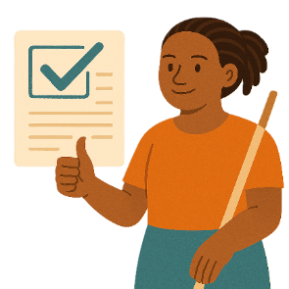 |  | - Shares information about the UN.
 |  | The Australian Government  - Supports organisations and people going to the forums  - Before the forum
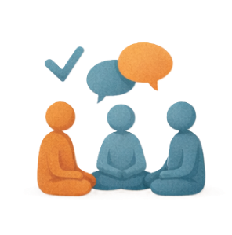 |  | - At the forum
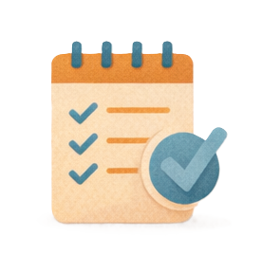 |  | - After the forum
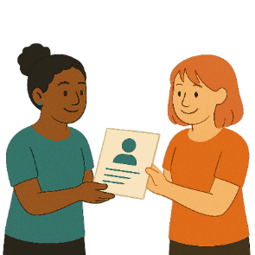 |  | - Gives information to people while they are at the forum.

Australian Government contact information

You can contact the Australian Government if you have questions about

- Funding
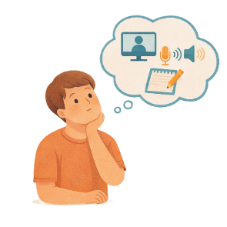 |  | - Your accessibility needs for the  - Forums  - Events
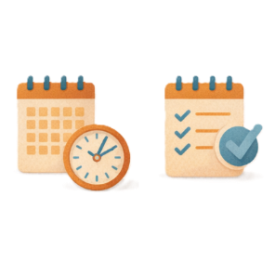 |  | - Ideas about activities  - Before the forum  - After the forum.
 |  | You can send an email to  SystemicDisabilityAdvocacy@health.gov.au

Some images in this Easy Read were made using AI.
You must not share or copy any of the images without permission.
August 2026.

