Supporting participation program
Part 1
AHRC
Roles and responsibilities
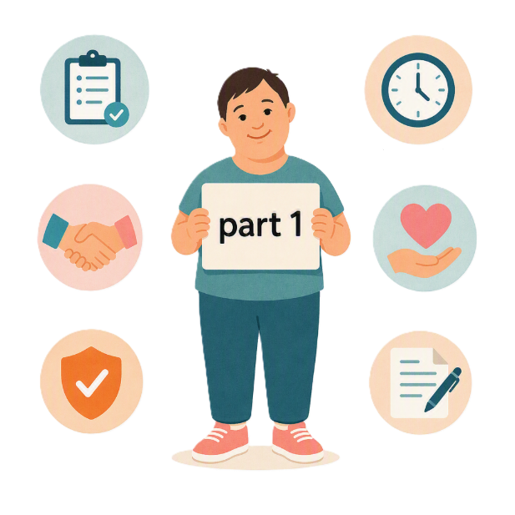
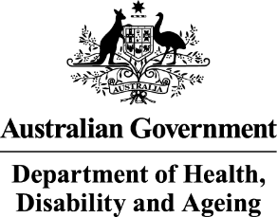 | - The Australian Government Department of Health Disability and Ageing  We say DHDA for short.
 | - The Australian Human Rights Commission  We say AHRC for short.  Wrote this together.  When you see the word we it means  DHDA and AHRC.
 | We wrote this in an easy to read way.  We use pictures to explain some ideas.
 | We have some words in bold.  This means the letters are thicker and darker.  These are important words.
 | This is an Easy Read summary of another document.  This means it has the most important ideas.
 | We can answer any questions by email.  Email us disability@humanrights.gov.au
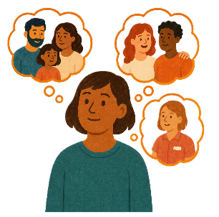 | You can ask for help to read this document.  You can ask  - A friend  - Family members  - A support person.
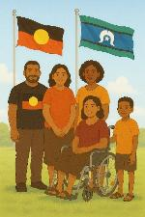 | We recognise Aboriginal and Torres Strait Islander people as the Traditional Owners of the land we live on.
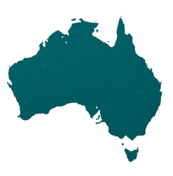 | They were the first people to live on and use the  - Land  - Waters.

Contents

Supporting Participation Program | 5
International forums in 2027 | 9
About this document | 12
AHRC objectives | 15
AHRC support | 18
AHRC contact information | 21

Supporting Participation Program

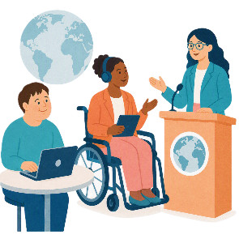 |  | This talks about the  Supporting Participation Program.  We call it SPP for short.
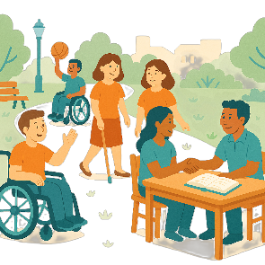 |  | Participation means taking part in something.
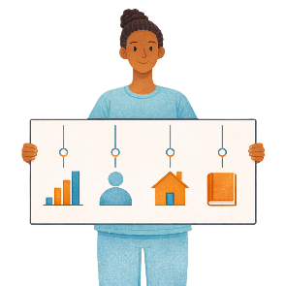 |  | Programs are done to support people in the community.
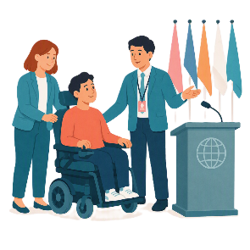 |  | SPP supports people with disability to go to international forums on human rights.  Like the United Nations Conference of States Parties.
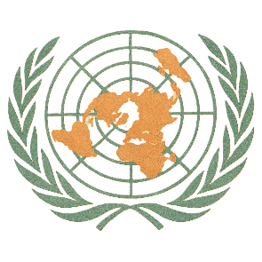 |  | The United Nations is an organisation where countries come together to  - Talk about world issues  - Fix world issues.  We call it the UN for short.
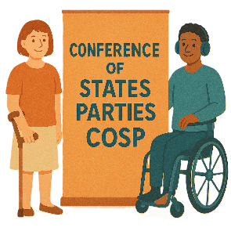 |  | The Conference of States Parties is a meeting for all countries that agreed to support the rights of people with disability.  We call it COSP for short.
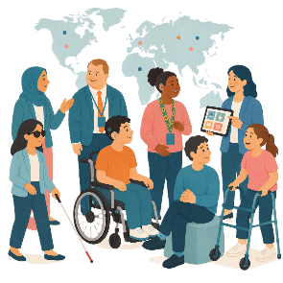 |  | International forums are meetings where people from different countries talk about important issues.
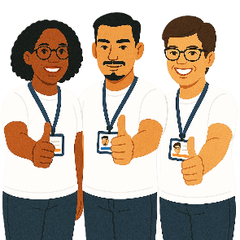 |  | Human rights are rights that everyone has.  Rights are rules about treating everyone  - Fair  - Equal.
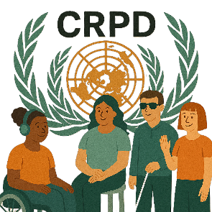 |  | SPP helps Australia to follow the  - UN Convention on the Rights of Persons with Disabilities.  We say CRPD for short.
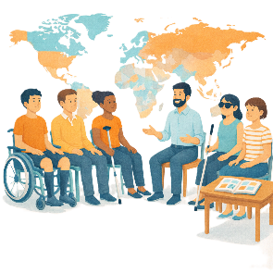 |  | CRPD is an agreement between different countries.  CRPD says how people with disability must have their rights respected.
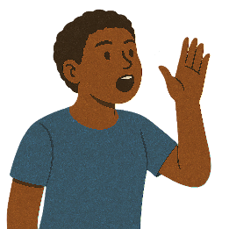 |  | SPP also supports people with disability to  - Speak up about their rights
 |  | - Represent their organisation.

International forums in 2027

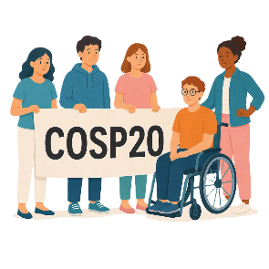 |  | There are 3 international forums in 2027.  They are  - 20th session of COSP  We call it COSP20 for short.
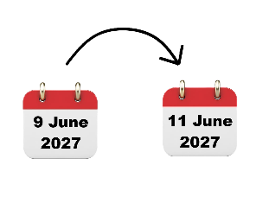 |  | COSP20 will be in the United States of America on  - 9 June to 11 June 2027.  We call it the USA for short.
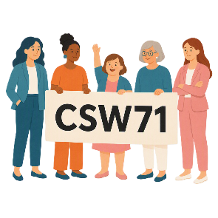 |  | - 71st Session of the Commission on the Status of Women  We say CSW71 for short.
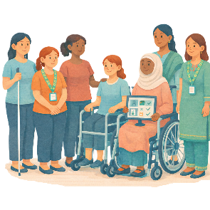 |  | CSW is about  - The rights of women  - Gender equality  Gender equality means that everyone is treated equal no matter your gender.
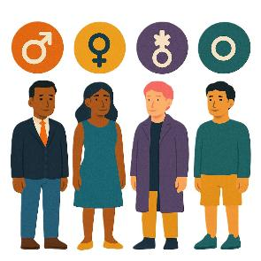 |  | People say what gender they are.  They might be  - A man  - A woman  - A different gender  - No gender.
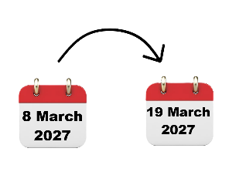 |  | CSW71 will be in the USA on  - 8 March to 19 March 2027.
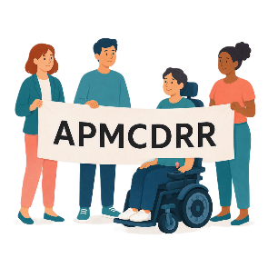 |  | - Asia Pacific Ministerial Conference on Disaster Risk Reduction.  We say APMCDRR for short.
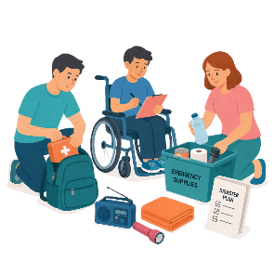 |  | APMCDRR is about  - Preparing for disasters  - Keeping people safe during disasters.
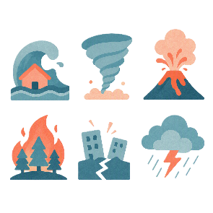 |  | Natural disasters are things like  - Cyclones  - Earthquakes  - Floods  - Volcanoes.
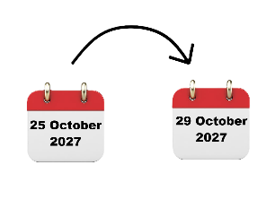 |  | APMCDRR will be in Japan on  - 25 October to 29 October 2027.

About this document

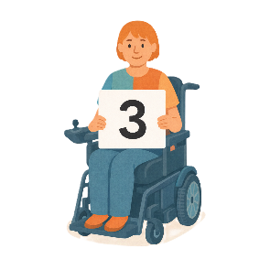 |  | This document is in 3 parts.
Part 1 is about the AHRC

- Objectives

 |  | Objectives are things that we want to do.
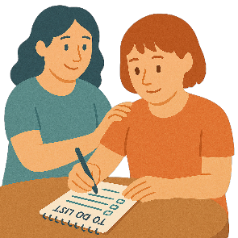 |  | - Roles and responsibilities.  Roles and responsibilities are the things you need to do for SPP.  This makes sure everyone knows what they need to do.
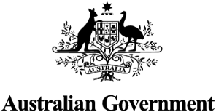 |  | Part 2 is about the Australian Government  - Objectives
 |  | - Roles and responsibilities.
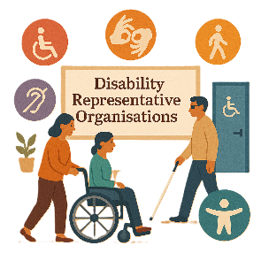 |  | Part 3 is about  - Disability Representative Organisations  We call them DROs for short.
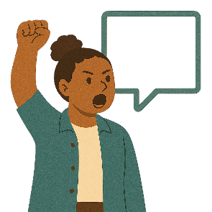 |  | - Advocacy organisations  Advocacy is when someone supports you to speak up for your rights.
 |  | - Their roles and responsibilities.
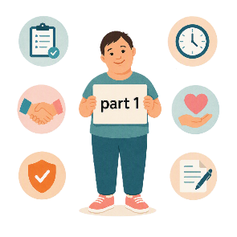 |  | This is part 1.

AHRC objectives

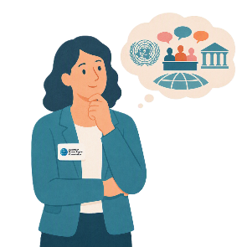 |  | AHRC have things they want to do at all international forums.
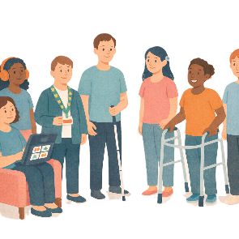 |  | AHRC want to  - Support civil society  Civil society is groups of people working together to support something.  It is not  - The government  - Business.
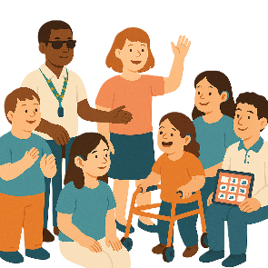 |  | - Include people with disability.
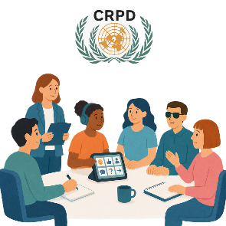 |  | AHRC want to help organisations and people to  - Take part in decisions about CRPD
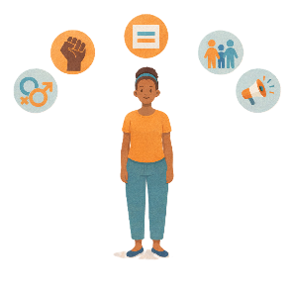 |  | - Understand human rights
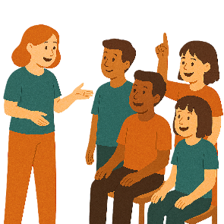 |  | - Promote human rights  Promote means to encourage other people to do something.
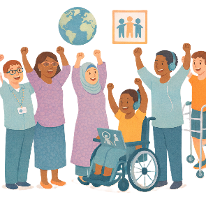 |  | - Work with other countries on human rights  This is called international engagement.
 |  | - Work to support human rights around the world.
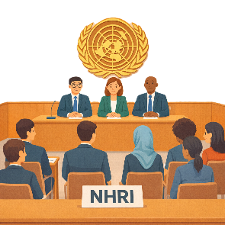 |  | AHRC is a National Human Rights Institution.  We call them NHRI for short.  NHRIs help  - Protect human rights in their country
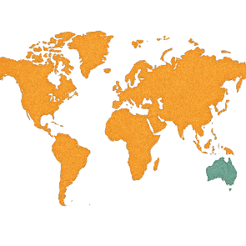 |  | - Human rights around the world.
 |  | - Share and learn about how to follow the CRPD.

AHRC support

 |  | AHRC will work with DHDA for the  - Applications to be part of SPP.
 |  | An application is when someone says they want to take part in something.
 |  | AHRC and DHDA will  - Make the rules for the application
 |  | - Write information about the application.
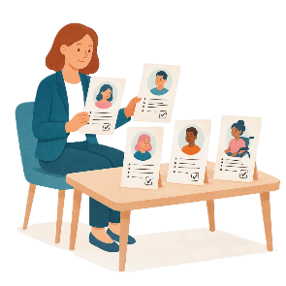 |  | AHRC will  - Be fair when they look at applications  - Follow the rules when they look at all applications.
 |  | - Write a report about who should get a grant.  They will share the report with DHDA to decide.
 |  | AHRC will  - Tell the people who put in an application if they  - Got a grant  - Did not get a grant.
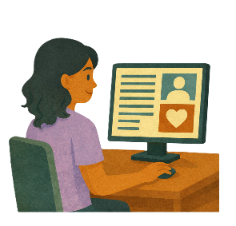 |  | - Look after the SPP information on their website
 |  | - Support activities before each forum  This will be done with the government.
 |  | - Support activities after each forum.  This will be done with the government.

AHRC contact information

 |  | You can contact AHRC if you need more information about
 |  | - Your application
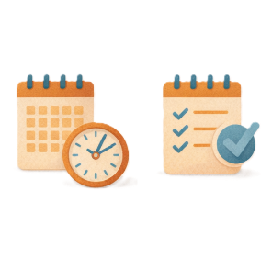 |  | - Ideas about activities  - Before the forum  - After the forum.
 |  | You can send an email to  disability@humanrights.gov.au

Some images in this Easy Read were made using AI.
You must not share or copy any of the images without permission.
August 2026.

