Supporting participation program

Application form
Part 2
About you
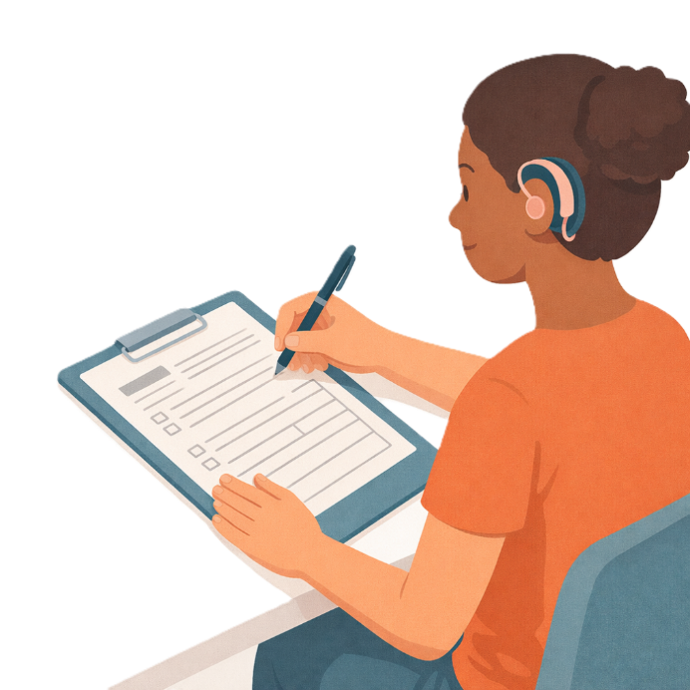
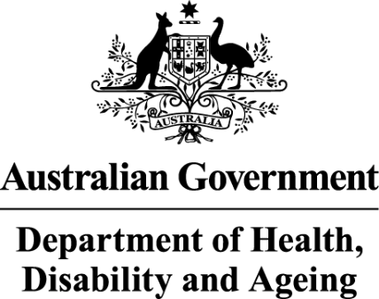 | - The Australian Government Department of Health Disability and Ageing  We say DHDA for short.
 | - The Australian Human Rights Commission  We say AHRC for short.  Wrote this together.  When you see the word we it means  DHDA and AHRC.
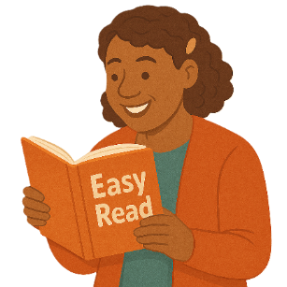 | We wrote this in an easy to read way.  We use pictures to explain some ideas.
 | We have some words in bold.  This means the letters are thicker and darker.  These are important words.
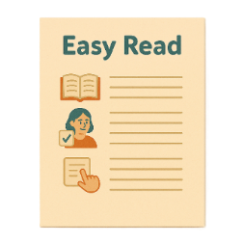 | This is an Easy Read summary of another document.  This means it has the most important ideas.
 | We can answer any questions by email.  Email us disability@humanrights.gov.au
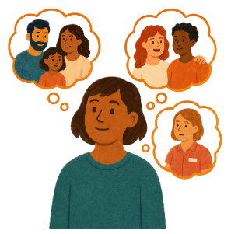 | You can ask for help to read this document.  You can ask  - A friend  - Family members  - A support person.
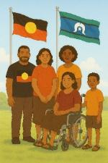 | We recognise Aboriginal and Torres Strait Islander people as the Traditional Owners of the land we live on.
 | They were the first people to live on and use the  - Land  - Waters.

Contents

Supporting Participation Program | 5
International forums in 2027 | 9
About this document | 12
How to fill out our form | 13
Questions about you | 15
How much funding you are asking for | 27
Assessment questions | 29
Sending in your form | 38

Supporting Participation Program

 |  | This talks about the  Supporting Participation Program.  We call it SPP for short.
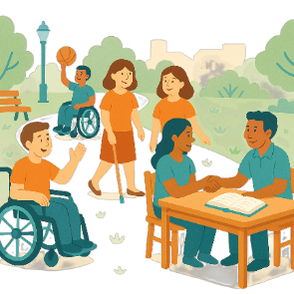 |  | Participation means taking part in something.
 |  | Programs are done to support people in the community.
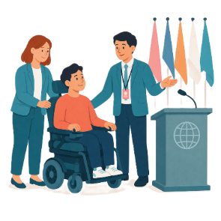 |  | SPP supports people with disability to go to international forums on human rights.  Like the United Nations Conference of States Parties.
 |  | The United Nations is an organisation where countries come together to  - Talk about world issues  - Fix world issues.  We call it the UN for short.
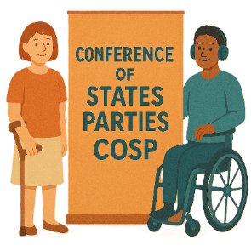 |  | The Conference of States Parties is a meeting for all countries that agreed to support the rights of people with disability.  We call it COSP for short.
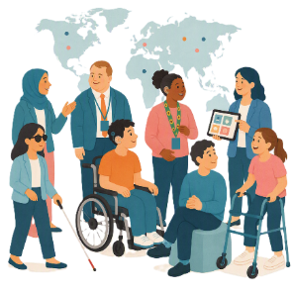 |  | International forums are meetings where people from different countries talk about important issues.
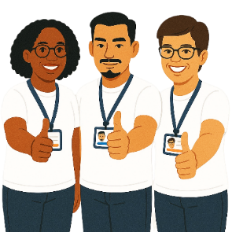 |  | Human rights are rights that everyone has.  Rights are rules about treating everyone  - Fair  - Equal.
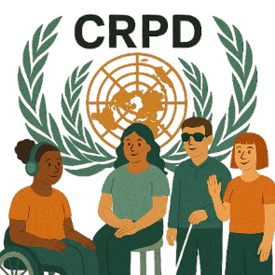 |  | SPP helps Australia to follow the  - UN Convention on the Rights of Persons with Disabilities.  We say CRPD for short.
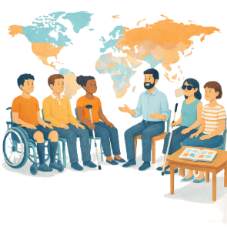 |  | CRPD is an agreement between different countries.  CRPD says how people with disability must have their rights respected.
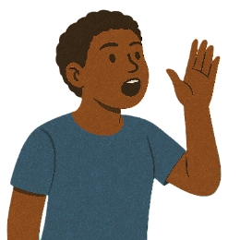 |  | SPP also supports people with disability to  - Speak up about their rights
 |  | - Represent their organisation.

International forums in 2027

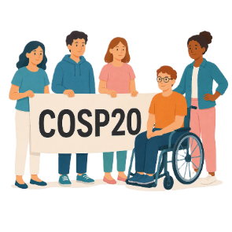 |  | There are 3 international forums in 2027.  They are  - 20th session of COSP  We call it COSP20 for short.
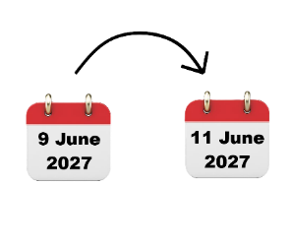 |  | COSP20 will be in the United States of America on  - 9 June to 11 June 2027.  We call it the USA for short.
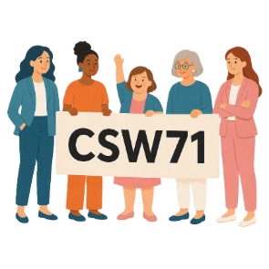 |  | - 71st Session of the Commission on the Status of Women  We say CSW71 for short.
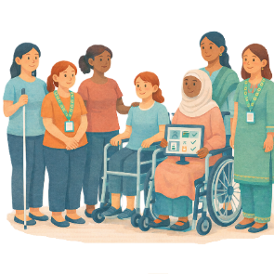 |  | CSW is about  - The rights of women  - Gender equality  Gender equality means that everyone is treated equal no matter your gender.
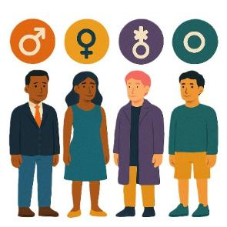 |  | People say what gender they are.  They might be  - A man  - A woman  - A different gender  - No gender.
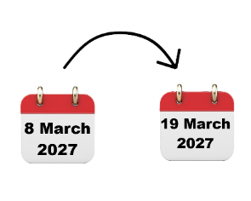 |  | CSW71 will be in the USA on  - 8 March to 19 March 2027.
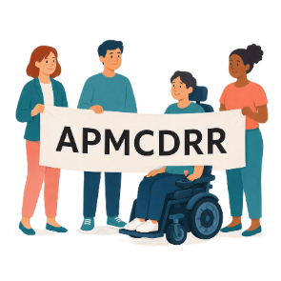 |  | - Asia Pacific Ministerial Conference on Disaster Risk Reduction.  We say APMCDRR for short.
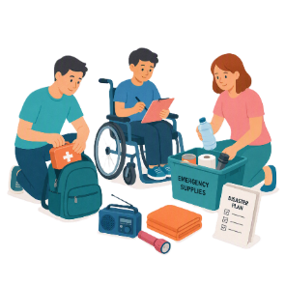 |  | APMCDRR is about  - Preparing for disasters  - Keeping people safe during disasters.
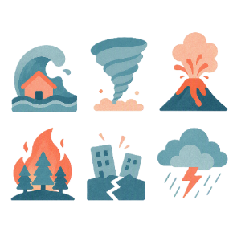 |  | Natural disasters are things like  - Cyclones  - Earthquakes  - Floods  - Volcanoes.
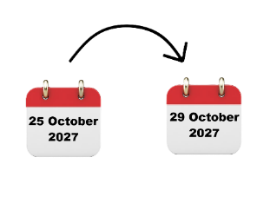 |  | APMCDRR will be in Japan on  - 25 October to 29 October 2027.

About this document

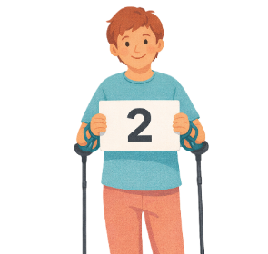 |  | This document is in 2 parts.
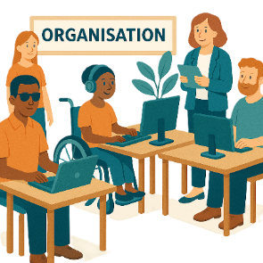 |  | Part 1 is about  - Your organisation.
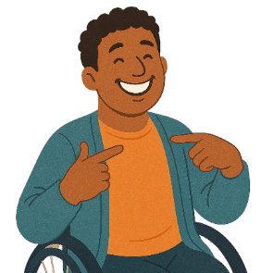 |  | Part 2 is about  - You.  You need to fill out a part 2 form for each person in your organisation who wants to go to the forums.
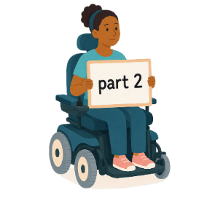 |  | This is part 2.

How to fill out our form

 |  | There are a few ways to fill out this form.  You can type your answers.
 |  | You need to  1. Keep this document open.  2. Open a new Word document.
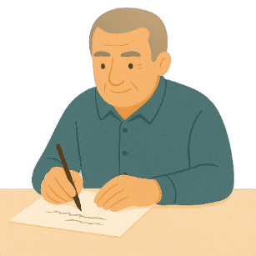 |  | You can write your answers.
 |  | You need to  1. Keep this document open.  2. Write your answers on a blank piece of paper.
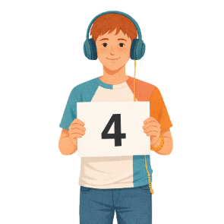 |  | There are 4 sections for our form.
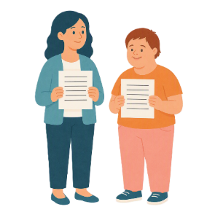 |  | Each person who wants to go to the forum will need different answers for  - Questions about you  - How much funding are you asking for  - Assessment questions.
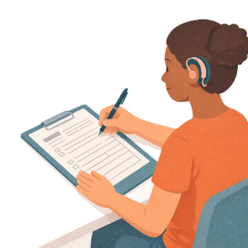 |  | An assessment is looking at information in your application to make a decision.
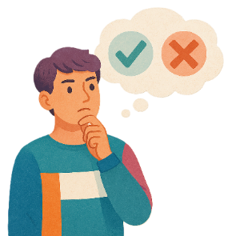 |  | You can decide what questions you want to answer.  You do not have to answer any questions you do not want to.

Questions about you

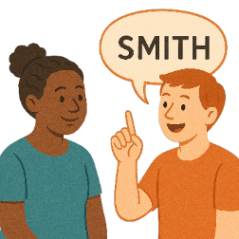 |  | Question 1  What is your  - Full name
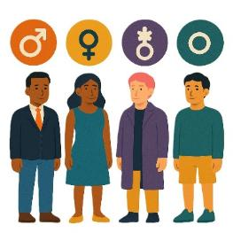 |  | - Gender
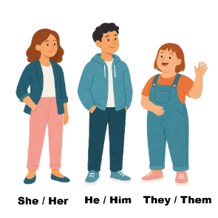 |  | - Pronouns.  Pronouns are the words you use when talking about someone.  You do not use their name.  You could say  - She or her  - He or him  - They or them.  People can choose the pronouns that are right for them.
Question 2

What is the name of the organisation you are part of.
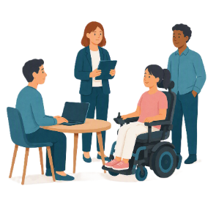 |  | What do you do for the organisation.
 |  | Question 3  What is your  - Email address
 |  | - Phone number.
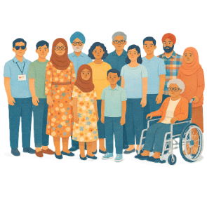 |  | We will think about the diversity of the people who want to go to the forums.  Diversity means how people are different from each other.  The next questions are about diversity.
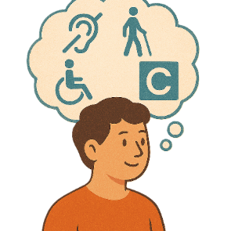 |  | Question 4  Do you have a disability.  - Yes  Or  - No.
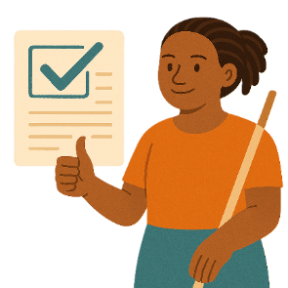 |  | What information about your disability would you like to share with us.
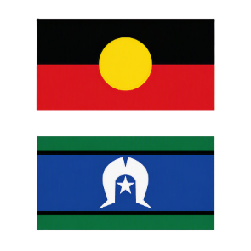 |  | Question 5  Are you Aboriginal or Torres Strait Islander.  - Yes  Or  - No.
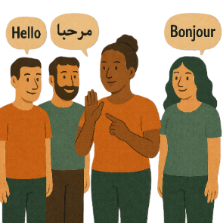 |  | Question 6  Are you someone who  - Speaks different languages  - Comes from different cultures.  - Yes  Or  - No.
 |  | Question 7  Are you part of the LGBTQIA+ community.  - Yes  Or  - No.
 |  | Question 8  Do you live in  - Regional community  - Remote community.  - Yes  Or  - No.
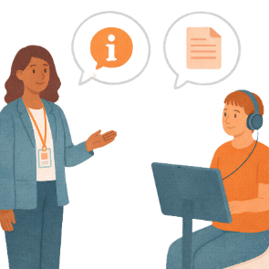 |  | Question 9  What other information would you like to share with us.
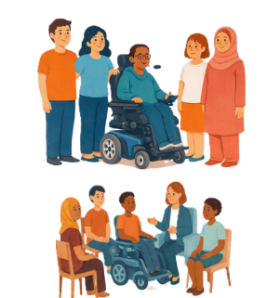 |  | Question 10  Would you like to be a  - General Delegate  Or  - Emerging Young Leader.
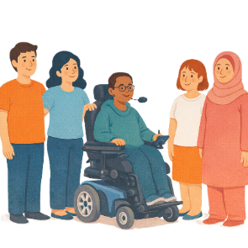 |  | General Delegates are given funding to go and support other people at the international forum.
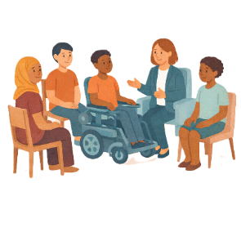 |  | Emerging Young Leaders are given funding to go.  They are learning to be leaders.  You must be aged 18 to 35 to be an Emerging Young Leader.
Question 11

Please write all the forums you would like to go to

  - COSP20
 |  | - CSW71
 |  | - APMCDRR.
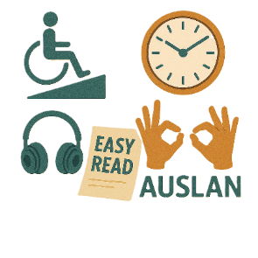 |  | Question 11  What reasonable adjustments do you need to take part.  Reasonable adjustments are things that make it easier for people to take part.
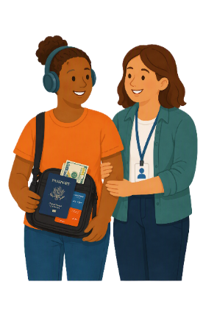 |  | Question 12  Do you need someone from your organisation to go with you to the forum.  - Yes  Or  - No.
 |  | If you answer yes to this question  - Please tell us more about this.
Question 13

Have you

- Been before to

  - COSP
  - CSW
  - APMCDRR.

- Been part of SPP before.

  - Yes

Or

  - No.
If you answer yes to these questions

Please tell us more about

- What forums you went to
- When you went
- What activities you took part in.
 |  | Question 15  Does you give permission for the organisation in part 1 to share information about you.  - Yes  Or  - No.
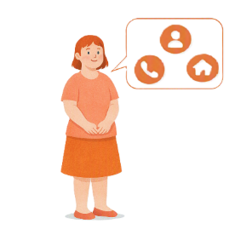 |  | This includes sharing  - Personal information  Personal information is information like your  - Name  - Phone number  - Address
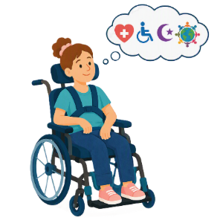 |  | - Sensitive information.  Sensitive information is information like your  - Health  - Disability  - Religion  - Culture.
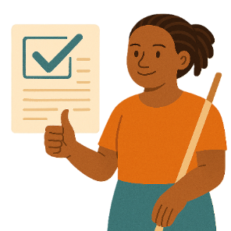 |  | Question 16  Do you agree with the way we use the information given to us.  - Yes  Or  - No.
 |  | You can look at how we use your information on the website.
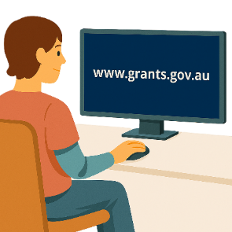 |  | You can register on this website to read them.  www.grants.gov.au/  They are not in Easy Read.
You can also go to this website to read the same documents

humanrights.gov.au/our-work/topics/disability-rights-what-were-doing/supporting-participation-program

They are not in Easy Read.

How much funding you are asking for

 |  | Question 1  - Please tell us how much funding you would like to ask for.
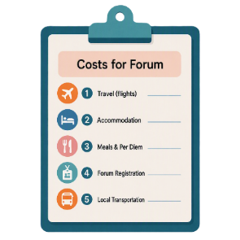 |  | Question 2  Please tell us how much it will cost for  - Supports to take part in the forum.
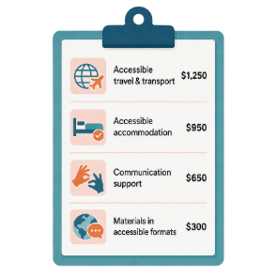 |  | Question 3  Please tell us how much it will cost for  - Reasonable adjustments for you to take part in the forum.
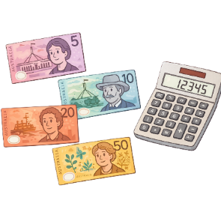 |  | Question 4  Please tell us about how you think you will use the funding.
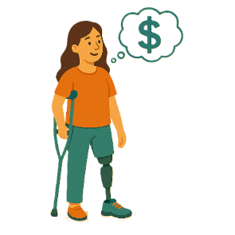 |  | Question 5  Please tell us about any funding your organisation will give you to go to the forum.
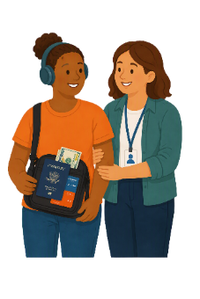 |  | Question 6  Please tell us about any other supports your organisation will give to help you go to the forum.

Assessment questions

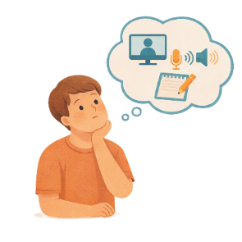 |  | Please answer all the assessment questions.  You can give your answers in different ways.  You can
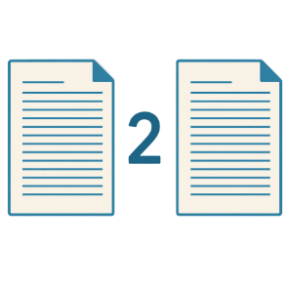 |  | - Write your answers  You can write no more than 2 pages.
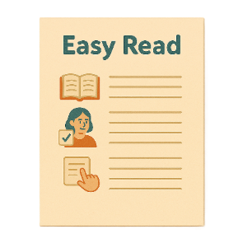 |  | - Send an Easy Read  Your Easy Read can be as long as you want.
 |  | - Send a video  Your video must be under 5 minutes.
 |  | - Send an audio file.  An audio file is speaking only.  Your audio file must be under 5 minutes.
     |  | If you send an  - Easy Read  - Video  - Audio
 |  | You can write as well.  You must write no more than 1 page.
 |  | - Organisation supports.  Please tell us what your organisation will do to support you to take part in the forums.
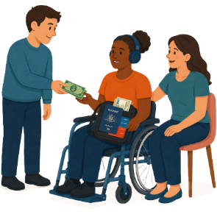 |  | Supports may be things like  - Booking the travel  - Having support staff  - Helping to prepare for the event.
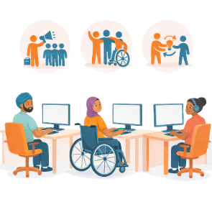 |  | - Organisation experience.  Please tell us what experience your organisation has in human rights work.
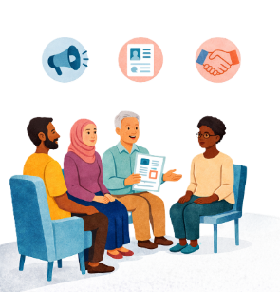 |  | This could talk about your organisations  - Goals  - Work on human rights forums  - Work on disability advocacy.
 |  | - Individual knowledge and experience.  Individual means 1 person.
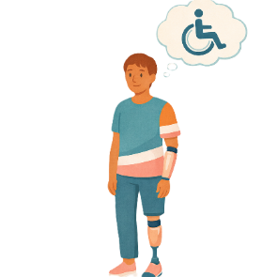 |  | Please tell us what you know about  - Disability issues in Australia
 |  | - The CRPD
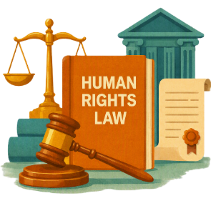 |  | - Human rights
 |  | - How the UN works.
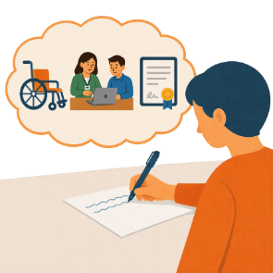 |  | You could share about  - Your experiences
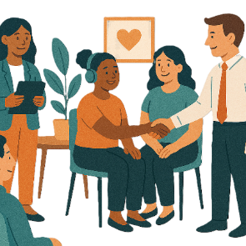 |  | - Work that you have done
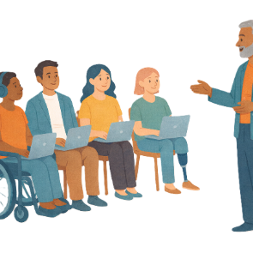 |  | - Training you have done
 |  | - Awards you have won for your work
 |  | - Qualifications you have.  Qualifications are proof that you have  - Learned a skill  - Finished training to do a job.
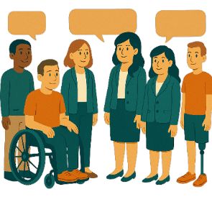 |  | - Individual delegation supports.  Please tell us how you will work with people from other organisations.
 |  | This could be how you would  - Ask for advice about issues
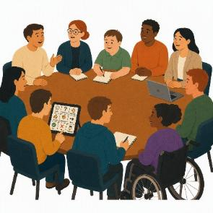 |  | - Build your skills to take part in forums
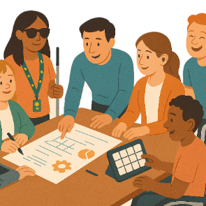 |  | - Support with planning events for the forums.
For general delegates

You need to talk about how you will mentor members from the

- Emerging Young Leaders Delegation.
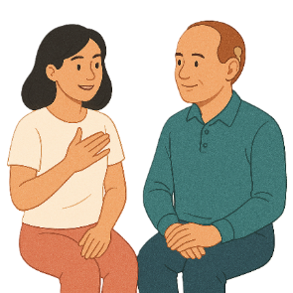 |  | Mentoring someone helps them to learn and grow.  Mentoring is about support.  It is not telling someone what to do.
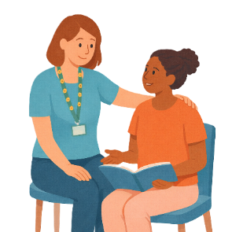 |  | For members of the Emerging Young Leaders Delegation  You need to talk about how you will  - Take having a mentor.  This is called being a mentee.
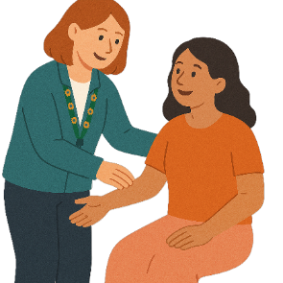 |  | - Impact of attendance.  Please tell us how going to the forums would help  - You  - Your organisation.
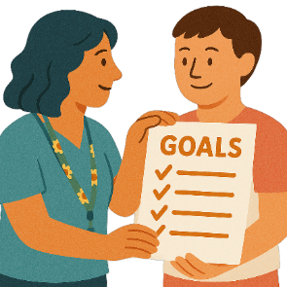 |  | This could be about  - Future goals
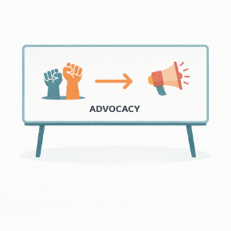 |  | - Making advocacy better.
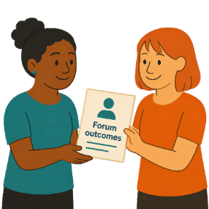 |  | - Sharing forum outcomes.  Outcomes are goals that people finish.
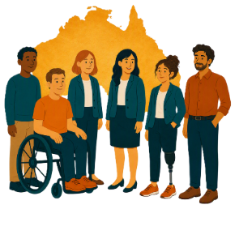 |  | Please tell us how you and your organisation will  - Share information from forums with the community.

Sending in your form

 |  | You need to send your form to us when you have finished writing your answers.
 |  | If you have typed your answers you need to  1. Save the document  2. Email it to us.  disability@humanrights.gov.au
 |  | If you wrote your answers you need to  1. Scan it into your computer or take a photo  2. Email it to us.  disability@humanrights.gov.au

Some images in this Easy Read were made using AI.
You must not share or copy any of the images without permission.
September 2026.

