Supporting participation program
Common questions
Part 3
Where to find information
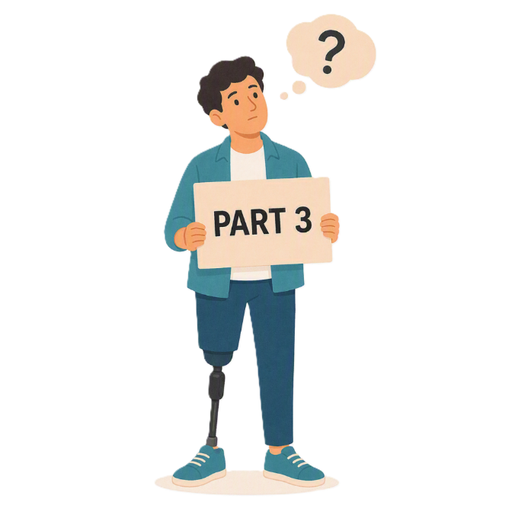
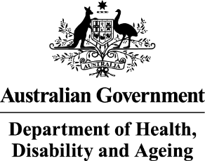 | - The Australian Government Department of Health Disability and Ageing  We say DHDA for short.
 | - The Australian Human Rights Commission  We say AHRC for short.  Wrote this together.  When you see the word we it means  DHDA and AHRC.
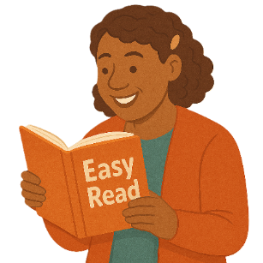 | We wrote this in an easy to read way.  We use pictures to explain some ideas.
 | We have some words in bold.  This means the letters are thicker and darker.  These are important words.
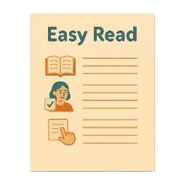 | This is an Easy Read summary of another document.  This means it has the most important ideas.
 | We can answer any questions by email.  Email us disability@humanrights.gov.au
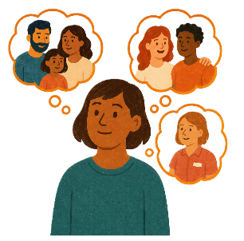 | You can ask for help to read this document.  You can ask  - A friend  - Family members  - A support person.
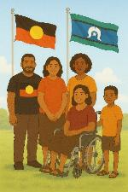 | We recognise Aboriginal and Torres Strait Islander people as the Traditional Owners of the land we live on.
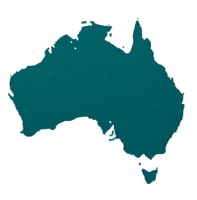 | They were the first people to live on and use the  - Land  - Waters.

Contents

About the Supporting Participation Program | 5
About this document | 9
Information organisations have to send | 12
Can you help with my application | 15
What will be looked at in my application | 16
How will organisations know they got funding | 18
Who can apply | 19

About the Supporting Participation Program

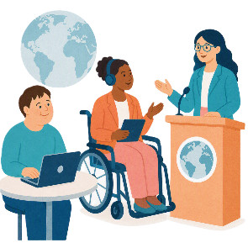 |  | This talks about the  Supporting Participation Program.  We call it SPP for short.
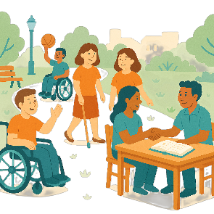 |  | Participation means taking part in something.
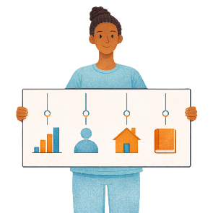 |  | Programs are done to support people in the community.
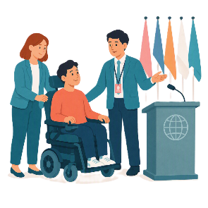 |  | SPP supports people with disability to go to international forums on human rights.  Like the United Nations Conference of States Parties.
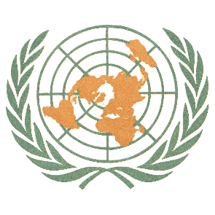 |  | The United Nations is an organisation where countries come together to  - Talk about world issues  - Fix world issues.  We call it the UN for short.
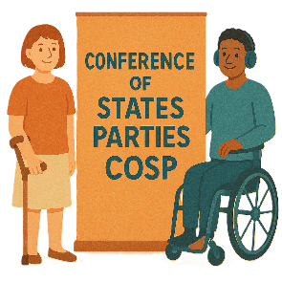 |  | The Conference of States Parties is a meeting for all countries that agreed to support the rights of people with disability.  We call it COSP for short.
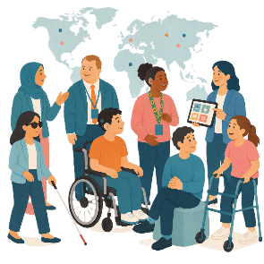 |  | International forums are meetings where people from different countries talk about important issues.
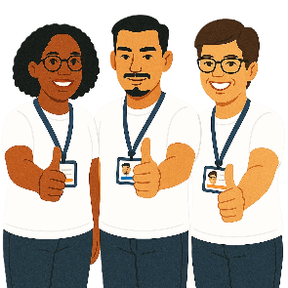 |  | Human rights are rights that everyone has.  Rights are rules about treating everyone  - Fair  - Equal.
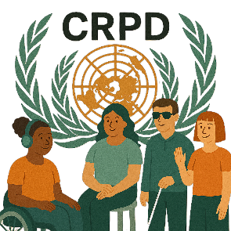 |  | SPP helps Australia to follow the  - UN Convention on the Rights of Persons with Disabilities.  We say CRPD for short.
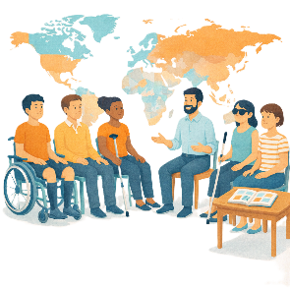 |  | CRPD is an agreement between different countries.  CRPD says how people with disability must have their rights respected.
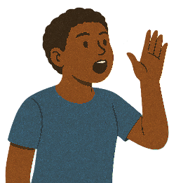 |  | SPP also supports people with disability to  - Speak up about their rights
 |  | - Represent their organisation.

About this document

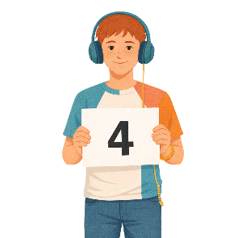 |  | This document has 4 parts.
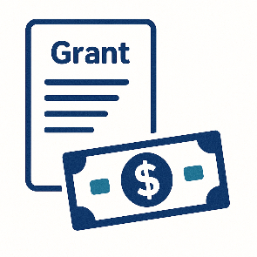 |  | Part 1 is about  - The grant  A grant is when the government gives you money to do something.
 |  | - Where to find information about the grant
 |  | - Rules for the grant.
 |  | Part 2 is about  - Funding.  Funding is money from the government to take part.
 |  | Part 3 is about  - What information is needed
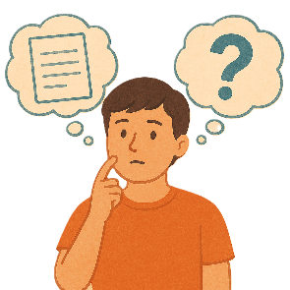 |  | - Can I get help
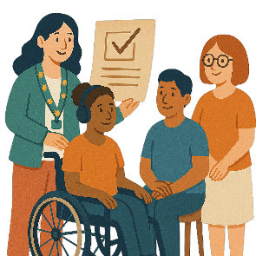 |  | - How organisations will know if they got a grant.
 |  | Part 4 is about  - Your application  Applications are forms you fill out to say you want funding to go to a forum.
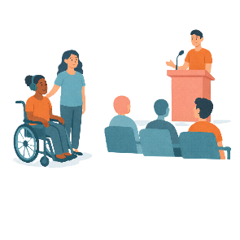 |  | - Going to the forum.  A forum is a meeting to talk about a problem.
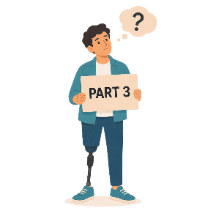 |  | This is part 3.

Information organisations have to send

 |  | We need to make sure the information for your organisation is right.
 |  | If you get a grant  - AHRC will send your organisation an email.
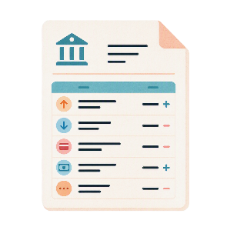 |  | You organisation will need to send us  - A bank statement.  It is best if it is from the last 6 months.
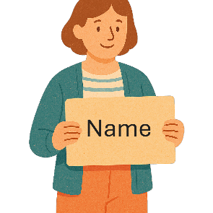 |  | It needs to have  - The name of the organisation applying for the funding
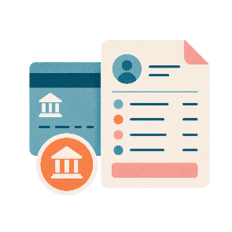 |  | - Bank account information.  You do not need to show  - The amount of money in the account  - What the money has been spent on.
 |  | Your organisation will also need to send the  - Australian Securities and Investments Commission registration documents  We call it ASIC for short.
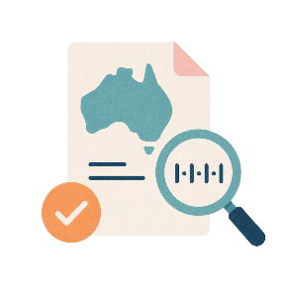 |  | - Australian Business Number.  This is called ABN for short.
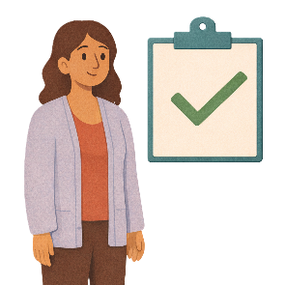 |  | This will help us make sure the right information is on the grant agreement.

Can you help with my application

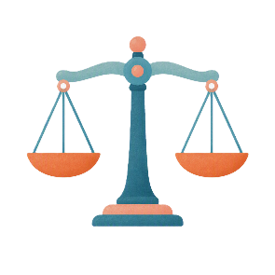 |  | No.  To make it fair for everyone  - AHRC  - DHDA  Can not help you with your application.
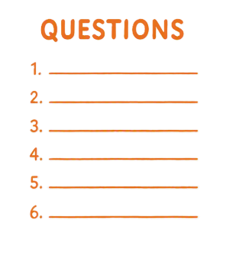 |  | We can not tell you if you have good answers to the questions.

What will be looked at in my application

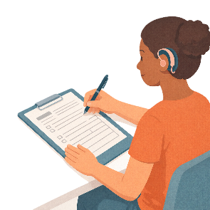 |  | Your answers for the assessment questions will help us decide who gets the grants.
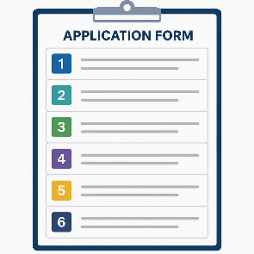 |  | There are 6 assessment questions.  An assessment is looking at information in your application to make a decision.
 |  | You can read more about the assessment questions on the AHRC website.  humanrights.gov.au/our-work/topics/disability-rights-what-were-doing/supporting-participation-program  It is not in Easy Read.
You can go to GrantConnect.

www.grants.gov.au/Go/Show?GoUuid=e0d1e575-e433-4a86-afbb-06efe6ae3af6

It is not in Easy Read.

How will organisations know they got funding

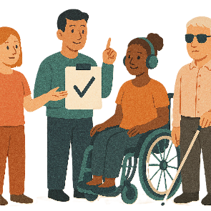 |  | AHRC will send an email to tell organisations if they  - Got funding  - Who the funding is for
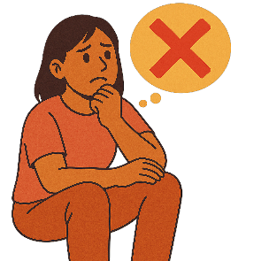 |  | - Did not get funding.
You can apply again next year if you do not get a grant this time.

You should include more information next time.

This might help you get a grant next time.

Who can apply

 |  | You need to read the documents about the grant carefully.  You can decide if you can apply.
To make it fair we do not give advice about who

- Can
- Can not

Apply for a grant.
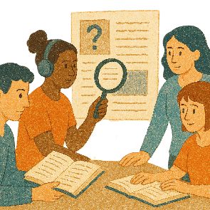 |  | We will check your application against the rules.  Only applications that follow the rules will be looked at.

Some images in this Easy Read were made using AI.
You must not share or copy any of the images without permission.
August 2026.

