Supporting participation program

Privacy Collection Notice

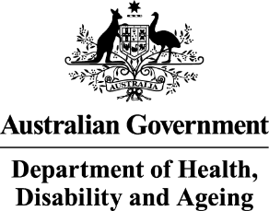 | - The Australian Government Department of Health Disability and Ageing  We say DHDA for short.
 | - The Australian Human Rights Commission  We say AHRC for short.  Wrote this together.  When you see the word we it means  DHDA and AHRC.
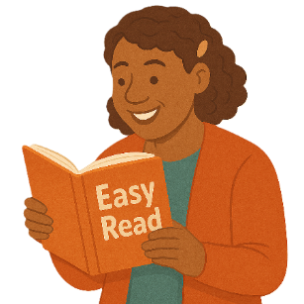 | We wrote this in an easy to read way.  We use pictures to explain some ideas.
 | We have some words in bold.  This means the letters are thicker and darker.  These are important words.
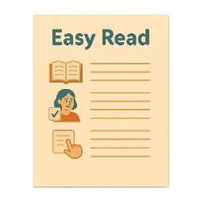 | This is an Easy Read summary of another document.  This means it has the most important ideas.
 | We can answer any questions by email.  Email us disability@humanrights.gov.au
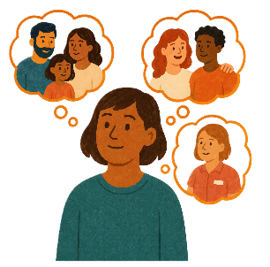 | You can ask for help to read this document.  You can ask  - A friend  - Family members  - A support person.
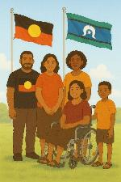 | We recognise Aboriginal and Torres Strait Islander people as the Traditional Owners of the land we live on.
 | They were the first people to live on and use the  - Land  - Waters.

Contents

Privacy Collection Notice | 5
What is personal information | 8
Personal information we need | 9
What is sensitive information | 13
Sensitive information we might need | 14
Why we collection your information | 17
How we collect your information | 18
Who we might share your information with | 19
More information | 20
Consent | 22
Information given to DHDA | 23
Contact us | 25

Privacy Collection Notice

 |  | This document tells you  - The rules we must follow when we collect your information  - What we will do with your information.
 |  | You will need to share information with us when you answer questions to be part of  - Supporting Participation Program.  We call it SPP for short.
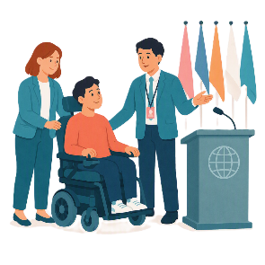 |  | SPP supports people with disability to go to international forums on human rights.  Like the United Nations Conference of States Parties.
 |  | The United Nations is an organisation where countries come together to  - Talk about world issues  - Fix world issues.  We call it the UN for short.
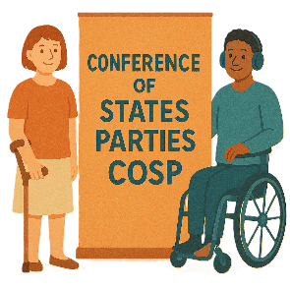 |  | The Conference of States Parties is a meeting for all countries that agreed to support the rights of people with disability.  We call it COSP for short.
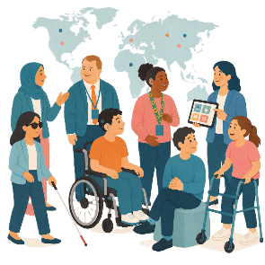 |  | International forums are meetings where people from different countries talk about important issues.
 |  | Human rights are rights that everyone has.  Rights are rules about treating everyone  - Fair  - Equal.
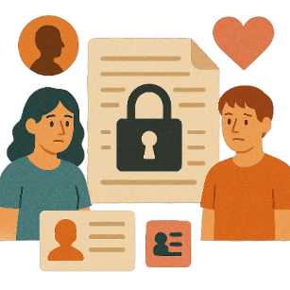 |  | You might share  - Personal information  - Sensitive information.

What is personal information

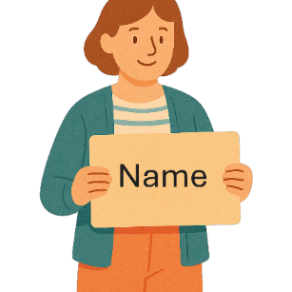 |  | Personal information is things like your  - Name
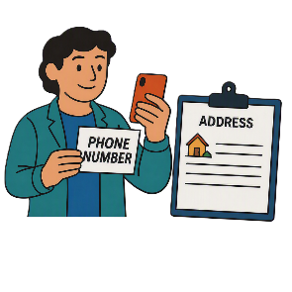 |  | - Phone number  - Address.
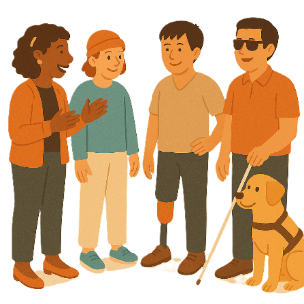 |  | It is information so we can tell people apart.
 |  | We have rules we must follow when people share information with us.

Personal information we need

 |  | You need to share some personal information in your SPP application.  Applications are forms you fill out to say you want funding to go to a forum.
This is things like

- Your name
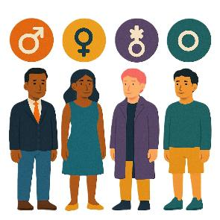 |  | - Your gender  People say what gender they are.  They might be  - A man  - A woman  - A different gender  - No gender.
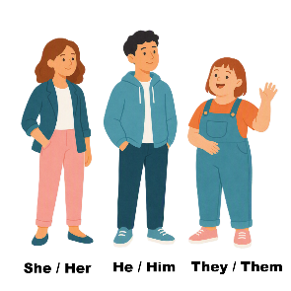 |  | - Your pronouns  Pronouns are the words you use when talking about someone.  You do not use their name.  You could say  - She or her  - He or him  - They or them.  People can choose the pronouns that are right for them.
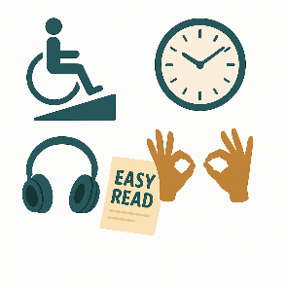 |  | - Accessibility needs  Accessibility needs are things that support people to take part.
 |  | - Where you live in Australia
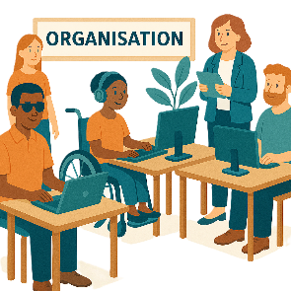 |  | - The organisation supporting you.
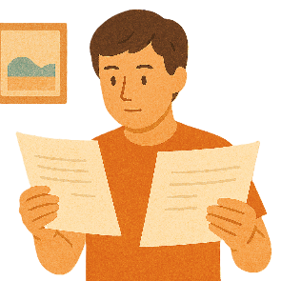 |  | We will use the information in your application to compare it to other applications.  Compare means to look at 2 or more things.  We will check all the applicants have followed the rules.  This will help us decide who will get funding.
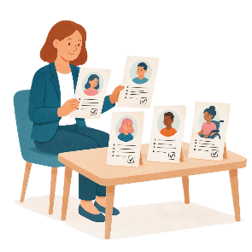 |  | AHRC will  - Look at the applications  - Give all the applications a score  - Write a report about who they think should get a grant.
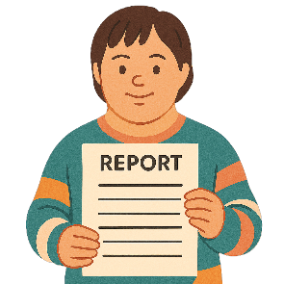 |  | AHRC will then send the report to DHDA.
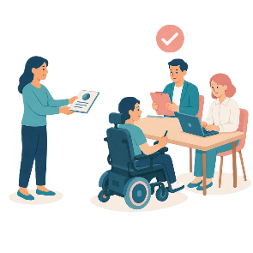 |  | DHDA will  - Read the report  - Read the applications  - Decide who gets a grant.

What is sensitive information

 |  | Sensitive information is things like  - What you think  - Different groups you join.
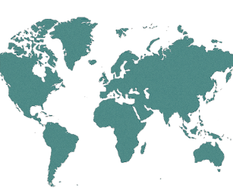 |  | This could be  - What country you are from
 |  | - What you think about politics  - What religion you practice
 |  | - Who you have relationships with.

Sensitive information we might need

 |  | You might need to share some sensitive information in your SPP application.
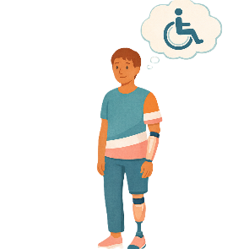 |  | This is things about your  - Disability
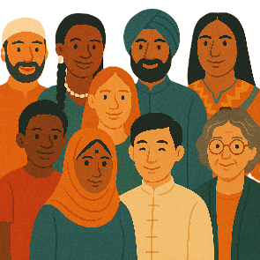 |  | - Ethnicity.  Ethnicity is a group of people who shares  - Culture  - Language  - History.
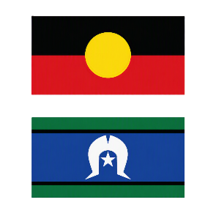 |  | You might tell us  - If you are a First Nations person
 |  | - If you are part of the LGBTQIA+ community
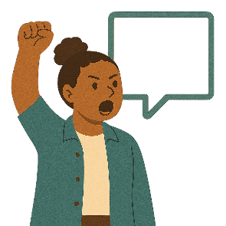 |  | - Your experience in advocacy.
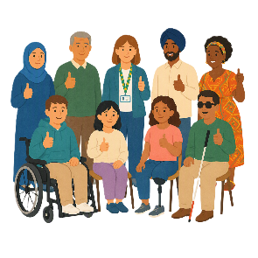 |  | You might include  - How taking part will help  - You  - Your organisation
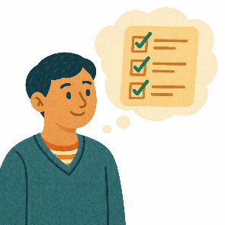 |  | - What issues you are interested in
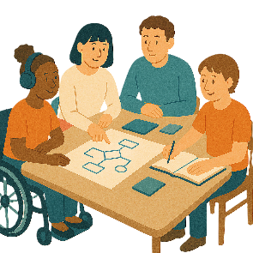 |  | - How you will work with other people at the forum
 |  | - About the work you have done before.

Why we collect your information

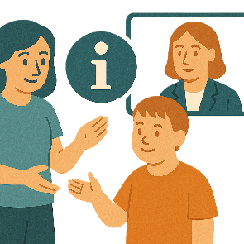 |  | We collect your information to decide if you can be part of SPP.
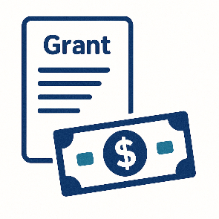 |  | It will help us decide who can get a grant.  A grant is when the government gives you money to do something.

How we collect your information

 |  | The information you give us will be part of your application for SPP.
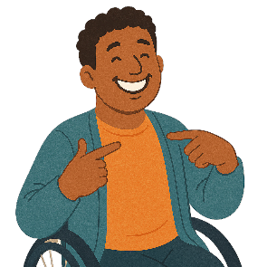 |  | It will be given to us by  - You
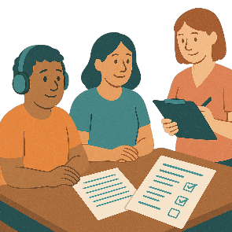 |  | - Someone supporting you to put in an application.  - Your organisation.  They can only give us your information if you say it is okay.

Who we might share your information with

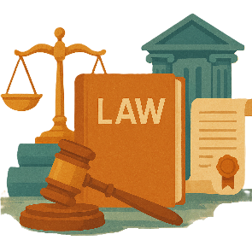 |  | We might need to share your information like if the law says we have to.  Laws are rules for how we live.
 |  | We will tell you before we share any of your information.

More information

 |  | You can read more about how the AHRC looks after your personal information on their website.  humanrights.gov.au/about-us/what-we-do/corporate-publications/policies/commission-policies/privacy  It is not in Easy Read.
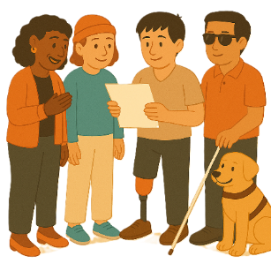 |  | It has more information about how you can  - Look at your personal information
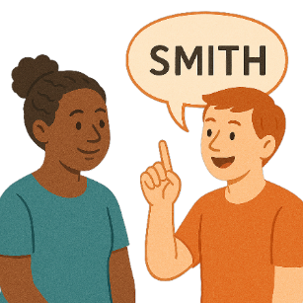 |  | - Make changes to your information like if it is wrong.
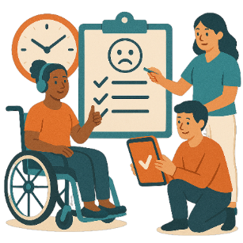 |  | It also tells you how to make a complaint if you think we have not followed the rules.  Complaints are when you tell someone they have not done a good job.  Everyone has the right to make a complaint.
You can go to the website to look at DHDA privacy policy.

Policies are plans for how to do things.

www.health.gov.au/resources/publications/privacy-policy

It is not in Easy Read.

Consent

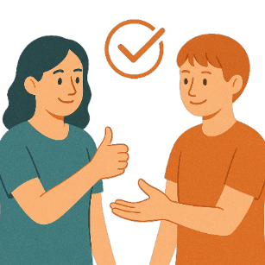 |  | We will ask you for consent  Consent means you agree.  We will ask for consent when  - You share information in your application
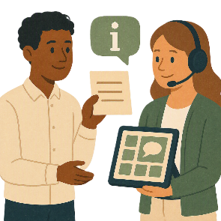 |  | - Your organisation shares your information.
 |  | If you are sharing information about someone else you can only do this  - If they have given you permission.  Permission means they said you could share about them.

Information given to DHDA

 |  | DHDA might use some of your information to
 |  | - Decide about who AHRC think should get a grant
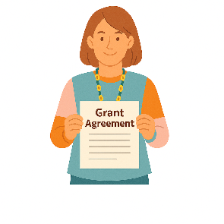 |  | - Make the grant agreements  This says  - How the money can be used  - What rules must be followed.
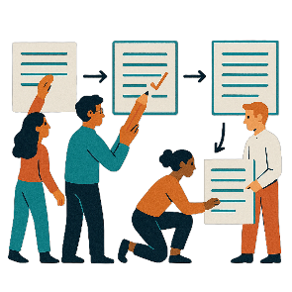 |  | - To make applications better in the future.
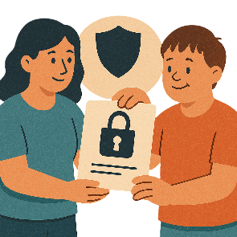 |  | DHDA might share your information with other parts of the government.
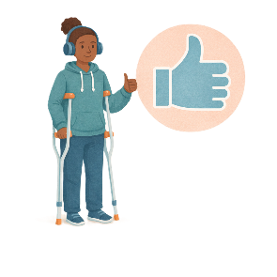 |  | By giving us your information you  - Agree for us to use it like we have said.

Contact us

 |  | You can contact us if you need more information.
 |  | You can send the AHRC an email.  privacy@humanrights.gov.au
 |  | You can look at the AHRCs website.  humanrights.gov.au/about-us/what-we-do/corporate-publications/policies/commission-policies/privacy  It is not in Easy Read.
You can send DHDA an email

privacy@health.gov.au
You can look at DHDA website.

www.health.gov.au/resources/publications/privacy-policy

It is not in Easy Read.

Some images in this Easy Read were made using AI.
You must not share or copy any of the images without permission.
August 2026.

