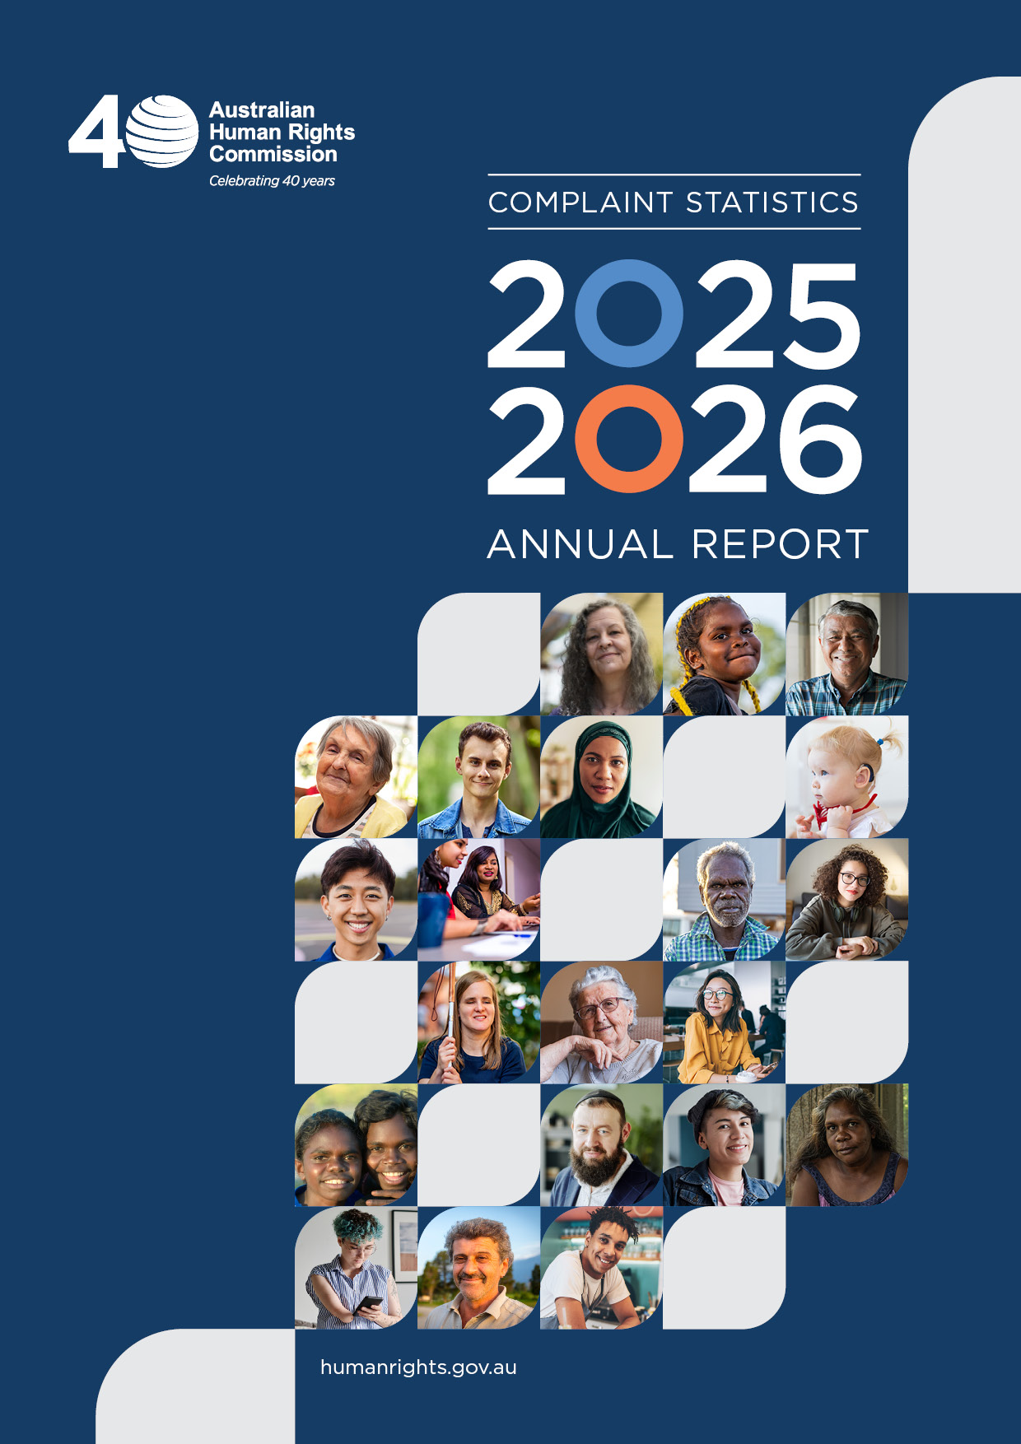

Contents
1 Comparison to 2024-25 4
1.1 Key results 4
1.2 Complaints received by Act 4
1.3 Complaints finalised by Act 5
1.4 Complaints resolved by Act 5
1.5 Service Satisfaction results 6
2 Comparison over the past seven years 6
2.1 Complaints received by Act 6
2.2 Complaints finalised by Act 7
2.3 Complaints resolved 8
3 Complaints Overview 9
3.1 Complaints received 9
3.2 Complaints received by Act 9
3.3 Complaints finalised by Act 10
3.4 Complaints received by State or Territory of the complainant 10
3.5 Complaints by Aboriginal and Torres Strait Islander People 11
3.6 Time from receipt to finalisation of complaints 11
3.7 Outcomes achieved through conciliation 12
3.8 Complaints that proceeded to court 13
3.9 Termination of complaints without inquiry 14
4 Disability Discrimination Act 14
4.1 Complaints received and finalised 14
4.2 Nature of complainant’s disability 14
4.3 Complaints received by ground 16
4.4 Complaints received by area 16
4.5 Outcomes of finalised complaints (table) 17
4.6 Outcomes of finalised complaints (chart) 18
5 Sex Discrimination Act 18
5.1 Complaints received and finalised 18
5.2 Complaints received by Complainant Category 18
5.3 Complaints received by ground 19
5.4 Complaints received by area 19
5.5 Outcomes of finalised complaints (table) 20
5.6 Outcomes of finalised complaints (chart) 21
6 Racial Discrimination Act 21
6.1 Complaints received and finalised 21
6.2 Complaints received by ground 21
6.3 Complaints received by area 22
6.4 Racial hatred complaints received by sub-area 22
6.5 Outcomes of finalised complaints (table) 23
6.6 Outcomes of finalised complaints (chart) 24
7 Age Discrimination Act 24
7.1 Complaints received and finalised 24
7.2 Age group of complainants 24
7.3 Complaints received by ground 25
7.4 Complaints received by area 25
7.5 Outcomes of finalised complaints (table) 26
7.6 Outcomes of finalised complaints (chart) 26
8 Australian Human Rights Commission Act 27
8.1 Complaints received and finalised 27
8.2 Complaints received by ground 27
8.3 Complaints received by area 27
8.4 Outcomes of finalised complaints (table) 28
8.5 Outcomes of finalised complaints (chart) 29
9 Enquiries 29
9.1 Enquiries received by mode of contact 29
9.2 Enquiries received by State/Territory of enquirer 30
9.3 Main grounds of enquiries received 30
10 Complaint Demographic Data 31
11 Service Satisfaction 32
11.1 Surveys sent and returned 33
11.2 Survey Results 33
11.3 Charter of Service 34

Comparison to 2024-25

Key results

 | 2025-26 | Compared to 2024-25
📄 Complaints received | 2,974 | 56%
📄 Complaints finalised | 3,126 | 530%
✅ Conciliation rate | 27% | 6 3%
⏱️Average processing time | 10.8 months | 51.2 months
😊 Satisfaction rate | 84% | 6 2%
📞 Enquiries received | 12,355 | 611%

Complaints received by Act

Complaints received | 2025-26 | Compared to 2024-25
Disability Discrimination Act | 1,456 | 512%
Sex Discrimination Act | 759 | 521%
Racial Discrimination Act | 460 | 6 8%
Age Discrimination Act | 130 | 615%
Australian Human Rights Commission Act | 169 | 621%
Total | 2,974

Complaints finalised by Act

Complaints finalised | 2025-26 | Compared to 2024-25
Disability Discrimination Act | 1,515 | 548%
Sex Discrimination Act | 668 | 533%
Racial Discrimination Act | 480 | 519%
Age Discrimination Act | 161 | 533%
Australian Human Rights Commission Act | 302 | 613%
Total | 3,126

Complaints resolved by Act

Conciliation rate | 2025-26 | Compared to 2024-25
Disability Discrimination Act | 32% | 66.5%
Sex Discrimination Act | 32% | 63%
Racial Discrimination Act | 20% | 64%
Age Discrimination Act | 23% | 65%
Australian Human Rights Commission Act | 7% | ↔
Overall rate | 27%

Conciliation success rate | 2025-26 | Compared to 2024-25
Disability Discrimination Act | 53% | 66%
Sex Discrimination Act | 47% | 64%
Racial Discrimination Act | 33% | 69%
Age Discrimination Act | 45% | 611%
Australian Human Rights Commission Act | 18% | 616%
Overall rate | 46%

Service Satisfaction results

 | 2025-26 | Compared to 2024-25
😀 Satisfied | 84% | 62%
⭐ Very Good / Excellent | 64% | 62%
⏰ Timely Service | 59% | 58%
⚖️ Treated Fairly | 79% | 65%

Comparison over the past seven years

Complaints received by Act

 | 2019-20 | 2020-21 | 2021-22 | 2022-23 | 2023-24 | 2024-25 | 2025-26
Disability Discrimination Act | 1,006 | 1,163 | 1,960 | 1,190 | 1,164 | 1,305 | 1,456
Sex Discrimination Act | 479 | 504 | 597 | 561 | 586 | 626 | 759
Racial Discrimination Act | 403 | 523 | 464 | 473 | 388 | 499 | 460
Age Discrimination Act | 168 | 191 | 217 | 160 | 138 | 153 | 130
Australian Human Rights Commission Act | 251 | 732 | 498 | 178 | 432 | 214 | 169
Total | 2,307 | 3,113 | 3,736 | 2,562 | 2,708 | 2,797 | 2,974

Complaints finalised by Act

 | 2019-20 | 2020-21 | 2021-22 | 2022-23 | 2023-24 | 2024-25 | 2025-26
Disability Discrimination Act | 939 | 1,053 | 1,461 | 1,325 | 1,288 | 1,022 | 1,515
Sex Discrimination Act | 500 | 437 | 555 | 461 | 615 | 503 | 668
Racial Discrimination Act | 476 | 441 | 459 | 359 | 488 | 404 | 480
Age Discrimination Act | 117 | 201 | 199 | 130 | 180 | 121 | 161
Australian Human Rights Commission Act | 205 | 492 | 664 | 263 | 200 | 349 | 302
Total | 2,237 | 2,624 | 3,338 | 2,538 | 2,771 | 2,399 | 3,126

Complaints resolved

 | 2019-20 | 2020-21 | 2021-22 | 2022-23 | 2023-24 | 2024-25 | 2025-26
Conciliation rate | 46% | 41% | 35% | 30% | 33% | 30% | 27%
Conciliation success rate | 70% | 70% | 62% | 58% | 56% | 53% | 46%

Complaints Overview

Complaints received

Type | Number
Counted by complaints and acts | 2,974
Primary complaints | 2,587
Secondary complaints | 387
Counted by complainants (incl co-complainants & on behalf of) | 3,231
Counted by respondents | 4,358
Counted by grounds of discrimination raised in the complaint | 7,286
Counted by areas of discrimination raised in the complaint | 3,929

Complaints received by Act

Disability Discrimination Act 49%
Sex Discrimination Act 26%
Racial Discrimination Act 15%
Age Discrimination Act 4%
Australian Human Rights Commission Act 6%

Complaints finalised by Act

Disability Discrimination Act 48.5%
Sex Discrimination Act 21%
Racial Discrimination Act 15%
Age Discrimination Act 5%
Australian Human Rights Commission Act 10%

Complaints received by State or Territory of the complainant

State of origin | Number | Percentage
New South Wales | 932 | 31%
Victoria | 583 | 20%
Queensland | 492 | 17%
Western Australia | 371 | 12%
South Australia | 168 | 6%
Australian Capital Territory | 124 | 4%
Northern Territory | 31 | 1%
Tasmania | 27 | 1%
Unknown/overseas | 246 | 8%
Total | 2,974

Complaints by Aboriginal and Torres Strait Islander People

 | DDA | SDA | RDA | ADA | AHRCA | TOTAL
Aboriginal | 1% | 2% | 19% | < 1% | < 1% | 4%
Torres Strait Islander | < 1% |  | < 1% |  |  | <1%
Both of the above | < 1% | < 1% | 1% | < 1% |  | <1%
None of the above/Unknown | 98% | 98% | 79% | 99% | 99% | 95%

Time from receipt to finalisation of complaints

 | 0-3 months | 0-6 months | 0-9 months | 0-12 months
Disability Discrimination Act | 214 | 460 | 637 | 808
Sex Discrimination Act | 89 | 201 | 284 | 350
Racial Discrimination Act | 57 | 156 | 210 | 270
Age Discrimination Act | 15 | 33 | 46 | 61
Australian Human Rights Commission Act | 32 | 78 | 114 | 149
Cumulative total | 407  (13%) | 928  (30%) | 1291  (41%) | 1638  (52%)

Outcomes achieved through conciliation

We attempted conciliation in 1,827 matters. Of those, 833 or 46% were resolved. This represents successful dispute resolution for more than 1,666 people and organisations involved in complaints before the Commission.

Conciliation success rate | Number resolved | Number of conciliation processes | Percentage resolved
Unlawful discrimination complaints | 812 | 1710 | 47.5%
Human rights and ILO complaints | 21 | 117 | 18%
Total | 833 | 1,827 | 46%

3.7.1 Driving systemic improvement and understanding

Nearly one in four complaints resolved through conciliation resulted in changes that benefited more than just the individual who raised the issue.

Approximately 22% of conciliated complaints led to systemic improvements, including:
- introduction or review of anti-discrimination policies
- undertaking of anti-discrimination or disability awareness training
- improvement to complaints handling processes

Case study: Disability discrimination

This case study demonstrates how conciliation can deliver broader systemic change by improving access and reducing barriers for people with disability across an industry.
A man with multiple sclerosis and Stage 4 cancer was using subsidised taxi travel vouchers for transport through the Taxi Transport Subsidy Scheme (TSS). The man said that drivers for the respondent taxi service refused to accept his travel vouchers.

The Taxi Service agreed to:
- review and update its driver training on the TSS, including reviewing training to ensure drivers understand their obligations under the TSS
- undertake ongoing advocacy by engaging with the state Taxi Council about industry communications on the TSS.

3.7.2 Increasing participants’ understanding of federal human rights and anti-discrimination law

The Commission's complaint process does more than resolve disputes. It also helps educate participants about their rights and responsibilities.

Our survey data indicates that 73% of participants in conciliated complaints reported a better understanding of their rights and responsibilities under federal human rights and anti-discrimination law as a result of taking part in the process.

Complaints that proceeded to court

Based on data provided to the Commission, only a small proportion of unlawful discrimination complaints proceed to court. In 2025-26, approximately 78 complaints (58 primary complaints and 20 secondary complaints) reached this stage.

Termination of complaints without inquiry

Upon receipt and acceptance of a complaint, under s 46PF(1) of the Australian Human Rights Commission Act, the President (or their delegate) must consider whether a complaint of unlawful discrimination should be terminated without inquiry, having regard to the grounds of termination in s 46PH of the Australian Human Rights Commission Act.

In 2025-26, the Commission
- assessed 202 complaints as potentially being appropriate for pre-inquiry termination (7% of total complaints received)
- terminated 149 complaints without inquiry (5% of total complaints finalised).

Upfront termination complaints | Received | Finalised
Disability Discrimination Act | 122 | 103
Racial Discrimination Act | 41 | 28
Sex Discrimination Act | 32 | 15
Age Discrimination Act | 7 | 3
Total | 202 | 149

Disability Discrimination Act

Complaints received and finalised

Disability Discrimination Act | Number
Received | 1,456
Finalised | 1,515

Nature of complainant’s disability

Complainant’s disability* | Number | Percentage
Mental health/psychosocial | 618 | 26%
Neurological disability | 451 | 19%
Medical condition | 318 | 14%
Physical disability | 294 | 13%
Assistance animal | 135 | 6%
Disability aid | 127 | 5%
Blind or vision impaired | 72 | 3%
Learning disability | 65 | 3%
Deaf or hearing impaired | 56 | 2%
Carer/Associate | 53 | 2%
Intellectual disability | 46 | 2%
Work-related injury | 46 | 2%
Presence in the body of organisms causing disease | 27 | 1%
Physical disfigurement | 3 | <1%
Other/Unknown | 40 | 2%
Total | 2,351
* One complainant may have multiple disabilities.

Complaints received by ground

Ground* | Number | Percentage
Disability of person(s) aggrieved | 2,680 | 77%
Disability standards | 223 | 6%
Victimisation | 192 | 5%
Associate | 127 | 4%
Disability – person assisted by an assistance animal | 125 | 4%
Disability – aid | 93 | 3%
Causes, instructs, induces, aids or permits an unlawful act | 24 | 1%
Harassment | 20 | 1%
Disability – accompanied by a carer or assistant | 15 | <1%
Total | 3,499
* One complaint may raise multiple grounds and may include claims of both direct and indirect discrimination.

Complaints received by area

Areas* | Number | Percentage
Goods, services and facilities | 735 | 37%
Employment | 482 | 24%
Education | 230 | 12%
Disability standards | 223 | 11%
Access to premises | 99 | 5%
Administration of Commonwealth laws and programs | 90 | 5%
Accommodation | 75 | 4%
Superannuation & insurance | 20 | 1%
Clubs or incorporated associations | 11 | 1%
Sport | 10 | 1%
Qualifying bodies | 5 | <1%
Registered organisations | 1 | <1%
Requests for information | 1 | <1%
Total | 1,982
* One complaint may relate to more than one area.

Outcomes of finalised complaints (table)

Outcomes of finalised complaints | Number
Terminated after inquiry* | 494
No reasonable prospect of conciliation (NRPC) | 423
Inquiry not warranted | 46
Trivial, vexatious, frivolous, misconceived, lacking in substance | 32
Not unlawful discrimination | 11
More effective or convenient remedy | 2
Adequately dealt with | 1
Conciliated | 470
Discontinued | 310
Terminated without inquiry under section 46PF | 103
Withdrawn | 101
Administrative closure | 37
Total | 1,515
* One complaint, where terminated, may have been terminated for more than one reason

Outcomes of finalised complaints (chart)

Terminated after inquiry 33%
Conciliated 32%
Discontinued 21%
Terminated without inquiry 7%
Withdrawn 7%

Sex Discrimination Act

Complaints received and finalised

Sex Discrimination Act | Number
Received | 759
Finalised | 668

Complaints received by Complainant Category

Ground* | Number | Percentage
Female | 590 | 78%
Male | 140 | 18%
Intersex | 2 | <1%
Other category* | 27 | 4%
Total | 759
* Includes sex not specified, joint/multiple complainants, or organisation

Complaints received by ground

Ground* | Number | Percentage
Sex discrimination | 475 | 24%
Sexual harassment | 460 | 23%
Sex based harassment | 288 | 14%
Hostile workplace on the basis of sex | 212 | 11%
Victimisation | 212 | 11%
Pregnancy | 97 | 5%
735Gender identity | 83 | 4%
Family responsibilities | 71 | 4%
Sexual orientation | 39 | 2%
Causes, instructs, induces, aids or permits an unlawful act | 34 | 2%
Marital or relationship status | 20 | 1%
Breastfeeding | 17 | 1%
Intersex | 5 | <1%
Total | 2,013
* One complaint may raise multiple grounds and may include claims of both direct and indirect discrimination.

Complaints received by area

Areas* | Number | Percentage
Employment | 638 | 81%
Goods, services and facilities | 105 | 13%
Education | 17 | 2%
Administration of Commonwealth laws and programs | 16 | 2%
Accommodation | 9 | 1%
Superannuation & insurance | 3 | <1%
Total | 788
* One complaint may relate to more than one area.

Outcomes of finalised complaints (table)

Outcomes of finalised complaints | Number
Terminated after inquiry* | 255
No reasonable prospect of conciliation (NRPC) | 242
Inquiry not warranted | 10
Trivial, vexatious, frivolous, misconceived, lacking in substance | 8
Not unlawful discrimination | 2
Conciliated | 212
Discontinued | 94
Withdrawn | 81
Terminated without inquiry under section 46PF | 15
Administrative closure | 11
Total | 668
* One complaint, where terminated, may have been terminated for more than one reason

Outcomes of finalised complaints (chart)

Terminated after inquiry 39%
Conciliated 32%
Discontinued 14%
Withdrawn 12%
Terminated without inquiry 2%

Racial Discrimination Act

Complaints received and finalised

Racial Discrimination Act | Number
Received | 460
Finalised | 480

Complaints received by ground

Ground* | Number | Percentage
Race | 422 | 30%
Ethnic origin | 287 | 21%
Descent | 228 | 16%
National origin | 220 | 16%
Racial hatred | 132 | 9%
Colour | 101 | 7%
Victimisation | 5 | <1%
Association | 2 | <1%
Immigrant status | 2 | <1%
Total | 1,399
* One complaint may raise multiple grounds and may include claims of both direct and indirect discrimination.

Complaints received by area

Areas* | Number | Percentage
Section 9 | 330 | 39%
Employment | 184 | 22%
Provision of goods and services | 159 | 19%
Racial hatred | 132 | 16%
Education | 22 | 3%
Access to places and facilities | 9 | 1%
Land, housing and other accommodation | 9 | 1%
Insurance | 1 | <1%
Total | 846
* One complaint may relate to more than one area.

Racial hatred complaints received by sub-area

Racial hatred sub-areas* | Number | Percentage
Employment | 47 | 36%
Media – press/TV/radio | 22 | 17%
Internet - e-mail/webpage/chat room | 20 | 15%
Provision of goods and services | 18 | 14%
Personal conflict | 8 | 6%
Public debate | 7 | 5%
Neighbourhood dispute | 3 | 2%
Education | 2 | 2%
Racist propaganda | 1 | 1%
Sport | 1 | 1%
Other/Unknown | 3 | 2%
Total | 132

Outcomes of finalised complaints (table)

Outcomes of finalised complaints | Number
Terminated after inquiry* | 204
No reasonable prospect of conciliation (NRPC) | 190
Inquiry not warranted | 10
Trivial, vexatious, frivolous, misconceived, lacking in substance | 3
More effective or convenient remedy | 1
Discontinued | 99
Conciliated | 95
Withdrawn | 47
Terminated without inquiry under section 46PF | 28
Administrative closure | 7
Total | 480
* One complaint, where terminated, may have been terminated for more than one reason

Outcomes of finalised complaints (chart)

Terminated after inquiry 43%
Discontinued 21%
Conciliated 20%
Withdrawn 10%
Terminated without inquiry 6%

Age Discrimination Act

Complaints received and finalised

Age Discrimination Act | Number
Received | 130
Finalised | 161

Age group of complainants

Age group | Number | Percentage
0 – 12 years | 3 | 2%
13 – 17 years | 2 | 2%
18 – 24 years | 5 | 4%
25 – 34 years | 8 | 6%
35 – 44 years | 9 | 7%
45 – 54 years | 14 | 11%
55 – 64 years | 39 | 30%
65 – 74 years | 37 | 28%
>75 years | 13 | 10%
Total | 130

Complaints received by ground

Ground* | Number | Percentage
Age | 169 | 90%
Victimisation | 15 | 8%
Aids, permits or instructs | 4 | 2%
Total | 188
* One complaint may raise multiple grounds and may include claims of both direct and indirect discrimination.

Complaints received by area

Areas* | Number | Percentage
Employment | 94 | 65%
Goods, services and facilities | 32 | 22%
Accommodation | 6 | 4%
Insurance | 5 | 3%
Access to premises | 3 | 2%
Education | 3 | 2%
Administration of Commonwealth laws and programs | 1 | 1%
Total | 144
* One complaint may relate to more than one area.

Outcomes of finalised complaints (table)

Outcomes of finalised complaints | Number
Terminated after inquiry* | 54
No reasonable prospect of conciliation (NRPC) | 43
Trivial, vexatious, frivolous, misconceived, lacking in substance | 8
Inquiry not warranted | 4
Discontinued | 48
Conciliated | 35
Withdrawn | 15
Administrative closure | 6
Terminated without inquiry under section 46PF | 3
Total | 161
* One complaint, where terminated, may have been terminated for more than one reason

Outcomes of finalised complaints (chart)

Terminated after inquiry 35%
Discontinued 31%
Conciliated 23%
Withdrawn 10%
Terminated without inquiry 2%

Australian Human Rights Commission Act

Complaints received and finalised

Australian Human Rights Commission Act | Number
Received | 169
Finalised | 302

Complaints received by ground

Ground* | Number | Percentage
International Covenant on Civil and Political Rights | 90 | 48%
Criminal record (ILO 111) | 41 | 22%
Religion (ILO 111) | 24 | 13%
Convention on the Rights of Persons with Disabilities | 9 | 5%
Convention on the Rights of the Child | 8 | 4%
Political opinion (ILO 111) | 7 | 4%
Victimisation | 5 | 3%
Trade union activity (ILO 111) | 3 | 2%
Total | 187
* One complaint may raise multiple grounds.

Complaints received by area

Areas* | Number | Percentage
Acts or practices of the Commonwealth | 92 | 54%
Employment | 74 | 44%
No act or practice of the Commonwealth | 3 | 2%
Total | 169
* One complaint may relate to more than one area.

Outcomes of finalised complaints (table)

Outcomes of finalised complaints | Number
Declined* | 147
No reasonable prospect of conciliation (NRPC) | 96
Inquiry not warranted | 45
Trivial, vexatious, frivolous, misconceived, lacking in substance | 10
Out of time | 2
Adequately dealt with | 1
Does not constitute discrimination | 3
More appropriate remedy | 2
Discontinued – withdrawn | 100
Discontinued – lost contact | 28
Conciliated | 21
Referred for reporting | 5
Administrative closure | 1
Total | 302
* One complaint, where declined, may have been declined for more than one reason

Outcomes of finalised complaints (chart)

Declined 49%
Discontinued - withdrawn 33%
Discontinued - lost contact 9%
Conciliated 7%
Referred for reporting 2%

Enquiries

Enquiries received by mode of contact

Enquiry type | Number | Percentage
Written | 7,025 | 57%
Phone | 5,330 | 43%
Total | 12,355

Enquiries received by State/Territory of enquirer

State of origin | Number | Percentage
New South Wales | 2,541 | 21%
Victoria | 1,598 | 13%
Queensland | 1,478 | 12%
Western Australia | 1,045 | 8%
South Australia | 662 | 5%
Australian Capital Territory | 333 | 3%
Tasmania | 153 | 1%
Northern Territory | 122 | 1%
Unknown/overseas | 4,423 | 36%
Total | 12,355

Main grounds of enquiries received

Enquiry grounds | Percentage
Disability Discrimination Act | 24%
Sex Discrimination Act | 11%
Racial Discrimination Act | 11%
Human rights issues, including immigration | 10%
General employment matters, including bullying and harassment | 5%

Complaint Demographic Data

The available demographic data indicates that in 2025-26:
- 48 % of complaints were lodged by individual females
- 39 % of complaints were lodged by individual males
- 10 % of complaints were lodged by individual persons who identity as intersex or who did not specify a sex
- 3 % of complaints were lodged by joint/multiple complainants or organisations

Approximately 1,388 (47 %) complainants identified a referral source when making the complaint. The main referral sources were:
- private lawyers (32 %)
- previous knowledge of the Commission (31 %)
- family members and friends (17 %)
- community legal centres (12 %)
- trade unions (2 %)
- specialist advocacy agencies such as advocacy agencies for people with disabilities, women, migrants or Aboriginal and Torres Strait Islander people (2 %)

Where an income source was identified, 934 (31%) complainants indicated that their main source of income at the time of the alleged act was from a form of employment. The main income sources were:
- 78 % indicated they were in full or part-time permanent employment
- 21 % were engaged in casual or contract work.

Approximately 1,134 (38 %) of complainants said they were represented during the complaint process. The representative type included:
- privately funded solicitors (45 %)
- family members or friends (30 %)
- community legal centres, including Aboriginal or disability legal services (17 %)
- trade unions or professional associations (3 %)
- other advocacy groups such as working women’s centres or disability advocacy services (3 %)

The main respondent organisation categories were:
- private enterprises (53 %)
- state/territory departments/statutory authorities (15 %)
- Commonwealth departments/statutory authorities (12 %)
- Educational institutions (7.5%)

Service Satisfaction

We seek feedback on aspects of the service from people lodging complaints (complainants), people responding to complaints (respondents) and their representatives. The survey can be completed online or in other formats. Feedback is sought regardless of the outcome of the complaint and includes feedback from parties where the complaint was terminated, withdrawn or discontinued.

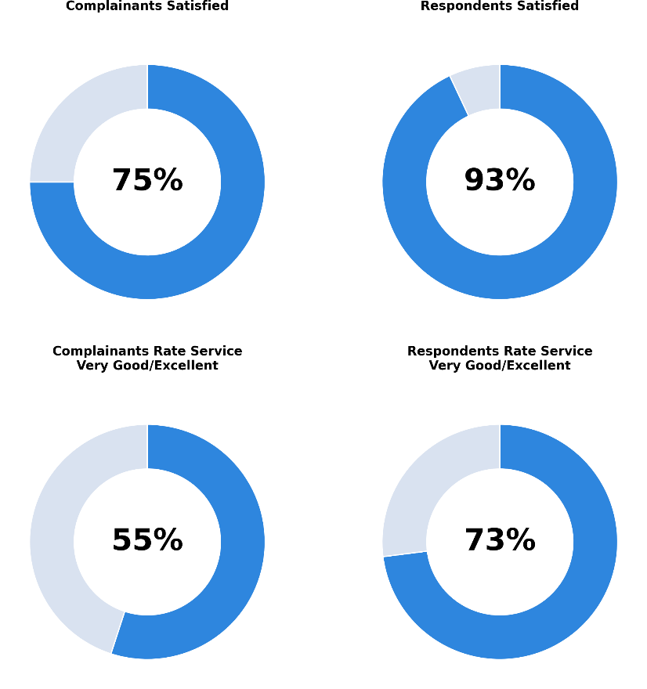

Surveys sent and returned

Survey figures | Total
Total number of surveys sent | 1,733
Total number of surveys returned | 619
Total number of surveys returned from complainants or their legal representatives | 320
Total number of surveys returned from respondents or their legal representatives | 299

Survey Results

Survey Results | All parties | Complainant | Respondent
Satisfied with the service provided | 84% | 75% | 93%
Service rated ‘Very good’ or ‘Excellent | 64% | 55% | 73%
Commission staff explained things in a way that was easy for them to understand | 88% | 84% | 92%
Commission forms and correspondence were easy to understand. | 90% | 87% | 93%
Commission dealt with the complaint in a timely manner | 59% | 51% | 68%
Commission treated the parties fairly | 79% | 72% | 87%

Survey Results – Conciliated complaints only | All parties | Complainant | Respondent
Satisfied with the service provided | 97% | 98% | 96%
With service rated ‘Very good’ or ‘Excellent | 79% | 82% | 74%

Charter of Service

Our Charter of Service provides an avenue through which complainants and respondents can understand the nature and standard of service they can expect, as well as contribute to continual improvement of our service. All complainants are provided with a copy of the Charter when their complaint is accepted by the Commission. Respondents receive a copy when notified of a complaint.

In 2025-26, the Commission received 2 complaints about its service under the complaint process provided in the Charter.

This measures the percentage of complaints that resolved against the total number of complaints finalised (excl administrative closures). From 2026-27 onwards, the Commission will be reporting on ‘Conciliation success rate’, which measures the percentage of complaints that resolved where conciliation was attempted.
We have included tables for both ‘Conciliation rate’ and ‘Conciliation success rate’. ‘Conciliation rate’ measures the percentage of complaints that resolved against the total number of complaints finalised (excl administrative closures). ‘Conciliation success rate’ measures the percentage of complaints that resolved where conciliation was attempted. From 2026-27 onwards, we will only report on ‘Conciliation success rate’.
We have included numbers for both ‘Conciliation rate’ and ‘Conciliation success rate’. ‘Conciliation rate’ measures the percentage of complaints that resolved against the total number of complaints finalised (excl administrative closures). ‘Conciliation success rate’ measures the percentage of complaints that resolved where conciliation was attempted. From 2026-27 onwards, we will only report on ‘Conciliation success rate’.
To accurately reflect the number of complaints received under each of the laws administered by the Commission, a secondary complaint is most commonly created in circumstances where a complaint raises discrete allegations under multiple laws administered by the Commission.
Includes periods of deferral where requested by the parties
Service satisfaction survey data is based on surveys received in the relevant financial year and may include surveys relating to complaints finalised in the previous financial year
Service satisfaction survey data is based on surveys received in the relevant financial year and may include surveys relating to complaints finalised the previous year
The Commission sends a voluntary survey to all parties except in circumstances where the complaint has been withdrawn or discontinued prior to the respondent being notified; or in circumstances where further contact with either party after the finalisation of a complaint would be inappropriate for reasons of personal safety of parties and/or staff.

