Supporting participation program
Application form
Part 1

About your organisation
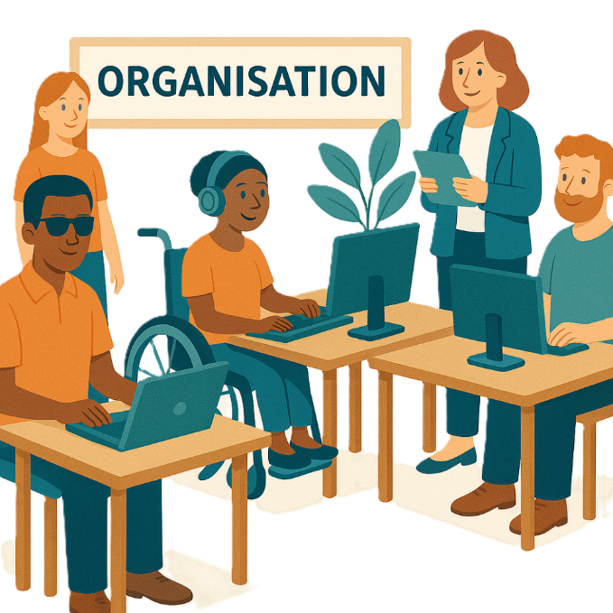
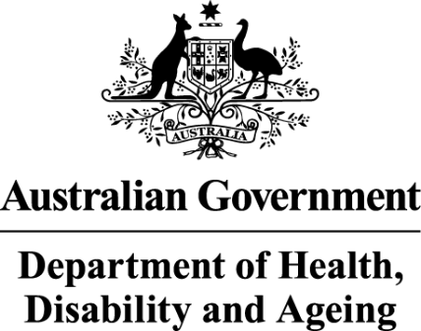 | - The Australian Government Department of Health Disability and Ageing  We say DHDA for short.
 | - The Australian Human Rights Commission  We say AHRC for short.  Wrote this together.  When you see the word we it means  DHDA and AHRC.
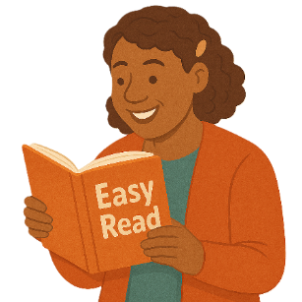 | We wrote this in an easy to read way.  We use pictures to explain some ideas.
 | We have some words in bold.  This means the letters are thicker and darker.  These are important words.
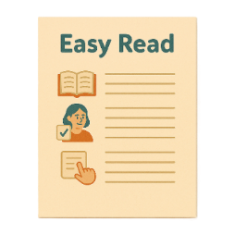 | This is an Easy Read summary of another document.  This means it has the most important ideas.
 | We can answer any questions by email.  Email us disability@humanrights.gov.au
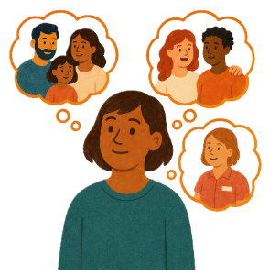 | You can ask for help to read this document.  You can ask  - A friend  - Family members  - A support person.
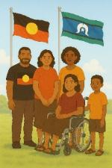 | We recognise Aboriginal and Torres Strait Islander people as the Traditional Owners of the land we live on.
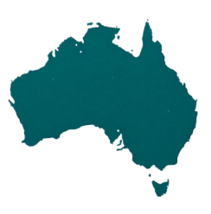 | They were the first people to live on and use the  - Land  - Waters.

Contents

Supporting Participation Program | 5
International forums in 2027 | 9
About this document | 12
How to fill out our form | 13
Questions about your organisation | 15

Supporting Participation Program

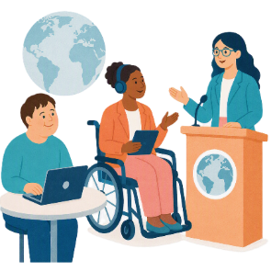 |  | This talks about the  Supporting Participation Program.  We call it SPP for short.
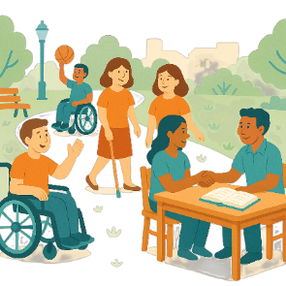 |  | Participation means taking part in something.
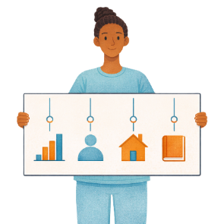 |  | Programs are done to support people in the community.
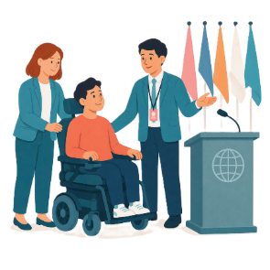 |  | SPP supports people with disability to go to international forums on human rights.  Like the United Nations Conference of States Parties.
 |  | The United Nations is an organisation where countries come together to  - Talk about world issues  - Fix world issues.  We call it the UN for short.
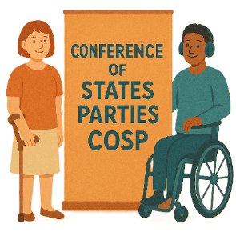 |  | The Conference of States Parties is a meeting for all countries that agreed to support the rights of people with disability.  We call it COSP for short.
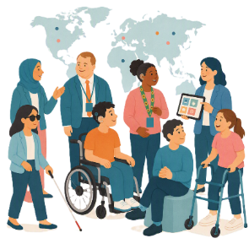 |  | International forums are meetings where people from different countries talk about important issues.
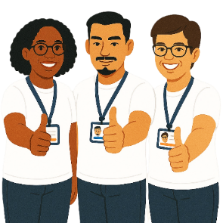 |  | Human rights are rights that everyone has.  Rights are rules about treating everyone  - Fair  - Equal.
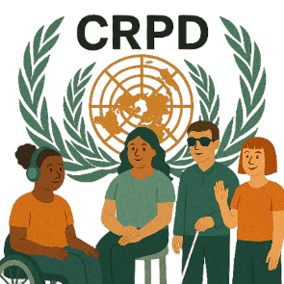 |  | SPP helps Australia to follow the  - UN Convention on the Rights of Persons with Disabilities.  We say CRPD for short.
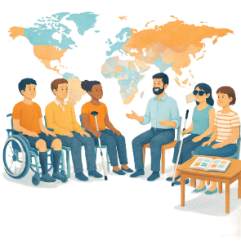 |  | CRPD is an agreement between different countries.  CRPD says how people with disability must have their rights respected.
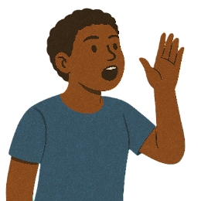 |  | SPP also supports people with disability to  - Speak up about their rights
 |  | - Represent their organisation.

International forums in 2027

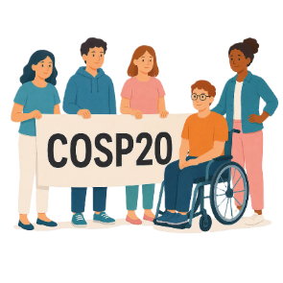 |  | There are 3 international forums in 2027.  They are  - 20th session of COSP  We call it COSP20 for short.
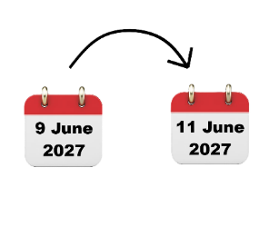 |  | COSP20 will be in the United States of America on  - 9 June to 11 June 2027.  We call it the USA for short.
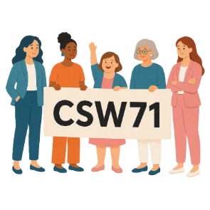 |  | - 71st Session of the Commission on the Status of Women  We say CSW71 for short.
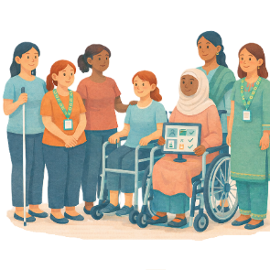 |  | CSW is about  - The rights of women  - Gender equality  Gender equality means that everyone is treated equal no matter your gender.
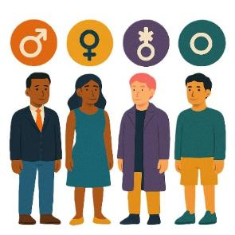 |  | People say what gender they are.  They might be  - A man  - A woman  - A different gender  - No gender.
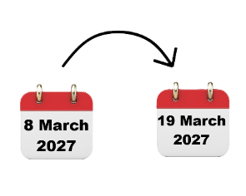 |  | CSW71 will be in the USA on  - 8 March to 19 March 2027.
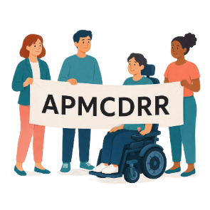 |  | - Asia Pacific Ministerial Conference on Disaster Risk Reduction.  We say APMCDRR for short.
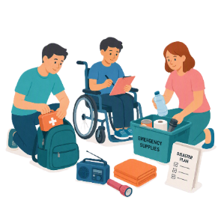 |  | APMCDRR is about  - Preparing for disasters  - Keeping people safe during disasters.
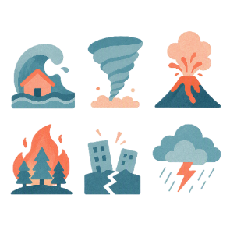 |  | Natural disasters are things like  - Cyclones  - Earthquakes  - Floods  - Volcanoes.
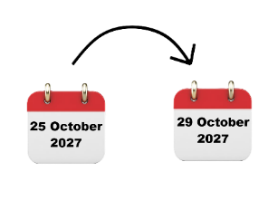 |  | APMCDRR will be in Japan on  - 25 October to 29 October 2027.

About this document

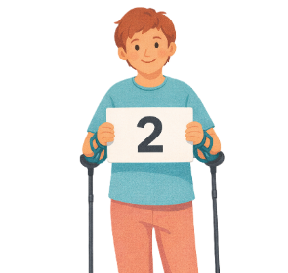 |  | This document is in 2 parts.
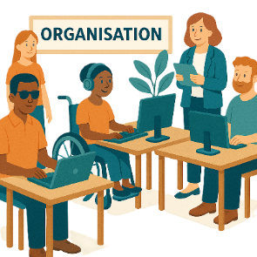 |  | Part 1 is about  - Your organisation.
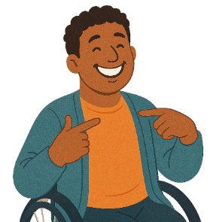 |  | Part 2 is about  - You.  You need to fill out a part 2 form for each person in your organisation who wants to go to the forums.
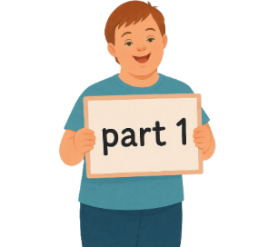 |  | This is part 1.

How to fill out our form

 |  | There are a few ways to fill out this form.  You can type your answers.
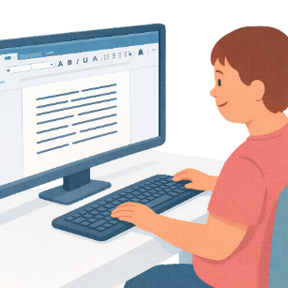 |  | You need to  1. Keep this document open.  2. Open a new Word document.
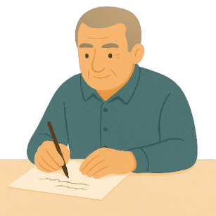 |  | You can write your answers.
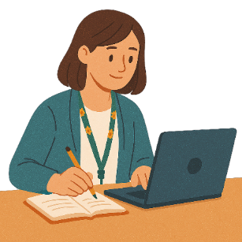 |  | You need to  1. Keep this document open.  2. Write your answers on a blank piece of paper.
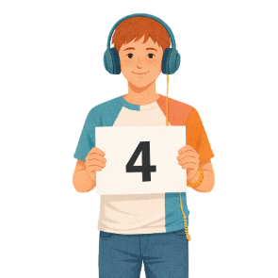 |  | There are 4 sections for our form.
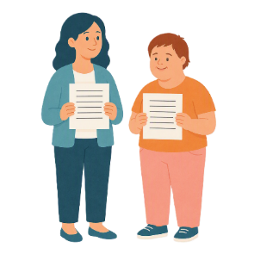 |  | Each person who wants to go to the forum will need different answers for  - Questions about you  - How much funding are you asking for  - Assessment questions.
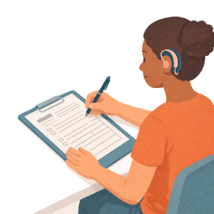 |  | An assessment is looking at information in your application to make a decision.
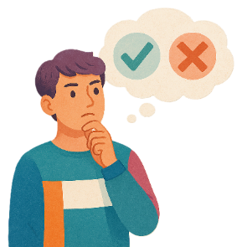 |  | You can decide what questions you want to answer.  You do not have to answer any questions you do not want to.

Questions about your organisation

Question 1

What is the name of your organisation.
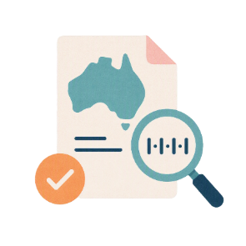 |  | Question 2  What is your organisation  Australian Business Number.  This is called ABN for short.
Question 3

What does your organisation do.
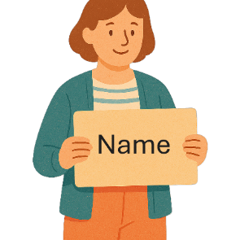 |  | Question 4  Tell us the name of 1 person in your organisation.  They need to be someone we could talk to about your form.
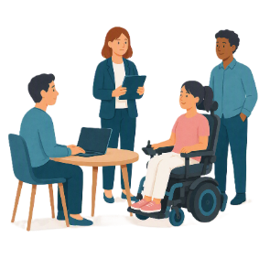 |  | What is their job at your organisation.
 |  | What is their  - Email address
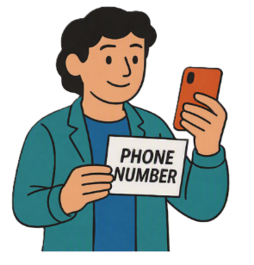 |  | - Phone number.
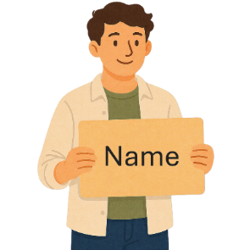 |  | Question 5  Tell us the name of another person in your organisation.  They need to be someone else we could talk to about your form.
 |  | What is their job at your organisation.
What is their

- Email address
 |  | - Phone number.
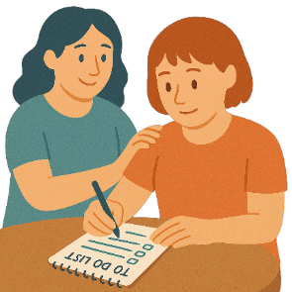 |  | Question 6  Can your organisation do all the  - Roles and responsibilities.  Roles and responsibilities are the things you need to do for SPP.  This makes sure everyone knows what they need to do.  - Yes  Or  - No.
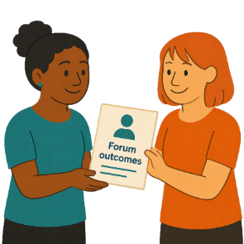 |  | Question 7  Will your organisation help share what is learned at the forum.  - Yes  Or  - No
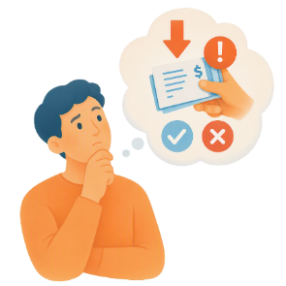 |  | Question 8  Will your organisation tell us if someone working for them is involved with the law about  - Fraud.  - Yes  Or  - No.  Laws are rules for how we live.
 |  | Fraud is when someone tries to get something they should not get.  Like tricking someone to get their money.
 |  | If you answer yes to this question  - Please tell us more about this.
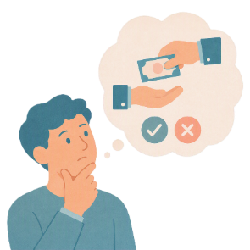 |  | Will your organisation tell us if someone working for them is involved with the law about corruption.  - Yes  Or  - No.
 |  | Corruption is when someone does the wrong thing to get something for themselves or someone else.  Like someone getting money for breaking the rules.
If you answer yes to this question

- Please tell us more about this.
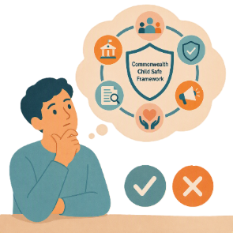 |  | Question 9  Will your organisation follow the rules for  - Commonwealth Child Safe Framework.  These are rules that help Australian Government organisations keep children safe.  - Yes  Or  - No.
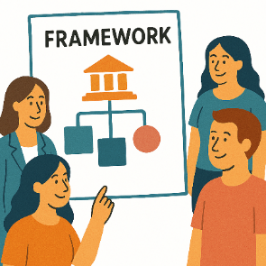 |  | A framework is how we will do something.
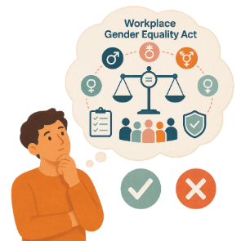 |  | Question 10  Will your organisation follow the rules for  - Workplace Gender Equality Act.  This is the law to make sure everyone is treated fairly at work.  - Yes  Or  - No.
 |  | Gender equality means that everyone is treated equal no matter your gender.
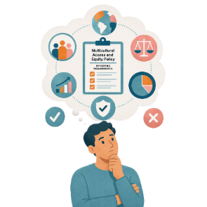 |  | Question 11  Will your organisation follow the rules for  - Multicultural Access and Equity Policy reporting requirements.  This helps government organisations say that their services are fair for people who  - Speak different languages  - Come from different cultures.  - Yes  Or  - No.
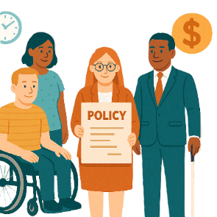 |  | Policies are plans for how to do things.
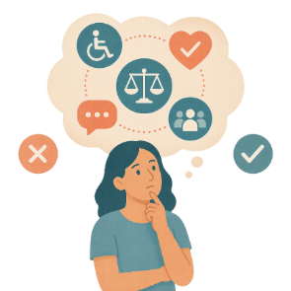 |  | Question 12  Will your organisation follow the rules for  - Disability Services and Inclusion Act.  This is the law to make sure people with disability get good services.  - Yes  Or  - No.
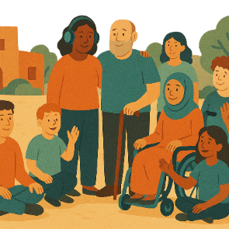 |  | Inclusion is when everyone  - Can take part  - Feels like they belong.
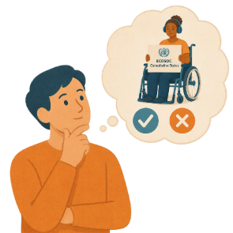 |  | Question 13  Does your organisation have UN Economic and Social Council Consultative Status.  We say ECOSOC for short.  - Yes  Or  - No.
 |  | ECOSOC status means  - Your organisation has been approved to take part in these meetings.  ECOSOC invites people from other countries to talk about ways to make the world a better place.
 |  | Question 14  What accreditation for other forums does your organisation have.  Accreditation means you are allowed to go to the forum and take part.
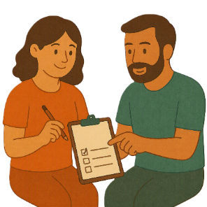 |  | The next 2 questions need to be answered by the people from your organisation.
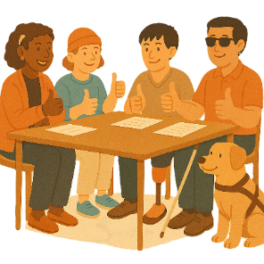 |  | Question 15  Does your organisation have permission to share information about people who want to go to the forums.  - Yes  Or  - No.
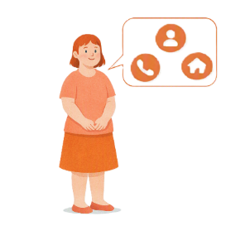 |  | This includes sharing  - Personal information  Personal information is information like your  - Name  - Phone number  - Address
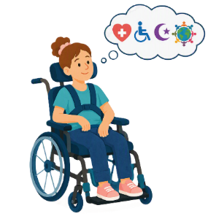 |  | - Sensitive information.  Sensitive information is information like your  - Health  - Disability  - Religion  - Culture.
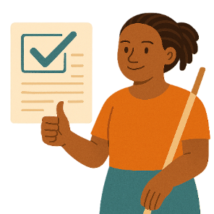 |  | Question 16  Does your organisation agree with the way we use the information given to us.  - Yes  Or  - No.
 |  | You can look at how we use your information on the website.
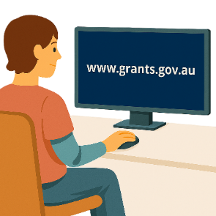 |  | You can register on this website to read them.  www.grants.gov.au/  They are not in Easy Read.
You can also go to this website to read the same documents

humanrights.gov.au/our-work/topics/disability-rights-what-were-doing/supporting-participation-program

They are not in Easy Read.
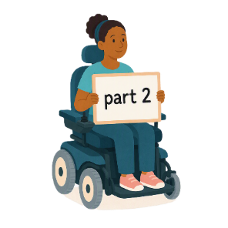 |  | These are all the questions for this part.  You need to fill out part 2 next.

Some images in this Easy Read were made using AI.
You must not share or copy any of the images without permission.
September 2026.

