Supporting Participation Program
Common questions
Part 4
- Going to the forum
- Putting in the application
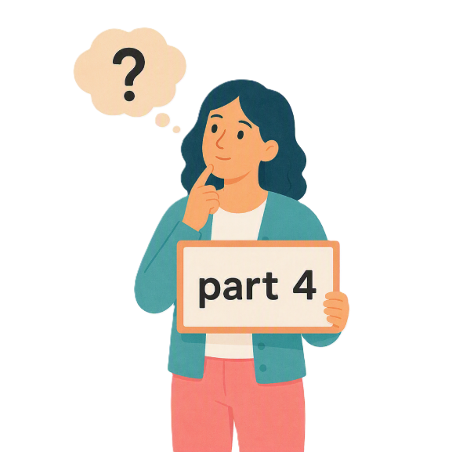
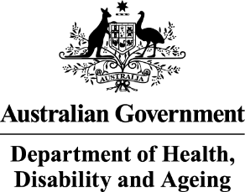 | - The Australian Government Department of Health Disability and Ageing  We say DHDA for short.
 | - The Australian Human Rights Commission  We say AHRC for short.  Wrote this together.  When you see the word we it means  DHDA and AHRC.
 | We wrote this in an easy to read way.  We use pictures to explain some ideas.
 | We have some words in bold.  This means the letters are thicker and darker.  These are important words.
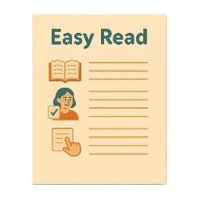 | This is an Easy Read summary of another document.  This means it has the most important ideas.
 | We can answer any questions by email.  Email us disability@humanrights.gov.au
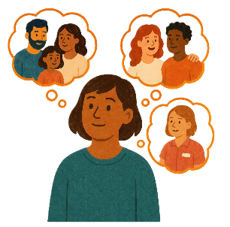 | You can ask for help to read this document.  You can ask  - A friend  - Family members  - A support person.
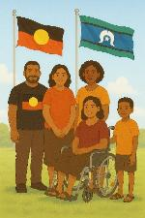 | We recognise Aboriginal and Torres Strait Islander people as the Traditional Owners of the land we live on.
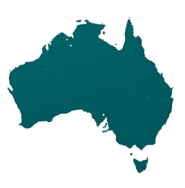 | They were the first people to live on and use the  - Land  - Waters.

Contents

About the Supporting Participation Program | 5
About this document | 9
Registration for APMCDRR | 12
Do I need to be part of an organisation | 15
Do I have to go to the whole forum | 18
When should I put in my application | 20
What to do if I do not get an email after putting in my application | 22
Can I change my application after I have put it in | 24

About the Supporting Participation Program

 |  | This talks about the  Supporting Participation Program.  We call it SPP for short.
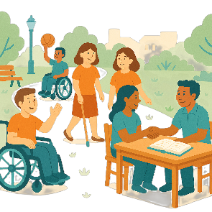 |  | Participation means taking part in something.
 |  | Programs are done to support people in the community.
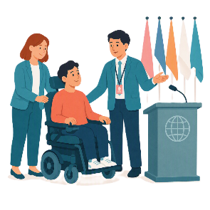 |  | SPP supports people with disability to go to international forums on human rights.  Like the United Nations Conference of States Parties.
 |  | The United Nations is an organisation where countries come together to  - Talk about world issues  - Fix world issues.  We call it the UN for short.
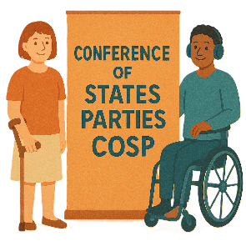 |  | The Conference of States Parties is a meeting for all countries that agreed to support the rights of people with disability.  We call it COSP for short.
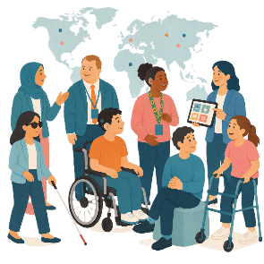 |  | International forums are meetings where people from different countries talk about important issues.
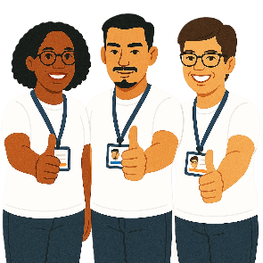 |  | Human rights are rights that everyone has.  Rights are rules about treating everyone  - Fair  - Equal.
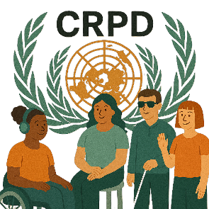 |  | SPP helps Australia to follow the  - UN Convention on the Rights of Persons with Disabilities.  We say CRPD for short.
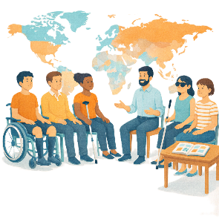 |  | CRPD is an agreement between different countries.  CRPD says how people with disability must have their rights respected.
 |  | SPP also supports people with disability to  - Speak up about their rights
 |  | - Represent their organisation.

About this document

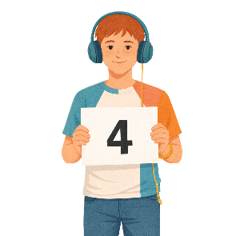 |  | This document has 4 parts.
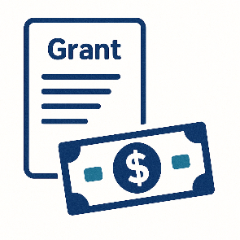 |  | Part 1 is about  - The grant  A grant is when the government gives you money to do something.
 |  | - Where to find information about the grant
 |  | - Rules for the grant.
 |  | Part 2 is about  - Funding.  Funding is money from the government to take part.
 |  | Part 3 is about  - What information is needed
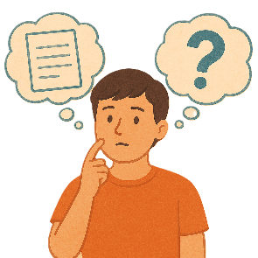 |  | - Can I get help
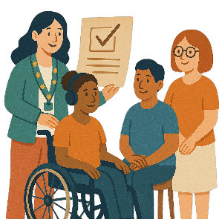 |  | - How organisations will know if they got a grant.
 |  | Part 4 is about  - Your application  Applications are forms you fill out to say you want funding to go to a forum.
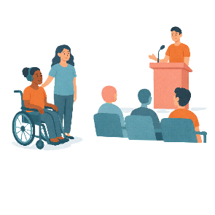 |  | - Going to the forum.  A forum is a meeting to talk about a problem.
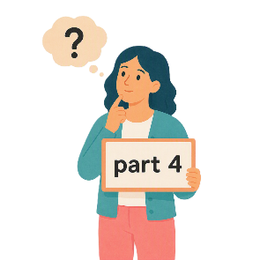 |  | This is part 4.

Registration for APMCDRR

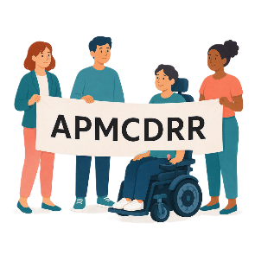 |  | This is about registration to go to  - Asia Pacific Ministerial Conference on Disaster Risk Reduction  We call it APMCDRR for short.
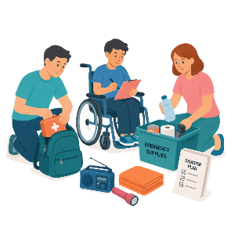 |  | APMCDRR is about  - Preparing for disasters  - Keeping people safe during disasters.
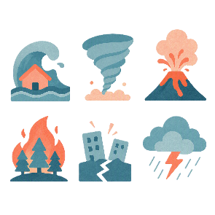 |  | Natural disasters are things like  - Cyclones  - Earthquakes  - Floods  - Volcanoes.
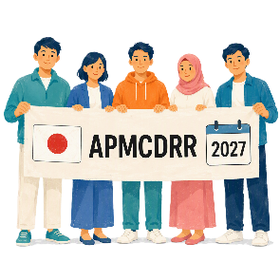 |  | APMCDRR will be in Japan in 2027.
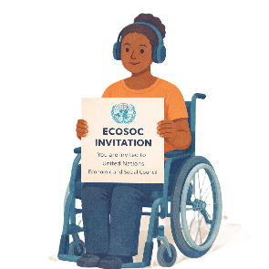 |  | Past APMCDRR have not needed  - ECOSOC status  ECOSOC status means  - Your organisation has been approved to take part in these meetings.  ECOSOC invites people from other countries to talk about ways to make the world a better place.
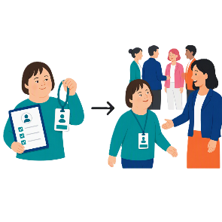 |  | Or  - Accreditation.  Accreditation means you are allowed to go to the forum and take part.
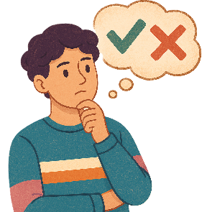 |  | This year Japan will decide if organisations need  - ECOSOC status  - Accreditation.  They will tell everyone in the next few months.
 |  | You can look at the website to read more about APMCDRR  apmcdrr.undrr.org/  It is not in Easy Read.

Do I need to be part of an organisation

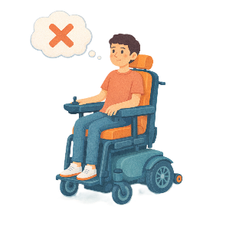 |  | Yes.  You need to be part of an organisation to apply.
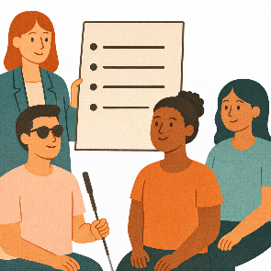 |  | This is so you can register for events.  Register means put your name down to go.  It can also be called registration.
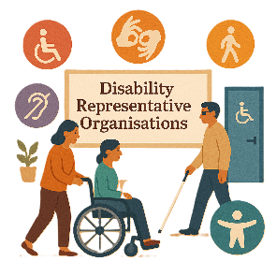 |  | You can contact Australian  - Disability Representative Organisations  We call them DROs for short.
 |  | - Disability advocacy organisations.  Advocacy is when someone supports you to speak up for your rights.
 |  | You can ask if they will support your application.
You can look on the website for organisations that have UN ECOSOC.

esango.un.org/civilsociety/displayConsultativeStatusSearch.do?method=search

It is not in Easy Read.
You can look on the website for organisations that can go to COSP.

social.desa.un.org/issues/disability/cosp/list-of-non-governmental-organization-accredited-to-the-conference-of-states

It is not in Easy Read.

Do I have to go to the whole forum

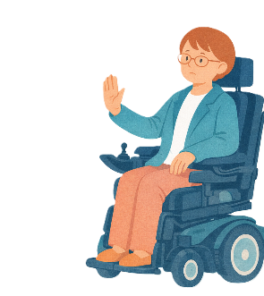 |  | No.  You do not have to go to the whole forum in person.
 |  | You should go to more than half of the forum in person.
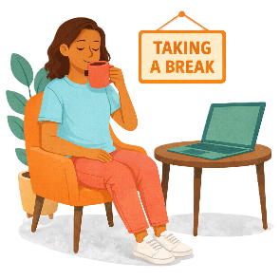 |  | This will give you a chance to  - Have a break at the forum
 |  | - Watch some parts of the forum online
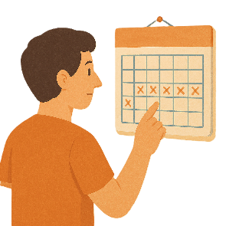 |  | - Not have to go for the whole time if the forum goes for 2 weeks.  You can be there for a shorter time.

When should I put in my application

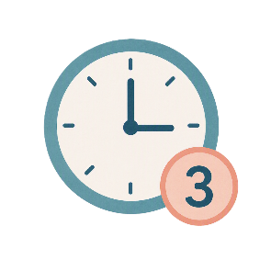 |  | You should send you application in  - At least 3 hours before it closes.
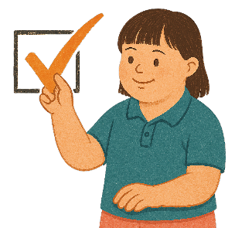 |  | This will give you time to make sure there are no mistakes when sending it.
 |  | You need to put in your application before  Sunday 1 November 2026  11pm AEDT.
 |  | AEDT is the time in  - Canberra  - New South Wales  - Tasmania  - Victoria  If you live somewhere else you will need to check the time to send it in by.
 |  | If you are having problems you can send an email to  disability@humanrights.gov.au.

What to do if I do not get an email after putting in my application

 |  | It can take up to 2 days for an email to come back saying  - We have got your application.
 |  | It will come from AHRC.
If you do not get an email after 2 days send an email to

disability@humanrights.gov.au
 |  | It might mean your application has not been put in.
 |  | If it has not been put in you can ask to put in a late application.

Can I change my application after I have put it in

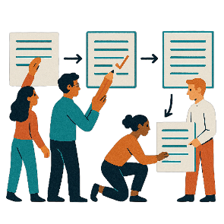 |  | Yes.  You can change your application before it closes.
Your organisation will need to email a new application to

disability@humanrights.gov.au
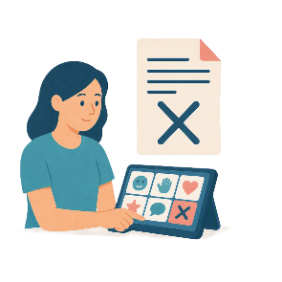 |  | Your organisation needs to tell us that you withdraw the application already sent.
After applications close you can only change it if

- You find a mistake after putting it in.

You need to send an email right away to

disability@humanrights.gov.au
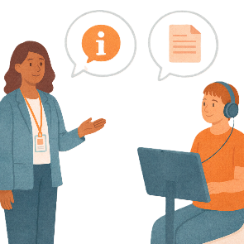 |  | We might ask for more information.  After applications close we might not be able to use the information.

Some images in this Easy Read were made using AI.
You must not share or copy any of the images without permission.
August 2026.

