Supporting participation program
Application guide
Part 2
How to apply
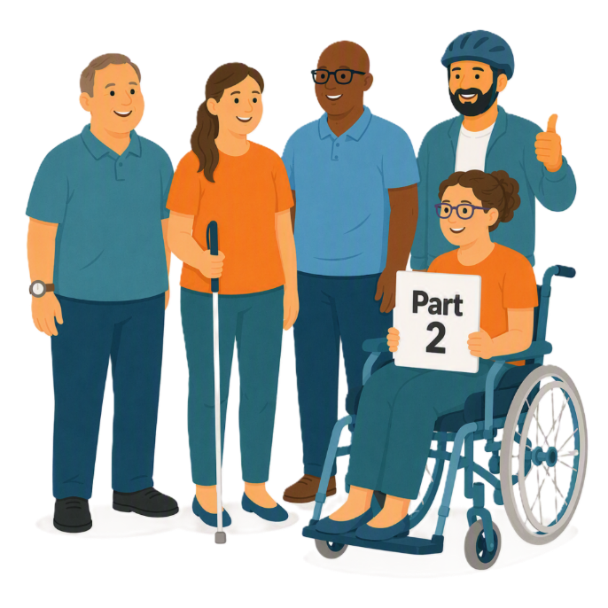

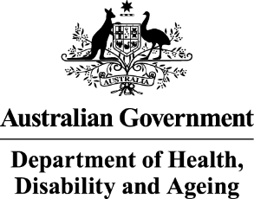 | - The Australian Government Department of Health Disability and Ageing  We say DHDA for short.
 | - The Australian Human Rights Commission  We say AHRC for short.  Wrote this together.  When you see the word we it means  DHDA and AHRC.
 | We wrote this in an easy to read way.  We use pictures to explain some ideas.
 | We have some words in bold.  This means the letters are thicker and darker.  These are important words.
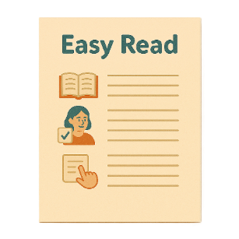 | This is an Easy Read summary of another document.  This means it has the most important ideas.
 | We can answer any questions by email.  Email us disability@humanrights.gov.au
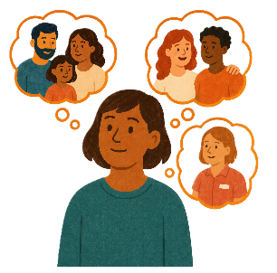 | You can ask for help to read this document.  You can ask  - A friend  - Family members  - A support person.
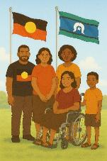 | We recognise Aboriginal and Torres Strait Islander people as the Traditional Owners of the land we live on.
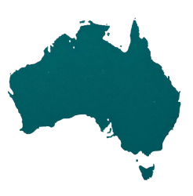 | They were the first people to live on and use the  - Land  - Waters.

Contents

About this document | 5
Supporting Participation Program | 7
About the grant | 9
Rules for applying for the grant | 11
What the grant can be used for | 13
What the grant can not be used for | 16
Assessment questions | 18
How to apply for the grant | 26
What we will do when looking at applications | 30

About this document

 |  | This document has 2 parts.
 |  | Part 1 is about the  - Supporting Participation Program  We call it SPP for short.
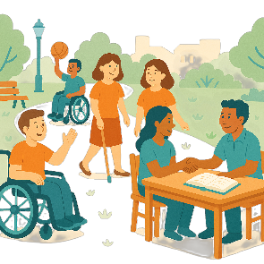 |  | Participation means taking part in something.
 |  | Programs are done to support people in the community.
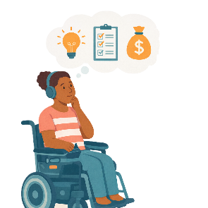 |  | Part 2 is about  - How to apply for the SPP grant.  A grant is when the government gives you money to do something.
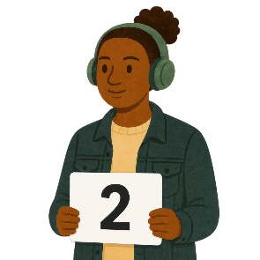 |  | This is part 2.

Supporting Participation Program

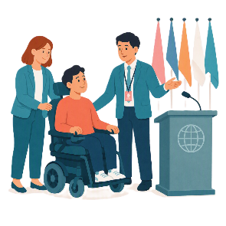 |  | The SPP supports people with disability to go to international forums on human rights.  Like the United Nations Conference of States Parties.
 |  | The United Nations is an organisation where countries come together to  - Talk about world issues  - Fix world issues.  We call it the UN for short.
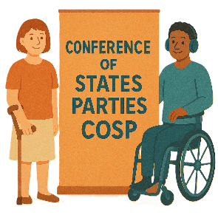 |  | The Conference of States Parties is a meeting for all countries that agreed to support the rights of people with disability.  We call it COSP for short.
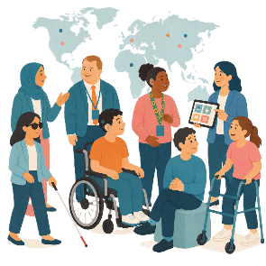 |  | International forums are meetings where people from different countries talk about important issues.
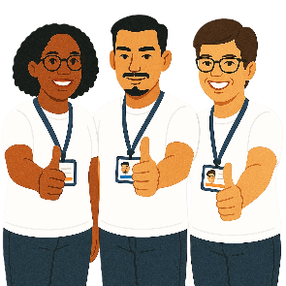 |  | Human rights are rights that everyone has.  Rights are rules about treating everyone  - Fair  - Equal.
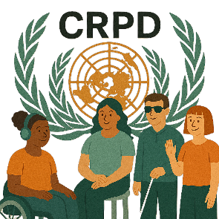 |  | SPP helps Australia to follow the  - UN Convention on the Rights of Persons with Disabilities.  We say CRPD for short.
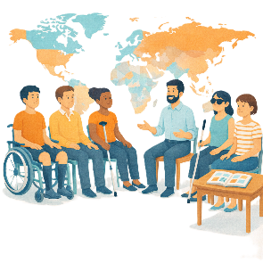 |  | CRPD is an agreement between different countries.  CRPD says how people with disability must have their rights respected.

About the grant

 |  | The grant supports people with disability to  - Speak up about their rights
 |  | - Represent their organisation.
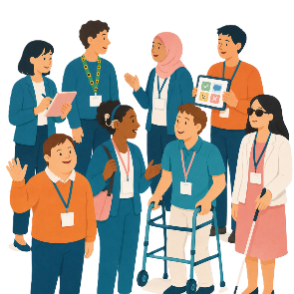 |  | People who get this grant will be a delegate for Australia.  A delegate is a person who  - Is part of an organisation  - Speaks for their organisation  - Speaks up about their experiences.
 |  | To be a delegate you must complete an  - Application form.
 |  | An application form is when someone says they want to take part in something.
 |  | This application is a form you send to ask for the grant money.

Rules for applying for the grant

 |  | There are rules for who can apply for the grant.
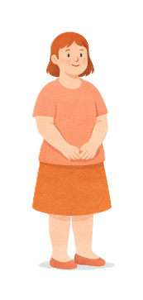 |  | You must be  - 18 years or older
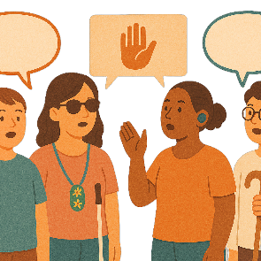 |  | You must be part of a  - Disability Organisation  - Advocacy organisation.  Advocacy is when someone supports you to speak up for your rights.
 |  | Your organisation must have  - Approval from the forums you would like to attend
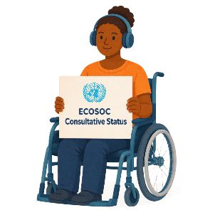 |  | Or  - UN Economic and Social Council Consultative Status.  We say ECOSOC for short.
 |  | ECOSOC status means  - Your organisation has been approved to take part in these meetings.  ECOSOC invites people from other countries to talk about ways to make the world a better place.

What the grant can be used for

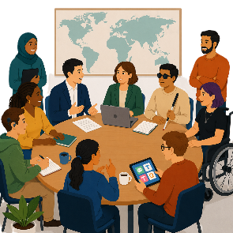 |  | The grant money is for  - Supporting people with disability to take part in international forums on human rights.
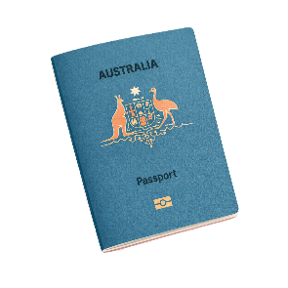 |  | It can be used to pay for things like  - Passport  A passport is a document from the government.  It says  - Who you are  - What country you are from.  It helps you travel to different countries.
 |  | - Visa  A visa is a document that says you can go to another country for a certain amount of time.
 |  | - Accommodation  This is where you stay when you are away from home.
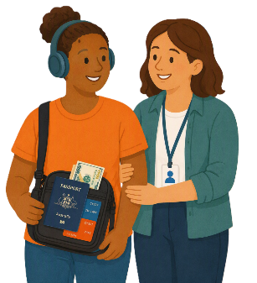 |  | - Support person
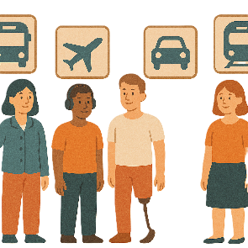 |  | - Transport  Transport is how people move from one place to another.  You can use  - Cars  - Buses  - Planes.
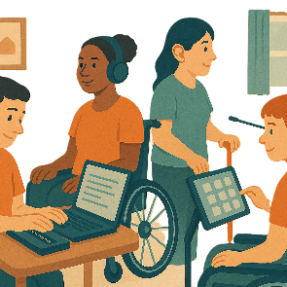 |  | - Assistive technology.  Assistive technology can be things to help you  - Speak  - Move  - See  - Hear.
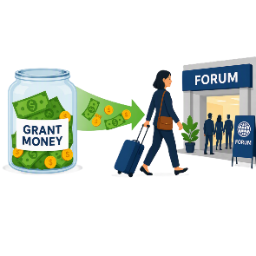 |  | Organisations must give all the grant money to help the delegate go to the forum.

What the grant can not be used for

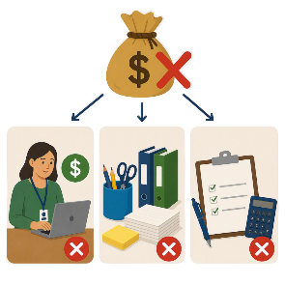 |  | Organisations can not use the grant money for  - Paying staff  - Office supplies  - Costs of applying for the grant.
 |  | Delegates can not use the grant money for  - Anything not needed to go to the forum like
 |  | - Buying souvenirs  Souvenirs are things you buy to remember a trip or event.  They are not things you need.
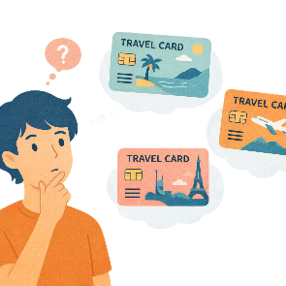 |  | - Extra travel that is not needed to go to the forum
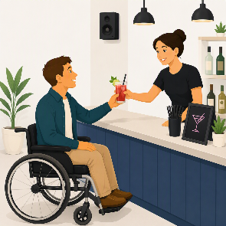 |  | - Alcoholic drinks.

Assessment questions

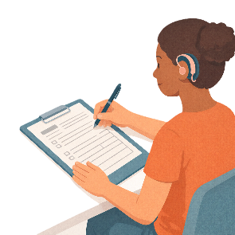 |  | An application for the grant needs to  - Answer all the assessment questions.  An assessment is looking at information in your application to make a decision.
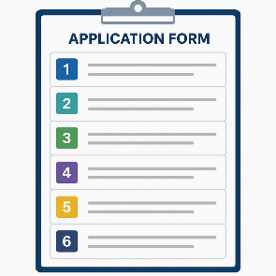 |  | Your application will be assessed on the answers to these questions.  There are 6 assessment questions.
 |  | - Organisation supports  This is how will your organisation will support you to take part in the forums.
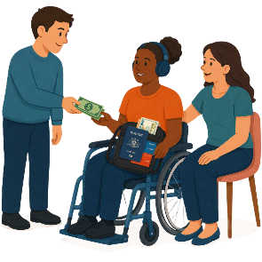 |  | Supports may be things like  - Booking the travel  - Having support staff  - Helping to prepare for the event
 |  | Organisations that help have more chance of getting the grant.
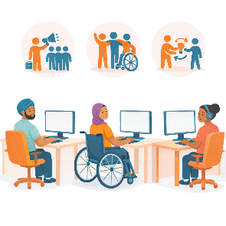 |  | - Organisation experience  This is what experience your organisation has in human rights work.
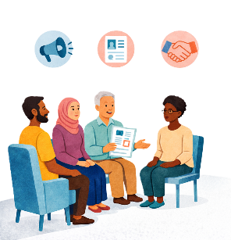 |  | This could talk about your organisations  - Goals  - Work on human rights forums  - Work on disability advocacy.
 |  | - Individual knowledge and experience  Individual means 1 person.
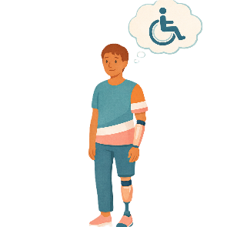 |  | This is what you know about  - Disability issues in Australia
 |  | - The CRPD
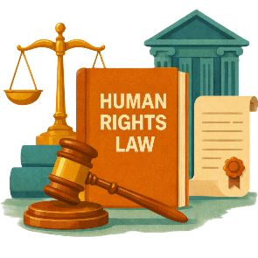 |  | - Human rights
 |  | - How the UN works.
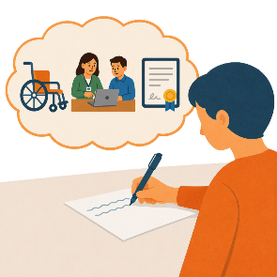 |  | You could share about  - Your experiences
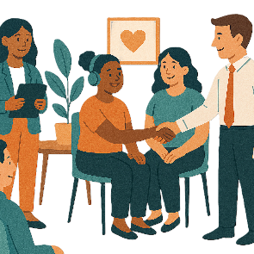 |  | - Work that you have done
 |  | - Training you have done
 |  | - Awards you have won for your work
 |  | - Qualifications you have.  Qualifications are proof that you have  - Learned a skill  - Finished training to do a job.
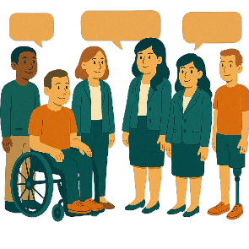 |  | - Individual delegation supports  This is how you will work with other delegates.
 |  | This could be how you would  - Ask for advice about issues
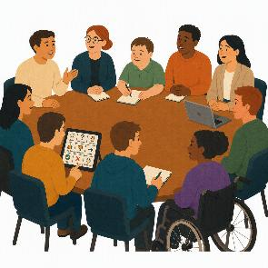 |  | - Build your skills to take part in forums
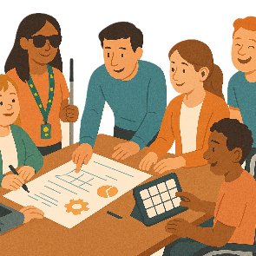 |  | - Support and plan events for the forums.
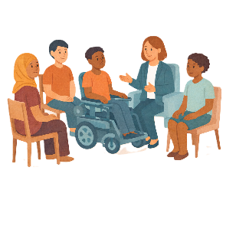 |  | For general delegates  You should also talk about how you will mentor members from the  - Emerging Young Leaders Delegation.  This is for people aged 18 to 35 years old.
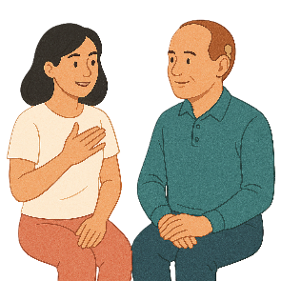 |  | Mentoring someone helps them to learn and grow.  Mentoring is about support.  It is not telling someone what to do.
 |  | This supports young people with disability build their skills and confidence to be leaders.
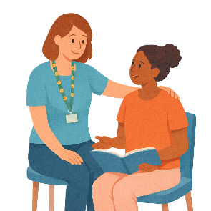 |  | For members of the Emerging Young Leaders Delegation  You should also talk about how you will  - Take having a mentor.  This is called being a mentee.
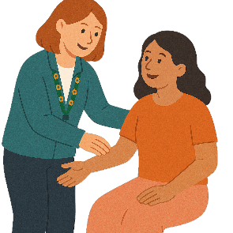 |  | - Impact of attendance  This is how going to the forums would help  - You  - Your organisation.
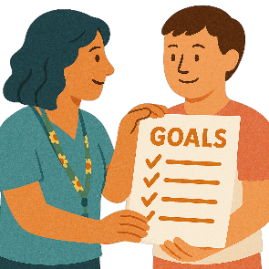 |  | This could be about  - Future goals
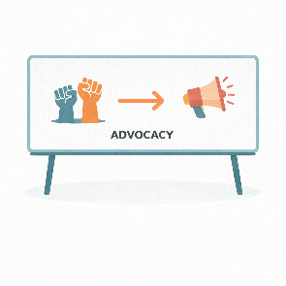 |  | - Making advocacy better.
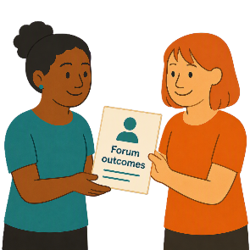 |  | - Sharing forum outcomes.  Outcomes are goals that people finish.
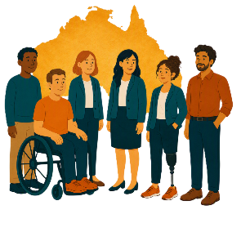 |  | This could be things like how you and your organisation will  - Share information from forums with the community.

How to apply for the grant

 |  | To apply for the SPP grant.  You need to  - Read all the documents about the grant.
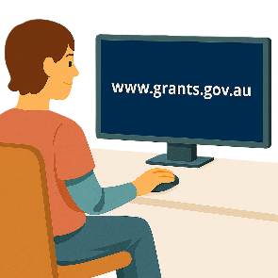 |  | You can register on this website to read them.  www.grants.gov.au/Go/Show?GoUuid=e0d1e575-e433-4a86-afbb-06efe6ae3af6  They are not in Easy Read.
 |  | You can also go to this website to read the same documents  humanrights.gov.au/our-work/topics/disability-rights-what-were-doing/supporting-participation-program  They are not in Easy Read.
 |  | - Fill in the application form
 |  | - Answer all the assessment questions.
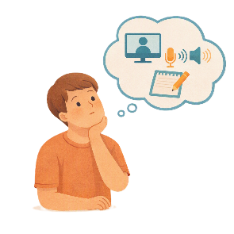 |  | You can give your answers in different ways.  You can
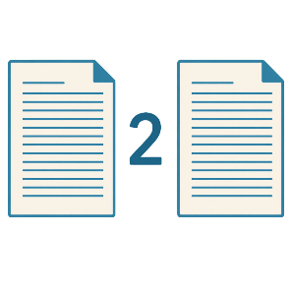 |  | - Write your answers  You can write no more than 2 pages.
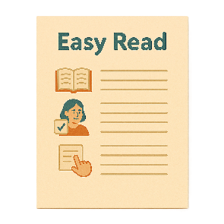 |  | - Send an Easy Read  Your Easy Read can be as long as you want.
 |  | - Send a video  Your video must be under 5 minutes.
 |  | - Send an audio file.  An audio file is speaking only.  Your audio file must be under 5 minutes.
     |  | If you send an  - Easy Read  - Video  - Audio
 |  | You can write as well.  You must write no more than 1 page.
 |  | Email your application to  disability@humanrights.gov.au
 |  | You need to put your application before  Sunday 1 November 2026  11pm AEDT
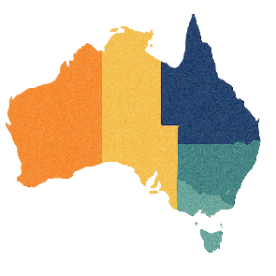 |  | AEDT is the time in  - Canberra  - New South Wales  - Tasmania  - Victoria  If you live somewhere else you will need to check the time to send it in by.

What we will do when looking at applications

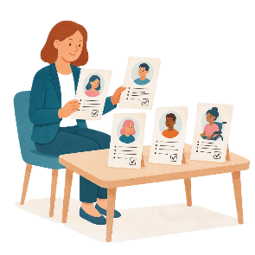 |  | AHRC will  - Look at the applications  - Give all the applications a score  - Write a report about who they think should get a grant.
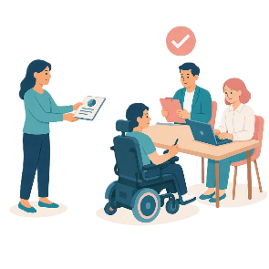 |  | AHRC will then send the report to DHDA.  DHDA will decide who gets a grant.
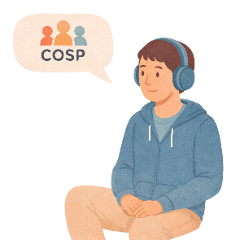 |  | We think COSP20 will have the most funding.
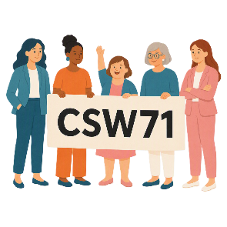 |  | There will be less funding for  - CSW71
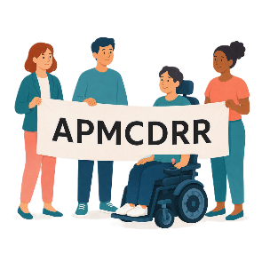 |  | - APMCDRR.
 |  | The amount of funding you get will depend on what is in your application.
 |  | We will think about the diversity of the applicants.  That means we will look at
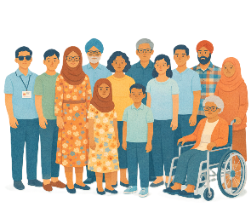 |  | - Different experiences about disability
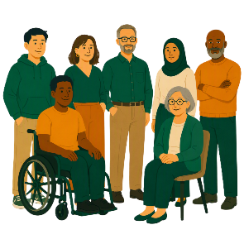 |  | - Age
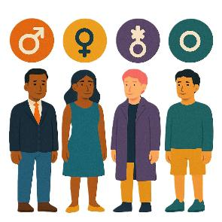 |  | - Gender  People say what gender they are.  They might be  - A man  - A woman  - A different gender  - No gender.
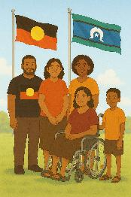 |  | - First Nations people
 |  | - People who are part of the LGBTQIA+ community
 |  | - People from areas that are  - Regional  - Remote
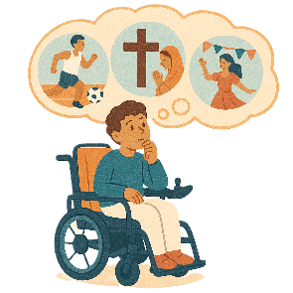 |  | - People from culturally and linguistically diverse backgrounds.  This means people who  - Speak different languages  - Come from different cultures.  We say CALD for short.

Some images in this Easy Read were made using AI.
You must not share or copy any of the images without permission.
August 2026.

