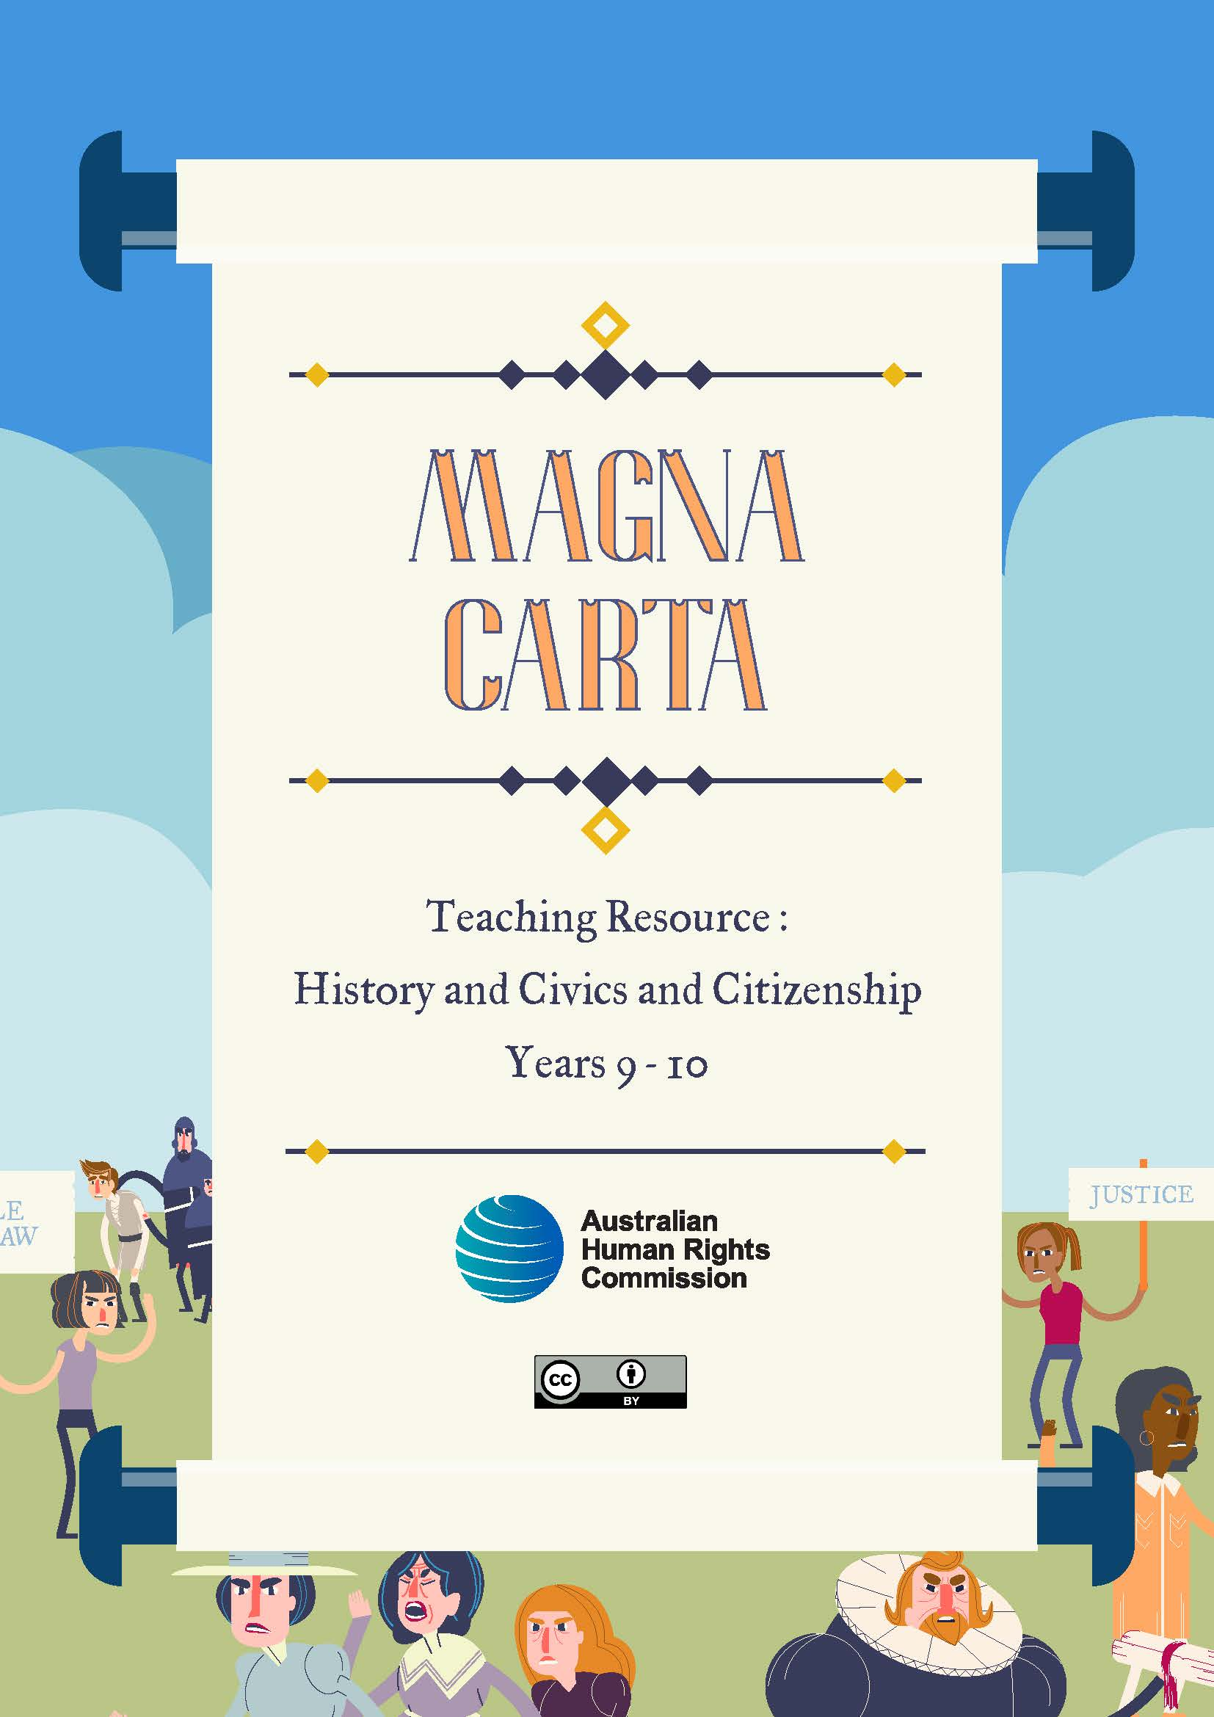

Introduction
Magna Carta has had an enduring legacy that has shaped the human rights and freedoms that all Australians enjoy today. In particular, Magna Carta advanced ideas of freedom, justice and the rule of law, principles which have become enshrined in our democracy.
To mark the 800th anniversary of Magna Carta, the Australian Human Rights Commission has created a series of online educational resources which explore the evolution of human rights since 1215 and the impact that Magna Carta has had on our human rights and freedoms in Australia.
The two digital resources - an interactive infographic and a short animated video - have been mapped to the Australian Curriculum for History and Civics and Citizenship for Years 9 and 10.

Australian Curriculum links
Australian Curriculum Content Description | Elaborations
Year 9 History (Making a Nation)
Key events and ideas in the development of Australian self-government and democracy, including women's voting rights (ACDSEH091) | - explaining the factors that contributed to federation and the development of democracy in Australia, including defence concerns, the 1890s depression, nationalist ideals, egalitarianism and the Westminster system
Year 9 Civics and Citizenship (Government and Democracy)
Reflect on their role as a citizen in Australian, regional and global contexts (ACHCS089) | - considering Australian, regional and global futures and how students might contribute as active and informed citizens
Year 10 History
The origins and significance of the Universal Declaration of Human Rights, including Australia’s involvement in the development of the Declaration (ACDSEH023) | - describing the drafting of the Universal Declaration of Human Rights and the contribution of Australia’s H.V. Evatt
The continuing nature of efforts to secure civil rights and freedoms in Australia and throughout the world, such as the Declaration on the Rights of Indigenous Peoples (2007) (ACDSEH143) | - identifying areas (for example education, health, work) that are the focus for continued civil rights action for Aboriginal and Torres Strait Islander Peoples
Identify and analyse the perspectives of people from the past (ACHHS190) | - Identify and analyse the perspectives of people from the past
Use chronological sequencing to demonstrate the relationship between events and developments in different periods and places (ACHHS182) | - using interactive timelines to explore the various manifestations or effects of an event in different geographical locations
Year 10 Civics and Citizenship (Government and Democracy)
Australia’s roles and responsibilities at a global level, for example provision of foreign aid, peacekeeping, participation in international organisations and the United Nations (ACHCK091) | - investigating Australia’s involvement with the United Nations, for example representation in the organisation and adherence to conventions and declarations that Australia has ratified
Reflect on their role as a citizen in Australian, regional and global contexts (ACHCS102) | - considering and identifying the qualities of a citizen in a contemporary, successful democracy

The Universal Declaration of Human Rights: “The international Magna Carta for all mankind”
Australian Curriculum content codes: History Year 10 ACDSEH023 and Civics and Citizenship Year 10 ACHCK091
This section explores the creation of the Universal Declaration of Human Rights (UDHR) in 1948 and its relationship to Magna Carta. It also details the role of prominent Australians who contributed to the creation of the UDHR.
Background Information:
Magna Carta: Magna Carta (meaning “The Great Charter” in Latin) is a powerful symbol of liberty and democracy around the world. The Magna Carta was signed in 1215 by King John of England and stated that everybody – including the King – was subject to the rule of law. Magna Carta also gave rights to (a select group of) people, including the right to a fair trial. Some of the fundamental principles in Magna Carta have been passed down into modern human rights laws and declarations, such as the UDHR.
The United Nations: Following the devastation of World War II, the governments of the world come together in 1945 to form an international organisation called the United Nations (UN), dedicated to upholding peace and security. The Charter of the UN states that the organisation’s purpose is to achieve co-operation in solving international problems of an economic, social, cultural, or humanitarian character, and to promote respect for human rights and fundamental freedoms for all without distinction as to race, sex, language, or religion.
The Universal Declaration of Human Rights: One of the first actions of the newly-founded UN was to create a Commission on Human Rights, with the purpose of drafting a document outlining the basic human rights shared by all people, everywhere. This resulted in the UDHR, which was adopted by the UN General Assembly on the 10th of December 1948.
The UDHR recognises the dignity of all people, and asserts that human rights should apply equally worldwide. Civil and political rights, economic and cultural rights, and the responsibility to uphold the rights of others are all emphasised in the Declaration.

Viewing activity: “The Story of Our Freedom” video
To gain an understanding of the events in Australia and around the world that led to the development of the UDHR, begin by watching the “The Story of Our Freedom” video.
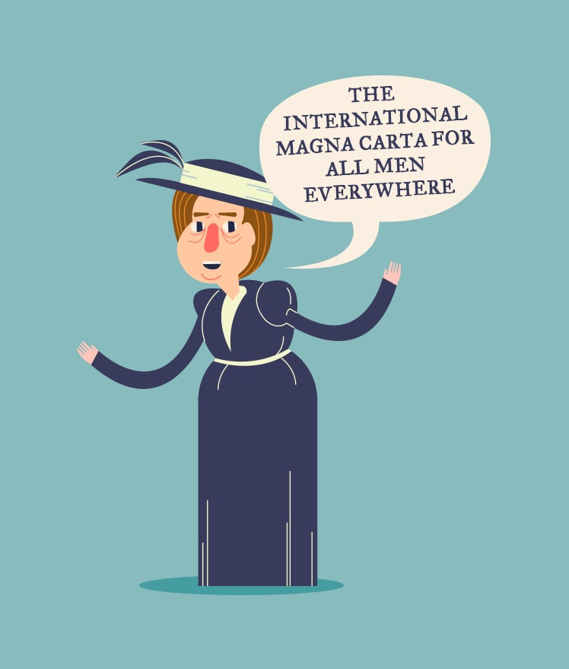
After watching the video, pose the following questions to the class:
- Why do you think Magna Carta was important in 1215, when it was signed by King John? What impact do you think it had on the lives of: common people/ on women/ on peasants/ on the King?
- Why do you think the UDHR was important when it was created by the UN in 1948? What impact do you think it has had on our lives today?
- Eleanor Roosevelt described the UDHR as the “International Magna Carta for men everywhere”, what do you think she meant by this?
This discussion should prompt students to think about the historical significance of these two documents. View a useful worksheet for assigning significance from the History Teachers’ Association of Australia.
Next ask students to compare and contrast these two key documents:
- What are some significant ideas that can be found in BOTH Magna Carta and the UDHR (e.g. the principles of the rule of law, rights to justice such as a fair trial, and ideas of democratic representation)?
- What are some important human rights principles in the UDHR that are NOT present in Magna Carta?
To assist students with their comparison you may wish to provide them with simplified versions of the two documents. A simplified version of the UDHR has been created by Discovering Democracy. The Magna Carta Project has created a list of all the clauses of the 1215 version of Magna Carta, which can be searched by clause number or topic.
Through class discussion, encourage students to identify elements of continuity and change between 1215 and today, and consider why some ideas in Magna Carta may have changed over time while others have endured.
For example, clauses 38, 39, 40 and 45 in Magna Carta have been influential in shaping contemporary rights relating to justice and the law. However it is also important to emphasise to students that Magna Carta only granted rights to “free men” and largely overlooked women and peasants. This is the fundamental distinction between Magna Carta and the UDHR, which emphasised the equality of everyone in its first article, stating that “All human beings are born free and equal in dignity and rights”.

Research activity: Australia’s involvement in the development of the UDHR
Australia was a founding member of the UN and played a prominent role in the negotiation of the UN Charter in 1945. Australia was also one of eight nations involved in drafting the UDHR.
Ask students to explore the Magna Carta interactive infographic, focussing specifically on the sections relating to the founding of the UN and creation of the UDHR.
Instruct students to select one of the important figures listed below and conduct an online inquiry into how this person contributed to the creation of the UDHR. Students should write a brief summary of their findings explaining why the contribution of their chosen person was significant in advancing human rights and freedoms.
Colonel William Hodgson | Jessie Street | Herbert V. Evatt
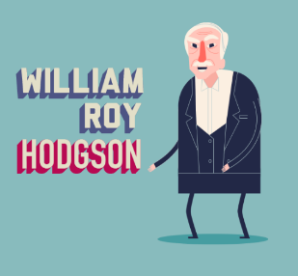 | 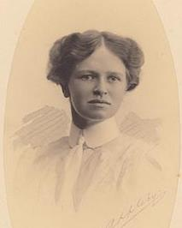
Key Points:  Col. William Hodgson was a soldier and diplomat and served in the First World War at Gallipoli where he was seriously wounded.  Under the leadership of Eleanor Roosevelt, Hodgson, along with representatives from other countries, helped define the basic human rights and responsibilities that were to be included in the UDHR.  While it was never agreed upon, Col. Hodgson pushed to have the Articles in the UDHR enforceable by law in all countries. | Key Points:  Jessie Street was the only female in Australia’s delegation to the United Nations.  She successfully campaigned for the recognition of equal rights for both men and women, leading to a change in the opening of the draft UDHR from “All men and brothers…” to “All human beings are born free and equal in dignity and rights”.  Jessie Street was also a prominent advocate for women’s rights and Aboriginal rights in Australia. | Key Points:  Dr HV. Evatt, or ‘the Doc’ as he was called, was a lawyer and well-known figure in Australian politics.  Prior to coming to the UN, Doc Evatt had been a judge of the High Court, Attorney-General and Minister for External Affairs. He was renowned for being a champion of civil liberties and the rights of economically and socially disadvantaged people.  Doc Evatt was elected the third President of the General Assembly and oversaw the vote by the UN countries to accept the UDHR. He also persuaded the then sceptical Australian Government to vote in favour of the UDHR.
Fun fact: The figures show in the UN section of the infographic depict the representatives from the eight countries selected to draft the UDHR (Lebanon, China, France, US, UK, Australia, Chile, Canada and the USSR). More information about the drafting of the UDHR drafters can be found on the UN’s UDHR website.

Changing rights and freedoms in Australia

Research activity: Struggles for human rights in the 20th Century
Refer students to the section of the infographic that depicts three groups in Australia who historically have struggled to receive recognition of their human rights and freedoms: women, migrants and Aboriginal and Torres Strait Islander Peoples.
Select one of the topics below and instruct students to conduct an online investigation into this topic. Students should summarise their findings in a five minute presentation.
Women’s rights and the suffragette movement | Post-World War II migrant experiences | Aboriginal and Torres Strait Islander Peoples’ civil rights movement
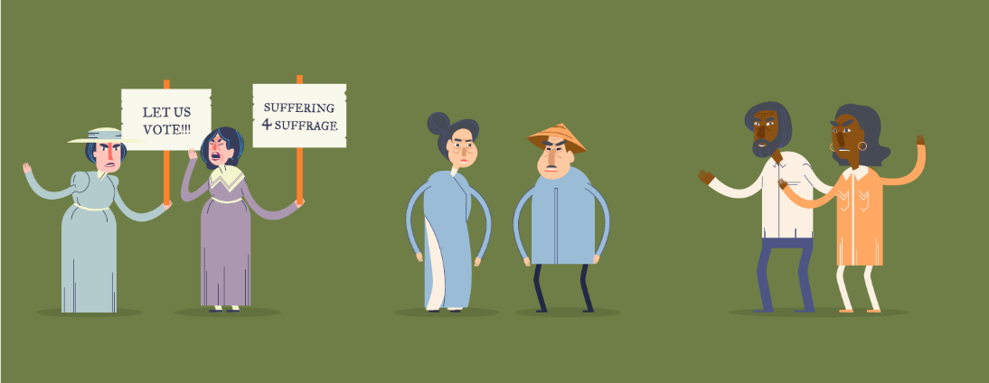
This investigation topic is best suited to the Year 9 History depth study: Australia and Asia - Making a nation (ACDSEH091) | This investigation topic is best suited to the Year 10 History depth study: The Globalising World – Migrant Experiences (ACDSEH144, ACDSEH145 and ACDSEH147) | This investigation topic is best suited to the Year 10 History depth study: Rights and Freedoms (ACDSEH023, ACDSEH104, ACDSEH105)
Students should summarise their findings in a five minute presentation, which responds to the following points:
- What rights and freedoms did your chosen group have to fight for?
- List some of the reasons why your chosen group was historically denied these rights and freedoms.
- Explain how your chosen group achieved recognition of their rights, with reference to one key historical event or person.
- Are there any rights that your chosen group is still fighting for? What strategies or campaigns are they currently engaged in?

What can I do?
Australian Curriculum content codes: Civics and Citizenship Year 9 ACHCS089, Civics and Citizenship Year 10 ACHCS102 and Year 10 History ACDSEH143
This section looks at existing rights movements and what actions we can take to support them. Specifically, it looks at the Close the Gap campaign and the different human rights activities that students can engage in.

Human Rights in Australia today…
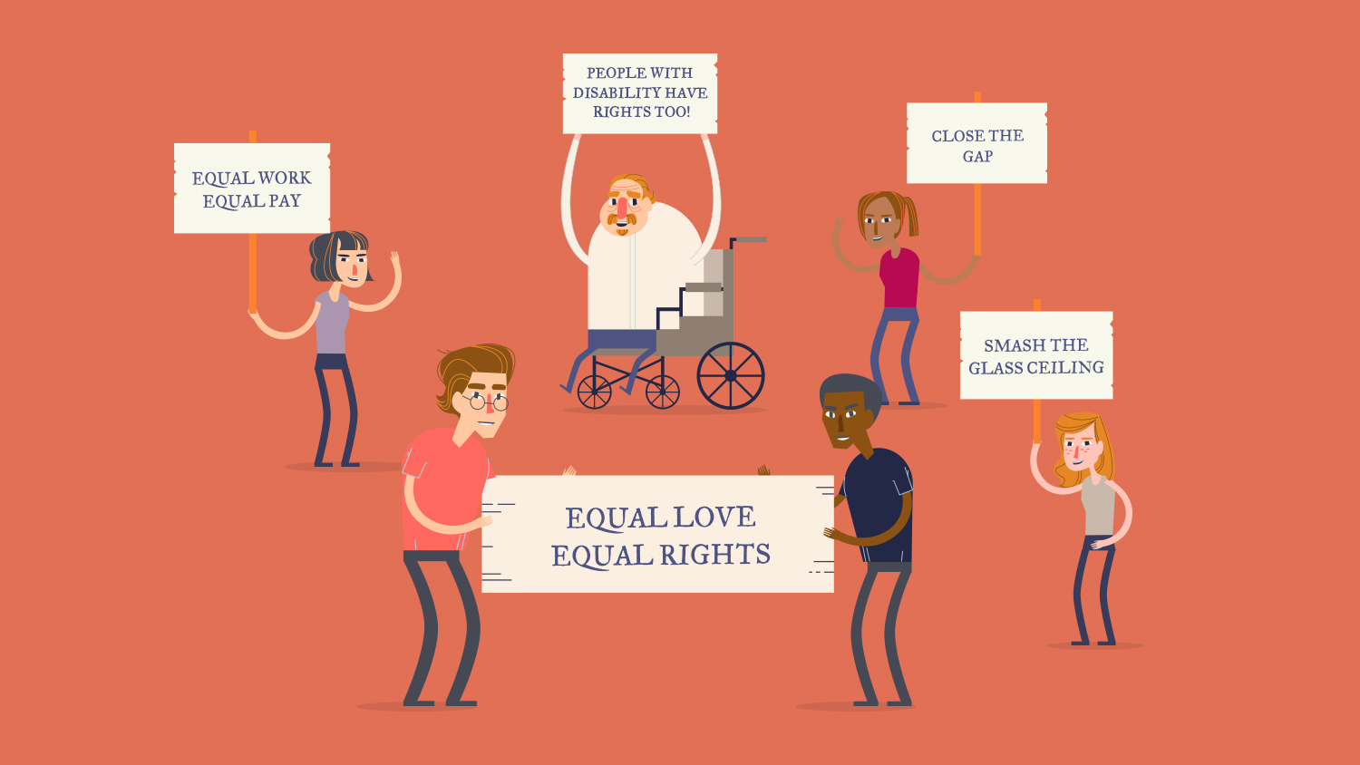
As the “Story of Our Freedom” video and infographic show, there has been a lot of progress in improving the rights of people worldwide. However, there is still a long way to go to ensure everyone has access to their human rights and freedoms.
Refer students to the image in the interactive infographic showing the group of people advocating for a range of important human rights issues in Australia today and ask if they can identify some of the rights and freedoms that they are advocating for.
Point out to students that one of the figures is holding a placard which says “Close the Gap”. This will be explored further in the case study in the next section.

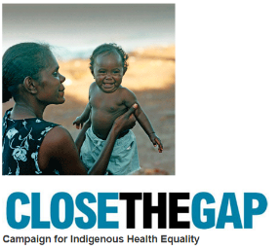
Case study: The Close the Gap campaign
The Close the Gap campaign is an example of a rights movement that still has a long way to go.
Since 2006, Australia’s peak Indigenous and non-Indigenous health bodies, NGOs and human rights organisations have worked together to promote better health and life expectancy outcomes for Aboriginal and Torres Strait Islander peoples. This is known as the Close the Gap campaign.

Research activity: Investigation and presentation
In pairs, ask students to create a short video, conduct an interview or write a newspaper article, in which one student takes the role of a journalist, and the other student is a representative of the Close the Gap campaign. Examples of the types of questions students can ask include:

- What is the Close the Gap campaign aiming to achieve?
- What is the life expectancy gap between Indigenous and non-Indigenous Australians?
- Why does this gap exist?
- What has the campaign identified as necessary in order to close the gap?
- Why do you think this campaign has received such significant support from government, non-government organisations and the wider Australian public alike?

As a starting point, refer students to the following sources:

- Australian Human Rights Commission – Close the Gap: Indigenous Health Campaign
- Oxfam Australia – Close the Gap
- National Aboriginal Community Controlled Health – Close the Gap http://www.naccho.org.au/aboriginal-health/close-the-gap-campaign/
- ABC Splash – Choose Your Own Statistics: Life Expectancy

Being active and informed
Explain to students that there are several ways that young people can be active and engaged citizens who stand up for human rights issues.
Instruct students to discuss - as a class or in small groups - a human rights issue that they particularly care about and come up with ideas about what can be done to improve this issue.
One possible action students can take is planning a human rights event in their school or community. For ideas about human rights days and causes that students can hold events for and other ways to promote human rights within their family, school or community, visit the sites below:
- Australian Human Rights Commission - Human Rights Calendar
- Australian Human Rights Commission – Get Involved
© Australian Human Rights Commission 2015, CC BY 3.0 AU

The Australian Human Rights Commission encourages the dissemination and exchange of information provided in this publication.
All material presented in this publication is provided under a Creative Commons Attribution licence, with the exception of the Australian Human Rights Commission Logo
The details of the relevant licence conditions are available on the Australian Human Rights Commission Copyright Statement webpage.
Attribution: Material obtained from this publication is to be attributed to the Australian Human Rights Commission with the following copyright notice: © Australian Human Rights Commission 2015.
Contact details: For further information about the Australian Human Rights Commission, please visit www.humanrights.gov.au or email mailto:communications@humanrights.gov.au
You can also write to: Human Rights Education Team Australian Human Rights Commission GPO Box 5218 Sydney NSW 2001

