A Guide for Children and Young People
The National Strategy to Prevent and
Respond to Child Sexual Abuse 2021–2030
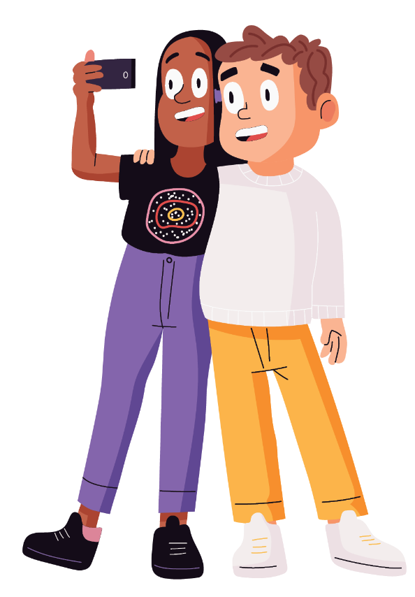

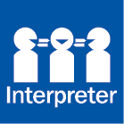
If you speak a language other than English and need help understanding this document, you can contact the free Translating and Interpreting Service on 131 450.
If you are deaf and/or find it hard hearing or speaking with people who use a phone, the National Relay Service (NRS) can help you. Please contact the NRS Helpdesk on 1800 555 660.
A Guide for Children and Young People to the National Strategy to Prevent and Respond to Child Sexual Abuse (2021-2030) and its Action Plans
© Commonwealth of Australia 2021
© Australian Human Rights Commission
ISBN 978-1-925364-79-8 (print)
ISBN 978-1-925364-80-4 (online)

Version
The information in A Guide for Children and Young People to the National Strategy to Prevent and Respond to Child Sexual Abuse (2021-2030) and
its Action Plans is current as at 11 October 2021.

Copyright Notice
This work is licensed under a Creative Commons Attribution 4.0 International licence (CC BY 4.0)
(https://CreativeCommons.org/Licenses/By/4.0/).


Third party copyright
Wherever a third party holds copyright in this material, the copyright remains with that party.
Their permission may be required to use the material. Please contact them directly.

Attribution
This publication should be attributed as follows:
© Commonwealth of Australia © Australian Human Rights Commission, A Guide for Children and Young People to the National Strategy to Prevent and Respond to Child Sexual Abuse (2021-2030) and its Action Plans.

Other uses
Enquiries regarding this document are welcome at:
National Office for Child Safety
Department of the Prime Minister and Cabinet
Ngunnawal Country
PO BOX 6500, Barton ACT 2600
Email: NationalOfficeForChildSafety@pmc.gov.au
This guide will help children and young people understand child sexual abuse, how and where to get help, and how the National Strategy is improving Australia’s response to child sexual abuse. When this guide refers to a child, it refers to anyone under the age of 18 years. This guide is recommended for children aged 9 years and up.

Acknowledgements
The National Office for Child Safety would like to thank the Australian Human Rights Commission for writing this guide in collaboration with children. In particular, we thank the children involved for sharing their views and suggestions to ensure this guide helps other children to understand child sexual abuse and how and when to get help.
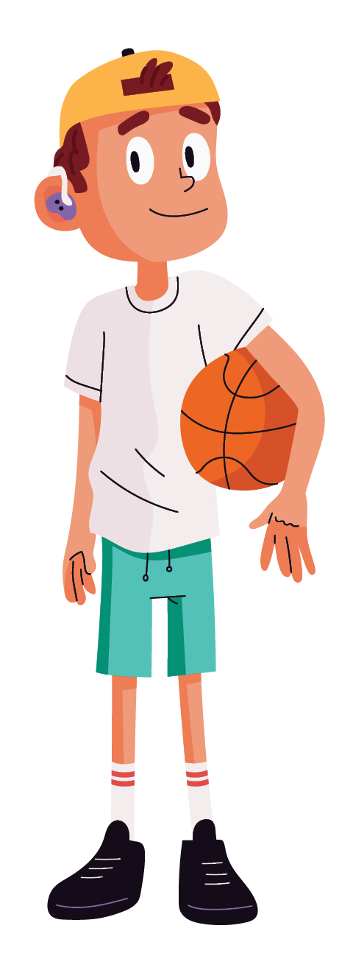

Who can help you?
If you feel worried or unsure of anything, it is very important that you ask for help. You can talk to an adult you trust, like someone in your family, a parent or carer, a family friend, your school teacher, a police officer, a doctor, a sports coach or a counsellor. You can also talk to another safe person in your life, like a friend or your brother or sister. The right person will help you with the next steps.
There are also places in the community that you can trust to help you and listen to what has happened. Calling these numbers is free, and you can call from a mobile, a school phone or a public phone box if you are unable to call from home.
If you are in immediate danger or in an emergency call the police on 000.
If you have been sexually abused, feel scared or unsafe, or something has happened and you want help from the police, you can call 131 444 or visit your local police station anytime.
Things you can say to the police include:
- I am calling the police because someone is touching me in a way I don’t like.
- I am calling the police because someone is speaking to me in a way that is sexual.
- I am calling the police because someone is asking me or making me do sexual things.
- I am calling the police because even though I am not sure how to describe it, I think someone is sexually abusing me.
- I am calling the police because I think someone is sexually abusing someone I know.
There is no time limit on getting help from the police and they will always want to hear about what has happened to you. You can call them about things that are happening right now or things that happened a while ago.

If you need someone to talk to or if you feel worried about someone’s behaviour towards or around you:
You can contact Kids Helpline:
- on the phone on 1800 55 1800
- online at www.KidsHelpline.com.au

If you are aged 12-25 years and need support:
You can talk to Headspace:
- on the phone on 1800 650 890
- online at www.eHeadSpace.org.au
- face-to-face at a Headspace centre, which you can find through their website at www.HeadSpace.org.au
You can talk to Beyond Blue:
- on the phone on 1300 22 4636
- online at www.BeyondBlue.org.au/who-does-it-affect/young-people

If something bad happens online:
You can get help from the eSafety Commissioner:
- online at www.eSafety.gov.au/kids
You can make a report to the Australian Federal Police:
- online at www.accce.gov.au/report
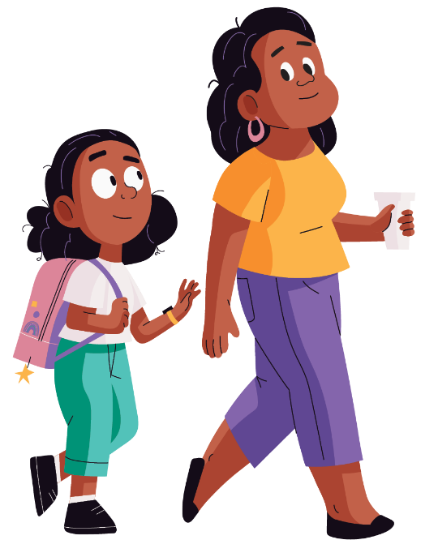

What is child safety and child sexual abuse?

What are your rights about safety?
As a child, you have a right to safety and a sense of wellbeing. This is true no matter what your age, gender, culture, religion, sexual identity, education level, or where you live.
You have the right to privacy. Your body belongs to you and you can say ‘no’, including when you feel scared, uncomfortable or unsafe. Children always have a right to feel safe, and if you don’t, you can tell an adult you trust. Trusted adults will listen to what you have to say because your thoughts and feelings matter.
You also have a right to be safe online, and to be able to learn, have fun and connect with people without feeling unsafe or uncomfortable. If anything happens online that you don’t like, you can tell a trusted adult. You should still tell them even if you’re embarrassed about what happened, or about what you said to someone or sent to someone.
The law protects you from certain things and from certain people that can make a situation unsafe, or that can harm your wellbeing. This includes sexual abuse, which is a crime.

What are your rights when it comes to your body?
Your body is your space. The parts of your body covered by swimwear or underwear are your private parts. No one should touch, or ask to look at, the private parts of your body, or make you look at theirs. You should also listen when other people tell you they do not want to be touched or looked at, and you should respect their privacy, too.
Sometimes, an adult (like a parent, carer, doctor or nurse) might need to touch you for health or hygiene reasons. But, they should ask you first and explain what they’re doing.
What are private parts?
A private part includes breasts, a bottom, an anus, and genitals such as the penis and vagina. In your family you might call these body parts different names and they can be a bit embarrassing to talk about. However, knowing the right words can help you explain if something is happening that you don’t like.
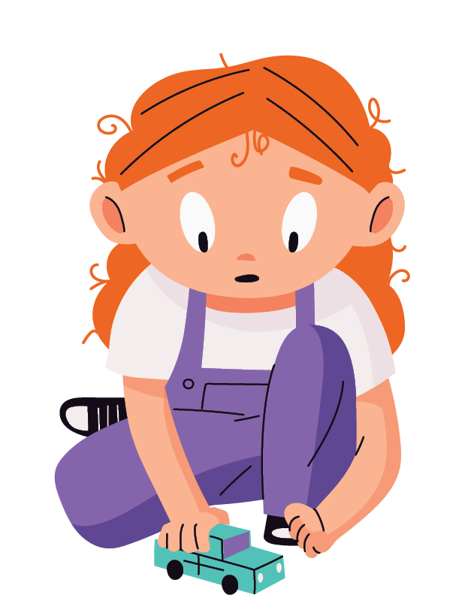
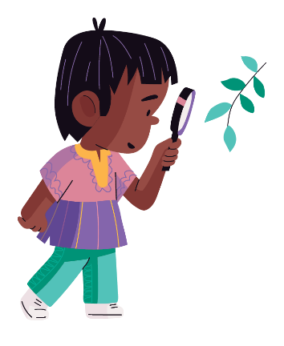

What is child sexual abuse?
Child sexual abuse is when an adult or child involves a child in any kind of sexual activity.
This is what child sexual abuse can look like:
A child being shown someone else’s private parts or someone encouraging or forcing a child to show their private parts

Asking a child to look at sexual videos or images

Making sexual comments to a child or about other children, like commenting on a child’s private parts

Someone looking at a child in a way that makes the child uncomfortable while they are going
to the toilet, are in the bath or shower, or are undressing

Doing anything sexual with or to a child’s body, including putting fingers, objects or their private parts in a child’s private parts or mouth, or encouraging or forcing a child to put their fingers, private parts or other objects in someone else’s private parts or mouth

Touching a child, either over or under clothing, in a way that makes the child uncomfortable, or encouraging or forcing a child to touch themselves or someone else in a sexual way

Encouraging or forcing a child to make or send videos or photos of themselves or other children in their underwear, partially dressed, or naked

As a child, you cannot consent (say yes or agree) to sexual activity. You also have the right to say no to things you don’t like or think are wrong, even if someone tells you that you can’t.
A good rule to follow is that if it does not feel right, you should tell someone you trust. Sexual abuse is not part of a normal relationship, it is not a sign of love, and it is never a child’s fault.

Why would someone want to sexually abuse a child?
There are a number of reasons why someone might sexually abuse a child. For example, they might be sexually attracted to children, or they might want to control someone and feel powerful. Whatever the reason may be, it is never okay, and it is never the child’s fault. It must be reported to someone.

Where and how can child sexual abuse happen?
Child sexual abuse can happen anywhere: online, in families, and during activities like sports and music lessons. Children can be abused in places they visit regularly, including at church, school or community group.
Sometimes, someone who is a stranger will abuse a child. But most of the time, sexual abuse will be done by someone a child knows and may trust. This could be a family member, neighbour or family friend. Sometimes, the abuse will be done by another child.
Children can also be sexually abused online either by people they know, or people they do not know. Online sexual abuse can include someone sending inappropriate images of themselves to a child, or asking a child to share photos or videos of themselves, including when they’re naked. Sometimes, a child might do what the person asks at first, and send them a photo or video. But that person may use what the child has sent to them to bribe or embarrass them into sending more.
If anything like this has ever happened to you or a friend, you should tell a trusted adult.
You won’t be in trouble and you are not alone.
Online sexual abuse can also involve someone talking in sexual ways through online chats, or encouraging a child to meet up with them in real life.
Someone who plans to sexually abuse a child may start by ‘grooming’ that child. This means they will do things that might make it easier to spend time with or talk to the child, or things that will make the child trust them and do what they say. For example, they might try to spend more time with the child, especially in private, or give them gifts or money. They might tell the child that their ‘relationship is a secret’. It can be hard to know why someone is doing these things, or even to notice that their behaviour has changed. And, not everyone who does these things will be trying to groom the child. But, whenever something doesn’t feel right, it is important that you tell a trusted adult or another safe person in your life.

What kind of feelings or physical impacts can sexual
abuse cause?
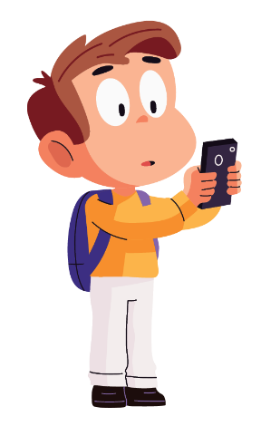
Children sometimes feel they might not be listened to or no one will believe them. Children may be scared they will get into trouble if they tell, or that it might cause a lot of problems. But, children have the right to tell their story at any time — for example, when it is happening, straight after it has happened, or days, weeks or even years later.
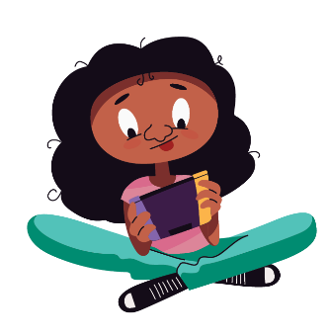
Children might be confused or embarrassed about what has happened to them. What has happened to them is very upsetting and it might have happened to other children. When a child talks to someone trustworthy, they will be able to support the child to get help.
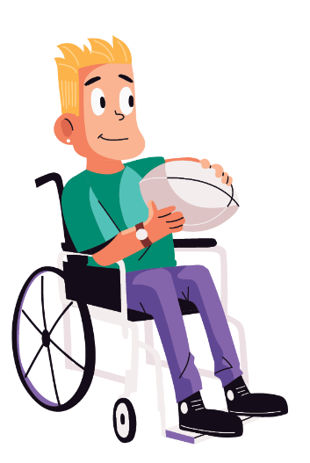
There are people who will listen to children and help them. Children have the right to be heard. If a child tells someone and they don’t believe them, it is important for the child to find another safe person to talk to.
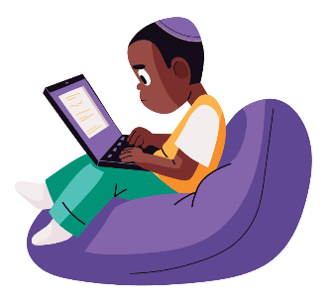
Children who have been sexually abused may experience a range of physical and emotional effects. Physical effects could include pain or injury to private parts, nightmares, weight loss and headaches. Emotional effects or changes to behaviour could include feeling down, worried, angry, or scared of certain people or places. Children may feel upset about what has happened to them and how they are feeling, but there are people who will help children feel better and keep safe.
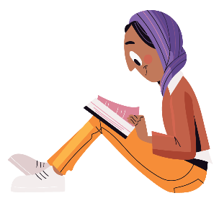
Children might feel they are to blame, especially if they didn’t clearly say ‘no’, or if they said ‘yes’ to something they didn’t understand or have changed their mind about. It is a common response to freeze when you feel scared, and sometimes children agree with adults even if they don’t want to. But, safe adults never ask you to do something unsafe. Children are never to blame, and what has happened is not their fault. Children have the right to tell the truth and to get help.
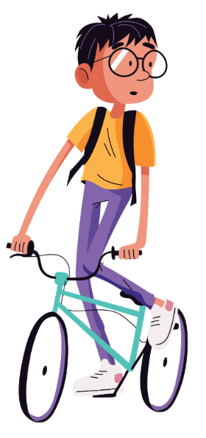
Children might care for or love the person who abused them. If a child has been abused by someone they know, like a family member, it can be confusing because they might be worried about them getting into trouble. But it is not a child’s job to protect someone who is hurting them or making them feel unsafe. There are adults whose job it is to help in these situations. It is important for children to speak up when they can, and help to keep themselves and other kids safe.

How can you keep yourself and your friends safe?
It is never a child’s fault if they are sexually abused. But there are things you can do to help keep yourself safe. Some of the things you can do to help to keep yourself safe are:
Be confident to speak up and say ‘NO’ when someone treats you in a way you do not like. Your body is your space, and it is private. You could say:
- Do not touch my body.
- Do not speak to me that way.
- I do not want to do the things you are asking me to do.
- Stop looking at my body.
- I know what you are doing is wrong, and I’m going to tell someone.
- You are making me uncomfortable and I do not want to be alone with you.
And then, if you can, leave the situation and find someone safe to talk to.

Have lots of conversations with trusted adults, like your parents, carers or teachers, or other safe people in your life. Always tell them if something doesn’t feel right. You can also ask for help through the helplines we have listed on page 5 if you don’t have someone safe you can talk to.

Understand your body parts and listen to your body’s early warning signs. Sometimes your body will tell you if someone or something isn’t safe. You might feel butterflies in your stomach, get shaky hands or a dry mouth, or feel your heart pounding in your chest.

Look out for your friends and your brothers and sisters. Sometimes, you might notice changes in them: they might behave differently and not want to do activities they used to enjoy, start ‘acting out’, or tell you something has happened to them. Watch out for the changes, be ready to listen, and check in by asking if there is anything they want to talk about. If they tell you they have been or they think they will be sexually abused, it is important to believe them and tell a trusted adult.

If you ever feel uncomfortable or unsafe, and you decide to talk to someone, the first person you talk to may not be the right person. Keep telling other trusted adults or safe people in your life until you have been heard, believed and someone helps you. The right person will take steps to make sexual abuse stop.

Who is on your helping hand?
Who are the people you can go to if you need help or feel unsafe? Write one name on each finger. Think about people in your family, at school, friends’ parents, or adults you know in your sports groups or community activities. You could include your teacher, the police, your parents and grandparents, your brothers or sisters, or Kids Helpline! Someone who will listen, believe and help you is someone you can trust.
If you can think of lots of people, you could trace your hand on another piece of paper and write even more names!
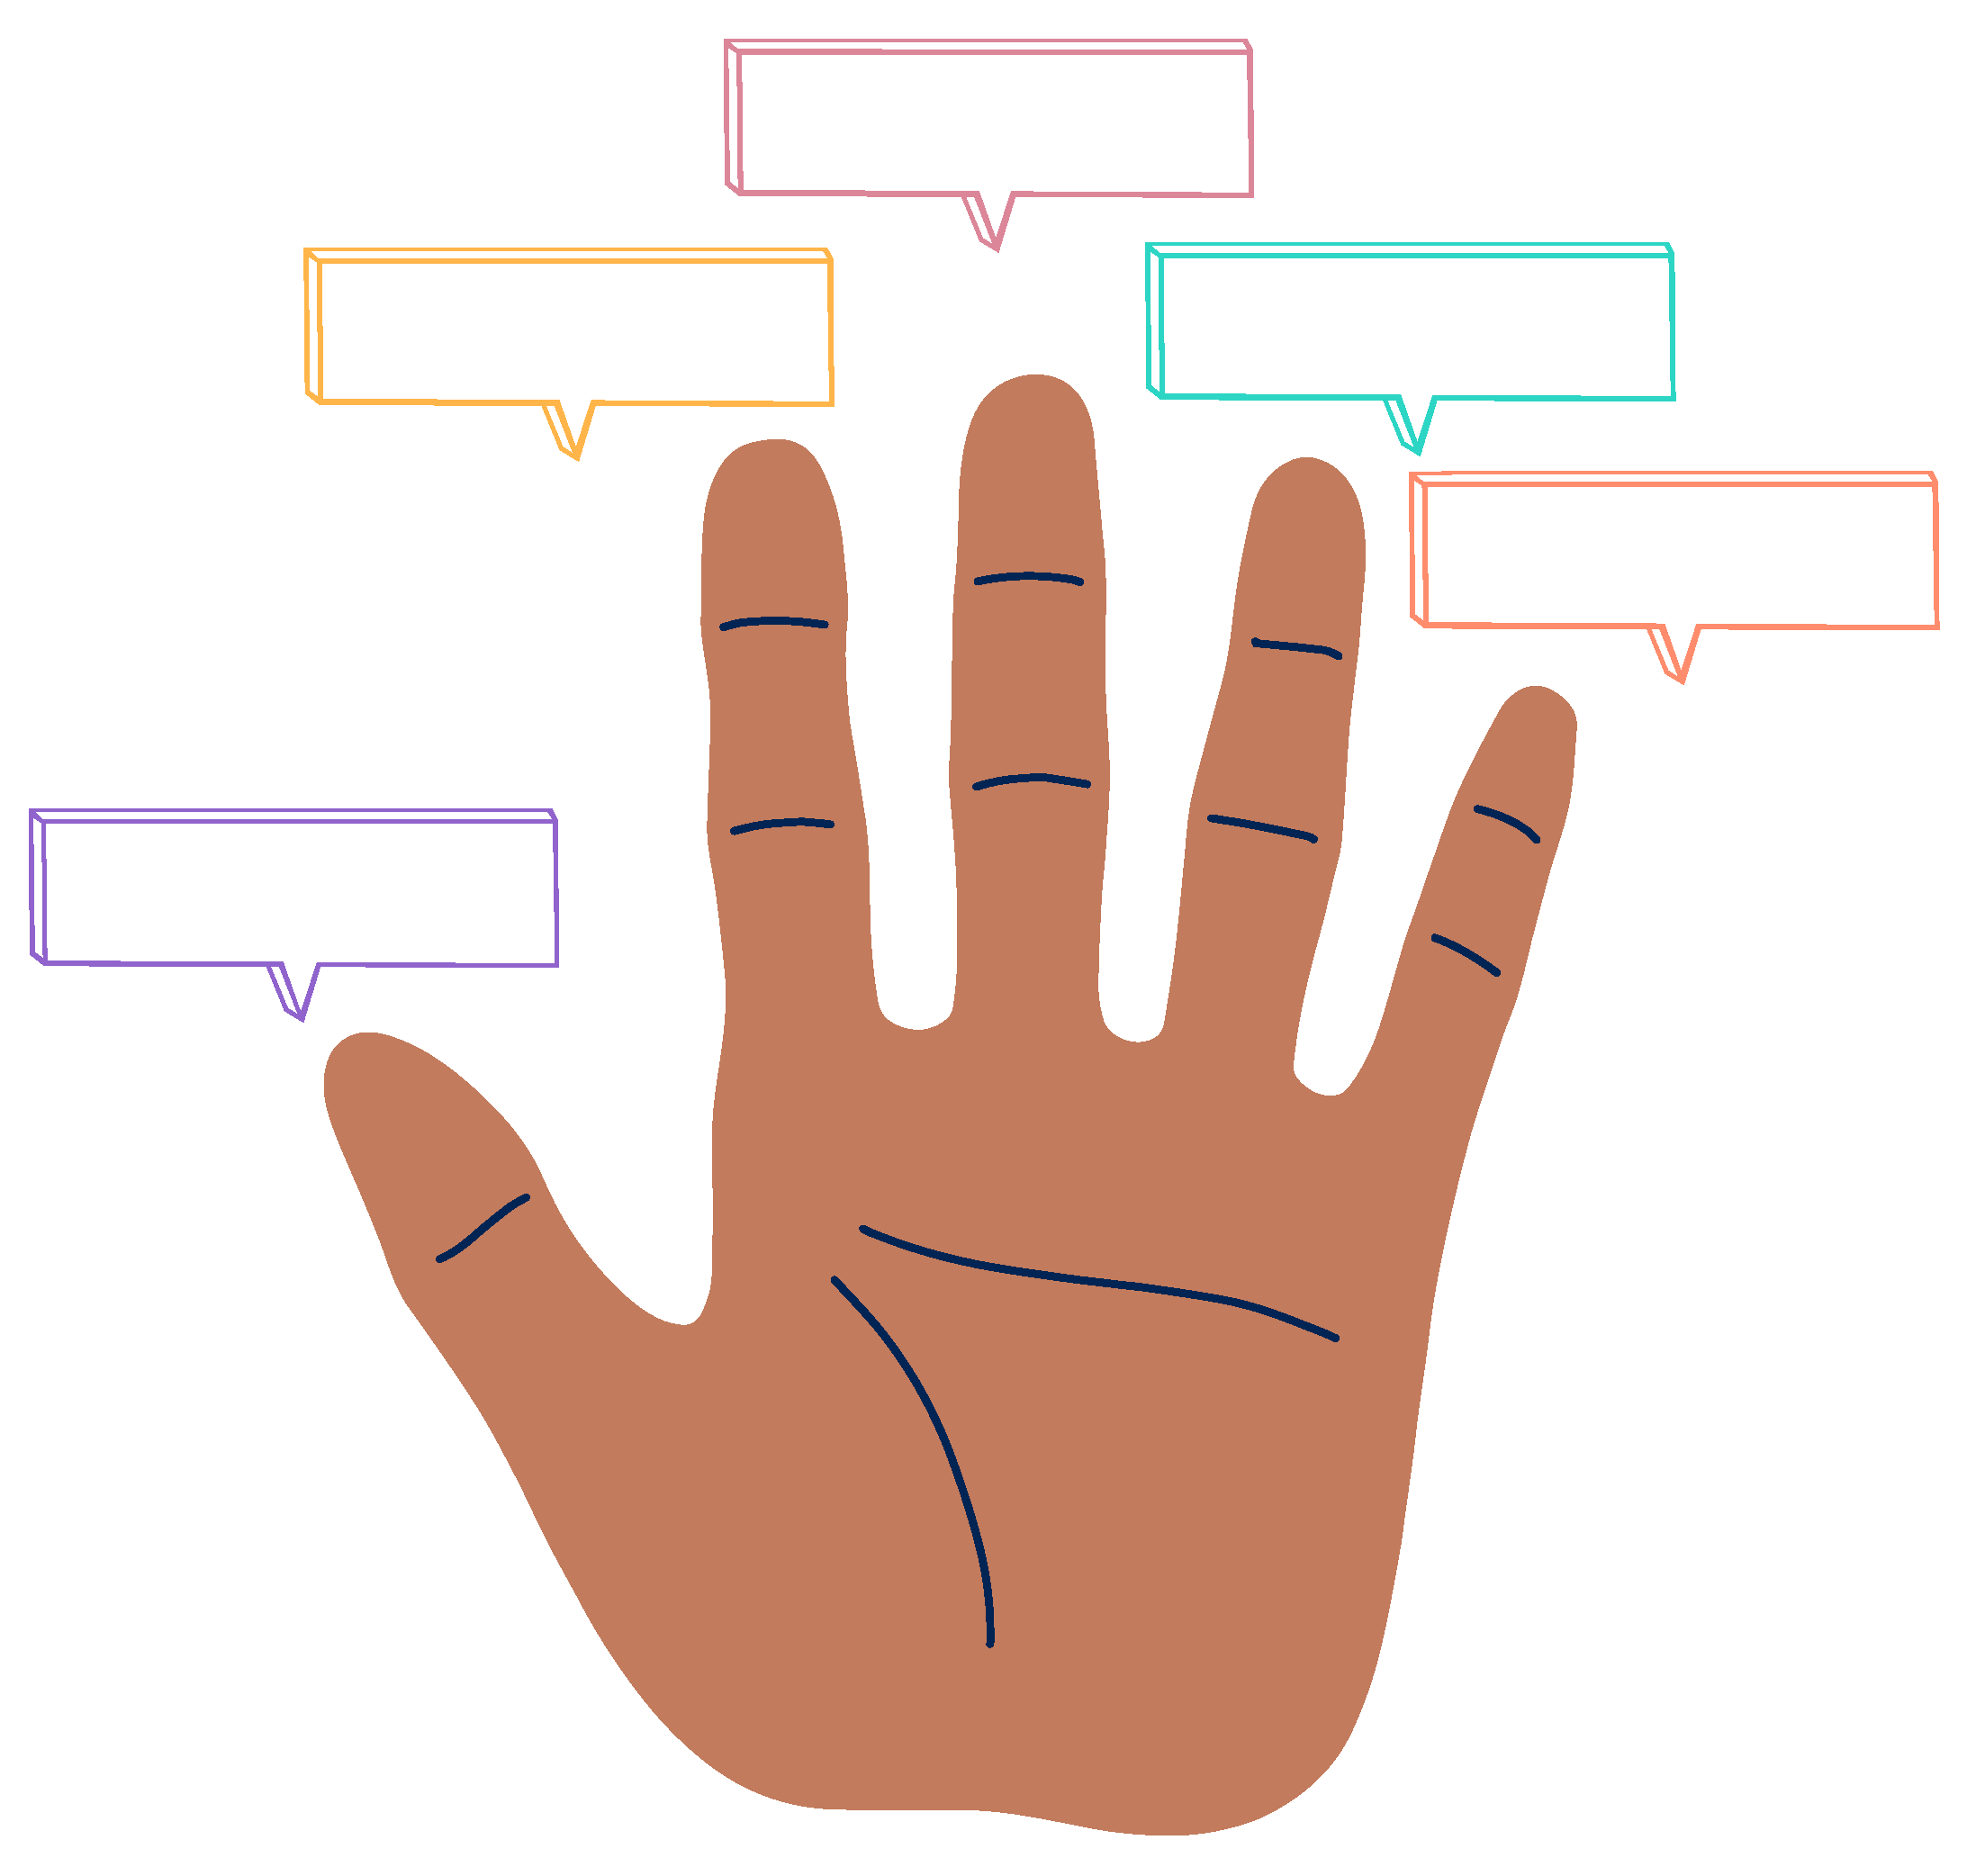

What is the National Strategy and what does it mean for you?
The National Strategy to Prevent and Respond to Child Sexual Abuse (we call it the National Strategy from here) is new and the first one we have had in Australia. It will last from 2021 to 2030 and is not just for children, but also for their families, communities and the organisations around them. Everyone in the community can and should help stop child sexual abuse. We want to keep children safe from abuse. We also want to stop abuse from happening, and help those who have been abused.
Two action plans – a First National Action Plan and a First Commonwealth Action Plan – will support the National Strategy. These will be followed by further Action Plans that will help us stop child sexual abuse, and will continue to help people who have been sexually abused as children. The Australian Government and all state and territory governments will work hard on projects and programs to deliver the Action Plans.

The National Strategy has 5 themes.
Within these themes, there are lots of things to do.
- Educate and build understanding about child safety
- Help victims of child sexual abuse
- Support children who show sexual behaviours that hurt people
- Stop child sexual abuse from happening
- Understand information and data on child safety

How can the National Strategy help you?
A few years ago, there was a Royal Commission that looked into child sexual abuse in Australia. At the Royal Commission, people told their stories of child sexual abuse and how it affected their lives.
The Royal Commission said we should write a National Strategy to prevent child sexual abuse and help people who have been abused. The Royal Commission also said we need to do a better job at making sure the ways we stop and respond to child sexual abuse are the same across the whole country.
All Australian governments have written the National Strategy to keep you and your friends safe. The National Strategy will also make sure that there are people who can help you if you need it. Some ways the National Strategy will keep you safe include:
- making sure everyone can learn how to be safe online, including you, your parents, carers and your family
- giving your teachers and principals more information to help you to be safe, and telling them how to support children who have been abused or need help
- giving you more and better ways to get help
- making sure sport and community activities, especially where adults are around, are safer for you
- doing more research on how to better keep children safe

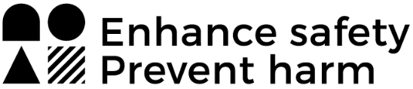

How the National Office for Child Safety works to keep you safe
The National Office for Child Safety (NOCS) looks after the delivery of the National Strategy.
At NOCS, we care about your safety. Our job is to work with organisations, governments and the community to keep children safe from harm, including from sexual abuse. NOCS reports to the Prime Minister, and helps the Prime Minister’s Office and other people who make decisions hear about your needs and interests.

Getting in touch with NOCS
This is the first time we have had a National Strategy, and we need your help!
We want you to be involved in how the National Strategy works, and for it to reflect what is important to you. At any time, you can share your views with us on what we can be doing to keep you safe. We want to know what you think about child safety so we can make the best decisions to help you.
We want to hear your voice on national child safety policies and initiatives, especially what goes into the next Action Plans.
You can visit our website www.ChildSafety.pmc.gov.au for more information about our child safety projects. You can also email us at NationalOfficeForChildSafety@pmc.gov.au or write us a letter at:
National Office for Child Safety
Department of the Prime Minister and Cabinet
Ngunnawal Country
PO Box 6500, Barton ACT 2600
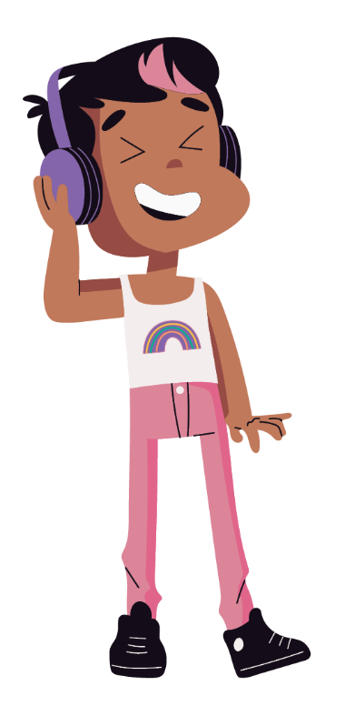

Crossword: How much do you remember?

Across
1 We must _ _ _ _ child sexual abuse
2 Sexual _ _ _ _ _ is a crime
5 NOCS stands for the National
Office for _ _ _ _ _ Safety
6 As a child, you have the _ _ _ _ _ to safety
8 _ _ _ _ _ _ _ _ in the community can
and should help stop child sexual abuse

Down
1 I have the right to feel _ _ _ _
3 NOCS looks after the delivery of a
National _ _ _ _ _ _ _ _ , which is new
and the first one we have had in Australia
4 If you are in immediate danger
you should contact the _ _ _ _ _ _
7 If you feel worried or unsure of anything,
it is very important that you ask for _ _ _ _

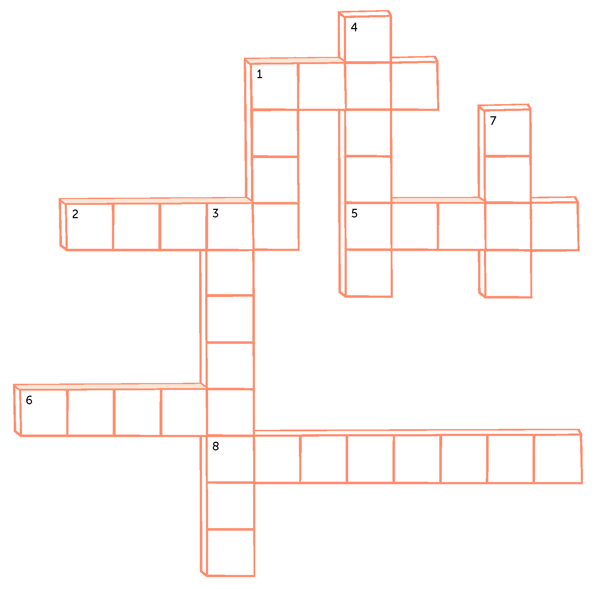
Across: 1.STOP 2.ABUSE 5.CHILD 6.RIGHT 8.EVERYONE
Down: 1.SAFE 3.STRATEGY 4.POLICE 7.HELP

Do you still have questions?
You may have some questions after reading this guide. You can write them down here and talk about them with a trusted adult, a friend, with the National Office for Child Safety or one of the helplines on page 5.
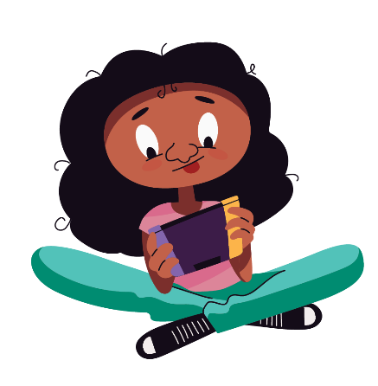
1.
2.
3.
4.
5.

