What does the
Children’s Rights
Report 2019 say?

for children and young people

© Australian Human Rights Commission 2020.
The Australian Human Rights Commission encourages the dissemination and exchange of information presented in this publication.
All material presented in this publication is provided under the Creative Commons Attribution 3.0 Australia, with the exception of:
- the Australian Human Rights Commission logo
- photographs and images
- any content or material provided by third parties.
The details of the relevant licence conditions are available on the Creative Commons website, as is the full legal code for the CC BY 3.0 AU licence.
Attribution
Material obtained from this publication is to be attributed to the Australian Human Rights Commission with the following copyright notice: © Australian Human Rights Commission 2020.
What does the Children’s Rights Report 2019 say? For children and young people
ISSN 2204-115X (Print)
ISSN 2204-1141 (Online)
Design and layout Lisa Thompson, JAG Designs
Printing Centrum
Cover image Three students participating in a consultation with the National Children’s Commissioner, taken by Sarah Bamford (Communications Team, Australian Human Rights Commission)
Electronic Format
This publication can be found in electronic format on the Australian Human Rights Commission’s website at www.humanrights.gov.au/about/publications/.
Contact details
For further information about the Australian Human Rights Commission please visit www.humanrights.gov.au or email kids@humanrights.gov.au.

Hi!
I’m Megan Mitchell, the National Children’s Commissioner.
My job is to protect the rights of all children in Australia and make sure you get the help you need to be safe and healthy.
In 2019 I wrote a report to the Australian Government telling it how we can do a better job of looking out for children and young people.
You can read the main things I said in the report here.

Who are Australia’s children?
Did you know there are around 5.5 million children (everyone under 18) in Australia?
That’s a lot of you!

Most of you live in large cities (71%), some live in regional areas (27%) and a small number of you live in remote places (2%).
6% are Aboriginal and Torres Strait Islander children.
About 1 in 10 children and young people was born overseas. There are over 300 different languages are spoken in Australian homes.
Most children live with both their parents, but quite a few live with one parent, and some live with other families.
Around 48,000 children can’t live with their parents and are living with relatives, foster carers or in residential care. This is more than ever before.
2% of you are 0-4 year old, 29% are 5-9 years old, 26% are 10-14 years old and 16% are 15-17 years old.
Did you know that we all have human rights?
We have these rights because we are human beings. Our human rights are the things that we all need to have a good life. They also make sure we are kind and fair to each other.
Children’s rights are written down in a document called the United Nations Convention on the Rights of the Child. It is important that you get to know what it says in the Convention, because it belongs to you!
Children have special rights because their needs are different from adults.
These are just some of the rights you have. Australian governments have promised to make sure that all the children living in Australia get all their rights.
- Be treated fairly
- Have a say about decisions affecting you
- Live and grow up healthy
- Get information that is important to you
- Be safe, no matter where you are or who you are with
- Be cared for and have a home
- Privacy
- Get an education
- Know who you are and where you come from

There is a special group of people called the United Nations Committee on the Rights of the Child who watch out for children all over the world and tell governments how they can better protect children’s rights.
In 2019, the Committee looked at what life is like for children in Australia and told the Australian Government what it could do to make things better.
To help them, I told the Committee what I had found out about children’s rights in Australia.
I told them that most children in Australia have their rights met and are growing up safe and well, but that many children are not having their rights protected enough—like children with disabilities, children in care, children in remote and rural Australia, children from different cultural backgrounds and LGBTI children.

Too many children:
• are being treated unfairly
• are not getting the education they need
• can’t live with their parents and families
• are not as healthy as they could be
• are worried and depressed
• do not have homes
• are in trouble with the law and need help
• are locked up
• experience violence at home, at school and in the community.
‘LGBTI’ is used to talk about people who are lesbian, gay, bisexual, transgender and intersex. It celebrates all the different ways people can experience their gender identity and love each other.

What did children and young people say?
I wanted to make sure the United Nations Committee on the Rights of the Child heard what children and young people thought too. So, I travelled around Australia talking to children and young people about their rights, what they loved about growing up in Australia and where we could do better.

Some of the things children and young people said they liked about growing up in Australia were:
- their families and friends
- controls on guns
- our weather
- our beaches, rivers, bush, animals and plants
- free education and good health care
- our many cultures.
Adults sometimes think kids don’t know things and ignore their ideas
10 year-old
Growing up in Australia is good because I can have my say and I get to participate in sport and things I like
10 year-old

We are very lucky that our country is in a safe place, we should accept more refugees and educate our people about their needs
11 year-old

I don’t think the Australian government should keep children in detention centres
10 year-old

I think Australia should do more to help the young Aboriginal and Torres Strait Islander children… to get a better education and have the rights to feel safe wherever they are
12 year-old

The government needs to help stop children being abused and domestic violence
17 year-old

Some of the things that they said needed to change were:
- more respect for culture and language
- stopping racism
- different ways to help kids learn in school
- helping poorer children and families
- making sure every child has a home to go to
- stopping people hitting and hurting children
- more help with mental health
- being kinder to refugees and asylum seekers
- letting kids have more of a say
- looking after the environment.
It should be compulsory for all children to learn about Aboriginal culture
9 year-old
It’s not just about feeling safe, it’s about feeling included

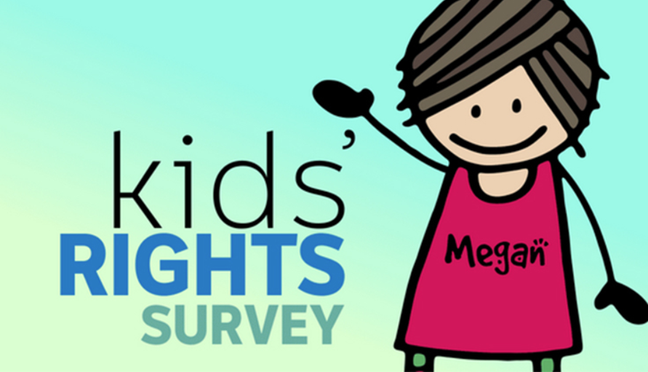
Nearly 23,000 children and young people also took part in a survey about their rights. Children helped to design the questions. Here’s what they said about which rights were most important to them, which were most true for them and which were least true:
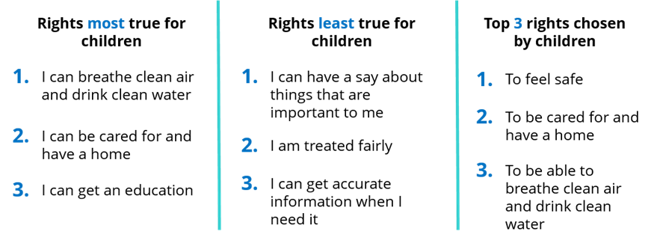

Children are strong people and they deserve to be heard
10 year-old

Do you think Australia does enough to help children…?
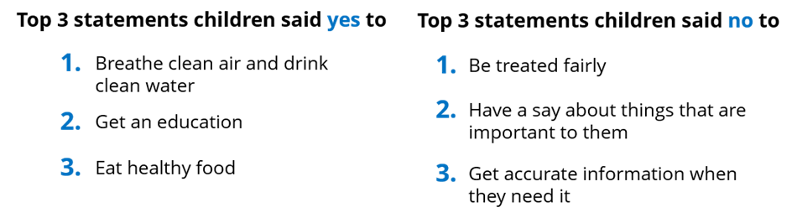

The main ideas
After listening to children, and to adults who care about children, I wrote down my main ideas for making sure all children get their rights. I put these ideas in a report called In their own right: Children’s rights in Australia. I sent this to the Parliament of Australia. I said that Australia should:
- have a BIG plan to make sure children get their rights and are safe and healthy, and collect better information to find out how children are going
- have a Minister who works for children and young people
- educate children and adults who work with children about children’s rights
- not lock up refugee or asylum seeker children
- change laws so children under 14 cannot be treated as criminals, and make sure children in trouble are treated fairly
- do more to make sure children with disability can go to school and are treated with respect
- do more to help children have good mental health
- make sure children can have a say in decisions made by governments and other people
- help more children stay with their families
- keep children safe from violence
- report back on what the Australian Government is doing about these ideas

And heaps more!

You can also read the full version of In Their Own Right: Children’s Rights in Australia here: https://www.humanrights.gov.au/our-work/childrens-rights/publications/childrens-rights-report-2019

Some facts about Australian children and young people
Young people can now access and control their own health information online with My Health Record from the age of 14.
On any day, about 1000 children are locked up for breaking the law. More than half of these are waiting for a court to decide whether they are guilty and what should happen to them.
97% of families with children under 15 can use the internet at home.
94% of Australian children are fully immunised at the age of 1.
Some children live in families where it is hard to afford food and other things (about 17%).
63% of children play sport or are active outside school at least once a week. 96% participate in a cultural activity outside school, and 79% enjoy reading.
99% of Australian children and young people help out at their schools and homes, and 97% contribute to their local communities (Kids Contribute Survey).
At least 2,700 children who have come to Australia seeking protection don’t know if they will be allowed to stay. Some children who have come to Australia alone are not allowed to have their families join them here.
About 16,000 children under 12 years old don’t have a home to go to or are in really crowded houses.
25% of children and young people are overweight.
Almost 1 in 7 children have mental health problems. Young people aged 15–19 say that mental health is their top issue.

What the United Nations Committee on the Rights of the Child said
After hearing from all of us and the Australian Government, the United Nations Committee on the Rights of the Child told us what they thought about children’s rights in Australia. They said that the Australian Government does a lot of good things for children and young people, but needs to do much more.
The Committee agreed with my main ideas, and also said that Australia should:
- make it the law that children and young people can get their rights and that they have a voice
- teach children about human rights at school and teach teachers about them too
- make sure businesses have to say what they are doing to protect children’s rights
- make sure trade deals with other countries cover children’s rights
- give more support to people working with children on climate change
- give more help to asylum seeker and refugee children
- make 18 the age that people can marry and let children know why
- change the laws to stop adults hitting children
- be more careful about giving drugs to children who have ADHD
- let children raise concerns directly with the United Nations, like adults can already do.

You can find out what other things both the Committee and I said about Australia here in my children’s rights scorecard: https://www.humanrights.gov.au/our-work/childrens-rights/publications/childrens-rights-australia-scorecard.

What will I do now?
I am working with the Australian Government to make sure children and young people are safe, well and have their rights met in all the places they go, now and into the future.
As well, I will let everyone know about how I think we can make things better for children and young people in Australia.

What can you do now?
Spread the word about children’s rights - in your families, schools, neighbourhoods, churches and clubs.
You can have your say about your rights, any time!
If you want to talk to me about something, you can:
- email me at kids@humanrights.gov.au
- find me online at www.humanrights.gov.au/our-work/childrens-rights

If you feel unsafe or worried about anything, it is important to speak up and ask for help. You can talk to someone you trust - like a family member, friend, teacher or school counsellor.

You can talk to Kids Helpline:
- on the phone on 1800 55 1800
- online at www.kidshelpline.com.au.

You can also talk to headspace:
- face-to-face at a headspace centre
- online at www.eheadspace.org.au
- on the phone on 1800 650 890.

If you think you are in immediate danger, you can call the police by dialling 000.

Things children and young people think are good about Australia…
Cultural background is key to feeling like you belong to something more.
We have freedom

My friends

Safe, good education, free healthcare

As a young person, I enjoy living and being in Australia due to the freedoms and rights that I [have]… I go to school everyday without a fear and am comfortable doing activities by myself. I am happy and proud to live here and I am so blessed and lucky to have the life I do

Close knit community

Australia is good
Good
So much opportunity and so many options for people growing up in Australia
eg sport, careers, education
Things that children and young people want something to be done about…
What’s good about living in Aus
- employment opportunities
- access to education
- access tp health
- facilities (mental & physical)
- equality
- Medicare & centrelink
Not so great
- Mental health in teens
- Bullying is a major issue
Improving education in remote areas
Young, single mothers to have more support, more financial help, proper, safe housing, support to young fathers – programs for them
To be treated fairly & to get more of a say/more cultural programs in schools
Racism prevention
More support for families
UNSATISFACTORY
The stigma surrounding young people (<18) being ‘incapable’ of making informed decisions about their own health & education
Everybody deserves a home

NEGATIVE
The expectation to take on much larger responsibilities at a young age eg criminal responsibility age (10)

Poverty

Know your rights exercise
This is what children and young people said keeps them safe.
What do the first letters in each of the blue boxes spell? [_ _ _ _ _ _]
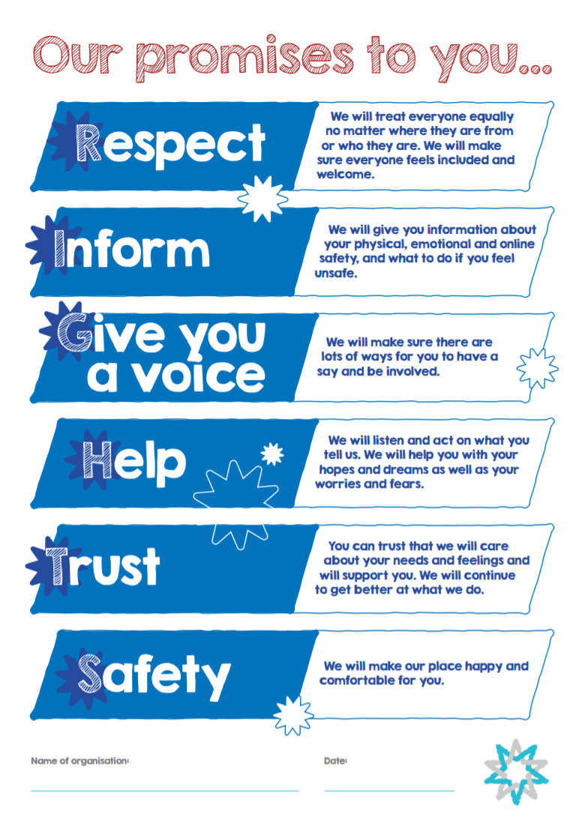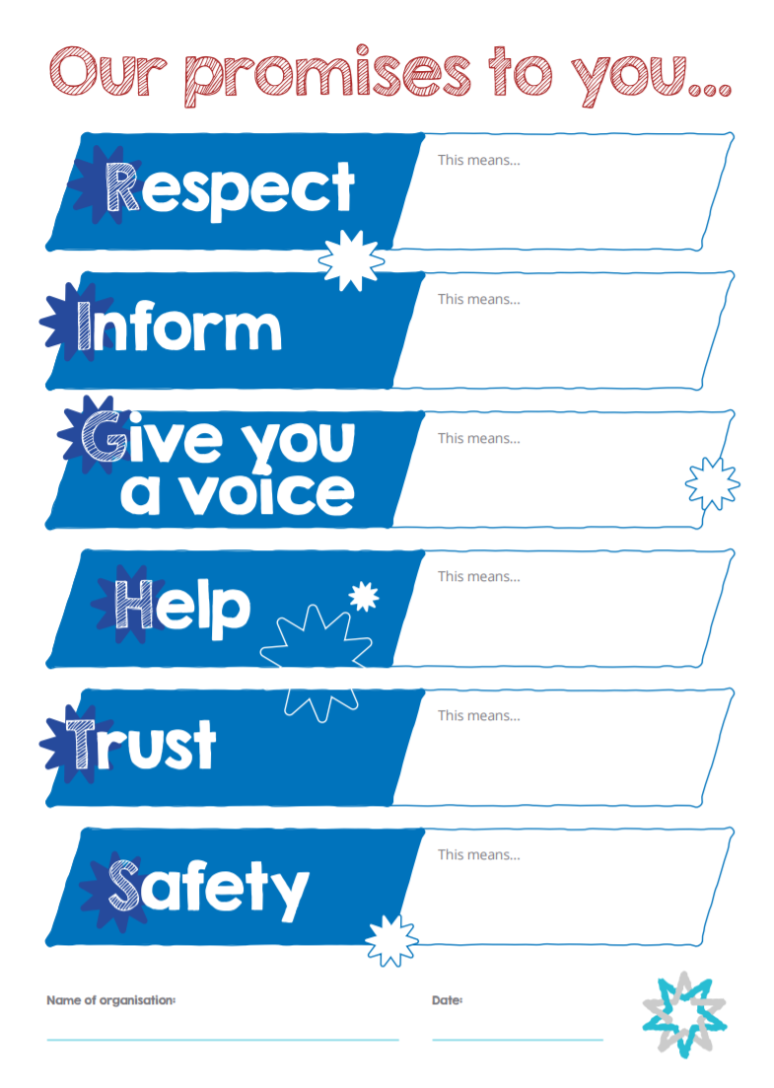
Why not make your own charter in your classroom or club? Together you can use the headings to work out what will help to make you feel safe, happy and well, ask people to sign up to it and put it up on the wall for everyone to see!
You can download it from our website: https://childsafe.humanrights.gov.au/sites/default/files/inline-files/CSO%20Charter%20of%20Commitment%20to%20Children%20and%20Young%20People.pdf

How much do you remember?
Try this crossword puzzle to test what you’ve learned about Australian children and their rights!
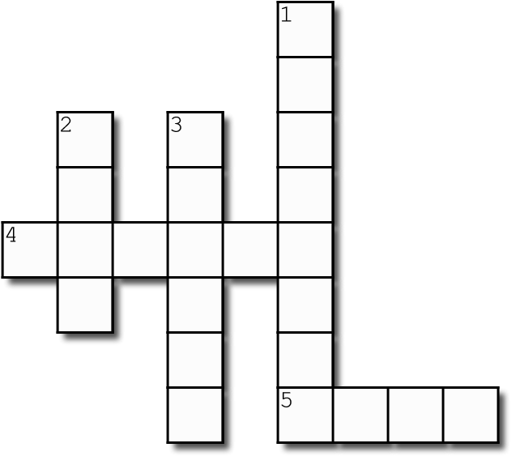

Across
4. It is the National Children’s Commissioner’s job to protect children’s _ _ _ _ _ _
5. In the Kids’ Rights Survey, what was the Number 1 right chosen by children? [To feel _ _ _ _]
Down
1. 9% of Australian children were born where? [_ _ _ _ _ _ _ _]
2. Human rights are the things that we all need to have a good life. They make sure we are kind and _ _ _ _ to each other.
3. The United Nations Committee on the Rights of the Child said that children should be taught about their rights at _ _ _ _ _ _.

