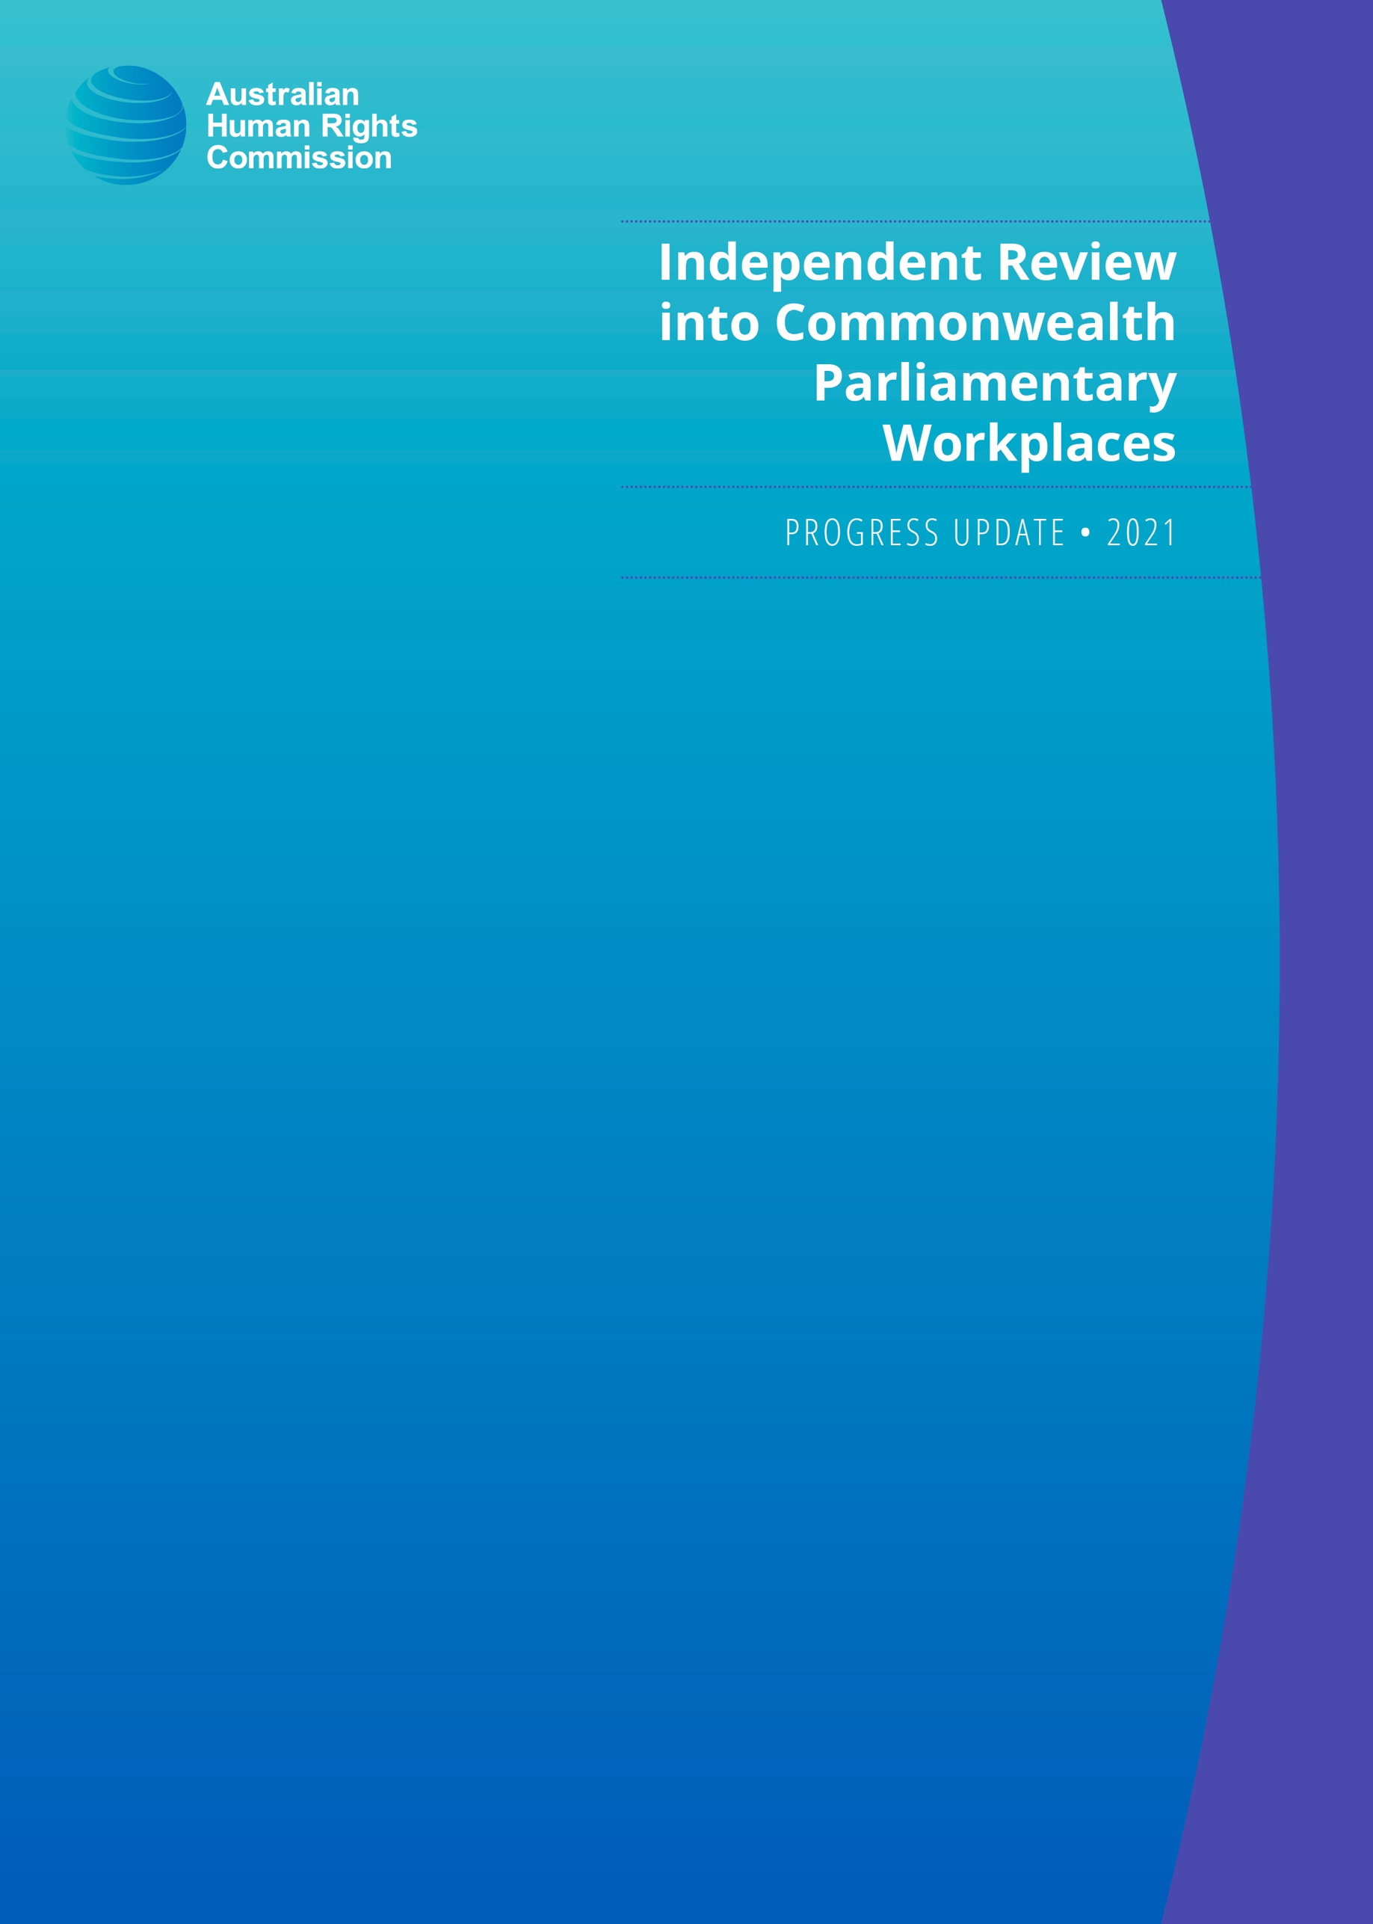

© Australian Human Rights Commission 2021.
The Australian Human Rights Commission encourages the dissemination and exchange of information presented in this publication.
All material presented in this publication is licensed under the Creative Commons Attribution 4.0 International Licence, with the exception of:
• photographs and images
• the Commission’s logo, any branding or trademarks
• where otherwise indicated.
To view a copy of this licence, visit https://creativecommons.org/licenses/by/4.0/legalcode.
In essence, you are free to copy, communicate and adapt the publication, as long as you attribute the Australian Human Rights Commission and abide by the other licence terms.
Please give attribution to: © Australian Human Rights Commission 2021.
Independent Review into Commonwealth Parliamentary Workplaces: Progress Update
ISBN: 978-1-925917-54-3
Acknowledgements
The Australian Human Rights Commission is grateful to all individuals that have participated in the Independent Review into Commonwealth Parliamentary Workplaces to date.
This publication can be found in electronic format on the Australian Human Rights Commission’s website at https://humanrights.gov.au/ourwork/publications.
For further information about the Australian Human Rights Commission or copyright in this publication, please contact:
Australian Human Rights Commission
GPO Box 5218, SYDNEY NSW 2001
Telephone: (02) 9284 9600
Email: communications@humanrights.gov.au
Design and layout: Dancingirl Designs

Independent Review into
Commonwealth Parliamentary Workplaces

Progress update

July 2021

Australian Human Rights Commission



Contents
Sex Discrimination Commissioner’s foreword 5
Review background 7
Methodology 8
Definitions and terminology 8
Participant numbers and overview 9
Interviews 11
Submissions 11
Survey 12
Focus groups 12
Requests for information 13
Research 13
Feedback 13
Communications and engagement 14
Reference points 15
Next steps 16
Appendix 1: Key definitions and terminology 17

Sex Discrimination Commissioner’s foreword
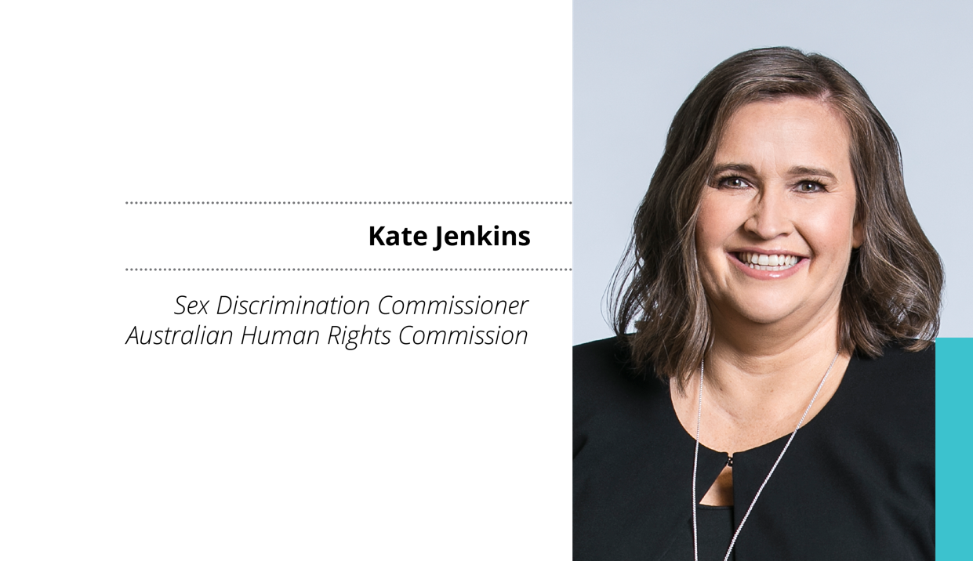
The Australian Human Rights Commission’s Independent Review into Commonwealth Parliamentary Workplaces (Review) is an important step in ensuring our national Parliament is a safe and respectful workplace and reflects best practice in the prevention and handling of bullying, sexual harassment and sexual assault.
I have been inspired by the courage, determination and insights of those who have already come forward and shared their experiences as part of the Review. We have heard about the challenges faced and your ideas for change, and it has been a privilege to be trusted with your experiences. Your commitment and drive for positive cultural change is clear.
As we continue to undertake this Review, I encourage all people who currently work, or have previously worked, in Commonwealth parliamentary workplaces to share your experiences, observations and insights, whether positive or negative. You have a few more weeks to participate in this historic opportunity to shape the Commonwealth parliamentary workplaces of the future.
There are a number of ways that you can still participate, whether that be through an interview, focus group, submission or the online survey. All contributions are valuable and will ensure the findings and recommendations made in our final report are based on a comprehensive understanding of the nature and culture of Commonwealth parliamentary workplaces.
The independence and integrity of the Review is critical to its success and to this end, the privacy of participants and confidentiality of all information received is central.
With the final report due in November this year for tabling in Parliament, I look forward to paving the way for a workplace culture that is safe and respectful for all.
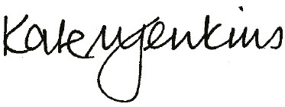
Kate Jenkins
Sex Discrimination Commissioner
19 July 2021

Review background
In March 2021, the Australian Human Rights Commission (the Commission), an independent statutory organisation, established to protect and promote human rights in Australia, was engaged by the Federal Government with the support of the Opposition and crossbench to undertake the Independent Review into Commonwealth Parliamentary Workplaces (Review).
The purpose of the Review is to build an understanding of the culture of Commonwealth parliamentary workplaces, with the aim of ensuring that all are safe and respectful work environments and reflect best practice in the prevention of, and response to, incidents of bullying, sexual harassment and sexual assault. Participation in the Review is open to:
- current and former Commonwealth parliamentarians
- people who work or have previously worked for Commonwealth parliamentarians
- other current and former workers in Commonwealth parliamentary workplaces
- volunteers, interns and students in Commonwealth parliamentary workplaces
- organisations and experts that have direct experience or expertise in the areas under Review.
The Commission will not investigate nor make findings about individual allegations of bullying, sexual harassment or sexual assault as part of the Review.
The Commission expects to report on its findings and recommendations in November 2021.

Methodology
Based upon the Commission’s expertise in conducting independent reviews and inquiries, the Commission has adopted a mixed methods approach for the Review, using both qualitative and quantitative research methods to develop a robust evidence base to inform the findings and recommendations for the final report. This approach includes face-to-face, online and telephone interviews; written submissions; an online survey (for current parliamentarians and employees); targeted focus groups (current employees/contractors); review of relevant legislation, policies and processes; as well as review and analysis of domestic and international research and data.
The data gathering phase of the Review commenced in mid-May 2021, following approval from the Human Research Ethics Committee of the University of New South Wales (HC210264). The Commission sought ethics approval to ensure that the proposed methodology was robust, trauma-informed and aligned with best research practice. This includes ensuring all participation in the Review is voluntary, and that participants provide informed consent and are made aware of available support services.
All data and personal information gathered from participants is treated as strictly confidential. While the final report may contain extracts from submissions or quotes from interviews and focus groups, the Commission will ensure that no individual is identified.

Definitions and terminology
The Commission has developed definitions for key terms in the Review’s Terms of Reference, including definitions for ‘workers’, ‘bullying’, ‘sexual harassment’ and ‘sexual assault’. The Commission also established a definition for what constitutes a ‘Commonwealth parliamentary workplace’. These definitions can be found at Appendix 1.

Participant numbers and overview
Submissions and interview registrations for the Review opened on 20 May 2021, inviting all people who currently or have previously worked in Commonwealth parliamentary workplaces to contribute.
As at 14 July 2021, there have been a total of 345 participants. This includes people who have participated through an interview and/or made a submission. Of the participants who provided information about their gender, 72% identified as female, and 28% as male.
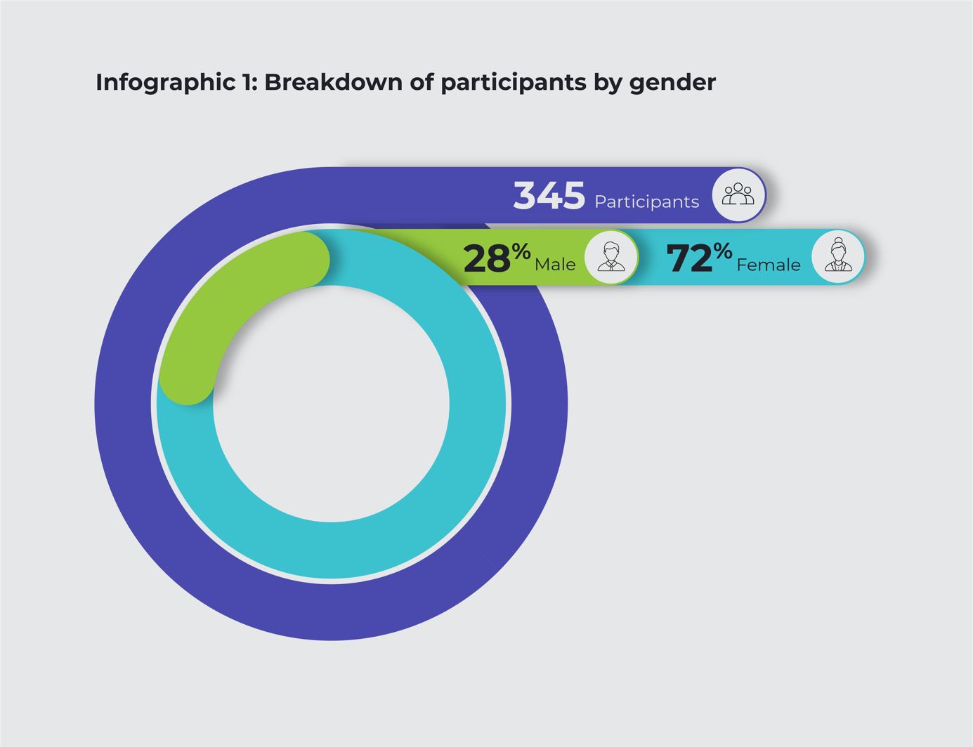

The breakdown of participants by role in Commonwealth parliamentary workplaces as at 14 July 2021, is set out below.
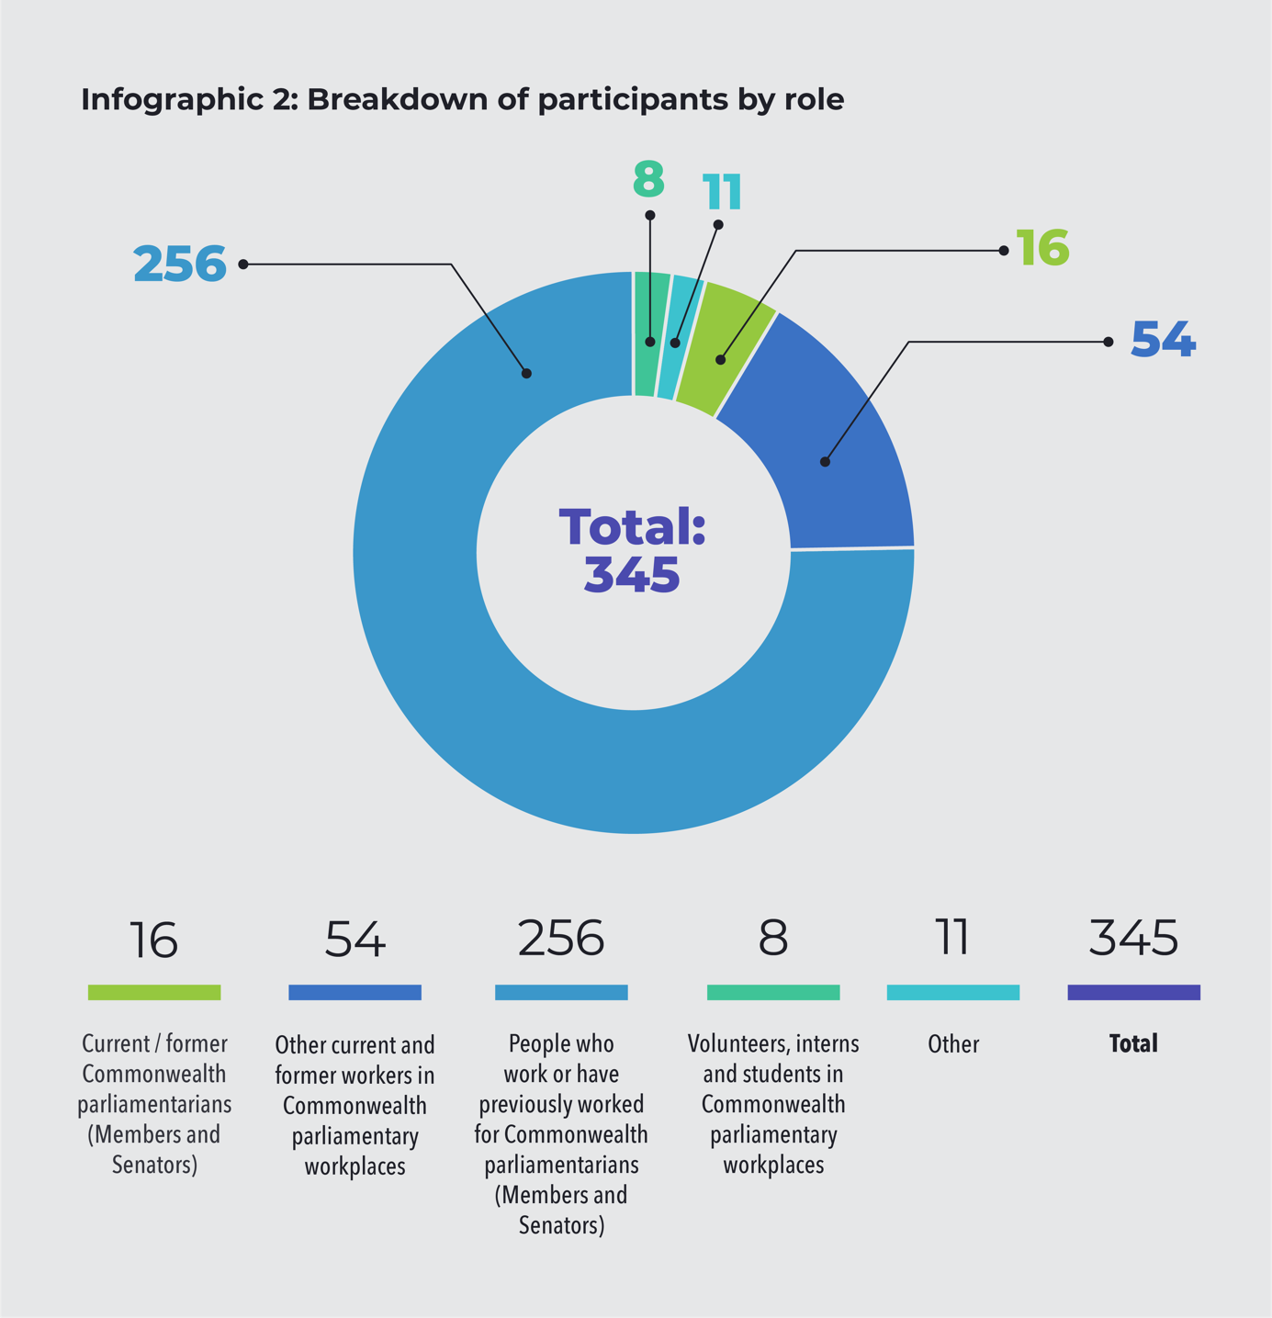

Full demographic data and information regarding participation will be included in the final report.

Interviews
As at 14 July 2021, the Commission has conducted 222 interviews across the country. A further 125 people have registered for an interview, including 12 current or former Commonwealth parliamentarians. Conducted by two Commission staff, the one-hour interviews use a semi-structured format and focus on individual experiences and observations of workplace culture, policies, processes and practices in Commonwealth parliamentary workplaces and recommendations for the Review.
In-person interviews have been conducted in Canberra, Sydney, Melbourne, Adelaide and Perth. Due to the impact of the COVID-19 pandemic, in-person interviews scheduled for Brisbane, Hobart and Darwin were converted to online and telephone. Due to demand, the Review has opened up additional opportunities for in-person interviews in Canberra, including in the first parliamentary sitting week in August.

Submissions
Submissions opened on 20 May 2021 and can be made through an online form available on the Commission’s website or by email. Submissions can be anonymous, confidential or public (with or without an individual’s name). Where appropriate, and consent provided, submissions will be published on the Commission’s website throughout the course of the Review.
As at 14 July 2021, the Commission has received 124 submissions that have been assessed as within scope of the Review’s Terms of Reference.

Survey
The Commission has engaged Roy Morgan Research to administer an online survey to investigate the current prevalence and nature of bullying, sexual harassment and sexual assault in Commonwealth parliamentary workplaces. The survey will be disseminated in July 2021 and will be open for three weeks.
The survey is intended to provide an accurate picture of the current workplace culture and the prevalence of bullying, sexual harassment, and sexual assault in Commonwealth parliamentary workplaces. As such, survey participation is restricted to current Commonwealth parliamentarians, people who work for Commonwealth parliamentarians and other current workers in Commonwealth parliamentary workplaces. The number of people who fall within these categories and who will be invited to participate in the survey is over 3,700.
The survey will be online with invited respondents accessing the questionnaire using a unique login. Participation in the survey is voluntary, no individual will be identified or identifiable, and all responses will be confidential.

Focus groups
The Commission intends to conduct targeted focus groups from late July 2021. The focus groups will be held as face-to-face sessions in Canberra and/or conducted online via videoconferencing facilities. Focus groups will primarily be used to facilitate engagement in the Review by people who are less likely to make a written submission or register for an interview, or who may feel more comfortable engaging in a group format.

Requests for information
The Commission has issued ten requests for information to the Department of Finance, Department of the Prime Minister and Cabinet, parliamentary departments and relevant external agencies. The types of information and documents requested include:
- demographic data of employees
- data on complaints received and referrals to external bodies/agencies
- data on external service providers
- information on training provided in relation to workplace bullying, sexual harassment and sexual assault
- policies and procedures relating to workplace bullying, sexual harassment and sexual assault.

Research
The Commission is undertaking review and analysis of domestic and international research and data relevant to the Review. The focus of this work is on identifying good and promising practice in enabling safe and respectful parliamentary workplaces, including national and international approaches to preventing and responding to bullying, sexual harassment, and sexual assault.

Feedback
The Commission has sought feedback from participants about their experience in engaging with the Review to both inform the process and ensure that any issues are addressed. Overall, participants have commented about how safe, respected and valued they have felt through the process. Additionally, many participants have emphasised that they have appreciated the opportunity to share their experiences and would encourage their colleagues to take part in the Review.
‘The one thing that really stood out for me in relation to the interview was how safe I felt to share my views.’
‘I found the conversation very easy and I felt that I was heard and that there was real interest in what my experiences and view were.’
‘I would encourage people to participate as I found it a safe process, particularly being via teleconference, and the care shown by the interviewers, who also took the time to follow up on my wellbeing, was genuine.’
‘Although it was deeply distressing reliving my [experience] I felt that I was listened to in a fair, supportive and respectful way. With the assurances that my evidence is protected I was able to be frank without the fear of repercussions.’
‘If you are thinking about participating in the review, you should, this is your chance to influence this workplace and make it a better place for all … [I]t was a confidential discussion and we talked about what works well here and what could be improved. I found it to be an easy conversation and feel that my contribution was valued.’

Communications and engagement
The Commission has sought broad and diverse participation as a priority to ensure gain a comprehensive understanding of Commonwealth parliamentary workplaces. The Commission has sought participation in the Review through direct engagement, briefings, social and traditional media, and word of mouth, including directly sending information on how to participate in the Review to:
- current Commonwealth parliamentarians
- current and former employees under the Members of Parliament (Staff) Act 1984 (Cth) through the Department of Finance, for whom they had contact details
- all staff of the Department of the House of Representatives, the Department of the Senate, the Department of Parliamentary Services, the Parliamentary Budget Office, and to the Secretaries of all 14 Government Departments that report directly to cabinet ministers
- Press Gallery journalists and Community and Public Sector Union members.
Online and in-person briefings with Commonwealth parliamentarians and staff were also led by the Sex Discrimination Commissioner and the Review Team to outline how to participate in the Review.

Reference points
In accordance with the Terms of Reference, all political parties and independents were invited to nominate between five and ten current and/or former staff members to act as reference points for the Review team. These nominations will remain confidential.
Reference points are invited to participate in an interview as part of the Review and play a role in encouraging participation in the process through their networks. Reference points do not play an advisory role and do not have access to any information provided to the Review.
There are no external advisers to the Review.

Next steps
Submissions will close on 31 July 2021 and interviews and focus groups will conclude in early August. The final report is currently expected to be provided to the Government in November 2021.

Appendix 1: Key definitions and terminology
Term | Definition
Workers | Refers to employees, contractors or subcontractors (and employees of contractors and subcontractors), labour hire employees, outworkers, apprentices, trainees, students gaining work experience, and volunteers.
Bullying | Refers to repeated and unreasonable behaviour that is directed towards a worker or a group of workers, and creates a risk to physical or mental health and safety.
Sexual harassment | Refers to an unwelcome sexual advance, unwelcome request for sexual favours or other unwelcome conduct of a sexual nature which, in the circumstances, a reasonable person, aware of those circumstances, would anticipate the possibility that the person would feel offended, humiliated or intimidated.
Sexual assault | Sexual assault is an act of a sexual nature carried out against a person's will through the use of physical force, intimidation or coercion, including any attempts to do this. This includes rape, attempted rape, aggravated sexual assault (assault with a weapon), indecent assault, penetration by objects, forced sexual activity that did not end in penetration and attempts to force a person into sexual activity.  Note, sexual assault occurs when a person is forced, coerced or tricked into sexual acts against their will or without their consent, including when they have withdrawn their consent.
Commonwealth parliamentary workplace | A Commonwealth parliamentary workplace includes Parliament House and the Parliamentary precinct, Ministerial, parliamentary and electorate offices, and any other place where work is carried out for a Commonwealth parliamentarian in any capacity, whether paid or unpaid.  A Commonwealth parliamentary workplace also includes, but is not limited to, work related travel and events, engagements, functions and any other work carried out by a person, in any capacity, in connection to the work of a Commonwealth parliamentarian.  Examples of places that are considered Commonwealth parliamentary workplaces include:  - Parliament House and the broader Parliamentary precinct  - ministerial, parliamentary, and electorate offices  - transitory or temporary workplaces such as airports, vehicles, aircraft, and function venues  - any other place where work may be carried out on behalf of a Commonwealth parliamentarian – this could include schools, community venues, function centres, retail environments and other places.

