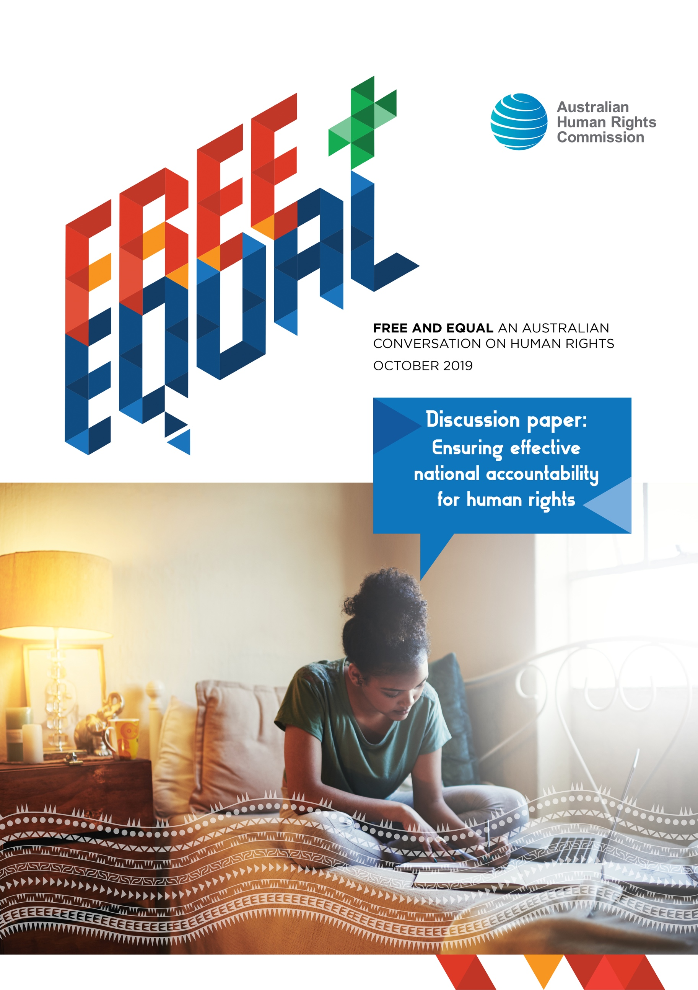

© Australian Human Rights Commission 2019
The Australian Human Rights Commission encourages the dissemination and exchange of information provided in this publication.
All material presented in this publication is provided under a Creative Commons Attribution 3.0 Australia, with the exception of:
- photographs and images;
- the Commission’s logo, any branding or trademarks;
- content or material provided by third parties; and
- where otherwise indicated.
To view a copy of this licence, visit http:// creativecommons.org/licenses/by/4.0/legalcode.
In essence, you are free to copy, communicate and adapt the publication, as long as you attribute the Australian Human Rights Commission and abide by the other licence terms.
Please give attribution to: © Australian Human Rights Commission 2019.
FREE AND EQUAL An Australian conversation on human rights 2019
ISBN 978-1-925917-13-0
The Australian Human Rights Commission thanks the Australian Human Rights Institute at UNSW Sydney, Professor Andrew Byrnes and Scientia Professor Louise Chappell for assistance in the preparation of this discussion paper.
This publication can be found in electronic format on the Australian Human Rights Commission’s website at: https://www.humanrights.gov.au/our-work/publications/
For further information about the Australian Human Rights Commission or copyright in this publication, please contact:
Australian Human Rights Commission
GPO Box 5218
SYDNEY NSW 2001
Telephone: (02) 9284 9600
Email: communications@humanrights.gov.au
Website: www.humanrights.gov.au
Design and layout Dancingirl Designs
Graphics We Are 27 Creative
Photography iStock

Contents
Introduction 4
Understanding human rights 5
The respect, protect, fulfil framework 5
What is a human rights-based approach? 9
Accountability for human rights in Australia⁠—key challenges 10
National Action Plans 12
Existing international scrutiny processes 16
Use of indicators and accountability measures 21
Indicator Frameworks 21
Case Study: Is Britain fairer? 22
Key considerations 24
Accountability frameworks 25
Discussion questions 28
Attachment: Workshop Report 30

Introduction
In 2018, the Australian Human Rights Commission announced a major project: ‘Free and Equal: An Australian conversation on human rights’ (the National Conversation). Through this project, the Commission is asking ‘what makes an effective system of human rights protection for 21st century Australia?’
By mid-2020 the Commission will release a report that identifies the key elements of a human rights reform agenda to modernise our system of human rights protection and to build partnerships and consensus on the future actions required across the Parliament, governments and the community to better protect and promote human rights.
The Commission has identified that there is an implementation gap in Australia between the international human rights standards that Australian governments have committed to uphold over many years, and the actual protections in our laws, policies and processes of government.
Of particular concern is the lack of robust, cohesive processes to set national priorities, measure progress in the achievement of human rights and to monitor compliance with international standards.
Addressing the implementation challenge is complex. Different approaches have been adopted across the globe, tailored to the particular situations of different countries.
There are, however, lessons to be learnt from different approaches globally as well as from approaches to different social policy issues within Australia.
To address the implementation challenge in Australia, two key questions are being asked by the Commission as part of the national conversation project, as follows:
- How should we measure progress in respecting, protecting and fulfilling human rights?
- How should we hold government to account for its actions in protecting human rights?
This paper briefly considers Australia’s experience addressing the implementation challenge and outlines some considerations for developing an effective measurement framework.

Understanding human rights

The respect, protect, fulfil framework
It is one thing to commit to realising human rights, it is another for them to be enjoyed. As former UN Secretary-General Kofi Annan said “without implementation, our declarations ring hollow. Without action, our promises are meaningless”.
For the Australian Government, agreeing that all people in Australia will be provided with the protections of human rights treaties creates legal commitments. Governments are obliged to respect, protect and fulfil human rights.
Any national human rights framework must be multi-dimensional and address each of these obligations.
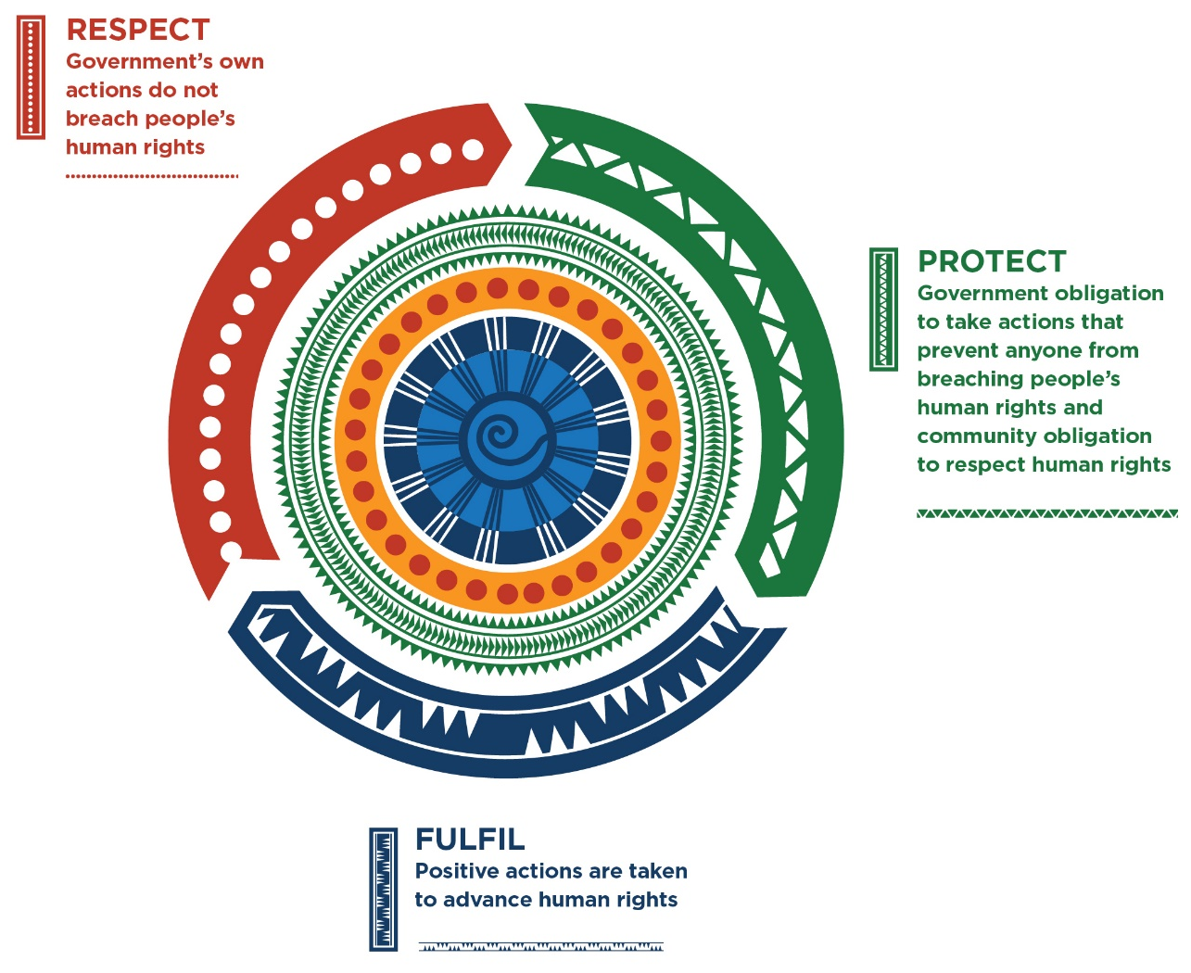

The obligation to respect human rights requires that governments, through their own actions, do not breach human rights and ensure remedies are available for breaches by governments and public officials.
The obligation to protect human rights requires governments to take actions to prevent others from breaching human rights and ensure accessible and effective remedies are available if rights are breached.
The obligation to fulfil human rights requires governments to take positive actions to fully realise the equal enjoyment of human rights.
In relation to economic, social and cultural rights, it is acknowledged that full protection of some aspects of these rights may take time. The progressive realisation obligation requires that governments take all necessary steps, to the maximum of available resources, to ensure that people fully enjoy their economic, social and cultural rights.
Governments must demonstrate that they are taking concrete steps to identify key human rights issues and are improving the level of enjoyment of those rights over time, at the greatest rate of progress that is achievable.
A government may breach its human rights obligations both by action and by failing to take action.
The nature of human rights obligations means that there is often no one single action that can fully protect human rights or remedy a breach of human rights. A variety of actions are required ranging from legal protections, complaint and compensatory procedures, education, community-based programs and social services, for example.
Because human rights aim to protect people’s essential dignity and ensure fairness of treatment, it is especially important to ensure that there is a strong focus on prevention of breaches of human rights from occurring in the first place. Where a human rights breach has occurred the law may be limited in what it can do to remedy that breach, although human rights law has developed a wide range of remedies to address the different forms of harm that may result from a violation of a person’s human rights.
The table below provides examples of the types of measures that can be taken by governments to respect, protect and fulfil human rights.
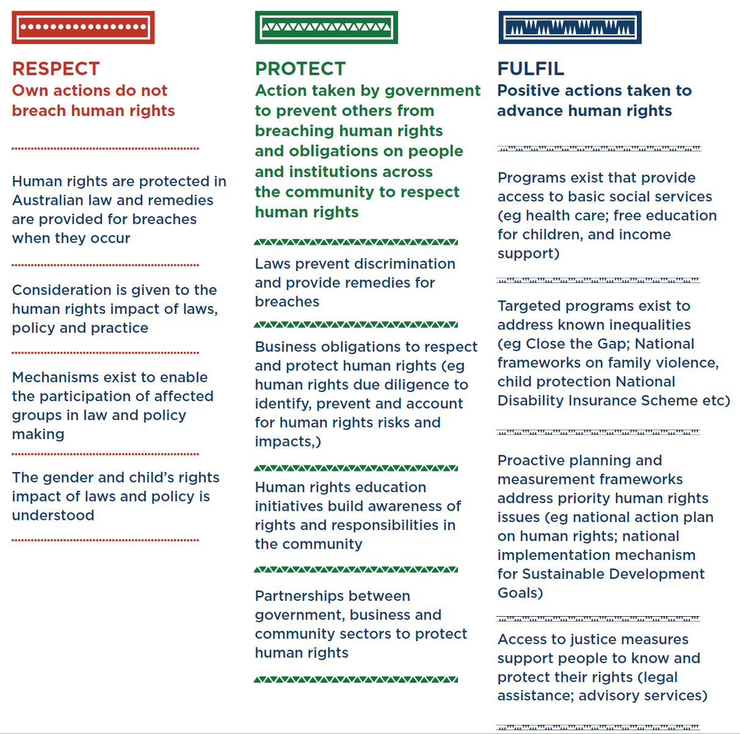
Figure: Government obligations to respect, protect and fulfil human rights

What is a human rights-based approach?
As the respect — protect — fulfil model illustrates, human rights have an important contribution to make across all areas of law, policy and practice.
Building human rights into all aspects of policy and decision making is often referred to as adopting a human rights-based approach. This is forward-looking and assists in envisioning what a positive future for all Australians looks like.
Some key features of a human rights-based approach include the following:
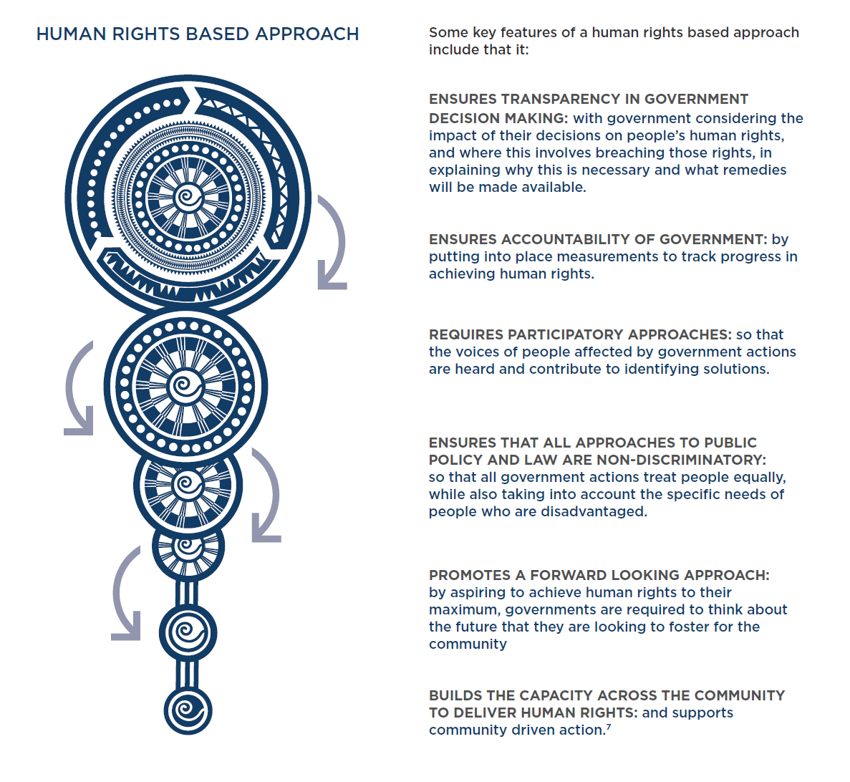

Accountability for human rights in Australia⁠—key challenges
The Commission’s Issues Paper for the National Conversation project, released in April 2019, sets out some considerations on how well Australia is going in protecting human rights.
The Commission notes variable progress in realising rights. While many people in Australia enjoy human rights most of the time, others experience entrenched inequality. There is insufficient focus on how these forms of inequality will be addressed, with the key elements of a human rights-based approach lacking in many instances.
This is the case where such inequalities have existed for long periods of time and have been well known. For example, the inequalities facing Aboriginal and Torres Strait Islander peoples.
The Commission also notes Australia currently does not have in place a robust system for prioritising human rights issues at the national level, nor for being held to account for progress in advancing and protecting human rights.
Reviews of Australia’s performance by UN human rights treaty committees and engagement in the Universal Periodic Review process provide some internationally based and focused processes to review progress. These are not, however, a substitute for a domestic, government-led process for considering and identifying priorities for human rights protection.
The governance arrangements that flow from our status as a federation complicate accountability for human rights implementation. When accepting international human rights treaty obligations, the Australian government undertakes that all governments in Australia will respect, protect and fulfil human rights. Responsibility for ensuring this actually happens is split between the federal government, and state and territory governments.
It is well established as a matter of international law, however, that such internal divisions of responsibility are not an excuse for non-compliance with human rights standards. Article 27 of the Vienna Convention on the Law of Treaties, for example, states that ‘A party may not invoke the provisions of its internal law as justification for its failure to perform a treaty’.
Article 50 of the International Covenant on Civil and Political Rights also states: ‘The provisions of the present Covenant shall extend to all parts of federal States without any limitations or exceptions’.
One of the challenges to implementation is significant gaps in the incorporation of human rights into Australian law, policy and practice.
Australian governments have enshrined some of the rights and freedoms derived from international treaties in our own laws, such as rights protecting us from unlawful discrimination on certain bases. There are some protections in our Constitution. Among other things, it guarantees our right to vote, an implied freedom of political communication and the right to be tried by a jury in certain cases. Since 2012 the Commonwealth Parliamentary Joint Committee on Human Rights has scrutinised all proposed new Commonwealth legislation for consistency with seven principal UN human rights treaties. However, although it has frequently found inconsistencies, governments have rarely amended legislation in response to the Committee’s concerns.
States also have legislated human rights protections. These include a number of State and Territory human rights acts (the ACT, Victoria and Queensland). These afford residents of those states explicit legislative protection of some but not all of the rights and freedoms guaranteed in international human rights treaties.
Australia has yet to positively incorporate all of its international human rights obligations into domestic law.
Reviews of our compliance with our treaty obligations routinely identify this as a matter of concern. For example in 2018 the UN Committee on the Elimination of Discrimination against Women, and in 2017 the UN Human Rights Committee (operating under the International Covenant on Civil and Political Rights) and the UN Committee on Economic, Social and Cultural Rights all urged Australia to fully implement the treaties in question.
The Commission and NGOs from Australia have similarly expressed concern that Australia has not introduced specific measures to incorporate key provisions of the Convention on the Rights of the Child into Australian law. The UN Committee on the Rights of the Child will consider Australia’s compliance with the relevant treaty in September 2019.
Consistent with the principle of legality, the courts will interpret legislation consistently with human rights where there is ambiguity as to the meaning of a law. This can minimise intrusions on human rights and fundamental freedoms.
It is, however, a limited protection as the principle does not apply where laws are unambiguous in their meaning (i.e., this interpretive provision does not apply where a law is clearly intended to have an effect that may be inconsistent with human rights).
To effectively implement many human rights, particularly economic, social and cultural rights, resources are required. Legal protections of themselves, while necessary, are often not sufficient to guarantee the full enjoyment of human rights.

National Action Plans
Australia has in place a number of national frameworks and inter-governmental agreements that prioritise action on certain issues. These are important mechanisms for realising human rights in Australia.
Some examples include:
- the National Framework for Protecting Australia’s Children;
- the National Plan to Reduce Violence against Women and their Children;
- the National Action Plan to Combat Human Trafficking and Slavery;
- the Australian National Action Plan on Women, Peace and Security, and
- Australia’s National Action Plan for Health Security, and
- the National Disability Strategy.

Common features to these, and other, national plans are:
- They are multi-year in commitment
- They are agreed to by all Australian governments, and identify actions that are to occur at each level of government
- They are resourced
- They have monitoring and evaluation mechanisms
- They are developed with community engagement.
There are mixed views on how effective these frameworks are⁠—in particular whether they are sufficiently resourced, have sufficient community engagement in design and implementation, and are rigorously monitored.
Australia has previously committed to introducing a comprehensive plan for implementing human rights in Australia: a national action plan on human rights.
The idea of a national action plan for human rights was put forward by Australia during the June 1993 Vienna World Conference on Human Rights. It was adopted as a recommendation in the Vienna Declaration and Programme of Action.
Australia was the first to develop its own national action plan under the Programme of Action, for an initial four-year period beginning in 1994. The approach then was for the Australian Government to prepare the plan after extensive consultation within government, and with states, territories and civil society.
The original plan was updated twice, in 1995 and 1996-7, before a new version emerged in 2005: Australia’s National Framework for Human Rights: National Action Plan.
The most recent national plan was developed in 2012⁠—the National Human Rights Plan⁠—as part of the Australian Human Rights Framework. The plan followed a baseline study identifying priority areas, including international human rights commitments; access to justice; legal protections; workers’ rights; climate change, and poverty, and specific population groups such as Aboriginal and Torres Strait Islander peoples, women, children and young people, gay, lesbian, bisexual and sex and/or gender diverse people, and carers.
This Plan was intended to be accessible to every Australian, provide a broad overview of policies and practices to protect human rights, accord equal priority to all human rights, and set out strategic priorities for future action.
The plan was not implemented when there was a change of government, and there has been no national action plan or substituted alternative since.
There has been no adequate/comprehensive evaluation on the efficacy of these plans in Australia. However, the Commission notes that some general features of these plans have been that:
- they have listed existing government initiatives rather than genuinely setting priorities for the future
- they have lacked dedicated funding to advance human rights priorities
- some plans have lacked community engagement to build consensus and partnerships for key human rights priorities
- federal relations have tended to make the plans complex and require long timeframes for their development – plans that have been finalised have not, however, had key features of other national frameworks in terms of commitments from state and territory governments (including of resources) to their implementation
- monitoring processes for these plans have been lacking or deficient.
Accordingly, consideration must be given to whether it is the concept of a national action plan that is challenging or if the deficiencies of past plans were the result of poor implementation by the government.
In developing any subsequent plan, attention must be given to avoiding any mistakes that resulted in these plans falling into disuse. Whether a ‘national action plan’ is an effective model must also be considered.

SUMMARY BOX: KEY CHALLENGES FOR HUMAN RIGHTS ACCOUNTABILITY
- An explicit human rights-based approach has generally not been adopted to address known inequalities
- Absence of any current national framework for prioritising human rights (for example, a national action plan on human rights)
- Absence of national framework leaves international human rights scrutiny processes as the default review processes for adequacy of national efforts to protect human rights
- Federal structure means responsibility for achieving human rights exists across multiple actors – Commonwealth, State and Territory – complicating the adoption of a coordinated approach to human rights issues
- Significant gaps exist in the incorporation of human rights into Australian law, policy and practice
- Courts have an important but limited role in protecting human rights by applying with existing legislative protections, limited constitutional protections and interpretive principles (such as the principle of legality), but must give effect to the clearly expressed intent of legislatures even if to do so is inconsistent with human rights
- A range of national frameworks and inter-government agreements do exist on specific thematic areas and provide a basis for advancing key human rights issues
- National Action Plans on Human Rights have previously been adopted in Australia, with significant gaps of time where no plan is in place. There is a lack of evaluation of the effectiveness of such plans and on the barriers to their success.

Existing international scrutiny processes
At the international level, there are a range of accountability processes that assess Australia’s compliance with international human rights standards.
Australia is party to many international human rights treaties, including seven of the core UN human rights treaties. These are not simply aspirational instruments but impose concrete obligations on countries for the fulfilment of which they are accountable under international law. There are multiple accountability mechanisms within the UN system in which Australia already participates.
Among these mechanisms are the Universal Periodic Review process conducted through the Human Rights Council, and the periodic reporting procedures under the principal UN human rights treaties such as the ICCPR and the ICESCR. Periodic reviews of Australia’s implementation of each of the seven principal UN human rights treaties to which it is party usually occur at an interval of 4-5 years (although this varies between different treaties).
It has become clear from these processes that Australia does not have an effective system for a transparent public discussion of the concluding observations of the treaty bodies and the implementation of the recommendations made.
Individuals who claim that they have suffered a violation of their rights under a number of the UN human rights treaties can also submit complaints to the relevant committee. The committees can issue decisions determining whether there has been a breach or not, and recommend remedies, including compensation to the aggrieved party and recommend changes to laws or policies to address the violation. While these recommendations are not legally binding, countries are under an obligation to give them considerable weight in deciding how they should act.
Up to the mid-1990s, Australia had a good record of responding to the outcomes of individual communications. However, in the past twenty years this has fallen away significantly.
These UN processes provide a framework for Australia to report to the international community on the implementation, benchmarking and monitoring of human rights in Australia.
The UN system also has other procedures for monitoring the implementation and observance of human rights in Australia. These include many special procedures, including independent expert Special Rapporteurs with mandates on thematic human rights issues, including arbitrary detention, freedom of expression, the protection of human rights in the context of counter-terrorism, extreme poverty and human rights, violence against women, the right to health, the rights of older persons, among many others.
Special Rapporteurs may receive complaints and seek responses from countries, may visit (and have visited) Australia at the invitation of the government. They issue public reports identifying areas for improvement in the implementation and observance of human rights in Australia.
The Universal Periodic Review (UPR) is a process undertaken by the UN Human Rights Council which brings every member State of the United Nations before the Council once every four years for ‘peer review’ by other member States of its human rights record. It is an opportunity for Australia to:
- take stock of how well we are protecting the human rights of all people in Australia
- inform the international community of the human rights situation in Australia
- engage with other countries about specified steps Australia will take to improve the enjoyment of human rights in Australia.
Importantly, review under the UPR does not depend on Australia being a party to a particular human rights treaty. Recommendations can be based on any human rights standard. It is a peer review process: country to country. Recommendations on actions Australia should take are made by individual governments of other countries.
Australia has undergone two reviews, and its third cycle review is scheduled for the 37th Session of the UPR Working Group in October-November 2020.
The UPR review is normally based on a report submitted by the Australian Government together with the following information:
- Information contained in the reports of treaty bodies, special procedures, including observations and comments by Australia in response to these mechanisms, and other relevant official UN documents, compiled in a report prepared by the Office of the High Commissioner for Human Rights
- Information provided by the Commission, NGOs and other relevant stakeholders to the UPR.
In the last UPR cycle for Australia, in 2015, 110 countries spoke at the review and provided 291 recommendations. The Australian Government provided its response to the Report of the Working Group on the UPR at the 31st Regular Session of the UN Human Rights Council in March 2016. Of the 291 recommendations, 150 were accepted, 50 were to be considered further, and 90 were simply noted (that is not acted on).
A new feature of the third cycle of the UPR is the use of an ‘implementation matrix’. NGOs, human rights commissions and UN agencies can provide an independent assessment of the status of implementation of recommendations by the state party under review.
Accordingly, the question of how well Australia has implemented recommendations that it has voluntary committed to implement will be a focus of discussion in the UN Human Rights Council in late 2020.
There are other fundamental rights treaties that Australia has ratified that also involve it in international monitoring and complaint processes. One example is the International Labour Organization, a UN specialised agency, which has adopted many treaties to protect the rights of workers and unions. Of particular importance are the conventions on the right to organise and bargain collectively, and discrimination in occupation and employment. Complaints may also be taken to these bodies and a number of decisions of ILO bodies have found violations of fundamental international labour rights by Australia.
There are also other international political or policymaking processes that focus on discrete human rights issues under which Australia has assumed obligations or takes policy decisions to enact certain laws and policies to address any deficiencies in the domestic framework.
These include action plans relevant to the implementation of human rights and other international law obligations stemming from, among other things, UN Security Council and UN General Assembly resolutions, and other UN processes.
For example, in October 2000, the UN Security Council adopted a landmark resolution linking gender equality to the maintenance of international peace and security, one of the core responsibilities of the body and the international community. Subsequent resolutions have reinforced the central theme of the protection and empowerment of women in conflict-affected countries. This has become the Women, Peace and Security agenda.
As part of this process, Australia (through the Department of the Prime Minister and Cabinet) developed the National Action Plan on Women, Peace and Security 2012-2018 to implement the UN Security Council Resolution 1325. In this document, the Government set out what steps it has taken to implement its obligations as part of this agenda, and how it is progressing.
Australia has also agreed to implement the Sustainable Development Goals. While not a binding treaty nor a human rights instrument as such, some of the goals make explicit reference to human rights and achievement of the goals has the potential to enhance the enjoyment of a wide range of human rights. In 2018, Australia lodged a voluntary report on progress in achieving the SDGs with the UN General Assembly. Although it has taken this commendable action, there is no national framework for implementing the SDGs (or linking these to Australia’s human rights obligations) and there is a lack of targets, benchmarks and monitoring tools to assess whether the commitments made are on track to be achieved or not.

SUMMARY BOX: INTERNATIONAL HUMAN RIGHTS SCRUTINY PROCESSES
- Periodic reviews of Australia’s compliance with human rights treaties occurs under each treaty roughly every 4-5 years and provides an opportunity for a comprehensive domestic and international review, and leads to recommendations by expert treaty bodes of the steps need to improve the enjoyment of human rights
- Individual communications under treaties identify human rights breaches
- The Universal Periodic Review is an international peer review process involving all other countries in the world resulting in recommendations to the country reviewed. Countries are expected to indicate the recommendations which they will prioritise before the next review, and the process now involves an ‘implementation matrix’ to track progress
- Special Rapporteurs of the UN Human Rights Council make recommendations to Australia on thematic issues or individual cases
- Australia’s implementation of recommendations across the above UN mechanisms is variable, with the government rejecting or refusing to implementation a significant number of recommendations
- Australia has also committed to undertaking actions through other UN led processes – for example, women, peace and security, and the Sustainable Development Goals.

Use of indicators and accountability measures
So how do we go about designing a new framework to comprehensively monitor the implementation and realisation of human rights in Australia? What things would we want measured and what system would we use to measure them?
In recent years, clear guidance on the necessary elements of human rights indicators have been developed at the international level. This provides greater clarity on the necessary elements of any accountability framework.
The Chief Commissioner of the New Zealand Human Rights Commission, Paul Hunt, has observed that ‘a human rights indicator derives from, reflects and is designed to monitor realization or otherwise of a specific human rights norm, usually with a view to holding a duty-bearer to account.’ Human rights indicators can also be used to measure the progress of human development on a human-rights basis and measure the impact or success of particular rights-based interventions.
Indicators can be used alongside baseline studies and national action plans on human rights to build a full picture of implementation and necessary future actions.
This section will briefly outline some of the key considerations when building a human rights indicator framework and how such a framework could fit alongside a new national action plan on human rights.

Indicator Frameworks
As outlined by the Office of the High Commissioner for Human Rights, indicators are tools to help translate human rights standards into tangible and operational goals that mean something in their country of use. They can be used to measure progress towards the fulfillment of rights over time.
To develop indicators, we can look to Australia’s international human rights obligations but must also be mindful of the things that Australians see as important to helping them live the lives they want.

Case Study: Is Britain fairer?
Under the Equality Act 2006 (UK), the UK Equality and Human Rights Commission has a statutory duty to monitor and report on social outcomes from an equality and human rights perspective. The Commission published the most recent report, ‘Is Britain Fairer?’ 2018, last year.
The Measurement Framework covers six domains which have been chosen because they “reflect the things or areas in life that are important to people and enable them to flourish”. These are: education, work, living standards, health, justice and personal security, and participation.
Each domain contains three ‘core’ indicators and some have additional ‘supplementary’ indicators. The indicators have been chosen, among other reasons, for their relevance for human rights, equality and non-discrimination and for their relevance for duty-bearers. The indicators are also specific, measurable, relevant over the long term, flexible, and the best possible options in each given domain.
Each indicator is monitored by looking at structures, or what the standards actually say, processes, or how the standards are implemented, and outcomes, or what people actually experience.
The Framework uses Sen’s Capability approach alongside the structure, process and outcome, as well as incorporating the concepts of ‘vulnerability’ and ‘intersectionality’.
The Framework draws on the best available qualitative and quantitative evidence to examine the structures, processes and outcomes that make up each indicator. This evidence is then disaggregated based on five components. These are: protected characteristics (such as age, sex, race and disability), socio-economic group, geographical location, people at higher risk of harm, abuse, discrimination or disadvantage and intersectionality.

Indicators must be specific to an issue and measurable in a consistent way over time. They must be designed in partnership with the community for the community to use but also be relevant to law and policy makers.
Human rights indicators can use quantitative or qualitative data as their evidence base. Data sources should be available or the ability to collect data that is relevant to the indicators should be possible so that progress can be measured against the indicators. This data must be able to be disaggregated based on different characteristics such as gender, ethnicity, and socio-economic status.
There are data gaps in some areas. However, in many areas we already have much of the relevant data to assess whether rights are being enjoyed. For example, regular surveys of homelessness in the community permit us to identify the number of persons who are homeless in Australia and the groups to which they belong. We have data on how many people are living in poverty in Australia measured by reference to the OECD standard. We know how many people in each age group spend years receiving unemployment benefits as a result of discrimination in the labour market. The challenge is in many cases to persuade policymakers and politicians to respond to what are clear failures to respect, protect or promote human rights.
When developing an indicator-based measurement framework, thought must also be given to the theoretical concepts that will underpin it. Is the framework being used to measure equality across different areas of life? What kinds of inequality or equality matter?
Many measurement frameworks, such as the UN Development Programme’s Human Development Index, use Amartya Sen’s capability approach as the basis for their analysis. This approach uses the concept of ‘capability’ or the actual valuable freedoms and opportunities that people have access to – the key things that people are actually able to do or be.

The approach has a number of features including:
- The evaluation of substantive freedoms and opportunities
- A positive interpretation of freedom – ‘freedom to’, not just ‘freedom from’
- Distinguishing between means and ends
- Recognising diversity in people’s circumstances, characteristics and goals
- Acknowledging the role of structures and processes in enabling or constraining people’s capabilities
- Recognising the role of individuals as agents, including in defining their own objectives, and being involved in decisions that affect them.
Other approaches can be used alongside or instead of the capability approach. These include using a utilitarian understanding of equality, using liberal egalitarianism as the grounding principle or using concepts such as intersectionality or vulnerability alongside the capability approach.

Key considerations
Indicator-based measurement frameworks are useful tools for turning complex concepts and standards into tangible and measurable outcomes. They can help law and policy makers to more easily identify where gaps in implementation are occurring and help advocates for human rights to use the language of technical measurement and science to ground their feedback to governments. However, despite these benefits, there are a number of considerations that must be addressed when developing a measurement framework for human rights.
Common critiques of indicator frameworks focus on the nature of power dynamics in the creation of frameworks, the risks of data reductionism, concerns about the validity of data being used, and questions about accountability.
Power-based critiques focus on who is involved in the construction of indicators and decisions about what measures are used. Indicator frameworks appear to present technical and objective measures and often fail to highlight the political nature of the decisions behind their construction. Decisions to include one measure over another or to leave out particular indicators are political decisions. The focus on technical measurement can also disguise how political factors shape the realisation of rights in the first place.
Some people have concerns about the use of data in indicator frameworks. A number of these critiques focus on the overwhelming use of quantitative data and question its ability to capture complex social realities. Others have concerns about the validity of the data used to draw conclusions about broader phenomena. Due to a lack of reliable or comprehensive data, some frameworks use poor proxies for the indicator they are attempting to measure. There must be a strong link between the indicator being measured and the data being used.
Finally, accountability-based critiques explore whether indicator frameworks without accountability mechanisms achieve results. The expectation is often that the demonstration of poor realisation of rights through an indicator framework will result in considerable changes to law and policy making. Do indicator frameworks need to be tied to strong accountability processes to ensure it is not ‘business as usual’ if results are unsatisfactory? The level of political support will greatly affect the level of effectiveness of any indicator and accountability framework.
These critiques demonstrate the care that must be taken when an indicator-based measurement framework is developed.
There are ways that the concerns expressed can be mitigated. For example, those developing indicators can ensure that participatory and co-design approaches are used in the building of any framework, with particular emphasis on including the voices of the most vulnerable in our community. And, a mix of qualitative and quantitative data can be used to measure against indicators.

Accountability frameworks
Accountability frameworks can also be built alongside measurement frameworks to ensure that results are acted upon. As discussed earlier in the paper, national action plans have been used with mixed success in the Australian context to effect improvements in the implementation and enjoyment of human rights.
Such plans should be able to turn the information presented through a measurement framework into practical policy goals. Ideally, it would set achievable targets so there can be a collective commitment to reach goals, enable realistic prioritisation and action-orientated planning for implementation. Adequate financial and administrative resources would need to be committed to ensuring implementation was effective.
There is also a need to ensure that work already done in implementing, benchmarking and monitoring human rights is acknowledged and/or integrated in any new plan. This will avoid duplication and ensure that resources are prioritised appropriately.
Australia’s unique federal system of government also means that work on implementing, benchmarking and monitoring human rights may already be underway at different levels of government and by other governments at the state and territory level.
This underlines the importance of early and comprehensive engagement and consultation by state and federal governments with each other and with civil society for ensuring resources are effectively deployed. It will also capture any crucial work performed by civil society in implementing, benchmarking and monitoring human rights in Australia to minimise any duplication.
Summary box: Key considerations in developing indicators and accountability measures
- There is much international guidance on what makes an effective human rights indicator framework
- Indicators provide a basis on which to measure progress over time, and to set targets that are measurable
- Data quality is a critical issue – is the source of data qualitative and/or quantitative; and disaggregated?
- There should be a clear underpinning purpose to the indicator and target framework – what freedom, capability or inequality is being measured?
- Any framework should be rigorously designed to ensure validity – this includes addressing issues of co-design and participation of stakeholders
- Useful examples include the UK equality reporting framework as well as UPR related implementation tools (including the NZ National Action plan process)

Discussion questions
This discussion paper has laid out the existing processes to monitor and hold Australia to account for progress in realising human rights. It has outlined how a comprehensive domestic monitoring process could help increase accountability for human rights outcomes and what the key considerations would be for developing such a process.
We want to hear from you about how Australia should set priorities for actions on human rights. You can make written submissions to the National Conversation based on any or all of the questions below. Everyone is invited to take part.
More information about the submissions process can be found at: https://www.humanrights.gov.au/free-and-equal.

- How should Australia set national priorities on human rights? What is the evidentiary basis required to ensure such decision-making is robust and what does a participatory decision-making model look like?
- How do you measure actions / outputs as well as outcomes in human rights protection? What sort of indicators, targets and benchmarks are required to measure progress in human rights protection and violations over time?
- What mechanisms could be utilised to ensure a proactive, effective approach to decision making about human rights? Different approaches might include a National Action Plan on Human Rights; indicator frameworks tracking progress on human rights; other national frameworks on a thematic basis (e.g. child protection; violence against women; women’s economic inequality etc).
- What lessons can we take from existing national frameworks and approaches to discrete, thematic social policy issues?
- Would an Australian Human Rights Act make implementing, measuring and monitoring human rights easier? Is compliance with human rights best measured against legal standards, such as in an Australian Human Rights Act?
- What data sources should be relied on to measure human rights compliance? How is qualitative data best presented, and in a digestible form for the public?
- Should there be a mix of government and independent led monitoring processes? For example, the UK Equality Reporting framework is conducted by the UK human rights institution which is independent of the government?

Attachment: Workshop Report

[W]ithout implementation, our declarations ring hollow. Without action, our promises are meaningless.
—Kofi Annan

Introduction

On 14 December 2018, Emeritus Professor Rosalind Croucher AM, the President of the Australian Human Rights Commission (Commission), announced that the Commission would conduct a national conversation on human rights (National Conversation). Through the National Conversation, the Commission aims, among other things, to identify the current limitations and barriers to better human rights protection and the key principles that should underpin Australian human rights reform. The Commission is convening technical workshops on areas relevant to the National Conversation, such as possible models for positive human rights reform and priorities for federal discrimination law reform in Australia.
On 15 August 2019, the Commission and the Australian Human Rights Institute at UNSW Sydney hosted a technical workshop entitled Ensuring Effective National Accountability for Human Rights (Workshop). The Workshop participants were invited to consider, among other things: (a) how progress in respecting, protecting and fulfilling human rights should be measured; and (b) how government should be held to account for its actions in protecting human rights.

Summary of Key Messages from the Workshop Discussion

- National action plans and other national frameworks can be a useful tool for driving change, but they must do more than describe the current state of affairs and must include a commitment to serious action. These documents will only have the effect of advancing rights if they include clear and measurable indicators, are adequately funded, are monitored on an ongoing basis, and there is strong political, bureaucratic and community commitment to the implementation of their goals.
- Good data is critical to measuring, monitoring and implementing human rights. Greater use of existing databases and the creation of new disaggregated databases are essential to understanding the extent of human rights violations and measuring performance.
- Accountability mechanisms and procedures for obtaining remedies for human rights violations need to be strengthened and better resourced. Political decision makers need to take current and rigorous research into account when making decisions that could have an adverse impact on human rights.
- Public servants, community workers, teachers, artists and others can play an important role in advocating for and protecting human rights. Community members who take on this role should be adequately supported, including through appropriate human rights training.

Workshop Discussion

This section summarises the discussion at the Workshop. It does so by answering the discussion questions developed by the Commission and outlined in the Discussion Paper Ensuring Effective National Accountability for Human Rights.
It begins by outlining participants’ contributions on the usefuleness of monitoring and accountability mechanisms, such as national action plans, for progressing the implementation of human rights. Participants considered how such mechanisms are best developed and the conditions that are required for such mechanisms to successfully operate.
The paper then summarises participants’ contributions on challenges to better implementing human rights in Australia and possible strategies to overcome them.
The Workshop was conducted on the basis that contributions would not be attributed to specific participants.

How do you measure actions as well as outcomes in human rights protection?

Measuring actions taken

The usefulness of action plans and monitoring frameworks for assessing the progress of human rights outcomes was discussed. Some participants thought that the effectiveness of government actions taken to improve the enjoyment of human rights could be measured using “capability” indicators — i.e. government actions could be assessed as effective if they were supporting people to “thrive”. In their view, this approach has been successfully deployed in other jurisdictions, such as the United Kingdom. Other participants thought that progress could only be effectively measured if deadlines and appropriate measurable indicators were identified. They noted that, to date, action plans for human rights in Australia have regularly failed to include these features. They also noted that national plans have regularly been treated as an end in themselves — the implementation work to which they should give rise is often left unfunded.
The Workshop heard a presentation from the Chief Human Rights Commissioner of New Zealand and former UN Special Rapporteur, Paul Hunt, who outlined a three-stage model for ensuring accountability on human rights.
A model for human rights accountability in three stages
Paul Hunt, Chief Human Rights Commissioner, New Zealand
- Monitoring: the collection of data based on priorities, co-designed by those affected
- Review: the (preferably independent) application of human rights standards to the data
- Remedial action: accessible, effective and well-resourced remedies must be available if the applicable human rights outcomes are found not to have been met

Potential pitfalls of measuring actions

Concerns were expressed that, in some cases, ostensibly positive action plans may not result in better enjoyment of human rights and that, in some cases, the actions taken were not maximally effective or efficient — e.g. in some cases, resources have been distributed in a non-optimal way between less efficient “tertiary” interventions and more efficient “primary” interventions. It is important that any plans produced and actions taken are as effective and efficient as possible, because their performance could influence the Australian community’s willingness and ability to apply resources to future ones. However, effectiveness can be difficult to measure.

What sort of indicators, targets and benchmarks are required to measure progress in human rights protection and violations over time?

Conducting a baseline assessment of the general current enjoyment of human rights against which progress or retrogression can be measured was acknowledged to be important. But, such assessments have not regularly been undertaken in the past, which has made measuring progress difficult and, in some cases, impossible.
If the members of a certain group in society are particularly affected by an issue, their meaningful participation in the creation of monitoring processes should be facilitated, and their views, including any proposals they make for change, should be a central part of decision-making.
However, consultation with such groups can be, and has been, treated as a “box-ticking” exercise. In order to be participatory, decision-making about (and subsequent implementation of) priorities must be done through “co-design” and true “co-ownership”. This “gives strength to people’s voices and recognises that people need access to participate in these conversations”.

What mechanisms could be utilised to ensure a proactive, effective approach to monitoring and decision-making about human rights?

Various mechanisms could be utilised to ensure that monitoring of and decision-making about human rights is proactive and effective, including:
- indicators, targets and benchmarks;
- national plans and other national frameworks;
- the effective use of data – existing/new, quantitative/qualitative;
- monitoring and investigative powers; and
- transparency-based reporting frameworks.
These mechanisms could also help drive effective decision-making into the future. A number of these mechanisms are discussed elsewhere in this paper.
Federalism

Depending on how political decisions are made, Australia’s federal system of government could either provide opportunities for or create obstacles to human rights progress. For example, some states and territories have enacted innovative human rights legislation (in circumstances where the Commonwealth has not), but some “gaps” in human rights protection persist because of “blaming” and “buck passing” between the Commonwealth and the states and territories in relation to certain policy issues.

What lessons can we take from existing national frameworks and approaches to discrete, thematic social policy issues?

The approaches to progressing human rights employed to date have had varying levels of success.

Preparing national plans and other similar documents

Preparing national plans and other similar documents can be a valuable activity, particularly where doing so builds consensus or a shared vision between disparate stakeholders. However, in some past cases, the pursuit of consensus between stakeholders has led to the articulation of vague or unambitious plans. When preparing such documents, specifying actions, deadlines and appropriate measurable indicators is important.
Some participants emphasised the importance of involving the duty-bearer (i.e. the actor whose behaviour the national plan or other similar document is intended to change or influence) as well as the rightsholders. This involvement should be meaningful and endure throughout the process of developing and implementing the national plan. There was general recognition that, in Australia, there are challenges to ensuring quality and effective engagement between government, business, civil society and affected communities. Such engagement is important for the long-term success of a national plan or other similar document.
Some participants cautioned that preparing national plans and other similar documents can be a waste of resources. In some cases, stakeholders are already largely in agreement about what needs to be achieved and how best to achieve it. It was emphasised that national action plans or frameworks should be “aspirational” and not simply detail what is already occurring. To succeed, a national plan must be implemented, and its performance must be monitored and evaluated against pre-determined indicators over time. Sufficient resources should be allocated to make these activities possible. If this is not achievable, plans are likely to fall into disuse. In that case, the resources used to prepare the plan might have been better directed to other available interventions.
In some cases, there might be no serious commitment on the part of the duty-bearer to do “something more” than they already do. As some participants noted, unless there is serious government commitment from the beginning, the whole exercise becomes less meaningful. Plans prepared in such circumstances could merely describe the status quo or “pat the duty-bearer on the back”.

Potential pitfalls of approaching social policy issues thematically

In some cases, approaching social policy development thematically has led to stakeholders giving too little or no attention to the “points of intersection” between different social policy issues.

Would an Australian Human Rights Act make implementing, measuring and monitoring human rights easier?

Some participants thought that the Commission could more readily discharge its functions if there were an Australian Human Rights Act.
Some participants noted that there might be some reluctance on the part of the Australian community to “embrace” international standards. If this is the case, “transforming” those international standards into Australian standards, such as by setting them out in an Australian Human Rights Act, could make achieving human rights progress easier.
Some participants referred to other steps that could make implementing, measuring and monitoring human rights easier. First, states and territories could be encouraged towards a uniform approach to human rights issues, perhaps with a view to adopting that approach nationally at a later stage. Some participants thought that the Commonwealth could (more readily) use its existing powers to do this.
Second, national standards could be set through “soft law”. Some participants thought that some national plans and standards had already come to function as de facto bills of rights for the social policy issue to which they were directed, demonstrating that taking a “sector-by-sector” or “right-by-right” approach could, in the absence of an overarching Charter, lead to positive rights outcomes.
Third, the existing administrative “apparatus” could be “infused” with human rights, for example through housing and tenancy laws or administrative law more generally. However, this could be difficult to achieve in the Australia context, including because of the complexities of Australia’s federal system.

Is compliance with human rights best measured against legal standards?

Participants’ experiences measuring human rights compliance against legal standards

Some participants reported that, in their experience, measuring human rights compliance against legal standards, for the purpose of holding government duty-bearers to account, had been successful, because duty-bearers are generally aware that they will eventually need to report against the language of those standards, including to the relevant UN human rights treaty body.
Some participants reported that, in their experience, inaction on or action inconsistent with human rights was not necessarily the result of “wilful” disregard of those standards. They thought that action consistent with human rights could be encouraged or facilitated by (greater) “prescriptive clarity” for duty-bearers.
Measuring compliance with non-legal standards

Some participants thought that to measure human rights performance, the use of specific and measurable non-legal standards, such as the Sustainable Development Goals (SDGs), could be beneficial. These measures might attract less resistance or opposition from duty-bearers or might be better understood by duty-bearers than legal standards. Some efforts have already been made in other jurisdictions to “map” the SDGs against the core international human rights obligations. A participant noted that various treaty bodies have made reference to the SDGs in their assessments of states’ human rights performance.
Some participants recognised the potential of non-judicial responses to help achieve human rights progress. They can act as “sites for experimenting”, including because non-judicial roles are not usually constrained in the same ways as judicial ones — e.g. the World Bank’s Ombudsman in the Office of the Compliance Advisor and some domestic ombuds institutions have been conferred with investigative powers. Even “rich, multiple stakeholder meetings” have been used as a simple and effective non-judicial response in the past. However, non-judicial redress mechanisms might not drive swift progress, because their outcomes are non-punitive.
One participant also reported that they had encountered obstacles to measuring human rights compliance against international standards. For example, where an international standard incorporated a “national definition” by reference, but no such definition existed in the Australian context, it was necessary to measure human rights compliance against a “de facto” national definition instead.
Incorporating “administrative” steps into compliance

Some participants thought that, in addition to complying with applicable legal standards, duty-bearers should have to declare when they purport to apply (or derogate from) those standards and make explicit their interpretation of those standards. This would allow appropriate scrutiny to be applied to the duty-bearers’ actions or decisions. In their view, the “implicit” use of applicable standards by duty-bearers is unsatisfactory.

What data sources should be relied on to measure human rights compliance?

Some participants considered that the ongoing difficulty of measuring human rights progress is a “shared failure” on the part of those working towards human rights progress. They thought that problematic “data gaps” persist for many reasons, including the inadequacy of funding for data collection and the incompleteness of mandated “data points”.
Some participants who regularly use data in their work reported that, in their experience, partnering with other actors who have ready access to extensive data had been successful. They noted that diverse actors, including governments, corporations and individuals, can now be repositories of data. They observed that those actors have tended to be more willing to contribute data when the recipients were able to provide reciprocal value — e.g. expert analysis of the data contributed.
Some participants thought that collecting disaggregated data should be prioritised, to ensure that the “data picture” is as representative as possible.

How is data best presented?

Some participants acknowledged that presenting data in a form that the Australian community can easily “digest” is an ongoing challenge — speaking simply and concisely about data, which is often complex and expansive, is difficult.
Some participants reported that, in their experience, the use of quantitative and qualitative data together had been particularly successful, in terms of enhancing the Australian community’s awareness and understanding of issues. In their view, the public is not necessarily “compelled” by quantitative data alone. For this, and other reasons, qualitative data should be used more when measuring human rights compliance and should not be dismissed as “mere storytelling”. Some participants also reported that the subsequent collection of targeted qualitative data had helped them to better understand the patterns that they had identified in their earlier quantitative data.

Should there be a mix of government and independent monitoring processes?

Some participants thought that, to the extent that it is legislatively empowered to do so, the Commission should independently report on the state of human rights in Australia. The approaches taken by the national human rights institutions in New Zealand and the United Kingdom in relation to monitoring – including, in the latter case, the use of “capability” indicators to measure government actions – were discussed. The various approaches available to regulators were also discussed — a regulator could take a “softer” approach, acting to educate and inform the regulated community, or a “harder” (more punitive) approach.
Some participants thought that accountability requires more than monitoring. Once information and disaggregated data has been collected, it should be thoroughly reviewed to determine whether the relevant state is meeting its obligations. As one participant outlined, this review process would preferably be conducted by an independent body. To the extent that the state is not fulfilling its obligations, genuine remedies should be available to rightsholders.

What are the challenges to progressing human rights protections in Australia and, in light of these, how should human rights reform be approached?

Overview

Participants at the workshop also discussed some of the challenges to acheiving progress towards the full implementation and realisation of human rights in Australia. These included the absence of a culture in which human rights are accepted and embraced, the inconsistency of community knowledge of human rights, and the dearth of political will to drive progress on human rights. This section outlines some of these challenges and suggests potential opportunities for achieving progress.

Using Australia’s existing international obligations to drive progress

Some participants thought that human rights could be best progressed in Australia by using the core international human rights treaties to which Australia has become a State Party and any human rights treaties to which it might subscribe or adhere in the future.
Other participants noted that members of the Australian community have not uniformly demonstrated a willingness to “embrace” international human rights standards. This could indicate that some members of the Australian community believe that these standards are externally imposed, rather than standards to which Australia has voluntarily agreed. A further problem could be that the Australian community does not fully appreciate the extent to which these standards are largely consistent with so-called “Australian values” and expectations. As one participant suggested “we have to start with Australians and get them to tell their stories … and this then ends with human rights”.
Some participants noted that there is also a general culture of apprehension towards rights among elected and non-elected officials. While some participants suggested that some international instruments have provided governments with useful concepts and language to develop rights-related policy, such as in the field of disability, others thought that explicitly acting on the basis of human rights frameworks has been “politically unsaleable” for Australian governments for some time. As a result, there was a perception that some within government would regard an adverse comment from an international observer on Australia’s human rights performance as a sign that current policy settings are appropriately “strong” or “tough”. As one participant observed, the Parliamentary Joint Committee on Human Rights produces excellent and well-researched human rights material for the Commonwealth Parliament but has a striking “lack of impact”. The participant suggested that Parliament sees this Committee as offering little practical value.
Some participants nevertheless thought that the Australian community would expect to see Australia strive to be a leader on the “world stage” and would not want Australia to fall behind the rest of the international community in its implementation of human rights. If true, this could suggest that human rights language could be more attractive to the Australian community if its members had a more complete knowledge and understanding of Australia’s relative human rights performance.

Using “Australian Values” to drive progress

Some participants thought that human rights in Australia could best be progressed by reference to so-called “Australian values”, on the basis that those values are largely consistent with Australia’s existing international obligations but are more easily understood by the Australian community. However, they acknowledged that, in light of the way that these “Australian values” are sometimes invoked, some caution should be exercised. The Australian community has recently demonstrated the importance it places on preserving human dignity, including through its response to the misconduct exposed by recent and ongoing Royal Commissions. Incidents and events that illustrate failures to respect, protect or fulfil human rights allow the Australian community to conceptualise lived experiences in human rights terms. When such incidents and events occur, it is important to conceptualise and speak about them as having human rights impacts or being human rights violations, as applicable.

Using “available opportunities” to drive progress

Some participants thought that human rights could best be progressed by drawing on “available opportunities” — i.e. by identifying (and then applying resources to) initiatives that have the potential to make the most positive difference, in terms of human rights outcomes. They thought that, because the Australian community faces many human rights challenges and there is limited political will to grapple with them, finite resources should be used strategically and pragmatically. For example, before using finite resources to advocate for a legislative change, the parliament’s existing/potential willingness to effect that change should be considered.
As one participant highlighted, the majority of the Australian community consistently thinks that human rights legislation is a good idea. But, the participant also said that, in their experience conducting consultations, many in the community mistakenly think that Australia already has a Charter of Rights. The provision of advice, information and education to the community is essential to help to build momentum for change.
Importantly, many participants thought that, even when political and institutional obstacles are present, it is important to keep working to improve rights protections. Though opportunities to go “full throttle” progressing human rights do arise from time to time, progress will more often be incremental. Incremental progress is better than none. When prevailing conditions are adverse to progress, it might nevertheless be possible to consolidate past progress and/or prepare and “mobilise” for future progress. One participant suggested that “the way to get things done is to apply gentle pressure relentlessly”. The conditions in which incremental or rapid progress in protecting human rights can be made were discussed at various points in the Workshop.
Some participants thought that, regardless of the political environment, it is important to push forward with a human rights agenda, including by using the language of rights, since achieving better human rights outcomes is “the right thing to do”. It was recognised that, in the past, economic arguments have helped to persuade the broader community to adopt changes that would advance human rights. However, some participants cautioned against letting an economic focus eclipse a focus on rights per se. As one participant highlighted: “Economic arguments did not get marriage equality over the line. That was driven by a more fundamental values-oriented argument.” However, there was recognition that government departments do often value economic arguments.

Using particular challenges affecting minority groups to drive progress

Some participants thought that, in setting national priorities on human rights, particular attention should be paid to the human rights challenges that affect minority groups. They recognised that these groups are particularly vulnerable to failures to respect, protect or fulfil their human rights and that the human rights challenges that affect them can have severe consequences. Although many minority groups have managed to secure a place on the Australian human rights agenda for the challenges that affect them, this has come at a significant cost to those groups. They have, for example, invested significant resources in advocating to and educating the broader Australian community. To the extent that the lived experiences of minority groups and their members need to be invoked to build a feeling of solidarity within the broader Australian community, steps should be taken to ensure that further adverse effects, including victimisation, (re-)traumatisation, exhaustion and/or deprivation of agency are avoided or minimised.
While it was recognised that, at particular times, certain rights will be more present in the public dialogue, some participants cautioned against pushing for some rights only. They underlined the importance of advocacy for the better protection and implementation of all rights. Given that we live in a diverse and pluralistic society, there are many issues on which members of society have different views. Accordingly, it was acknowledged that human rights provide an ideal framework to consider and balance these views against one another.

Using discussion about human rights between members of the Australian community to drive progress

Some participants thought that effective progress on human rights could only be made if reforms/changes were preceded by and based on a robust discussion about human rights between members of the Australian community. However, they queried whether ongoing discussions about human rights in Australia are sufficiently inclusive, representative and accurate. Participants expressed concern that, in some respects, discussions appear to be superficial, underdeveloped or erroneous. Other participants thought that a robust human rights dialogue could more readily take place once the Australian community had decided upon some national human rights priorities.
Some participants were concerned that opportunities to meaningfully participate in discussions about human rights are reserved for a small number of actors, specifically senior administrative officials, ministers, delegates, academics, experts and other political actors. As one participant put it, “appeals to human rights often do not resonate beyond a certain community”. Some participants queried whether such dialogues were likely to capture the multitude of views held by members of the Australian community. We should prevent human rights become a “utopian project” that frightens people away by reorienting the focus of our human rights discussions to core themes like dignity and equality. This would help demonstrate that rights are valuable and important.
Participants proposed various steps that could be taken to improve the quality of human rights discussions in Australia: independent actors, such as the Commission, could (continue to) produce educational resources on human rights, including to complement existing curricula; those who regularly interact with rightsholders – such as teachers, health and social workers, and public servants – could be provided with more specific training in human rights; the Australian community could negotiate a common “language” in which to conduct its discussions — in some participants’ view, this language should maintain as close a relationship with the language in which the underlying human rights were framed as the imperatives of accessibility and acceptability would permit. Many participants highlighted that the language of human rights allows people to engage with various complex and important issues, including torture, freedom of religion and disability rights.
Concepts like dignity and respect, on which the Australian community places importance, underlie human rights. Some actors have recently embraced human rights language, despite having resisted it in the past (e.g. various religious organisations have been discussing the freedom of religion in human rights terms, despite having been reluctant to understand the campaign for marriage equality in human rights terms; some parts of the media have been discussing the recent AFP raids on journalists and media organisations in terms of the freedoms of expression and speech). Ideally, such actors would use human rights language whenever it is relevant.

Compromise and negotiation

Some participants recognised that human rights have, at times, been a polarising topic in Australia. This means that it can be difficult to have rational discussions around the importance and value of human rights to Australians. One participant said, “it is almost a given in some circles that human rights are a bad thing”. Some participants thought that the contemporary political climate has made compromise, where views on a human rights issue differ, more difficult than in the past. In one participant’s words, “collectively we are no longer prepared to settle for less than what we want”. In another’s, “human rights fundamentally require negotiation. In areas where negotiation is difficult, this means progress is also difficult”.
Because of these difficulties, (even small) victories should be welcomed. One participant suggested that experts and advocates should adopt a pragmatic approach to progressing human rights — e.g., if adopting the preferred language of a duty-bearer, rather than insisting on the use of human rights language, is likely to deliver a better human rights outcome, experts and advocates should consider doing so.

The most beneficial form of human rights dialogue

Some participants thought that the Australian community would most benefit from engaging in an “applied” dialogue — i.e. a dialogue in which human rights concepts are discussed and understood by reference to topical, “galvanising” issues, such as those issues that have recently been the subject of a Royal Commission. In their view, such a dialogue would allow the Australian community to conceptualise lived experiences in human rights terms.
One participant made the point that some international instruments have provided society with a language in which to discuss and engage with the human rights challenges to which they are directed — e.g. the Convention on the Rights of Persons with Disabilities “provides a standard with which to engage in the disability conversation”.
Other participants thought that the Australian community would most benefit from engaging in a “gentler”, more generalised dialogue. In their view, such a dialogue would be more likely to allow minds, whose strong competing views on topical issues might seem irreconcilable, to meet. They thought that the National Conversation was a good example of this kind of dialogue.

The importance of accessibility, acceptability and meaningful participation

Some participants emphasised that, in order for knowledge and understanding of human rights to become embedded in the Australian community, the Australian human rights dialogue should be made accessible and acceptable to all Australians.
Some participants raised a concern that human rights, broadly conceived, have become conflated with human rights law. This, as some participants acknowledged, acts as a barrier for broad community engagement. There was recognition by some participants that bringing non-lawyers into human rights discussions is important for more effective implementation and enjoyment of human rights. Many individuals have experienced a denial of social justice or a violation of their human rights, and we should endeavour to make space for their views and stories in our human rights discussions.
Acknowledgements
The Commission thanks Joshua Gibson, Glen Wolter and the Australian Human Rights Institute at UNSW Sydney for assistance in the preparation of this report.

Workshop participants

Babington, Brian | CEO, Families Australia
Bessell, Sharon | Director of Gender Equity and Diversity, Crawford School of Public Policy, Australian National University
Burn, Jennifer | NSW Interim Anti-Slavery Commissioner
Byrnes, Andrew | Professor of International Law, UNSW Law, UNSW Sydney
Chappell, Louise | Director, Australian Human Rights Institute, UNSW Sydney
Croucher, Rosalind | President, Australian Human Rights Commission
Dick, Darren | Senior Policy Executive (Human Rights and Strategy), Australian Human Rights Commission
Durbach, Andrea | Professor, UNSW Law, UNSW Sydney
Garcia, Patricia | Honorary Associate and Sectional Lecturer, Department of Peace and Conflict Studies, University of Sydney
Gerber, Paula | Deputy Director, Castan Centre for Human Rights, Monash University
Henderson, Kim | Director of Policy and Evaluation, Our Watch
Hunt, Paul | New Zealand Chief Human Rights Commissioner
Kayess, Rosemary | Senior Research Fellow, Social Policy Research Centre, UNSW Sydney
Lamoin, Amy | A/Director of Policy and Advocacy, UNICEF
Lyons, Libby | Director, Workplace Gender Equality Agency
MacDonald, Edwina | Legal Director, Human Rights Law Centre
Mapedzahama, Virginia | Senior Research Officer, ANROWS
Marshall, Shelley | Senior Research Fellow, Graduate School of Business and Law, RMIT University
McGrath, Sarah | Director of International Engagement and Business and Human Rights, Australian Human Rights Commission
Mitchell, Megan | National Children’s Commissioner, Australian Human Rights Commission
Moyle, Sally | Honorary Associate Professor, ANU College of Asia and the Pacific, Australian National University
Nolan, Justine | Associate Professor, UNSW Law, UNSW Sydney
Phillips, Jacqueline | Director of Policy, ACOSS
Powell, Abigail | Co-Director, Centre for Social Impact (UNSW Research)
Sidoti, Chris | Adjunct Professor, Australian Catholic University
Venn, Danielle | Inquiry/Research Manager, Productivity Commission
Walter, Andrew | First Assistant Secretary, Civil Law Unit, Attorney-General’s Department
Watson, Hugh | Director (Human Rights and Indigenous Section), Department of Foreign Affairs and Trade
Williams, George | Dean of Law, UNSW Law, UNSW Sydney
Wynn-Pope, Phoebe | Head of Business and Human Rights, Corrs Chambers Westgarth

Kofi Annan, In Larger Freedom: towards development, security and human rights for all (UN Doc. A/59/2005, 21 March 2005).
Most commonly a human rights based approach is described using the PANEL principles: Participation, Accountability, Non-Discrimination, Empowerment and Legality. See further: https://www.humanrights.gov.au/human-rights-based-approaches.
Vienna Declaration and Programme of Action, adopted by the World Conference on Human Rights in Vienna on 25 June 1993 [71] 17.
Resolution 1325, UN Doc. S/RES/1325 (2000) (31 October 2000).
See, for example, most recently Resolution 2242 (2015), which established the Informal Experts Group to address, among other things, persistent obstacles in implementing the Women, Peace and Security agenda.
Paul Hunt, WHO Workshop on Indicators for the Right to Health: A Background Note (2003).
Margaret L. Satterthwaite and Annjanette Rosga, ‘The Trust in Indicators: Measuring Human Rights’ Institute for International Law and Justice: International law and Justice Working Paper 2008/12).
Sally Merry, ‘Measuring the World: Indicators, Human Rights, and Global Governance’ in Law in Transition: Human Rights, Development and Transitional Justice (ed., Ruth Buchanan and Peer Zumbansen) (Oxford, Hart Publishing Ltd, 2014) 149.
Office of the United Nations High Commissioner for Human Rights, ‘Handbook on National Human Rights Plans of Action’ Professional Training Series No. 10 (29 August 2002) 2.

