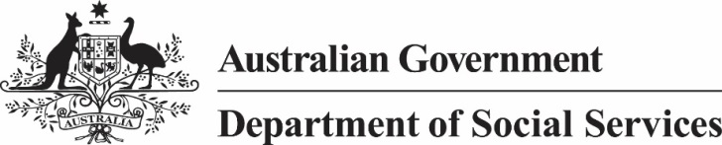
The following data is provided to the Australian Human Rights Commission in a consistent format to that required under condition a b and c of the 18 December 2015 exemption under the
Disability Discrimination Act 1992 for the Commonwealth and all Australian Disability Enterprises (ADEs) using or proposing to use the Business Services Wage Assessment Tool (BSWAT).
The period covered is from 18 December 2015 to 31 January 2016.
Commonwealths steps to ensure transition from BSWAT to an alternative wage tool approved by the Fair work Commission (FWC)
In early-January 2016, the Department of Social Services (the Department) contacted ADEs that may not have transitioned from the BSWAT to request their transition status; and for those that have not completed transition, to forward the Department a written plan. The Department also informed ADEs that they would not receive wage transition grants until they fully transition.
Applications to the Fair Work Commission for a further transitional period
Since 18 December 2015, the Department is not aware of any ADEs that have applied to the FWC for a further transitional period.
Organisation-level data:
Report period | Number or organisations previously using BSWAT | Number of organisations with all workers using alternate tool | Number of organisations with alternative tool and completed some assessments | Number of organisations with alternative tool, but have not commenced assessments | Number of organisations who have not identified an alternate tool
As at 31 January 2016 | 108 | 101 | 7 | 0 | 0

Supported employee-level data: ¹
Report period | Number of supported employees who work at an ADE that had previously used BSWAT | Number of supported employees assessed under alternate tool | Number of supported employees yet to be assessed by alternate tool | Percentage of employees who have transitioned to new wage tool
As at 31 January 2016 | 8,628 | 8,216 | 412 | 95 per cent

Further analysis of supported employee-level data:
Report period | Number of supported employees who work at an ADE that had previously used BSWAT | Number of supported employees assessed under alternate tool | Number of supported employees yet to be assessed by alternate tool, where organisation has commenced assessments on alternate tool | Number of supported employees yet to be assessed by alternate tool, where organisation has NOT commenced assessments on alternate tool
As at 31 January 2016 | 8,628 | 8,216 | 412 | 0

This data has been reported by organisations to the Department
This data has been reported by organisations to the Department

