Sharing the stories of Australian Muslims project
Content to promote the survey
Note: Remember to insert the survey link provided to you in the Commissioner’s email
Social media | Have a spare 15 minutes? Complete this survey to share your experiences of Islamophobia, race hate, discrimination and related intolerances. #MuslimStoriesAHRC #RDCsurvey #itstopswithme #islamophobiasurvey #humanrightssurvey Survey Link  The Race Discrimination Commissioner is conducting a survey to gain insight into Australian Muslim’s experiences of Islamophobia and Discrimination. Click the survey, spend 15 minutes and help make effective change. #MuslimStoriesAHRC Survey Link  The Human Rights Commission have released a survey for Muslims to share their experiences of Islamophobia, race hate, discrimination and related intolerances. Complete it now! #MuslimStoriesAHRC #RDCsurvey #itstopswithme #islamophobiasurvey #humanrightssurvey Survey Link  Complete this survey to share your experience as an Australian Muslim. #MuslimStoriesAHRC Survey Link  Do this survey and share the stories of your community’s strengths and challenges. #MuslimStoriesAHRC Survey Link
Electronic direct message, website and newsletter content | The Race Discrimination Commissioner, Mr Chin Tan is leading the Sharing the stories of Australian Muslims project for the Australian Human Rights Commission.  This important initiative was announced by the Commissioner in the aftermath of the tragedy in Christchurch. It aims to hear, record and share the views, opinions and experiences of Australian Muslims and identify their challenges, priorities and aspirations.  An important part of this project is a national online survey for Australian Muslims. Survey Link  The survey is a great opportunity for Australian Muslims to easily take part in this important project and give vital information that will help the Commissioner share their stories.  It will build robust national intelligence on Islamophobia, race hate and discrimination. It will also identify the community strengths and concerns of Australian Muslims, as well as the factors that contribute to our social cohesion and inclusion.  Share your story by completing the survey and help build a national picture of the experiences of Australian Muslims.  Find more information about the project on the project page on the Commission’s website.
 | 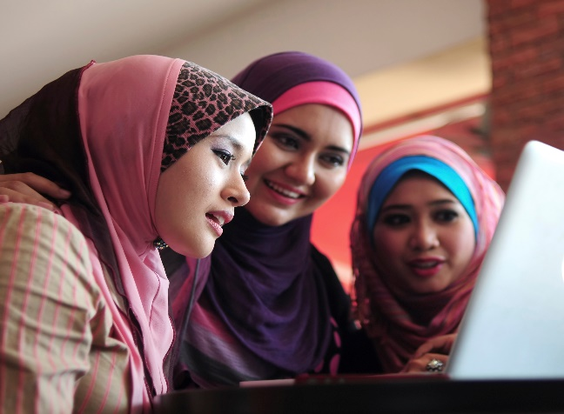 | 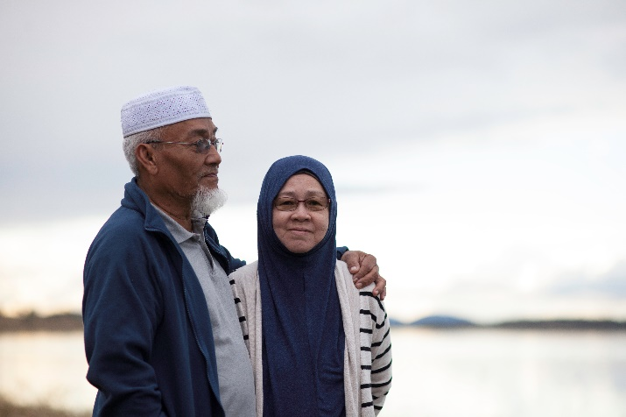
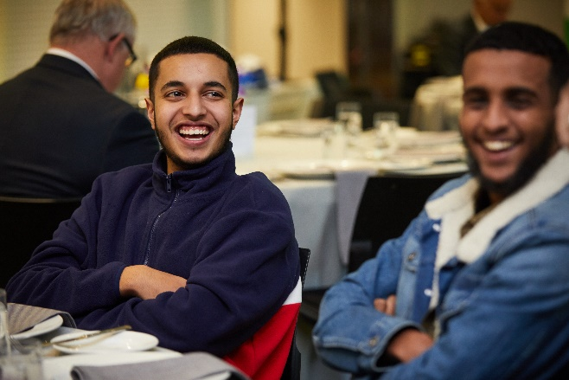 Please credit www.matthoustonphotography.com.au if you use this final image

Australian Human Rights Commission logos

