Operating context: analysis covering the period 2020–21 to 2023–24
We work in a complex social and political context with multiple factors that can affect how and how well we achieve our purpose. In deciding how to exercise our functions, we regularly assess the risks/challenges, opportunities, and capabilities in our environment that may affect our work, including over a multi-year horizon. The figure below shows the key factors identified in the assessment for 2020–21 to 2023–24.
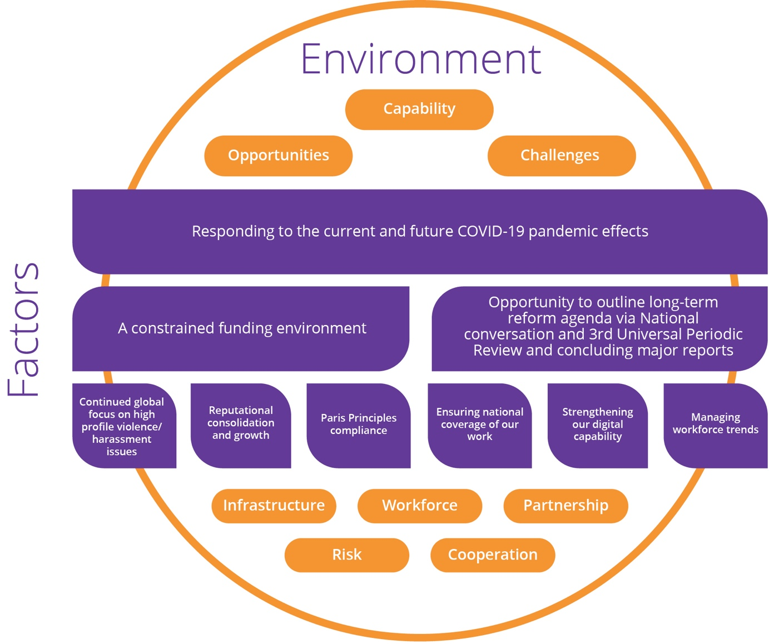
Our work involves a mixture of forward looking, agenda setting activities that seek to put important human rights front of mind, as well as reactive activities where we provide human rights expertise and input to government priorities, parliamentary processes, relevant court proceedings and through the operation of our national information service and complaint handling functions.
We are most effective in our impact where our knowledge and expertise align with the external processes in which we engage.
The most significant factor that will affect our work in the coming period is the COVID-19 pandemic. Our Commissioners have a leadership role to provide robust, independent human rights expertise during the pandemic to ensure that no-one is left behind during and in the aftermath.
Our national information service and investigation and conciliation service will continue to provide information and assistance to people making and responding to complaints about discrimination and human rights breaches. Data from these services will also be utilised to identify key trends so that we can proactively address emerging or prevalent human rights and discrimination issues arising from the pandemic and the responses to it.
The Commission is continuing the Free and Equal project, which is aimed at identifying a national reform agenda for human rights for the next decade. We will build on the lessons from the handling of the COVID-19 pandemic as we shape the recommended actions in this project, and also leverage Australia’s participation in the Universal Periodic Review process (at the United Nations Human Rights Council) to achieve some key reforms.
The Commission will complete significant and novel research and consultation processes in the coming period, which will provide guidance on key human rights challenges in our community. This includes through the finalisation of human rights and technology project; Wiyi Yanu U Thangani report on the voices of Aboriginal and Torres Strait Islander women and children; as well as reports on OPCAT implementation, forced surgical procedures on people with intersex variations and voices of Muslim communities. It also includes through the implementation of the report of the national inquiry into sexual harassment in Australian workplaces, Respect@Work.
We anticipate that all our work will take place in a constrained resourcing environment, and with significant economic pressures facing the entire community.
We will look to embed further changes to working practices that have arisen during the COVID-19 pandemic, such as increased workplace flexibility and digital engagement tools.
We will also have some possible change to our leadership team, with Commissioner terms due to expire in the coming year for three Commissioners—Age Discrimination, Human Rights and Sex Discrimination.

Key factors, challenges, opportunities, outlook, and management
This table summarises the key environmental, capability, cooperation and risk factors that may affect our operations in the four- year outlook of this plan and outlines their associated challenges, opportunities, our level of control over them and management strategies.
Factor | Assessment |  | Level of Control
 | Challenges, risks, opportunities and outlook | Management | A lot | Some | None
Responding to the current and future COVID-19 pandemic effects | Our President and Commissioners were at the forefront of discussions on the human rights impacts of the COVID-19 pandemic. This has included responding to:  - increased reports of racial discrimination, particularly faced by the Chinese community,  - the gendered impact of the pandemic (due to the higher rates of women in casual and unsecure work, greater demands on parents for caring responsibilities with school closures),  - impacts on older people, persons with disability and Aboriginal and Torres Strait Islander communities,  - mental health impacts on vulnerable groups, including children,  - assessing the appropriateness of restrictions on human rights (through lockdowns) and the human rights impact of the COVID-Safe App. | To respond to the challenges presented by the pandemic, we:  - reorientated our current project work to prioritise addressing COVID-19 related impacts,  - sought to proactively address emerging trends, including through our complaints and information services, to prevent human rights abuses and discrimination,  - within remaining capacity, continued to progress other important work priorities but undertook necessary changes to external engagement,  - continue to support the leadership role of our commissioners to provide robust, independent human rights expertise during the pandemic to ensure that no-one is left behind during and in the aftermath. |  | X
 | Before the pandemic, much of our work was anchored in face-to-face program components and advocacy. We swiftly ensured staff could work remotely (maintaining our business) and had the tools to conduct activities through digital engagement. This has minimised disruption to our work activities and ensured that we have greater digital engagement capabilities moving forward. | In this four-year period, we will continue to strategically build our technical and program digital capabilities, including through our learning management system, web-based submissions and engagement hub, and enhancing skills in web seminars and consultations.  We will continue to focus on partnerships as well as community engagement that ensures our activities and services are accessible to vulnerable and marginalised people and communities, to ensure that the increased reliance on digital technologies does not impact negatively. | X
A constrained funding environment | A constrained post pandemic economic environment is inevitable. Fiscal restraint across government appropriations are expected in addition to the current efficiency dividends. The impact of this on small agencies will continue to drive tight internal budgeting.  We have an increasing reliance upon external partnerships and fund-raising to support achievement of the Commission’s overall workplan.  While we have been successful in attracting funding for specific projects, in a recession environment this support may be at risk over several of the reporting periods.  Building partnerships and work needs agility, guidance, coordination and recognition that not all Commission functions or priority work areas can attract such funding. | We need to:  - ensure our program of work is flexible to respond to changing government priorities that have key human rights impacts,  - ensure support through core budget for such activities to ensure that the Commission maintains a balanced work program across all commissioners and areas of responsibility,  - continue to build our partnership and engagement capability using its agreed principles and a strategic decision-making process to seek and implement partnership opportunities,  - ensure we can demonstrate our value prospect in achieving common goals and human rights benefits. |  | X
Leading a national conversation on human rights | The Commission commenced the ‘Free and Equal: An Australian conversation on human rights’ project in 2018 as a flagship multi-year initiative to set out the main priorities for human rights reform over the next decade. The key challenge is to deliver a persuasive national reform agenda for human rights that can garner support from government and Parliament to drive the human rights priorities over the next decade at the federal level.  The realisation of the reform agenda will provide a long-term stage for this work, increasing the reach and relevance of our education and awareness programs to the broader community. | In the coming year, the free and equal project will build on the extensive consultations conducted and submissions received in 2019 and publish a national reform agenda for human rights. We will  - promote our findings through Australia’s participation on the Universal Periodic Review process (at the United Nations Human Rights Council) to achieve some key reforms,  - conduct expert roundtables on thematic issues in order to build broader consensus on key human rights reforms. |  | X
Continued national and international focus on high profile violence/ harassment issues | The COVID-19 pandemic has confirmed the significance of issues relating to violence and harassment, including the need for a greater focus on addressing racial discrimination, extremism and the prevalence of domestic violence.  A continued global focus on violence and abuse against women, such as through the #MeToo and #TimesUp movements, will likely ensure high public interest in the Commission’s monitoring and reform proposals in these areas.  The United Nations global campaign on violence against children provides international context to work in Australia that is responding to the Royal Commission into institutional abuse of children, and to other forms of violence against children.  The Royal Commissions into institutional abuse of persons with disabilities and aged care provides a spotlight to advance human rights protections and a safeguarding focus for vulnerable groups and people. | The Commission has identified how its activities can contribute to addressing racial discrimination, through public awareness and building community cohesion. Our challenge is to ensure adequate resourcing to implement this.  The Commission will also conduct and finalise activities targeted at addressing violence, harassment and abuse, including by:  - conducting activities to promote awareness and implementation of the report of the national inquiry into workplace sexual harassment,  - research and public engagement on elder abuse,  - publishing the outcomes of national consultations and surveys with Muslim communities. |  | X
Reputational consolidation and growth | The Commission continually seeks to further its track record of being sought out for its expertise, recognised for its robust and quality work, and being valued for its advice across government portfolios and departments.  In the coming years, a challenge will be to focus our activities in a way that best responds to the COVID-19 pandemic and post-pandemic environment. This necessarily includes by advocating for the most vulnerable and marginalised, whose voices may be increasingly distanced from public awareness.  The Commission remains actively engaged in the regional and global system for national human rights institutions, and as an expert independent source of information in United Nation processes. Australia’s appearance in the Universal Periodic Review process in 2021 will provide a focal point for this, as well as the pending visits to Australia of international scrutiny procedures. | In 2020, the Commission will finalise and release the outcomes of significant research and consultation projects that will contribute to our reputation, including:  - Wiyi Yanu Thangani – Women’s Voices,  - Human rights and technology,  - Voices of Muslim communities.  In this coming year, a new National Children’s Commissioner will commence their term and three other commissioners will enter the final year of their current terms as commissioners.  - Our systems and planning will focus on ensuring that new commissioners are supported as they begin their terms and outgoing commissioners are supported to maximise the outcomes of their key activities to achieve their goals. | X
Paris Principles compliance | The Paris Principles (Principles Relating to the Status of National Human Rights Institutions) provide an internationally agreed basis for assessing the independence and effectiveness of national human rights institutions. The Commission’s compliance will next be assessed in 2021, providing an opportunity to consider the effectiveness of the Commission’s operating arrangements and breadth of functions. | The Commission will work with the Government to address compliance issues ahead of Australia’s next accreditation review in 2021. |  | X
Ensuring national coverage of our work | The single base of our organisation in Sydney, with some commissioners located inter-state, and our resourcing creates challenges for ensuring engagement with regional, rural and remote Australia.  The COVID-19 pandemic has significant implications for the foreseeable future for engagement strategies, with limits on the ability to conduct face to face consultations and travel nationally. | The COVID-19 pandemic has resulted in significant changes to external outreach strategies, due to the lack of ability to travel or conduct face to face consultation and meetings. Over the coming year, we shall look to embed these new practices and build our technical capability to conduct online and remote consultation.  We also monitor and publicly report data on the national coverage of our work. |  | X
Managing workforce trends | Underlying the staffing challenges of the future is an appreciation of a stronger mobility mindset among our newest cohorts and the need to harness this talent quickly and effectively rather than building for a longer-term return on investment.  The breadth of work that the Commission engages in vs how much we can do within limited budget and resources continues to challenge our capacity.  There is a need to recognise the opportunities in effective home-based work (HBW) practices, virtual team environments and opening roles to geographically remote personnel as appropriate. | In managing a more mobile workforce our strategy includes investing in our more senior tiers to build the capacity of managers to work with this cohort and to develop internal systems to manage the retention of corporate knowledge.  Robust planning processes will be important in reality-checking ambitious workplans with the aim to:  - ensure that our workload remains achievable against resourcing, and  - that staff and internal support systems are productive but not overwhelmed.  We will build on our stronger digital capability to harness the productivity, attraction, retention and reputational benefits that could flow from greater HBW arrangements. | X
Strengthening our digital capability | Last year’s investment in our digital technology infrastructure has delivered benefits including streamlined information management with 24/7/365 access to systems and data, increased security, more workforce flexibility and versatility and efficiencies in our program activities.  These benefits and our agility in this area were demonstrated in our swift response to remote working and our creation of a virtual ‘business as usual’ culture during the COVID-19 lockdown period. | Our focus is on:  - increased use of centralised web outreach through our new ‘Have your say’ portal,  - increased use of digital engagement tools,  - more strategic and coordinated communications outreach through digital channels. | X

Capability through digital infrastructure and investment
Information and communications technology (ICT) have a crucial role in supporting the organisation’s communication and sharing of information, both internally and externally. Investing in this aspect of our capability has been challenging given our long-term fiscal environment and as a small Commonwealth agency.
Over recent years, our ICT team has led the Commission through a range of significant ICT infrastructure projects. Partnership arrangements have been entered into to deliver innovative, high value and low-cost ICT capabilities to service our organisational needs. This has led to the Commission being one of the first Commonwealth entities to deliver services through cloud-based infrastructure, as well as trialling industry leading options for an artificial intelligence centred document management system.
We have also commenced rolling out new electronic financial and human resources management systems, which will continue in the coming year with new modules to be added.
This has increased our capability to support remote work and access to live data through our financial systems. The increase in our capability was demonstrated in our technical and cultural response to the COVID-19 pandemic. Our ICT team were able to respond rapidly to the dramatic change in work practices, enabling the entire workforce to be transitioned to remote working arrangements within a week, supported by new digital tools for internal and external engagement, as well as full access to financial management and human resources functions remotely while maintaining appropriate security.
This experience coupled with other and future digital investments positions us well to embed this new capability and realise the benefits over the four-year period ahead.

Capability and our workforce
Our most important asset is our people. We understand the importance of a diverse and inclusive workplace culture and the need to foster excellence and expertise in our staff. With our internal and external stakeholders, we lead by example and operate in accordance with the human rights standards that we expect of others.
The main internal workforce capability gap that we face is matching the breadth of the work we want to do with the limited appropriated budget and other resources available to do so. Our challenge is to ensure that our workload remains achievable and our staff are productive but not overwhelmed. This challenge particularly arises in supporting eight statutory officer holders and in managing our national complaint handling function.
To achieve this, we implement strategies such as robust planning processes and systems that emphasise feasibility and seek to identify partnership potential, while ensuring that we retain the agility to move internal resources to take advantage of new opportunities and shifting work priorities.
In the 2019 Australian Public Service (APS) Employee Census survey:
97% of the Commission respondents believed strongly in the Commission’s purpose and objectives (82% APS wide), with
86% agreeing: ‘I am proud to work in my agency’ (74% APS wide), and
95% agreeing they were happy to go the extra mile at work when required (91% APS wide), however
92% also confirmed: ‘I work beyond what is required in my job to help my agency achieve its objectives’ (79% APS wide).
In managing our complaint handling function, we ensure regular capacity building of our staff to handle complex interactions and continual skills building in alternative dispute resolution to ensure swift resolution and satisfaction for all parties.
Our main externally facing challenge is managing a stronger ‘mobility mindset’ among our newer staff cohorts and the flow-on effects such as the risk to corporate knowledge. This is a global trend we expect will continue over the four-year outlook of this workplan.
Our approach is to harness this talent early, as well as building our capacity for the longer-term. This includes investing in the leadership capacity of our more senior staff—building their capacity to operate with a more mobile workforce without compromising our work.

Cooperation and capability through our partnerships
The Commission regularly operates through partnerships and collaborations with government, business, the non-government sector and internationally.
We have built a reputation for expertise in human rights in research, consultation, and implementation design. Our operation as an independent agency is critical to our capability in this regard: it means we are a trusted neutral interlocutor that can bring diverse and often competing interests together to address difficult human rights challenges.
Partnerships increase our capability through shared skills and resources and create a collective ability to achieve outcomes greater than the individuals or organisations acting alone. It is a central feature of how we work.
Our partnerships are two-way. First, we receive significant pro-bono support from the private sector—especially from law and consulting firms. Second, we also enter a range of ‘fee for service’ partnerships on a cost-recovery basis where we can provide our technical expertise to third parties.
Governments and entities from all sectors consistently invite us to work with them to share our human rights expertise and to enter collaborations on specific human rights projects and advocacy activities. In doing so, we have become accomplished in collaborating with professionalism and integrity.
With government partners, such arrangements include: the development of national child safety principles and educational tools to support their rollout in light of the Royal Commission into institutional abuse of children; international technical cooperation that increases the human rights capabilities of neighbouring countries and contributes to regional cooperation and security; and collaborations with universities, sporting codes and business to provide guidance on responding to challenging human rights issues.
Our partnerships are diverse and take many forms including agreements for in-kind support, pro bono support and/or financial support. They can be informal or formalised by a letter, MOU or legal contract and they may be short-to-long-term.
The Commission’s partnership strategy is streamlined and centralised. This ensures that we approach these issues in a strategic, professional manner that is risk assessed.
Each year our planning process captures data on our partner organisations, the figure below shows the range of partner categories in our forward workplan.
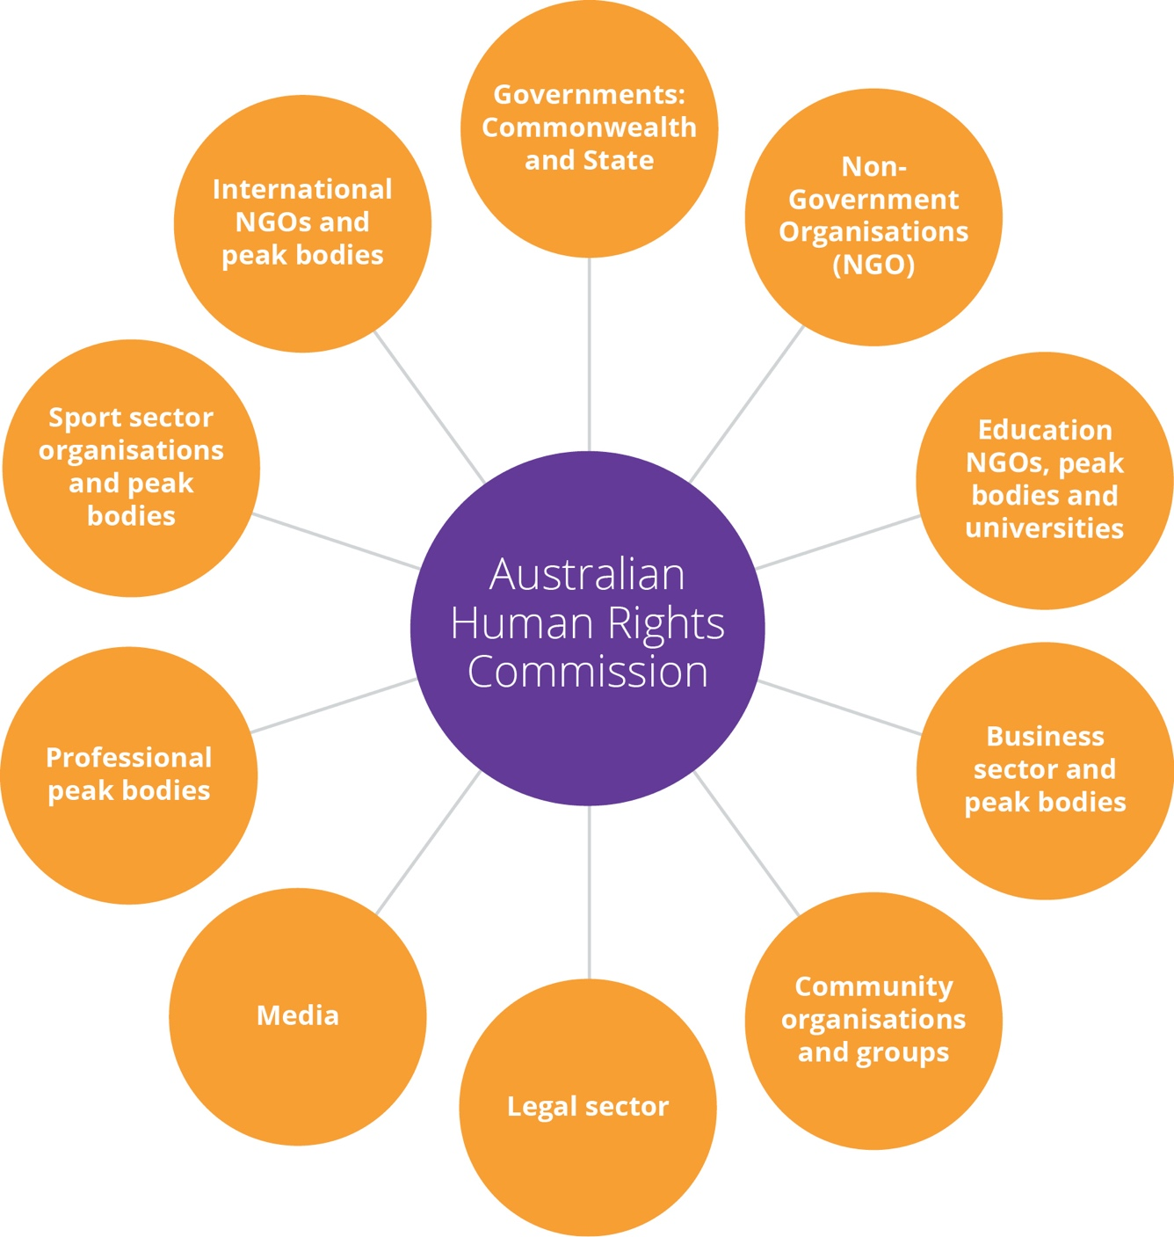

Risk oversight and management
We adopt a positive risk management culture that promotes an open and proactive approach to managing risk.
Our existing risk management framework provides a mechanism for proactively identifying and mitigating risks across the organisation, and for monitoring the operating environment. The risk management framework is tailored to meet the needs of the Commission, and covers three main areas:
- Key strategic risks: including a constrained funding environment, damage to the Commission’s independence and reputation, not managing relationships with key government stakeholders and other external parties, and not responding quickly and effectively to a changing political landscape.
- Core business risks: including policy activities that are not aligned to the Commission’s strategic objectives, failing to provide an accessible and effective complaint handling service that complies with all relevant laws, and community engagement activities that fail to achieve the objective of increased public awareness of human rights.
- Corporate support risks: including failure to recruit and retain appropriately skilled and diverse staff, the misuse of assets or resources, business continuity processes not in place, IT interruption, outage or information compromise, and an unsafe work environment.
We have the following mitigation strategies and controls in place to manage these key risks. A risk owner has been allocated for each risk that has been identified. The risk owner has responsibility for managing the particular risk.
We undertake regular reviews of the Commission’s risk management framework and the risks being managed, to ensure new risks are identified and existing risks remain appropriately managed. Our most recent review was undertaken by senior executive staff and the accountable authority in February 2020.
We have also embedded risk management into our decision-making and key business processes. For example, risk evaluations are conducted during procurement processes and in program planning processes. Simple templates have been developed to ensure these risk assessments are accessible to all staff.
We have also developed specialist policies and processes for particular risk categories, including business continuity, fraud control, work health and safety, privacy, and child safety and wellbeing.
We are supported by our internal auditors who conduct regular audit reviews and other assurance activities for our strategic planning and core business processes.
The Commission’s Audit and Risk Committee also has a role in overseeing risk management practices. The Audit and Risk Committee provides independent assurance to the Accountable Authority on the Commission’s financial and performance reporting responsibilities, risk oversight and management, and system of internal control and assurance.

