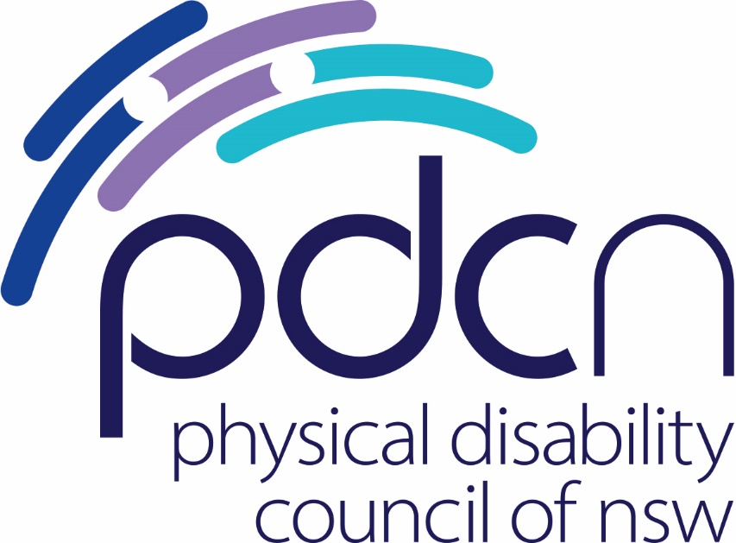

Submission to the Australian Human Rights Commission on the

Australasian Railway Association Application for Temporary Exemptions to the Disability Standards for Accessible Public Transport 2002 (Cth) and the Disability (Access to Premises – Buildings) Standards 2010 (Cth)

29 September 2020

Physical Disability Council of NSW
3/184 Glebe Point Road, Glebe NSW 2037

02 9552 1606
www.pdcnsw.org.au

alice.wilmshurst@pdcnsw.org.au

Contents

Who is the Physical Disability Council of NSW? 3
Recommendations 4
Introduction 5
Response 6
Conclusion 7

Who is the Physical Disability Council of NSW?

The Physical Disability Council of NSW (PDCN) is the peak body representing people with physical disabilities across New South Wales. This includes people with a range of physical disability issues, from young children and their representatives to aged people, who are from a wide range of socio-economic circumstances and live in metropolitan, rural and regional areas of NSW.

Our core function is to influence and advocate for the achievement of systemic change to ensure the rights of all people with a physical disability are improved and upheld.

The objectives of PDCN are:
- To educate, inform and assist people with physical disabilities in NSW about the range of services, structure and programs available that enable their full participation, equality of opportunity and equality of citizenship.
- To develop the capacity of people with physical disability in NSW to identify their own goals, and the confidence to develop a pathway to achieving their goals (i.e. self-advocate).
- To educate and inform stakeholders (i.e.: about the needs of people with a physical disability) so that they are able to achieve and maintain full participation, equality of opportunity and equality of citizenship.

Recommendations

Recommendation 1:
The application for exemption should be rejected in full.

Recommendation 2:
If the Australia Human Rights Commission (AHRC) is minded to grant the exemptions, either in part or totality, the AHRC should require that the ARA provide:
- a publicly accessible report of progress made to date in meeting accessibility requirements;
- a publicly accessible strategic plan to meet accessibility requirements, identifying responsibilities, outcomes and timeframes

Recommendation 3:
If the AHRC is minded to grant the application, we would recommend that the ARA be provided with a shorter time frame and that they be required to report to the AHRC regularly to determine whether the exemption is still necessary across all requests and to update on overall progress.

Introduction

PDCN would like to thank the Australian Human Rights Commission (AHRC) for the opportunity to make a submission to the Australasian Railway Association (ARA)’s application for exemption from the Disability Standards for Accessible Public Transport 2002 (Cth) (DSAPT) and Disability (Access to Premises – Buildings) Standards 2010 (Cth).

PDCN submits that exemptions should not be granted on the basis that it would be a denial of human rights. You cannot ‘opt out’ of human rights. At present, Australia has no single act responsible for enshrining human rights. As a party to the United Nations Convention on the Rights of People with Disabilities (CRPD), we have an obligation to ensure we meet its standards – but there are no repercussions for not doing so.

We are uncomfortable with exemptions across a theme – they should be granted on a case by case basis, as the aspiration to meet human rights is there, but there can be limitations. Blanket, long term exemptions that are provided without firm strictures around expected progress to meeting accessibility standards provide no incentive for groups to achieve full accessibility. We would submit that the exemptions discourage groups from trying and note that this is not the first occasion that ARA has sought exemptions on these issues.

PDCN would like to acknowledge the work undertaken by members of the ARA to improve accessibility and recognises that the number of exemptions being sought has reduced from 30 to 4, however the application does not provide evidence on if or how the other standards have been met, and this is something we would like to see as a means of indicating that progress to meeting standards is being made. It is difficult to assess how genuine the ARA is around meeting accessibility requirements, as a determinate of whether further exemptions should be supported, without transparency on progress to date.

It would be useful, as an ongoing tool, for the ARA to provide publicly accessible strategies and benchmarks on how standards are being met. PDCN, while acknowledging that the DSAPT, legislated in 2002, needs updating and is currently under review by the Federal Department of Infrastructure, Transport, Regional Development and Communications (a review which commenced in 2017), find this to be an unacceptable excuse for an exemption, as the DSAPT does not currently, and is unlikely to contain the level of detail to which these exemptions are referring. For example, to say that flange gaps at level crossings are not recognised in the DSAPT is not a reason to be granted an exemption – if a flange gap hinders access, efforts should be undertaken to rectify this.

PDCN’s submission will not speak directly to each individual exemption, rather address the broader issue of meeting human rights obligations, and how exemptions deny people with disability those rights.

Response

A question of rights

Article 9 of the CRPD states:
1. To enable persons with disabilities to live independently and participate fully in all aspects of life, States Parties shall take appropriate measures to ensure to persons with disabilities access, on an equal basis with others, to the physical environment, to transportation, to information and communications, including information and communications technologies and systems, and to other facilities and services open or provided to the public, both in urban and in rural areas. These measures, which shall include the identification and elimination of obstacles and barriers to accessibility, shall apply to, inter alia: (a) Buildings, roads, transportation and other indoor and outdoor facilities, including schools, housing, medical facilities and workplaces;

Australia, as a signatory to the CRPD, has an obligation to ensure we comply with the CRPD, however there is no consequence, apart from a proverbial ‘slap on the wrist’ from the UN, if we do not.

The CRPD acts as a persuasive tool, a way to encourage countries to meet their obligations. Australia has no bill of rights, rather human rights can be found in the constitution, or legislation of each individual state, meaning there is no one overarching piece of legislation that enshrines our human rights. As a broader issue, we are concerned that all too often, UN pressure appears to have little impact as to whether human rights are enforced in a domestic context.

The UN can only make recommendations, and protections in a legal context are limited, so the AHRC is one of the limited avenues people have as a mechanism for upholding their fundamental rights, and even then the onus is on the person to make a complaint, which can be both emotionally and financially draining. AHRC is essentially the last line of defence of their human rights, and a constrained one at that.

Role of the Australian Human Rights Commission

The AHRC website states that it has “a responsibility to monitor Australia’s performance in meeting its international human rights commitments” – and as mentioned above, Australia has an obligation to ensure people with disability have equal access to transport. Transport plays an important role in ensuring people with disability are included in the community. The importance of access and inclusion is a focus of all Government Disability Inclusion Action Plans and is highlighted in the National Disability Strategy (NDS). Policy Direction Four of the Strategy states ‘a public, private and community transport system that is accessible for the whole community’ is vital for people with disability to have mobility in the community and ‘underpins all aspects of life for people with a disability.’’

For some people with disability, public transport is their only means for accessing the community and goes a long way to ensuring their inclusion in that community. This in turn contributes to their quality of life, and it has been well documented that people with disability have lower quality of life compared to other groups in society. A 2009 report by the Organisation for Economic Cooperation and Development (OECD) found that Australia ranked lowest of OECD countries in terms of quality of life for people with disability, and in 2015, PricewaterhouseCoopers reported that 45% of people with disability in Australia were living in poverty., It is therefore vital that all efforts are made to achieve accessible public transport, to allow them to access the community.

Lack of consultation

Another issue of relevance to people with disability is consultation. People with disability can and should be consulted when it comes to making these applications, but also as an ongoing commitment to ensure standards are being met. PDCN acknowledges that there are access committees - PDCN itself is a member of Transport for NSW’s Accessible Transport Advisory Committee (ATAC), however members of these committees are often chosen by governments, and are not always sufficiently briefed and informed about the issues at hand. The consultation undertaken by these groups is often tokenistic.

For example, when the ATAC was informed of the intention of ARA to make this application, it was not a consultation, members were simply advised. PDCN has concerns that this application was made without sufficient prior consultation of people with disability or their advocates. The ARA’s report states that “there was no opposition from the Committee (ATAC)”, however when the ATAC was notified, it was to advise members of the committee that the application was being made. It was not an open forum to raise issues and ask questions – this is not true consultation. If there is to be true consultation, these committees should be utilised to access the members of the organisations – people with disability – and consult with them on all issues pertaining to the DSAPT, so governments and policy makers have a thorough understanding of what the issues are – and why all efforts should be made to meet all standards.

The point to be made here is that consultation should not be taken for granted, and the process undertaken by the ARA points at it doing just that. This application was made right before the previous exemptions were due to expire, with only a month’s turnaround to make submissions, suggesting that the ARA believes it does not need to comply with the standards, and that what they have done is acceptable. However, we would argue that this does not take consultation seriously, and consultation is key. It is not always within the scope of the people or organisation making a submission to find out if people with disability agree or disagree with the specifics of an exemption. That is something that the ARA, or its member organisations, should be doing prior to making the application.

Conclusion

There is a fine interplay between what is reasonable and what is good for society.

We find that all too often human rights are viewed as conditional and are considered under a lens of what is ‘reasonably practicable’. We know all too well that ‘reasonably practicable’ can be used to deny rights for a range of reasons that do not hold up against the consequences to the individuals affected. When a human right is not met, people are seriously and adversely impacted. Therefore, exemptions should only be afforded in exceptional circumstances – we do not believe that in this instance, exceptional circumstances are present.

PDCN has every faith that the AHRC will consider the application with due seriousness and facilitate access to human rights for people with disability. We refer to its recent decision not to grant exemptions to the State of Queensland and Queensland Rail. While the specifics of this case are different, we suggest it speaks to the broader issue that no one is exempt from human rights and sets a precedent for denying the ARA exemptions.

If the AHRC were to grant an exemption, we would want to see a requirement that the ARA provide an ongoing strategy as to how standards will be met as soon as possible. The current reports, provided by the ARA, are light on detail and this does not instil confidence that the ARA takes its accessibility responsibilities seriously. They do not, for example, include timelines or targets. We would like to see greater public accountability and a commitment to benchmarks – a timeline for meeting these standards and a report on how the previous exemptions have been met, to understand how ARA’s members, for example Transport for NSW, are meeting standards (or attempting to).

The upholding of human rights should be emphasised as essential to a just and equitable society, and the granting of exemption should only be given sparingly by the AHRC as the authority responsible for ensuring the rights of people with disability are upheld. The AHRC, in considering this proposition is directly accountable to people with disability.

Australasian Railways Association, Application for Temporary Exemption to the Disability Standards for Accessible Public Transport 2002 (Cth) and Disability (Access to Premises – Buildings) Standards 2010 (Cth), p.15
United Nations 2006, Convention on the Rights of Persons with Disabilities, https://www.un.org/disabilities/documents/convention/convention_accessible_pdf.pdf, accessed 9 September 2020
Australian Human Rights Commission 2020, https://humanrights.gov.au/about/what-are-human-rights, accessed 9 September 2020
Commonwealth of Australia, National Disability Strategy (NDS) 2010- 2020, page 32
Organisation for Economic Cooperation and Development 2009. Sickness, Disability and work: Keeping on Track in the Economic Downturn, http://www.oecd.org/employment/emp/42699911.pdf, accessed 18 September 2020
Gooding, P., Anderson, J. and McVilly, K., 2017. Disability and social inclusion ‘Down Under’: A systematic literature review. Journal of Social Inclusion, 8(2), pp.5–26, https://josi.org.au/articles/abstract/10.36251/josi.121/, accessed 19 September 2020
Note: while this is not within the scope of this submission, a 2017 review of the literature by Gooding, Anderson and McVilly found there are many gaps in policy, practice and research pertaining to the social inclusion of people with disability in Australia.
Ibid, note 2, page 19

