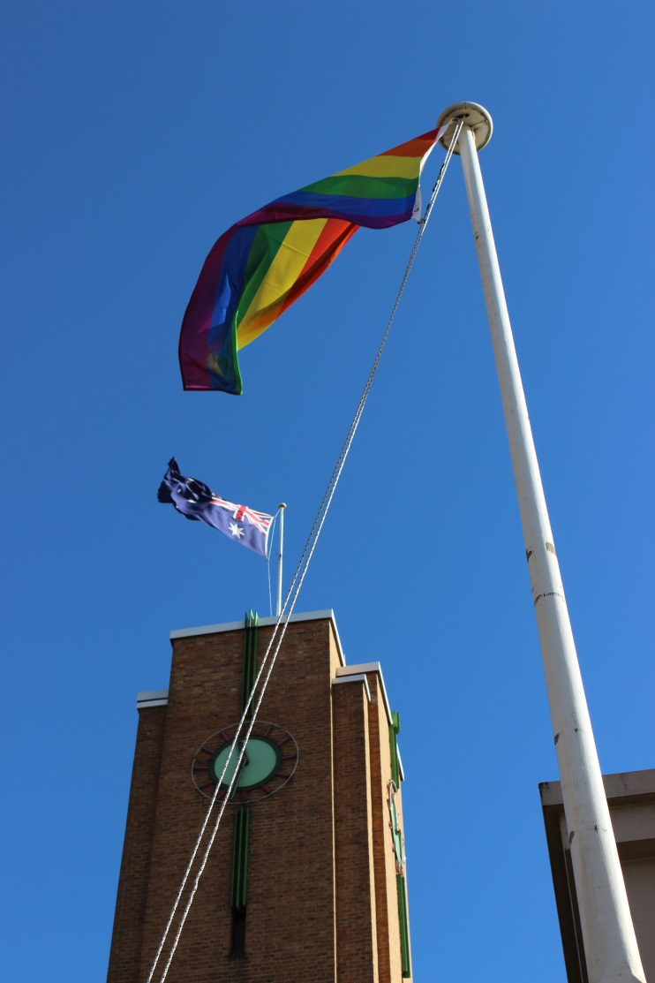

Sexual Orientation Gender Identity and Intersex Rights
Snapshot Report Consultation
Submission to the Australian Human Rights Commission

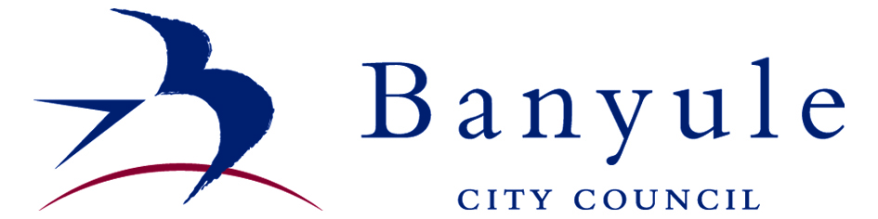
Banyule City Council - Case Study

The purpose of this case study submission is to present the priorities of the Lesbian, Gay, Bisexual, Transgender, Intersex (LGBTI) community in Banyule. Many of the concerns of the LGBTI community in Banyule will be common across other communities and provide a useful snapshot for the Australian Human Rights Commission of issues at the local community level. The submission also outlines the ways in which Banyule City Council is currently working with the LGBTI community to promote change.

Consultation with the LGBTI community in Banyule

In early 2014, Banyule City Council established an LGBTI Advisory Committee made up of community members and representatives from organizations that work with the LGBTI community. The Committee meets every two months and is chaired by a Councillor to ensure there is a line of communication between Council and the Committee.

Council also consults with the LGBTI community at a range of community events, including Council run events, such as Banyule Youth Summit and LGBTI community events such as Midsumma Carnival in Melbourne.

Based on our consultation with the community and meetings with the advisory committee, the priority issues for the LGBTI community in Banyule fall into four main themes:

- Ensuring that young people have access to safe environments, both within school and outside of school, to discuss issues of gender and sexuality.

- Increasing recognition and visibility of the LGBTI community, for example through holding events to celebrate IDAHO Day

- Establishing safe social spaces for the LGBTI community to connect with each other and discuss ideas, such as book clubs or sport groups

- Supporting services and businesses to develop practices that are inclusive of the LGBTI community, such as through displaying the rainbow sticker on shop fronts or having gender neutral toilets

(Note: It should be noted that the consultation focused on local issues. Therefore, concerns around State and Federal legislative reform were beyond the scope of the consultation.

How Council is working with the LGBTI community

In response to this feedback Council has developed its LGBTI Plan 2014-2017 and is now implementing the plan, in partnership with Council’s LGBTI Advisory Committee. Some of the actions that Council has implemented are:

Supporting young people

In 2014 Banyule Youth Services facilitated a youth focused program “Queer Sphere”. The Queer Sphere program delivered multiple elements including:

- A social and recreational youth group
- Individual support and referral
- Workshops for secondary school students on International Day Against Homophobia and Transphobia (IDAHOT)
- School based drama workshops addressing issues of diversity and inclusion

The IDAHOT Day workshop brought together students from a number of secondary schools in Banyule for one day. Students discussed why it is important to support diversity in schools and what schools and individuals can do to create inclusive school environments free of homophobia and transphobia.

The school based drama workshops took place over a period of four weeks at two schools in Banyule and with three drama class groups. Issues of diversity, inclusion, exclusion, labelling, bullying, stereotypes and identity were explored in depth.

Throughout the process of both workshops, and supported by evaluation, it became evident that young people have a good awareness of the challenges they face in developing their identity and challenging gender stereotypes but do not have adequate forums to discuss and explore them.

Feedback from a teacher of a drama class that participated in the workshops:

“The discussions around gender and sexuality were very powerful and really made them think about issues that they are presented with today. Many of the students in the class have now been very engaged in their script writing and are putting some ideas that were raised in the workshops into their scripts”.

Feedback from students who participated in the drama workshops:

“Most lessons (workshops) I left with a sort of ‘Woah’ feeling, everything was interesting and new to talk about at school. Most (other) classes/teachers just brush it off”

“I had always assumed that there was just he/she. I had never been asked what my (preferred) pronoun was until now. I thought I didn’t have a choice”.

Increasing recognition and visibility

Council has increased recognition and visibility through participating in festivals and events. In January 2015 Council held a stall at the Midsumma Carnival at Alexandra Gardens and staff and Councillors marched in the annual Pride March in St Kilda.

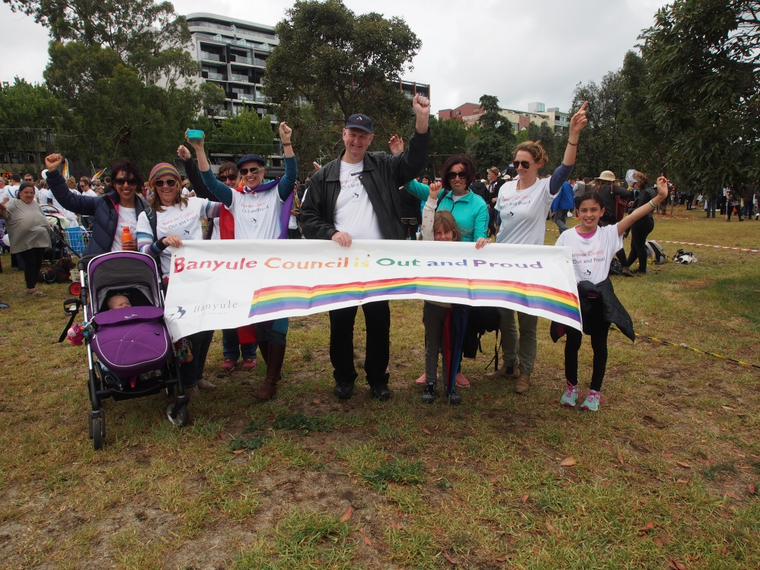

In 2013 and 2014 Council held events to mark IDAHOT Day. A flag raising ceremony was held in the morning and the rainbow flag remained flying at Council Chambers throughout the day. In 2014, Council also hosted a cocktail event in the evening. Throughout the day ‘No To Homophobia’ messages were promoted through the Council’s website and social media.

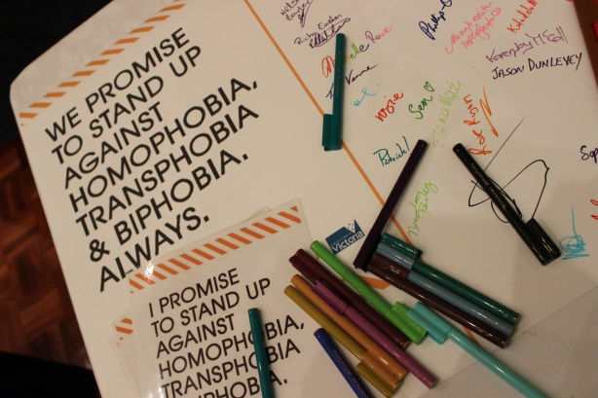 | 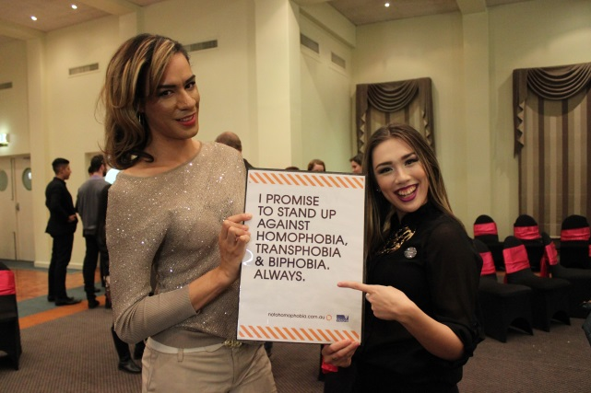
Safe social spaces

Council is currently working with the LGBTI Advisory Committee to identify opportunities for the LGBTI community to connect and share ideas.

Inclusive services

Through the LGBTI Plan 2014-2017 Council is working to ensure that its services are inclusive of the LGBTI community. In 2015 we will deliver awareness training for some of our staff. Council is also reviewing communication processes to ensure that the language we use is inclusive and relevant to the LGBTI community.

Our Home and Community Care service, which provides help and basic care for people who want to stay at home, is currently working towards rainbow tick accreditation. Achieving accreditation requires meeting six service standards and involves considerable planning, resources and commitment.

Should you wish to discuss any of the initiatives mentioned in this submission please contact Council’s Community and Social Planning Unit on 9490 4222.

