Australia as a nation — race, rights and immigration
Warning: This resource contains references to Aboriginal and Torres Strait Islander people who have passed away.

Introduction
This unit focuses on Australia’s development as a nation from 1900 onwards, by exploring changing experiences of democracy and citizenship through the stories of Aboriginal and Torres Strait Islander peoples, migrants, refugees and asylum seekers.
In this unit, students will have the opportunity to develop their understanding of the impacts of racism and discrimination, investigate racist and anti-racist actions of citizens and governments, and learn about the lives of ethnic and cultural minorities in Australia.
Students will develop knowledge and understanding about human rights and Australia’s responsibilities to its citizens, particularly groups vulnerable to discrimination.
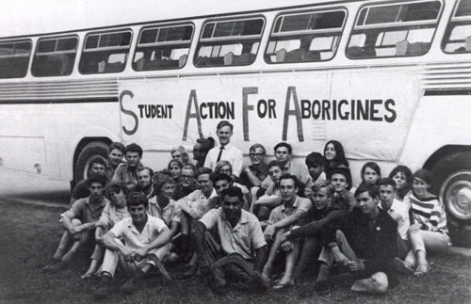
Students involved in the demonstration against discrimination of Aboriginal people in Walgett, NSW. Photograph reproduced with permission of Wendy Watson-Ekstein.
Table of Contents
Contents
Introduction 1
Focus 8
Teaching and learning activities 8
Teacher support 10
Achievement and learning outcomes 11
Sequence 1—Exploring human rights and freedoms 13
Sequence 2— Ending racial discrimination 21
Sequence 3—Exploring migrant experiences 49
Sequence 4— Refugees and asylum seekers 69
Unit review 78
Resources for Australia as a nation — race, rights and immigration 79
Worksheets 83

About this resource:

The Australian Human Rights Commission encourages the dissemination and exchange of information provided in this publication.
All material presented in this publication is provided under Creative Commons Attribution 3.0 Australia, with the exception of:
- the Australian Human Rights Commission Logo
- photographs and images
- any content or material provided by third parties.
The details of the relevant licence conditions are available on the Creative Commons website, as is the full legal code for the CC BY 3.0 AU licence

Attribution
Material obtained from this publication is to be attributed to the Australian Human Rights Commission with the following copyright notice:
© Australian Human Rights Commission 2014.

Electronic format
This publication can be found in electronic format on the website of the Australian Human Rights Commission: www.humanrights.gov.au/publications/index.html.
Contact details
For further information about the Australian Human Rights Commission, please visit www.humanrights.gov.au or email communications@humanrights.gov.au.

You can also write to:
Human Rights Education Team
Australian Human Rights Commission
GPO Box 5218
Sydney NSW 2001

Links to the Australian Curriculum
Year 10 History: Australia as a nation

Content
The content in this unit relates to the Australian Curriculum: History for Year 6 which looks at Australia as a nation.

General Capabilities
The general capabilities emphasised in this unit of work are Intercultural understanding, Ethical understanding, Literacy, Personal and social capability, Critical and creative thinking, and Information and communication technology (ICT) capability.

Cross-curriculum priority
The cross-curriculum priorities emphasised in this unit are Aboriginal and Torres Strait Islander histories and cultures and Asia and Australia´s engagement with Asia.

Content descriptions | Elaborations
ACHHK114 — Experiences of Australian democracy and citizenship, including the status and rights of Aboriginal people and/or Torres Strait Islanders, migrants, women, and children. | - the lack of citizenship rights for Aboriginal Peoples and Torres Strait Islander peoples in Australia  - describing the significance of the 1967 referendum  - investigating the stories of individuals or groups who advocated or fought for rights in twentieth-century Australia
ACHHK115 — Stories of groups of people who migrated to Australia (including from ONE Asian country) and the reasons they migrated, such as World War II and Australian migration programs since the war. | - comparing push and pull factors that have contributed to people migrating to Australia
(ACHHK116) The contribution of individuals and groups, including Aboriginal and Torres Strait Islander people and migrants, to the development of Australian society, for example in areas such as the economy, education, science, the arts, sport. | - investigating the role of specific cultural groups in Australia’s economic and social development (for example the Snowy Mountains Scheme)  - considering notable individuals in Australian public life across a range of fields, including Aboriginal and Torres Strait Islander peoples

Key Historical Concepts
The Australian Curriculum for History outlines a number of key historical concepts that should be taught in conjunction with historical knowledge and skills.
These key concepts provide a focus for historical investigation, a framework for organising historical information and a guide for developing historical understanding and analysing sources.
This unit includes a focus on the following key historical concepts.
Cause and effect - used by historians to identify chains of events and developments over time, short term and long term
Continuity and change - aspects of the past that remained the same over certain periods of time are referred to as continuities. Continuity and change are evident in any given period of time and concepts such as progress and decline may be used to evaluate continuity and change.
Empathy - empathy is an understanding of the past from the point of view of a particular individual or group, including an appreciation of the circumstances they faced, and the motivations, values and attitudes behind their actions
Perspective - a person’s perspective is their point of view, the position from which they see and understand events going on around them. People in the past may have had different points of view about a particular event, depending on their age, gender, social position and their beliefs and values. For example a convict girl and an Aboriginal Elder would have had quite different perspectives on the arrival of the First Fleet in Australia. Historians also have perspectives and this can influence their interpretation of the past.
Sources and evidence - any written or non-written materials that can be used to investigate the past, for example coins, photographs, letters, gravestones, buildings. A source becomes ‘evidence’ if it is of value to a particular inquiry (for example the relative size of historical figures in an ancient painting may provide clues for an inquiry into the social structure of the society). Evidence can be used to help construct a historical narrative, to support a hypothesis or to prove or disprove a conclusion.
For a more detailed explanation of the key historical concepts outlined in the Australian Curriculum, refer to the History Teachers’ Association of Australia's key concepts guide.

Resources
Key concepts, History Teachers’ Association of Australia

Focus
The unit is designed to support the Australian History curriculum. In this unit, students investigate how racism and attempts to combat it have shaped important events and developments in Australia’s history. Students will also explore how migrants have contributed to Australia’s changing identity.
Through investigating the stories of Aboriginal and Torres Strait Islander peoples, migrants, refugees and asylum seekers, students will explore how these groups experienced democracy and citizenship. Using the key concept of continuity and change, students will examine how discrimination and racism impacted on ethnic and cultural groups and the ways in which individuals and groups fought for their rights.
This unit is divided into two parts:
The first part of this unit explores basic human rights, obligations to support these rights and how advocates and activists have championed the fulfilment of these rights. The second part of the unit focuses on the stories of migrants, the motivations for migration and the positive and negative experiences of migrants in Australian society.
This unit provides opportunities to explore the following inquiry questions:
- How did Australian society change throughout the twentieth century?
- What contribution have significant individuals and groups made to the development of Australian society?
- Which groups of people have migrated to Australia? Why did they come?

Teaching and learning activities
The teaching and learning activities for this unit are divided into the following four sequences;
- Exploring human rights and freedoms
- Ending Discrimination
- Exploring migrant experiences
- Refugees and asylum seekers

The depth and range of topics provided in these sequences have been designed to allow teachers to select which materials and activities to use in class. Create a comprehensive teaching and learning program by using the Program Planner located at the back of this resource to select content, outcomes and activities from this unit.
English as an Additional Language or Dialect (EAL/D) learners may need an explanation of vocabulary in order to understand each teaching and learning sequence. Teachers should aim to build a student glossary or word-bank during each sequence.

Resources
Program Planner

Teacher support
Please be aware that a number of the activities in this unit raise issues that may be sensitive or controversial and should be addressed with care.
When confronted with sensitive or controversial issues, young people are likely to express a wide range of responses based on their different experiences, learning styles and emotional intelligence levels. It is important to handle these issues without reinforcing stereotypes, increasing confusion or raising tension between students.
Some strategies for introducing controversial topics and managing responses can be found in the guide Dos and don’ts when teaching about cultural differences, from Civics and Citizenship Education.
Other strategies and techniques include:
- Splitting the class into smaller groups. This will ensure that greater confidentiality exists and enables less confident students to express their opinions in a less-pressured environment.
- Frame discussions around controversial issues in ways that are as open-ended and inclusive as possible and challenge students to consider issues from a variety of perspectives and sources.
- Encourage all students to develop and maintain a sense of pride in their language, their lived culture, their experiences, their families, and their communities.
As further reading, the report The Impact of Racism upon the Health and Wellbeing of Young Australians includes examples of how racism is experienced by young people and can provide some background in supporting teacher understanding.
Resources:
Dos and don’ts when teaching about cultural differences, Civics and Citizenship Education.
The Impact of Racism upon the Health and Wellbeing of Young Australians, the Foundation for Young Australians

Achievement and learning outcomes
As a result of this unit of study students will:
- Identify key features of human rights including the key areas of human rights law that protect against racism and discrimination
- Examine an annotated timeline overview of Aboriginal and Torres Strait Islander rights in Australia from 1945 to 1975
- Demonstrate an understanding of advocacy and activism for human rights
- Investigate the role of the Freedom Riders (1965) in revealing racial discrimination against Aboriginal people
- Analyse the key features of the Racial Discrimination Act (1975)
- Develop an understanding of the ‘push and pull factors’ motivating post-war refugees and migrants to Australia
- Profile the experiences of different migrants and refugees, such as displaced persons and Vietnamese refugees.

This will be evident when students:
- Create a Wordle or mind map to summarise key features of human rights
- Contribute to a class poster project to highlight the key features of the Universal Declaration of Human Rights or the Convention on the Elimination of all forms of Racial Discrimination
- Identify discriminatory restrictions that impacted on the human rights of Aboriginal and Torres Strait Islander peoples in the period of 1945 to 1975
- Explain how human rights advocacy can support action against racism
- Complete an informative text on how and why the Freedom Riders achieved a breakthrough for the human rights of Aboriginal and Torres Strait Islander peoples
- Create mind maps to identify and briefly describe the push and pull factors of post-war migration to Australia
- Research and complete an informative text comparing the experiences of different migrants and refugees, such as displaced persons and Vietnamese refugees.

Resources
Find a list of the resources used in each teaching and learning activity in the ‘Resource’ side bar. Alternatively click on the resource symbol above to find the full list of resources at the back of this unit.

Sequence 1—Exploring human rights and freedoms

Introduction
Human rights and freedoms are essential to ensure that all people are treated equally and are able to live fulfilling lives.
Human rights are basic to humanity. They apply to all people everywhere. An understanding of human rights is an important part of our individual status as human beings and of our collective status as members of the global community of humankind.
The stories of Aboriginal and Torres Strait Islander peoples and migrant groups in Australia and their experiences of democracy and citizenship, which are explored later in this unit, demonstrate how individuals, groups, organisations and governments all play a role in establishing and maintaining human rights and freedoms.
In order to provide students with a foundation for understanding how fundamental human rights principles connect to pivotal events in Australian history, this initial sequence will explore some of the key human rights concepts and mechanisms.
In this sequence, students will have the opportunity to focus on:
- What are human rights and freedoms?
- The Universal Declaration of Human Rights
- The Convention on the Elimination of All Forms of Racial Discrimination

What are human rights and freedoms?
Recognising that the life of every person is valuable, human rights provide a set of moral and legal guidelines that aim to make sure every person can live a life of dignity.
In the following teaching and learning sequence students can consider the key features of human rights and freedoms, including how racism undermines those rights and freedoms.
The basic notion of human rights lies in the recognition of the need to protect and affirm every person’s dignity. No matter where people come from, or what their age, gender, culture, religion, ability or income may be, human rights are universal. Human rights issues are often seen as national or international in scope, but human rights are equally relevant at an individual and community level.
Teacher’s note: This section introduces some of the important terminology used to discuss human rights. It also explains the concept of human rights in a way that will set the context for the ideas explored in the later stages of the unit.
The activities associated with this part of the unit help establish the level of knowledge students already have about human rights. It is likely that the term is not completely new to many of them, however the depth and accuracy of each student’s understanding may vary widely. It may be interesting to compare the difference in students’ levels of understanding by looking at their responses to the following activities both before and after the delivery of the unit.

The Universal Declaration of Human Rights
In 1945, following the end of World War II, the United Nations (UN) was formed. Australia was a founding member of the UN and was also one of eight nations involved in drafting the Universal Declaration of Human Rights (UDHR).
Australia’s key role in drafting the UDHR was largely due to the influential leadership of Dr Herbert Vere Evatt, the head of Australia’s delegation to the UN, a former High Court Justice and politician who was renowned for being a champion of civil liberties and the rights of economically and socially disadvantaged people.

‘What are human rights?’ Class Discussion
Begin this class discussion activity by asking students what they already know about human rights. Make a list of points made by students on the board.
Provide students with the What are Human Rights and Freedoms? resource and activity sheets. Allow time for students to read through the information on the resource sheet and complete the activity sheet. As a class, discuss students’ responses to the statements on the activity sheet and add any new ideas to the list on the board.
Resources
What are Human Rights and Freedoms? Resource Sheet
What are Human Rights and Freedoms? Activity Sheet

Exploring the Universal Declaration of Human Rights
Begin this activity by providing students with the resource sheet The Universal Declaration of Human Rights and other human rights instruments to read through.
Next ask students to consider the 30 human rights articles in the Universal Declaration of Human Rights (UDHR). The Compasito manual on human rights education for children, produced by the Council of Europe, has a student-friendly version of the UDHR. Additionally, you may wish to use the Zen Pencils poster below as a visual stimulus for the class discussion.
Ask the class to compare the articles in the UDHR with the class list of human rights and to identify which rights need to be added to the class list.
Next, divide students into smaller groups and allocate each group with a human rights article from the UDHR. Particular articles that relate to the content explored in this unit include: Article 1 – the right to equality, Article 2 – the right to freedom from discrimination, Article 13 – the right to freedom of movement and Article 14 – the right to seek asylum. Have students identify what they think this right entails. Incorporate these ideas into the class list.
Finally, use the ‘Think-Pair-Share’ strategy to consolidate learning from this activity.
Think: Ask students to identify why the human right that they were assigned is important. Allow students 1-3 minutes to think about their answer.
Pair: Divide students into pairs. You may choose whether to assign pairs or let students pick their own partner. Remember to be sensitive to learners' needs (reading skills, attention skills, language skills) when creating pairs. Students share their thinking with their partner, discuss ideas, and ask questions of their partner about their thoughts on their particular human right for 2-5 minutes.
Share: Once partners have had ample time to share their thoughts and have a discussion, teachers expand the ‘share’ into a whole-class discussion.
Ask students to create a digital mind map using Bubbl.us or a word cloud using Wordle that incorporates all the key features of human rights that have been explored in the previous activities and discussions.

Teacher’s note: For further activities that explore human rights refer to What are human rights? from Discovering Democracy, and Exploring human rights from Civics and Citizenship Education.

Resources:
The Universal Declaration of Human Rights and other human rights instruments Resource Sheet
Student-friendly version of the UDHR, Compasito manual, Council of Europe
The Universal Declaration of Human Rights, Gavin Aung Than, Zen Pencils
What are human rights?, Discovering Democracy
Exploring human rights, Civics and Citizenship Education.
Bubbl.us website
Wordle website
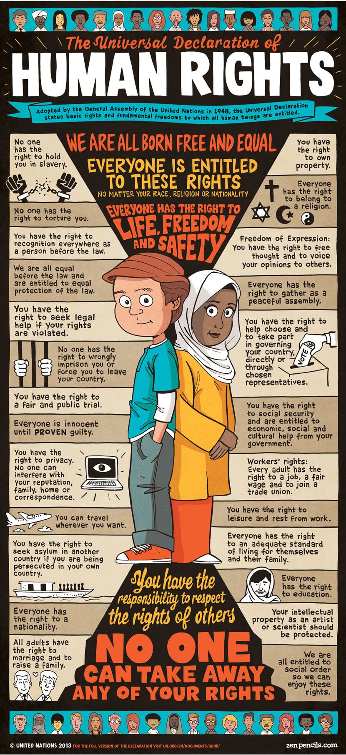
The Universal Declaration of Human Rights illustrated by Gavin Aung Than at Zen Pencils, reproduced with permission.

Convention on the Elimination of All Forms of Racial Discrimination
During the 1960s, increasing international pressure to address officially sanctioned forms of racial discrimination and segregation in countries such as the United States and South Africa culminated in the creation of the United Nations International Convention on the Elimination of All Forms of Racial Discrimination (CERD).
CERD was one of the first human rights treaties to be adopted by the United Nations (UN) and today is widely supported, with more than 156 countries (four-fifths of the membership of the UN) having signed the convention.
Australia signed the Convention on 13 October 1966 and made its commitment to CERD official in 1975 through the creation of the Racial Discrimination Act.
Prior to this point, Australia had a series of racially discriminatory policies and legislation under the White Australia Policy, which limited who was allowed to enter the country. CERD was one of the global influences that helped to dismantle the White Australia Policy.
More recently, Australia has also recognised the specific rights of children and young people to be free from discrimination by signing and ratifying the United Nation’s Convention of the Rights of the Child in 1990.
Resources
International Convention on the Elimination of All Forms of Racial Discrimination (CERD), the United Nations Office of the High Commissioner for Human Rights

Discussion—‘What is racism?’
As a way of prefacing the information on the UN Convention on the Elimination of All Forms of Racial Discrimination, you may wish to conduct a brief class discussion about racism and what it entails.
Initiate class discussion about what racism is and what it looks like to treat others unfairly because of their race or cultural heritage. Describe age appropriate examples of racism. For example: making jokes or negative comments about a particular ethnic group, calling someone racist names, or bullying and intimidating someone because of their race.
Teacher’s Note: In preparation for this discussion you may wish to refer to this “do’s and don’t’s” guide from Civics and Citizenship Education which outlines some points for conducting constructive conversations about race and racism.
As a class explore the What You Say Matters website. What You Say Matters is a resource designed to engage young people with the issues of racism. It is part of the Racism. It Stops With Me website by the Australian Human Rights Commission.
Ask students to discuss why it is important to have an international agreement between governments that aims to eliminate racism.
Resources
Dos and don’ts when teaching about cultural differences, Civics and Citizenship Education
What You Say Matters website

Assessment for Sequence 1

Create a human rights poster
Have students design a human rights poster based on the Universal Declaration of Human Rights or the Convention on the Elimination of All Forms of Racial Discrimination, using cardboard or digital means, such as Prezi.
Refer to examples such as The Universal Declaration of Human Rights poster from Zen Pencils to help students develop ideas,

Achievement standards:
- examine sources to identify and describe points of view
- develop texts

Key historical concepts:
Sources and evidence; perspective; empathy; significance

Resources
Prezi website
The Universal Declaration of Human Rights, Gavin Aung Than, Zen Pencils

Resources in Sequence 1
Click here for a summary of all the resources used in this sequence.

Sequence 2— Ending racial discrimination

Introduction
Racial discrimination undermines basic human rights in many societies. History shows that individuals, groups, institutions and governments have made a difference to the lives of individuals and disadvantaged groups by advocating and acting against racial discrimination.
In this teaching and learning sequence students have the opportunity to focus on:
- The human rights of Aboriginal and Torres Strait Islander peoples, 1945 to 1975
- The Freedom Riders
- 1967 Referendum
- The Racial Discrimination Act (1975)

The Human Rights of Aboriginal and Torres Strait Islander peoples, 1945 to 1975
In this section, students will gain an overview of the changing rights of Aboriginal and Torres Strait Islander peoples from after World War II to 1975.
Students will explore the types of human rights restrictions experienced by Aboriginal and Torres Strait Islander peoples in this time period and will investigate how advocacy and action to change laws and policies improved rights and freedoms.
This information serves as a background to the Freedom Riders case study.

Racism towards Aboriginal and Torres Strait Islander peoples
Aboriginal and Torres Strait Islander peoples today are still dealing with the legacy of past laws, government policies and social attitudes and behaviours which considered them inferior to other Australians.
Prior to 1967, Aboriginal and Torres Strait Islander peoples were not considered to be Australian citizens. There were extensive restrictions on many aspects of their lives, such as restrictions on where they could go, where they could live and what they could do.
This entrenched discrimination at a systemic and social level created significant disadvantage for Aboriginal and Torres Strait Islander peoples, leading to problems with health, education and housing which were not experienced to the same degree by other Australians. This is a disparity which continues to be a problem today.
For introductory teaching activities exploring the rights of Aboriginal and Torres Strait Islander peoples in Australia, view What is Australia's record on Indigenous people's rights? from Discovering Democracy.
Teacher’s note: In this section you will need to introduce and explain the policy of ‘segregation’ (i.e. the practice of separating individuals belonging to a particular group from others, in public areas and facilities) and explain how this is a form of racial discrimination.
Resources:
What is Australia's record on Indigenous people's rights?, Discovering Democracy.

Source analysis
Show students the following cartoon from 1888 and ask students to consider how this reflects on historical attitudes towards Aboriginal and Torres Strait Islander peoples.
Pose the following questions:
- What is happening in this cartoon?
- What do you think it means to be a ‘curiosity’ in your own country?
- What does the cartoon tell us about attitudes towards Aboriginal Australians in 1888?
- What comment do you think the cartoonist is trying to make?
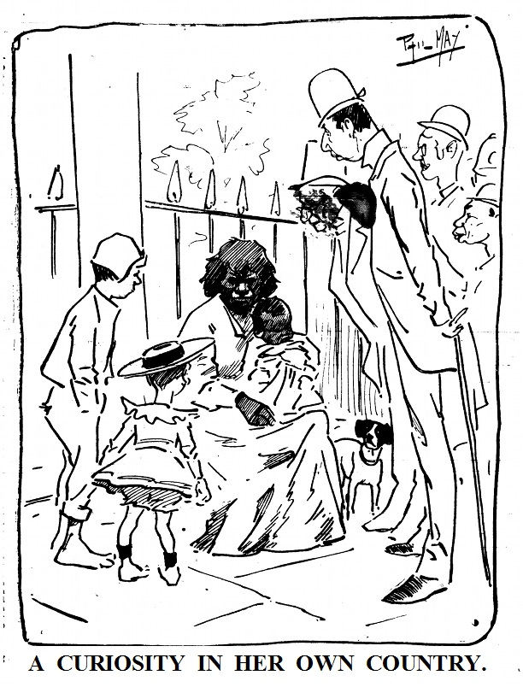
Source: Phil May, The Bulletin, 3 March 1888. National Library of Australia
Teacher’s note: The questions for this activity are adapted from the White Australia lesson on Difference Differently.
Resources:
White Australia, Difference Differently

Building a Timeline
Using the Aboriginal and Torres Strait Islander History, 1945–1975 Timeline as a teacher guide (using an overhead projector or smartboard), explain some of the key events that took place between 1945 and 1975 relating to Aboriginal and Torres Strait Islander peoples.
Ask students to complete the chronology task on the Aboriginal and Torres Strait Islander History, 1945–1975 Activity Sheet. As a class, discuss student responses. Highlight on the timeline where the rights of Aboriginal and Torres Strait Islander peoples were denied or restricted, and where efforts were made to remove those restrictions and recognise the rights of Aboriginal and Torres Strait Islander peoples. Highlight instances of rights being denied or upheld in different colours.
Allow time for students to modify the responses on their worksheet if needed.

Extension research activity
As an extension of this timeline activity, consider asking students to conduct independent online research to find additional information and historical sources (such as photographs and posters) that could be added to the timeline.
Ask students to focus on ‘big picture’ issues, such as changing government policies and laws and key events that aimed to improve the rights of Aboriginal and Torres Strait Islander peoples.
Once students have had the opportunity to conduct their research and collect sources, an annotated timeline can then be collaboratively compiled by the class.
Teacher’s note: As a reference for this extension activity, view the sample annotated timeline provided by ACARA, on pages 19–21 of the ACARA Year 6 History Work Sample Portfolio.

Resources:
Aboriginal and Torres Strait Islander History, 1945–1975 Timeline
Aboriginal and Torres Strait Islander History, 1945–1975 Activity Sheet
Year 6 History Work Sample Portfolio, ACARA

Exploring personal accounts
Guide students in gaining a greater understanding of how discriminatory attitudes and policies towards Aboriginal and Torres Strait Islander peoples impacted on individuals by exploring some of the personal accounts from the National Museum of Australia’s exhibition From Little Things Big Things Grow, 1920 - 1970.
Ask students to select one of following personal accounts which provide evidence of racial discrimination towards Aboriginal and Torres Strait Islander peoples in the 1950s and 1960s.
- Beulah Pickwick, on growing up and working on the New South Wales and Queensland border. Read the transcript for ‘Just going to the movies’
- Darce Cassidy, on growing up in Sydney and discrimination in country New South Wales. Cassidy was one of the students who participated in the Freedom Rides. Read the transcript for ‘Downstairs ... that’s where they go’
- Debai Baira, formerly of Badu Island, Torres Strait, now a resident in Sydney, on the limitations of moving around and working in the Torres Strait. Read the transcript for ‘Gotta ask permission’
- Dr Jan Richardson, on injustices and triumphs in Western Australia in the 1960s and 1970s. Read the transcript for ‘Café colour bar’
- Dr John Moriarty AM, on restrictive laws imposed on Aboriginal people in the 1950s and 1960s and the fight to overcome them. Read the transcript for ‘Dog tag’
The National Museum also provides these interviews in video format on the exhibition’s main web page. Please be aware that these videos contain the images and names of Aboriginal and Torres Strait Islander peoples who have passed away.
After students have read or viewed the personal account they have chosen, ask students to individually write a short paragraph of four to five sentences which sums up the restrictions faced by the person in their account.
Once students have completed this summary, discuss as a class the aspects of Australian society in this period which reflected racism towards Aboriginal and Torres Strait Islander people.
Ask students to draw on their awareness of human rights developed in the earlier part of this sequence to comment on whether this person’s human rights were being denied or fulfilled.
Resources:
From Little Things Big Things Grow, 1920 - 1970 exhibition, National Museum of Australia

The Freedom Riders
In this part of the sequence, students will have the opportunity to investigate the ‘Freedom Riders’ of 1965 and their role in improving the human rights and freedoms of Aboriginal and Torres Strait Islander peoples.
Throughout this case study, ask students to take notes on the information explored using the Freedom Riders Worksheet.
Teacher’s note: For a brief overview of the events that took place during the Australian Freedom Ride refer to the Didj "u" Know – Stories: Freedom Rides, from the ABC Message Club.
Resources:
Freedom Riders Worksheet
Didj "u" Know – Stories: Freedom Rides, ABC Message Club

Background
Begin the case study by providing students with some background on world events that lead to the Freedom Ride in Australia. Explain that the Freedom Rides originally began in the United States as part of the US civil rights movement. In 1961 in the United States, African Americans experienced significant discrimination and inequality and were denied many of their fundamental human rights. This included being subjected to segregation — meaning that African Americans were separated from white Americans in public areas such as buses, cafes and cinemas or forced to use separate facilities.
In protest against these discriminatory restrictions, a group of black and white American protesters sat together on interstate buses and in bus terminal cafes in Southern America over a period of many months. It became known as the ‘Freedom Rides’ campaign. They used passive resistance rather than violence to make their protest.

Viewing Activity
As a class, watch and discuss the short video 'Have you ever met an Aborigine?' from the National Film and Sound Archive.
This video contains footage from 1965 and begins with a series of interviews with non-Indigenous Australians answering the question ‘Have you ever met and Aborigine?’. The answers given are reflective of attitudes towards Aboriginal and Torres Strait Islander peoples at the time. The second part of the video contains footage of Charles Perkins advocating for a change in treatment of Aboriginal people.
After viewing this video, pose the following questions to the class:
- Based on the answers given at the beginning of the video, how do you think the general public felt about Aboriginal and Torres Strait Islander peoples?
- How much do you think most Australians knew about Aboriginal and Torres Strait Islander peoples?
- In his interview, what sort of changes did Charles Perkins want to see? What sort of actions was he calling for?
Resources:
'Have you ever met an Aborigine?', the National Film and Sound Archive.

Who were the Freedom Riders?
Show students the following image from 1965 and ask them what information about the freedom riders can be gathered from this primary source (i.e. they were students, they were primarily non-Indigenous Australians)
Students involved in the demonstration against discrimination of Aboriginal people in Walgett, NSW. Photograph reproduced with permission of Wendy Watson-Ekstein

Explain to students that the Freedom Riders were 30 students who formed the group S.A.F.A (Student Action for Aborigines) to advocate for the rights of Aboriginal and Torres Strait Islander peoples.
The group was created in 1964 when, at a protest against segregation in the United States held at the University of Sydney, students were challenged by members of the public to consider the rights and status of Aboriginal and Torres Strait Islander peoples in Australia.
In a report to the 8th Annual conference of Aboriginal Affairs in 1965, Charles Perkins describes how the creation of S.A.F.A was sparked by this event:
‘Student Action for Aborigines (S.A.F.A) stemmed primarily from the demonstration carried out in mid-1964 by Sydney University Students against America’s treatment of the race issue. Onlookers at the demonstration challenged the students to “look at” and “do something” about Australia’s Aboriginal question firstly. It brought home to students the fact that they must get their own house in order before they queried someone else’s’
Source for quotes above: The Annual Report of SAFA to the 8th Annual conference of Aboriginal Affairs, April 1965, prepared by Charles Perkins.
Some notable members of the Freedom Ride included Charles Perkins (a prominent Aboriginal activist and later influential government bureaucrat), Ann Curthoys (an academic, historian and author), Jim Spigelman (Chief Justice and Lieutenant Governor of New South Wales from 1998 – 2011) and Darce Cassidy (ABC News reporter).
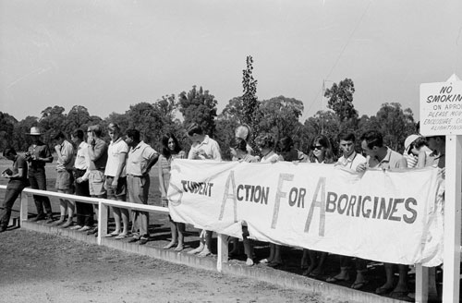
The Freedom Ride through western New South Wales towns in February 1965 drew attention to the racism in these towns. Photo: State Library of New South Wales and Courtesy Tribune / SEARCH Foundation - ON161/220/11. Reproduced with permission
After covering this information, ask students to complete the questions: ‘Who were the Freedom Riders?’ and ‘Why did the Freedom Riders decide to act?’ on the Freedom Riders Worksheet.
Resources:
Freedom Riders Worksheet.
The Annual Report of SAFA to the 8th Annual conference of Aboriginal Affairs, April 1965, prepared by Charles Perkins, from Collaborating for Indigenous Rights – National Museum of Australia

Case Study: Charles Perkins
A key person in instigating the 1965 Freedom Ride was Sydney University student and Arrente man Charles Perkins.
In 1965, Charles Perkins was one of only two Aboriginal students at the University of Sydney. He played a key role establishing the ‘Student Action for Aborigines’ protest group and organising the Freedom Ride.
His leadership and involvement in the Freedom Ride gained him national notoriety and he became well recognised as a leader and spokesperson for the rights of Aboriginal and Torres Strait Islander peoples.
After the Freedom Ride, Perkins went on to accomplish many other significant achievements. In 1966, he became the first Aboriginal man to graduate from a university in Australia.
After university Perkins worked as a public servant for the federal government. By 1984, Perkins had been appointed to the role of Secretary of the Department of Aboriginal Affairs, the first Aboriginal Australian to attain such a senior position in the government bureaucracy. In his time as a public servant, Perkins continued to advocate and work towards improving the lives of Aboriginal and Torres Strait Islander peoples.

Viewing Activity
Begin this activity by asking students to read a profile of Charles Perkins on the website Collaborating for Indigenous Rights, from the National Museum of Australia. Have students note his background and possible motives for planning the Freedom Ride protest.
Next ask students to view the video Charles Perkins – Freedom Ride from the National Film and Sound Archives, which contains an interview with Perkins discussing the Freedom Ride.
Teacher’s note: this video contains one instance of mild course language.
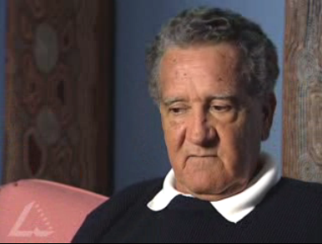
Screenshot from Charles Perkins – Freedom Ride, the National Film and Sound Archives
After viewing the video, pose the following questions to the class:
- According to Charles Perkins, what was the purpose of the Freedom Ride through rural New South Wales?
- What does Perkins mean by Aboriginal people being ‘second class’?
- What do you think the living conditions were like in Aboriginal fringe settlements described by Charles Perkins and shown briefly in the historical footage?
- Charles Perkins says of the Freedom Ride that the ‘timing was right’. What you think he means by this?
Teacher’s note: These viewing questions have been adapted from the classroom activities provided on the National Film and Sound Archives website.
Resources:
Charles Perkins, Collaborating for Indigenous Rights, National Museum of Australia
Charles Perkins – Freedom Ride, the National Film and Sound Archives

What did the Freedom Riders decide to do?
The group Student Action for Aborigines had three main aims. These were:
- ‘To arouse to public attention the fundamental Aboriginal problems in health, education, housing, etc
- To break down social discrimination barriers to the extent possible by student action
- To stimulate the interest of the Aborigines themselves in resisting discrimination.’
Source: The Annual Report of SAFA to the 8th Annual conference of Aboriginal Affairs, April 1965, prepared by Charles Perkins.
They planned to do this by conducting a bus tour of western and coastal New South Wales towns to find out more about the extent of discrimination against Aboriginal people. They also wanted to encourage Aboriginal people and members of the general public to take action against discrimination. They planned to do this by interviewing both Aboriginal and non-Aboriginal residents of the towns they visited and conducting public events and debates.
Throughout this section ask students to complete to remaining questions on the Freedom Riders Worksheet.
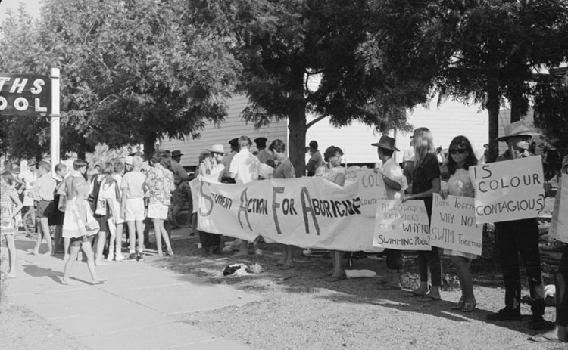The Freedom Ride, 1965. Photo: State Library of New South Wales and Courtesy Tribune / SEARCH Foundation - ON161/220/11. Reproduced with permission
Teacher’s note: S.A.F.A did not originally consider its fact-finding and protest trip a ‘Freedom Ride’ in the American sense of the words. The Australian ‘ride’ was one bus trip over about two weeks whereas the American ‘rides’ used buses for different purposes, highlighting segregation on transport and at terminal cafes, and went for over a year in southern America. However, the common purpose of identifying racial discrimination and passively protesting against it where it was actually happening meant that the ride in Australia became identified as a ‘Freedom Ride’ by the media, the public and later the participants themselves.
Resources:
The Annual Report of SAFA to the 8th Annual conference of Aboriginal Affairs, April 1965, prepared by Charles Perkins, from Indigenous Rights – National Museum of Australia

What happened on the Freedom Ride?
Have students get an overview of the journey taken by the Freedom Riders by looking at this map of the Freedom Ride bus route, provided by the Aboriginal Institute of Aboriginal and Torres Strait Islander Studies (AIATSIS).
In the process of surveying both Aboriginal and non-Aboriginal people in the towns they visited, the Freedom Riders unearthed many examples of racial discrimination against Aboriginal people.
The Freedom Riders’ method of interviewing members of town communities about Aboriginal rights and freedoms and then protesting about the key issues they identified, caused uproar in every town they visited.
Resources:
Freedom Ride bus route, AIATSIS

Viewing Activity
The Freedom Riders, alongside local supporters, protested at public places which excluded local Aboriginal people from entering. One example of this involved taking young Aboriginal children from Moree to the local swimming pool.
As a class view the video ‘Children join the bus’, from the National Archives of Film and Sound, which shows footage of the Moree children on their way to the pool. The video contains a voice over from Lyle Munro, who was one of the children on the bus.
After viewing the video, pose the following questions:
- What was the general attitude of the children on the bus? What do you think these young people were feeling?
- How would you feel if you were excluded from or segregated at a swimming pool because of you race?
Teacher’s note: You may wish to continue the exploration of the events at the Moree swimming pool by listening to the audio recording 'Freedom Ride' bus tour through rural NSW, provided on the ABC website - 80 Days that changed our lives.
Resources:
‘Children join the bus’, National Archives of Film and Sound
'Freedom Ride' bus tour through rural NSW, 80 Days that changed our lives, ABC

Research Activity
Ask students to conduct research into the events that occurred during the Freedom Ride. Students should use the following inquiry questions to guide their research
Inquiry questions:
- What types of racial discrimination were identified by the Freedom Riders?
- What did the Freedom Riders and their supporters do as a protest against racial discrimination?
- How did the local people react to the Freedom Riders?
You may wish to guide student investigation by allocating to individuals or groups the following sources to investigate:
- A short video of original footage by Freedom Rider, James Spigelman, from the National Museum of Australia’s exhibition From Little Things Big Things Grow, 1920 - 1970 (note, you will need Quicktime to view this video)
- The newspaper cartoon ‘Getting in the swim!’ by John Frith, published in the Melbourne Herald, 20 February 1965.
- The newspaper article Violence explodes in racist town: Moree battles students, in the Daily Mirror, Sydney, 2 February 1965
- A transcript from diary of Freedom Rider Ann Curthoys, provided by AIATSIS. The entries for Moree and Walgett are particularly useful as they document some of the significant events of the tour.
Resources:
Insider footage by James Spigelman, the National Museum of Australia
Getting in the swim!, Melbourne Herald, from the National Museum of Australia
Violence explodes in racist town: Moree battles students, the Daily Mirror, the National Museum of Australia
Transcript from the diary of Freedom Rider Ann Curthoys, AIATSIS

Significance and impact of the Freedom Ride
The Freedom Ride of 1965 was a significant historical event in the shared history of Aboriginal and Torres Strait Islander peoples and other Australians. The two week bus ride undertaken by some 30 university students and local supporters, and the widespread media attention it received, helped the Australian general public to recognise the existence of racial discrimination in Australian society.
This is a clear example of how human rights advocacy helped create an environment for social change.

Teacher’s note: For further teaching activities exploring the significance of the Freedom Ride, see How did the Freedom Riders escalate the campaign for justice for Aboriginal people? from Discovering Democracy, and How Did the Freedom Riders Confront Injustice Toward Aboriginal People in the 1960s? From Civics and Citizenship Education.
Resources:
How did the Freedom Riders escalate the campaign for justice for Aboriginal people?, Discovering Democracy
How Did the Freedom Riders Confront Injustice Toward Aboriginal People in the 1960s?, Civics and Citizenship Education.

Reflection Activity
As young historians, ask the class to review and comment on how they see the Freedom Riders and their aims and actions.

The 1967 Referendum
One of the significant flow-on consequences of the Freedom Ride was that it helped move public thinking towards a ‘Yes’ vote in the 1967 constitutional referendum.

What is a referendum?
Explain to students that a referendum is a single political question that is put to the voting population (which in Australia is everyone over the age of 18) to decide the outcome.
In Australia, in order to make any changes to the Australia Constitution – our nation’s founding document – there must be a constitutional referendum.
Teacher’s note: You may wish to explain to students that in Australia, it is particularly challenging to successfully achieve a constitutional referendum. Since Federation, only 8 out of 44 proposals to amend the Constitution have been successful. This is in part because our laws require a ‘double majority’ (where both the national majority and the majority of states are in favour of the referendum). For a teaching activity that highlights the process of a referendum view the Civics and Citizenship Education webpage on Referendums: Getting the numbers: How a double majority works.

What did the 1967 referendum do?
The 1967 referendum was of great significance to Australian society because it sought to eliminate some of the discriminatory elements against Aboriginal and Torres Strait Islander peoples from the Australian Constitution.
The referendum proposed to: remove the provisions in the Constitution which prevented the Federal Government from making laws for Aboriginal and Torres Strait Islander peoples; and remove the provisions which excluded Aborigines from being counted in the census.
This first point was significant because prior to the referendum only state and territory governments were able to make laws for Aboriginal and Torres Strait Islander peoples. This meant that the laws governing Aboriginal and Torres Strait Islander peoples were different everywhere and in some states they were highly discriminatory. For example, Queensland did not give Aboriginal and Torres Strait Islander peoples the right to vote until 1965.
The proposal to count Aboriginal and Torres Strait Islander peoples in the Australian Census was also significant because it meant acknowledging that Aboriginal and Torres Strait Islander peoples were Australian citizens.
Teacher’s note: The 1967 referendum did not give Aboriginal and Torres Strait Islander peoples the right to vote. Amendments to the Commonwealth Electoral Act in 1962 allowed Aboriginal and Torres Strait Islander people to vote in Commonwealth elections, however state governments could still exclude them from voting in state elections.
On May 27, 1967, an overwhelming majority of Australians voted in favour of changing the Australian Constitution. 90.77% of Australians voted ‘Yes’. This is by far the highest affirmative vote ever achieved in an Australian referendum.

What was the significance of the referendum?

The successful referendum was significant for a number of reasons.
Firstly, the majority “Yes” vote indicated that there was a clear public support for the Federal Government to take greater action to enhance the rights of Aboriginal and Torres Strait Islander peoples, and the change to the Constitution meant that the government now had the power to do so.

While this did not translate into an immediate radical shift in political attitudes towards Aboriginal and Torres Strait Islander peoples, there was a gradual but perceptible shift in government funding and initiatives towards supporting Aboriginal and Torres Strait Islander peoples. The legal traps created by different laws governing Aboriginal and Torres Strait Islander peoples in each state and territory were also eliminated by the changes to the Constitution.
The referendum victory also provided a morale boost to the broader movement championing equality and justice for Aboriginal and Torres Strait Islander peoples. Many of the Aboriginal and Torres Strait Islander people who were active advocates during the referendum campaign went on to become important leaders in the ongoing struggle for rights and justice for Aboriginal and Torres Strait Islander peoples.

Additionally, the referendum had and continues to have strong symbolic significance for Aboriginal and Torres Strait Islander peoples and the wider Australian population. The solidarity between Indigenous and non-Indigenous people that was created in the campaign for the 1967 referendum was an inspiration and model for the reconciliation movement of the 1990s.

For more detailed information on the 1967 referendum refer to this Teacher Resource, from the Victorian Curriculum and Assessment Authority.
Other useful information resources include:
- Referendum remedies the Constitutional treatment of Aboriginal people 80 Days that changed our lives, ABC
- History of the Indigenous vote, Australian Electoral Commission

Resources:
Referendums: Getting the numbers: How a double majority works, Civics and Citizenship Education
Teacher Resource, the Victorian Curriculum and Assessment Authority
Referendum remedies the Constitutional treatment of Aboriginal people 80 Days that changed our lives, ABC
History of the Indigenous vote, Australian Electoral Commission

Class discussion
In class, outline the 1967 Referendum and its result for Aboriginal and Torres Strait Islander peoples.
As a class, discuss what the consequences the referendum would have had for Aboriginal and Torres Strait Islander peoples and Australian society more broadly. Use the ‘Right wrongs, Write Yes for Aborigines’ poster below as a visual stimulus for discussion.
You may wish to draw on the following additional resources for further information about the referendum and its impacts:
- For a series of activities exploring the 1967 referendum, see the 1967 Referendum unit of work from the National Museum of Australia’s Collaborating for Indigenous Rights website.
- The Didj "u" Know – Stories: 1967 Referendum, from ABC Message Club, provides a useful timeline outlining the historical developments leading up to the 1967 referendum.
- ABC Splash has created an interactive student digibook called Righting wrongs in the 1967 referendum which uses primary sources to explore events leading up to and after the referendum.
- The 1967 Referendum, a unit of work created by Civics and Citizenship Education

Resources:
1967 Referendum unit of work, Collaborating for Indigenous Rights, the National Museum of Australia’s
Didj "u" Know – Stories: 1967 Referendum, ABC Message Club,
Righting wrongs in the 1967 referendum digibook, ABC Splash
The 1967 Referendum, Civics and Citizenship Education

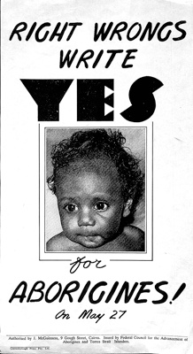
MS 8256 Series 11.2, courtesy Federal Council for the Advancement of Aborigines and Torres Strait Islanders (FCAATSI), National Library of Australia. Reproduced with permission

Extension Activity
As an additional activity, ask students to compare and contrast the 1967 referendum with the upcoming referendum to be held on the question of recognising Aboriginal and Torres Strait Islander peoples in the Australian Constitution.
Some student-friendly resources looking at this proposed referendum can be found on the Recognise This website.
Additionally, Oxfam Australia has created a useful infographic that depicts a timeline of significant events leading to the current constitutional recognition referendum campaign, including the 1967 referendum.

Resources:
Recognise This website
Constitutional Recognition infographic, Oxfam Australia

Improving Human Rights: the Racial Discrimination Act
Around 1970, the Australian Government position on the discriminatory White Australia policy was changing.
In 1966, the Holt Government began to liberalise Australia’s restrictive immigration policy and in 1972, the newly elected Whitlam Government began to formally dismantle the White Australia Policy.
In response to changing public attitudes and as part of a policy shift towards multiculturalism, the Australian Government formalised its commitment to the United Nations International Convention on the Elimination of All Forms of Racial Discrimination (CERD) in 1975 by introducing the Federal Racial Discrimination Act 1975.
Teacher’s note: In this part of the sequence, students will investigate the Racial Discrimination Act, and some of its key features, as a turning point in government action against racism.
Before beginning this section, you may wish to refer students back to the ideas explored in the class discussion on racism conducted in Sequence 1. Remind students that racism can take many forms, it can involve direct racism such as jokes or comments that cause offence or hurt, and it can also include systemic or institutional racism in policies, conditions or practices that disadvantage certain groups.
What does the Racial Discrimination Act do?
The Racial Discrimination Act aims to ensure that Australians of all backgrounds are treated equally and have the same opportunities.
This Act makes it against the law to treat someone unfairly, or to discriminate against them, on the grounds of race, colour, descent, national or ethnic origin, and immigration status. It also makes racial hatred against the law.
The Act protects you against discrimination in many areas of public life, including:
- employment – getting a job, terms and conditions of a job, training, promotion, being dismissed
- education – enrolling or studying in a course at a private or public school, college or university
- accommodation – renting or buying a house or unit
- getting or using services – such as banking and insurance services, services provided by government departments, transport or telecommunication services, professional services like those provided by lawyers, doctors or tradespeople, services provided by restaurants, shops or entertainment venues
- accessing public places – such as parks, government offices, restaurants, hotels or shopping centres.
Explain to students that the Racial Discrimination Act is civil law, which means that criminal penalties do not apply if the law is breached, (i.e. you cannot go to jail for racial discrimination). Complaints of discrimination under the Racial Discrimination Act are most commonly dealth with by the Australian Human Rights Commission through a process of conciliation.

Teacher’s note: For more information on the Racial Discrimination Act, view the guide Know your rights: Racial discrimination and vilification, by the Australian Human Rights Commission.
Resources:
Know your rights: Racial discrimination and vilification, Australian Human Rights Commission

Analysing the Act
Display and read out the following two sections from the Racial Discrimination Act to the class:
Section 2 (a)
Each State Party undertakes to engage in no act or practice of racial discrimination against persons, groups of persons or institutions and to ensure that all public authorities and public institutions, national and local, shall act in conformity with this obligation.
Section 11 (a)
It is unlawful for a person to refuse to allow another person access to or use of any place or vehicle that members of the public are, or a section of the public is, entitled or allowed to enter or use, or to refuse to allow another person access to or use of any such place or vehicle except on less favourable terms or conditions than those upon or subject to which he or she would otherwise allow access to or use of that place or vehicle; ... by reason of the race, colour or national or ethnic origin of that other person or of any relative or associate of that other person.

Ask students to write down in their own words what these two sections mean. Discuss student responses as a class and clarify any areas where students are unsure of word meanings.
Teacher’s note: Be prepared to explain key terms such as: ‘legislation’, ‘ethnic origin’, ‘jurisdiction’, ‘institution’, clarify ‘goods and services’ and ‘access to places and facilities’.
Next ask students to identify how these sections of the Racial Discrimination Act relate to the experiences of the Freedom Riders on their bus tour.
Pose the question to the class: what consequences might this new legislation have in the towns that the Freedom Riders visited?

Class discussion
Consolidate student knowledge by discussing, as a class, the following questions:
- According to the act, what are the grounds for unlawful discrimination? (The Act makes it against the law to discriminate against someone on the grounds of race, colour, descent, national or ethnic origin and migrant status)
- What areas of life are covered in the Act? (Areas of public life such as employment, education, accommodation, etc.)
- How important is it to make racism unlawful?
- What other options, aside from using the law, are available to take action against racism? (e.g. local community initiatives promoting respectful relationships, social events celebrating diversity)
- What can schools do to combat racism?

Assessment for Sequence 2
In the rich assessment task for this sequence ask students to draft and complete an informative text, on paper or with ICT, focusing on how and why the Freedom Riders helped to improve the human rights and freedoms of Aboriginal and Torres Strait Islander peoples.
Encourage students to create a multi-modal presentation, using a combination of text, images, video and audio. For example, students could create an audio podcast. Find support for using Audacity software or internet broadcast with Spreaker.

Achievement standards:
- describe the causes and effects of change on society
- explain the significance of an individual and group
- develop texts, particularly narratives and descriptions which use historical terms and concepts and incorporate relevant sources

Key historical concepts
Cause and effect; sources and evidence; continuity and change; significance

Resources:
Audacity teach guide
Spreaker website

Resources in Sequence 2
Click here for a summary of all the resources used in this sequence.

Sequence 3—Exploring migrant experiences

Introduction
Immigration has been a significant influence shaping Australian identity since its beginning as a nation. Since the end of World War II, changes in immigration programs and the end of the White Australia Policy have seen the arrival of migrants and refugees with a wide range of different cultures, traditions and ideas. While some have come because of crises in their home countries, and others for work and for more freedom, they have all arrived expecting a better way of life.
In this teaching and learning sequence students have the opportunity to focus on following topics:
- ‘Populate or perish’
- Push and pull factors
- Post-World War II arrivals
- Migrant experiences in Australia

Teacher’s note: For this sequence, you will need to provide students with a background on the White Australia Policy. For a short overview of White Australia Policy, view the Australian Department of Immigration and Border Protection’s fact sheet on the policy. Alternatively the Australian Human Rights Commission’s resource for Year 10 History, The Globalising World, provides an in depth exploration of the policy and its origins.
Resources:
Fact Sheet 8 – Abolition of the 'White Australia' Policy, Australian Department of Immigration and Border Protection
The Globalising World, Australian Human Rights Commission

‘Populate or perish’
World War II marked an important turning point in Australia’s immigration history. The conflict in the Pacific against Japan made the government re-think Australia’s position in the world and their policies towards immigration. In 1945 the Department of Immigration was established. The department began with just 24 officers — six in Canberra, six in Melbourne and 12 in London. Arthur Calwell was Australia’s first Minister for Immigration. It was Arthur Calwell who promoted the concept of ‘populate or perish’.

Source analysis
Read students the following excerpt from a speech made by Minister Calwell and ask students to think about the significance of the slogan ‘Populate or perish’.

‘If Australians have learned one lesson from the Pacific War ... it is surely that we cannot continue to hold our island continent for ourselves and our descendants unless we greatly increase our numbers. We are but 7 million people and we hold 3 million square miles of this earth’s surface. Our coastline extends for 12 thousand miles and our density of population is only 2.5 persons per square mile ... While the world yearns for peace and abhors war, no one can guarantee that there will be no more war ... Our first requirement is additional population. We need it for reasons of defence and for the fullest expansion of our economy.’
Source: Excerpt from a speech by Arthur Calwell to Parliament, August 2, 1945, Hansard.
Inquiry questions
- Why did Minister Calwell and the Federal government believe Australia had a defence problem in 1945?
- What solution is proposed for the problem?

Moving away from the White Australia Policy
In order to fulfil the catchcry of ‘populate or perish’, Arthur Calwell and the Australian Government set a target of 2 per cent population increase per year, with 1 per cent of that increase coming from migrants — called ‘New Australians’ at the time.
However, up until this point the White Australia Policy - through the Immigration Restriction Act (1901) - had limited migration to Australia, in particular the migration of people from non-Europeans countries. This made Calwell’s decision to expand immigration a significant shift away from the principles of the White Australia Policy.
Looking back, this was the change in thinking and policy which would unintentionally begin the end of the White Australia Policy.

Source analysis
Read students the following excerpt from Calwell’s ‘the days of our isolation are over’ speech. Point out to students that this speech is significant because it gives us insight into what the Australian Government was thinking at that time.

It is my hope that for every foreign migrant there will be ten people from the United Kingdom ... Aliens are and will continue to be admitted only in such numbers and of such classes that they can be readily assimilated. Every precaution is taken to ensure that they are desirable types, and they must satisfy consular or passport officers and security service officers that they are people of good character before their passports are visaed for travel to Australia … the days of our isolation are over.
Source for text above: Commonwealth Parliamentary Debates, House of Representatives, 22 November 1946, Vol. 189
Inquiry questions
- Identify which foreign migrants are preferred by the Australian government
- What other word is used in the speech for ‘migrant’? What do you think is meant by the term ‘desirable types’?
- From this speech, how do you think Calwell and the government at the time viewed migrants who weren’t from the United Kingdom? Was their perception positive?

Push and pull factors
Introduce and explain push and pull factors for migration. The ‘push–pull’ theory of migration suggests there are two main factors causing migration, negative push and positive pull. Push factors are things that are bad about the country that people live in and pull factors are those things that are good about another country that would attract people to that country. Choose an example like family ties or climate to elaborate on your explanation as these could be either push or pull factors.

Investigating Push and Pull factors
Begin this activity by allocating students to small groups and guiding them to identify examples which explain push factors.
Use the Timeline of migration from Global Words as a source for a few examples of push factor events to help start the group work. For example, you could introduce the concepts of ‘forced migration’ and ‘voluntary migration’ by looking at the post-war problems in Europe which ‘pushed’ migrants from Europe to Australia, Canada and the United States.
If appropriate to the class’s learning level, apply the tags ‘economic’, ‘social’ and ‘environmental’ to categorise the different push factors idenitifed by students.
Point out to students that many migrants who have arrived in Australia after World War II have experienced various forms of hardship and discrimination before coming to Australia.
Next, move the group discussions on to a consideration of pull factors. Ask students to discuss in their groups what pull factors Australia possessed which attracted migrants after World War II.
Explain to students that Australia attempted to attract migrants after World War II using recruitment advertisements and promotional schemes that highlighted Australia’s most appealing elements. Refer to tourism advertisements and campaigns as examples that highlight commonly used techniques for attracting visitors. You may wish to provide students with some background on Post-World War II migration schemes, such as the ‘10 Pound Pom’ passages explored later in this sequence.
Conclude this activity by asking students to individually create two mind maps, one for ‘push factors’ and the other for ‘pull factors’. Students should draw on information gathered from their own investigations as well as the teacher-guided discussion.
Students can create their mind maps in their workbooks or online, using a digital mind map tool such as a bubble.us.

Resources:
Timeline of migration, Global Words
bubble.us website

Post-World War II arrivals
In this section, students investigate the different types of migrants who arrived in Australia after World War II and explore how Australia’s immigration selection process determined who was let in and who was not.
The following case studies are examined in this section, to compare the experiences of different migrant groups:

- Children of the Blitz
- ‘10 Pound Poms’
- Displaced Persons

Children of the Blitz
One of the first groups to be offered a temporary home because of the war in Europe were British children from towns and cities like London and Birmingham, which had been bombed by Germany. The damage had left many thousands without homes and many children were left in vulnerable situations. A decision was made to move children out of the major cities and towns to the countryside or overseas.
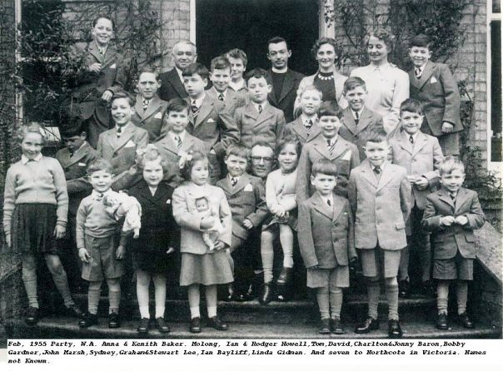
12th post-war party of Child Migrants [to Australia] at Fairbridge Knockholt Kent UK. Photo by Nigel Petrie Thomas Owen

Source Analysis
Have students explore how children around their own age were received as ‘temporary migrants’ to Australia. The following sources provide information and ideas for class discussion and student notes.
Source 1: Voyage of the Batory, Manly Library,
As a class, have students read this article about the children called ‘Winston’s Specials’ and summarise reasons for the migration and compare conditions and treatment on the voyage and on arrival as a starting point for further comparisons of migrant experiences after the war.
Pose the question: What evidence is mentioned about the dangers of such voyages during World War II?
Source 2: British children evacuate to Australia 1940
Have the class view the following short video showing historical footage and record their impressions.
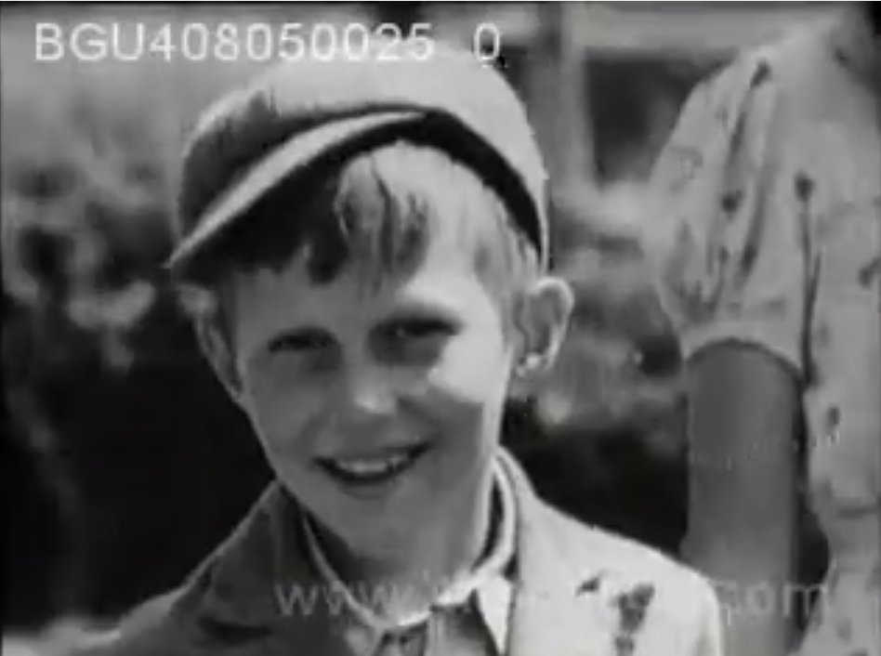
Screenshot from British children evacuate to Australia 1940
Source 3:— Youngsters say “me for Australia”
Young British boys and girls were regarded as ‘ideal’ migrants after World War II. In the following newsreel clip, the Immigration Minister Arthur Calwell is in Britain to farewell a few of the young migrants.
Ask students if they think these young migrants to Australia knew much about the country they were going to.
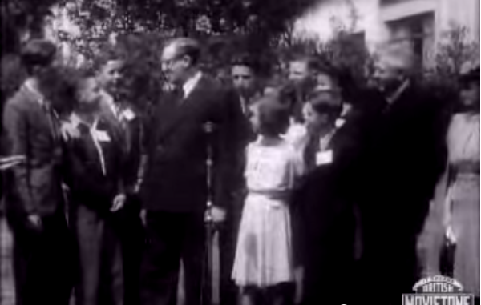
Screenshot from Youngsters say “me for Australia”
After considering these sources, ask the class to discuss the situation and treatment of the Children of the Blitz.
Pose the following questions:
- Why were Australia and Canada chosen as temporary homes for the Children of the Blitz, when these countries were so far away from the United Kingdom? (Remind students of the connections to the British Empire, its language and customs)
- Do you think the children sent to Australia from the UK were treated well? Do you expect that all refugees arriving after World War II would be treated much the same? (The answer to this question will be explored further in the following case studies)

Resources:
Voyage of the Batory, Manly Library,
British children evacuate to Australia 1940 YouTube video
Youngsters say “me for Australia” YouTube video

‘10 Pound Poms’
Although, the Post-World War II migration recruitment schemes opened up Australia to migration from a range of European countries, migration schemes targeted at British citizens such as the ‘Ten Pound Pom’ program (the colloquial name for the scheme which offered British citizens subsidised passage to Australia for only 10 pounds) show that the Australian Government was still primarily interested in attracting white, Anglo-Saxon migrants.

Poster Analysis
Briefly explain to students the purpose of the ‘10 Pound Pom’ scheme. (More detailed information about the program can be found on the Immigration Museum’s Ten Pound Poms webpage).
Poster 1: 'Australia: build your children's future!' migrant recruitment poster
In small groups, have students examine the Migrant recruitment poster from the Powerhouse Museum’s collection, and write down a few points about the poster’s purpose, main message and style. This could include the following details: Poster title, Year/s produced, wording, images used.
To the whole class, follow up with questions exploring the influence of the underlying White Australia Policy. Pose the following questions:
- What is being promised?
- What are the incentives for this particular group of migrants to come to Australia?
- Why were British migrants targeted in this scheme?
Poster 2: ‘Australia, Land of Tomorrow’ migrant recruitment poster
Have the class analyse the second migrant recruitment poster ‘Australia, Land of Tomorrow’, using similar inquiry questions and list the responses on the board.
Pose one or more of these questions:
- What people are shown in the poster images?
- What messages is this poster trying to convey?
- Do you think this poster is an accurate reflection of what life was like in Australia at the time?
- What problems would you expect new migrants/New Australians to face for the first few years?
- Why might they face problems?

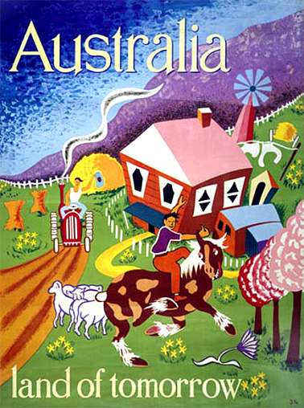
Image by Joe Greenberg, from 1940s–60s: A Journey for Many, Museum Victoria, reproduced with permission.
Resources:
Ten Pound Poms, Immigration Museum
Migrant recruitment poster, Powerhouse Museum
‘Australia, Land of Tomorrow’ poster, 1940s–60s: A Journey for Many, Museum Victoria,
Race and recruitment: the family who missed out
British migrants were the Australian government’s first preference to help increase Australia’s population and wealth, however not all British migrants were accepted. Some who missed out were excluded because of health reasons, however for some there were less obvious reasons.
Provide students with the Race and Recruitment Worksheet and ask them to read the story of a family from Nottingham who seemed to meet the criteria for selection — but didn’t. After students have read the story, ask them to complete the accompanying inquiry questions.

Explain to students that the British Commonwealth at the time still had colonies all around the world, meaning that it had many citizens of diverse ethnic and racial origins.

Ask students to identify some of the discriminatory elements of Australian immigration policy at this time and explain how these elements are evidence of racist attitudes in Australia at the time.

Resources:
Race and Recruitment Worksheet

Displaced Persons
While migrants from the United Kingdom were preferred, the Australian Government could not hope to reach the desired number of new migrants relying on British migrants alone.
In Europe, thousands of people who had lost their homes and families during the war and become ‘displaced persons’ (another term for a refugee) were looking for a new home.
In 1947, the Australian federal parliament passed the Displaced Persons Act to allow migrants from war-torn Europe to come to Australian to live and work. Approximately 170,000 Displaced Persons came to Australia from Europe between 1947 and 1952. This was the first non-British mass migrant intake into Australia, and the first time that Australia saw the arrival of large numbers from Eastern European countries such as Latvia, Estonia, Lithuania and Poland.
Australia welcomed this wave of Displaced Persons arriving from Europe as a vital workforce to assist in boosting the Australia’s economy, particularly through major projects like the Snowy Mountains Scheme.

Case Study: The Kalnins family
In 1949, the Immigration Department organised a special welcome for the arrival of Australia’s 50,000th migrant, seven year old Maira Kalnins.
Have students investigate the story of the Kalnins family’s arrival on the National Archives of Australia’s webpage Cost of a kiss: the Displaced Persons Program.
Ask students the following questions:
- Why did the Australian Government go to such great lengths to welcome the 50,000th migrant?
- Why do you think Maira Kalnins and her family were chosen?
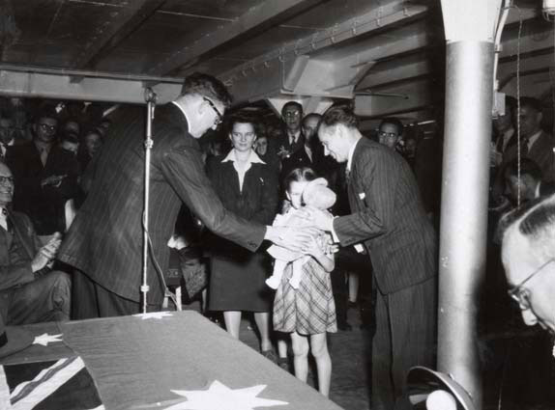
Mr Arthur Calwell with the Kalnins family, National Archives of Australia.

Resources:
Cost of a kiss: the Displaced Persons Program, National Archives of Australia’s webpage

‘New Homes’ interactive investigation
The activity allows students to explore in greater depth the personal experiences of migrants who came to Australia after World War II.
Direct students to the website New Homes, an interactive resource from the National Museum of Australia. Next, provide students with the New Homes worksheet, which contains the instructions for this activity.
Using the New Homes resource, students cam explore the stories of two women from Europe, Petronella Wensing and Lilija Brakmanis, who were displaced persons resettled in Australia.

Their stories illustrate the hardships most displaced persons faced before arriving in Australia, and how their status as migrants often meant they experienced significant difficulties in their new home as well.

Teaching instructions
Step 1: Read the introductory text on the first page of the website aloud to the class and ask if any aspect needs further explanation. Guide students to click on ‘play’ or ‘enter’ to show the map of Europe and the red Australian Immigration Department car. Students will need to use the arrow keys on their keyboard to direct the car across Europe and uncover the number of Displaced Persons in each country.
Step 2: Allow time for the Displaced Persons numbers to be tabulated on the worksheet. You could mention that the immigration recruitment officers in teams of 2–4 came face to face with the personal tragedies and the poor conditions in the refugee camps. No disabled or disfigured refugees were considered. The clue for the third question about ‘why some of these countries had so many Displaced Persons’ is the actions of Russia after the war — Russia's continued occupation of eastern European countries like Latvia caused many to leave.
Step 3: Instruct students to press ‘enter’ again to view the interactive map overview. After this has played students have the option to select the story of either Petronella Wensing or Lilija Brakmanis. Have students explore the interactive timeline of their chosen person and create a personal profile of them in their workbooks. In creating their profiles ask students to identify the push and pull factors that led Petronella Wensing and Lilija Brakmanis to migrate to Australia.
Step 4: Ask students to create an online exhibition on either Petronella Wensing or Lilija Brakmanis using the ‘Create Exhibition’ tool in the New Homes resource. Their exhibition should include an exploration of any disadvantages or discrimination experienced by the new migrants in Australia (for example, not having previous education qualifications recognised) and why this was the case.
To conclude this activity, ask students to complete an individual reflection on what they learnt about being a Displaced Person.

Teacher’s note: An alternative online resource which features interactive elements and personal accounts for students to explore is the Sydney Morning Herald resource, The First Wave: Beyond White Australia, which looks at the journey of the SS Misr in 1947. The resource contains passenger stories, an interactive timeline and a map of the journey.

Resources:
New Homes, National Museum of Australia
The First Wave: Beyond White Australia. Sydney Morning Herald

Extension Activity
Ask students to list 10 things that they would take with them if they had to flee their homes and travel to another country at short notice, as was the case for many Displaced Persons. Inform students that they must be able to fit their items into a backpack and carry them.
As a class, ask students to share what items they selected to take with them. Next, ask students to identify which belongings they would not be able to take with them (for example, their house, a family pet).
Finally, ask students to think about what non-physical things they could take with them to another country (for example, their language, their cultural traditions, their skills and abilities).
For an extended version of this activity which explores a detailed scenario about become a refugee, view the Time to Flee activity by Amnesty International Australia.
Resources:
Time to Flee activity, Amnesty International Australia.

Summative activity
Consolidate student learning for the first part of this sequence by asking students to write a half page summary on why Australia decided to welcome Displaced Persons as migrants to Australia after World War II.
In their summary, ask students to identify why this represented a shift away from previous immigration policy under the White Australia Policy.

Migrant experiences in Australia
This section explores the treatment and experiences of migrants who arrived in Australia after the war, with a particular focus on the Snowy Mountains Hydro-Electric Scheme.
Introduce this section by explaining to students that the conditions that new migrants experienced on arrival would not have been acceptable to most Australians.
The glowing promises on the immigration recruitment posters did not show that most migrants would be spending the first few months in Australia living in migrant hostels (also known as migrant reception or training centres or migrant camps), such as the Bonegilla Reception and Training centre in Victoria shown below.
Explain to students that the migrant hostels were established to accommodate the large numbers of migrant arrivals in Australia. They were often set up in former military buildings or camps and often featured very basic facilities. Some migrant hostels were very overcrowded and migrants had to endure poor living conditions.
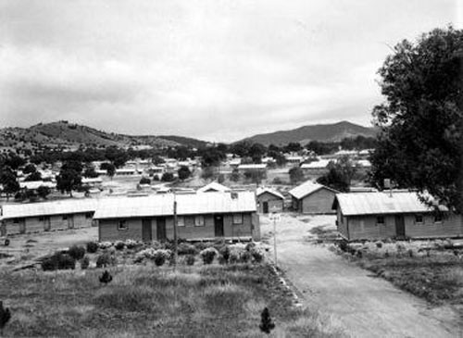
Above: Bonegilla migrant camp, Victoria. Source: Nationaal Archief/Spaarnestad Photo via Nationaal Archive. Public domain image via Wikimedia Commons

Source analysis
Show students the image of the Bonegilla migrant camp and a selection of other photographs depicting life in Australia’s migrant hostels. You can find a wide range of images in the National Archives of Australia’s Hostels and migrant centres collection. The South Australian Migration Museum also features detailed descriptions of South Australia’s migrant hostels and personal accounts from families who lived in them.
Ask students to describe what they think it might have been like to live in one of the post war migrant hostels in Australia. Do they think this experience matched what new migrants were expecting when they arrived in Australia?
Resources:
Hostels and migrant centres, National Archives of Australia
Hostels, South Australia Migration Museum

The Snowy Mountains scheme
The Snowy Mountains scheme took 25 years to complete. Almost two thirds of the 100,000 construction workers were new migrants. Living and working in such a mix of cultures, in harsh and dangerous surroundings, was a challenge. However, the workers and townships faced these difficulties, including overcoming conflicts and prejudice, to build a world-class hydro-electric scheme.

Overview activity
As a class, watch ‘The Snowy’ Part 1 – the Vision, an excerpt from the first of a two part SBS documentary from 1999 on the Snowy Mountain Hydroelectric Scheme in Australia. Ask students to take notes on the key features of the project, its origins and its purpose.
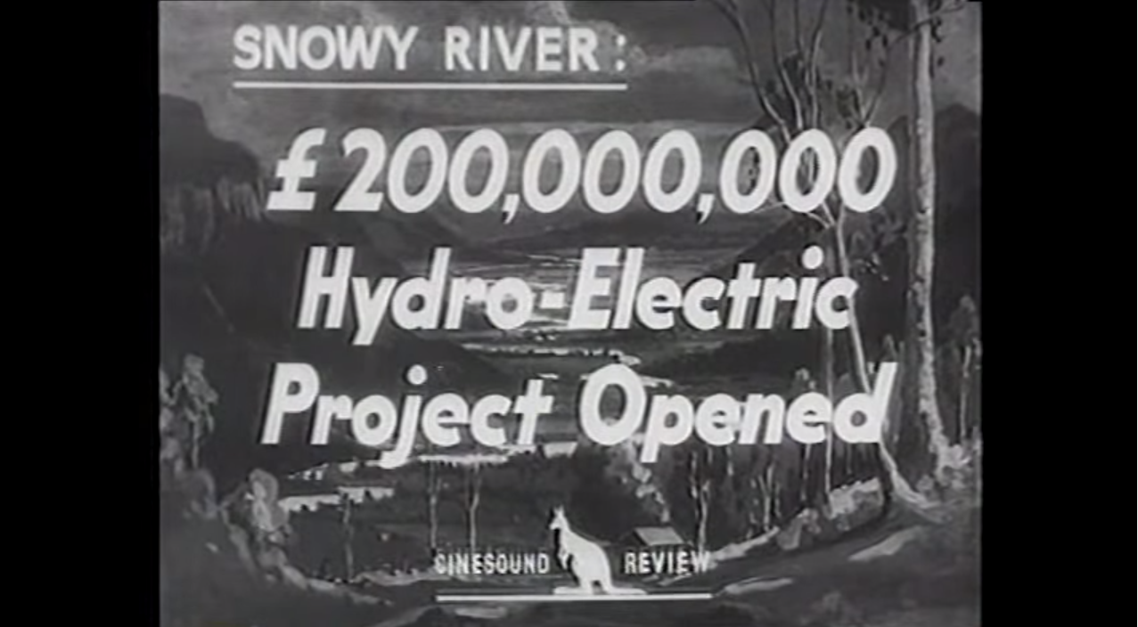
Screenshot from ‘The Snowy’ Part 1 – the Vision, SBS
Next, read the class the following passage and ask students to answer the inquiry questions below:
Early tensions surfaced between Australians and the ‘New Australians’ — less polite terms for the immigrants included wogs, dagos, garlic-munchers and reffos (refugees). The locals were mystified by their food, their manners and their origins. Some, like the Germans and Italians, had been fighting Australia in the Second World War only a few years before. Among the immigrants, there were other scores to settle. Poles and Czechs had suffered terribly at German hands, while Serbs and Croats maintained ancient hostilities in their new land. Somehow racial differences were put aside, as the challenges of the construction welded the disparate workforce into a united team that set world records in tunnelling and earthmoving.
Source for text above: Siobhán McHugh research findings for The Snowy: The People Behind The Power
Inquiry questions
- What were some differences between the migrant workers and the Snowy mountains locals?
- Why did the Snowy migrants have reasons to disagree or even fight?
- What helped to bring ‘harmony’ to the Snowy Mountains Scheme?

Ask students to conduct their own investigation into the Snowy Mountains scheme online and write a summary of the information gathered from their own research and the viewing activity in their notebooks. This summary should include the following details:
- the key features of the project
- an explanation of the mix of cultures on the Snowy Scheme project (i.e. which cultures were represented and why)
- three or four reasons why there could have been racial and ethnic conflict on the Snowy Scheme
- why the Snowy Scheme migrant workers and the community were able to work together so successfully (overcoming conflict and racism)

You may wish to refer students to the following sources as a starting point for their investigation:
- The Snowy Mountains Scheme fact sheet, Racism. No Way
- Snowy Scheme 50 years (1999 anniversary) video, A Current Affair

Resources:

‘The Snowy’ Part 1 – the Vision, SBS
The Snowy: The People Behind The Power, Siobhán McHugh
The Snowy Mountains Scheme fact sheet, Racism. No Way
Snowy Scheme 50 years (1999 anniversary) video, A Current Affair

Assessment for Sequence 3
Using the sources on the Museum Victoria webpage 1950s — a million post-war immigrants, ask students to locate an image or item that would be useful to an historian studying post World War II migration to Australia.
Using their own research, students locate two other primary sources which provide evidence on the topic of immigration and migrant experiences.
Once students have found their three sources, instruct students to write a report explaining why each of their chosen items would be useful to an historian and outlining what evidence the sources provide about migration to Australia.

Achievement standards:
- explain the significance of an individual and group
- examine sources to identify and describe points of view
- develop texts, particularly narratives and descriptions which use historical terms and concepts and incorporate relevant sources

Historical concepts:
Source and evidence; perspectives; empathy

Resources:
1950s — a million post-war immigrants, Museum Victoria

Resources in Sequence 3
Click here for a summary of all the resources used in this sequence.

Sequence 4— Refugees and asylum seekers

Introduction
The stories of migrant experiences in Australia since World War II reflect the evolution towards a less discriminatory immigration policy. However, immigration has remained a contentious area within Australian politics and public perceptions.
The issue of refugees and asylum seekers has historically been a particularly hot topic and the arrival of refugees and asylum seekers in the 1970s from Vietnam and Cambodia, and more recently from Iran, Iraq, Afghanistan and Sri Lanka, has had a considerable impact on immigration to Australia.
In this teaching and learning sequence students have the opportunity to focus on the arrival of different waves of refugees in recent decades, with particular focus on refugees arriving after the Vietnam War.
By exploring the personal stories of refugees and Australia’s international human rights obligations, students will gain greater knowledge of the history surrounding this challenging aspect of Australia's changing identity.
Students will look at:
- Vietnam War refugees
- Refugees and asylum seekers today

Vietnam War refugees
After the end of the Vietnam War in 1975, thousands of Vietnamese, Cambodian and Laotian people fled the new communist governments in their home countries in search of refuge and a new life.
Between 1976 and 1986, some 100,000 refugees arrived in Australia from Vietnam, Cambodia and Laos.
The arrival of large numbers of Indo-Chinese refugees had a major impact on Australia’s immigration policy. The then Prime Minister Malcolm Fraser made a radical departure from previous Eurocentric attitudes to immigration by allowing large numbers of Indo-Chinese refugees to settle in Australia.

Overview Activity
The following sources and investigation questions provide an overview and some detail about the key features of this topic.
Begin by asking students to explore the Timeline: Vietnamese immigration to Australia from ABC News and answer the following questions.
- How many Vietnamese people were there in Australia before 1975?
- Why did the ‘wave’ of Vietnamese refugees begin in 1975?
- By 1981 what percentage of Vietnamese arrivals had come by boat?

Next show students some images from the collection of photographs from the National Library of Australia, which documents the arrival of Vietnamese ‘boat people’ in Darwin in 1977. Ask students to describe what information can be gathered from these photos. Consider pointing out features of the photographs such as the cramped conditions on the small boats, the lack of amenities and the presence of young children on the boats.
You may also wish to show students the interactive timeline created by SBS to accompany their series Once Upon a Time in Cabramatta, which shows some key events in the history of the Vietnamese community in Australia from the Vietnam War to 2012.
As a class discuss, discuss why large numbers of people became refugees after the Vietnam War. Ask students to explain why some Vietnamese refugees chose to travel to Australia by boat.

Resources:
Vietnamese boat people, Darwin, November 1977, National Library of Australia
Once Upon a Time in Cabramatta interactive timeline, SBS
Timeline: Vietnamese immigration to Australia, ABC News

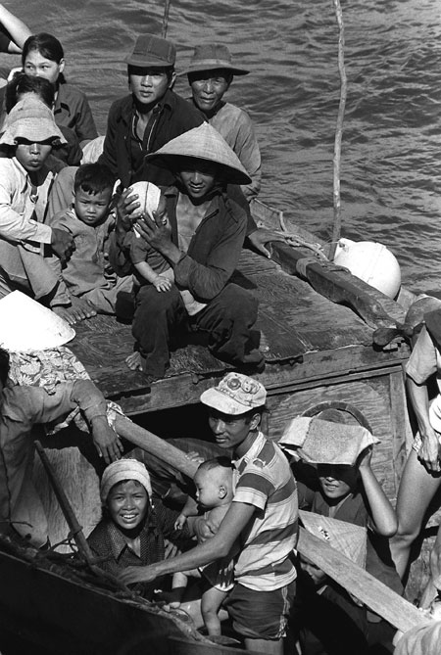
Thirty-five Vietnamese refugees await rescue after spending eight days at sea. Photo by Lieutenant Carl R Begy. Public domain image via Wikimedia Commons

Exploring personal accounts
Guide students in exploring the personal story of a Vietnamese refugee from one of the following sources or a source of your own selection. Ask students to reflect on the challenges faced in getting to Australia and any challenges experienced on arrival.
- A remarkable journey, a profile of Hieu Van Le, a Vietnamese refugee and successful political figure in Australia, by the University of Adelaide
- The Little Refugee a picture book telling the story of comedian Anh Do. You may also wish to show students this ABC news interview with Anh Do where he discusses his experiences as a refugee.

Resources:
A remarkable journey, University of Adelaide
The Little Refugee YouTube video
Anh Do wins book of the year, ABC news interview

Refugees and asylum seekers today
In this section, students gain a better understanding of some of the key concepts and international agreements relating to refugees and asylum seekers.
Explain to the class that Australia has international obligations to protect the human rights of all asylum seekers and refugees who arrive in Australia, regardless of how or where they arrive and whether they arrive with or without a visa. This is because Australia has committed to the United Nations Refugee Convention.
The Refugee Convention was drafted in the aftermath of World War II to deal with the huge numbers of Displaced Persons that had been left homeless after the war. The fundamental principles of the Refugee Convention are as important today as they were when drafted in 1951.
For more detailed information about asylum seekers and refugees and our international human rights obligations to them, view the Australian Human Rights Commission’s Asylum seekers and refugees guide.

Resources:
Asylum seekers and refugees guide, Australian Human Rights Commission

Coming to terms with ‘terms’
This activity helps students gain a clear understanding of the terms ‘migrant’, ‘refugee’ and ‘asylum seeker’.
Use the Asylum seekers, refugees and migrants fact sheet provided by Racism. No Way as a guide for class work.
Divide the class into three groups and assign one term to each group. Ask each group to read and talk about the term provided and then compose a one-sentence definition with the key features included. Have each group assign one person to write the definition on the board and allow comments to be made to the class by the group.
Conduct a class discussion around one or more of the following questions.
- What is the main difference between these groups?
- Does Australia have an obligation to help each of these groups?
- Who are ‘illegal immigrants’?

Ask students to identify which of the following groups studied in this unit were refugees and which were migrants: Children of the Blitz, ‘10 Pound Poms’, Displaced Persons and arrival from Vietnam.

Point out to students that the difference between the three categories (migrants, refugees and asylum seekers) can be unclear. For example, you could highlight how after World War II it was difficult to distinguish between migrants and refugees. Additionally, the distinction between refugees and asylum seekers is often blurred because, although not all asylum seekers are recognised to be refugees, all refugees are initially asylum seekers.

Resources:
Asylum seekers, refugees and migrants fact sheet, Racism. No Way

Viewing Activity: young refugees in Australia
To develop a better insight into the perspective of young refugees living in Australia and the importance of Australia’s humanitarian program, have students watch and discuss the video Refugee kids from ABC’s Behind the News.
The video provides background information about why refugees come to Australia and the adjustments some young refugees have to make after arriving in Australia.
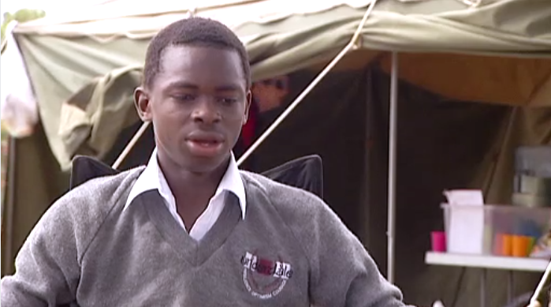
Screenshot from Refugee kids, Behind the News, ABC
Ask students to think about their everyday life and identify what special knowledge they need to do everyday tasks efficiently, for example, catching the bus to school. As a class, list examples of these things that a newly-arrived refugee would have to learn.
Teacher’s note: As this topic raises sensitive issues, please be mindful to select an approach and level of information that is appropriate for your class.
The following sources offer additional information about the experiences of refugees and asylum seekers in Australia:
- Welcoming a refugee family to Australia, ABC Splash
- Students resources, Asylum Seeker Resource Centre:
- Asylum seeker stories, Asylum Seeker Resource Centre
- Frequently Asked Questions guide, Refugee Council Australia
- The national inquiry into children in detention 2014 Discussion Paper, Australian Human Rights Commission

Resources:
Refugee kids, Behind the News, ABC
Welcoming a refugee family to Australia, ABC Splash
Students resources, Asylum Seeker Resource Centre:
Asylum seeker stories, Asylum Seeker Resource Centre
Frequently Asked Questions guide, Refugee Council Australia
The national inquiry into children in detention 2014 Discussion Paper, Australian Human Rights Commission

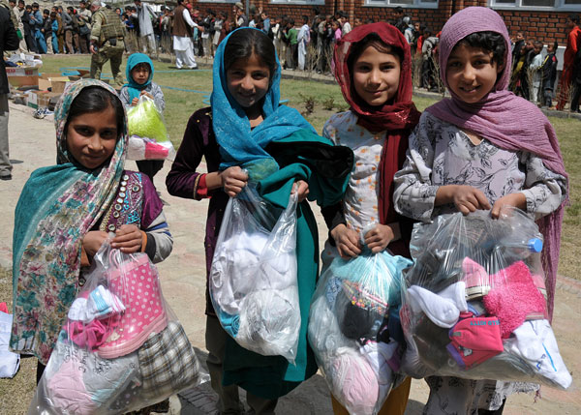
Above: Afghan refugee children. Photo by NATO, public domain image via Wikimedia Commons

Extension activity: literacy and English integration
As an extension activity for Sequence 4, consider integrating texts or extracts from contemporary fiction and true stories about refugees and asylum seekers to help students develop historical empathy and understanding.
Imaginary narratives can convey a sense of history, explore key issues and assist students to better understand the human side of history. Young people can connect with true stories, like Anh Do's ‘The Little Refugee’, which can give them eye-witness evidence and a perspective beyond a history textbook.
Some relevant works that explore migrant stories include:
- Morris Glietzman (2004) Girl Underground, Penguin Books
- Morris Gleitzman (2002) Boy Overboard, Penguin Books
- David Miller (2004) Refugees Curriculum Press
- Liz Lofthouse (2007) Ziba Came on a Boat, Kane/Miller Book Publishers
- John Marsden (2008) Home and Away, Lothian Books, Hachette Australia
- Shaun Tan (2006) The Arrival, Hodder Children’s Books
- Anh Do and Suzanne Do (2011) The Little Refugee, Allen & Unwin
- Ben Morely (2009) The Silence Seeker, Random House

Assessment for Sequence 4
In the assessment task for this sequence students plan, draft and present an informative text.
Using information gathered from class work and independent student investigations, ask students to describe and compare the experiences of at least two migrants/refugees.
Instruct students to include an explanation of how the issue of discrimination affected their lives before and after their migration to Australia.
This task could be based on the earlier student investigation into the migration experiences of Petronella Wensing and Lilija Brakmanis, explored in Sequence 3.
Student could create their informative text online through tools such as Wikispaces— a social writing platform for education, for teachers and students.

Achievement standards:
- compare the different experiences of people in the past.
- explain the significance of an individual and group

Key historical concepts:
Source and evidence; cause and effect; perspectives; empathy

Resources:
Wikispaces website

Resources in Sequence 4
Click here for a summary of all the resources used in this sequence.

Unit review
At the end of the unit ask students to consider one or more of the unit inquiry questions:
- How did Australian society change throughout the twentieth century?
- What contribution have significant individuals and groups made to the development of Australian society?
- What did the Freedom Riders do to address systemic racism and improve the lives of Aboriginal and Torres Strait Islander peoples?
- What groups of people came to Australia after World War II? Why did they come? What difficulties did they face in their journey to Australia and upon arrival?

Resources for Australia as a nation — race, rights and immigration
The following resources have been used in the development of this unit for History Year 6.

Introduction
- Program Planner
- Key concepts, History Teachers’ Association of Australia
- Dos and don’ts when teaching about cultural differences, Civics and Citizenship Education.
- The Impact of Racism upon the Health and Wellbeing of Young Australians, the Foundation for Young Australians

Sequence 1—Exploring human rights and freedoms
- What are Human Rights and Freedoms? Resource Sheet
- What are Human Rights and Freedoms? Activity Sheet
- The Universal Declaration of Human Rights and other human rights instruments Resource Sheet
- Student-friendly version of the UDHR, Compasito manual, Council of Europe
- The Universal Declaration of Human Rights, Gavin Aung Than, Zen Pencils
- What are human rights?, Discovering Democracy
- Exploring human rights, Civics and Citizenship Education.
- Bubbl.us website
- Wordle website
- International Convention on the Elimination of All Forms of Racial Discrimination (CERD), the United Nations Office of the High Commissioner for Human Rights
- Dos and don’ts when teaching about cultural differences, Civics and Citizenship Education
- What You Say Matters website
- Prezi website

Sequence 2— Ending Racial Discrimination
- What is Australia's record on Indigenous people's rights?, Discovering Democracy.
- White Australia, Difference Differently
- Aboriginal and Torres Strait Islander History, 1945–1975 Timeline
- Aboriginal and Torres Strait Islander History, 1945–1975 Activity Sheet
- Year 6 History Work Sample Portfolio, ACARA
- From Little Things Big Things Grow, 1920 - 1970 exhibition, National Museum of Australia
- Freedom Riders Worksheet
- Didj "u" Know – Stories: Freedom Rides, ABC Message Club
- 'Have you ever met an Aborigine?', the National Film and Sound Archive.
- The Annual Report of SAFA to the 8th Annual conference of Aboriginal Affairs, April 1965, prepared by Charles Perkins, from Collaborating for Indigenous Rights – National Museum of Australia
- Charles Perkins, Collaborating for Indigenous Rights, National Museum of Australia
- Charles Perkins – Freedom Ride, the National Film and Sound Archives
- The Annual Report of SAFA to the 8th Annual conference of Aboriginal Affairs, April 1965, prepared by Charles Perkins, from Indigenous Rights – National Museum of Australia
- Freedom Ride bus route, AIATSIS
- ‘Children join the bus’, National Archives of Film and Sound
- 'Freedom Ride' bus tour through rural NSW, 80 Days that changed our lives, ABC
- Insider footage by James Spigelman, the National Museum of Australia
- Getting in the swim!, Melbourne Herald, from the National Museum of Australia
- Violence explodes in racist town: Moree battles students, the Daily Mirror, the National Museum of Australia
- Transcript from the diary of Freedom Rider Ann Curthoys, AIATSIS
- How did the Freedom Riders escalate the campaign for justice for Aboriginal people?, Discovering Democracy
- How Did the Freedom Riders Confront Injustice Toward Aboriginal People in the 1960s?, Civics and Citizenship Education.
- Referendums: Getting the numbers: How a double majority works, Civics and Citizenship Education
- Teacher Resource, the Victorian Curriculum and Assessment Authority
- Referendum remedies the Constitutional treatment of Aboriginal people 80 Days that changed our lives, ABC
- History of the Indigenous vote, Australian Electoral Commission
- 1967 Referendum unit of work, Collaborating for Indigenous Rights, the National Museum of Australia’s
- Didj "u" Know – Stories: 1967 Referendum, ABC Message Club,
- Righting wrongs in the 1967 referendum digibook, ABC Splash
- The 1967 Referendum, Civics and Citizenship Education
- Recognise This website
- Constitutional Recognition infographic, Oxfam Australia
- Know your rights: Racial discrimination and vilification, Australian Human Rights Commission
- Audacity teach guide
- Spreaker website

Sequence 3—Exploring migrants’ experiences
- Fact Sheet 8 – Abolition of the 'White Australia' Policy, Australian Department of Immigration and Border Protection
- The Globalising World, Australian Human Rights Commission
- Timeline of migration, Global Words
- bubble.us website
- Voyage of the Batory, Manly Library,
- British children evacuate to Australia 1940 YouTube video
- Youngsters say “me for Australia” YouTube video
- Ten Pound Poms, Immigration Museum
- Migrant recruitment poster, Powerhouse Museum
- ‘Australia, Land of Tomorrow’ poster, 1940s–60s: A Journey for Many, Museum Victoria,
- Race and Recruitment Worksheet
- Cost of a kiss: the Displaced Persons Program, National Archives of Australia’s webpage
- New Homes, National Museum of Australia
- The First wave: Beyond White Australia. Sydney Morning Herald
- Time to Flee activity, Amnesty International Australia.
- Hostels and migrant centres, National Archives of Australia
- Hostels, South Australia Migration Museum
- ‘The Snowy’ Part 1 – the Vision, SBS
- The Snowy: The People Behind The Power, Siobhán McHugh
- The Snowy Mountains Scheme fact sheet, Racism. No Way
- Snowy Scheme 50 years (1999 anniversary) video, A Current Affair
- 1950s — a million post-war immigrants, Museum Victoria

Sequence 4—Refugees and asylum seekers
- Vietnamese boat people, Darwin, November 1977, National Library of Australia
- Once Upon a Time in Cabramatta interactive timeline, SBS
- Timeline: Vietnamese immigration to Australia, ABC News
- A remarkable journey, University of Adelaide
- The Little Refugee YouTube video
- Anh Do wins book of the year, ABC news interview
- Asylum seekers and refugees guide, Australian Human Rights Commission
- Asylum seekers, refugees and migrants fact sheet, Racism. No Way
- Refugee kids, Behind the News, ABC
- Welcoming a refugee family to Australia, ABC Splash
- Students resources, Asylum Seeker Resource Centre:
- Asylum seeker stories, Asylum Seeker Resource Centre
- Frequently Asked Questions guide, Refugee Council Australia
- The national inquiry into children in detention 2014 Discussion Paper, Australian Human Rights Commission
- Wikispaces website

Worksheets

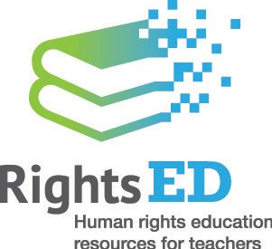
Program Planner
Select content, outcomes and suggested sequence activities based on resources in this Unit and create your own teaching and learning program.
Name of unit | Stage | Hours | Sequences

Unit summary

Achievement standards | Historical concepts

Content and teaching and learning sequence activities | Resources

Sequence 1 Resource Sheet: What are human rights and freedoms?
The basic notion of human rights lies in people’s recognition of the need to protect and affirm every other person’s individual dignity. Human rights are important.
No matter where people come from, or what their age, culture, religion or income may be, human rights are universal. Human rights issues are often seen as national or international in scope, but human rights are equally relevant at an individual and community level.
So what are human rights and freedoms?
There is no universally agreed definition; indeed, people’s understanding of human rights is continually evolving. There are general understandings, though, of what is meant by the term. One way of looking at rights is to see them as a special kind of claim on others. For example, the right to education means that everyone is entitled to a good education and, in particular, that governments have an obligation to provide education facilities and services.
Rights are related to the values that societies live by. These values have their origins in the world’s great religions and philosophies. Value systems can vary in detail between one society and another but the fundamental ideas are very similar. Concepts of justice and human dignity are at the heart of these values.
Rights also relate to what is lawful: that is, some rights may be laid down in law. If you have a legal right to something, you may be able to defend it in court. In many situations, though, rights exist but are not covered by law. These rights are often called moral rights. Moral rights are based on people’s sense of what is fair or just.
Which rights and freedoms?
There can be differing views on human rights – for example about which rights are more important or whether a particular moral or legal right is a human right. When we talk about human rights we are usually referring to those principles that the nations of the world have agreed to refer to as human rights. These have been set down in international agreements and form part of international law. The rights set out in these agreements are often also written into the domestic law of individual countries.
Human rights and freedoms cover virtually every area of human activity. They include civil and political rights, such as freedom of speech and freedom from torture. They also include economic and social rights, such as the rights to health, education and work.
Some rights apply to individuals, such as the right to a fair trial: these are called individual rights. Others apply to groups of people, such as the right to a healthy environment or to native title: these are called collective rights.
Human rights and responsibilities
Human rights involve responsibility and duties toward other people and the community. Individuals have a responsibility to respect the rights of others and ensure that they exercise their rights with due regard for the rights of others. For example, exercising freedom of speech should not infringe someone else’s right to privacy.

Sequence 1 Activity Sheet: What are human rights and freedoms?
The following activity explores what you currently know about human rights.
Look at each of the statements below. Place a tick in the appropriate box to indicate whether you think the statement is true, false, or if you aren’t sure.
Statement | True | False | Not sure
1. There are rights which every person has and which cannot be taken away from them
2. There are responsibilities which go with every right
3. The individual is the most important unit in society and has to come first
4. The group is the most important unit in society and has to come first
5. Rights must ultimately be consistent with religious principles
6. People have basic economic rights
7. People have basic obligations towards the environment
8. Within a society there may be special Indigenous people’s rights
9. People have the right to say what they think
10. All people have equal rights

Make some notes here about any of the statements where you answered ‘not sure’. Would you need to change the wording of any of the statements to make them easier to identify as ‘true’ or ‘false’?

Sequence 1 Resource Sheet: The Universal Declaration of Human Rights and other human rights instruments
The Universal Declaration of Human Rights was adopted by the United Nations General Assembly in 1948. It is the basis for human rights protection and promotion around the world and has been endorsed by all countries. Many countries have included its provisions in their basic laws or constitutions.
Those who drafted the Declaration had in mind the extreme human rights violations that had been perpetrated during World War II and the preceding years. The United Nations was all about promoting a better world through international co-operation, including in the field of human rights. In adopting the Declaration, the United Nations emphasised the inherent dignity of every person and that recognition of human rights was the basis for freedom, justice and peace. It called on governments and individuals to promote respect for human rights through education and government policies.
The Universal Declaration is a powerful and eloquent statement, setting standards that provide a framework for human rights supporters to call human rights violators to account. In its own words, it is
‘… a common standard of achievement for all peoples and all nations …’
The rights set out in the Universal Declaration cover not only civil and political rights, which protect individuals from government abuse of power, but also economic, social and cultural rights, which are the basis for adequate standards of living that will ensure human dignity.
The existence of the Universal Declaration by itself does not mean that human rights violations do not continue to occur. Some countries are ruled by dictatorships, people are tortured and killed and there is discrimination and vilification. Some individuals are victims of poverty, unemployment, ill health and lack of educational opportunity. Nevertheless there has been much progress since 1948. There is widespread recognition of what human rights are, due largely to the existence of the Universal Declaration and other United Nations human rights standards.
The Universal Declaration has great moral force and standing and the standards it sets out have come to be the basis for much of the development of human rights law that has followed.
International human rights standards that are legally binding are in the form of agreements between different countries of the world. These agreements, or ‘treaties’, are worked out by representatives of governments sitting down together at the United Nations to discuss ideas and wording that all can agree on. Human rights treaties are usually called ‘conventions’ or ‘covenants’.
After adopting the Universal Declaration, the United Nations went on to draft two major treaties that elaborated on the provisions of the Universal Declaration in a way that made them legally binding on countries that agreed to become parties to them. The two treaties were the International Covenant on Civil and Political Rights (ICCPR) and the International Covenant on Economic, Social and Cultural Rights (ICESCR). They were adopted by the General Assembly in 1966.
When countries sign and ratify a treaty, they take on an obligation to observe the provisions of that treaty. In the case of major human rights treaties, the obligations include regular reporting to and scrutiny by, UN human rights bodies. Each country has an interest in maintaining a rule-based international system because they don’t want others to break the rules. While there are no penal sanctions, most governments do not like to be exposed to international criticism for failing to observe human rights standards.
In Australia’s case, there is usually a substantive review of legislation and practice before ratifying a human rights treaty, to ensure that Australian law complies with the treaty concerned (though these laws can always be changed).
In some cases, the ratification of a human rights treaty has been accompanied by the passage of specific legislation to give effect to the treaty. The Racial Discrimination and Sex Discrimination Acts are examples.

Sequence 2 Timeline: Aboriginal and Torres Strait Islander History 1945–1975
Year | Key events
1948 | The Commonwealth Citizenship and Nationality Act — Aboriginal and Torres Strait Islander people now regarded in federal law as Australian citizens. But at state level they still suffer legal discrimination.  The Universal Declaration of Human Rights (UDHR) is passed by the United Nations and signed by Australia.
1949 | Aboriginal and Torres Strait Islander people are given the right to enrol and vote at federal elections if they are allowed to vote in state elections or have served in the armed forces (World War II). Few Aboriginal and Torres Strait Islander people met these criteria.
1953 | Australia allows Britain to test atomic weapons at Maralinga in South Australia (Operation Totem). Land contaminated with radio-active materials. Aboriginal people of Maralinga forced to abandon lands.
1956 | Further atomic tests at Maralinga, South Australia (Operation Buffalo).
1957 | More atomic testing (Operation Antler) at Maralinga, South Australia despite Aboriginal people on the test site.  The Federal Council for the Advancement of Aboriginals and Torres Strait Islanders (FCAA) is established. Work for Aboriginal and Torres Strait Islander people rights.
1960 | Aboriginal and Torres Strait Islander people become eligible for social service benefits like other Australian citizens.
1962 | The Commonwealth Electoral Act is amended to give the right to vote (franchise) to all Aboriginal and Torres Strait Islander people, extending the right to vote to Aboriginal people in the states of Western Australia and Queensland and the Northern Territory.  FCAA starts ‘National Petition, Towards Equal Citizenship for Aborigines’.  Charles Perkins and the ‘Freedom Riders’ protest against discrimination in NSW country towns, including refusal of service in shops and segregated cinemas, swimming pools, hotels and clubs.  Charles Perkins becomes the first Aboriginal university graduate (University of Sydney) with a Bachelor of Arts.
1964 | United States Civil Rights Act, prohibiting discrimination based on race, colour, religion or national origin.
1965 | Campaign for equal wages for Aboriginal and Torres Strait Islander people rural workers. Awarded 1966 but not to start until 1968 > Wave Hill Protest.
1966 | The South Australian Prohibition of Discrimination Act bans all types of race and colour discrimination in employment, accommodation, legal contracts and public facilities in that state. The South Australian Lands Trust Act is the first legislation providing land ownership and compensation to dispossessed Aboriginal and Torres Strait Islander people.
1967 | 1967 Commonwealth Referendum by Australian voters gets 90% support for changes to the Australian Constitution: deleting section 127, and amending clause 51. Aboriginal people will be counted in the census and Federal government now able to make laws for Aboriginal and Torres Strait Islander people.
1968 | Albert Namatjira, first named Aboriginal and Torres Strait Islander person honoured on an Australian stamp. The Commonwealth Office of Aboriginal Affairs is established and in 1972 becomes the Department of Aboriginal Affairs.
1971 | Aboriginal and Torres Strait Islander people included in the first Commonwealth census since the 1967 Referendum. Aboriginal and Torres Strait Islander people’s Flag flown for the first time in Adelaide. Evonne Cawley, an Aboriginal tennis player, made the Australian of the Year. Neville Bonner became the first Aboriginal and Torres Strait Islander people member of Parliament as a Senator.
1972 | New Federal government under Whitlam abolishes White Australia Policy and introduces a policy of self-determination.
1973 | Aboriginal Land Rights Commission established.
1975 | The Department of Aboriginal Affairs established by the Whitlam Government.

Sequence 2 Activity Sheet: Aboriginal and Torres Strait Islander History, 1945–1975
Task: Identify, list in chronological order and briefly describe 5–10 key events from the Timeline provided which illustrate:
- human rights restrictions on Aboriginal and Torres Strait Islander peoples
- methods used to remove human rights restrictions
- better recognition of Aboriginal and Torres Strait Islander peoples.

Year | Key events

Sequence 2 Worksheet: The Freedom Riders
Who were the ‘Freedom Riders’?

Why did the Freedom Riders decide to act?

What did the Freedom Riders decide to do?

Where did the Freedom Riders go?

What did the Freedom Riders do to act against racial discrimination?

Sequence 3 Work Sheet: Race and Recruitment
British migrants were the Australian government’s first preference to increase population and wealth, however not all British migrants were accepted.
Some who missed out were excluded because of health reasons, however for some there were less obvious reasons…
Read the following paragraph and answer the inquiry questions below.
‘Trickier were the cases which inevitably arose within the normal selection procedures in Britain. Generally there were very few non-white applications to Australia House. But an immigration officer remembered a particular case in 1948: a family in Nottingham with 13 children applied to Australia House and was greeted as a splendid case for publicity. The newspapers and cameramen were alerted and the family assembled (except for the most recent baby - asleep in a cot upstairs). The press pleaded with the parents to bring the baby to complete the photo call. As the recruiting officer put it, 'And then, lo and behold, the thirteenth child, as black as the ace of Spades. The rest of the family was completely European white. The mother was the grand-daughter of a Jamaican seaman and her thirteenth child was thrown back to that colour'. The press cooperated and agreed not use the story. One month later the family was told that they had been rejected. As the Immigration Officer noted, 'coloured people simply accepted the fact that they couldn't migrate to Australia'. Not even the British could be relied upon to be consistently white and the selection methods occasionally lapsed into farce. But the implementation of the policy was never less than serious in terms of the expectations of the Australian public.’
Source: Eric Richards (2008) Destination Australia – Migration to Australia since 1901, UNSW Press, page 194.
Inquiry questions
- Why was the Nottingham family marked for selection at first?
- Why was the family finally rejected?
- What does this story tell us about Australia’s post-World War II immigration selection processes?

Sequence 3 Worksheet: New Homes
Step 1: Background — Europe 1947–1952
Read the introduction over the map of Europe. Then click on ‘play’ or ‘enter’ to show the map of Europe and your red Australian Immigration Department car.
Step 2: Selecting Displaced Persons
Australian immigration officials worked directly in European countries to select migrants ‘suitable’ for Australia’s population and economic needs. Imagine you are an Australian immigration official touring Europe in your car. Follow the keyboard control instructions.
Record the Displaced Person numbers in the table and rank them with a number, where 1 is the highest number of displaced persons.
Country | Number of Displaced Persons | Rank (1–12)
France
Germany
Sweden
Estonia
Latvia
Lithuania
Poland
Ukraine
Czechoslovakia
Hungary
Yugoslavia
Italy
Total

Were most Displaced Persons from Western Europe or Eastern Europe?

What events led to these people becoming Displaced Persons?

Step 3: Interactive map overview
Click on ‘Enter’ and watch and listen to the interactive map overview.
Why did Australia select displaced persons as migrants to Australia at this time?

Step 4: New Homes
Click on the picture of Petronella Wensing or Lilija Brakmanis to explore their story. Using the information in their timeline create a profile about Petronella or Lilija in your notebook.
In your profile, include the following information about your chosen person:
- Their country of origin
- Their age when they migrated to Australia
- A few reasons why they decided to immigrate to Australia (identify any push or pull factors)
- Their early life in Australia
- The highlights of their life in Australia
- Any examples of discrimination they faced in Australia

Step 5: Conclusions
What did you learn about the life of a ‘Displaced person’ in their original home and in their ‘New Home’?

