**REQUEST TO JOIN EXEMPTION APPLICATION LODGED BY THE DEPARTMENT OF   
FAMILIES, HOUSING, COMMUNITY SERVICES AND INDIGENOUS AFFAIRS (FaHCSIA)   
UNDER S55 OF *THE DISABILITY DISCRIMINATION ACT* (1992) (CTH)**

IM/e seek to join/support the exemption application submitted by FaHCSIA as follows:

* INVe seek an exemption for all existing ADEs from sections 15 and 24 of the DDA, and the Commonwealth (and officers of the Commonwealth) from section 29 for a period of three years,
* This exemption would apply to use of the BSWAT to:

1. assess wages for employees; and
2. pay wages to ADE employees based on assessments conducted under the BSWAT.

* The proposed exemption would apply while alternative wage setting arrangements are being considered, devised and/or established and implemented by FaHCSIA.

**COMMENTS**

It is now a very pressing issue as many supported employees' assessments are overdue. A temporary exemption will allow time to determine which best tool will be use in the future and prevent a crisis in supported employment.

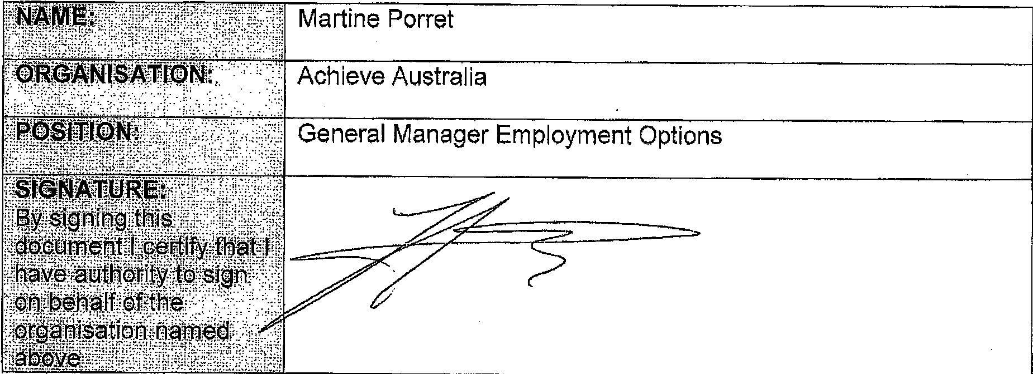

General Manager Employment Options