Australian Human Rights Commission
GPO Box 5218
Sydney
NSW 2001

By email to disability@humanrights.gov.au

5 February 2015

Dear Madam/Sir

I am writing to submit an Action Plan under section 64 of the Disability Discrimination Act 1992.
Background

The project involves the re-development of the old New Town Post and Telegraph Office at 176 New Town Road, Hobart.

The building first opened its doors in 1891 and is a Heritage listed building.


While an architecturally unsympathetic extension was added at the front of the building in the 1970’s the building is an iconic landmark and has a strong local community presence.

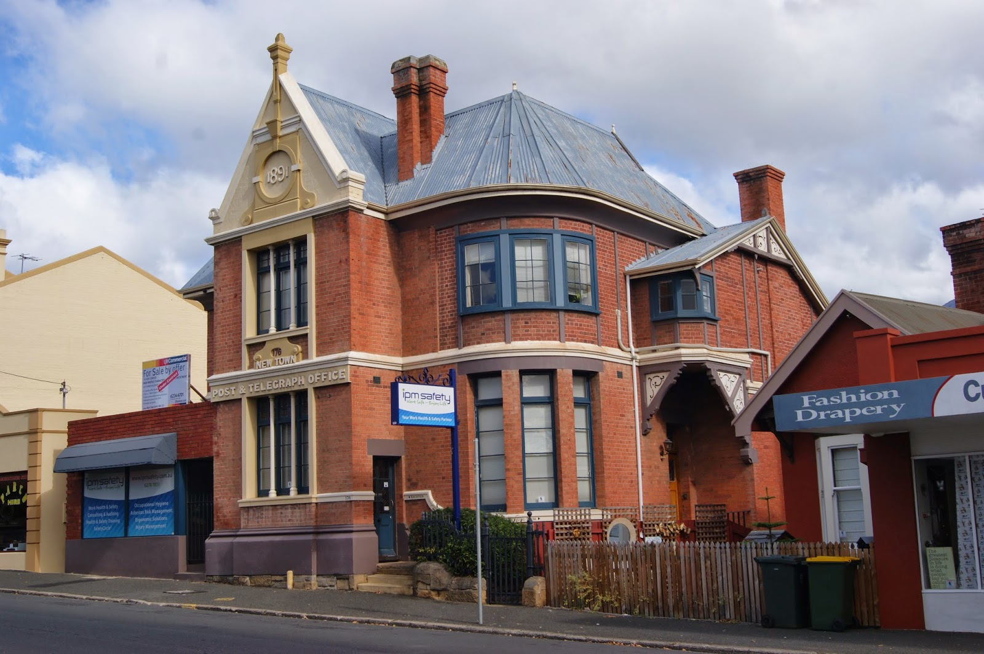
Figure 1 shows the front of the building with the 1970’s addition to the left

The building is linked to a large rear outbuilding (also heritage listed) by a stepped side passage. This outbuilding was used recently as a training/studio space.

The building sits on the allotment boundary with a number of steps up from the footpath to the main entrance. At the moment there is no access for people with mobility disability who use wheelchairs to any part of the building or outbuildings and no accessible toilet facilities.

I recently purchased the property and my vision is to create an inspirational art and cultural venue that promotes a unique lifestyle experience every day.

I am a professional community artist working with members of the community to create visual artwork, and to promote better health through art.

I run a weekly art program at the Royal Hobart Hospital (RHH) and facilitate community programs and artist in residence projects. I am also a nurse in the Department of Psychological Medicine at the RHH.

As a passionate advocate for sustainability, I promote the use of recycled materials wherever possible; to remake or up-cycle them in a creative way.

The development will include a gift shop, art studios, a large art studio/event space and the Not Junk Resource Hub; all operating concurrently throughout the day.

As Business Arts manager, I will take care of the studios, the gift shop and the resource hub. I will co-ordinate artists and makers for the studios and gift shop, roster a workshop program, liaise with educators, process bookings and payments, organise equipment and materials as necessary, and facilitate some studio activities.

I will be responsible for the studio, gift shop and resource hub presentation and maintenance, policies and procedures, occupational health and safety, record keeping and promotional activities.

The building has been most recently used as office space and the change in use will require significant upgrade of features such as safety and amenity, including access for people with disability.

This includes the provision of access to the main building and associated studio, internal circulation requirements and the provision of an accessible unisex toilet.

The location of the building on the allotment boundary, the significant resource demands of opening up this new initiative and heritage status of the building present some real difficulties in achieving compliant access immediately, however, I am committed to progressive action to achieve full access as soon as practicable.

I note that the Disability (Access to premises – buildings) Standards 2010 (Premises Standards) recognise that in some situations where immediate compliance might not be feasible the submitting of an Action Plan and evidence of its implementation may be considered a relevant factor in the event of a complaint.

Proposed approach

While substantial design, budgeting and financial viability work was undertaken prior to purchase of the property the range of issues that have to be addressed in order to open the business and establish financial viability have proved to be extensive.

I am proposing a 2-stage approach to progressively addressing the access requirements of people with mobility disability to both the studio/event experience and the café/gift shop.

I believe the financial viability of the business relies on being able to open and operate as soon as possible in order to accumulate funds to address any outstanding re-development issues.

In order to do this I have sought a temporary occupation certificate from my building certifier to operate for a period up to 2 years on condition that the actions identified in this plan are implemented.

This means that if at the end of the period of temporary occupation the actions have not been completed occupancy approval would be withdrawn.

Stage 1
Stage 1 will prioritise 2 access features
- access to the unique services and opportunities being offered in the large studio/event space from the footpath will be provided through the installation of a compliant ramp from the public footpath, alongside the main building
- the installation of a compliant accessible unisex toilet in the café area.

While access to the café and gift shop from the footpath is to be addressed in Stage 2 the provision of this accessible unisex toilet in Stage 1 will both:
- provide more amenable toilet facilities to all patrons of the café including people with mobility disability who do not use wheelchairs, and
- signal my intention to achieve full accessibility to all parts of the business required to be accessible.
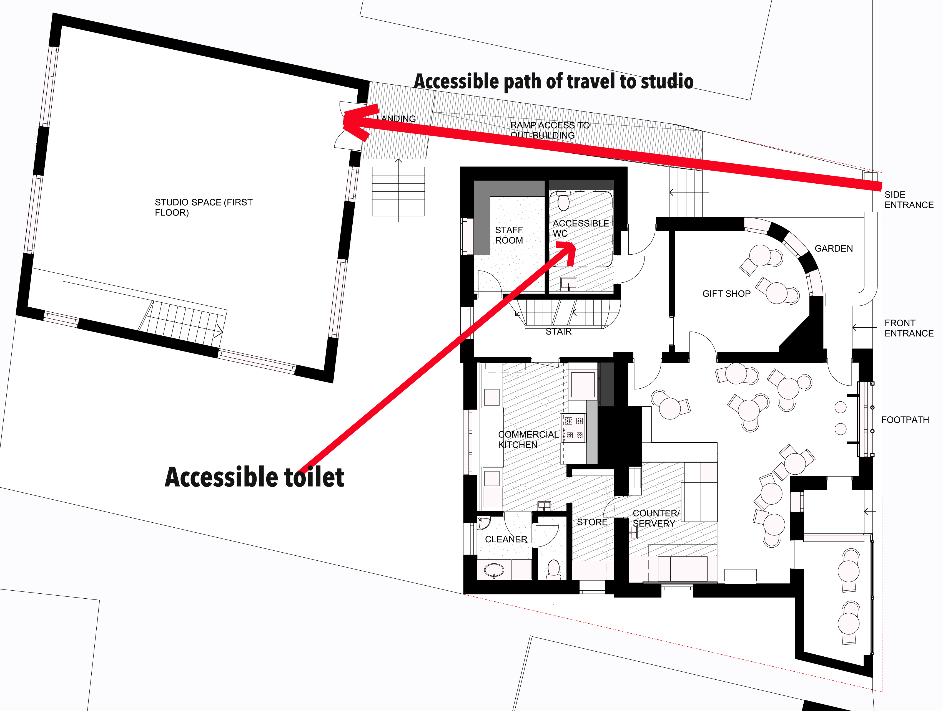
Figure 2 shows the Stage 1 development

Stage 2

Stage 2 will involve the securing of approval from the Heritage Council to remove the existing extension to the main building and the construction of a new main entrance including a compliant ramp.

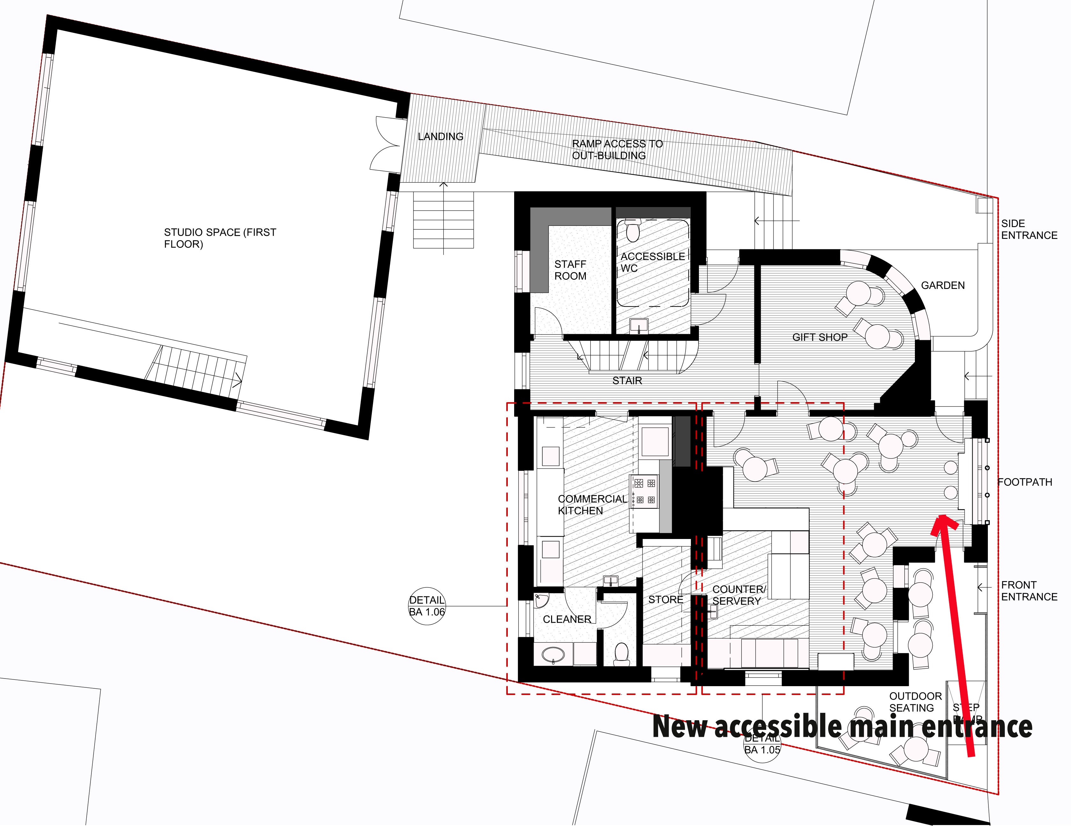
Figure 3 shows the Stage 2 development

While initial discussions with the Heritage Council and Hobart City Council have been positive the formal process of gaining approval to remove the extension, undertake remedial work and establish the proposed new entrance is likely to take many months.

In the meantime I believe the financial viability of the business relies substantially on our ability to open as quickly as possible in order to generate funds to fulfil the commitments in this Action Plan.

I would be grateful if you could inform me when the Action Plan has been registered.

Yours sincerely

Tanya Lapaglia
Owner
176 New Town Road, Hobart
tanyalapaglia@hotmail.com

Appendix 1: Action Plan

Appendix 1

Action Plan

Goal: To ensure equitable access to each of the services and experiences provided by the business.

Action | Timeframe | Responsibility | Reporting
1. Obtain approval for a Temporary Occupation Permit for a period of 2 years subject to meeting the actions set out in this plan. | Within 2 months of the registration of this Action Plan | Tanya Lapaglia | A brief report informing of the granting of the Temporary Occupation Permit and any attached conditions to be provided to the Commission within 2 months of the registration of this Action Plan.
2. Complete the Stage 1 works of the proposed plan to provide an accessible unisex toilet and access to the studio/event space | Within 6 months of the registration of this Action Plan | Tanya Lapaglia | A report on progress will be provided to the Commission six months from the registration of this Action Plan
3. Obtain approval to demolish the modern extension to the original building and secure approval to establish a new main entrance that provides for access to the café and gift shop area . | Within 9 months of the registration of this Action Plan. | Tanya Lapaglia | A report on negotiations with Heritage Council and confirmation of approval to proceed with the new work provided to the Commission 9 months from the registration of this Action Plan
4. Complete the Stage 2 works to establish a new main entrance with compliant ramp access. | Within 24 months of the registration of this Action Plan. | Tanya Lapaglia | A report on completion of the access arrangements to the provided to the Commission within 24 months of the registration of this plan.

