Taking bystander action against sexual harassment in the workplace: A fact sheet for employees

Who are bystanders? And what is bystander action?
Bystanders are people who see sexual harassment firsthand or who hear of the incident after it occurs.
What is sexual harassment?
Sexual harassment is any unwelcome conduct of a sexual nature. If a reasonable person would anticipate this behaviour might make you feel offended, humiliated or intimidated, it may be sexual harassment. Sexual harassment is unlawful under the Sex Discrimination Act 1984 (Cth).
To understand more about what is workplace sexual harassment see: Recognising and responding to sexual harassment in the workplace: Information for employees

Examples of a bystander can be …
- an employee in a shop who sees a colleague being harassed by another colleague, or the employer or a customer
- an employee listening to colleagues make inappropriate sexual comments about their female colleagues at after work drinks
- an employee who is told by a colleague that she is being sexually harassed by the manager
- a manager who is informed about an employee sexual harassing another employee.

Bystander action is the action people can take in response to either seeing the sexual harassment or hearing about it after it has occurred.
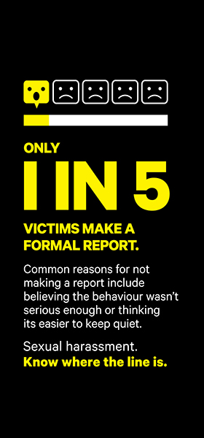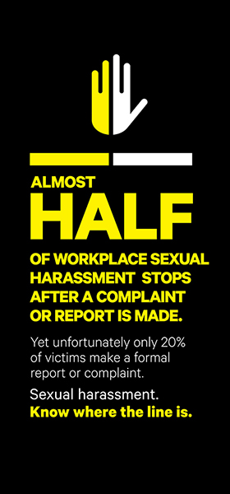
Why is bystander action important?
Fewer than one in six respondents to the Australian Human Rights Commission 2012 Sexual Harassment Survey, who reported sexual harassment, had formally reported the incident - either because they were fearful that reporting would have a negative impact or they felt that the response would be inadequate.
Because so few people report their experiences of sexual harassment, bystanders have a powerful role to play in calling out behaviour that crosses the line and supporting colleagues who experience sexual harassment.
It takes courage to speak up but don’t underestimate the positive impact that calling out workplace sexual harassment can have, not only on the person being harassed but on your colleagues and the culture of your organisation.

How can bystanders take action on workplace sexual harassment?

You can take bystander action if you witness sexual harassment at work. You can also take action if you didn’t see the sexual harassment occur but someone told you that it happened. The action you take may be different but both forms of action can be effective.

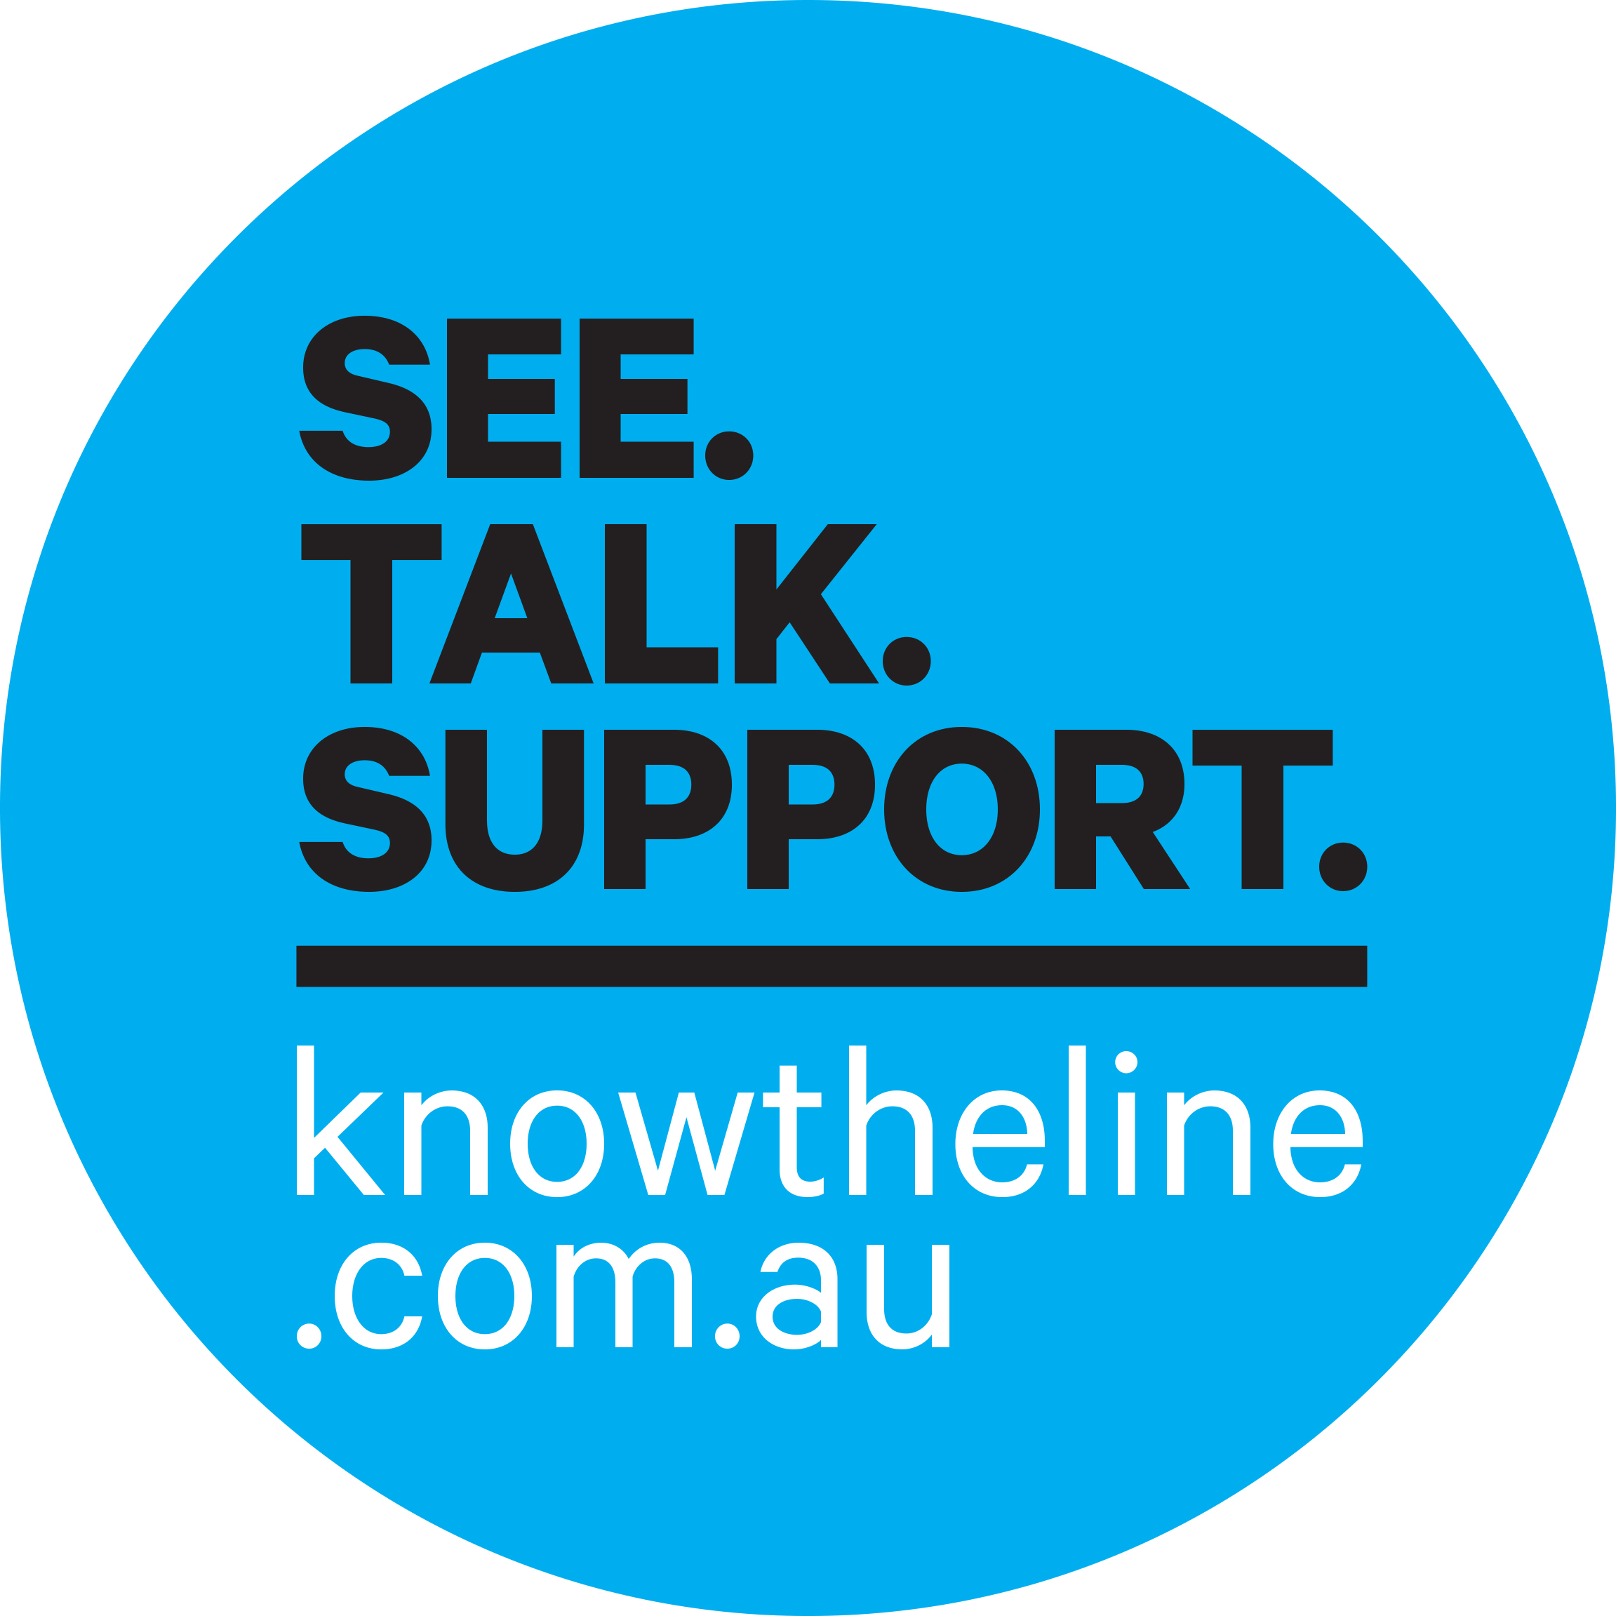

- You can see harassment when it occurs – recognise the behaviour for what it is, name it, and do not ignore it

- You can talk – to the person who is doing the harassment, telling him/her to stop the harassment

You can also, with the permission of the person experiencing the harassment …
- speak to your employer
- speak to your human resources manager
- speak to your colleagues.

- You can support the person experiencing the harassment – you can help them take action for themselves. You can support them by:

- listening to them
- referring them to your organisation’s policies and procedures about sexual harassment
- assisting them find information about how to make a complaint
- encouraging them to report the problem
- offering to accompany them when they report the problem.

- There are also other things you can do:

- talk to your manager or Human Resources about organising sexual harassment training for the workplace
- talk to your manager or Human Resources about developing and implementing sexual harassment policies and displaying them in a prominent place
- talk to a union delegate or union about raising awareness of sexual harassment in the workplace.

What bystander action is possible will differ in different workplace contexts, so it may be necessary to adapt what action you take to the context of your workplace.

What about the risk of victimisation?

People who experience sexual harassment and bystanders can both be subject to victimisation.

Victimisation involves retaliatory action, or the threat of such action, against a person because they made a complaint of sexual harassment or because they took bystander action in support of a complaint.

There are specific provisions in the Sex Discrimination Act that prohibit victimisation in some circumstances.

A person could be victimised by the harasser themselves, or by co-workers who support the harasser, especially if either of these parties are in more senior organisational positions or have power over the person being victimised.

Examples of victimisation could be:
- terminating a person’s employment
- not giving a person a promotion
- sidelining a person
- singling out a person
- some other form of detrimental behaviour towards a person

… because they took some sort of bystander action in response to sexual harassment in the workplace (i.e. spoke up about it, reported it etc.).
Organisations which encourage bystanders to be proactive in responding to sexual harassment should recognise the risk of victimisation and expressly communicate to employees that bystanders will be protected from victimisation and undertake disciplinary measures if victimisation does occur.

What can employers/workplaces do to encourage bystander action?
Bystander action in workplaces is more likely to be successful when:
- there is strong leadership demonstrating a zero tolerance for sexual harassment
- bystanders know how to take action
- bystanders have confidence if a person is found to have sexually harassed another person, action will be taken against the harasser
- bystanders have confidence they will be supported by their colleagues and their organisation and will not be victimized for taking action
- the organisation actively promotes gender equality and respectful relationships.
Employers/ workplaces can encourage bystander action by:

- Developing policies and guidelines for bystander action on sexual harassment.

- Providing education and training about bystander action: This can teach people how to safely and effectively intervene in incidents and challenge sexual harassment.

- Creating a workplace environment that encourages reporting of sexual harassment:
  - encouraging leaders to speak out positively about taking bystander action
  - providing multiple communication channels to report sexual harassment
  - responding to reports of sexual harassment in a timely way
  - providing training for those responsible for acting on reports of sexual harassment.

- Conducting ongoing monitoring and evaluation of bystander strategies.

For further information see:
- Ending workplace sexual harassment: A resource for small, medium and large employers – this provides practical guidance on how employers can prevent sexual harassment and how to respond effectively when it occurs.
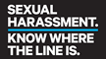
- Know Where the Line Is
For information about workplace sexual harassment, how to take bystander action or to watch a video about different forms of bystander action, visit www.knowtheline.com.au

- Encourage. Support. Act!: Bystander Approaches to Sexual Harassment in the Workplace (2012), written by Paula McDonald, Queensland University of Technology and Michael Flood, University of Wollongong for the Australian Human Rights Commission https://www.humanrights.gov.au/publications/encourage-support-act-bystander-approaches-sexual-harassment-workplace-2012

- VicHealth, More than ready: Bystander action to prevent violence against women (2012) http://www.vichealth.vic.gov.au/Publications/Freedom-from-violence/Bystander-Research-Project.aspx

- VicHealth, ‘Stepping in’: A bystander action toolkit to support equality and respect at work – A resource for State Sporting Associations (2014) https://www.vichealth.vic.gov.au/media-and-resources/publications/bystander-action-toolkit

- Men Speak Up: A toolkit for action in men’s daily lives (2011), written by Dr Michael Flood for the White Ribbon Foundation’s Policy Research Series No.4 http://www.whiteribbon.org.au/uploads/media/Research_series/Men_speak_up_Flood_2011.pdf
If you believe you have experienced sexual harassment or believe you have been victimised as a result of reporting sexual harassment or taking bystander action, you can make a complaint to the Australian Human Rights Commission.
Call the National Information Service on 1300 656 419 (TTY: 1800 620 241) or email us at infoservice@humanrights.gov.au

